**Corona Virus Pandemic**

In this article, I will talk about some positive and negative impacts during coronavirus pandemic and also discuss how can we sustain all of the positive impacts in the future and how to get rid of the negative impact.

We can sustain the positive environmental changes occurred from this pandemic situation. First of all, we need to know all of the positive impacts on the environment for COVID-19.

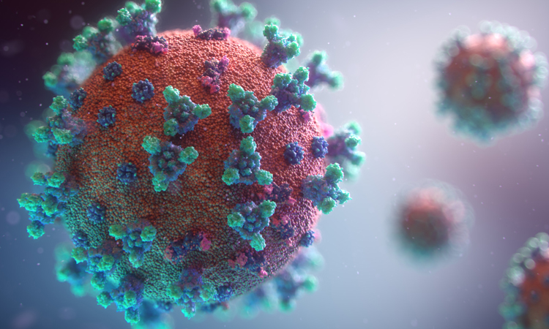

**Positive Impacts of Coronavirus**

**Fewer cars and blue skies:**

Due to the Coronavirus outbreak, all of the peoples ordered to stay home. Office, school, college, industry ordered to closed. People started their daily life in their homes. All of the public and private transport ordered to stop for the outbreak of Coronavirus. For this reason, traffic on roads has fallen in most of the busy cities in the world like New York, Rome, London as well as Dhaka. If we talk about Los Angeles, we can see traffic on roads and highways has fallen dramatically over the past week as the coronavirus outbreak forces people to stay at home. Pollution has dropped too. A satellite that detects emissions in the atmosphere linked to cars trucks shows huge declines in pollution over Los Angeles. The Satellite shows that atmospheric levels of nitrogen dioxide and carbon dioxide, which are influenced in large part by car and truck emission, were considerably lower over Los Angeles in the first two weeks of March compared to the same period last year. For this reason, the air become fresh. Air travel has also taken a major hit for reducing air pollution during the coronavirus pandemic.

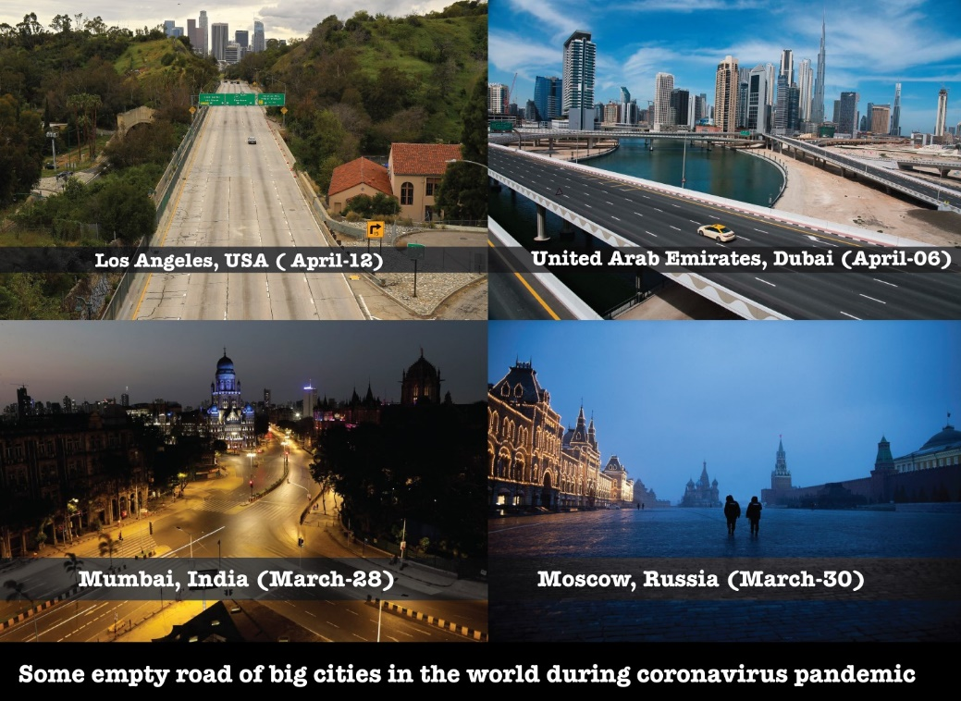

**Nature is thriving:**

Due to less pollution of the environment, nature becomes thriving and the ozone layer is healing day by day. With industrial activity slowing down because of lockdown restrictions, new satellite imagery from the European Space Agency has found that air pollution leaves in China and Italy are markedly lower than this time last year. In fact, some cities have seen nitrogen-dioxide levels fall by up to 60% on the same period last year. Before lockdown, our Dhaka was 3rd worst city in the world, but due to lockdown it ranked 12th in the Air Quality Index with a score of 112 (April 14,2020)

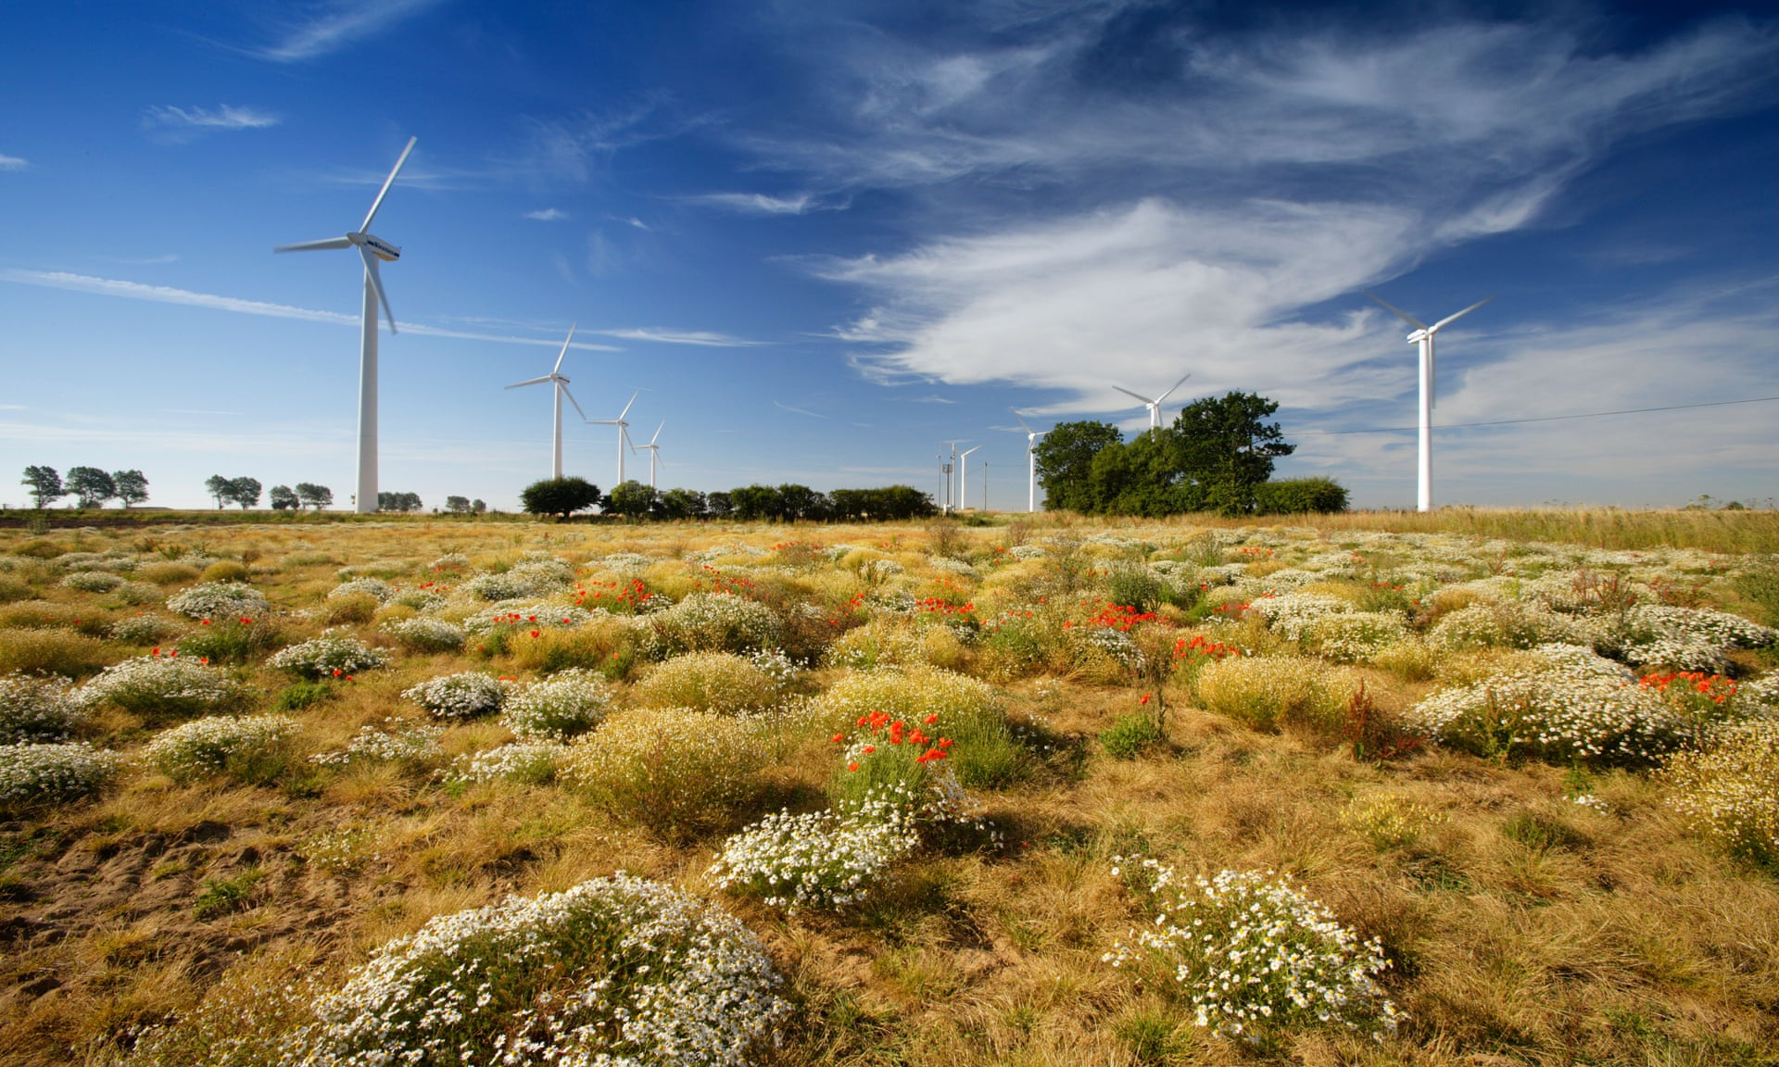

**Priorities of medical research:**

Still now (May 10, 2020) scientists could not invent any vaccine of coronavirus. They were not ready to face this virus. For this reason, people are affected and become dead day by day. If we were invested more money in our medical research then maybe we could easily invent the vaccine. Now we can see that many famous business industries like Amazon, Alibaba, Microsoft company start to donate money to invent vaccines. So, it is really good things to invest money in medical research.



**Stay connected with all of the countries:**

During this pandemic, we can see that all of the countries are stay connected and trying to help each other. One country trying to help another country by giving money, food, medical equipment, medicine, and many other things.

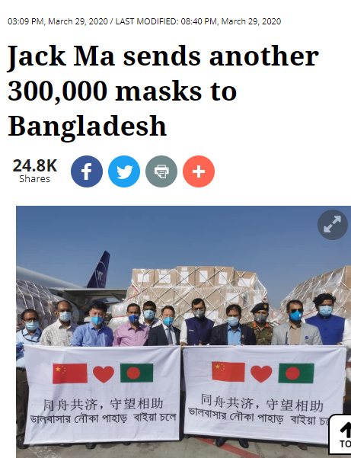

**People are being modern and self-depended:**

As all of the market and shopping malls are closed, people are going towards online shopping. They are adopting a new lifestyle. They are also being self-dependent as there is no maid available. People are using more social media. It’s raising awareness among them. People are nurturing their hobbies like cooking, painting, singing so on.

**Sustaining Positive Impacts of Coronavirus**

If we want to sustain all of the positive impact of coronavirus for our environment when the pandemic will be gone, then we need to follow some rules. If we want to control our traffic jam then we need to provide exclusive lanes for public transport, optimize traffic-light management, use CCTV to monitor road condition, extend residents parking zones, existing rail network, the center island on road, drones for delivery services as like Amazon is on the way to introduce a new and fastest way to deliver their goods to consumers. To control nature, we need to plants trees more and more, in cities all building’s rooftop needs to make a garden for fresh air and fresh vegetable or foods. We should stop deforestations and take necessary steps for tree plantation. We need to invest more money in the medical sector, as well as all of the important sector. All of the richest countries should help for the poor country. By following all of these points we can sustain our environment in the future.

**Negative Impacts of Coronavirus**

**Recycling problem:**

Due to lockdown, people can not go out of the house. All of the recycling factories are closed. For this reason, all of the waste cannot be recycled. Many wastes and also medical wastage is being stuck beside the road. It creates air and environmental pollution.

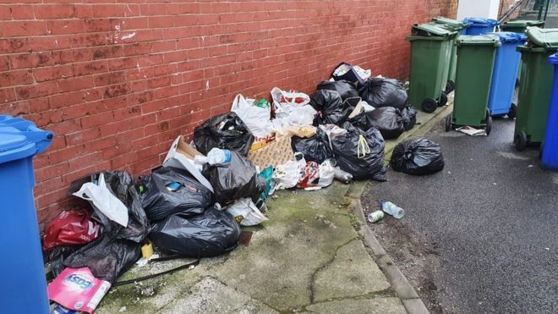

**Deforestation problem:**

Reusable bags are banned in several states like New Hampshire, Illinois, and Massachusetts in the US. For this reason, more trees needed for making bags. So, it will be the main reason for deforestation, and our environment will become worse day by day.

**Peoples health:**

During the lockdown, people cannot go out of the house. For this reason, people can not do exercise and also can not take fresh air. It will be affected people’s health in the future.

**Lack of food and nutrition:**

People cannot go to the market for buying fresh vegetables or fresh food. They used their stoked food day by day.

**Ecosystem at risk:**

Natural ecosystems and also protected species are at risk during coronavirus. We can see in many countries’ environment protection workers at parks, land, forest, and marine zones are required to stay at home in lockdown during this pandemic. For this reason, they leave all of these areas. Their absence has resulted in a rise in illegal deforestation, fishing, and wildlife hunting. These activities will take out ecosystems at risk in the future.

**Eradicating Negative Impacts of Coronavirus**

If we want to eradicate all of this negative impact during coronavirus, we need to take some steps. All of the natural protected areas need to use CCTV to monitor those areas so that people can not cut trees or hunting wildlife. After taking this step, if any people trying to cut trees then the protected areas officer needs to take a necessary step against them. If peoples want to keep their body fit, then they should start exercise inside their house. They need to eat healthy food. To keep our countries economy rate all of us need to start work in our own home by using the online platform. People can start freelancing in online for income money. Medical wastages need to recycle or dispose of in a proper way so that it cannot be harmful to our environment.