**How to use plastic without damaging ecosystem**

It is possible to live a modern life without using plastic pollutants. In this article, I will discuss about how can we live by using plastic but not polluting plastic through the plastic. Firstly, I will discuss how to plastic is polluting day by day in our environment, who is responsible for creating plastic pollution. Secondly, I will discuss the major future threats from plastic pollution and all of the negative impacts on humans and our ecosystem. Finally, I will discuss how can we live in modern life without using plastic pollutants, and all of the solution to eradicate our plastic pollution without totally banning plastic.

As the world’s population continues to grow day by day, so does the amount of garbage that people produce. On-the-go lifestyles require easily disposable products, such as soda cans or bottles of water, but the accumulation of these products has led to increasing amounts of plastic pollution around the world. As plastic is composed of major toxic pollutants, it has the potential to cause significant harm to the environment in the form of water, land, and air pollution.

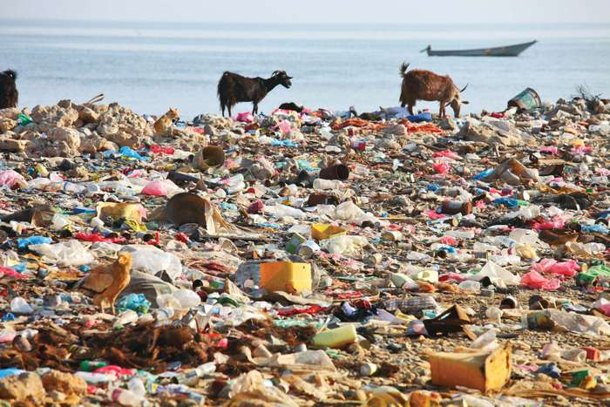

**What is plastic pollution:**

Plastic pollution is when plastic has gathered in an area has begun to negatively impact the natural environment and creates a problem for plants, wildlife, and even human population. We know that plastic is a useful material, but it is also made from toxic compounds that are responsible for our illness.

**How it is polluting:**

The world now produces more than 380 million tonnes of plastic every year and that is nearly equivalent to the weight of the entire human population, also this plastic which could end up as pollutants, entering our natural environment and oceans. All of our plastic waste is not end up in the ocean, some are ends up in our landfills. Global plastic waste that enters the ocean is around 3%. In a survey, we can see that in 2010 that was around 8 million tonnes. Half of all plastic ever manufactured has been made in the last 15 years. Production increased exponentially, from 2.3 million tonnes in 1950 to 448 million tons by 2015. Production is expected to double by 2050. Plastic is everywhere, even on those items you may not expect it to be. Milk cartons are lined with plastic, water bottles are handed out everywhere, and some products may even contain tiny plastic beads. The packaging was the dominant use of primary plastics, with 42% of plastics entering the use phase. Building and construction were the second largest sector utilizing 19% of the total.

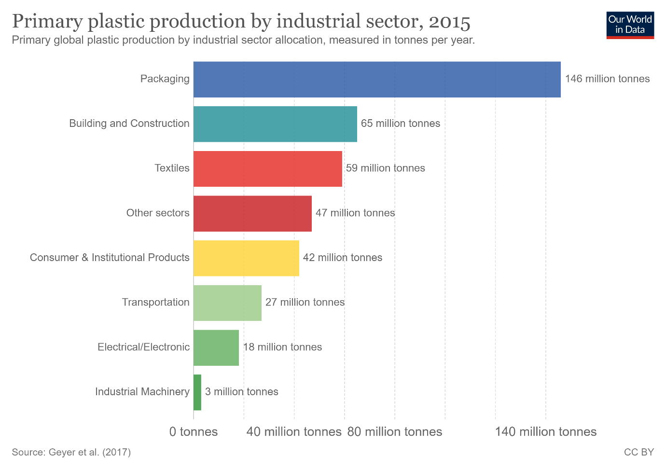

Plastic pollution can afflict land, waterways, and ocean. It is estimated that 1.1 to 8.8 million tonnes of plastic waste enter the ocean from coastal communities each year. Living organisms, particularly marine animals, can be harmed either by mechanical effects, such as entanglement in plastic objects, problems related to the ingestion of plastics that interfere with their physiology. As of 2018, about 380 million tonnes of plastic are produced worldwide each year. From 1950 up to 2018, an estimated 6.3 billion tonnes of plastic has been produced worldwide, of which an estimated 9% has been recycled and another 12% has been incinerated. A large amount of plastic waste enters the environment, with studies suggesting that the bodies of 90% of seabirds contain plastic debris. In some areas, there have been significant efforts to reduce the prominence of free-range plastic pollution, through reducing plastic consumption, litter cleanup, and promoting plastic recycling. Some researchers suggest that by 2050 there could be more plastic than fish in the ocean by weight.

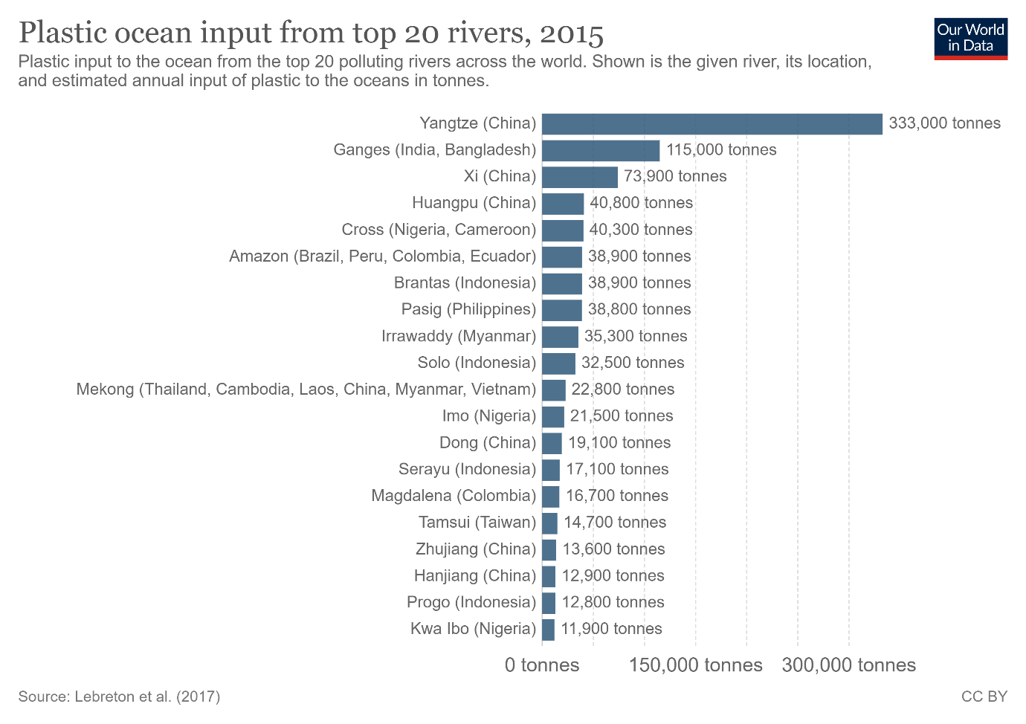

**Effects of plastic pollution:**

It seems rather obvious that this amount of a material that isn’t meant to break down can wreak havoc on natural environments, leading to long-term issues for plants, animals, and people. Some of the major long-term effects of plastic pollution are-

**Air pollution:**

Burning of plastic in the ocean air leads to environmental pollution due to the release of poisonous chemicals. The polluted air when inhaled by humans and animals affects their health and can cause respiratory problems.

**Land pollution:**

When plastic is dumped in landfills, it interacts with water and forms hazardous chemicals. When these chemicals seep underground, they degrade the water quality. The wind carries and deposits plastic from one place to another, increasing the land litter. It can also get stuck on poles, traffic lights, trees, fences, towers, and animals that may come in the vicinity and might suffocate them to death.

**Groundwater pollution:**

Water conservation is already a concern in places ranging from California to parts of India, but the world’s water is in great danger because of leaking plastics and waste. If you’ve ever seen a garbage dump, imagine what happens every time rains- then imagine that being in your drinking water. Groundwater and reservoirs are susceptible to leaking environment toxins. Most of the litter and pollution affecting the world’s oceans also derives from plastics. This has had terrible consequences on many marine species, which can lead to consequences for those that eat fish and marine life for nutrients including people.

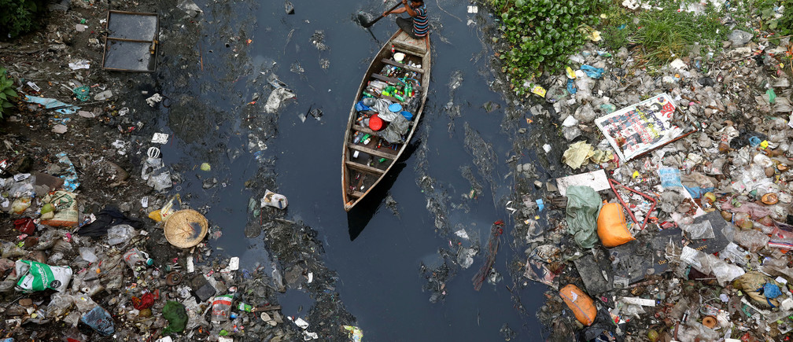

**It kills animals:**

Despite countless TV ads over the years showing ducks or dolphins trapped in six-ring plastic can holders, these items are still used and discarded a masse each day. Whether because the mass of plastic has displaced animals or the related toxins have poisoned them, plastic pollution does a lot of damage to the world’s ecosystems.

**It is poisonous:**

Man, artificially makes plastic by using a number of toxic chemicals. Therefore, the use of and exposure to plastics has been linked to a number of health concerns affecting people around the world. The processed of making, storing, disposing of, and just being around plastics can be extremely harmful to living things.

**It is expensive:**

It costs millions of dollars each year to clean affected areas after exposure, not to mention the loss of life to plants, animals and people. As land becomes more valuable, just finding a place to put garbage is becoming a problem in many parts of the world. Excess pollution leads to decreased tourism in affected areas, significantly impacting those economies.

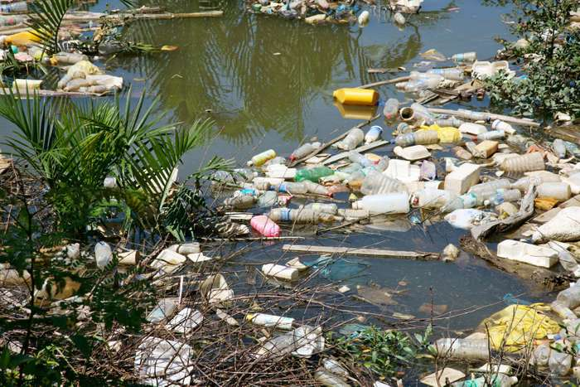

**Solution:**

Though there are plastic pollution around our environment even we can live in a modern live without plastic pollutants. We can’t just ban bad products of plastic or banning straws and bags won’t solve our plastic problem, so we must invest in alternatives way for reducing plastic pollution.

**Recycle everything:**

We need to invest in redesigning plastics so that they can be readily broken down into their molecular units and remanufactured into new plastics of the same quality, the essence of a closed loop system. We need better recycling technology that can address the major obstacle of recycling plastics: about 25 percent of plastics collected are contaminated and therefore unusable. Try and select items that come in no-plastic recycled and recyclable packaging, to do your best to properly handle items that can’t be reused. Check everything before you put it in the trash, as more and more items are able to be recycled these days. Remember that because plastic doesn’t break down easily, recycling plastic means that it is still plastic, just being used for a different purpose. Therefore, you’re not actually reducing plastic amounts or exposure, even in the recycling process.

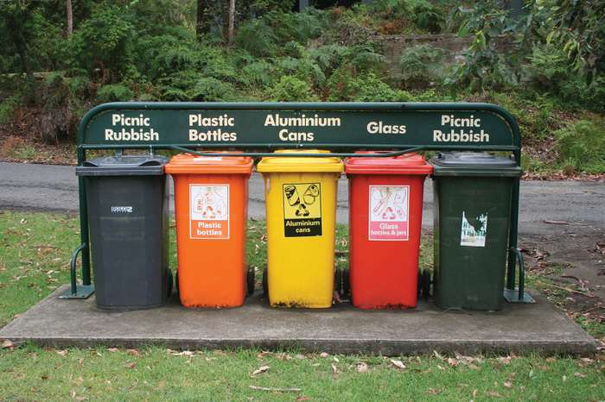

**Shop friendly:**

Plastic bags were once a modern convenience but can be efficiently replaced by reusable bags, many of which fold up compactly in order to be portable. Just think about how many bags you typically carry out of a grocery store, and multiply that by the number of times your grocery shop. That’s a lot of plastic! Carry a bag and always reuse plastic bags as much possible if you have them.

**Get rid of bottled water:**

People are meant to drink lots of water each day, and plastic water bottles have become a great way to say hydrated throughout the day. However, most of these are only recommended for single-use, and that means that every time someone finishes a bottle, it goes into the trash. Many companies now sell reusable water bottles as a substitute, reducing plastic waste and exposure to leaking bottles.

**Forget to-go containers:**

You would be surprised at how much plastic is involved in the making and packaging of food containers. Think the coffee shop’s drink cup is paper? It’s likely linked with plastic for insulation. Plastic food containers, lids and utensils are all easily replaced by reusable containers, which will cut down significantly on even a single meal’s waste.

**Education businesses:**

Speak to local restaurants and businesses about options that they can switch to for packaging, storing and bagging items. Many companies are starting to come up with excellent low-cost replacements, such as bamboo utensils in place of plastic ones.

**Get involved:**

Speak to lawmakers and get involved with government on any level, and you’ll see how many special interest groups have made it so that we are dependent on plastic without needing to be. Encourage the development of items, and propose alternatives when applicable.