Legislation Process Management System for the Federal Parliament of Canada

Testing Report

**Introduction**

* **Overview**: The Legislative System is a web-based application designed to streamline legislative procedures, enabling Members of Parliament (MPs), Administrators, and Reviewers to interact with bills through creation, review, voting, and management.
* **Objective**: The system aims to provide an efficient and transparent legislative workflow, supporting each user role with specific features to simplify their tasks.

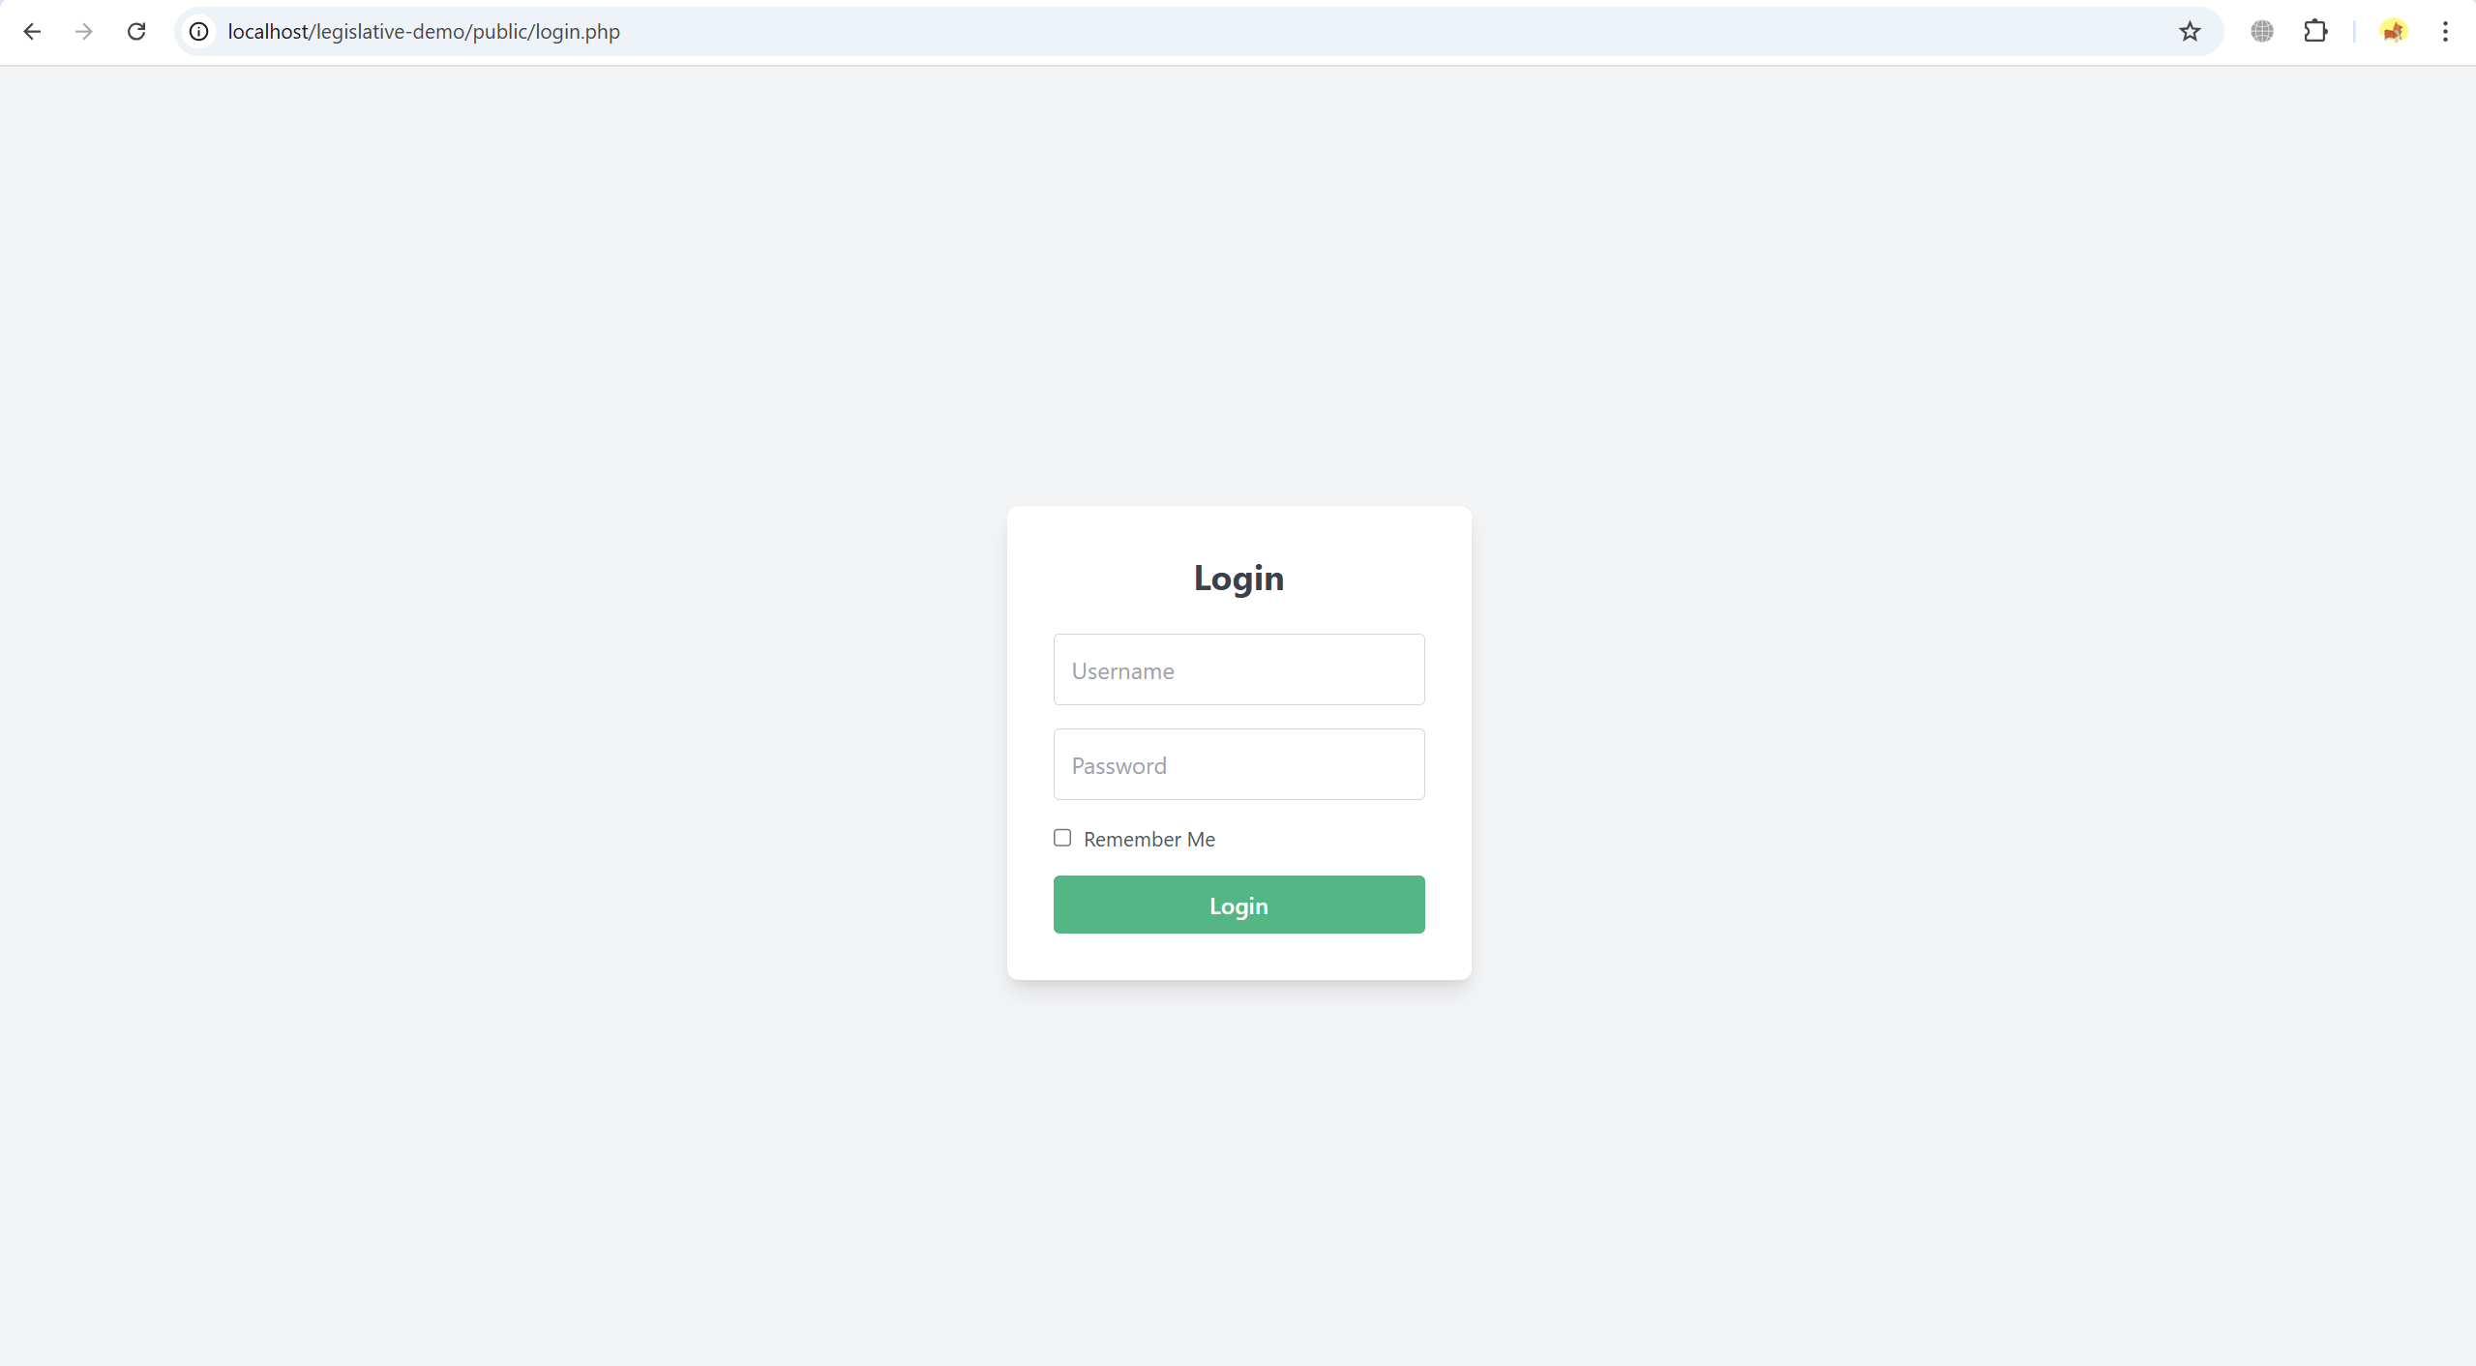

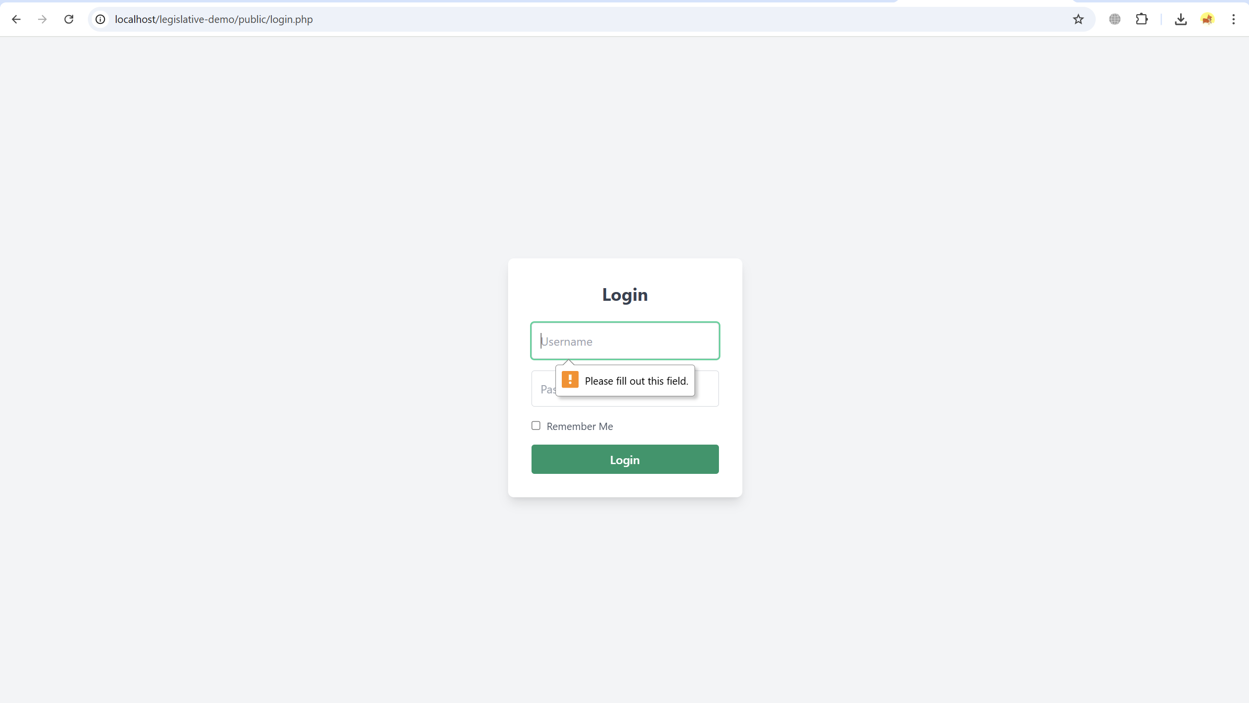

**1. Member of Parliament (MP) Role**

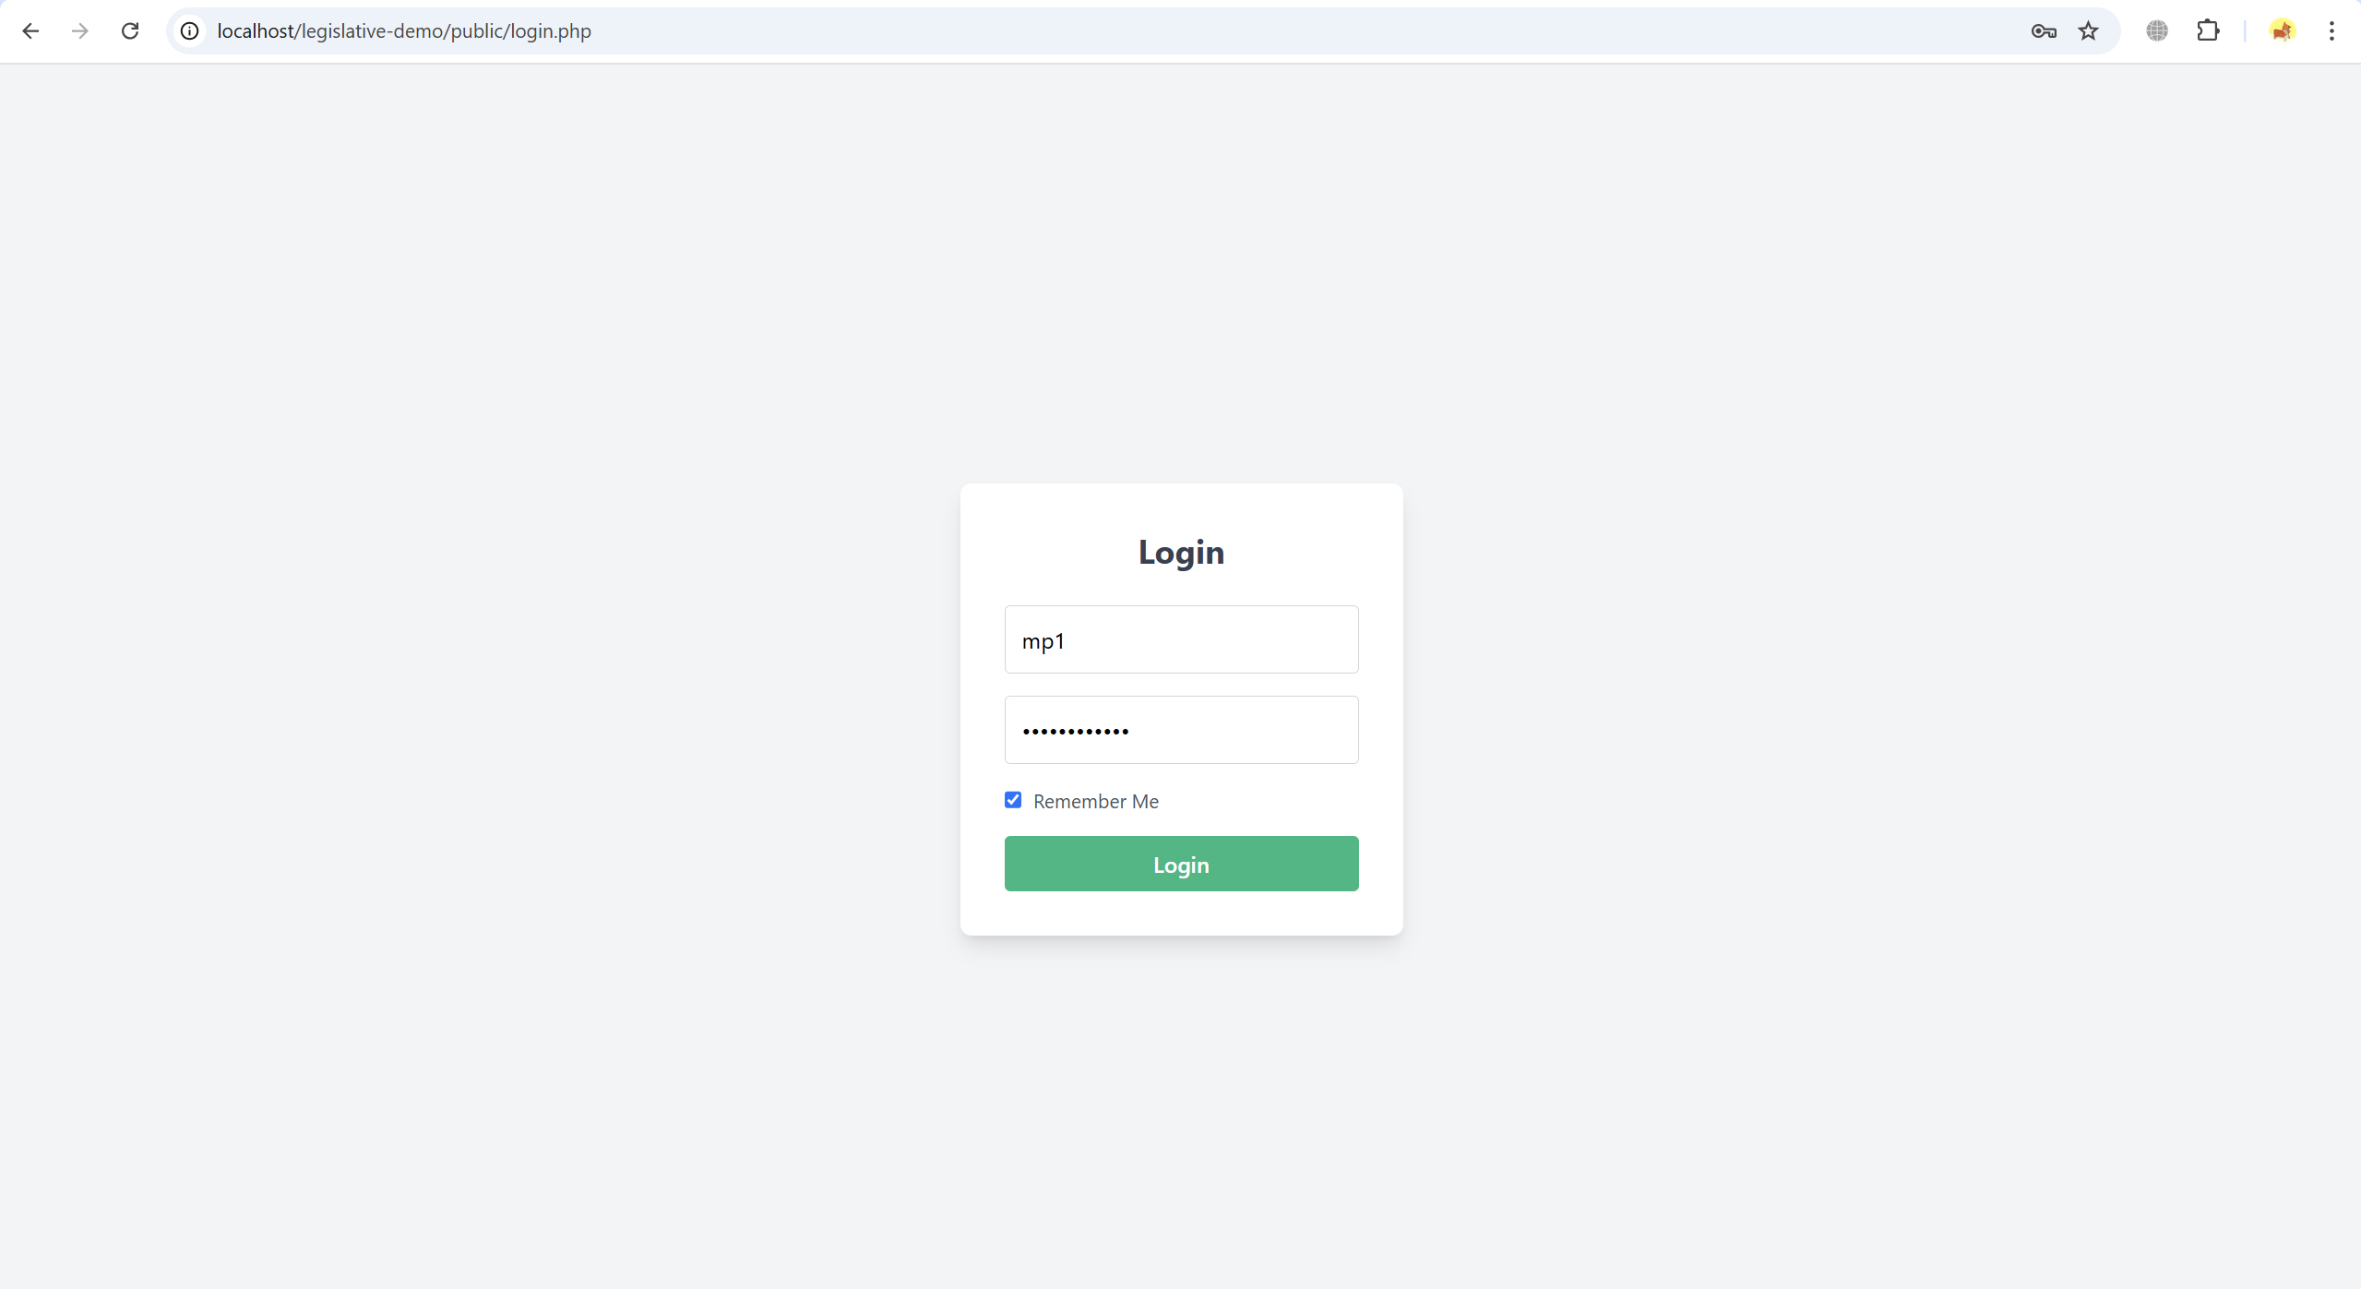

**Dashboard Overview**

* MPs have access to a dashboard that shows all bills available for voting, pending actions, and the option to create new bills.
* The dashboard displays the title, description, status, and actions available for each bill.

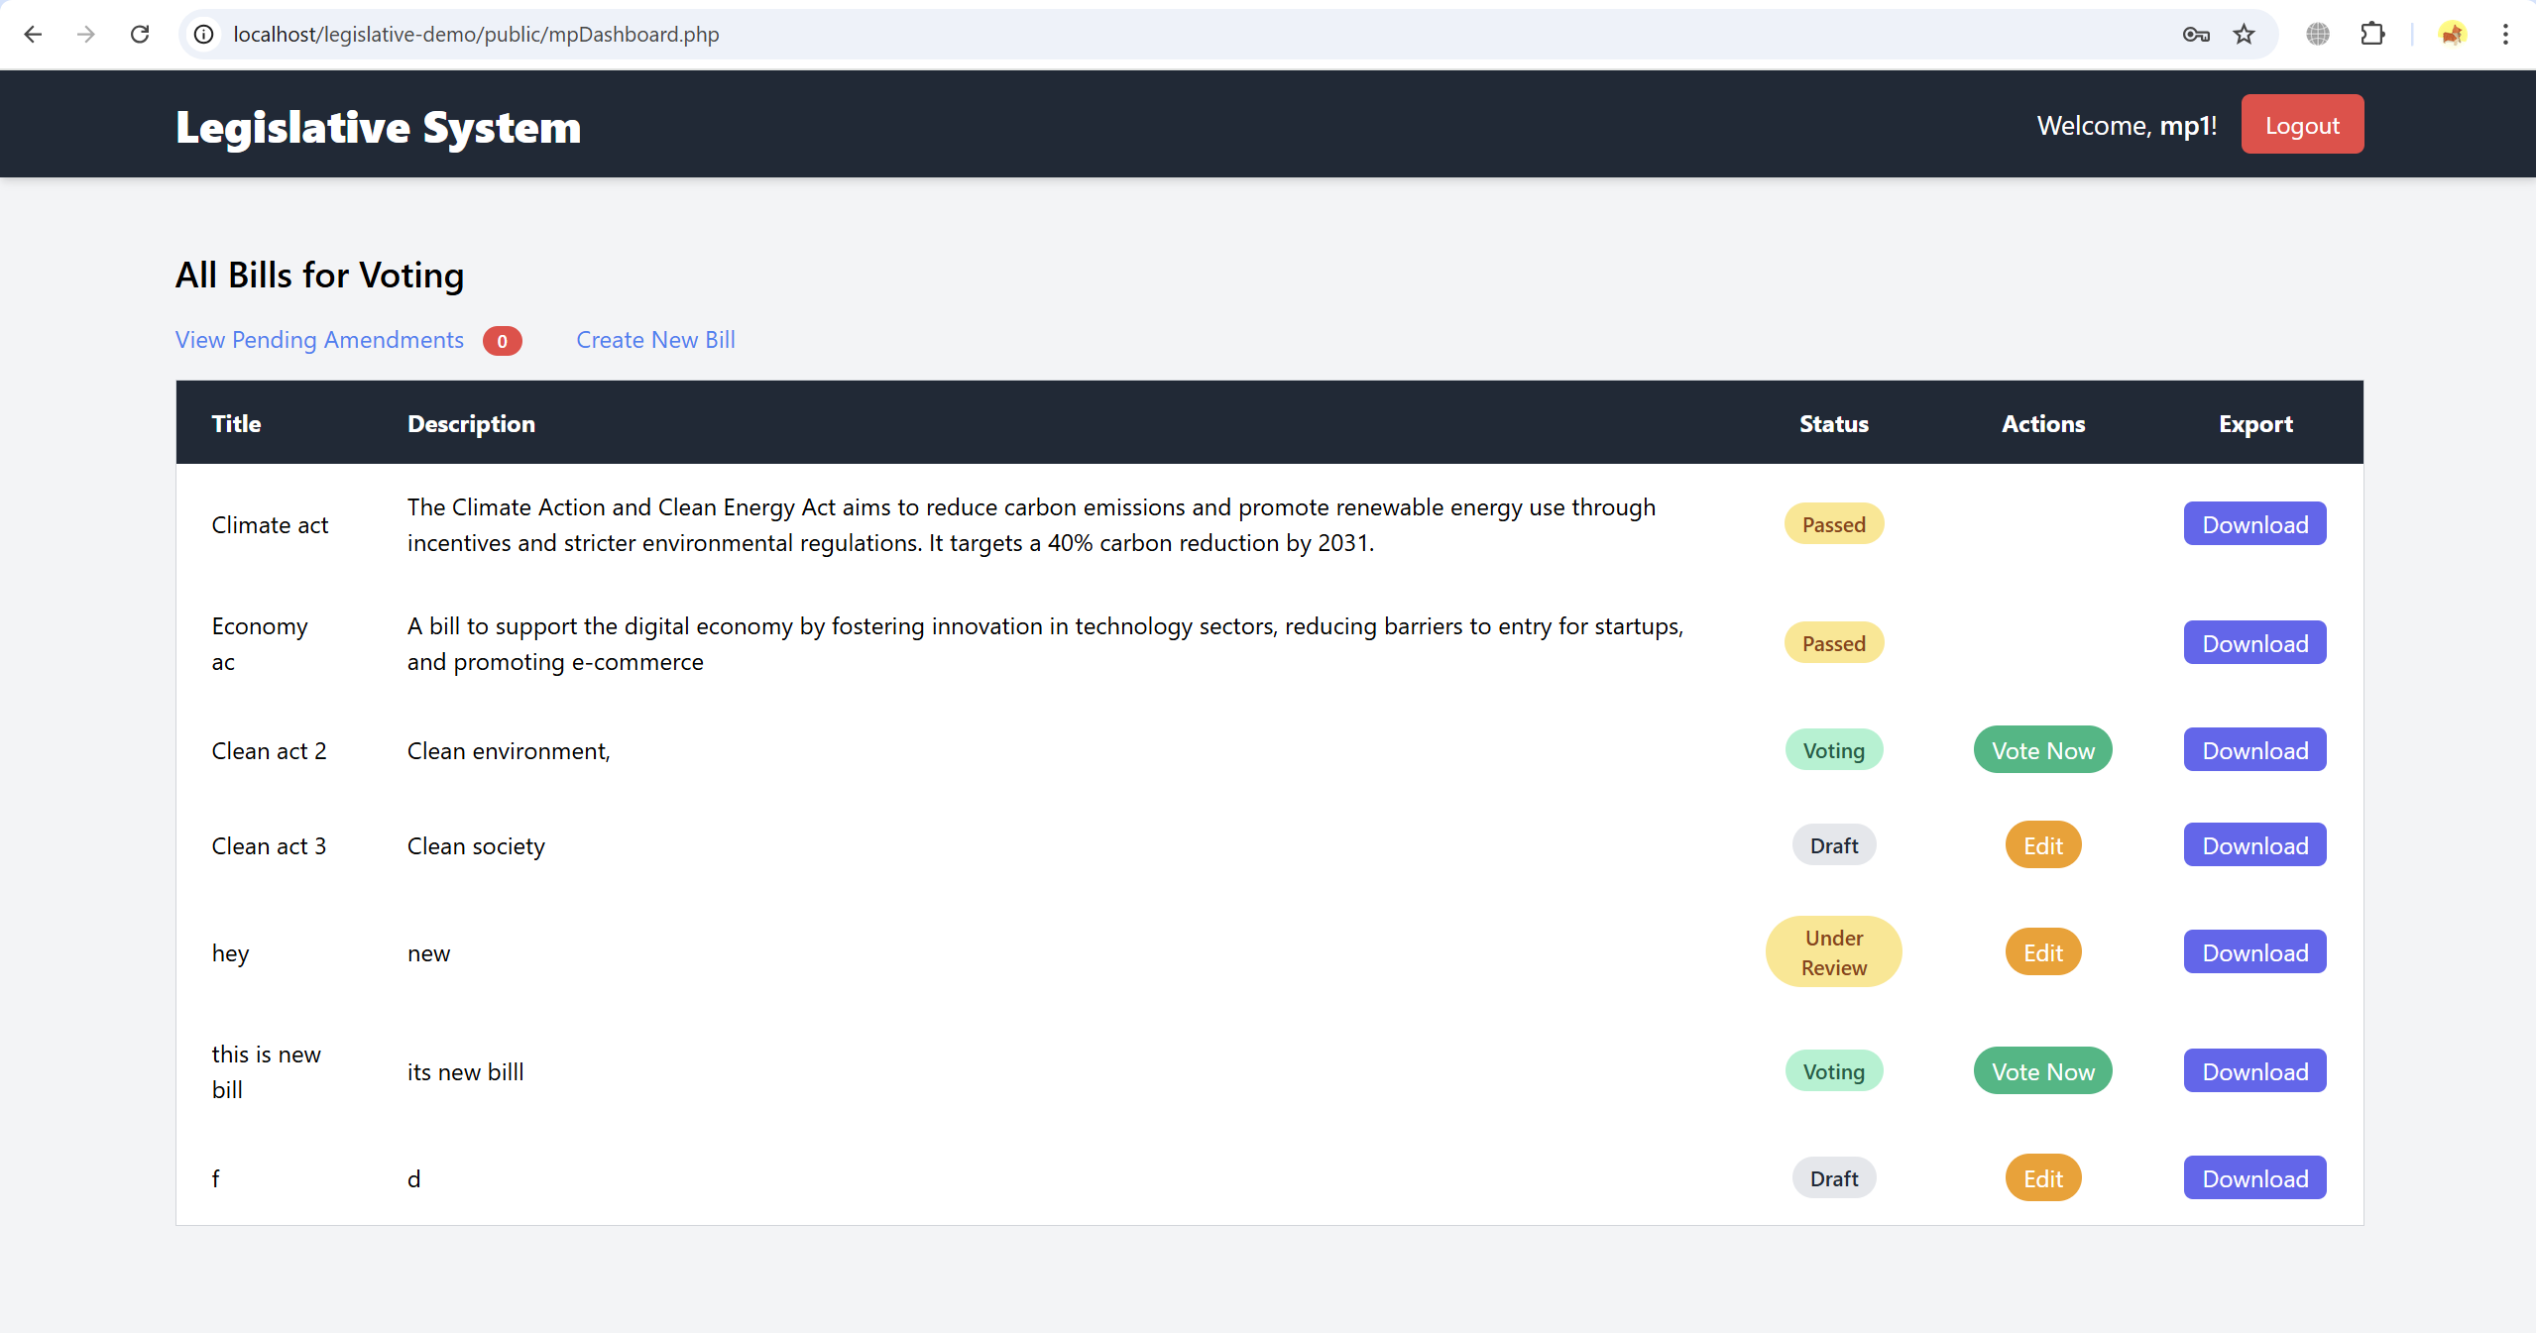

**MP Functionalities**

* **Create New Bill**:
  + MPs can initiate the legislative process by creating new bills. This involves filling out a form with details such as the title, description, and an initial status (Draft or Under Review).
  + Once created, the bill is visible on the MP’s dashboard.

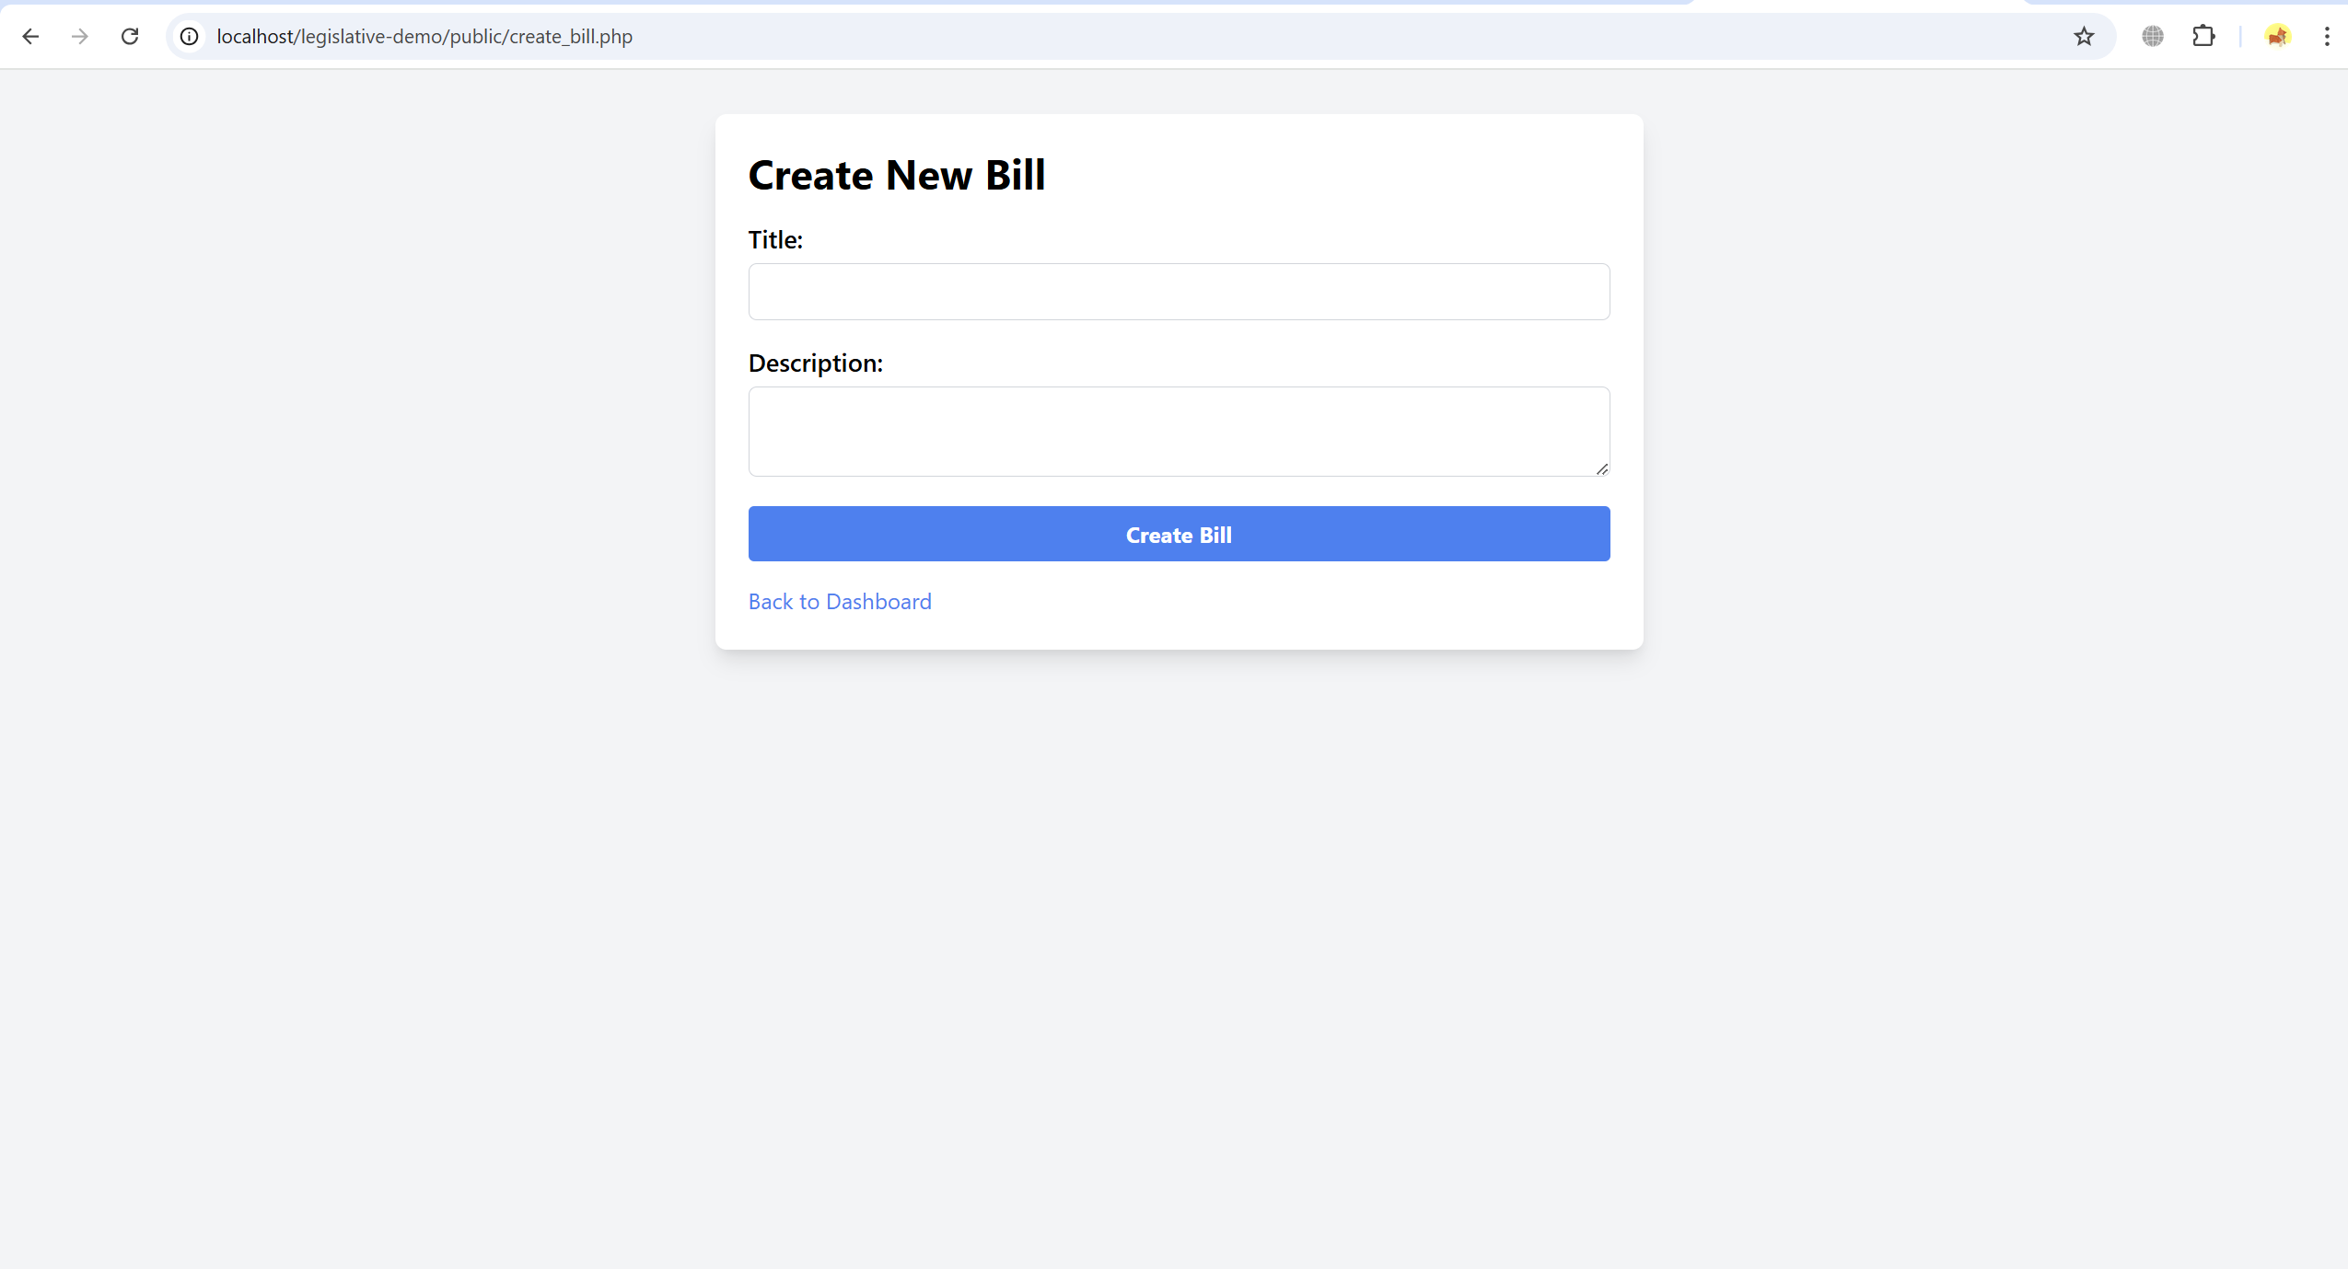

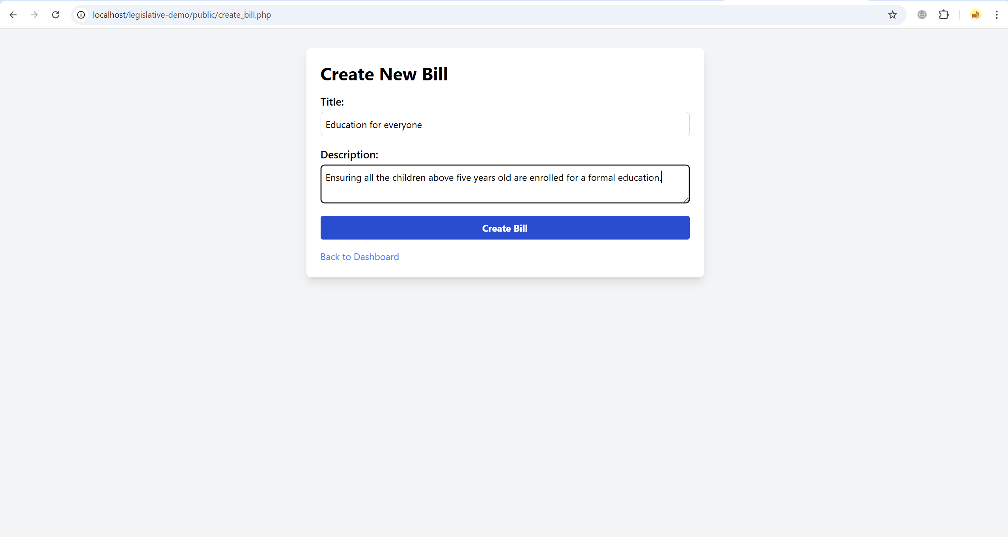

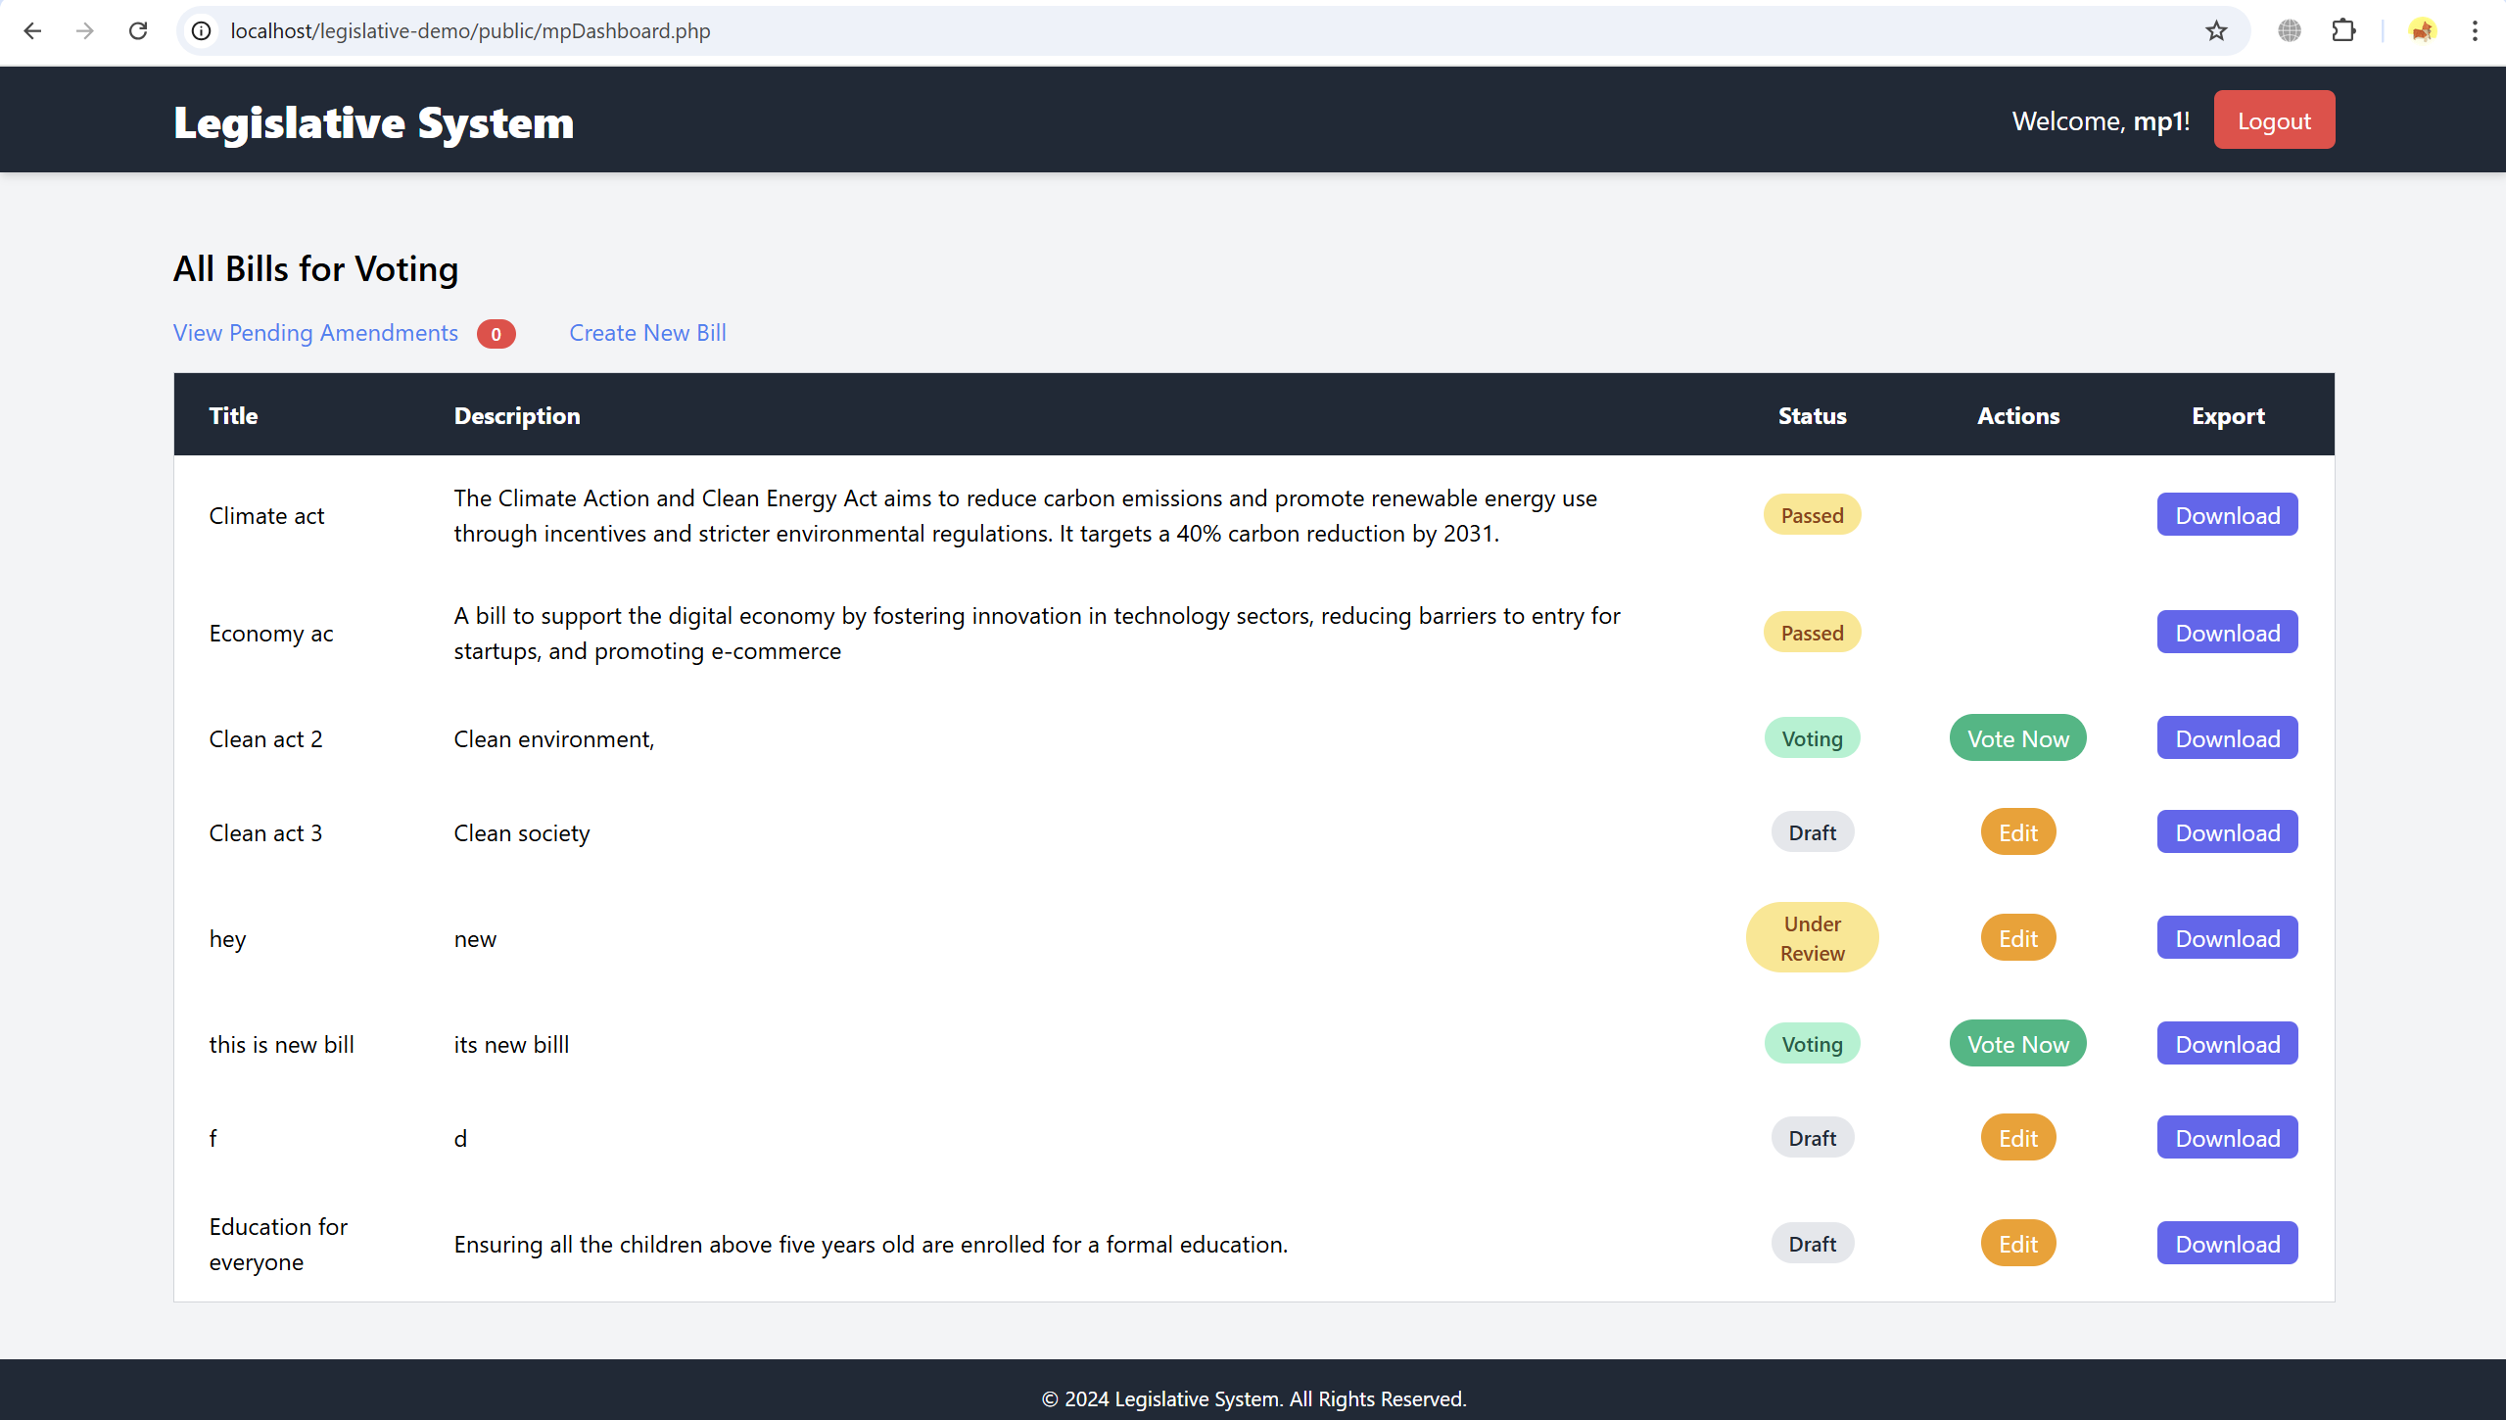

**Edit Bill**:

* MPs can edit their own bills as long as the status is “Draft” or “Under Review.” This allows them to refine the bill's content before it moves to the next phase.

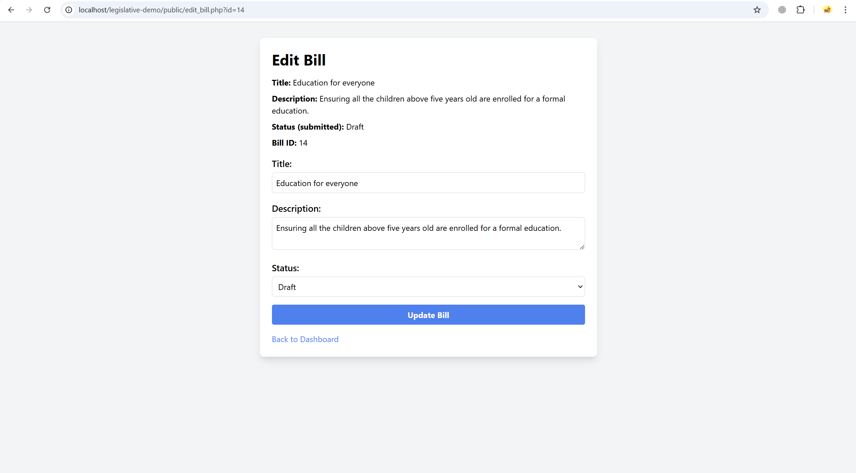

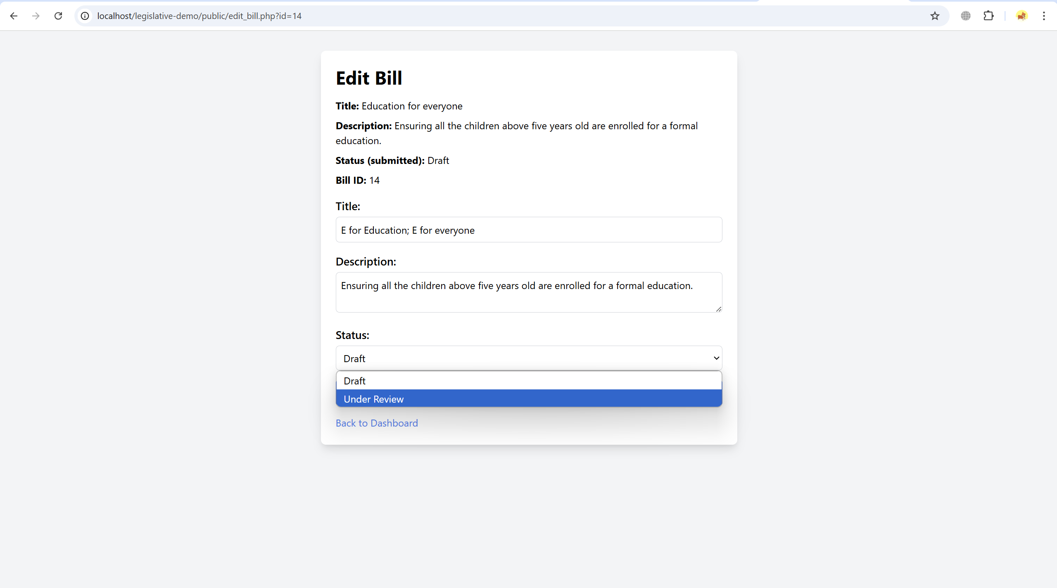

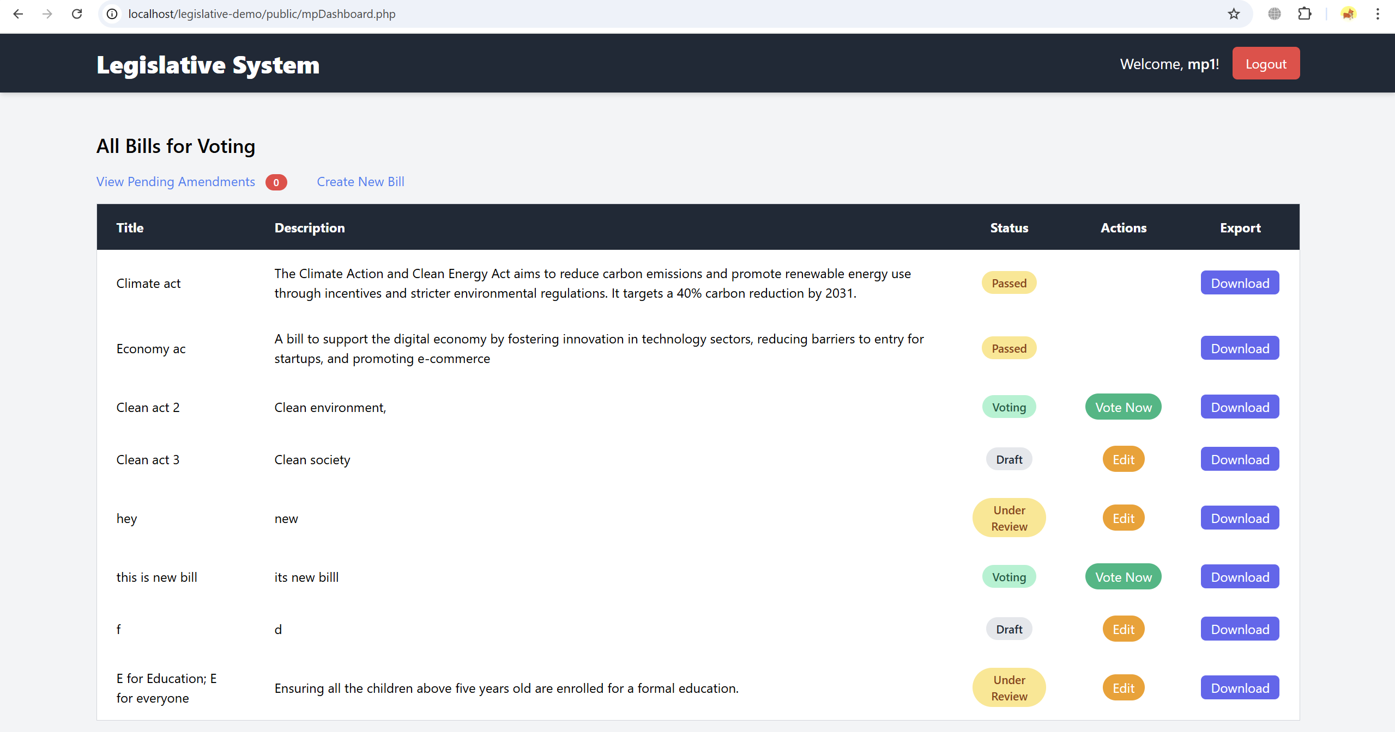

**Export Data**:

* MPs can export the details of any bill to XML or JSON formats, allowing for record-keeping or data sharing.



**Vote on Bills**:

* MPs are given the option to vote on bills that are in the "Voting" phase. They can select “For,” “Against,” or “Abstain” as their vote.
* The system tracks votes in real-time, and MPs can view live voting results once they submit their choice.

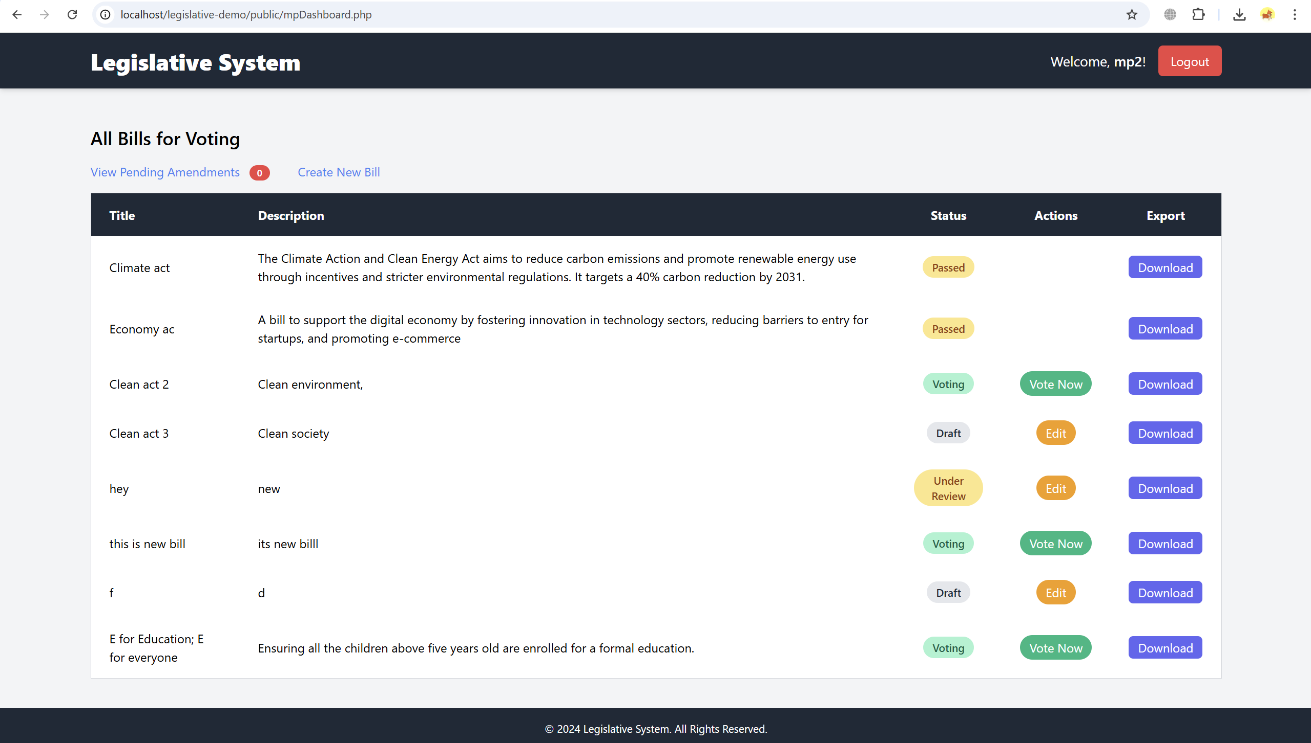

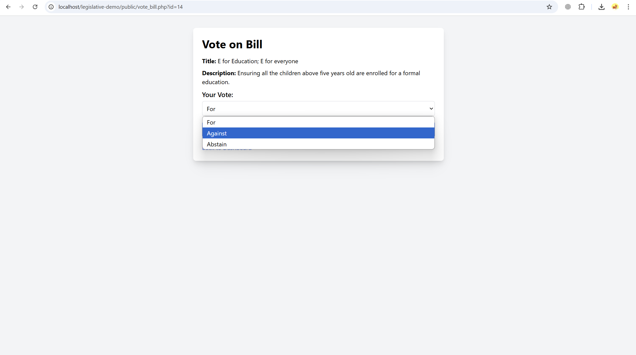

2. **Reviewer Role**

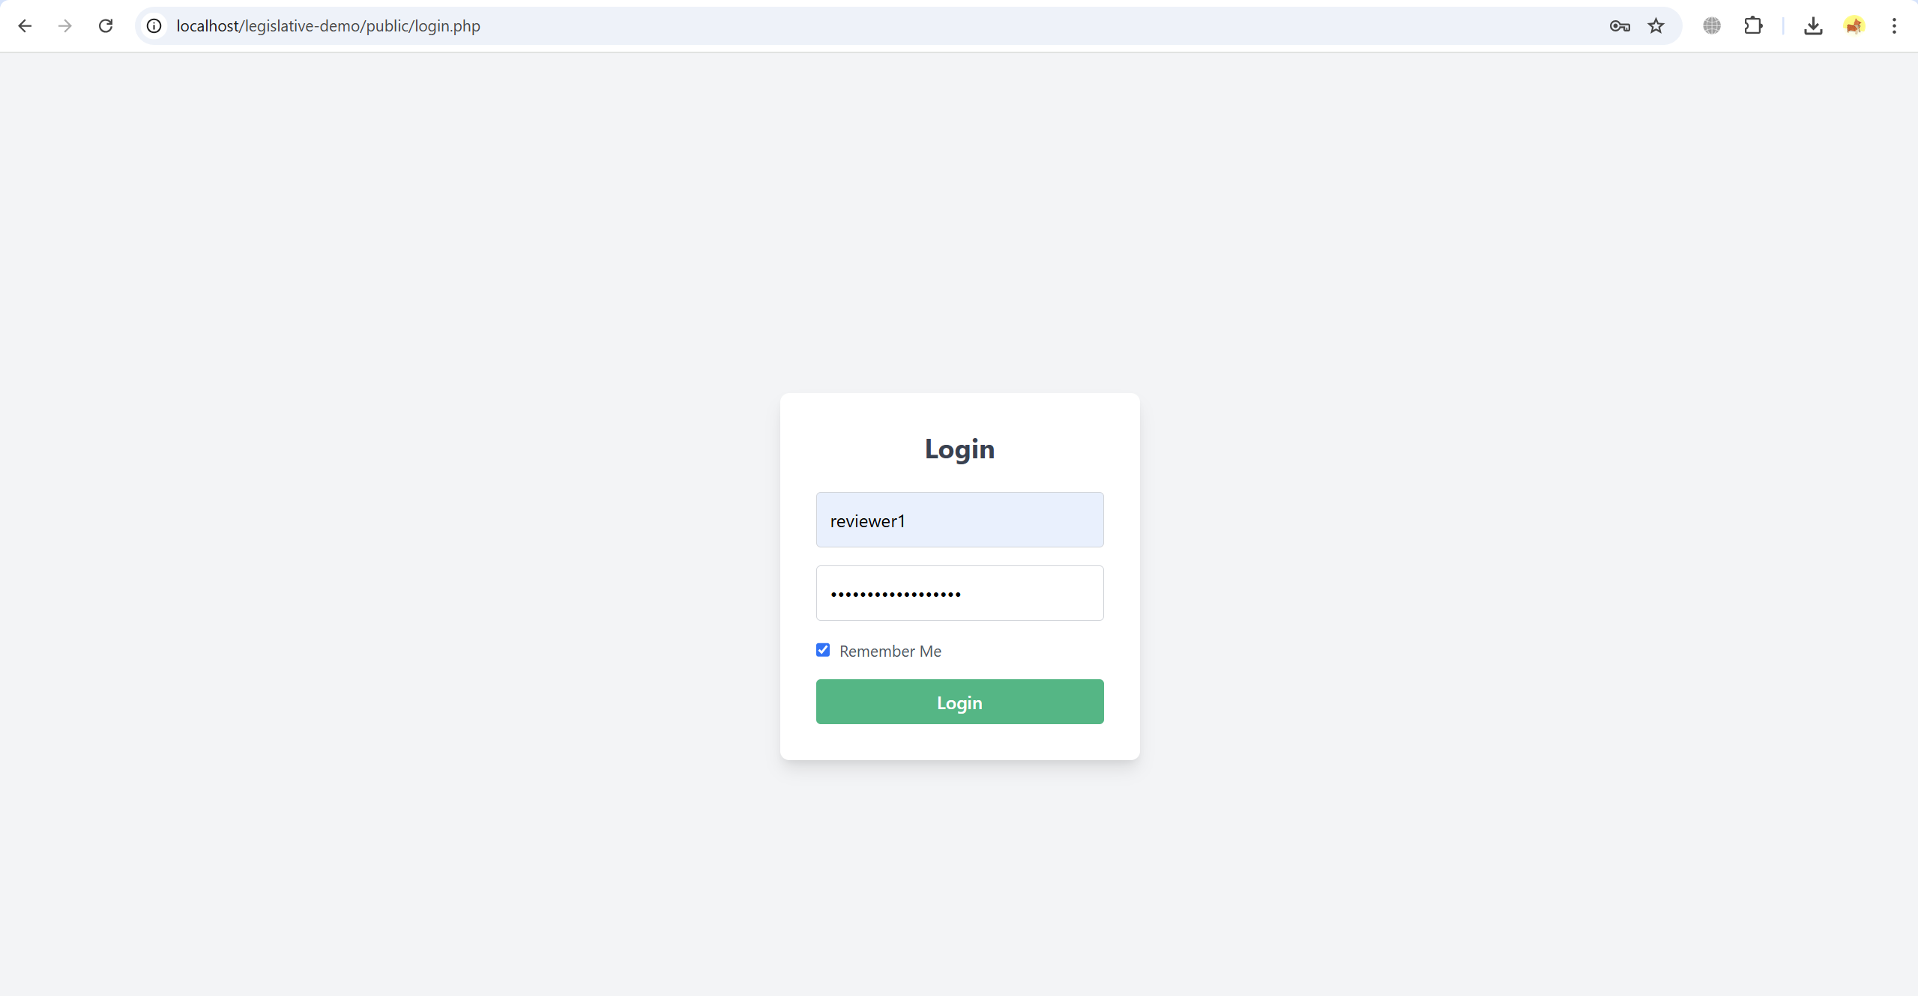

**Dashboard Overview**

* Reviewers have a dashboard that displays all bills in need of review or those that require amendments.
* Each bill entry on the dashboard includes a title, description, and the option to suggest amendments or mark the bill as “Ready for Voting.”

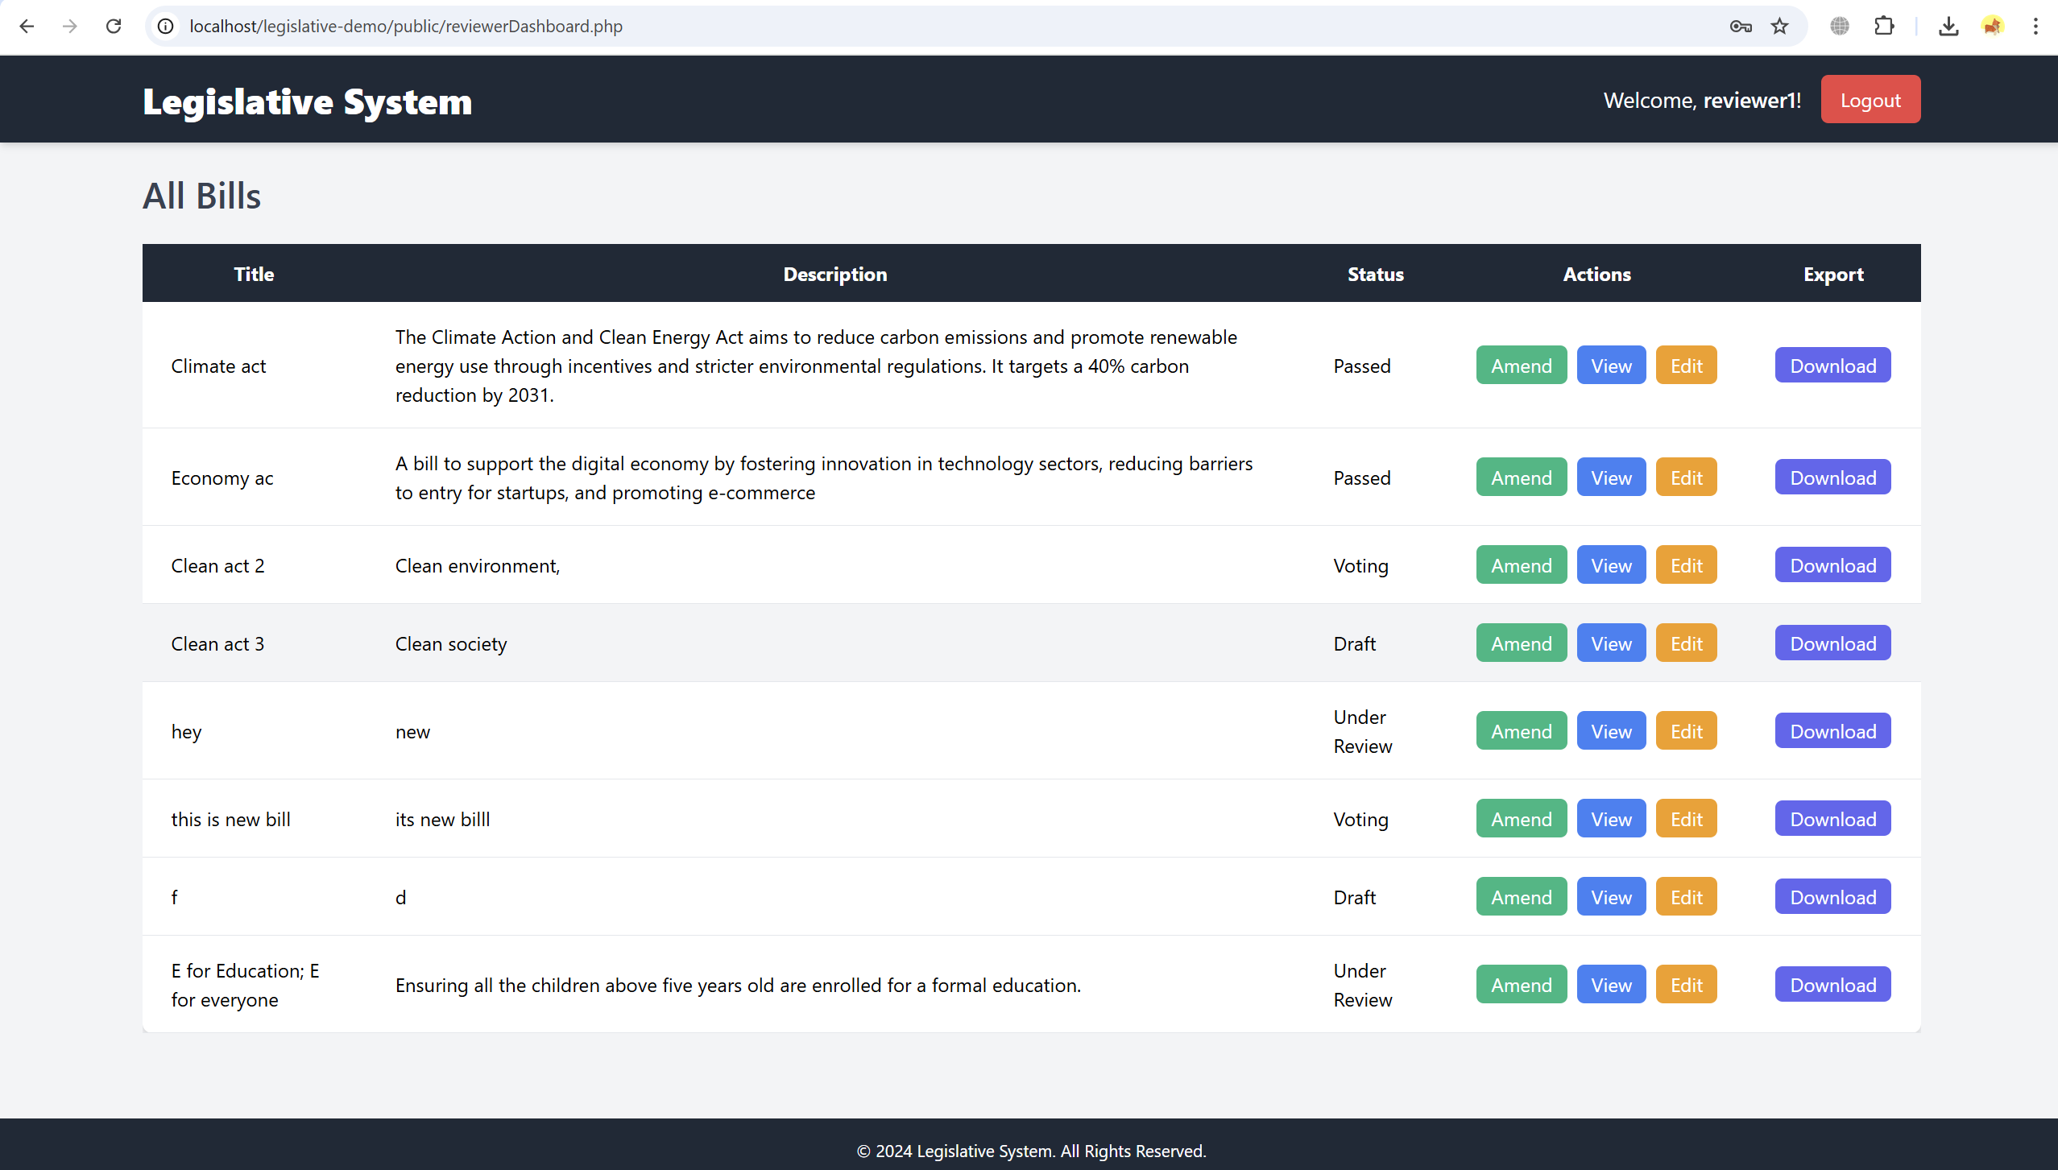

**Reviewer Functionalities**

* **Review and Amend Bills**:
  + Reviewers can view the details of each bill and submit amendments. They can add comments or suggestions for improvement, which are recorded and sent back to the bill's author (usually an MP).

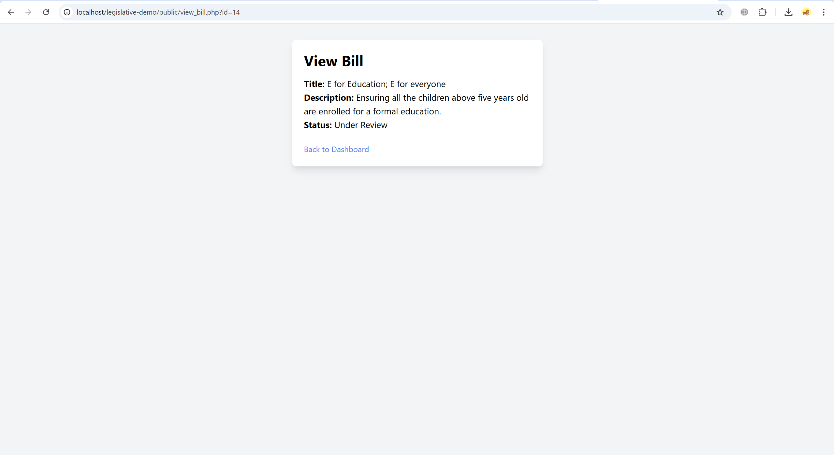

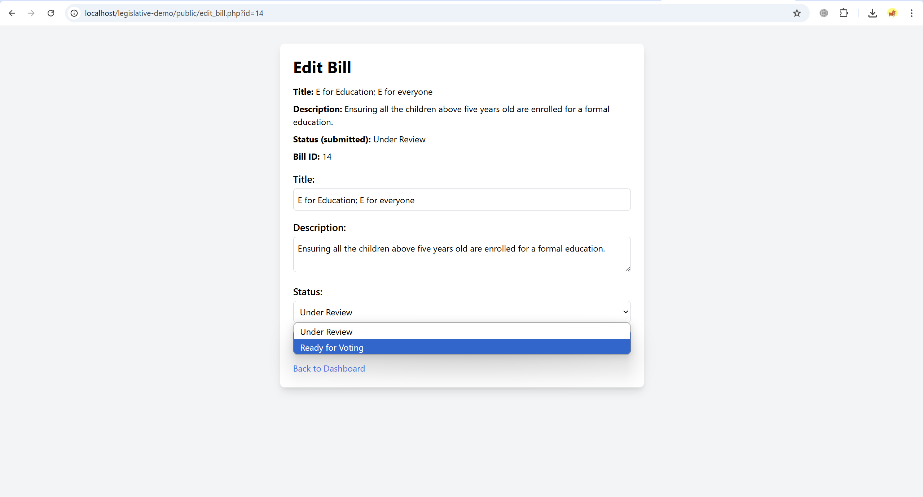

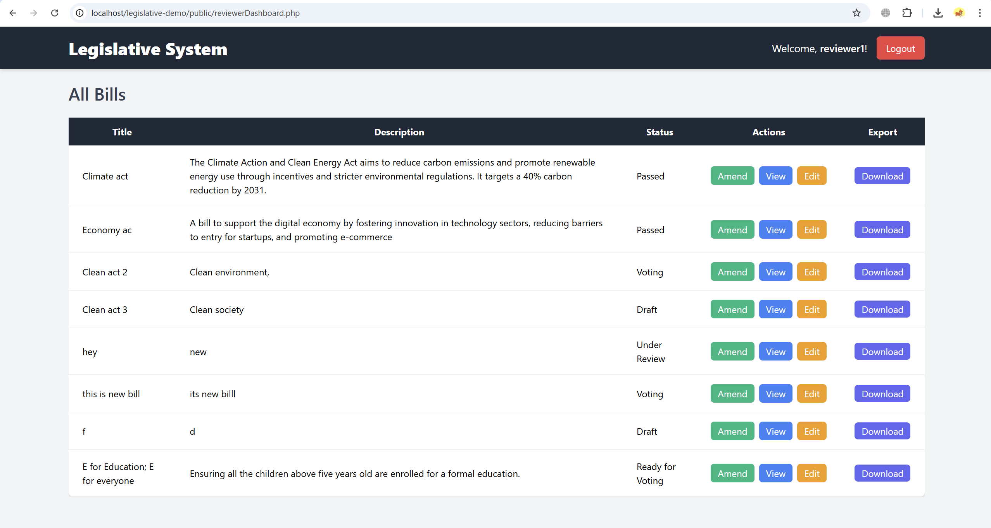

**3. Administrator Role**

**Dashboard Overview**

* The Admin dashboard provides a comprehensive view of all bills in the system. Admins can see bill titles, descriptions, current status, and actions (e.g., view, delete, or export data).
* The dashboard displays real-time statistics on pending actions, voting status, and any bills requiring administrative attention.

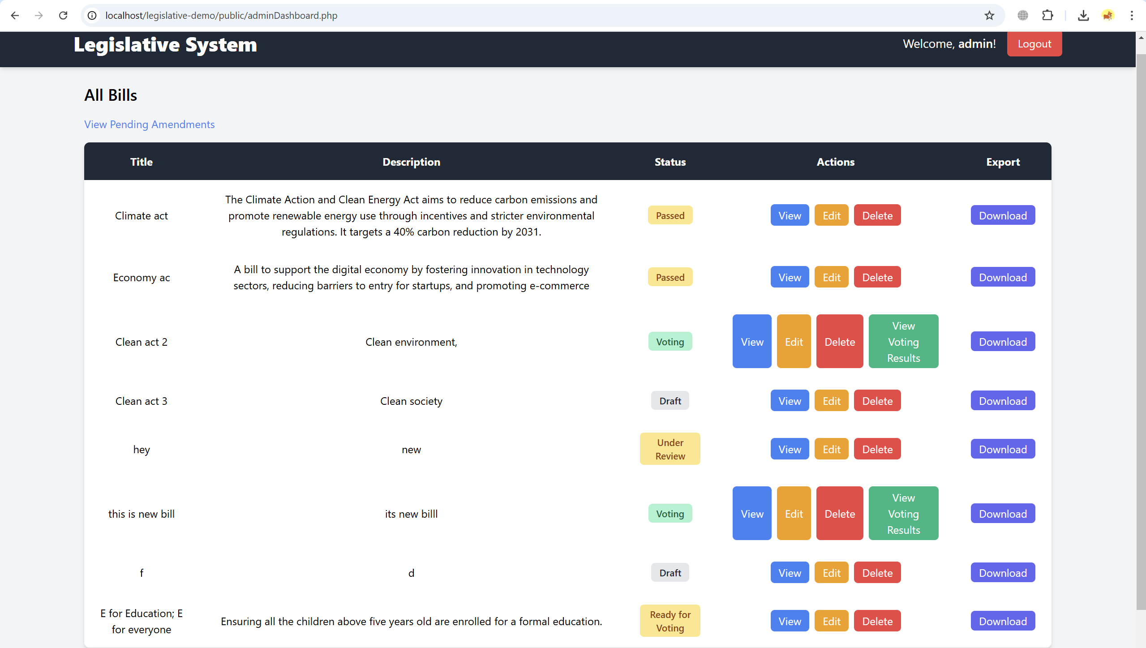

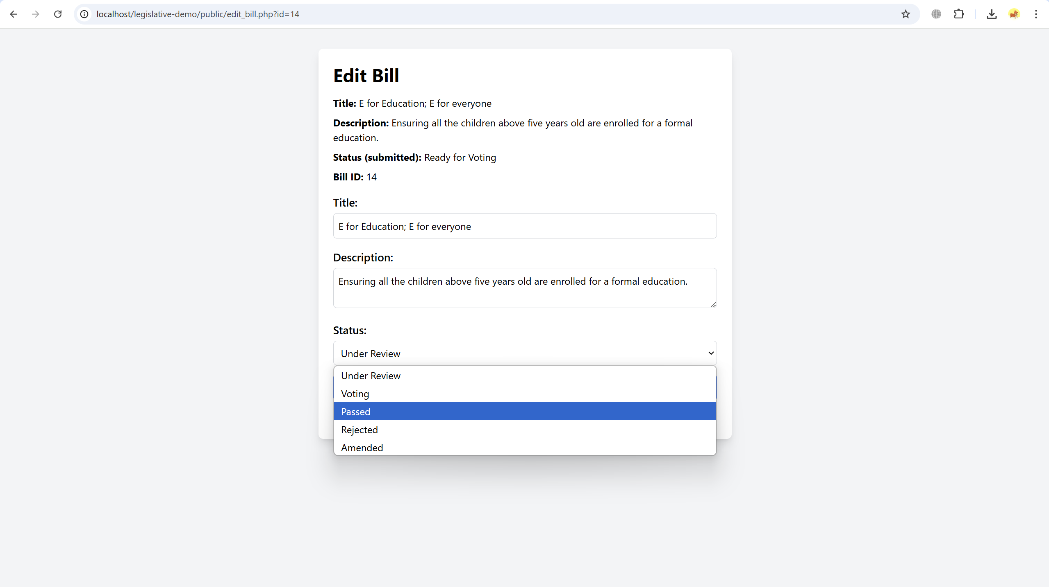

**Administrator Functionalities**

* **Manage Bills**:
  + Admins have full control over bill management. They can view, edit, delete, or update the status of any bill.
  + The “Edit” function is limited to status changes only, ensuring that content integrity is preserved while allowing for administrative control.

**View Voting Results**:

* Admins can access and monitor voting results for each bill, enabling them to make informed decisions and manage the legislative process effectively.

