eFloStop II
Production Programming & Test Tool
Operator Manual
Program • Functionally Test • Label the WiFi Hub, Valve, and Leak Sensor
Document ID | EFS2-MFG-OM-001
Revision | Rev A
Issue date | 2026-07-01
Applies to | eFloStop II Production Tool (all three device tabs)

Document control note
This is a controlled document. It carries NO fixed firmware version number. The tool's title bar shows a build/version string that the operator should DISREGARD; the firmware version to verify is the batch version supplied on the QA / build release note, which the operator types into the 'Expected FW version' field. The version reported by the device on screen is the source of truth.
Revision history
Rev | Date | Author | Change summary
A | 2026-07-01 | Manufacturing Engineering | Initial release.

Table of Contents
Right-click here and choose “Update Field” to build the table of contents.

1. Purpose and Scope

1.1 Who this manual is for
This manual is for production-floor operators. No engineering or firmware knowledge is assumed. Follow each numbered step exactly and in order. Where the manual says to click a button or read a status, the exact on-screen wording is shown in bold.

1.2 What the tool does
For each device you connect, the eFloStop II Production Tool will, in one guided run:
- Flash (program) the firmware onto the board.
- Run a sequence of automatic tests plus a few manual checks you confirm.
- Generate a serial number and a QR-code label for the device.
- Record a PASS or FAIL result you can review later on the History tab.

1.3 The three device types
The tool has one tab per device, plus a History tab: **WiFi Hub**, **Valve**, **Leak Sensor**, and **History**. Each device tab works the same way; the differences are called out in that device's chapter.

1.4 Out of scope
This manual does not cover firmware development, editing the firmware manifest on the line, installing the tool, or repairing devices. If firmware files are missing or the tool will not start, refer to your station lead.

2. Prerequisites and Station Setup
Complete this section once when setting up a station, before programming any unit.

2.1 Software
- Windows PC with the eFloStop II Production Tool installed.
- STM32CubeProgrammer (the STM32_Programmer_CLI) — required for the Valve and Leak Sensor. (The Hub's flashing tool, esptool, ships with the tool.)

2.2 Programming hardware per device
- **WiFi Hub:** a CP2102 USB-UART adapter between the PC and the Hub board.
- **Valve:** an ST-Link debugger on the board's SWD header (used with STM32CubeProgrammer).
- **Leak Sensor:** an ST-Link debugger on SWD, plus an optional Tag-Connect lead for reading the UART log.
- **All devices:** a Windows Bluetooth adapter, used for the wireless (BLE) verification scans.
⚠ CAUTION Attach only one programmer (ST-Link) at a time. If more than one is connected, the programming tool may pick the wrong one.

2.3 USB / Bluetooth drivers
ℹ NOTE The exact USB-serial (CP210x), ST-Link, and Bluetooth-dongle driver names and versions are not specified in the tool's documentation and must be confirmed by your station lead (TBD). Do not assume a driver version; if a device or port is not detected, have the station lead verify the correct driver is installed.

2.4 Firmware files
The tool reads its firmware from a firmware folder described by a file called manifest.yaml. When firmware is correctly staged, the firmware strip at the top of the window shows each device in **green**. The Valve and Leak Sensor each need **both** a debug and a production firmware binary; the Hub needs its four binaries.
⚠ CAUTION Stage firmware strictly by the manifest. Any firmware file list in the project README is out of date — it omits the debug binaries the tool requires and uses the wrong file extensions. Trust manifest.yaml, not the README.

2.5 Launch the tool
1. Start the eFloStop II Production Tool (double-click its shortcut, or run it as your station lead directs).
2. The main window opens (Figure 1). Disregard the version number shown in the window title bar.
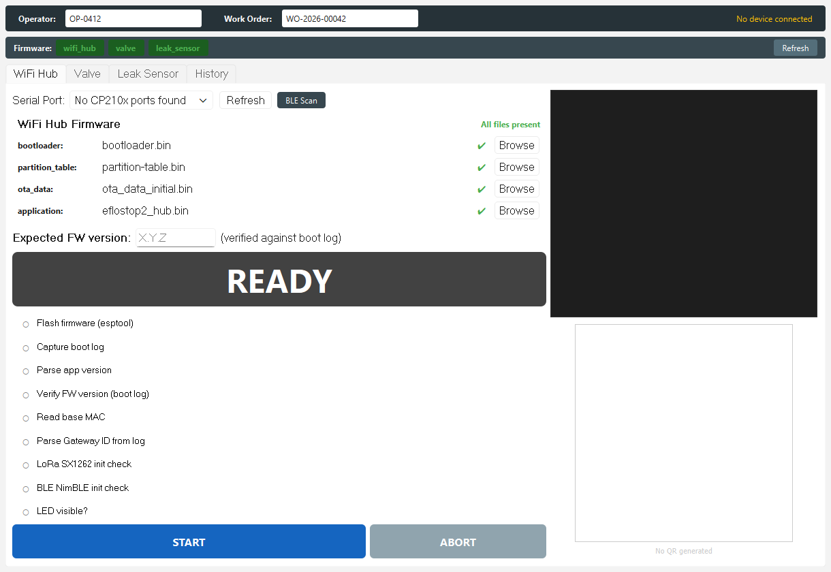
Figure 1. The main window: operator bar (top), firmware status strip, and the four tabs.
3. Confirm the firmware strip shows every device in green. A red tag means firmware is missing — see Section 8.1.

2.6 One-time printer setup
Set up the label printer once per session using the **Printer Setup** button on any device tab (see Section 5.7). The chosen printer is remembered for the rest of the session.

3. Safety — Read Before You Start
These hazards are real on this line. Read them once here; they are repeated at the exact step where they apply.
⚠ WARNING Electrostatic discharge (ESD). You handle bare circuit boards (ESP32-S3, STM32WB, STM32WBA) and probe them. Wear a grounded wrist strap and work on an ESD-safe mat, or you may destroy the board.

⚠ WARNING Coin-cell battery (Leak Sensor). Observe polarity, never short the cell, and dispose of cells per site rules. A shorted coin cell can overheat.

⚠ WARNING Motorized valve. During the Valve's servo check the valve physically moves when you press its button. Keep fingers clear of the mechanism.

⚠ CAUTION Handle USB and programmer cables gently; do not hot-unplug a board mid-programming.

4. How the Screen Works
Every device tab is laid out the same way. Learn it once here; the device chapters then stay short.

4.1 Operator bar
Along the top are **Operator** (your ID, e.g. OP-0412) and **Work Order** (optional). At the far right a status reads **No device connected** until a run starts.
Figure 2. Operator bar: Operator ID (required) and Work Order (optional).
ℹ NOTE You must enter your Operator ID before starting a run, or the tool blocks you with “Enter your Operator ID before starting.”

4.2 Firmware status strip
Below the operator bar, one tag per device shows firmware status: **green** = all files present, **red** = firmware missing. The **Refresh** button re-checks the firmware folder.
Figure 3. Firmware strip with all firmware present (green).

4.3 The four tabs
**WiFi Hub**, **Valve**, and **Leak Sensor** each program and test that device. **History** shows past results (Section 9).

4.4 A device tab, part by part
Each device tab has, on the left: the **port** row and **Refresh**; the firmware panel; the **Expected FW version** box; the big **status banner**; the **step list**; and the **START** / **ABORT** buttons. On the right: the **log** and the **QR panel**.
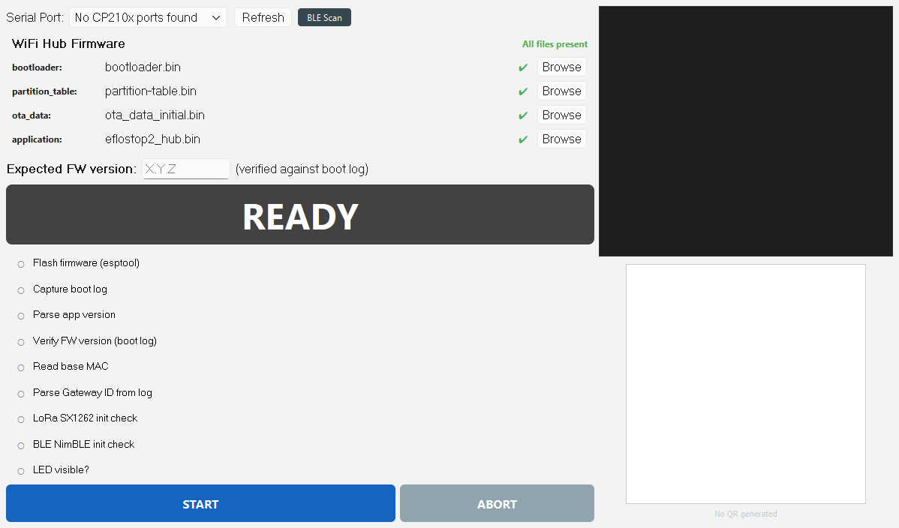
Figure 4. Anatomy of a device tab (WiFi Hub shown) in the READY state.

4.5 Reading the status banner
The big banner shows one of four states: **READY** (gray), **RUNNING…** (blue), **PASS** (green), **FAIL** (red).
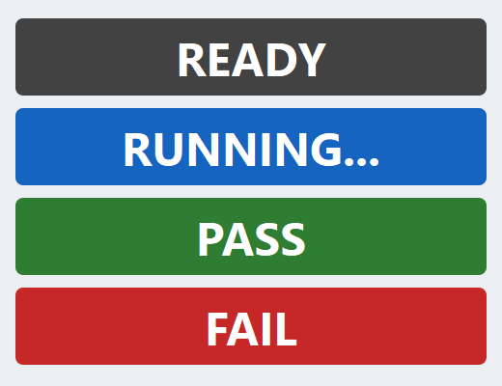
Figure 5. The four status-banner styles.
ℹ NOTE There is no separate colour for an aborted run: ABORTED appears in the red FAIL style with the word ABORTED.

4.6 Reading the step list
Each step shows a symbol: pending, running, pass, fail, or skipped. A **skipped** step is normal for optional checks — it is **not** a failure.
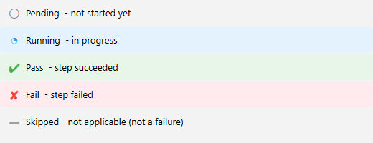
Figure 6. Step-status symbols.

4.7 The Expected FW version box
Type this batch's firmware version here so the tool checks the device reports that exact version. Leave it blank and the check is advisory only (the version is shown but not enforced).
⚠ CAUTION Type the version exactly as digits and dots, e.g. 1.0.0 — no leading “v”, no spaces. The check is case- and character-exact, so “V1.0.0” or a trailing space will FAIL a good unit. Get the batch version from the QA / build release note, not from this manual.

4.8 The Operator Check dialog
For manual checks the tool shows a large **Operator Check** dialog with a question and big green **YES** / red **NO** buttons. Answer honestly by what you observe.
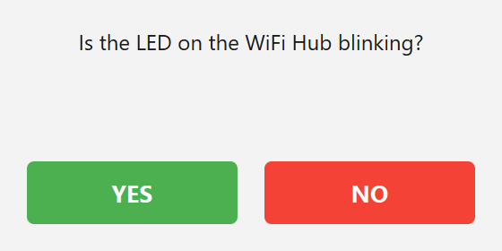
Figure 7. The Operator Check YES / NO dialog.

4.9 What to do on a FAIL
There is **no** automatic retry and **no** per-step retry. If a run fails: fix the cause and press **START** to run the whole sequence again, or set the unit aside as a reject. **ABORT** stops a run in progress.
ℹ NOTE If a step stays blue (RUNNING…) and nothing changes for about 30 seconds, press ABORT, reseat the programmer/cable, press Refresh, then START again.

5. WiFi Hub — Program, Test, and Label
This chapter programs, tests, and labels one WiFi Hub on the **WiFi Hub** tab. Do the steps in order.

5.1 Connect the Hub
1. Wearing an ESD strap, connect the Hub to the PC with the CP2102 USB-UART adapter (Figure 10).
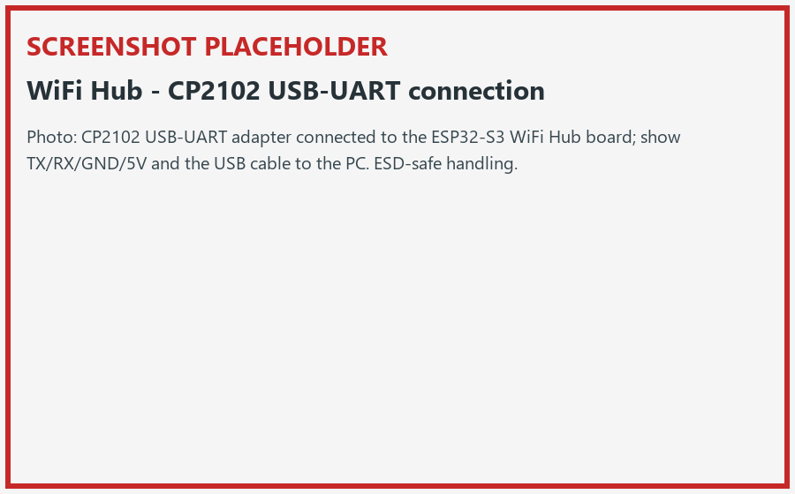
Figure 10. Connecting the WiFi Hub via the CP2102 USB-UART adapter.
2. Open the WiFi Hub tab. In the Serial Port: drop-down choose the Hub's port. If the list is empty, press Refresh.

Figure 9. The WiFi Hub tab in the READY state.
✔ The port appears in the **Serial Port:** list.
✘ **“No CP210x ports found”** means nothing is detected — check the cable/driver (Section 2.3), then Refresh.

5.2 Pre-flight checks
3. Enter your Operator ID in the operator bar.
4. Confirm the firmware panel shows All files present.
5. Type the batch version into Expected FW version (Section 4.7).

5.3 Program the Hub (Flow A)
6. Press the big blue START button.
7. Watch the step list. The Hub flashes in one step — Flash firmware (esptool) — which erases and writes all firmware and reads the board's MAC address.
ℹ NOTE The WiFi Hub does not re-flash a second time; the Valve and Leak Sensor do.

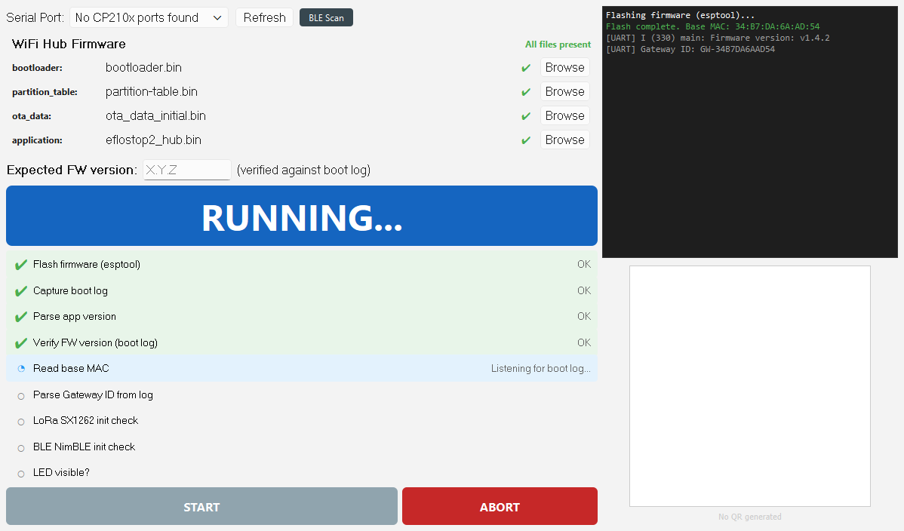
Figure 11. A WiFi Hub run in progress (RUNNING banner and boot log).

5.4 Functional test (Flow B)
After flashing, the tool captures the Hub's start-up (boot) log and checks it, in this on-screen order:
- **Capture boot log** → **Parse app version** → **Verify FW version (boot log)**
- **Read base MAC** → **Parse Gateway ID from log**
- **LoRa SX1262 init check** and **BLE NimBLE init check** (either may show **skipped** — that is OK)
ℹ NOTE The Hub does not run an automatic BLE advertising scan. The separate BLE Scan button on this tab is only a 5-second diagnostic and is not part of PASS/FAIL.

8. When the Operator Check dialog asks “Is the LED on the WiFi Hub blinking?”, answer YES if it blinks, else NO.

5.5 PASS and QR label (Flow C)
9. On PASS the banner turns green and a QR code appears on the right with a caption showing SN, ID, WiFi SSID, and FW.
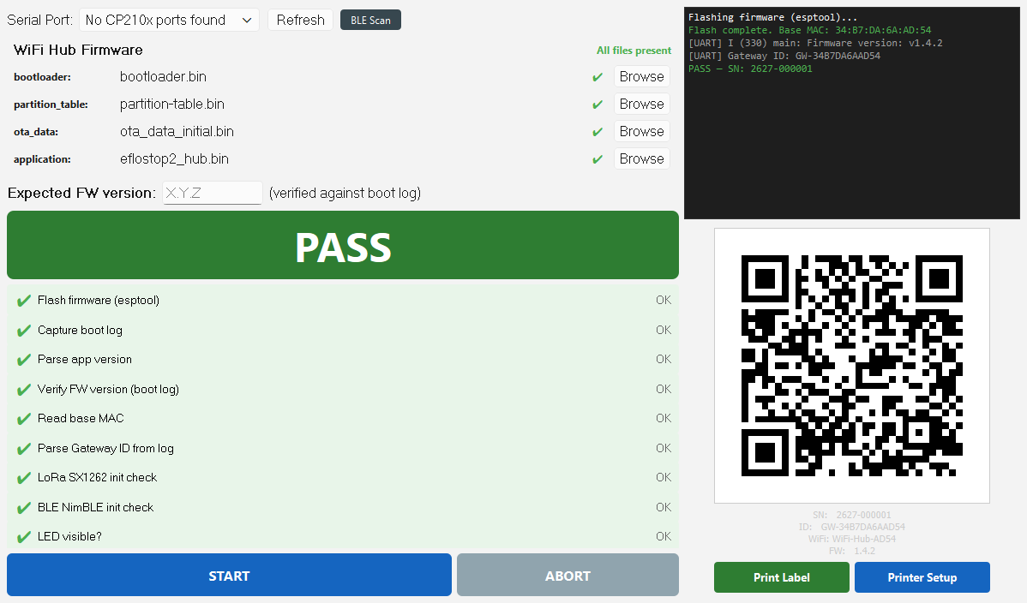
Figure 12. A WiFi Hub PASS with its generated QR label.
The QR code is a plain-text string the phone/commissioning (Watts) app reads. For this device it begins **id=GW-** followed by the device address, then **&type=**, **&hw=**, and **&sw=** (the device-reported firmware). See Figure 27 for the field breakdown.
10. Press Print Label to print. The first time, press Printer Setup and choose the label printer (Section 5.7).
The Hub's serial number begins **EFS2H**. Apply the printed label to the unit. The app links the Hub by scanning this QR.

5.6 If the Hub fails
Follow the FAIL rule in Section 4.9 and the string-matched fixes in Section 8.

6. Valve — Program, Test, and Label
This chapter programs, tests, and labels one Valve on the **Valve** tab. The Valve is flashed twice: a debug build for testing, then the production build at the end.
⚠ WARNING ESD: wear a wrist strap. The Valve's servo check later will physically move the valve — keep fingers clear.

6.1 Connect the Valve
1. Connect the Valve with an ST-Link on the SWD header (only one programmer attached). Figure 14.
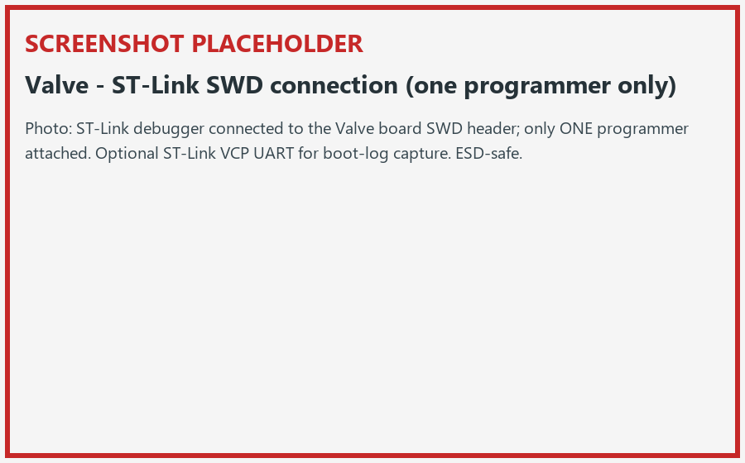
Figure 14. Connecting the Valve via ST-Link SWD.
2. Open the Valve tab. The UART Port (ST-Link VCP): drop-down is only for capturing the boot log; choose the port, or choose “(Skip UART capture)”. Flashing itself goes over SWD, not this port.
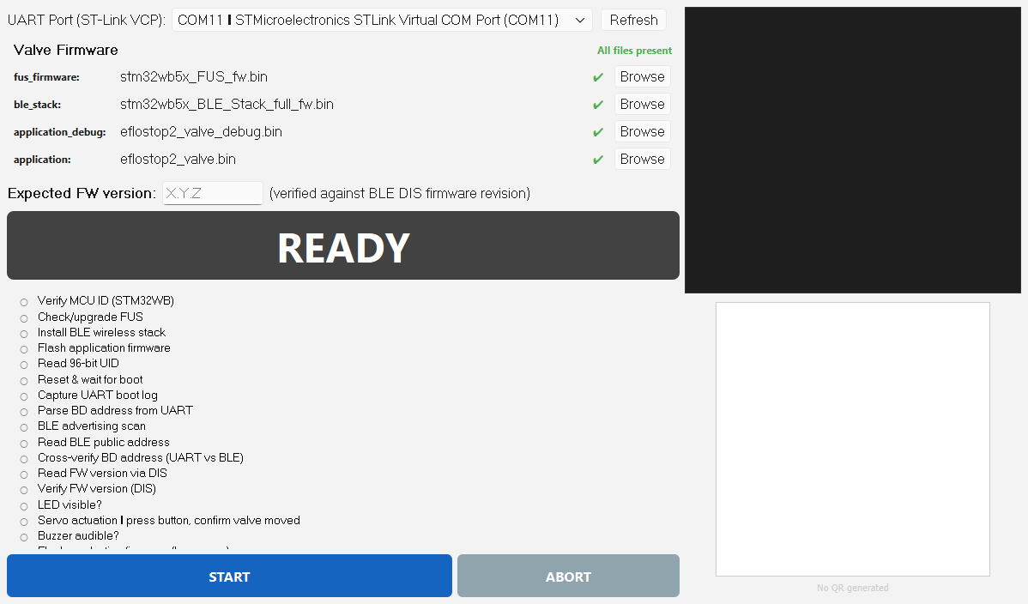
Figure 13. The Valve tab in the READY state.

6.2 Pre-flight checks
3. Enter your Operator ID.
4. Confirm the firmware panel shows All files present (the Valve needs both debug and production binaries).
5. Type the batch version into Expected FW version.

6.3 Program the Valve (Flow A)
6. Press START. The step list runs, in order: Verify MCU ID (STM32WB), Check/upgrade FUS, Install BLE wireless stack, Flash application (debug), Read 96-bit UID, Reset & wait for boot.
ℹ NOTE Check/upgrade FUS and Install BLE wireless stack may show skipped if already present on the board — that is normal.

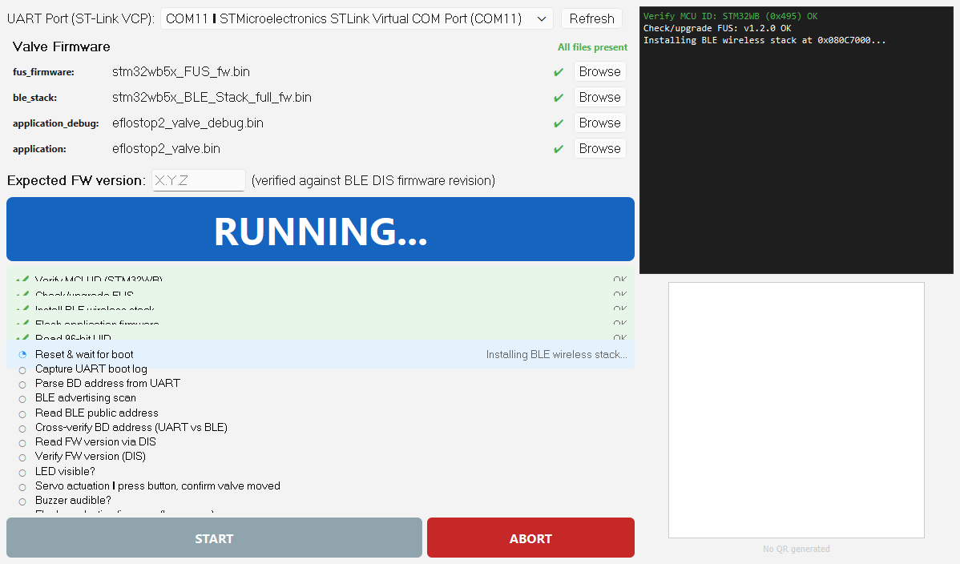
Figure 15. The Valve flash sequence in progress.

6.4 Functional test (Flow B)
The tool then captures the boot log and verifies the radio, in this order:
- **Capture UART boot log** → **Parse BD address from UART**
- **BLE advertising scan** (about 15 seconds) → **Read BLE public address**
- **Cross-verify BD address (UART vs BLE)** → **Read FW version via DIS** → **Verify FW version (DIS)**

6.5 Manual checks
7. “Is the LED on the Valve board visible?” — YES / NO.
⚠ WARNING Motorized valve — keep fingers clear during the next step.

8. “Press the button on the valve. Did the servo actuate (valve moved)?” — press the valve button; answer YES only if the valve physically moved.
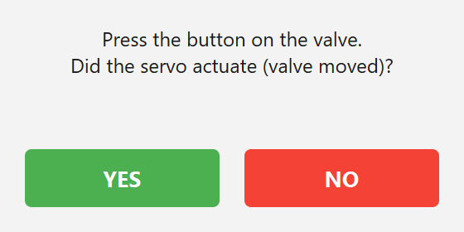
Figure 16. The servo-check Operator Check dialog.
9. “Did you hear the buzzer?” — YES / NO.

6.6 Production re-flash and PASS
10. As the final automatic step the tool flashes the production firmware (low-power). The banner then turns green (PASS) and the QR appears.
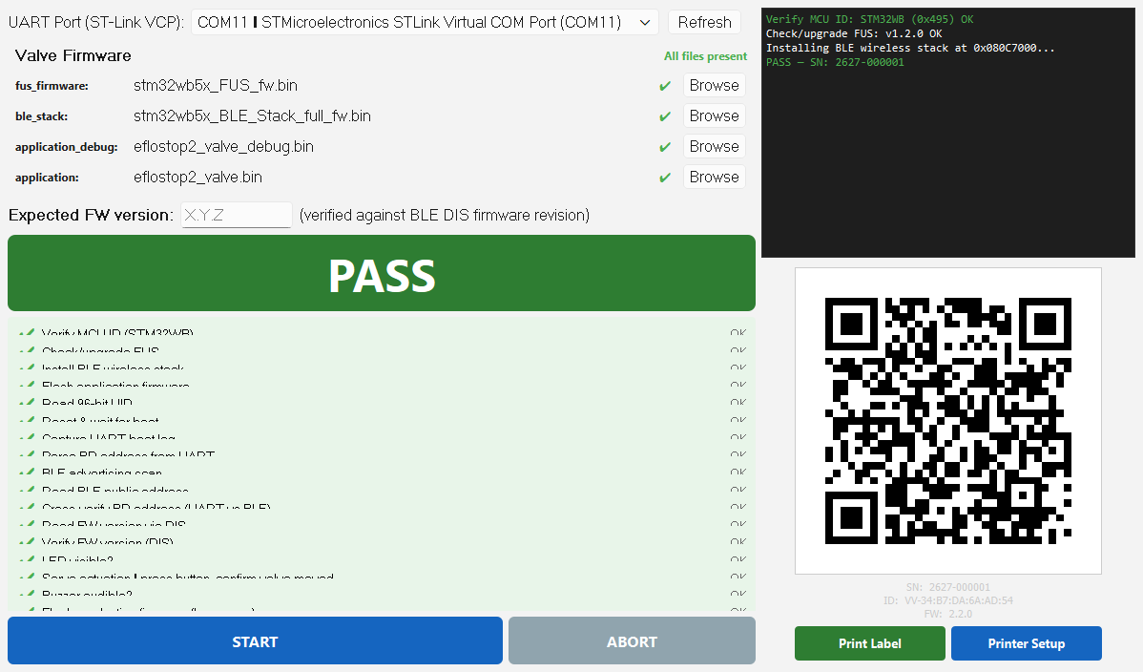
Figure 17. A Valve PASS with its generated QR label.
The QR code is a plain-text string the phone/commissioning (Watts) app reads. For this device it begins **id=VV-** followed by the device address, then **&type=**, **&hw=**, and **&sw=** (the device-reported firmware). See Figure 27 for the field breakdown.
11. Print Label. The Valve's serial number begins EFS2V. Apply the label.

6.7 If the Valve fails
Follow Section 4.9 and Section 8. A repeated **Wrong MCU** or **BD address mismatch** means the unit is a reject.

7. Leak Sensor — Program, Test, and Label
This chapter programs, tests, and labels one Leak Sensor on the **Leak Sensor** tab. Like the Valve, it is flashed with a debug build for testing and a production build at the end, and it adds a battery check and a leak-probe test.
⚠ WARNING Coin cell + ESD. Observe cell polarity and never short it; wear a wrist strap.

7.1 Prepare and connect
1. Install the coin cell with correct polarity (Figure 19).
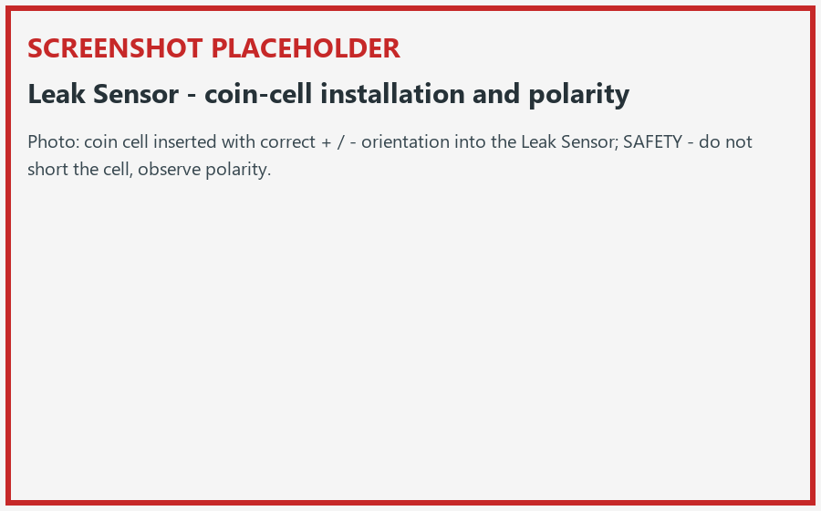
Figure 19. Coin-cell installation and polarity.
2. Connect the ST-Link on SWD (one programmer). Optionally connect the UART Port (Tag-Connect): lead for the log.
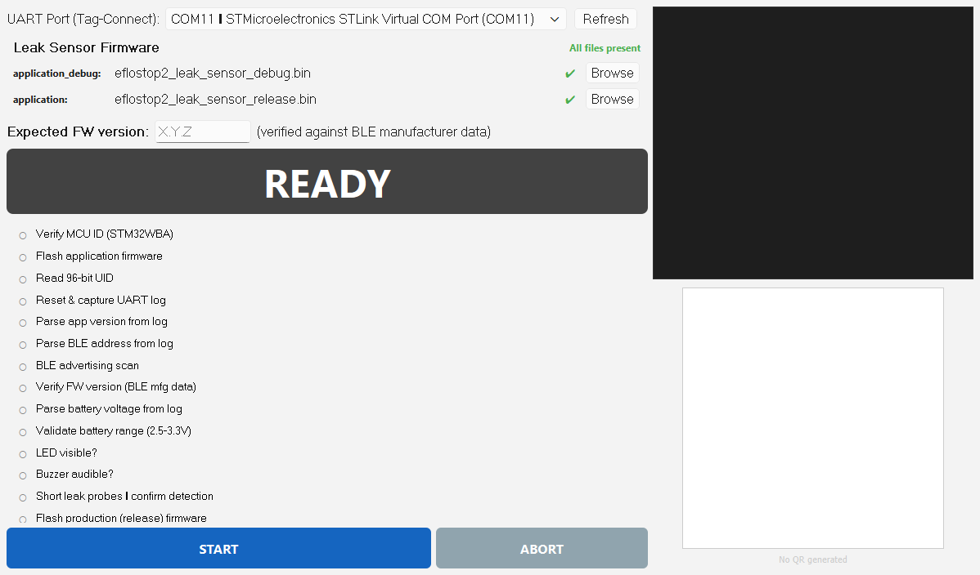
Figure 18. The Leak Sensor tab in the READY state.
✔ **“No serial ports found”** in the UART list means no lead is detected — this is OK if you are not capturing the log.

7.2 Pre-flight checks
3. Enter your Operator ID; confirm firmware All files present; type the batch version into Expected FW version.

7.3 Program the Leak Sensor (Flow A)
4. Press START. Steps run in order: Verify MCU ID (STM32WBA), Flash application (debug), Read 96-bit UID, then a reset.

7.4 Functional test (Flow B)
The tool captures the UART log and checks, in this order:
- **Reset & capture UART log** → **Parse app version** → **Parse BLE address** (this one must be found in the log)
- **Parse battery** → **Validate battery range (2.5-3.3V)**
- **BLE advertising scan** (about 15 s) → **Verify FW version (BLE mfg data)**
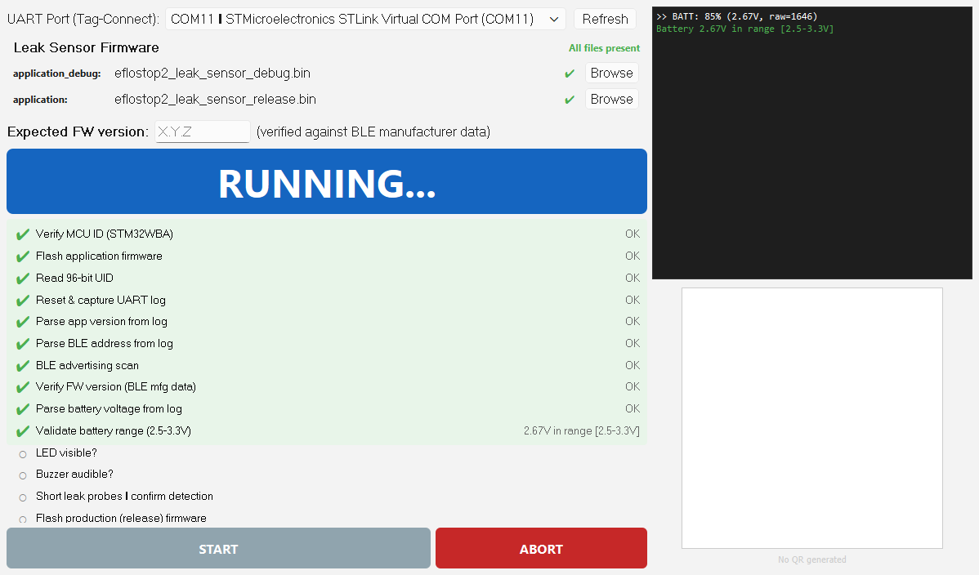
Figure 20. The battery-range validation step passing.
ℹ NOTE The battery must read between 2.5 V and 3.3 V. Outside that range the step fails with “<v>V outside range [2.5-3.3V]” and the unit is a reject (try a fresh cell first).

7.5 Manual checks
5. “Is the LED on the Leak Sensor visible?” — YES / NO.
6. “Did you hear the buzzer?” — YES / NO.
7. “Short the leak detection probes with a wet finger or wire. Did the sensor detect a leak?” — short the probes; answer YES only if a leak is detected (the UART log shows LEAK DETECTED).
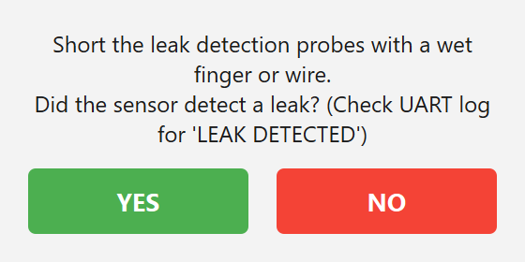
Figure 21. The leak-probe Operator Check dialog.

7.6 Production re-flash and PASS
8. The tool flashes the production (release) firmware as the final step, then shows PASS and the QR.
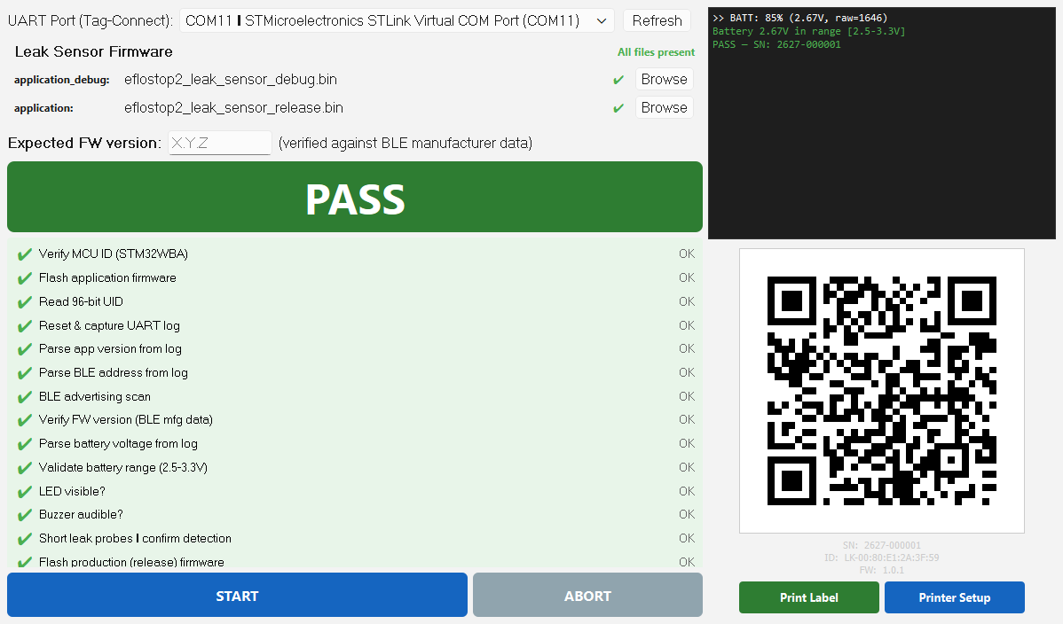
Figure 22. A Leak Sensor PASS with its generated QR label.
The QR code is a plain-text string the phone/commissioning (Watts) app reads. For this device it begins **id=LK-** followed by the device address, then **&type=**, **&hw=**, and **&sw=** (the device-reported firmware). See Figure 27 for the field breakdown.
9. Print Label. The Leak Sensor's serial number begins EFS2S. Apply the label.

7.7 If the Leak Sensor fails
Follow Section 4.9 and Section 8.

8. The QR Label and App Linking
Every device's QR encodes the same kind of plain-text string. The phone / commissioning app reads the text directly and identifies the device from the **id=** prefix: **GW-** = WiFi Hub, **VV-** = Valve, **LK-** = Leak Sensor.
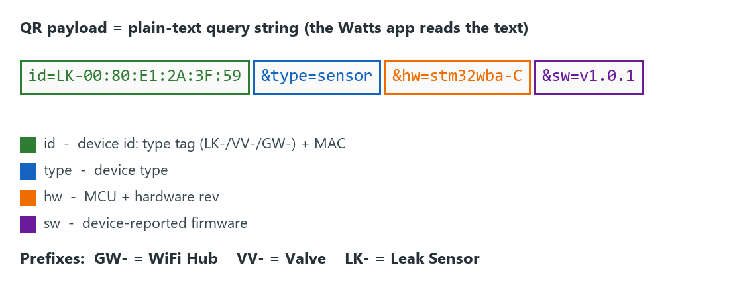
Figure 27. Anatomy of the QR payload string.
The QR panel shows **No QR generated** until a unit passes; after PASS it shows the code with **Print Label** and **Printer Setup** buttons.
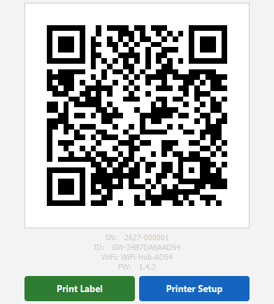
Figure 25. The QR panel after a PASS (Print Label / Printer Setup).

8.1 Printing
Press **Printer Setup** once to choose the label printer (Figure 26); it is remembered for the session. Then **Print Label** prints a 40 mm QR with the human-readable SN / ID / FW beside it (Figure 24).
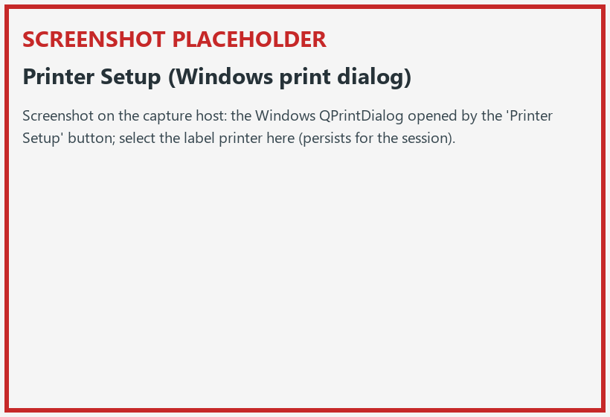
Figure 26. The Windows Printer Setup dialog.
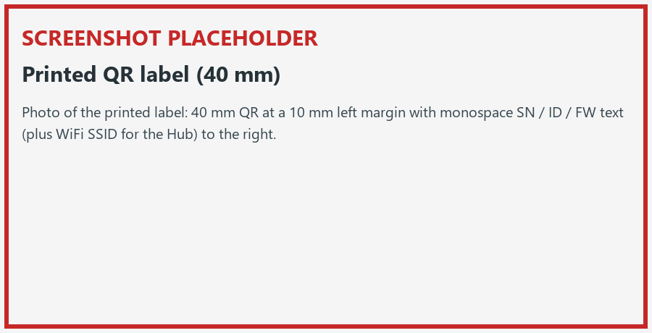
Figure 24. A printed 40 mm QR label.

9. Troubleshooting
Find the exact words you see on screen in the left column.
On-screen message | Means | What to do
Enter your Operator ID before starting. | No Operator ID entered. | Type your Operator ID in the operator bar, then START.
Select a serial port first. (Hub) | No port chosen. | Pick the port; Refresh if empty.
Firmware files missing. Check firmware folder. (Hub) | Hub firmware not staged. | Tell your station lead; stage firmware per manifest, Refresh.
Debug firmware (application_debug) missing. / Production firmware (application) missing. (Valve, Sensor) | A required binary is absent. | Station lead to stage the missing binary. (The Hub never shows these — it has no debug binary.)
Leak sensor firmware not configured. / Valve firmware not configured. | That device is not in the manifest. | Station lead to fix the manifest.
No CP210x ports found / No serial ports found | No adapter/lead detected. | Check cable and driver (Section 2.3); Refresh.
Cannot open <port> after 3s retry | The port is busy or gone. | ABORT, reseat the cable, Refresh, START. If a step hangs ~30 s, do the same.
Wrong MCU! Expected STM32WB (0x495) / STM32WBA (0x492) | Wrong board on the fixture. | Confirm you have the correct device; if it repeats, reject the unit.
No BLE device found / BLE advertising not detected after flash | The radio did not advertise. | Re-run once; check the Bluetooth adapter. Persistent = reject.
BD address mismatch! UART reports X but BLE scan found Y (Valve) | UART and BLE addresses disagree. | Reject the unit.
FW version mismatch: device reports v<x>, expected v<y>. | Device version ≠ what you typed. | First re-check the Expected FW field for a typo (Section 4.7). If correct, the wrong firmware was flashed — re-run or reject.
<v>V outside range [2.5-3.3V] (Sensor) | Battery out of range. | Try a fresh cell; if still out of range, reject.
Operator: LED not visible / Servo did not move / Buzzer not heard / Leak probe test failed | You answered NO to a manual check. | Reject the unit (or re-seat and re-run if you suspect a fixture issue).
Aborted by operator | You pressed ABORT. | Fix the cause and START to re-run.
Print Error — Could not start printing. | Printer not available. | Check the printer is on/connected; re-open Printer Setup.

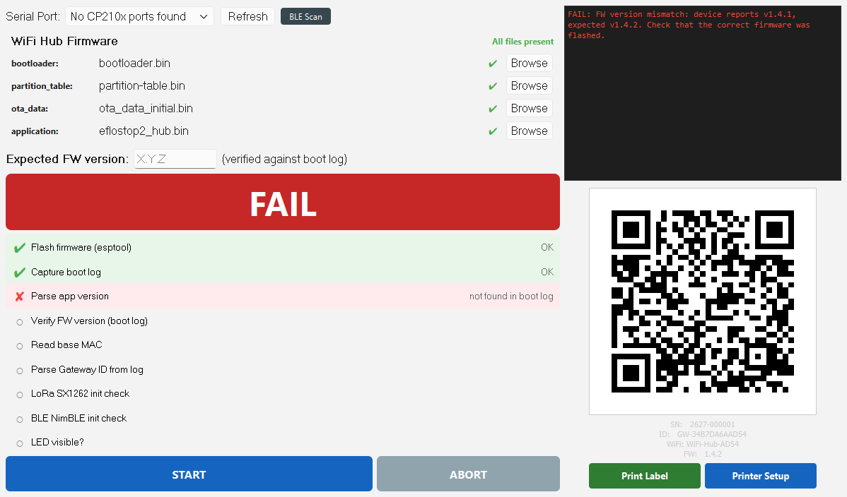
Figure 23. A FAIL: red banner and a FAIL line in the log.
ℹ NOTE Golden rule: a FAIL means fix and press START to re-run the whole sequence. A repeated wrong-MCU, address-mismatch, or out-of-range battery means set the unit aside as a reject.

10. Reviewing Records (History Tab)
Every run — PASS or FAIL — is recorded. Open the **History** tab to review and export.
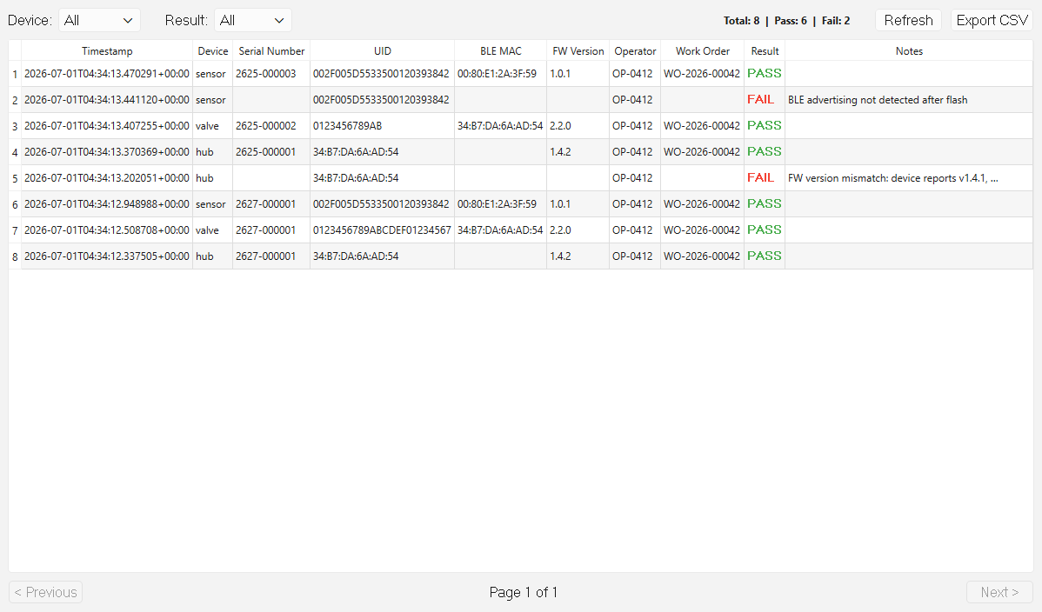
Figure 28. The History tab: filters, stats, records, and Export CSV.
1. Filter with the Device and Result drop-downs. The Total / Pass / Fail counts update.
2. Read the 10 columns: Timestamp, Device, Serial Number, UID, BLE MAC, FW Version, Operator, Work Order, Result, Notes. PASS is green, FAIL is red.
3. Use < Previous / Next > to page through records, and Refresh to reload.
4. Press Export CSV, choose a file, and confirm; the tool reports Export Complete. Do this at end of shift for QA.

11. Glossary
Term | Meaning
BLE | Bluetooth Low Energy — the short-range radio the devices use.
BD address / BLE MAC | The device's unique Bluetooth address.
Boot log | Text a device prints as it starts, captured over the UART lead.
Debug vs production firmware | A test build (used during the run) vs the final low-power build flashed last.
DIS | Device Information Service — a BLE service the Valve reports its firmware version through.
ESP32-S3 / STM32WB / STM32WBA | The microchips in the Hub / Valve / Leak Sensor.
FUS | Firmware Upgrade Service on the STM32WB — checked/updated before the BLE stack.
Gateway ID | The Hub's identity (begins GW-), used in its QR.
Manifest | manifest.yaml — the file that tells the tool which firmware to use.
QR payload | The plain text encoded in the QR (id=&type=&hw=&sw=).
ST-Link / SWD | The debugger and the wiring standard used to flash the STM32 boards.
Tag-Connect | A no-solder probe lead used to read the Leak Sensor's UART log.
UART / VCP / CP2102 | A serial connection / virtual COM port / the USB-serial adapter chip used for it.
UID | A unique ID number burned into each STM32 chip.
Watts app | The phone/commissioning app that scans the QR to link a device.

Appendix A — Quick Reference Cards
 | WiFi Hub | Valve | Leak Sensor
Tab | WiFi Hub | Valve | Leak Sensor
Port label | Serial Port: | UART Port (ST-Link VCP): | UART Port (Tag-Connect):
Programmer | CP2102 USB-UART | ST-Link SWD | ST-Link SWD (+Tag-Connect)
Manual checks | LED | LED, Servo, Buzzer | LED, Buzzer, Leak-probe
Battery check | — | — | 2.5-3.3 V
Production re-flash | No | Yes | Yes
Serial prefix | EFS2H | EFS2V | EFS2S
QR id prefix | GW- | VV- | LK-

Appendix B — Screenshot & Figure Capture Guide
Most figures were captured automatically from the live tool UI with the capture helper at docs/manual/capture/capture.py (no hardware needed). This appendix tells a human how to reproduce every figure and how to replace the placeholders. **Always caption a figure with the exact on-screen text — never paraphrase or shorten it.**

B.1 Auto-captured figures
Run python docs/manual/capture/capture.py from the project root. It renders the tool on the native Windows platform with WA_DontShowOnScreen (no windows appear), using the real firmware manifest for the green firmware state, and writes PNGs to docs/manual/assets/. Idle/READY tabs, the operator bar, the firmware strip, the Operator Check dialog, the banner and step legends, the warning dialog, and the empty QR panel all come from here directly.

B.2 Run-state figures (mock-driven)
RUNNING / PASS / FAIL banners, populated step rows and log, and the populated QR only exist while a worker runs. The helper reproduces them by calling each tab's own UI methods (status_banner.set_status, step_list.update_step, log_viewer.append, and _finish_pass / _on_fail) with canned data — no real flasher, BLE, or serial worker. To re-shoot on a live line instead, photograph a real qualifying run per device.

B.3 Placeholders to replace
Figure | How to produce it
3b — red firmware strip | Temporarily rename firmware/manifest.yaml (or delete one .bin), relaunch, screenshot the strip, then restore.
10 — Hub wiring | Photo of the CP2102 USB-UART adapter connected to the ESP32-S3 Hub (TX/RX/GND/5V + USB to PC).
14 — Valve wiring | Photo of the ST-Link on the Valve SWD header, one programmer only.
19 — Coin cell | Photo of the coin cell installed with correct polarity in the Leak Sensor.
24 — Printed label | Photo of the printed 40 mm QR label (SN / ID / FW text beside the code).
26 — Printer Setup | Screenshot of the Windows print dialog opened by Printer Setup on the capture PC.

ℹ NOTE Ignore the tool's unused/stale paths when documenting: the base64/JSON QR spec, the ZPL 25 mm label path, and the title-bar version number are not the live behaviour. The real QR is the plain-text query string and the real print path is the 40 mm QR label.

