**Methods**

**Dengue Data**

The number of reported dengue-related data, including total new cases, total new deaths, total cases per thousand, and total deaths per thousand have been extracted from the WHO situation reports/Weekly bulletin and Ministry of Health website from January 2000 to December 2023 of eight South Asian countries (Afghanistan (2021-2023) 1–3, Bangladesh (2000-2023)4, Bhutan (2004-2019) 5,6, India (2000-2023) 7, Maldives (2018-2022) 8,9, Nepal (2010-2023) 10, Pakistan (2005-2023) 11, and Srilanka (2000-2023) 12,13. All reports in the Ministry of Health used the WHO case definition 14. We collected Dengue serotypes from different published papers over the period 2000–2023 from all South Asian countries Afghanistan 1–3, Bangladesh 15–17, Bhutan 16,18,19, India 16,20, Maldives8,9,21, Nepal 16,22,23, Pakistan 16,24,25, and Srilanka 16,26–28.

**Case-fatality ratio (CFR)**

We computed dengue's Case Fatality Rate (CFR) as the percentage of dengue-attributed deaths among confirmed cases, using the formula: CFR = (dengue-attributed deaths / confirmed cases) x 100.

**Time series model to predict the trend**

A time-series model (i.e., auto-regressive integrated moving average (ARIMA)), was used to identify the trend of south-Asian dengue cases, deaths, and CFR from 2000-2023. The specifics of the ARIMA model are detailed in a previous article on dengue 29. Additionally, we employed a Mann–Kendall (M–K) trend analysis to identify potential upward or downward trends. The null hypothesis assumes no monotonic trend, while the alternative hypothesis suggests the presence of a trend, which may be positive, negative, or non-null. Furthermore, we conducted Sen’s slope test to evaluate variations in annual dengue cases and deaths. A positive slope indicates an upward trend, while a negative slope indicates a downward trend over a given period 30.

**Statistical analysis**

We analyzed summary statistics, including the mean, standard deviation (SD), and interquartile range (IQR) with 1st and 3rd quartile dengue cases and deaths across South Asian countries. Our observations revealed dynamic shifts in dengue cases, deaths, and CFR trends over time. To forecast future trends, we employed time-series models. All statistical analyses were performed using R version 3.5.2.2.

**Results**

**Table 1: Comparison of dengue cases, deaths, and CFR between the SA Countries**

|  |  |  |  |  |  |  |
| --- | --- | --- | --- | --- | --- | --- |
|  | **Cases/100000** | | **Deaths** | | **CFR (%)** | |
| **SA Countries** | **Mean (SD)** | **IQR (1st-3rd)** | **Mean (SD)** | **IQR (1st-3rd)** | **Mean (SD)** | **IQR (1st-3rd)** |
| **Afghanistan** | 0.45 (1.16) | 0.00 (0.00-0.00) | 0.04 (0.20) | 0.00 (0.00-0.00) | 0.01 (0.01) | 0.00 (0.00-0.00) |
| **Bangladesh** | 15.08 (41.32) | 4.32 (0.75-5.06) | 106.42 (346.88) | 45.75 (1.75-47.50) | 0.46 (0.58) | 0.32 (0.14-0.46) |
| **Bhutan** | 64.42 (121.81) | 75.62 (0.00-75.62) | 0.33 (1.27) | 0.00 (0.00-0.00) | 0.02 (0.09) | 0.00 (0.00-0.00) |
| **India** | 5.10 (5.30) | 7.09 (1.19-8.28) | 155.08 (94.29) | 132.75 (83.50-216.20) | 0.67 (0.57) | 0.91 (0.18-1.09) |
| **Maldives** | 290.47 (448.71) | 466.14 (0.00-466.1) | 0.38 (1.35) | 0.00 (0.00-0.00) | 0.02 (0.07) | 0.00 (0.00-0.00) |
| **Nepal** | 19.25 (51.93) | 3.25 (0.03-3.29) | 5.29 (18.12) | 1.50 (0.00-1.50) | 0.09 (0.19) | 0.05 (0.00-0.05) |
| **Pakistan** | 7.98 (10.61) | 8.65 (0.80-9.45) | 32.04 (78.94) | 17.25 (0.00-17.25) | 0.35 (0.77) | 0.19 (0.00-0.19) |
| **Sri Lanka** | 194.37 (201.48) | 186.14 (53.43-239.57) | 106.17 (102.38) | 67.25 (44.75-112.00) | 0.46 (0.36) | 0.45 (0.17-0.62) |
| **Total** | 74.64 (204.51) | 25.74 (0.01-25.75) | 50.72 (144.99) | 48.75 (0.00-48.75) | 0.26 (0.48) | 0.30 (0.00-0.30) |

Maldives holds the record for the highest mean cases per 100,000 population over 24 years, standing at 290.47 (standard deviation (SD) 448.71), whereas Afghanistan has the lowest rate at 0.45 (SD 1.16). The interquartile range (IQR) is narrowest in Afghanistan, at 0.00, and widest in Maldives, at 466.14. India reported the highest mean number of deaths at 155.08 (SD 94.29), while Afghanistan reported the lowest at 0.04 (SD 0.20). For deaths, the IQR is highest in India, at 132.75, and lowest in Afghanistan, at 0.00. India also has the highest mean Case Fatality Rate (CFR) at 0.67% (SD 0.57%), with an IQR of 0.91. Overall, the average number of dengue cases per 100,000 population stood at 74.64 (SD 204.51 and IQR 25.74). The mean number of deaths was 50.72 (SD 144.99 and IQR 48.75), while the mean CFR was 0.26% (SD 0.48% and IQR 0.30%) (Table 1).

Figure 1: **Trend of dengue cases and CFR between the SA Countries**



In 2023, Afghanistan documented the highest number of cases (1496), with the highest CFR also occurring in that year (0.07%). Bangladesh reported its highest number of cases in 2023 (321,179), while the highest CFR was recorded in 2003 (2.06%). Bhutan's peak in cases was in 2019 (3309), and its highest CFR occurred in 2006 (0.41%). In 2022, India recorded its highest number of cases (233,251), with the highest CFR noted in 2002 (1.71%). Maldives' highest case count was in 2020 (6,896), and its highest CFR occurred in 2015 (0.32%). Nepal's peak in cases was in 2022 (54,784), with the highest CFR recorded in 2015 (0.74%). Pakistan's highest number of cases was in 2022 (79,007), and its highest CFR occurred in 2004 (3.32%). Sri Lanka's highest case count was in 2017 (186,101), with the highest CFR observed in 2004 (1.25%).

Figure 2: **Trend of dengue cases and deaths in SA**



Across South Asian countries, the highest number of cases was reported in 2023 (570,957), deaths in 2023 (1865) with the highest CFR noted in 2003 (6.13%) (Figure 2).

Figure 3: Dengue serotypes in South Asia (200-2023)



Between 2000 and 2023, the distribution of dengue virus serotypes varied across South Asian countries. Afghanistan predominantly experienced DENV-1 and DENV-3 serotypes, comprising 30% of cases. Bangladesh and Bhutan exhibited a prevalent distribution of DENV-1 and DENV-2 serotypes, accounting for 36.36% of cases. India reported the highest distribution across DENV-1, DENV-2, and DENV-3 serotypes, making up 28.92% of cases. Maldives notably saw a dominance of DENV-3 serotypes, representing 50% of cases. Nepal followed suit with a majority distribution of DENV-3 serotypes, at 57.14%. Pakistan's profile was marked by DENV-2 serotypes, constituting 39.47% of cases. Sri Lanka, on the other hand, exhibited a prevalence of DENV-3 serotypes, accounting for 34.04% of cases. Overall, DENV-1 serotypes were most widespread across South Asia, comprising 32.37% of cases (Figure 3).

Figure 4: Number of serotypes in each year

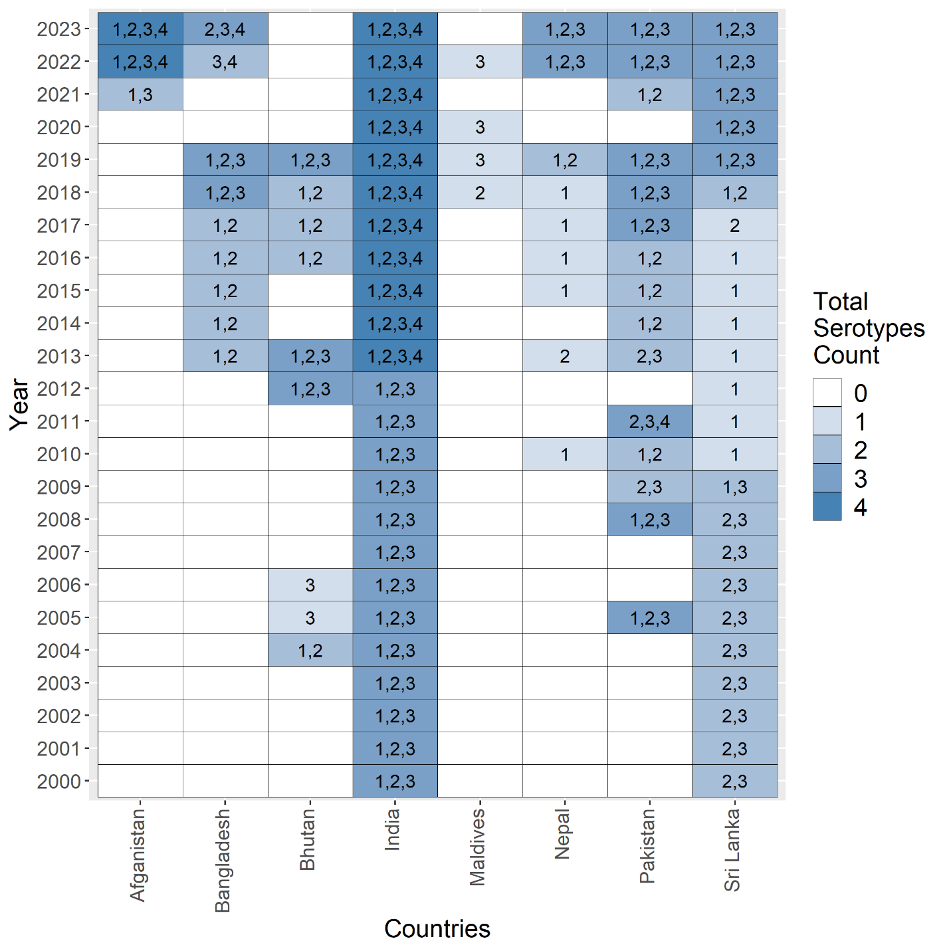

Figure 5: The observed and forecasted number of dengue cases, deaths, and CFR in South Asia using the autoregressive moving average (ARIMA) model including a 95% confidence interval.



In the ARIMA model, we detected an increasing trend for the first few years of forecasting, which then started to decline in deaths. However, a strong rise in cases was observed in cases and CFR (Figure 5).

References

1 Home | Ministry of Public Health. https://moph.gov.af/en/ (accessed May 13, 2024).

2 National Disease Surveillance & Response (NDSR) (Afghanistan) | GHDx. https://ghdx.healthdata.org/organizations/national-disease-surveillance-response-ndsr-afghanistan (accessed May 13, 2024).

3 WHO EMRO | Infectious disease outbreak situation reports | Information resources | Afghanistan. https://www.emro.who.int/afg/information-resources/infectious-disease-outbreak-situation-reports.html (accessed May 13, 2024).

4 ডেঙ্গু প্রেস রিলিজ সমূহ. https://old.dghs.gov.bd/index.php/bd/home/5200-daily-dengue-status-report (accessed May 13, 2024).

5 Royal Centers For Disease Control – Official Website of Royal Centers For Disease Control. https://www.rcdc.gov.bt/web/ (accessed May 13, 2024).

6 MoH Press Release on Dengue Outbreak | Ministry of Health. https://www.moh.gov.bt/assessing-dengue-outbreak/ (accessed May 13, 2024).

7 Home :: National Center for Vector Borne Diseases Control (NCVBDC). https://ncvbdc.mohfw.gov.in/ (accessed May 13, 2024).

8 SEAR Epidemiological Bulletins. https://www.who.int/southeastasia/outbreaks-and-emergencies/health-emergency-information-risk-assessment/sear-epi-bulletins (accessed May 14, 2024).

9 Health - Maldives Health Ministry. https://health.gov.mv/en (accessed May 14, 2024).

10 EDCD|Home. https://edcd.gov.np/ (accessed May 13, 2024).

11 National Institutes of Health, Islamabad Pakistan. https://www.nih.org.pk/health-data-center (accessed May 13, 2024).

12 - Epidemiology Unit. https://www.epid.gov.lk/web/index.php?option=com_content&view=article&id=171&Itemid=487&lang=en (accessed May 14, 2024).

13 NDCU - Home. https://www.dengue.health.gov.lk/web/index.php/en/ (accessed May 13, 2024).

14 Dengue Outbreak Toolbox. .

15 Haider N, Asaduzzaman M, Nayeem Hasan M, *et al.* Bangladesh&#x0027;s 2023 Dengue outbreak &#x2013; age/gender-related disparity in morbidity and mortality and geographic variability of epidemic burdens. *International Journal of Infectious Diseases* 2023; **136**: 1–4.

16 Shrestha DB, Budhathoki P, Gurung B, *et al.* Epidemiology of dengue in SAARC territory: a systematic review and meta-analysis. *Parasit Vectors* 2022; **15**. DOI:10.1186/S13071-022-05409-1.

17 Hossain MS, Noman A Al, Mamun SA Al, Mosabbir A Al. Twenty-two years of dengue outbreaks in Bangladesh: epidemiology, clinical spectrum, serotypes, and future disease risks. *Trop Med Health* 2023; **51**: 1–14.

18 ZangmoID S, Bdr DarnalID J, GyeltshenID S, *et al.* Molecular epidemiology of dengue fever outbreaks in Bhutan, 2016-2017. 2020. DOI:10.1371/journal.pntd.0008165.

19 Dorji T, Yoon IK, Holmes EC, *et al.* Diversity and Origin of Dengue Virus Serotypes 1, 2, and 3, Bhutan. *Emerg Infect Dis* 2009; **15**: 1630.

20 Zala DB, Khan V, Kakadiya M, Sanghai AA, Das VK. Circulation of dengue serotypes in the Union Territory of Dadra & Nagar Haveli (India). *Parasite Epidemiol Control* 2018; **3**: e00069.

21 Mutoh Y, Moriya A, Yasui Y, *et al.* Two Cases of Dengue Virus Type 2 (DENV-2) Infection in a Japanese Couple Returning from the Maldives during the 2018 Dengue Outbreak. *Jpn J Infect Dis* 2020; **73**: 58–60.

22 Rauniyar R, Prajapati S, Manandhar B, *et al.* Dengue virus infection during window period of consecutive outbreaks in Nepal and assessment of clinical parameters. *Scientific Reports 2023 13:1* 2023; **13**: 1–11.

23 Rimal S, Shrestha S, Pandey K, *et al.* Co-Circulation of Dengue Virus Serotypes 1, 2, and 3 during the 2022 Dengue Outbreak in Nepal: A Cross-Sectional Study. *Viruses* 2023; **15**: 507.

24 Khattak A, Khan S, Ali I, *et al.* Burden and distribution of dengue infection in Pakistan (2000-19): a review. *Brazilian Journal of Biology* 2023; **84**: e267982.

25 Ali L, Gul Z, Ijaz A, *et al.* An overview of dengue viral infection circulating in Pakistan. *J Vector Borne Dis* 2022; **59**: 109–14.

26 Sirisena PDNN, Noordeen F. Evolution of dengue in Sri Lanka-changes in the virus, vector, and climate. 2014. DOI:10.1016/j.ijid.2013.10.012.

27 Jayadas TTP, Kumanan T, Gomes L, *et al.* Regional variation in dengue virus serotypes in sri lanka and its clinical and epidemiological relevance. *Diagnostics* 2021; **11**. DOI:10.3390/DIAGNOSTICS11112084/S1.

28 Kanakaratne N, Wahala WMPB, Messer WB, *et al.* Severe Dengue Epidemics in Sri Lanka, 2003–2006. *Emerg Infect Dis* 2009; **15**: 192.

29 Hasan MN, Khalil I, Chowdhury MAB, *et al.* Two decades of endemic dengue in Bangladesh (2000–2022): trends, seasonality, and impact of temperature and rainfall patterns on transmission dynamics. *J Med Entomol* 2024; **61**: 345–53.

30 Hasan MN, Haider N, Stigler FL, *et al.* The Global Case-Fatality Rate of COVID-19 Has Been Declining Since May 2020. *Am J Trop Med Hyg* 2021; **104**: 2176.