Figure 1: Schematic diagram of the analytic study

Figure 2: 2(a).Model assessment curve of fitted final model 2(b).Area Under ROC curve 2(c).Calibration belt plot

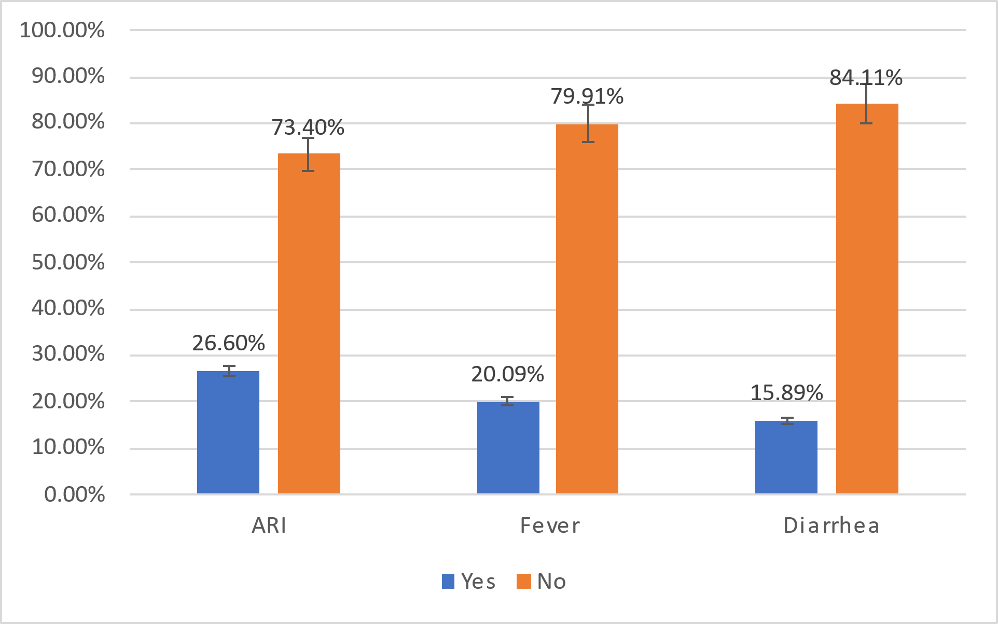

Figure 3: Percentage of ECE Program participation with different types of disease

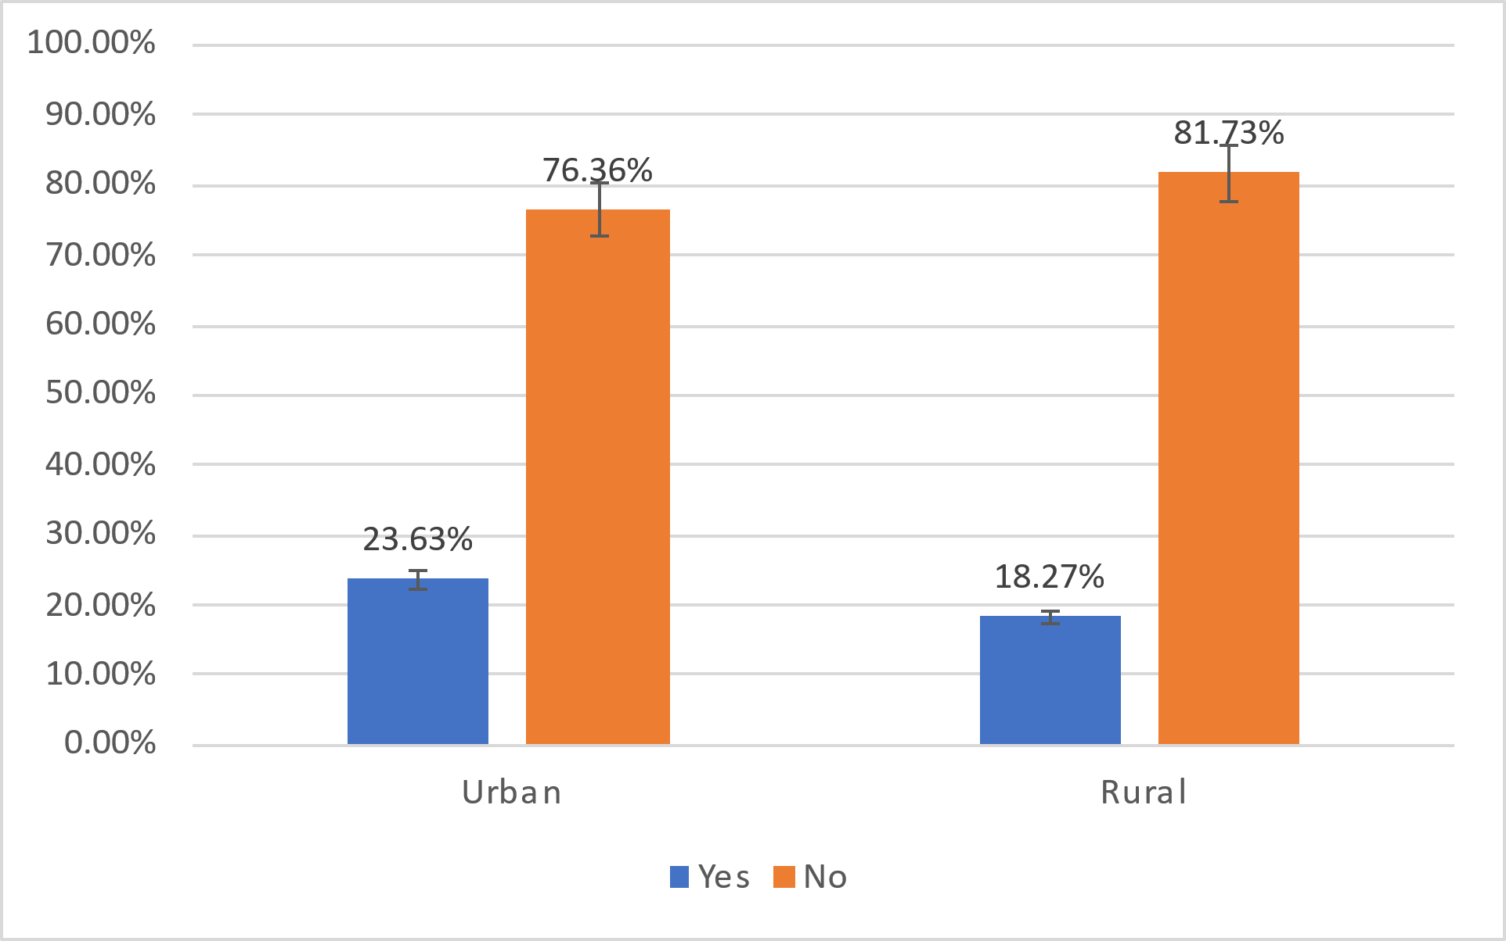

Figure 4: Participation in ECE program in Urban and Rural Area