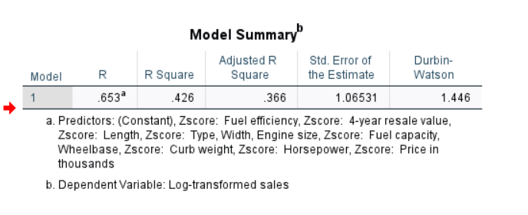

**Durbin-Watson (1.446)**:

* This statistic tests for autocorrelation in residuals.
* A value close to **2** indicates little to no autocorrelation, while values near **0** or **4** indicate strong positive or negative autocorrelation.
* **1.446** suggests mild positive autocorrelation, which might need further checking.