If p<0.05 reject null hypothesis

p>0.05 null hypothesis accepted

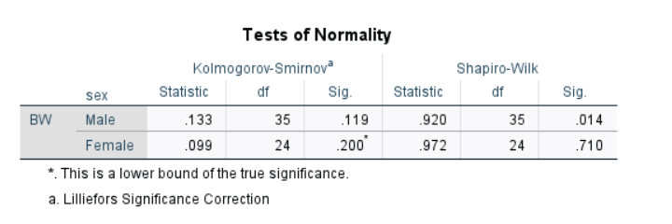



For male, Shapiro-Wilk= 0.014 < 0.05 so, reject null hypothesis, the distribution is not normal

For female, Shapiro-Wilk=0.710>0.05 so, accept null hypothesis, the distribution is normal

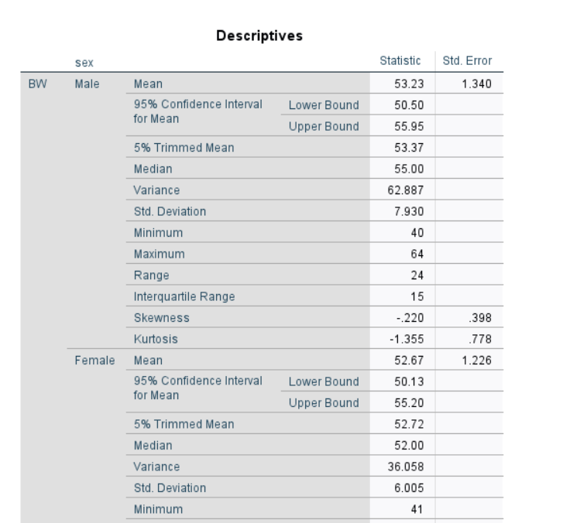



From Skewness,

Statistic/Std Error lies between $±1.96$

We can say may be normaly distributed

Same for Kurtosis