RHS ED – Projection of Care space requirements by ED area

# **1 Parameters given:**

## 1.1 Annual ED visits

Annual ED visits for every year up to 2035, broken out by CTAS and 5-year age bins.

|  |  |  |  |  |  |  |
| --- | --- | --- | --- | --- | --- | --- |
| **Base case summary** | |  |  |  |  |  |
| **CTAS** | **2017** | **2018** | ***2020*** | ***2025*** | ***2030*** | ***2035*** |
| 1 - Resuscitation | 416 | 442 | *512* | *597* | *707* | *859* |
| 2 - Emergency | 8936 | 9630 | *10,653* | *12,958* | *15,350* | *17,345* |
| 3 - Urgent | 27453 | 28711 | *31,409* | *37,475* | *41,672* | *45,740* |
| 4 - Semi-Urgent | 18390 | 18631 | *18,861* | *20,504* | *21,464* | *22,597* |
| 5 - Non-Urgent | 1863 | 1624 | *1,756* | *1,881* | *1,986* | *2,100* |
| **Grand Total** | **57058** | **59038** | ***63,192*** | ***73,415*** | ***81,179*** | ***88,641*** |
|  |  |  |  |  |  |  |
| *% Change from 2018* | |  | *7.0%* | *24.4%* | *37.5%* | *50.1%* |

**Source folder**: G:\VCHDecisionSupport\Coastal_Richmond_SI\2019-09-17_RH_Emergency-ED-Projections-Planning\results\final-results

**Source file**: 2019-09-24_rhs_ed-visits-projections-by-age-and-ctas

## 1.2 Number of care spaces by ED area:

**Source folder:** G:\VCHDecisionSupport\Coastal_Richmond_SI\2019-11-15_rh_ED-ssp-unit-bed-requirement-projection\data

# **2. Required results:**

Estimate number of care spaces necessary in each ED area for the years 2025, 2030, 2035.

# **3. Methodology**

Treat each ED area as a separate M/M/c queuing system.

For each area, we will need to know at least one of the following:

1. Average “census” in the area (L)
2. Average arrival rate to the area (lambda)

We also need to know:

1. AVG LOS in each area (W = 1/mu)
2. Num care spaces in each area (see Section 1.2 above)

Given the parameters above, we can produce graphs like the following for each ED area:

[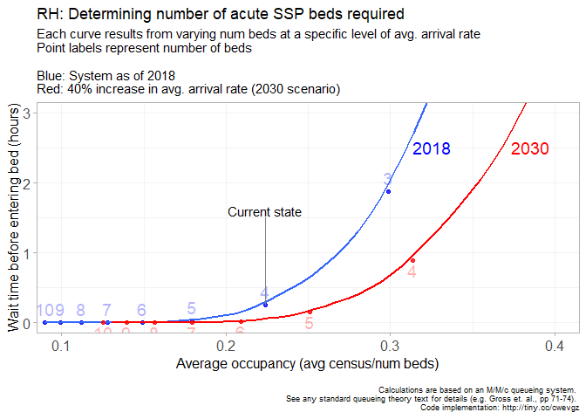](https://raw.githubusercontent.com/nayefahmad/Richmond-Hospital-SSP-unit-bed-requirement-projection/master/src/2019-11-15_rh_ED-ssp-unit-bed-requirement-projection_files/figure-html/unnamed-chunk-14-1.png)

For details, see R scripts here: G:\VCHDecisionSupport\Coastal_Richmond_SI\2019-11-15_rh_ED-ssp-unit-bed-requirement-projection\src