Project Report

CSE 215 (JAVA)

Project Name:

Universal Management and Printing Tool

Project By,

Md. Nayem Ahmed Niloy

ID: 2121228042

Table of Contents

Chapter 1: Page-1

• Description of the problem statement

• Objectives and Goal

• Importance of my work

Chapter 2: Page-(2-3)

• Methodology of the project

Chapter 3: Page-4

• Conclusion

Chapter 1

Description of the problem statement:

A universal management system and printing tool has an initiative of making a moral impact on management systems. Management systems are necessary for a person or an organization to maintain their current workings and future goals. We must reduce our efforts on maintaining our daily expenses or bills to a note book like old ages. It’s the era of technology and computer so let’s enjoy the shiny day with clouds every day and leave the rest to a computer.

Objectives and Goal:

The main theme of a universal management system is to work with any kind of management work. Let’s describe what my project is trying to achieve and explain why I am pursuing it:

•Reduce efforts on managing things like old days with a pen and paper.

• Save time on managing things.

• Using computer is not hard to manage things.

• Never lost a paper of your costing and notes of important things.

•Have a few clicks and get your work done within a second.

•Print it and take it with you just like old days.

•Lost the printed copy and cry. No, that’s not going to happen. Always have a backup file in your computer and hang around tension free.

Importance of my work:

This tool will help a lot of people on managing their daily life like expenses, fare receipt, shopping receipt, taking notes and print it instantly and a lot more. Don’t forget it’s a universal tool so make it as you want and as you like to use it.

1

Chapter 2

While thinking about making a project I was thinking about what should I make. Everything was there already so I thought why don’t I just make a project that everyone can use just by modifying some variables and methods. Then I came up with the Idea of making a universal tool for everyone.

For the demonstration I made a Toll Management System. It will manage the Toll fares for different vehicles, print a receipt and store the data for further uses. This Demo project can be used in any Bridge you want to make the toll management easy as clicking some few buttons.

I have used **JFrame Form** on NetBeans 15 to make the GUI (Graphical User Interface) and designed the project very simply and with simple user interface. Take a glance of it.

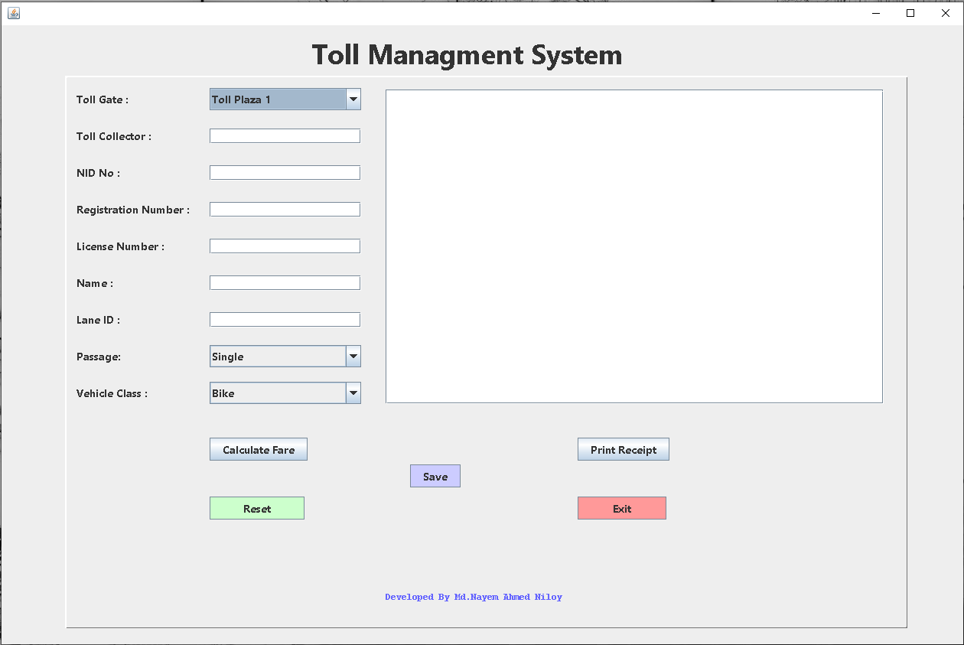

Caption: Graphical User Interface of the Project.

2

I have used Labels, textField, textArea, ComboBox, Button from JFrame Form for this project. I have also declared necessary String variables so that I can take inputs from text fields. Then I printed those inputs in textArea to show the receipt type. The receipt will have all the information about the toll including date, time, fare. I especially designed this management system for Padma Bridge so all the vehicles and their fare cost are built-in this project.

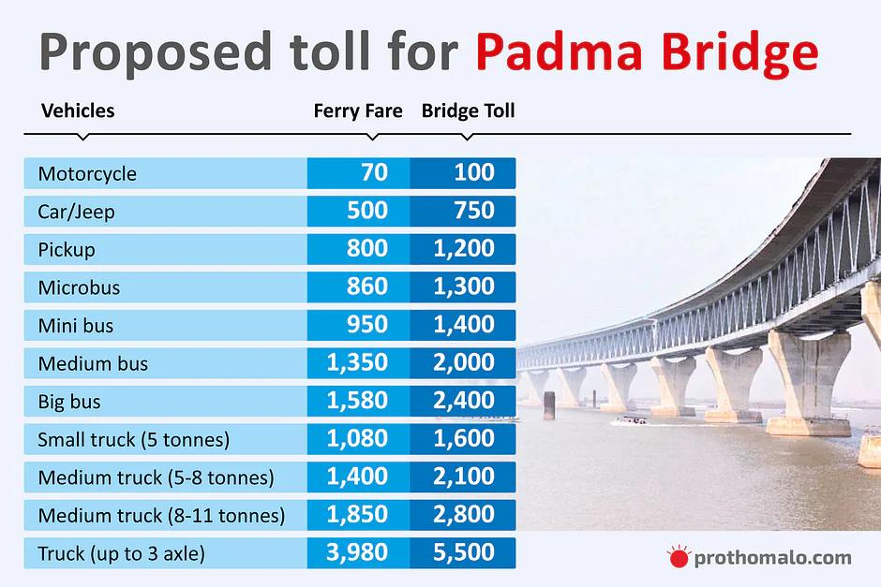

Caption: Toll Fare of Padma Bridge

Necessary methods and action performed are placed on the code to perform exact actions. This project also has five jButtons. Calculate Fare button will generate the receipt in the textArea with the exact fare for the consumer. Save button will create a file in the computer with the data for further usage. Print Receipt button will print the receipt shown in the textArea. Reset button will reset the textFields and textArea for new consumer and the the Exit button will close the program.

3

Chapter 3

Conclusion:

I hope this project will help a lot of people to manage various things in various fields. Demo project is just for demonstration and doesn’t mean the you can only use the project for toll management system. You can use it for personal note taking, A small business start-up, in a general store or in a pharmacy. This project also gives you the facility to store your data so that you can use it any further. In a nutshell, It’s not a fancy project after all. It’s just a basic project to help people with their daily life management and printing various things with a minimal software.

Thank You

4