4/29/2017

Proposal for
XYZ HR Platform Development
Project name: All Peoples Portal (APP)*

Submitted by:
YOURCOMPANYATOZ Limited
7-D, Commercial Plot # 2342, 6345 343ingh Lane, Upper Serangun, Dhaka, Bangladesh
Email: naqib@YourCompanyAtoZ.co
Phone: +88 01755605053,
Website: www.YourCompanyAtoZ.co
* Name can be changed

Table of Contents

Table of Contents 2
Tables 3
Introduction 4
About YOURCOMPANYATOZ Limited 4
Background and Product Context 5
User Story 7
Use Case 1: 7
Use Case 2: 7
Use Case 3: 7
Limits 7
Solution Description 8
Architecture 8
Front-end plan 9
Back end development 9
Performance plan: 10
Open-source web page tester (https://www.webpagetest.org/) 10
Google Page evaluation (https://developers.google.com/speed/pagespeed/insights/) 10
Others Comments 10
Development Plan 11
Phase 1 11
Deliverables: 11
Phase 2 11
Deliverables: 11
Phase N 11
Hardware/Hosting Plan 12
Collaboration Plan 13
Project Schedule 14
Budgetary Price 15
Appendix 16
Contact information 16
Special notes from meetings 16

Tables

Table 1: Cloud hosting plans 12
Table 2: Collaboration plan 13
Table 3: Phase 1 Schedule 14
Table 4: Expense Breakup for Development 15

Introduction
This is a proposal of development of a universal digital portal for human resources of diverse skillsets, availability, employability that equally caters to diverse requirements from employers / engagement programs of all categories. This document contains high requirements, product vision and user stories, phase wise development outline and expectation. This document will remain as a living document to be shared online collaboration to undergo phase wise changes as the product i.e. the portal matures into a value generating platform.

About YOURCOMPANYATOZ Limited
The company, Your Company Atoz (YOURCOMPANYATOZ) Limited, develops business automation services. Starting with Taxi service automation in 2015, currently it develops location based team/fleet and visitor management software as service. Although newly formed, this company houses some of the brightest and best experts of industry with international experiences. Those experiences include Fortune 500 companies like Samsung, IBM, Cisco, Juniper, Huawei, Lenovo and Fujitsu. This company envisions becoming top tier software R&D organization in Bangladesh by 2020. Leveraging on cloud-mobile ecosystem this company embraced "build for next billion users" philosophy in its development strategy.
Learn more at http://www.YourCompanyAtoZ.co

Background and Product Context
Currently, a number of job portals enjoy popularity in Bangladesh. They act like free bulletin boards for job seekers. People browse and search for open available jobs on those sites. They also can view employers’ profile. Employers pay those portals for posting their jobs for display to attract applications. Those sites also allow employers to seek candidate profiles as per their requirement in return for a payment or subscription. So, essentially, the employers pay for the service while the seekers get a free portal. BDjobs.com, prothom-alo-jobs.com and so on fall into this category. These are typical classical job portals.
Some other portals allow service providers/ candidates post advertisement of their service for free. Also, the employers get a free listing of the service providers. Such as, bikroy.com, clickbd.com, ekhanei.com and so on belong to this category. This value chain looks simple: both service seekers and providers get a portal of cross connection. These portals earn revenue/ value by display of sponsored advertisements under their listing of from banner advertisements on the portal itself. However, such portals seldom receive individual candidates posting their skills for hire. This is a contrast between the classical job portals and this type of portals. Over all, the view point is a complete reversal of the first category. Here, to state in terms of job portals, candidates post their availability for certain skills. The employer can browse and choose whom to work with or employ. However, their appearance look more like a common market place for any commodity or service than like a classical job / employment related portal. This is the second category.
There is a third category of job portals known as free lancing site. For example, www.Upwork.com. Candidates post their skills and availability and rates. Employers view, search, browse, and filter candidates for free and anonymously. Therefore, the service direction is completely opposite to that of the first category. In addition, free-lancing portals allow candidates post and create their profiles and publish for free. The portal generates revenue when the candidates get paid for their work. Therefore, the primary customers to such sites are the employers but it’s the candidates who pay for the service as a fraction of their income.
Now, the forth category. Social networking solutions. They somewhat overlap on the job portal industry. Some of the popular SNS LinkedIn, Facebook and google plus offer display of individual’s professional profile. However, they don’t allow in their free version to enlist/filter candidates from HR’s point of view. Regardless of their extensive database of profiles, their utility from an HR manager’s usage point of view does not add much value. This is one of their weaknesses.
Considering the above 4 categories of job/service portals there is a room for creating a service that mixes category 1, 2 and 3 in a fine blend. For example, by making it free for both employers and candidates. Employers will anonymously browse, filter candidates profile much like freelancing sites allow. They will make shortlist, sort, keyword search and will be able to notify suitable candidates using the facility of this portal. Employers may engage in quick chat session with potential candidate using instant messages, voice/video calls and so on from this portal. Employer can also view candidates’ geo-location information on a map also get report on skills and expertise levels distributed on map. There will be option for seeing real time data of skill distributions like heat map on weather channels. Using this employer can plan on where to set up next office in the world to enjoy highest supply of suitable human resources. On the other hand, candidates will be able to easily enlist all formal and non-formal skills that they see fitting for the market. They will be able to post their charitable services also. This portal will display statistics of employers’ searches and queries in similar heat map. The candidate will be able to take informed movement where to move and which skills are in high demand. Based historical data, this portal will also project whether demand for a particular skill is rising or plummeting. Candidates will be able to form alliance and groups on the site based on their interest and skills’ cohesion. All categories of skill sets, white collar, blue collar, and hard-hat will get easy enlisting and searching facility here. Using mobile devices candidates can also go online to remain ready for hire at any time the day or week. This will slightly compete with category 4.
However, some questions remain open for further investigation and analysis. How they look like? Employer facing? Or candidate facing? How much flavor of Social Networking Service will it put on?
SNS allow massive interaction, auto routing/broadcasting sought after and /or likely interesting info/media to people or bots. Employers may engage in quick chat sessions with potential candidate(s) using instant messages, voice/video calls and so on from this portal. Employers can also view candidates’ geo-location information on a map also get report on skills and expertise levels distributed on map. There will be option for seeing real time data of skill distributions like heat map on weather channels. Using this employer can plan on where to set up next office in the world to enjoy highest supply of suitable human resources. On the other hand, candidates will be able to easily enlist all formal and non-formal skills that they see fitting for the market. They will be able to post their charitable services also. This portal will display statistics of employers’ searches and queries in similar heat map. The candidate will be able to take informed movement where to move and which skills are in high demand. Based on historical data, this portal will also project whether demand for a particular skill is rising or plummeting. Candidates will be able to form alliance and groups on the site based on their interest and skills’ cohesion.

With more SNS tones and features the internal design architecture will take very different shape. The more the interactive features added the more design architecture drifts away from traditional design. It will depend more on scalable middleware and deploy service oriented architecture. These are few design decisions that we need to make based on 1+ year vision. They may be few but very important to avoid rework.
Like Twitter? Or like Facebook? Or like LinkedIn? Or like a “utopic portal for all HR managers of the world” like view? How will it generate value? Where will it draw the fine line of protecting privacy of individuals? What about protecting employers. For example, any individual person taking up role of employer as opposed to a professional HR manager can seek quick list of resumes with perfect matches? Is that allowable? Free? All these questions require serious and at least, probabilistically correct answers.
Then again there is another serious question. Do all these analysis and probabilistic answer matter to build a just a prototype? No, it does not matter much to YOURCOMPANYATOZ if it engages in a short term, purely technology-project. Here, “technology project” means YOURCOMPANYATOZ receives a complete UX guideline (wireframe and interaction) and a set of performance benchmarks and delivers a compliant solution. On the other hand, if such engagement ranges mid to long term (a year or more), it becomes a necessity that developing company (YOURCOMPANYATOZ) understands the above product vision and remains completely in sync with partnering organization that originates the product concept (XYZ). To extend further, if YOURCOMPANYATOZ engages in developing UX that accommodates usability, accessibility and pleasure of a wide spectrum of users to match with products vision, value and business goals then there is no other alternative but to co-work with XYZ to analyze and understand prior to start of development. This can help avoid lots of re-work and save time and money.

User Story

Use Case 1:
Mrs. Nabila (Head of HR of a MNC). She needs to hire one HR Manager. She has two options.
- Search in XYZ job site. Which gives her options to sort resumes based on her requirements like Job experience, Salary range, Grade, Education etc. She needs to able to shortlist the candidates and send them mail or mobile notification for next level of activities like interview/ exam etc.
- She posts a job with a JD. Based on her JD system should send notification to those who’s competencies matches with her requirements and they will apply. others may apply seeing the ad. She will be able to sort the resume and send notification for next level of activities.

Use Case 2:
Mrs. Nabila (Head of HR of a MNC). While going home from office, her car breaks down middle of the road. She has two options.
- Search in XYZ site with location, available etc.
- Post a job and system should notify / pull nearest available mechanics

Use Case 3:
Mrs. Nabila (Head of HR of a MNC). After office / holydays she wants to do tuitions/ consultancy / volunteer works etc.
- Search in XYZ site
- Post an advertisement showing her willingness to be employed

Limits
<fill up as the project progresses in the first 2 weeks>

Solution Description

Architecture
Central DB will receive requests from multiple types of clients such android, iOS and windows apps and also browsers. Therefore a middleware message broker will cater to diverse clients and maintain connection and routing. 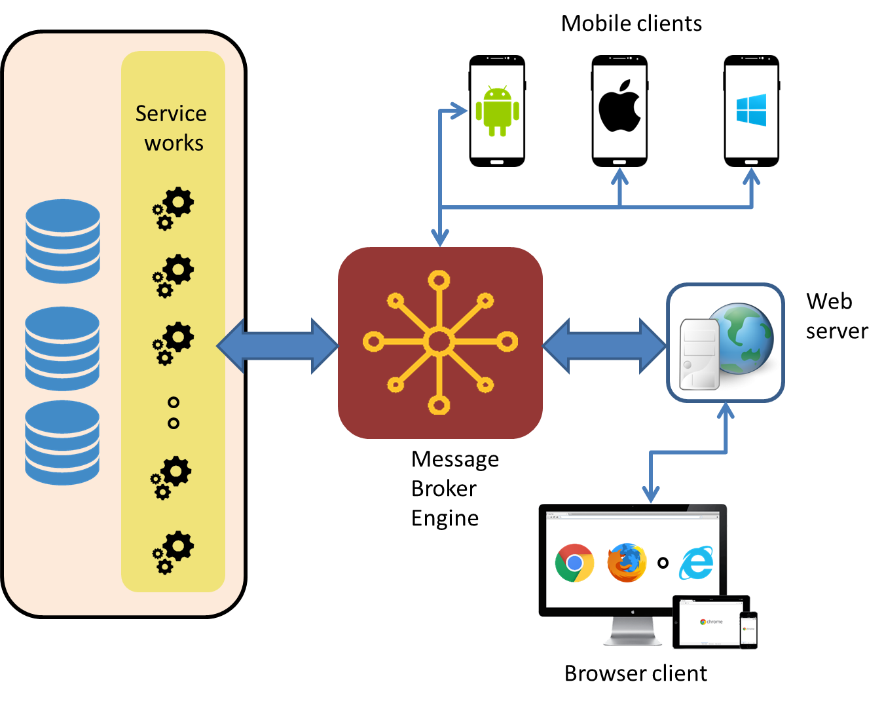
Figure 1: Architecture plan

The first phases will focus only on minimum viable product (MVP) with basic and initial UX and meeting acceptable performance benchmarks as set by Google and open source benchmarking tools available in the industry. To help reduce future rework SOA architecture needs development in the initial phase. Possible middleware candidates for SOA are Kafka and RabbitMQ.
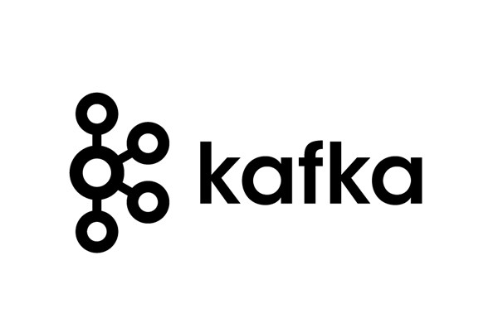
Credential information will use a MySQL DB and the rest of the info like job, profile, employer, and location data etc. all that must meet expanding future requirement will use MongoDB.

To facilitate rapid development, python (3~) Django platform will be used for server side programming. Since Django provides built in support of admin panels and dashboard this will expedite quick development into a fully maintainable site.


Front-end plan
A total of 8 page-templates in plan (as of April 30, 2017)
- Main page
- Search result page
- Job details page
- Candidate details page
- Job creation page
- Register/login page
- Candidate profile creation page (all steps 1,2,3 as one)
- Employer details page
Map layout on search results will be visible and this will use Google API.

Back end development
- Account Creating, Password Recover:
  - Sign up form, verification by mobile or email.
  - Login
  - Facebook login (Phase 2)
  - Google login (Phase 2)
  - Forgot Password
  - MySQL Database
- Profile Management:
  - DB plan design and dev: MongoDB
  - Peoples’ Profile
  - Company Profile
  - Job Profile
  - Others
- Searching facility:
  - Job category based
  - Location based
  - Employee search
  - Job Search
  - Employer search

Performance plan:

Open-source web page tester (https://www.webpagetest.org/)
- For TTFB < 200ms
- Compressed data transfer,
- Image compression all image
- static content caching
- Use separate media server for faster media delivery
- Use Bangladeshi CDN for minimum latency.

Google Page evaluation (https://developers.google.com/speed/pagespeed/insights/)
- Mobile 80/100 (bdjobs.com at 74/10)
- Desktop 85/100 (bikroy.com at 85/100)
- Average TTFB < 200ms
- Average DOMLoading < 3sec
- Maximum Page Loading time < 7 sec

Others Comments
- Mobile first design
- Bot filtering by captcha
- Privacy option for both employer and candidates.
- High level outline of requirements
- Will allow anonymous browsing for resume
- Will allow anonymous uploading of CV with just name and
- Responsive front end
- Assuming coverage area Bangladesh only
- Auto keyword generation and indexing from uploaded resume in phase 3
- Bulk download of data of list is not allowed to anonymous users. It can become allowable to paid/verified/premium category of users.

Development Plan
Development methodology will adopt agile methodology. Each cycle will complete in exactly 2 weeks (10 working days). At the end of each cycle, developing team will release a working software version. The platform planner team, UX designer team and the developer team will meet, run the software, test and provide their feedbacks vice versa. In the next cycle, each team updates their development plan within acceptable range of change.

Phase 1
Duration: Total 6 weeks for development and 1 week for final deployment. This phase shall develop a minimum viable product (MVP) with basic and initial UX. However, this phase will lay foundation of middleware to support SOA. Support front end plan as of April 30, 2017

Deliverables:
At the end of this phase, customer will receive a fully deployed functional website with acceptable performance and user experience. Basic hosting choice will be governed by emphasis on performance and minimal latency. It will satisfy use cases as described in the use case section update as of April 30, 2017

Phase 2
Phase 2 will comprise of optimization and performance targets as detailed in the solution description.

Deliverables:
Optimized performance tuned site.

Phase N
Phase 1 and Phase 2 will help decide goals and expectation from the next phases. The next required features can be mobile version for master push notification to job hunters or service providers who love to receive job alert or service request and respond instantly. The evolved user stories and learning from utilization gathered from 360 degrees of users all together will help guide design and development. Hence prior to this next phase it will be important to have a solid planning session.

Hardware/Hosting Plan
Here is a list of possible cloud plans. We have to choose one that fits best and also economical.
Table 1: Cloud hosting plans
Cloud Provider | DC location | Latency (ms) | Starter description | Starter price  (USD) | Mobile app ext. (with Redis) | Mobile app ext. price (USD) | Total expense (USD/mo)
AWS  (Amazon Inc.) | Singapore | 83 | EC2- small, EBS, Transfer 20TB, 0.12$/GB | $16.84 | 0.022/hr for a cache.t2.micro, goes lower ($0.009/hr) with 3 year term | $15.84 | $32.68
Godaddy  (Godaddy Inc.) | Singapore | 80 | 1 GB memory, 1 core, 30GB SSD, 2TB Transfer | $14.99 | 512 MB memory 1 CPU 20GB SSD 1TB transfer | $5.00 | $19.99
Azure (Microsoft) | Chennai | 110 | 1 core, 20 GB Disk, $0.018/hr, 0.75GB memory | $13.39 | 250MB, $0.022/hr | $16.37 | $29.76
Azure (Microsoft) | Singapore | 88 | 1 core, 20 GB Disk, $0.018/hr, 0.75GB memory | $13.39 | 250MB, $0.022/hr | $16.37 | $29.76
GCP  (Google Inc.) | Singapore | ?? | 1 shared vCPU .6 GB memory 10 GB disk | $4.28 | 0.6 GB memory, 10 GB disk | $4.28 | $8.56

Collaboration Plan

All issues to be reported on JIRA system at https://YourCompanyAtoZ-issues.atlassian.net/. YOURCOMPANYATOZ will provide access credential to XYZ team for raising issues as the development progresses.
Table 2: Collaboration plan
Tasks | Schedule | YOURCOMPANYATOZ | XYZ
Host dev-site and develop | ongoing basis | y
Build and release | every Thursday | y
Run Build Verification Tests (BVT) | every Sunday morning | y
Functional testing and reporting on JIRA | every Sunday morning | y | y
Full testing for QA check (Black box) | every alternate Sunday | y | y
Summary and discussion | every alternate Sunday | y | y
provide feedback on UI and functionality | as per need | y | y
use case testing | as per need | y | y
User data population (job, hr employer, candidates etc.) | as per need |  | y

Project Schedule
Phase 1 will take a total of 6 weeks from the day of start. Calculated Man-month = 8.5/4 = 2.123. Excluding front end development it will become
Table 3: Phase 1 Schedule
 |  | Week
SL | Deliverable | 1 |  | 2 |  | 3 |  | 4 |  | 5 |  | Man-week
1 | Front end development* | - | - | - | - | - |  |  |  |  |  | 2.5
2 | Profile management |  | - | - | - |  |  |  |  |  |  | 1.5
3 | Account management |  |  |  | - | - | - |  |  |  |  | 1.5
4 | Search facility |  |  |  |  | - | - | - | - |  |  | 2.0
5 | Deployment and final release |  |  |  |  |  |  |  | - | - |  | 1.0
 | Total duration | 1.5 |  | 2.5 |  | 2.5 |  | 1.5 |  | 0.5 |  | 8.5
* Assuming that front end PSD to HTML conversion will done by XYZ team

Budgetary Price
Excluding front end development (2.5 man-week) total time plan = 6 weeks. Following table shows development expense. In addition, based on requirement as it reveals during project development YOURCOMPANYATOZ will help XYZ choose the appropriate cloud hosting. That expense is not included here.
Table 4: Expense Breakup for Development
SL | Deliverable | Expense | Comment
1 | UI design | xxxxx
2 | Front end development (PSD wireframe to HTML transfer) | xxxxx
3 | Django back-end development | xxxxx
4 | Database design (MySQL and MongoDB) | xxxxx
6 | Setting up middleware (Rabbit MQ) | xxxxx
7 | UI integration ( HTML clean up and optimization) | xxxxx
 | Total | xxxxx

Note: Price is excluding of any Tax, VAT and other levies.

Appendix

Contact information

Contact Person Name: Md Naqib Imtiaz Hussain
Email: naqib@YourCompanyAtoZ.co
Mobile: +8801817181156

YOURCOMPANYATOZ Limited
7-D, Commercial Plot # 2342, 6345 343ingh Lane, Upper Serangun, Dhaka, Bangladesh
Email: naqib@YourCompanyAtoZ.co
Web : www.YourCompanyAtoZ.co

