Sample Website - User Interface Analysis

Author: Al Amin Hossain Nayem

Date: May 26, 2025

# Table of Contents

1. Introduction  
2. Website Structure Overview  
3. Screenshots  
4. User Interface Analysis  
5. Conclusions & Recommendations

# Introduction

This report presents the analysis of a sample website designed and implemented as part of an assignment on user interface (UI) evaluation. The website consists of multiple sections including Home, About, Products (with subpages), and Contact. The main objectives are to demonstrate menu navigation, multi-level menu structure, feedback, and error handling using modern web technologies: HTML, CSS, and JavaScript.

# Website Structure Overview

The website features a top navigation bar with the following structure:

- Home  
- About  
- Products  
 - Product 1  
 - Product 2  
- Contact  
  
Each section is accessible via the menu. The 'Products' section contains a submenu with two items, illustrating menu depth.

# Screenshots

Below are screenshots of the website's main sections:

## Home Page

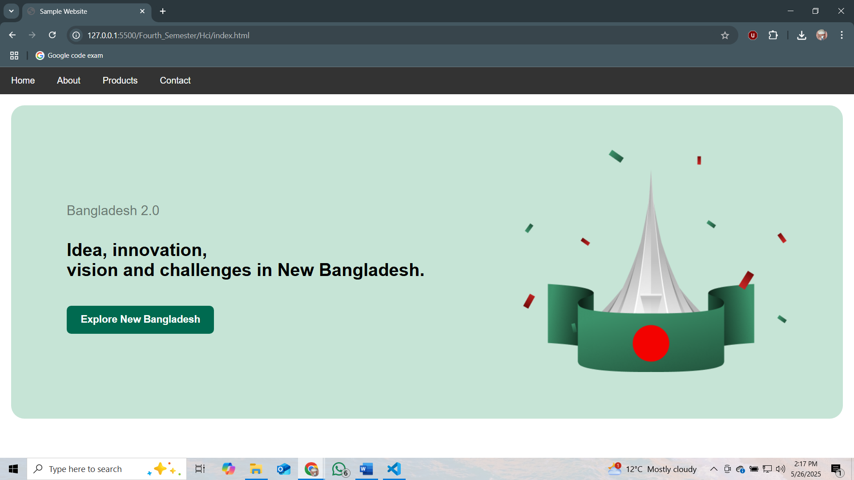

Home Page view.

## About Page

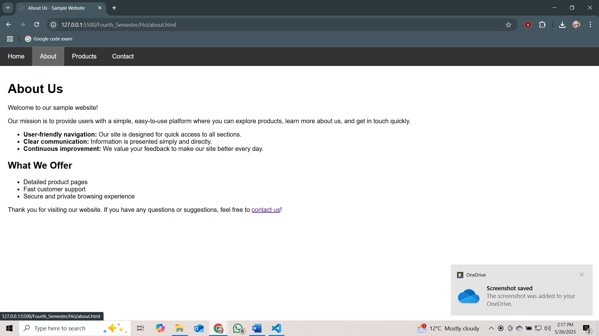

About Page view.

## Products Menu Dropdown

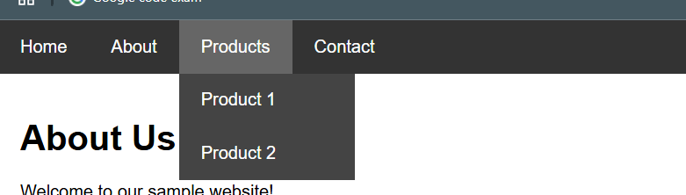

Products Menu Dropdown view.

## Product 1 Page

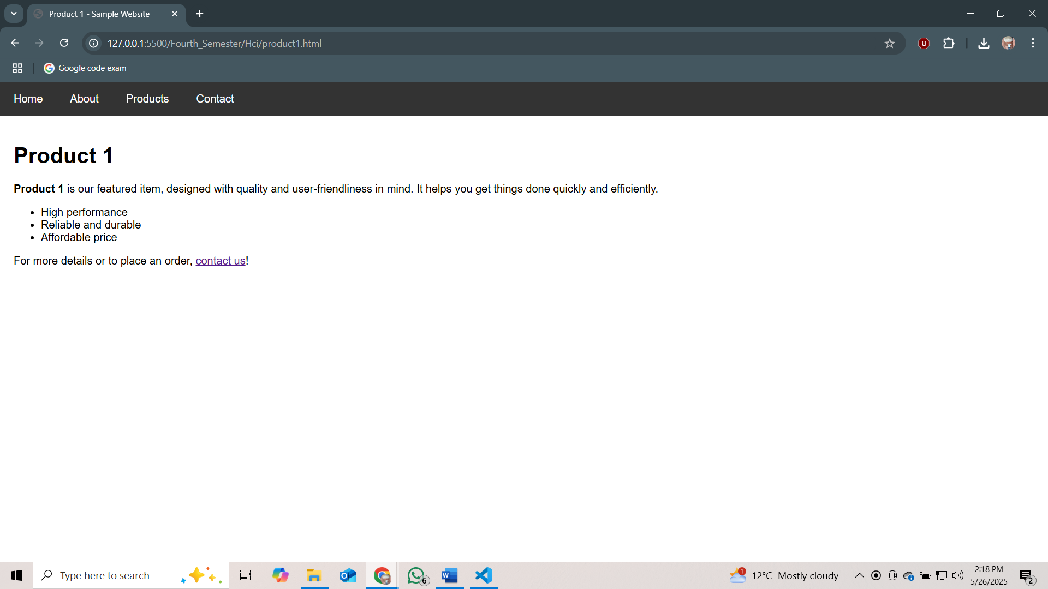

Product 1 Page view.

## Contact Page

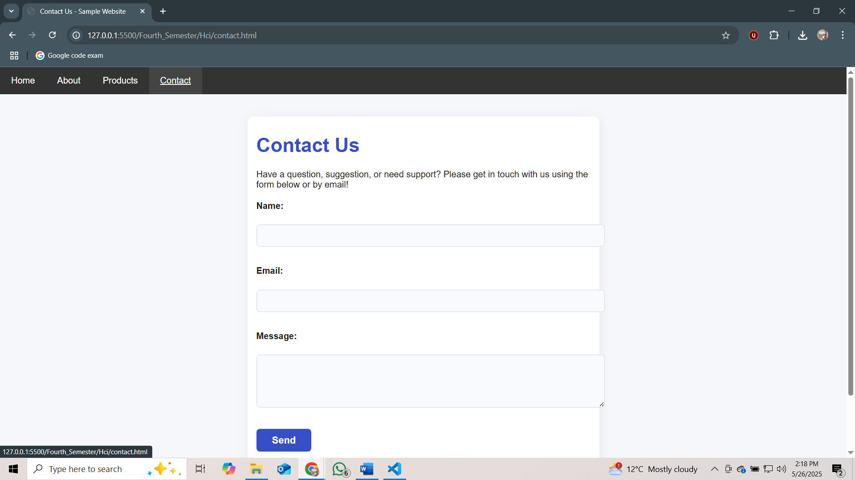

Contact Page view.

## Contact Form Error Example

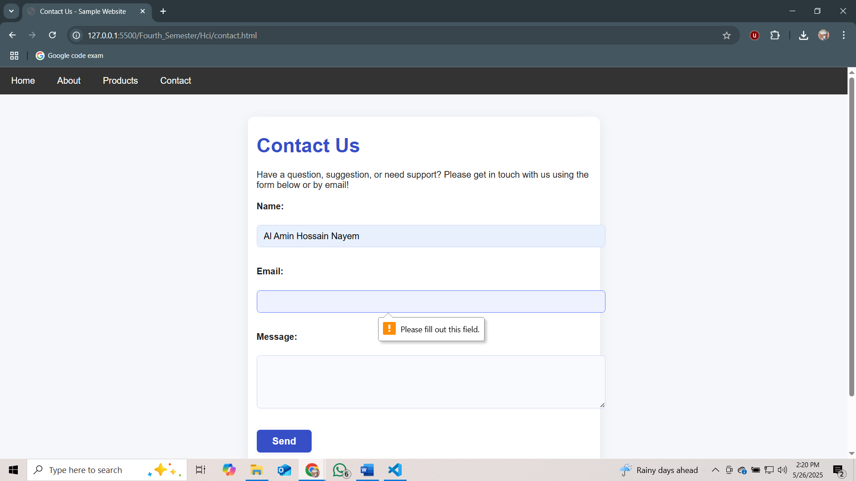

Screenshot showing the required field error validation when submitting the contact form without filling all mandatory fields.

# User Interface Analysis

## 1. Menu Navigation

The navigation bar is present at the top of each page, allowing users to easily move between the Home, About, Products, and Contact sections. Hovering over 'Products' reveals a submenu for deeper navigation.

Strengths: Simple and always visible. Submenu works smoothly.

Weakness: On small screens, menu may be hard to use (no hamburger menu).

Proposed Solution: Implement a responsive hamburger menu for mobile users.

## 2. Menu Depth

The 'Products' menu item contains two subpages, demonstrating at least two menu levels. The depth is appropriate for the site's size.

Strength: Clear two-level navigation; not too deep.

Weakness: Too much depth could confuse users.

Proposed Solution: Limit submenu nesting to two levels.

## 3. Grouping

Related items, such as products, are grouped logically under a single dropdown.

Strength: Keeps menu tidy and organized.

## 4. Feedback

Menu items provide visual feedback on hover. The contact form gives immediate feedback if required fields are not filled, as shown in the error screenshot.

Strength: Hover and error feedback help user navigation.

Proposed Solution: Add feedback for successful form submission.

## 5. Control Clarity

Navigation and form controls are clear and easily distinguishable. Labels and buttons are visible and appropriately sized.

## 6. Ability to Correct User Errors

Form validation ensures users cannot submit until required fields are filled. The error tooltip clearly explains the issue.

Strength: Prevents incomplete submissions.

Proposed Solution: Add a user-friendly error message on the page itself, not just as a tooltip.

## 7. Compatibility of Colors and Components

Color scheme is consistent across the site, with dark navigation and light content areas. Components (menus, buttons, forms) match the overall aesthetic.

Proposed Solution: Check contrast ratios to improve accessibility for visually impaired users.

## 8. Use of Appropriate Icons

No icons were used in the navigation bar or content. Icons could improve usability.

Proposed Solution: Add small icons for menu items (e.g., home, info, products, contact) to enhance visual cues.

## 9. Use of Hotkeys

No hotkeys have been implemented for navigation or form controls.

Proposed Solution: Add access keys for main menu items to improve accessibility.

## 10. Mouse Cursor Interaction

The mouse cursor changes to a pointer over all clickable elements, making interaction intuitive.

Strength: Standard practice helps guide users.

# Conclusions & Recommendations

The website provides a user-friendly experience with clear navigation, well-organized menus, and effective feedback on user actions. Some improvements are recommended: making the navigation responsive for mobile, adding user-friendly on-page error messages, using icons, implementing hotkeys, and ensuring color accessibility. Overall, the site meets the assignment requirements for demonstrating menu depth, usability, error handling, and basic web design best practices.