Lab Work 4 : IP

1. Select the first ICMP Echo Request message sent by your computer, and expand the Internet Protocol part of the packet in the packet details window. What is the IP address of your computer?

Ans .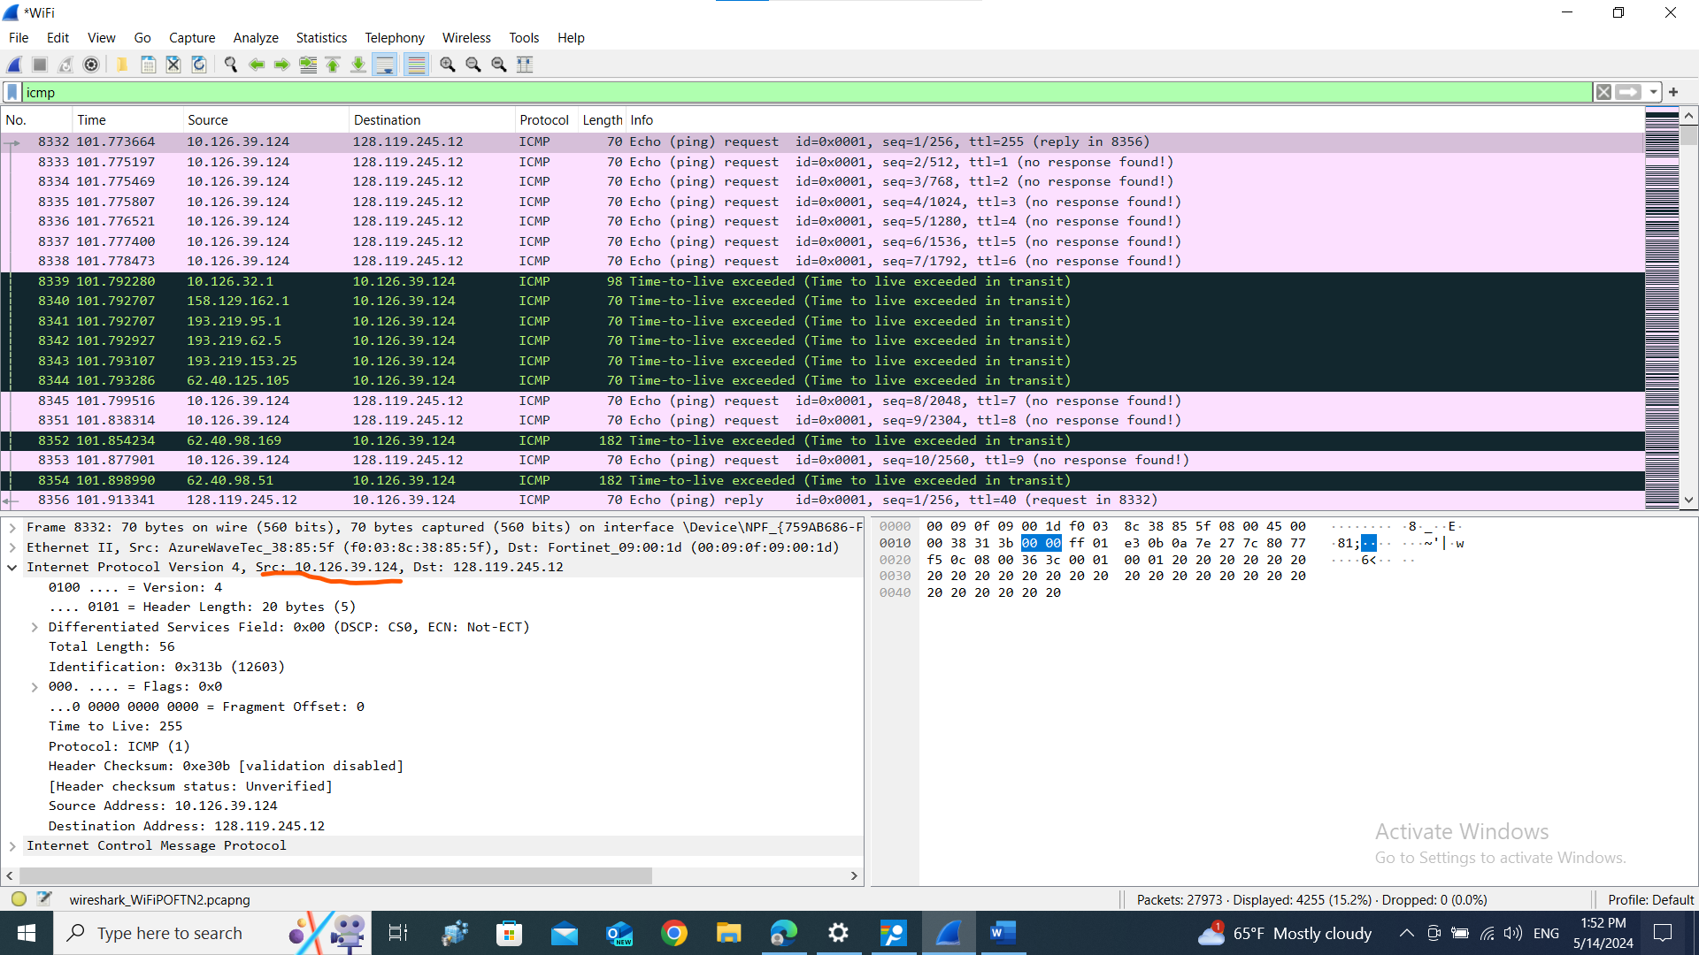

1. Within the IP packet header, what is the value in the upper layer protocol field?

Ans. ICMP(1)

1. How many bytes are in the IP header? How many bytes are in the payload of the IP datagram? Explain how you determined the number of payload bytes.

Ans. Header length : 20;

Total length : 56;

payload bytes : 56-20;

=36

1. Has this IP datagram been fragmented? Explain how you determined whether or not the datagram has been fragmented.A screenshot of a computer

   Description automatically generated
2. Which fields in the IP datagram always change from one datagram to the next within this series of ICMP messages sent by your computer?

Ans. I) identification

ii) header Checksum

iii)Time to Live

1. Which fields stay constant? Which of the fields must stay constant? Which fields must change? Why?

Ans. Not change : i)version

ii)header length

iii)flag

iv)fragmentation of set

change : I) identification

ii) header Checksum

iii)Time to Live

1. Describe the pattern you see in the values in the Identification field of the IP datagram?

Ans. I can see a incrementing pattern.

1. What is the value in the Identification field and the TTL field?A screenshot of a computer

   Description automatically generated
2. Do these values remain unchanged for all of the ICMP TTL-exceeded replies sent to your computer by the nearest (first hop) router? Why?

Ans. Identification field is changing and TTL is decreasing

1. Find the first ICMP Echo Request message that was sent by your computer after you changed the Packet Size in pingplotter to be 2000. Has that message been fragmented across more than one IP datagram?A screenshot of a computer

   Description automatically generated
2. Print out the first fragment of the fragmented IP datagram. What information in the IP header indicates that the datagram been fragmented? What information in the IP header indicates whether this is the first fragment versus a latter fragment? How long is this IP datagram?A screenshot of a computer

   Description automatically generated
3. Print out the second fragment of the fragmented IP datagram. What information in the IP header indicates that this is not the first datagram fragment? Are the more fragments? How can you tell?A screenshot of a computer

   Description automatically generatedA screenshot of a computer

   Description automatically generated
4. What fields change in the IP header between the first and second fragment?

Ans. More fragments fields are changed.

1. How many fragments were created from the original datagram?

Ans. 3 fragments

1. What fields change in the IP header among the fragments?

Ans. More fragments and fragment offset field.

