1. When run the code the main window will pop up and it will look like this.

Here I can only use character as password and the threads is fixed and that is 3.

1. When I enter password and clicked encrypt password button it will encrypt the password and that text we can see in the 3rd text box.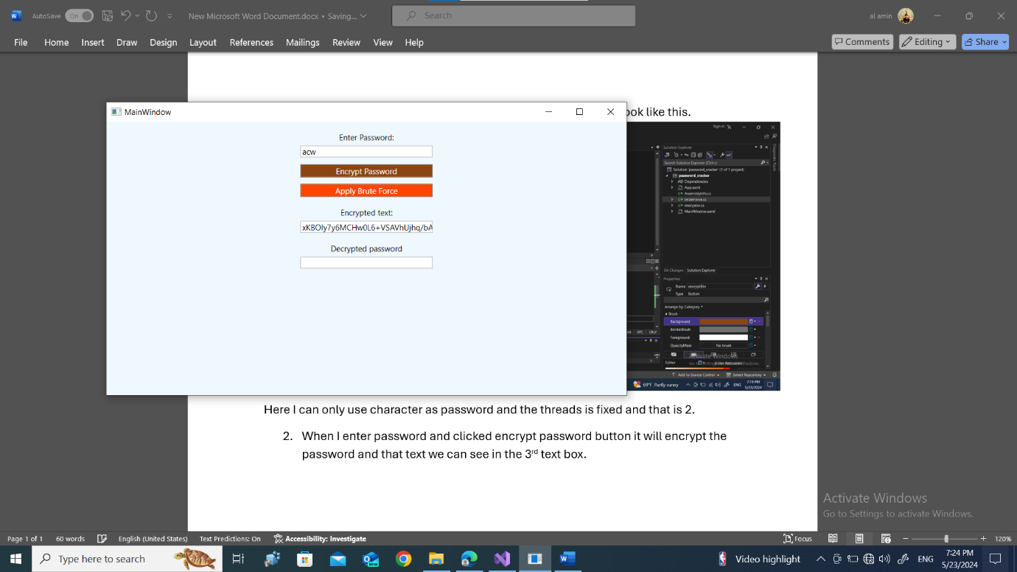
2. Now if I clicked in the apply brute force button it will take the text from the 2nd textbox and apply brute force method to crack the password. And the result will be shown in the last textbox.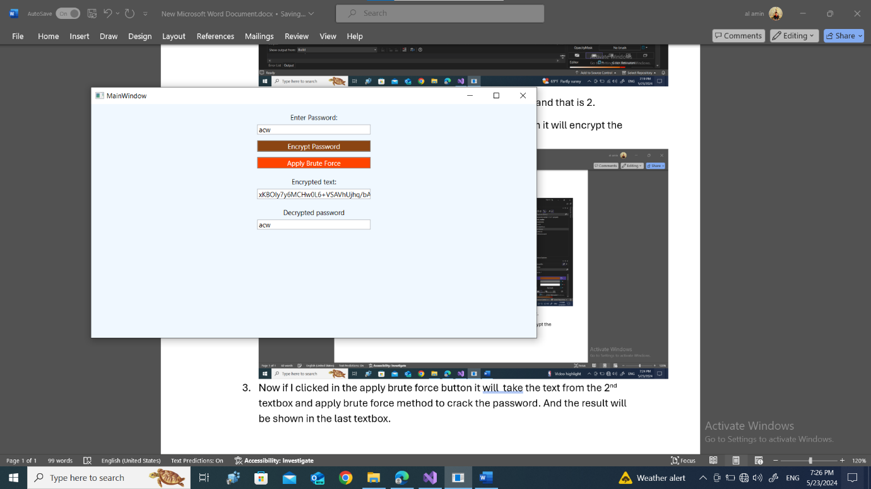
3. For encryption I use sha256 hashing algorithm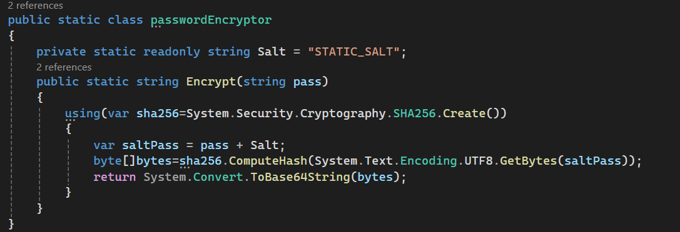

That’s all for my report. Thank you.