**Database Project Report**

**1. Objective**

The objective of this project was to:

1. Set up Microsoft SQL Server and SQL Server Management Studio (SSMS).
2. Restore the AdventureWorks sample database to understand its structure and relationships.
3. Create new tables with relationships, and develop a view combining data from these tables.
4. Populate the tables with sample data to verify the functionality of the relationships and view.

**2. Setup and Installation**

**2.1 Tools Installed**

* **Microsoft SQL Server (Developer Edition):** Used as the database engine.
* **SQL Server Management Studio (SSMS):** Used for database management and query execution.

**2.2 Sample Database**

* The **AdventureWorks sample database** was downloaded from GitHub and successfully restored using SSMS.

**3. Database Structure Analysis**

* The AdventureWorks database structure was analyzed to understand the relationships between tables.
* The **Database Diagram** tool in SSMS was used to generate a visual representation of table relationships.
* Additional resources and UML diagrams from the internet helped in comprehending the schema.

**4. Creation of New Tables**

**4.1 New Tables**

Two new tables, Customers and Orders, were designed to manage customer and order information. These tables were linked via a **foreign key** relationship, establishing a connection between a customer and their respective orders.

**5. View Creation**

A **view** named OrderSummary was created to combine and display information from the Customers and Orders tables. This view provided a unified summary of customer details along with their respective order information.

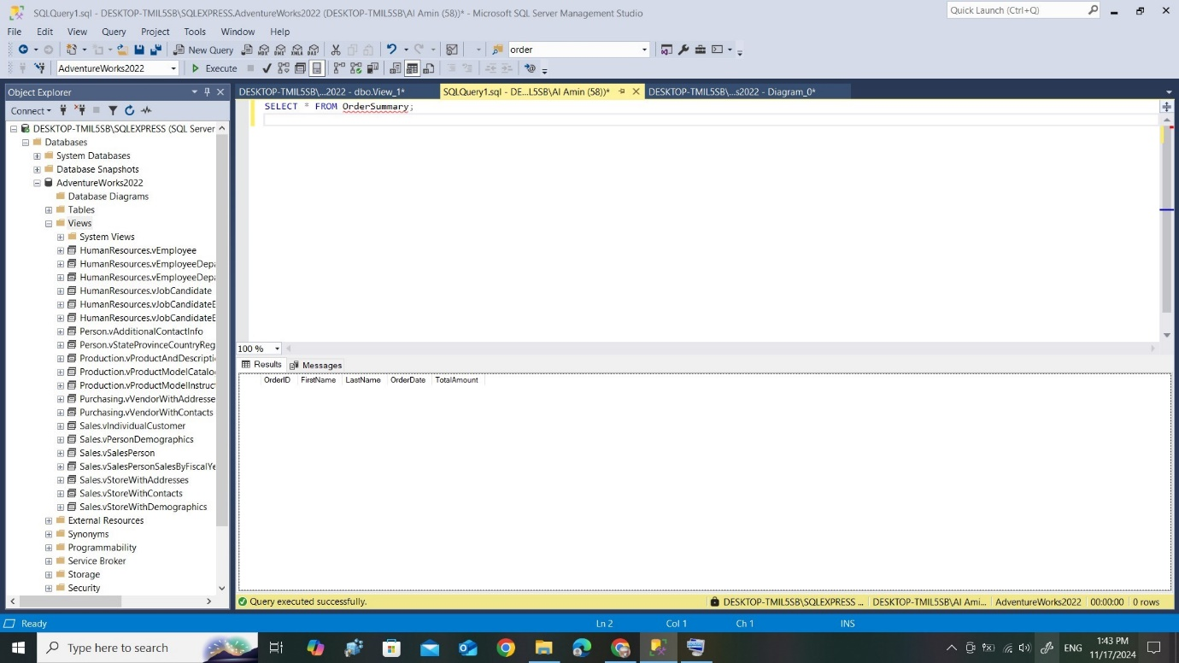

**6. Data Population**

**6.1 Data Inserted**

Sample data was inserted into the Customers and Orders tables to verify:

* The relationships between the tables.
* The functionality of the OrderSummary view.

**6.2 View Output**

The OrderSummary view dynamically displayed combined data from both tables, including customer names, order dates, and order amounts.

**7. Results**

1. **Successful Installation:** Microsoft SQL Server and SSMS were successfully installed and configured.
2. **Database Restoration:** The AdventureWorks sample database was restored and analyzed.
3. **Table Creation:** New tables with proper relationships were created.
4. **View Development:** The OrderSummary view provided real-time combined data.
5. **Functionality Validation:** Sample data insertion validated the relationships and view functionality.