- SELECT `name`, `surname`, `group` FROM student ORDER BY `group`, `surname`;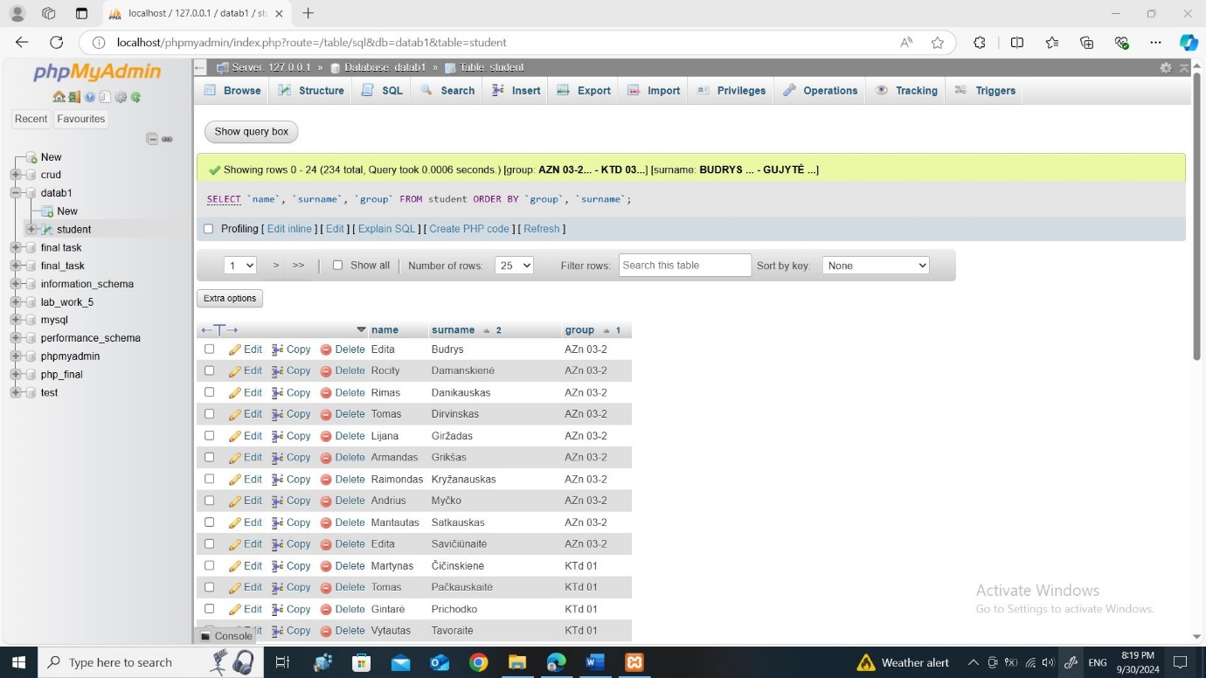
- SELECT COUNT(*) AS total_students FROM student;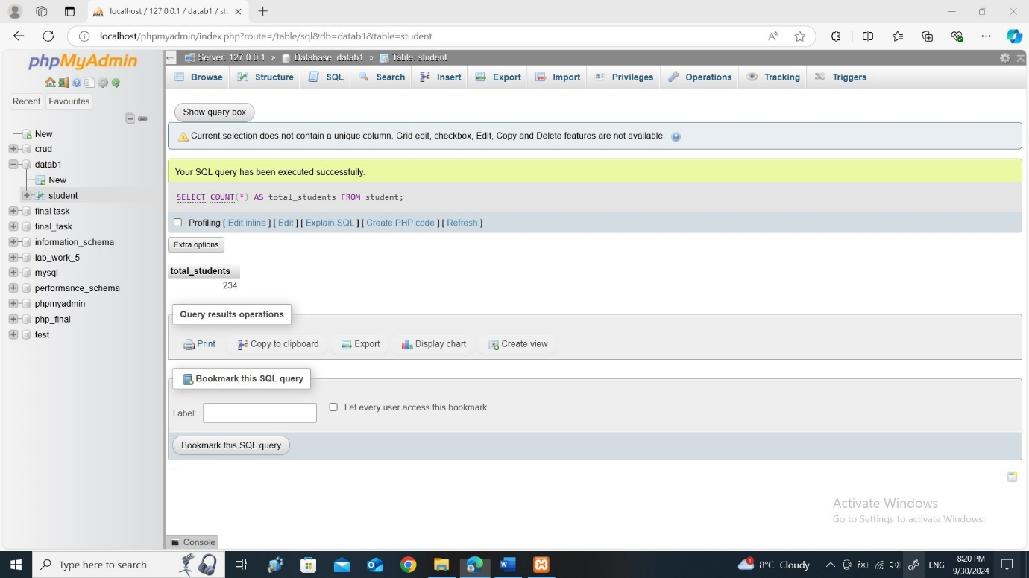
- SELECT `gen`, COUNT(*) AS count FROM student GROUP BY `gen`;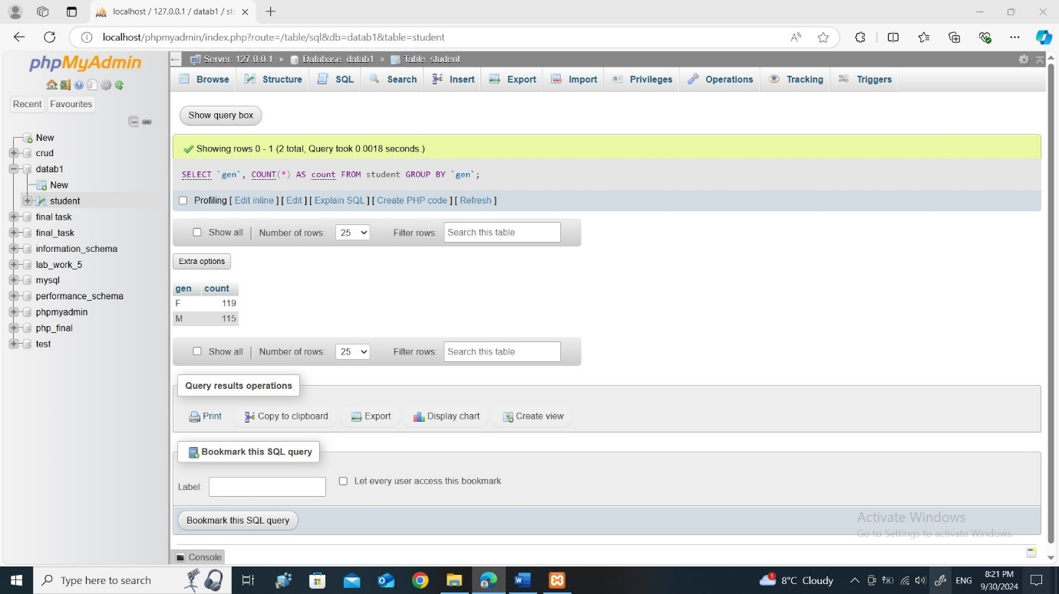
- SELECT city, COUNT(*) AS active_students FROM student WHERE status = 'active' GROUP BY city;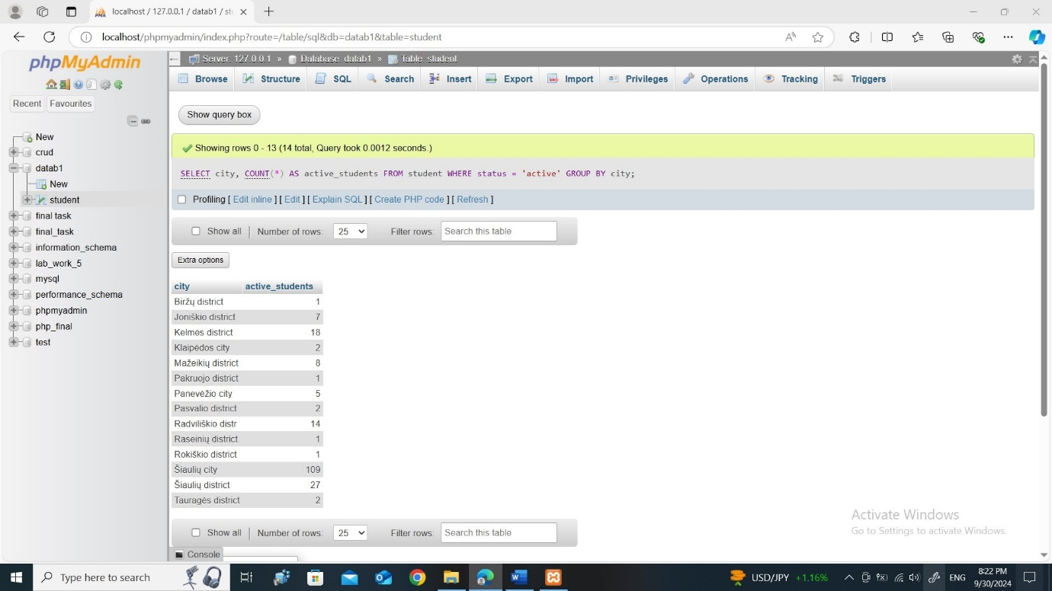
- SELECT DISTINCT `group` FROM student ORDER BY `group` DESC;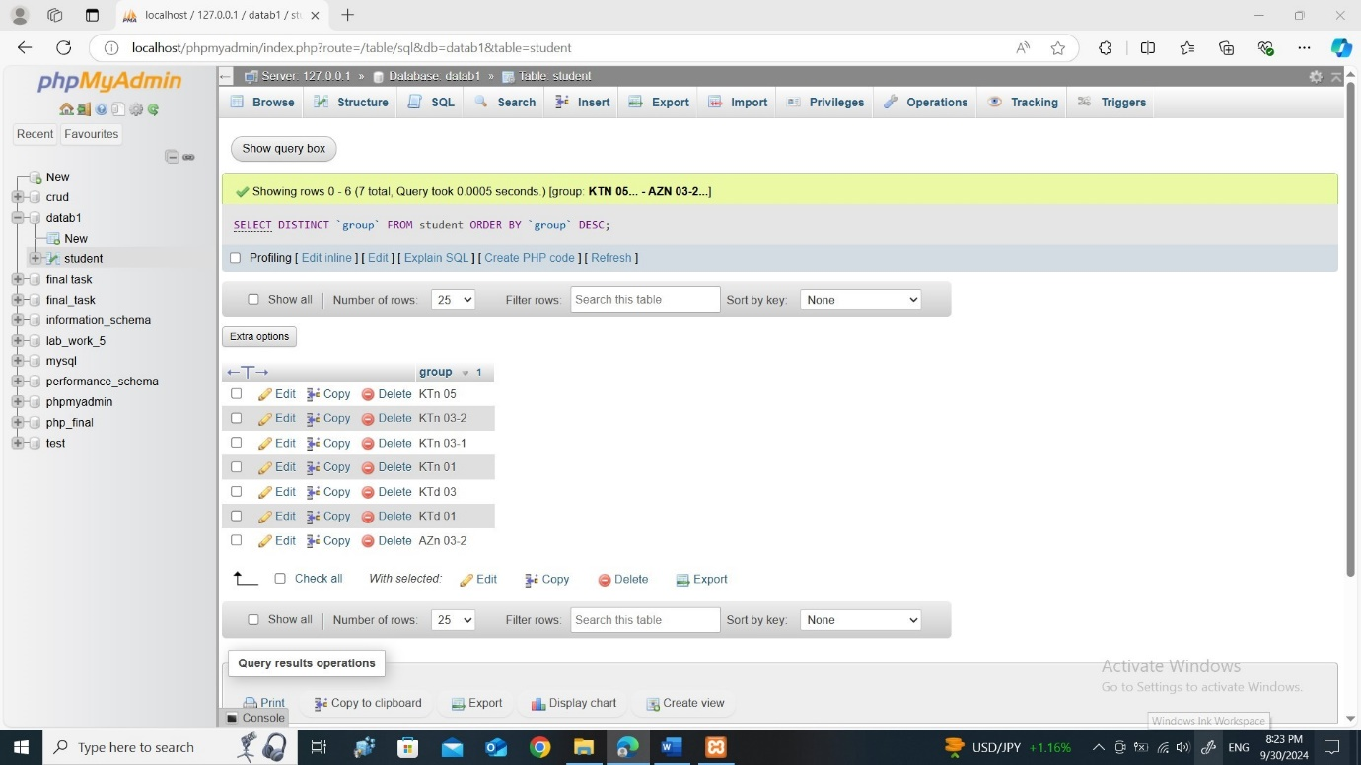
- SELECT name, surname, birthday FROM student WHERE birthday BETWEEN '1988-09-01' AND '1989-08-31';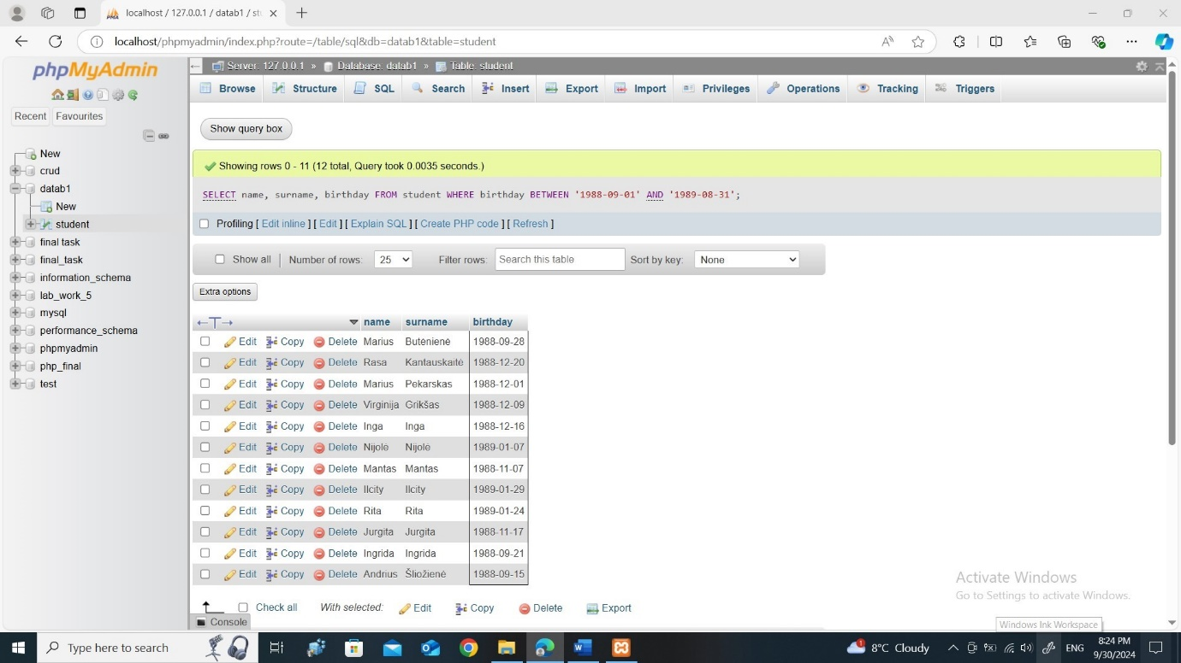
- SELECT name, surname, FLOOR(DATEDIFF(CURDATE(), birthday) / 365) AS age FROM student ORDER BY birthday ASC LIMIT 20;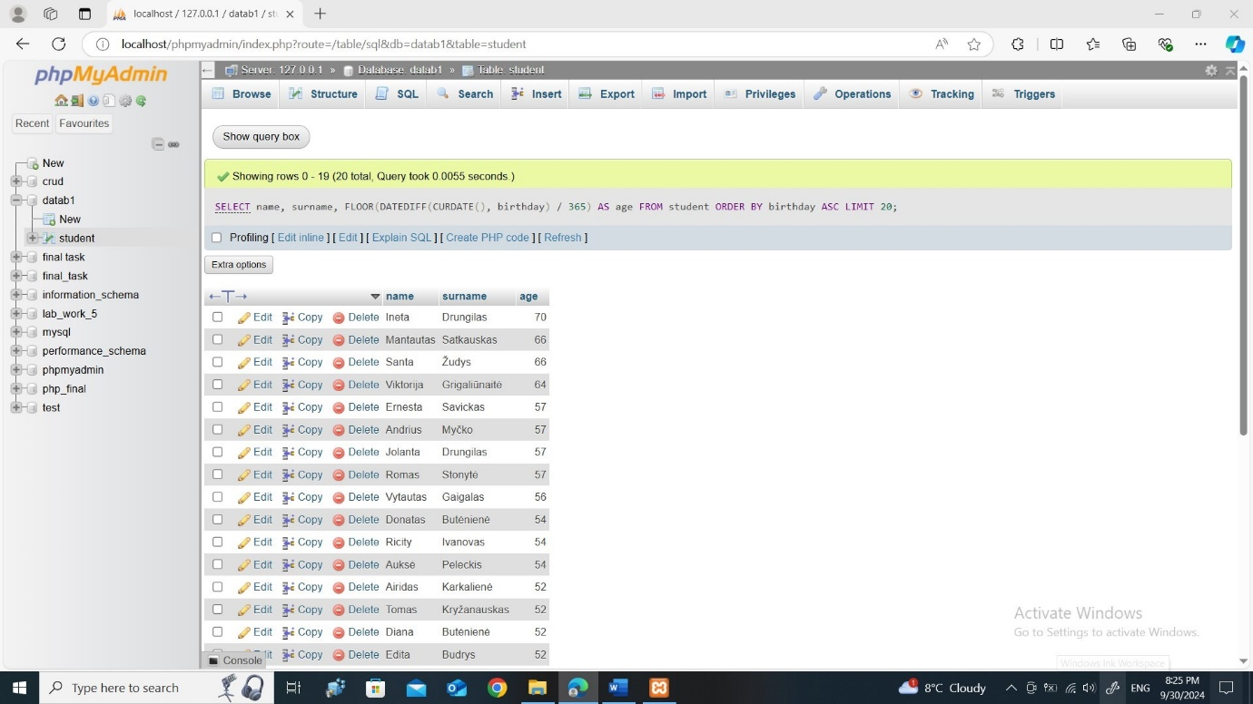

- SELECT city, COUNT(*) AS people_count FROM student GROUP BY city;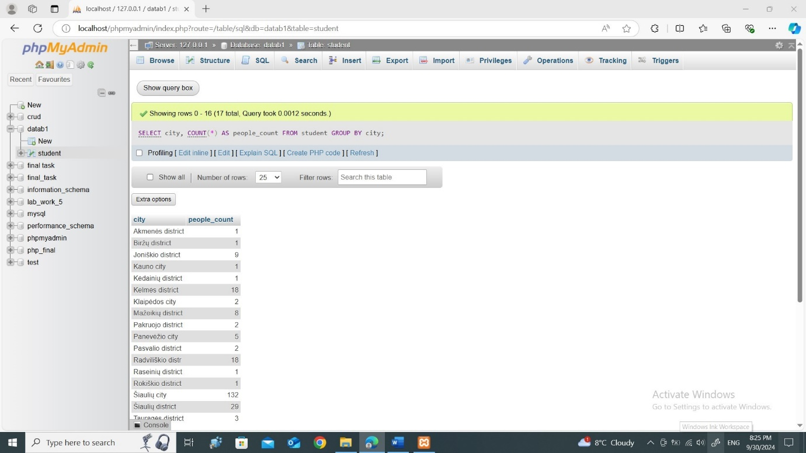
- SELECT COUNT(DISTINCT `group`) AS total_groups, COUNT(*) AS total_students FROM student;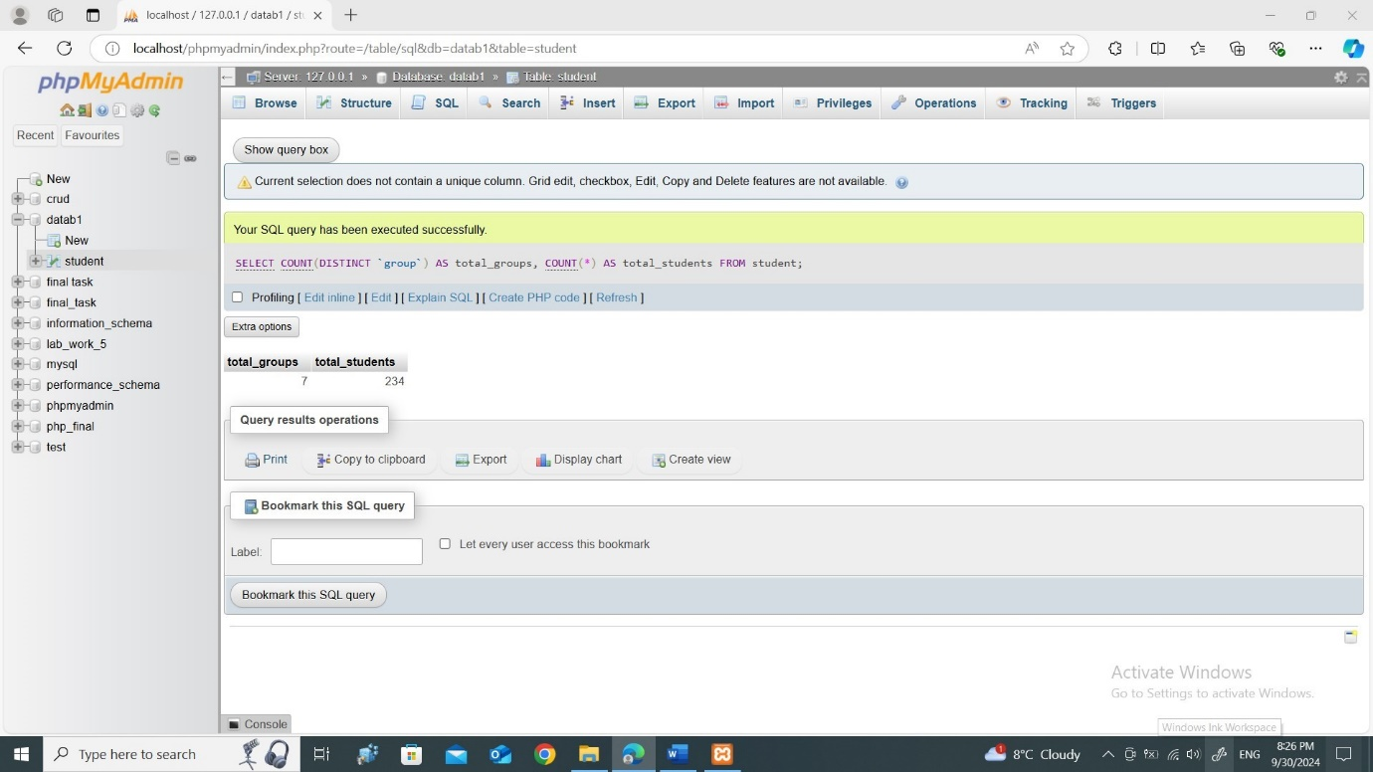
- SELECT status, COUNT(*) AS student_count FROM student GROUP BY status ORDER BY student_count DESC LIMIT 1;