CRUD
- First I create a database in mysql and the name of the database is lab_work_5. Inside the database I create a table name ‘userdata’ where I will save the user information.
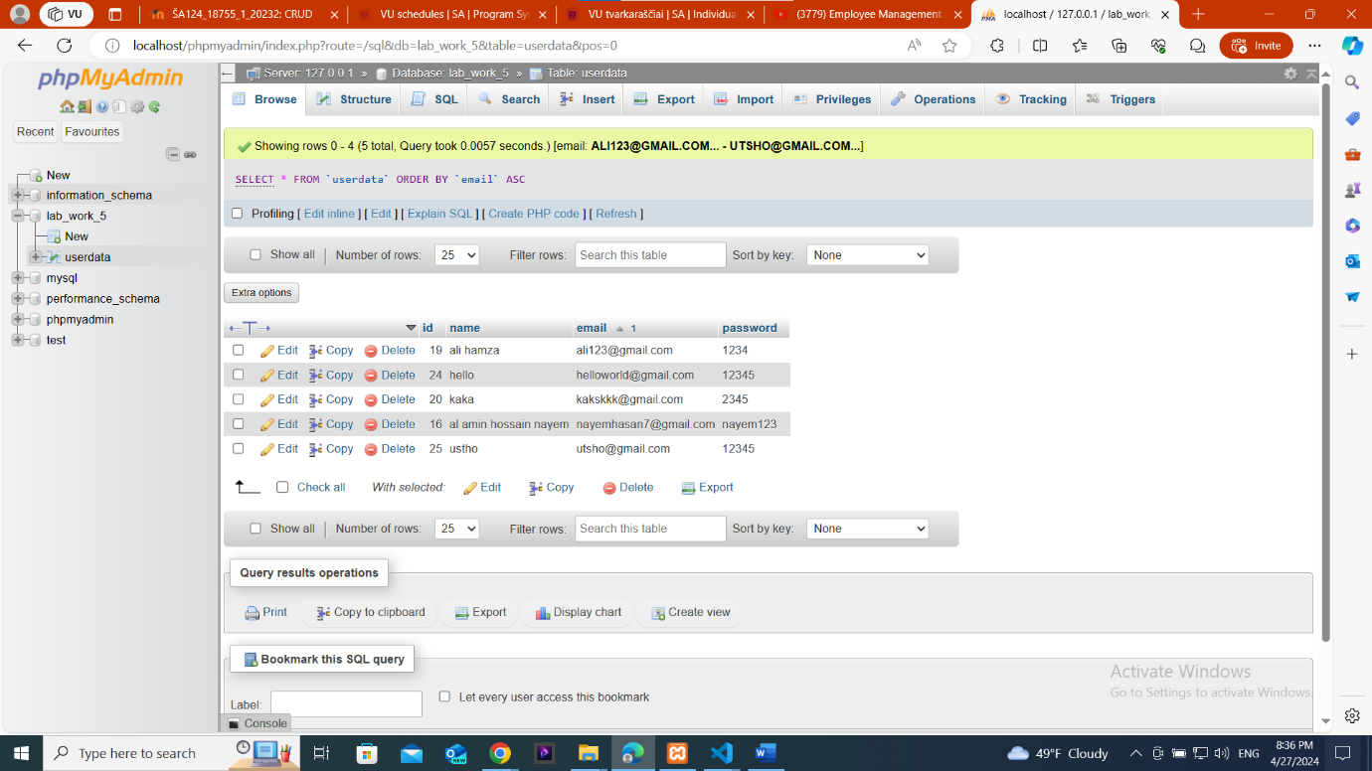
I create 4 row for (id,name,email,password).
- Then I created a sign up form for user to connect with the data base. Here I use some external source so that my sign up page look beautiful .
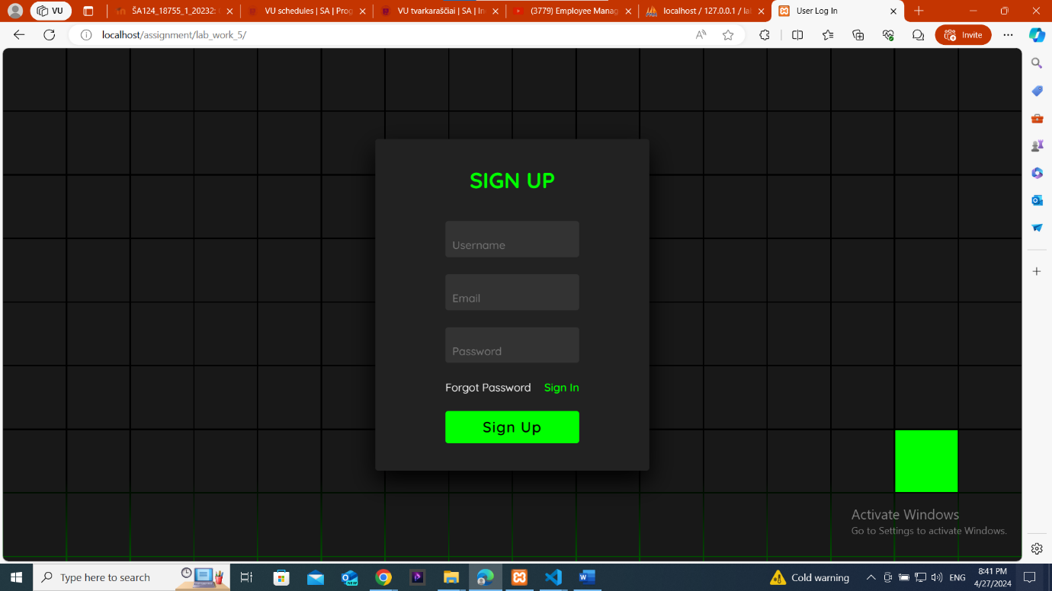
Here if I press the sign up button then it shows fill the form first like this picture below Also if I press the sign in button it automatically redirect me to the sign in page or log in page.
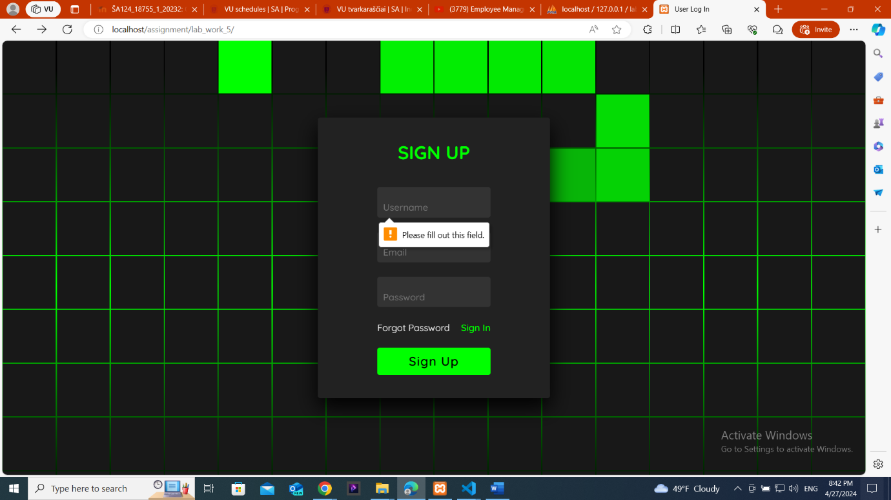
- When I fill the form and click the sign up button it’s shows a alert and submit this data into the data-base. When a new user came he/she had to sign up first . now I am filling a new user and store his information into the database.
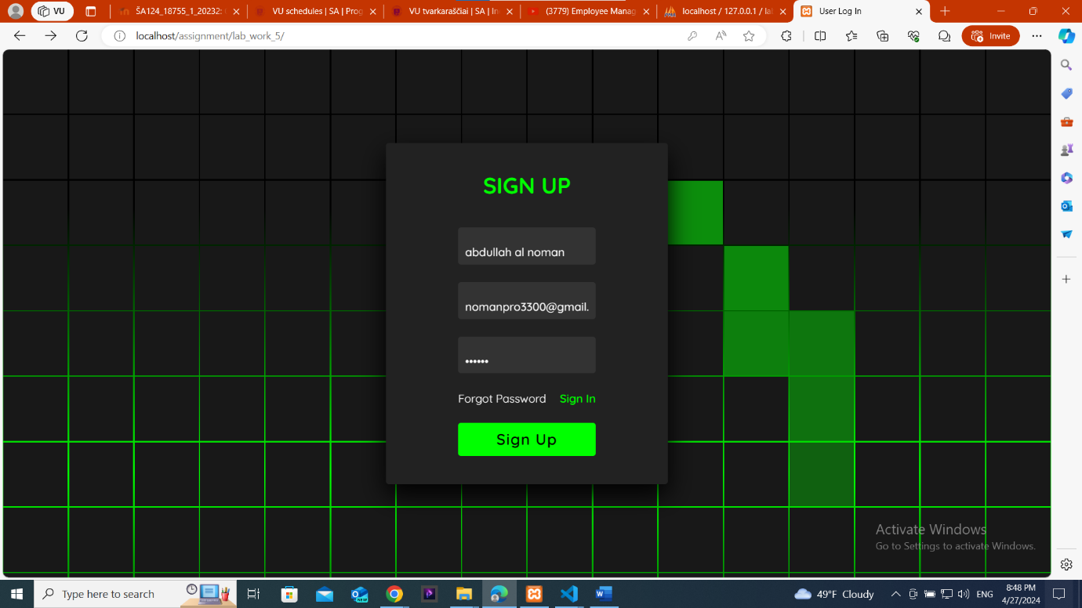
When I click in sign up it’s shows a alert.
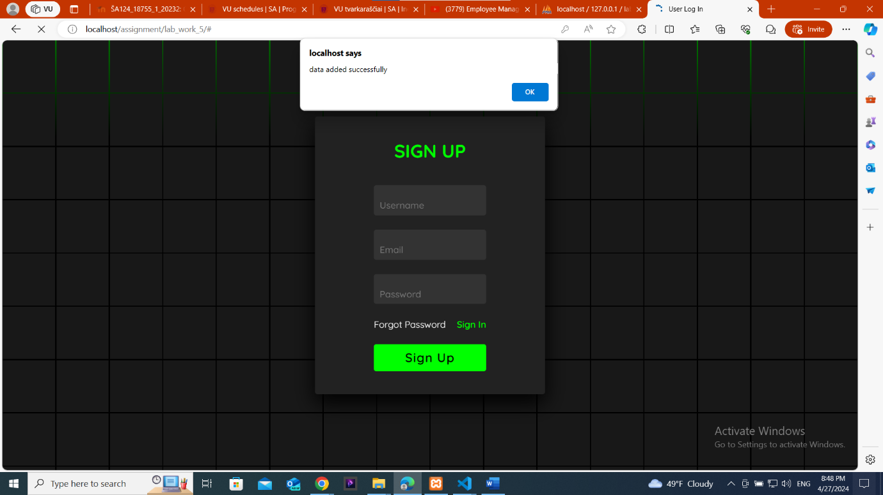

- After successful sign up I clicked the sign in button and went to a next page . when I put a user email and password it loged in his account. 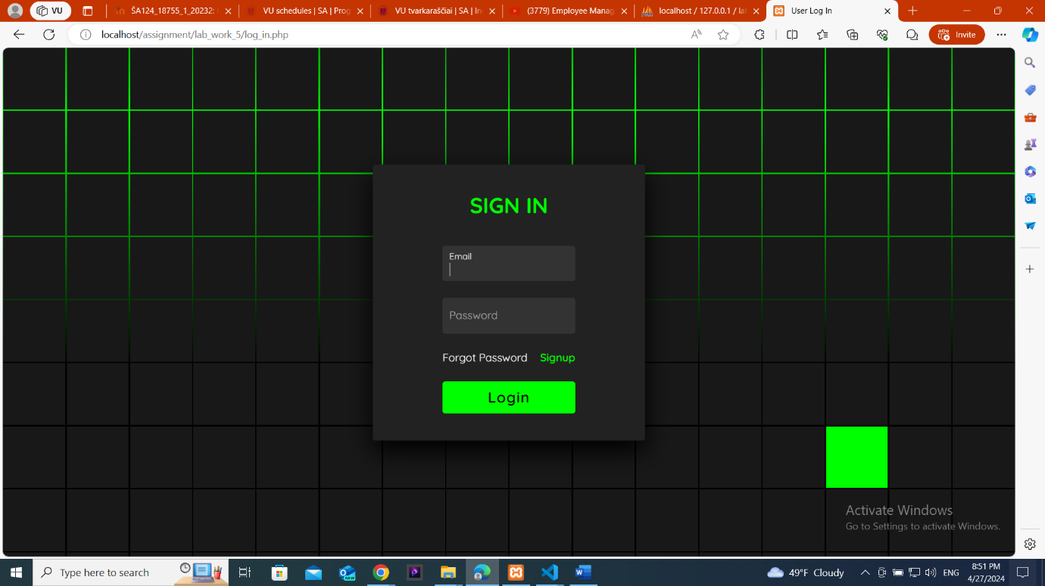

If the password didn’t match the database password it will through an error message.

If the password and email address matches then it will log in.
- When successfully loged into the account the email address of the user will be shown in the top corner of the page and all the user will be shown to him.
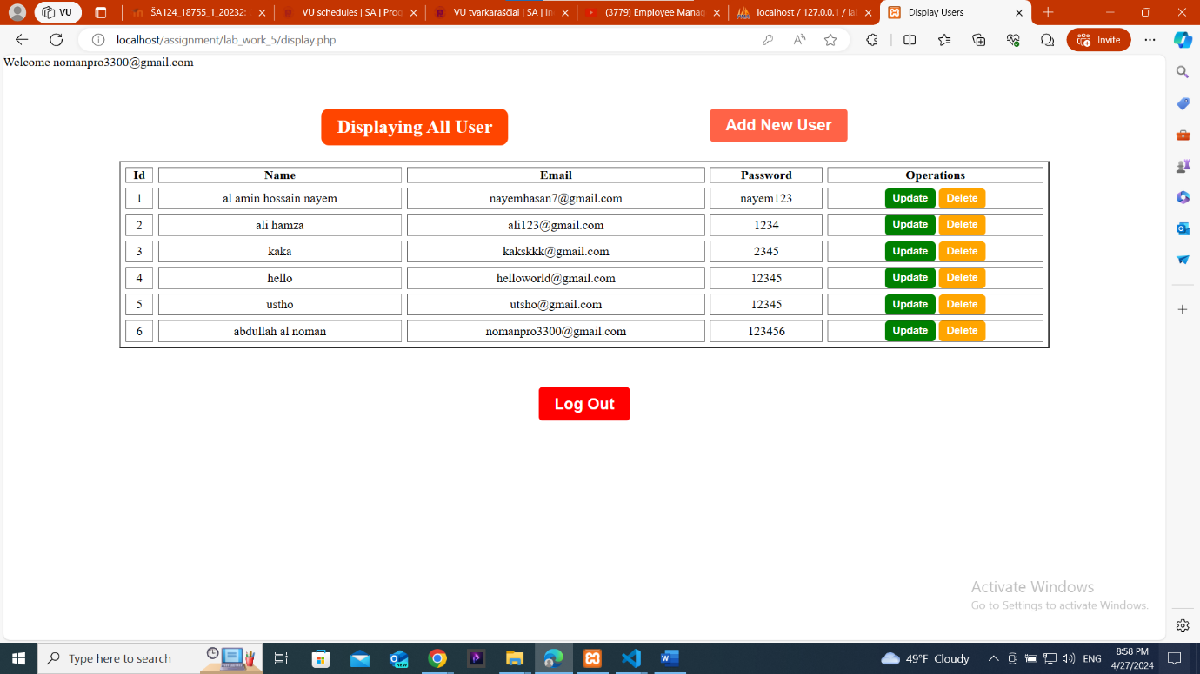
And also it store into the data base.
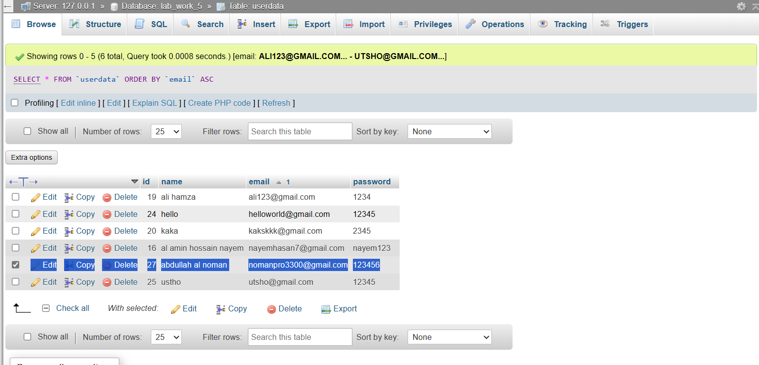
- When a user is loged in he can do CRUD(create,read,update,delete) in the database from the page and it’s also show which user is loged in now.
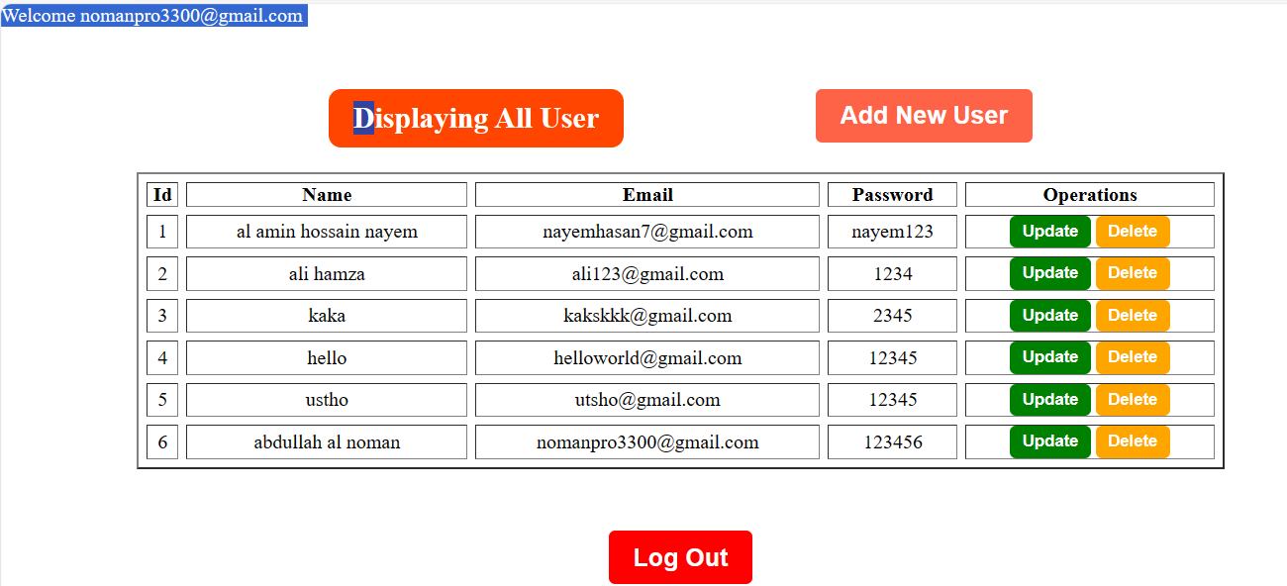
- If clicked in the update button it can be updated and if clicked in the delete button it will be deleted from the database and also from the display. 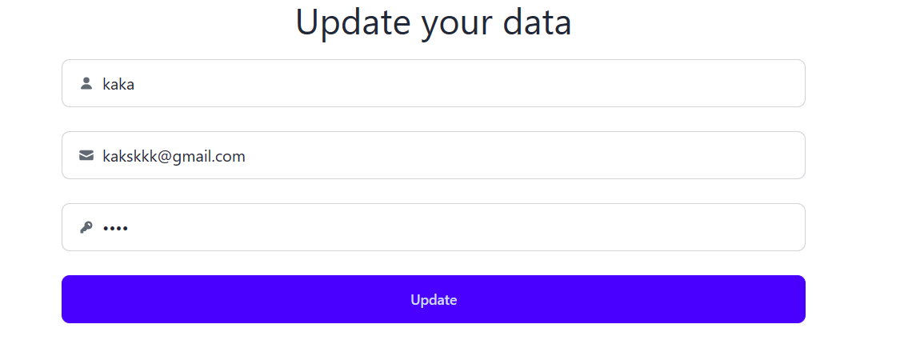
After clicking the update button it shows a alert.

Its updated from kaka to new user.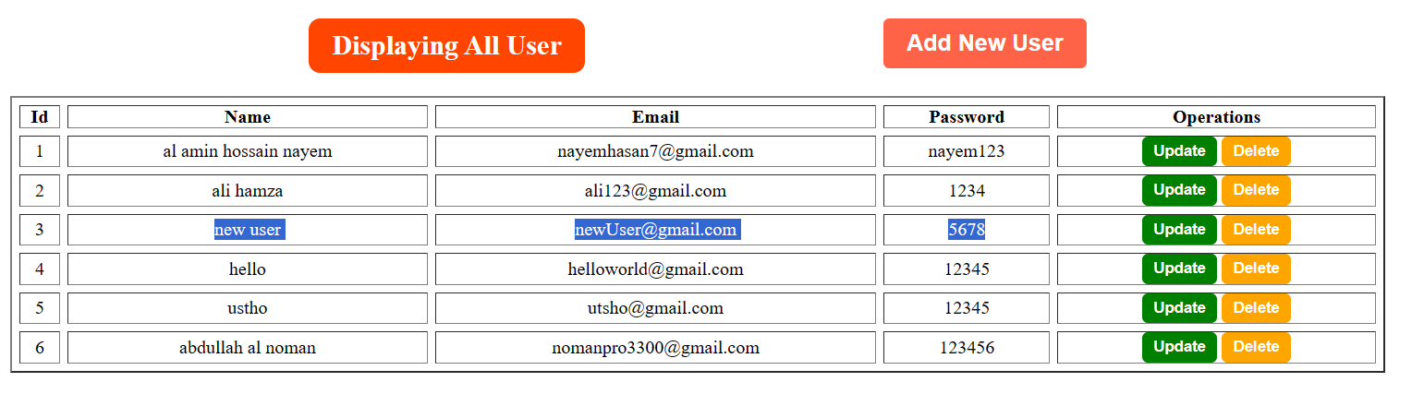
- When clicking the delete button it will ask a confirmation then delete it.
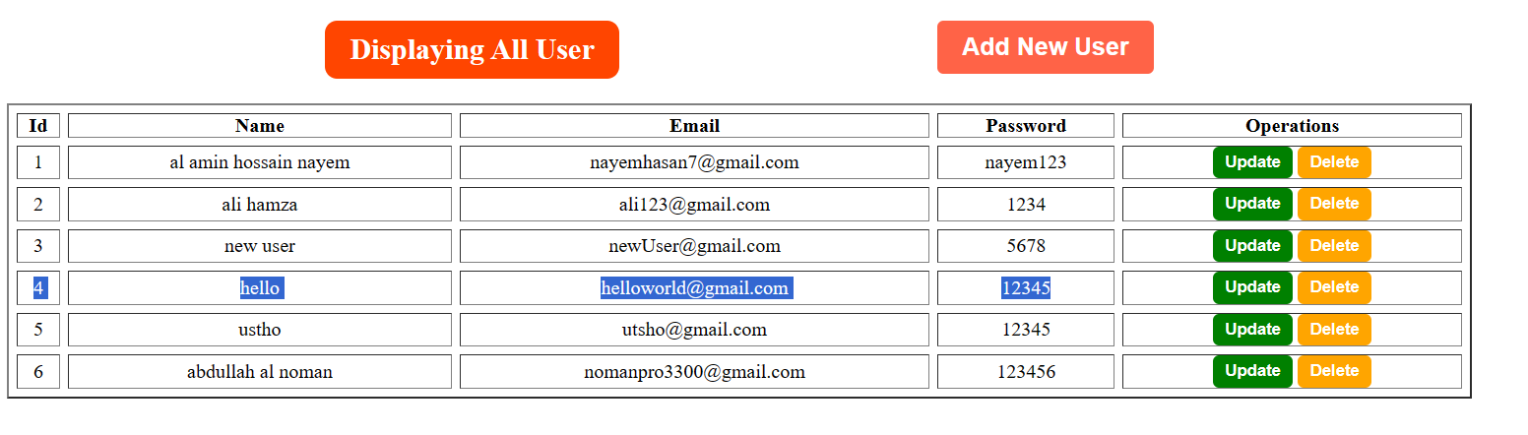
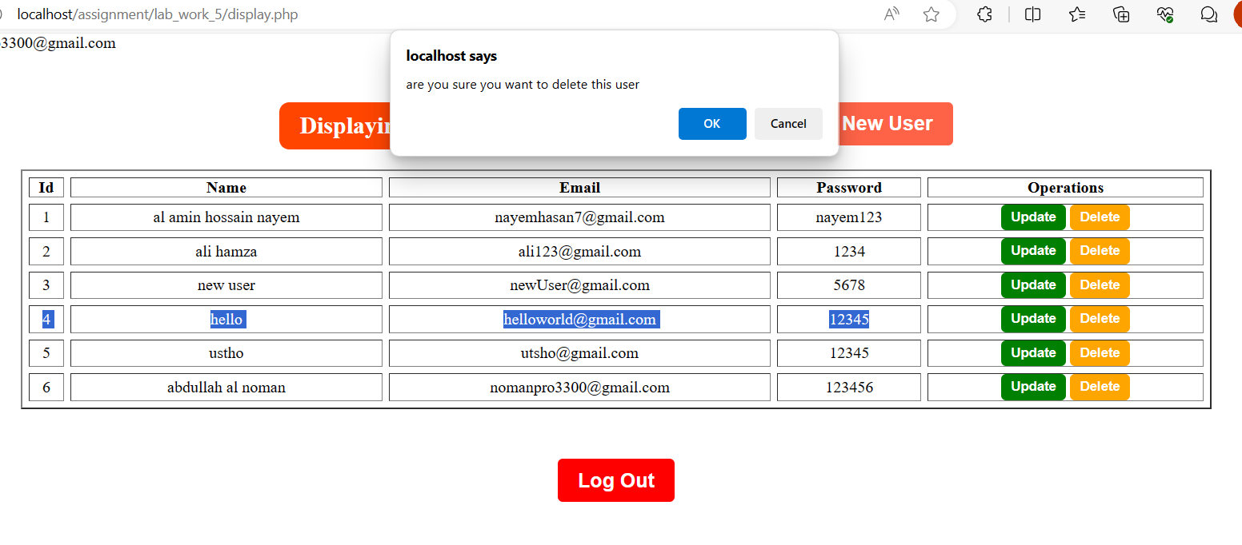

The user also deleted from the database too.
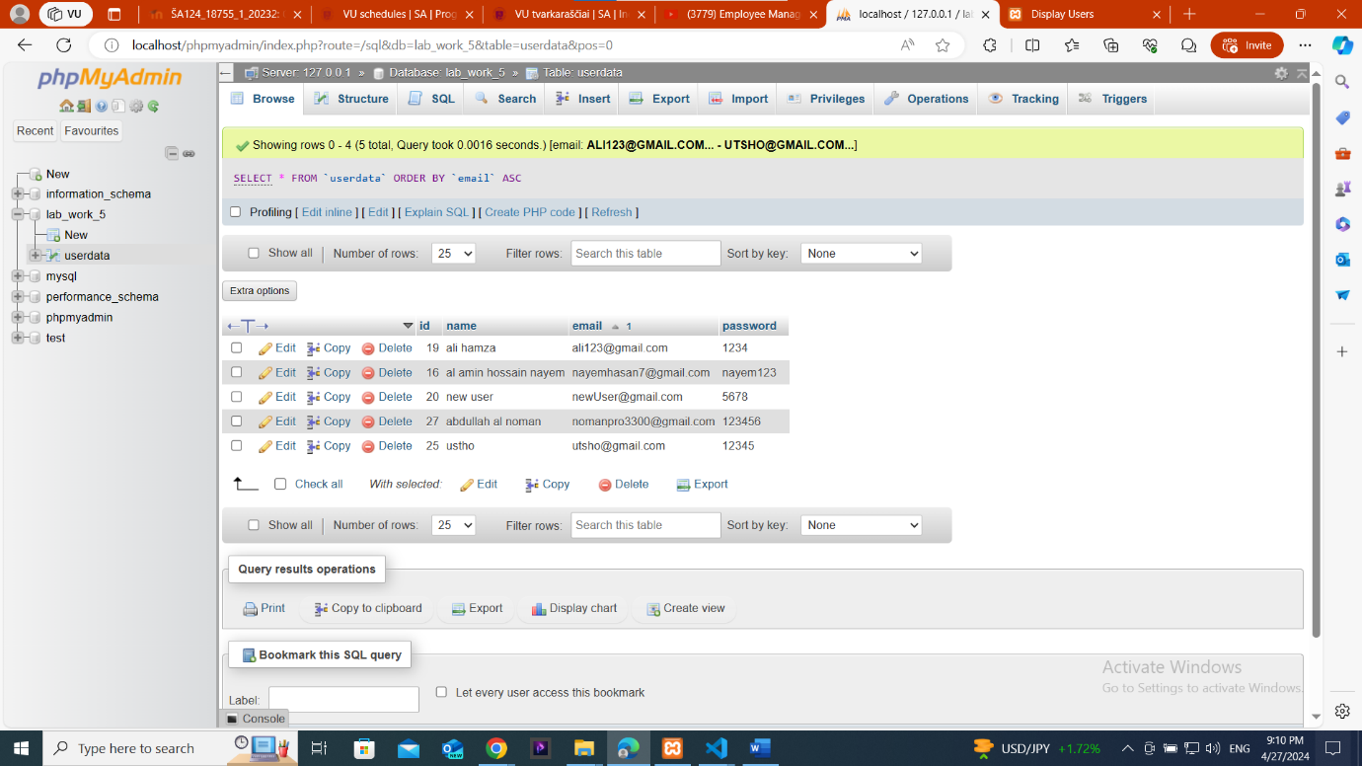

- If clicked into the log out button it will redirect to the sign in page.
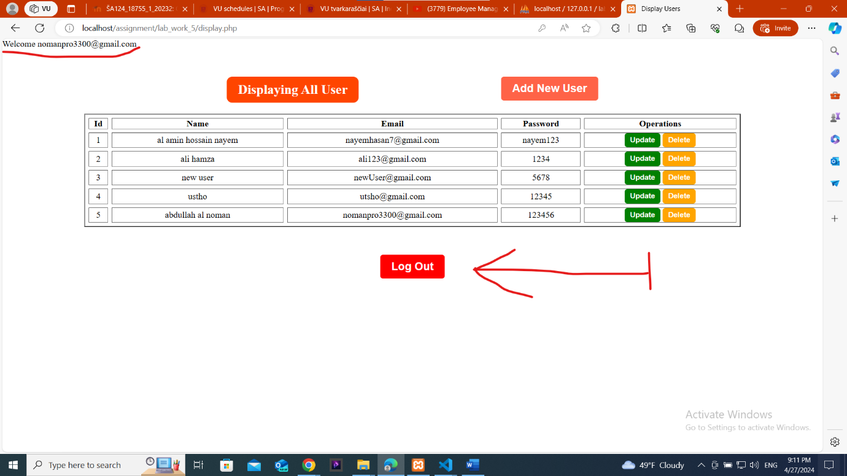
- If clicked into the add new user button it will redirect to the the sign up page.

