Task : Radix sort
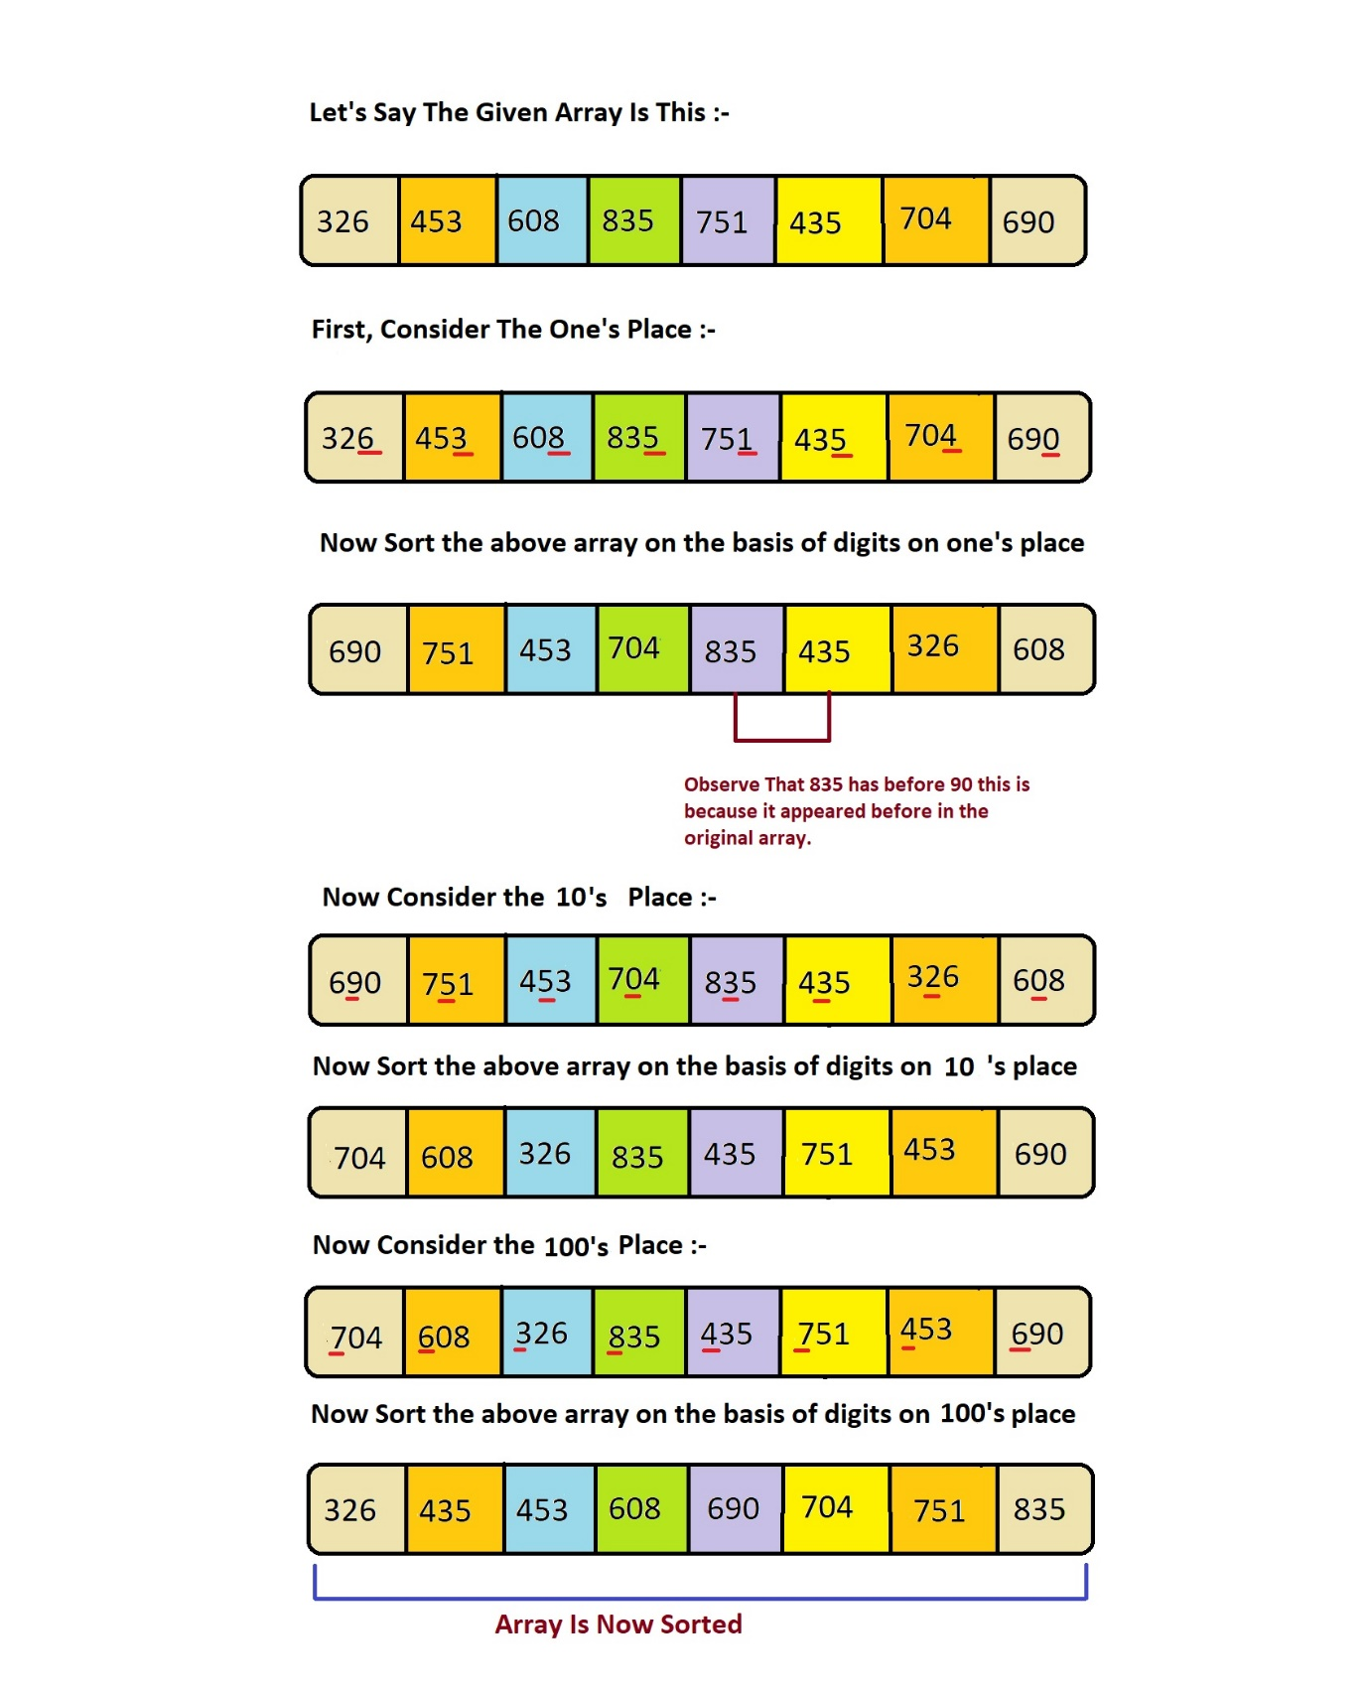

Here is a simple explanation of how Radix Sort works with an example in C++:
- Find the maximum number to know the number of digits.
- Create count arrays for each digit. (For base 10 numbers, this means 10 arrays).
- Sort each digit:
  - Do a count sort for each digit from least significant to most significant.
  - After all digits are sorted, the array is sorted.

- Identify the Range: Determine the maximum value in the array to establish the range of possible values.
- Initialize Count Array: Create an array (count array) with a length equal to the range, initialized to zero.
- Count Occurrences: Go through the input array and increment the corresponding index in the count array.
- Compute Prefix Sum: Transform the count array by adding the sum of the previous counts. This step determines the position of each element in the sorted array.
- Sort the Elements: Iterate over the input array and place each element in its correct position in the output array, decrementing the count in the count array each time an element is placed.
- Copy Back: Copy the sorted elements from the output array back to the original array.

#include <iostream>
using namespace std;
- // get the max number from an array
- int getMax(int arr[], int n) {
- int max = arr[0];
- for (int i = 1; i < n; i++) {
- if (arr[i] > max) {
- max = arr[i];
- }
- }
- return max;
- }
- // Using counting sort to sort the elements
- void countingSort(int arr[], int n, int place) {
- int output[n];
- int count[10] = {0};
- for (int i = 0; i < n; i++) {
- int index = arr[i] / place;
- count[index % 10]++;
- }
- for (int i = 1; i < 10; i++) {
- count[i] += count[i - 1];
- }
- for (int i = n - 1; i >= 0; i--) {
- int index = arr[i] / place;
- output[count[index % 10] - 1] = arr[i];
- count[index % 10]--;
- }
- for (int i = 0; i < n; i++) {
- arr[i] = output[i];
- }
- }
- // Radix Sort
- void radixSort(int arr[], int n) {
- int max_element = getMax(arr, n);
- for (int place = 1; max_element / place > 0; place *= 10) {
- countingSort(arr, n, place);
- }
- }
- int main() {
- int n;
- cout << "Enter the number of elements: ";
- cin >> n;
- int arr[n];
- cout << "Enter the elements: ";
- for (int i = 0; i < n; i++) {
- cin >> arr[i];
- }
- radixSort(arr, n);
- cout << "Sorted array: "; //Assending order
- for (int i = 0; i < n; i++) {
- cout << arr[i] << " ";
- }
- return 0;
- }

