My task: Write the program in C++ that Based on one vector, create another. The first element of the second vector must be obtained by adding the 1st and nth elements of the first vector, the second element of the second vector. email Equal to the sum of the 2nd and n-1, etc.

- First I create a dynamic array that take input from user.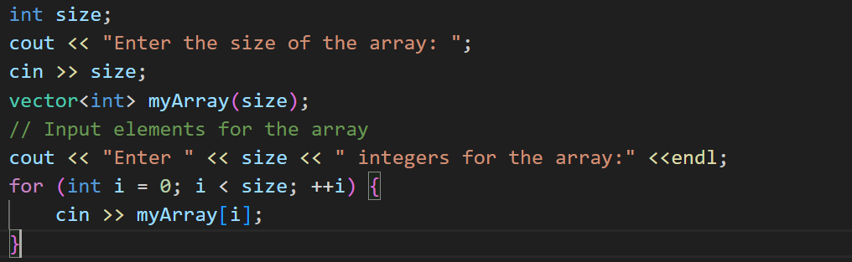
- Then I created a new vector and the size of the vector array is half of the first array.
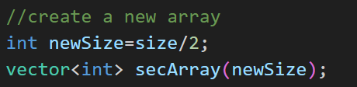
- After then I created the new vector array as mentioned in the task that the first element of the second array would be the sum of the first and last element of the first array an so on.
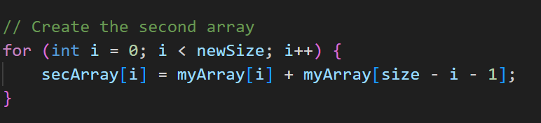
- So my logic is done now just print the array
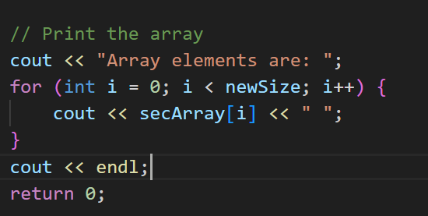

** I divide it by half because we are taking sum of the two elements from the first array into the second array that’s why the second array would be half in size compared to the original array.

#include <iostream>
#include <vector>
using namespace std;

int main() {
int size;
cout << "Enter the size of the array: ";
cin >> size;
vector<int> myArray(size);
// Input elements for the array
cout << "Enter " << size << " integers for the array:" <<endl;
for (int i = 0; i < size; ++i) {
cin >> myArray[i];
}
//create a new array
int newSize=size/2;
vector<int> secArray(newSize);

// Create the second array
for (int i = 0; i < newSize; i++) {
secArray[i] = myArray[i] + myArray[size - i - 1];
}

// Print the array
cout << "Array elements are: ";
for (int i = 0; i < newSize; i++) {
cout << secArray[i] << " ";
}
cout << endl;
return 0;
}

