
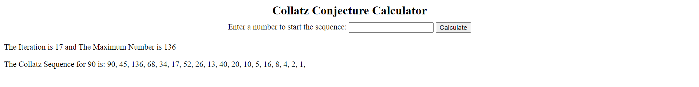
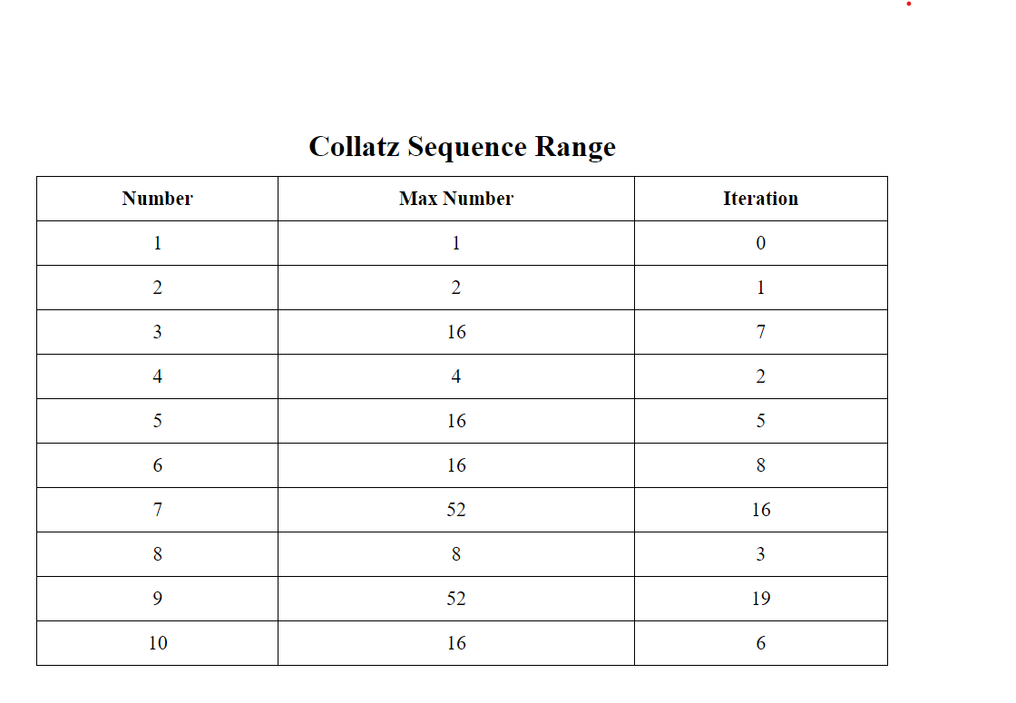
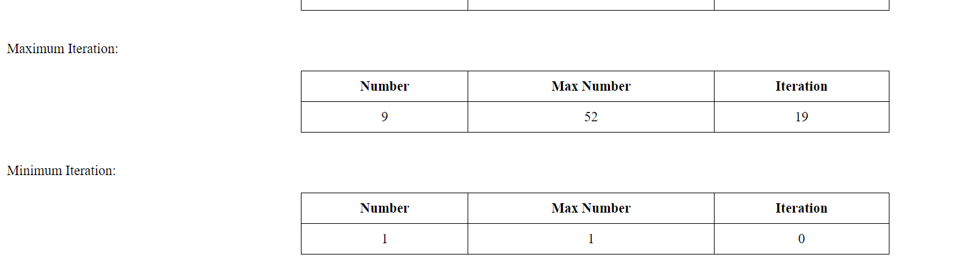

A nested list data structure is essentially a list that contains other lists as its elements. This allows for the creation of multi-dimensional arrays. In C++, this can be represented using vectors of vectors. Here’s an illustration of a nested list:
vector<std::vector<int>> nestedList = {
{1, 2, 3},
{4, 5, 6},
{7, 8, 9}
};
In this example, nestedList is a vector of vectors, where each element is itself a vector of integers.
Adding new elements to a nested list can affect the structure in several ways:
- Adding an Element to an Inner List: You can add an element to any of the inner lists, which will increase the size of that inner list but not the outer list.
- nestedList[0].push_back(4); // Adds 4 to the first inner list
- Adding a New Inner List: You can also add a whole new inner list to the outer list, which increases the size of the outer list.
- nestedList.push_back({10, 11, 12}); // Adds a new inner list
- Adding Elements with Different Sizes: When you add new inner lists of different sizes, the nested list becomes jagged, meaning the inner lists do not all have the same size.
nestedList.push_back({13, 14}); // Adds a new inner list with 2 elements

