Laboratory Work No. 6 Report
Student: Al Amin
Course: Systemic Programming
University: Vilnius University Šiauliai Academy
Task: MASM + Irvine32 Program (32-bit)

1. Task Description
The objective of this laboratory work was to configure the Visual Studio 2022 environment for MASM programming using the Irvine32 library and to implement a 32-bit console application.
The program must:
- Read the first character typed from the keyboard.
- If the character is a number (0–9), the program prints my name.
- If the character is a symbol or letter, the program prints my surname.
- After that, the user inputs an integer NOMB and one word.
- The program prints the entered word NOMB times, starting from line 10, always in the same column.
- The program must run inside a 32-bit CMD console window using Irvine32 procedures.

2. Environment Setup Summary
To complete this assignment, Visual Studio 2022 was configured with the following components:
- Desktop development with C++
- Microsoft Macro Assembler (MASM) build customizations
- Windows 11 SDK
- Irvine32 library placed in C:\Irvine
- Preconfigured project template Project32_VS2022
The MASM build customizations were enabled, the project was switched to Debug | Win32, and all linker paths were correctly configured for Irvine32.
The provided template project compiled successfully after setup.

3. Program Logic Overview
The program uses standard Irvine32 library procedures to handle input, output, and cursor positioning.
Main logic:
- ReadChar obtains the first keyboard input.
- IsDigit checks whether the input character is numeric.
- Based on the result:
  - If digit → prints AL AMIN
  - If symbol/letter → prints HOSSAIN
- ReadInt is used to read NOMB.
- ReadString collects a single word from the user.
- Starting from row 10, a loop prints the word NOMB times.
Cursor position is controlled using Gotoxy (DH=row, DL=column).
All core operations follow the assignment specification exactly.

4. Test Results
Below are the test cases demonstrating correct program behavior.
Test 1 — First Input is a Number
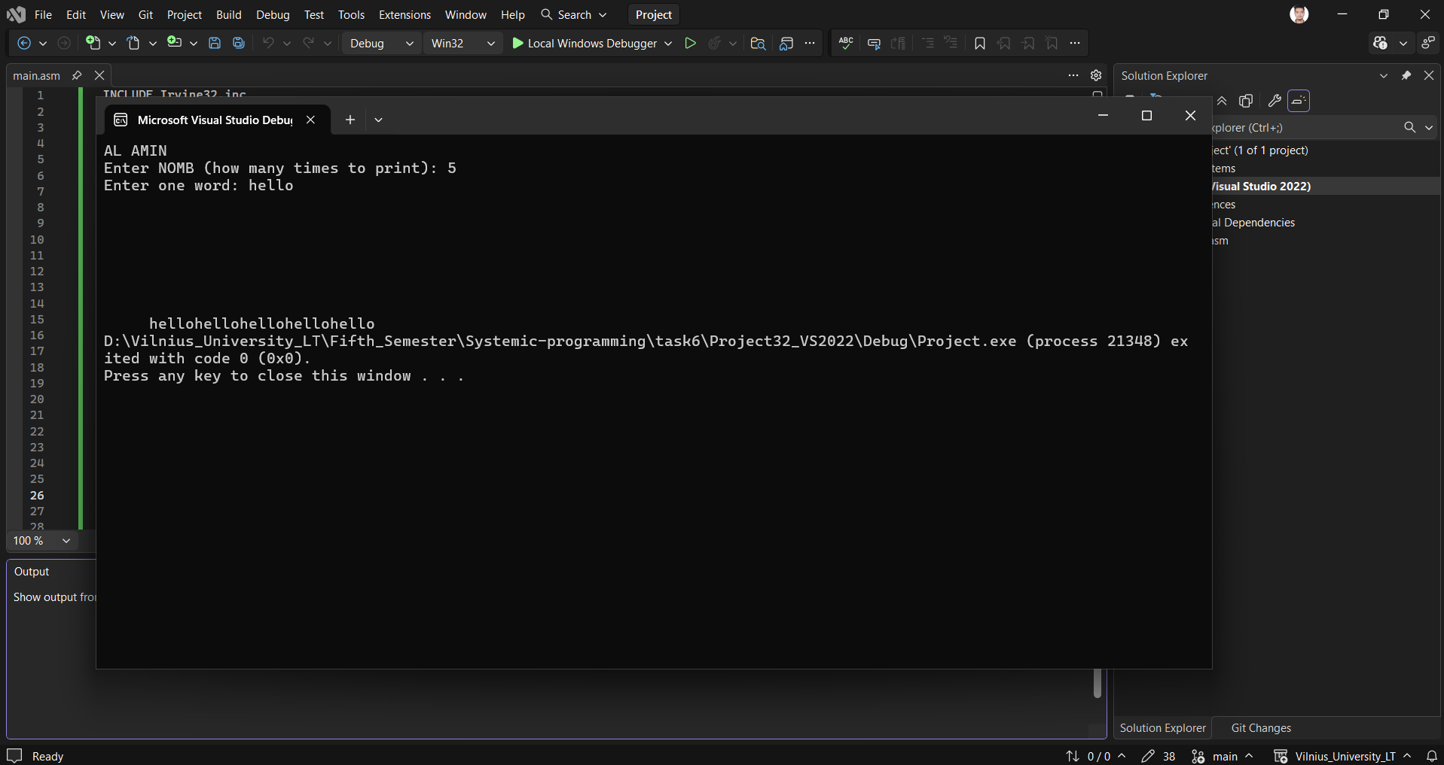Result:
- Program prints the name
- Accepts NOMB and a word
- Repeats the word correctly from line 10

Test 2 — First Input is a Character
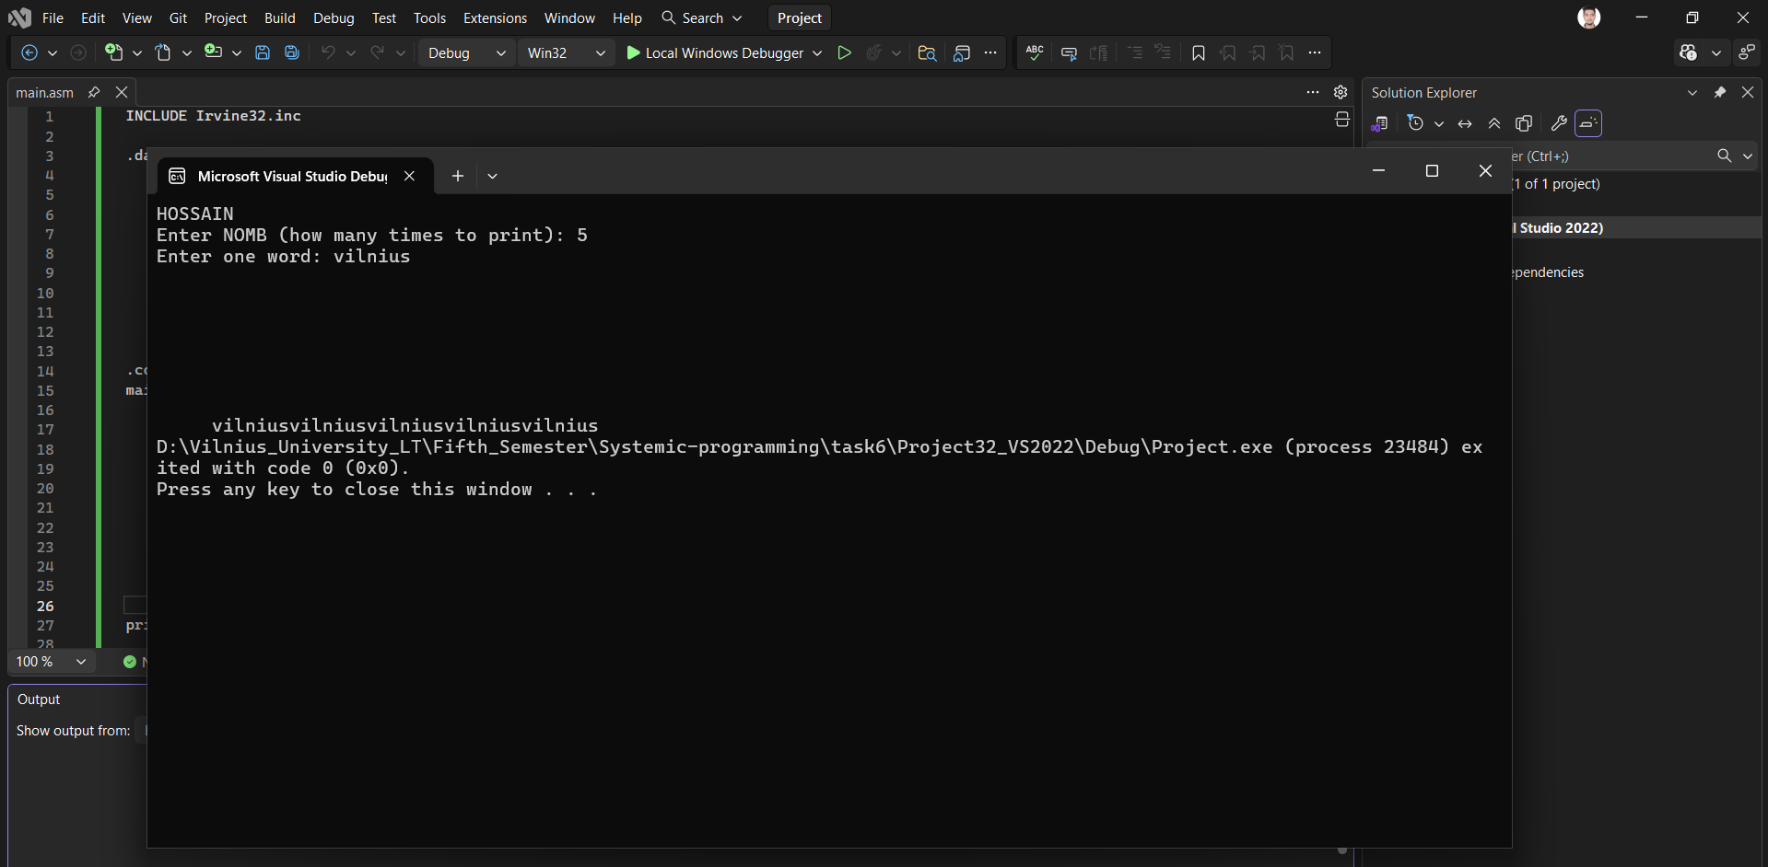Result:
- Program prints the surname
- Accepts NOMB and a word
- Prints the word NOMB times starting at line 10

5. Conclusion
The Visual Studio 2022 environment was successfully configured for MASM and Irvine32 programming.
The implemented program meets all functional requirements described in the laboratory task:
- Digit/symbol detection works correctly
- Name and surname outputs match the rules
- NOMB and word input handling is correct
- Word repetition from line 10 functions properly
- The executable runs correctly inside a 32-bit CMD-style console
The laboratory work is completed successfully, and the provided EXE file is included for evaluation.

