Lab Work 2 : DNS
Q1) Run nslookup to obtain the IP address of a Web server in Asia. What is the IP address of that server?
Ans. Ip address : 192.185.149.242
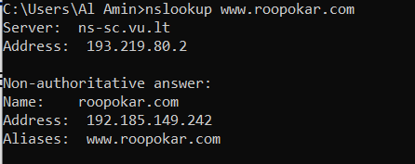
Q2) Run nslookup to determine the authoritative DNS servers for a university in Europe?
Ans. vu.edu nameserver = ns1.vanderbilt.edu
vu.edu nameserver = ns2.vanderbilt.edu
vu.edu nameserver = ns4.vanderbilt.edu
vu.edu nameserver = ns3.vanderbilt.edu

ns1.vanderbilt.edu internet address = 129.59.9.138
ns2.vanderbilt.edu internet address = 129.59.9.139
ns3.vanderbilt.edu internet address = 13.248.152.172
ns4.vanderbilt.edu internet address = 76.223.17.161
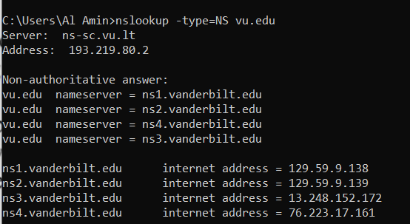
Q3) Run nslookup so that one of the DNS servers obtained in Question 2 is queried for the mail servers for Yahoo! mail. What is its IP address?
Ans. IP address : 75.2.77.85
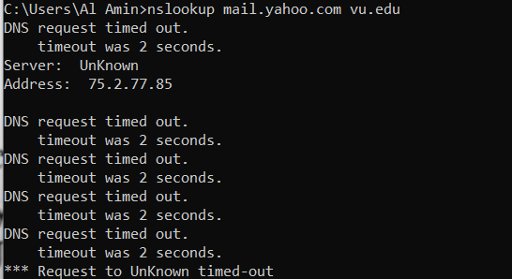
2. ipconfig
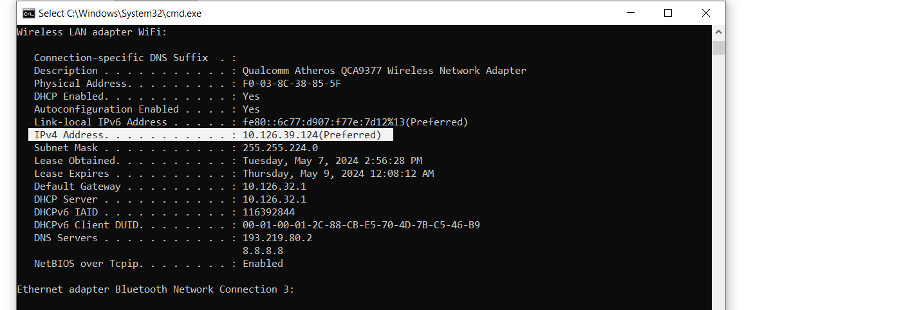
Q4) Locate the DNS query and response messages. Are then sent over UDP or TCP?
Ans. User Datagram Protocol (UDP)
Q5) What is the destination port for the DNS query message? What is the source port of DNS response message?
Ans. Destination port : 53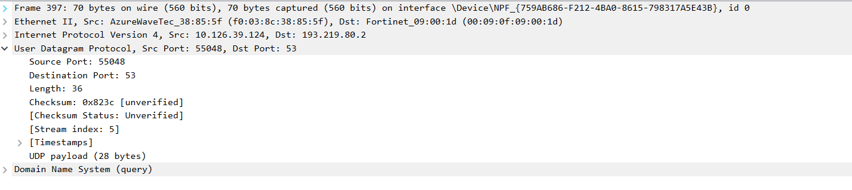
Source port : 53 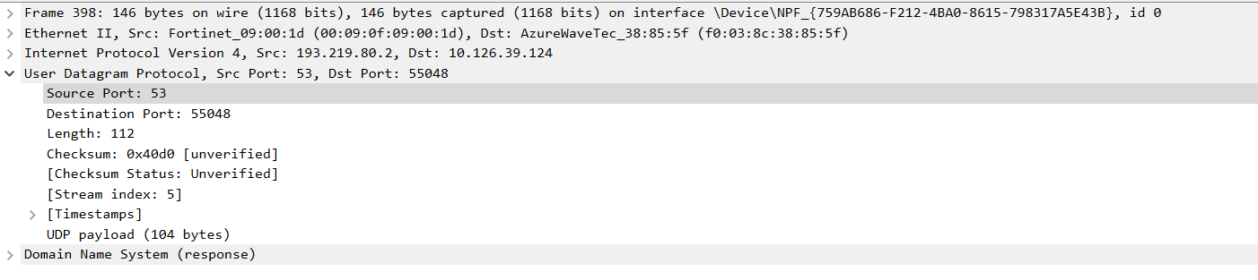
Q6) . To what IP address is the DNS query message sent? Use ipconfig to determine the IP address of your local DNS server. Are these two IP addresses the same?
Ans. Yes same .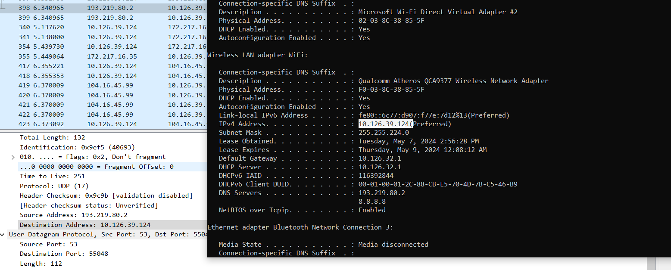
Q7) Examine the DNS query message. What “Type” of DNS query is it? Does the query message contain any “answers”?
Ans.

