- What is the IP address and TCP port number used by the client computer (source) that is transferring the file to gaia.cs.umass.edu?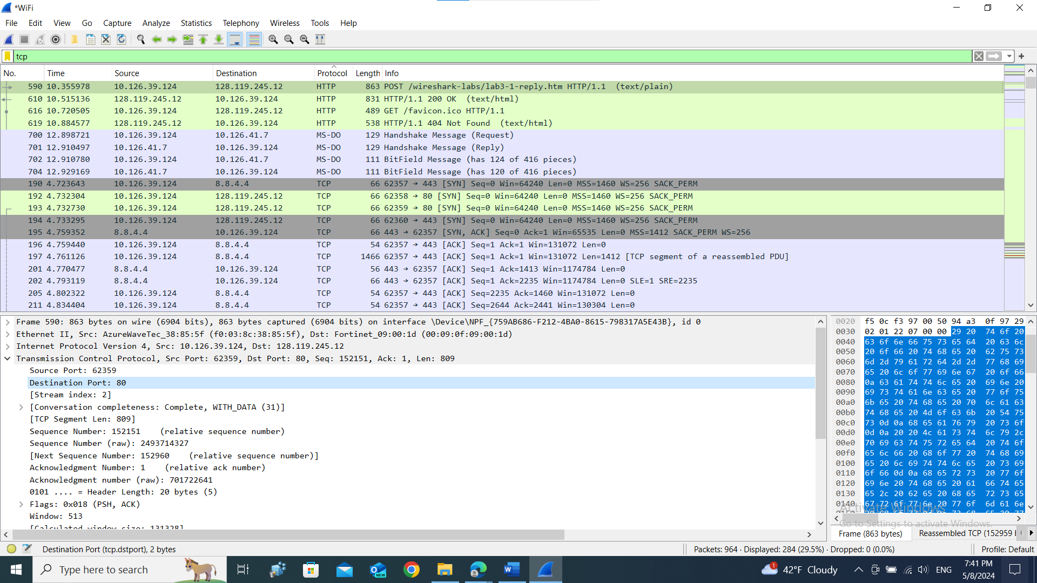
- What is the IP address of gaia.cs.umass.edu? On what port number is it sending and receiving TCP segments for this connection?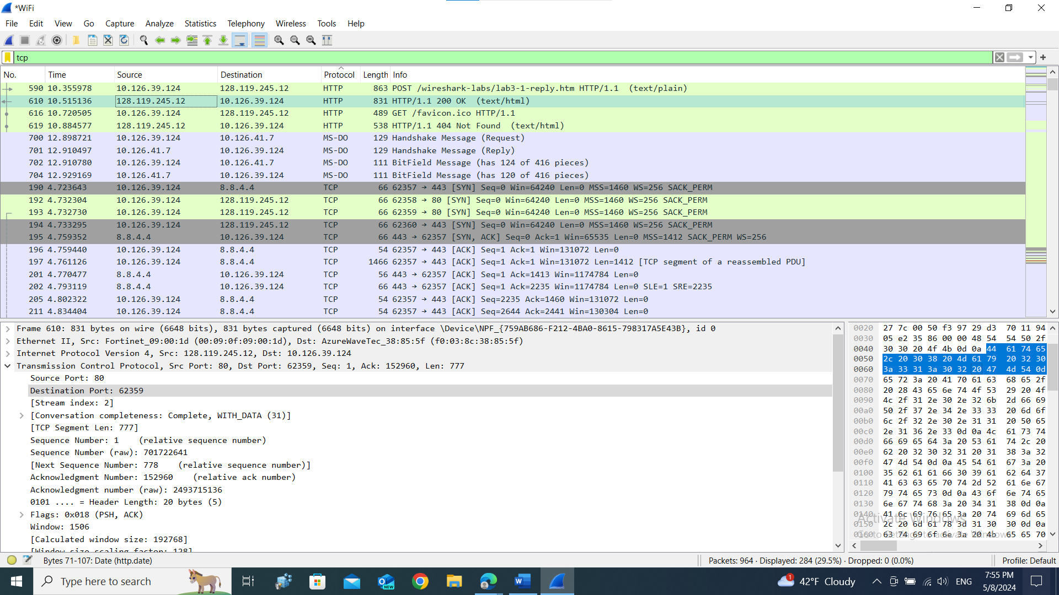
- What is the sequence number of the TCP SYN segment that is used to initiate the TCP connection between the client computer and gaia.cs.umass.edu? What is it in the segment that identifies the segment as a SYN segment?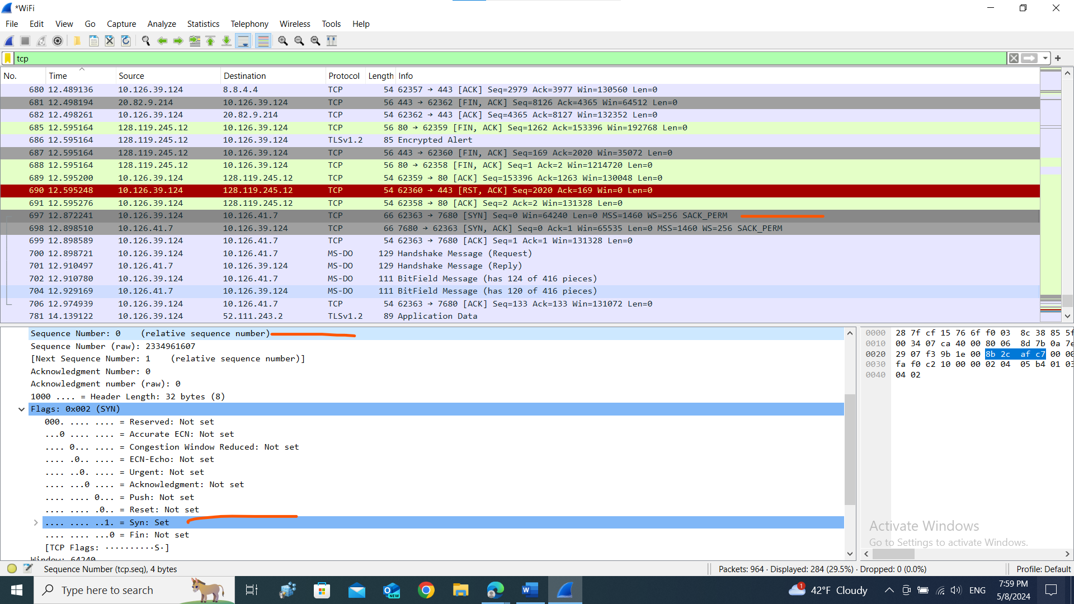
- What is the sequence number of the SYNACK segment sent by gaia.cs.umass.edu to the client computer in reply to the SYN? What is the value of the Acknowledgement field in the SYNACK segment? How did gaia.cs.umass.edu determine that value? What is it in the segment that identifies the segment as a SYNACK segment?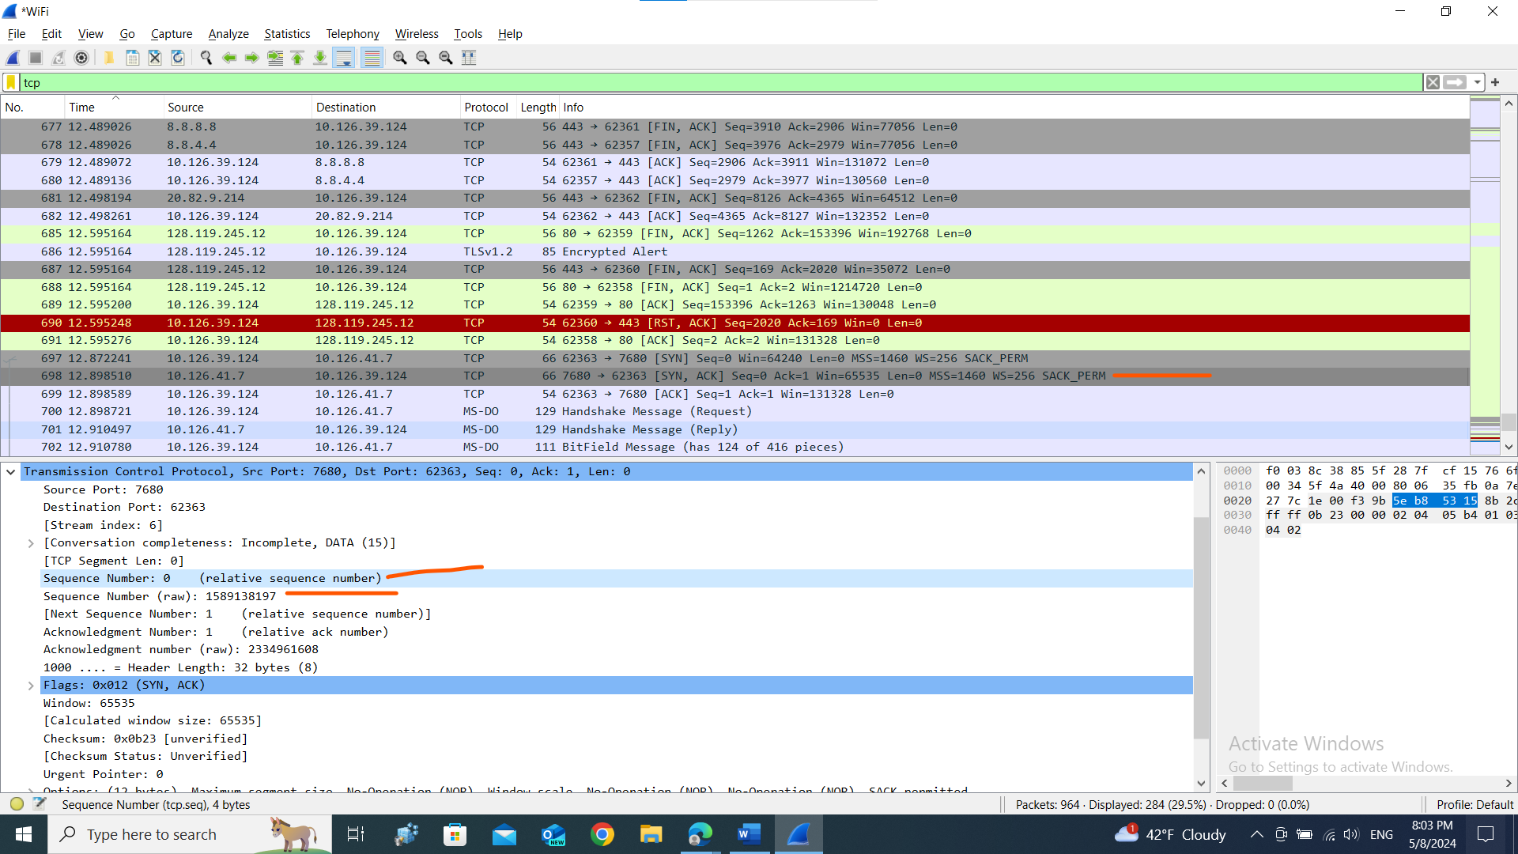
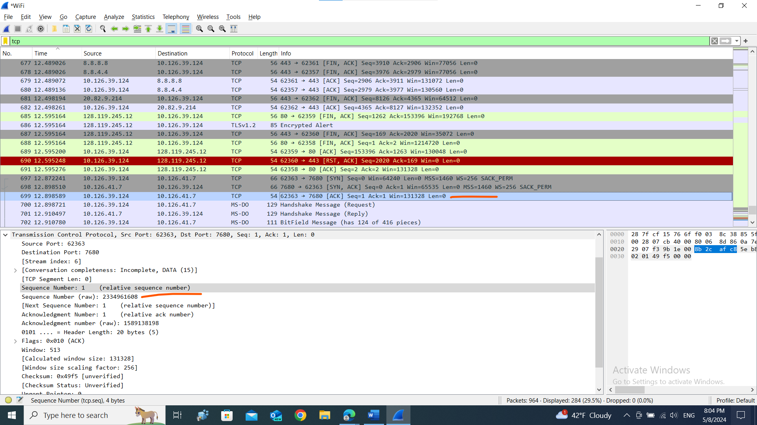
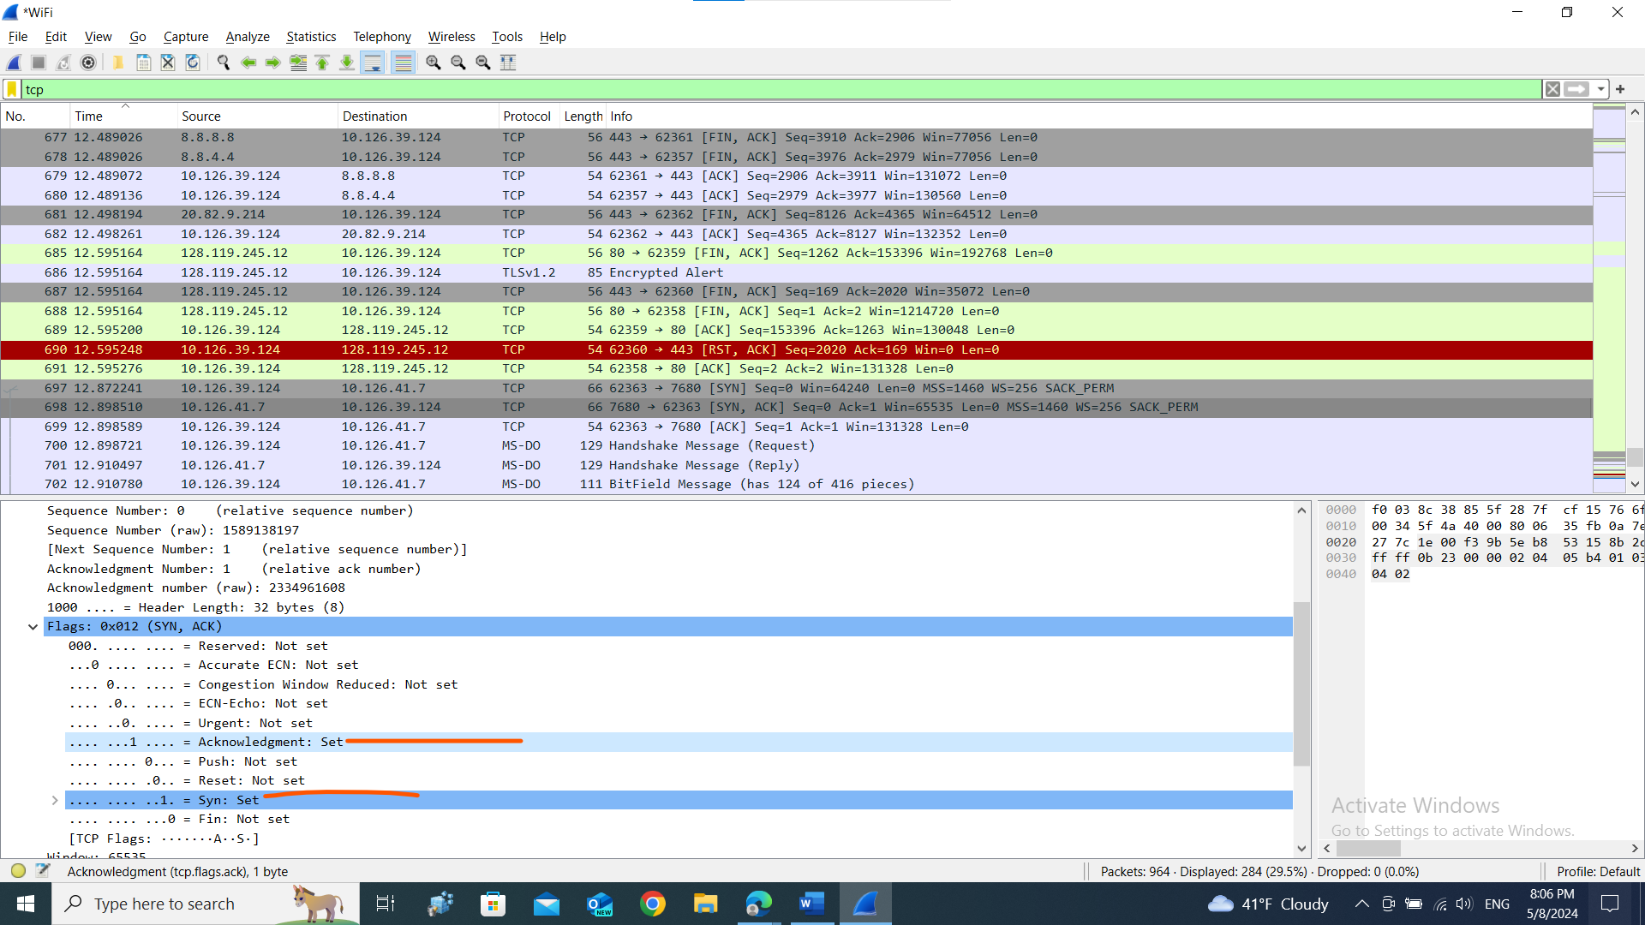
- What is the sequence number of the TCP segment containing the HTTP POST command? Note that in order to find the POST command, you’ll need to dig into the packet content field at the bottom of the Wireshark window, looking for a segment with a “POST” within its DATA field.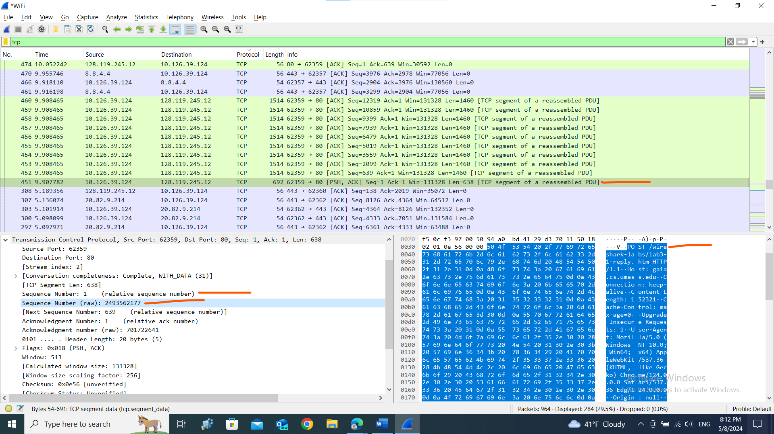
- Consider the TCP segment containing the HTTP POST as the first segment in the TCP connection. What are the sequence numbers of the first six segments in the …..
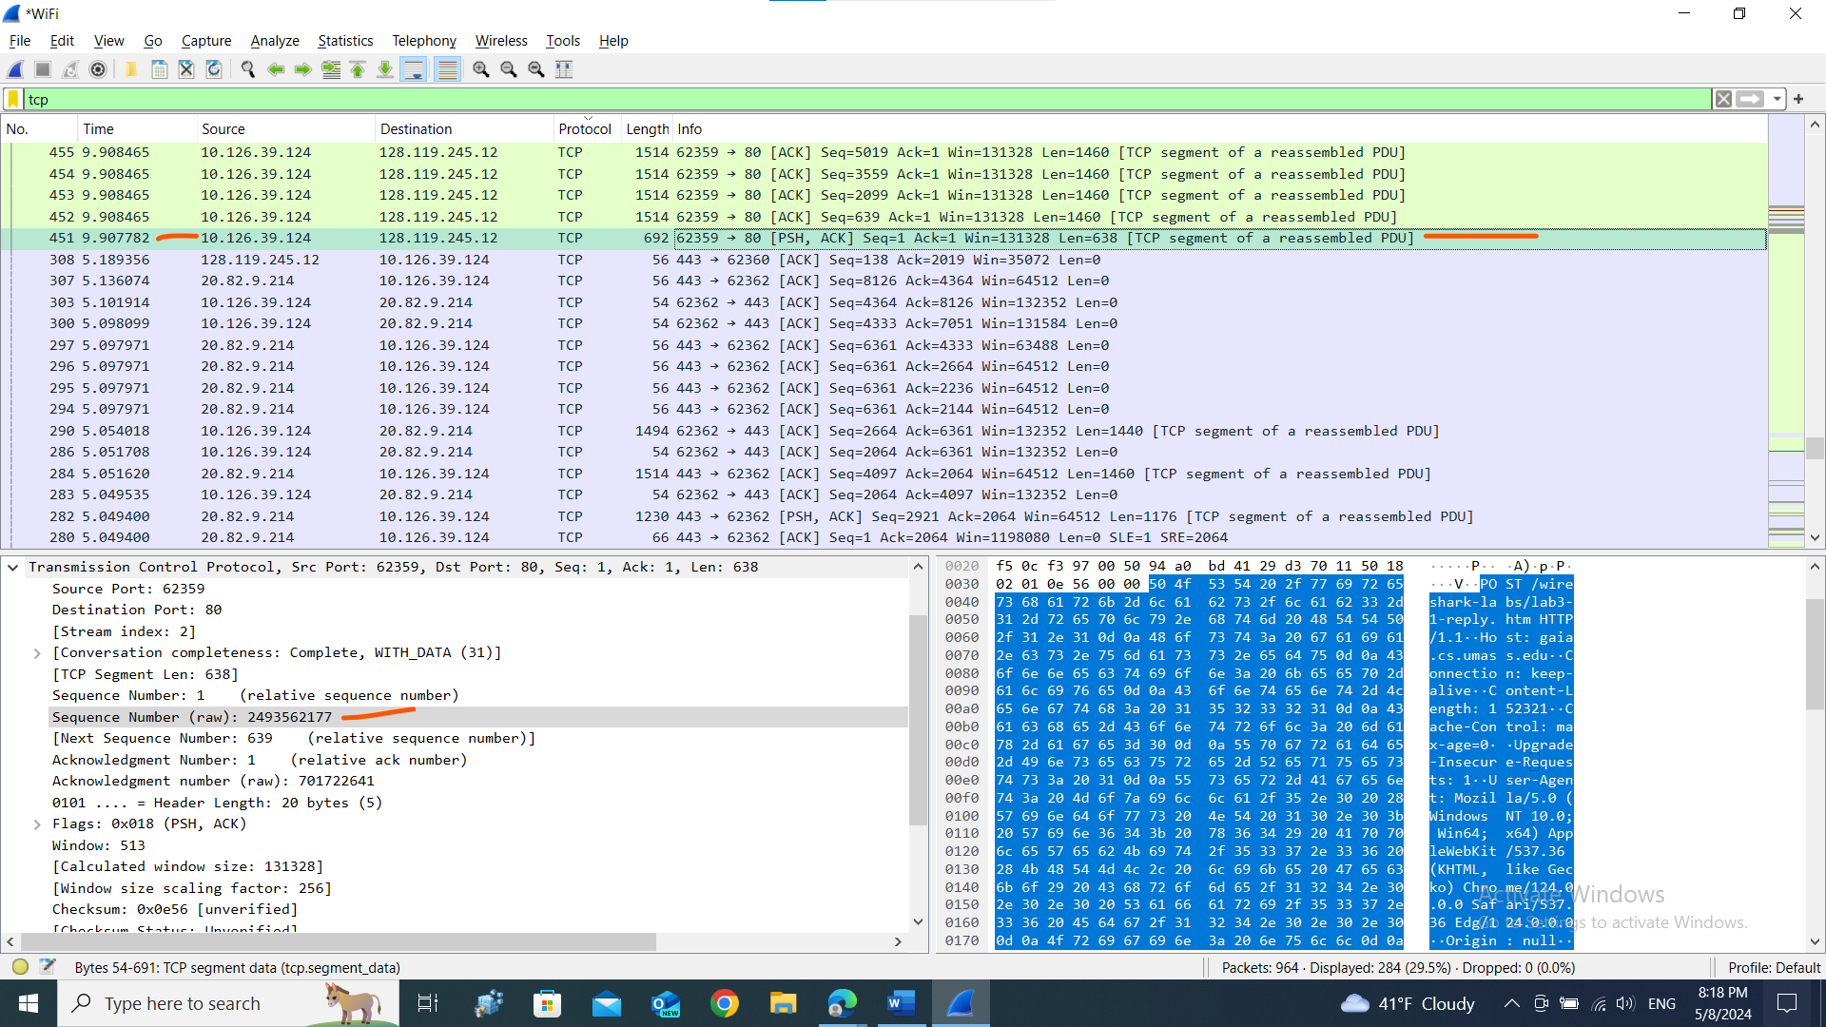
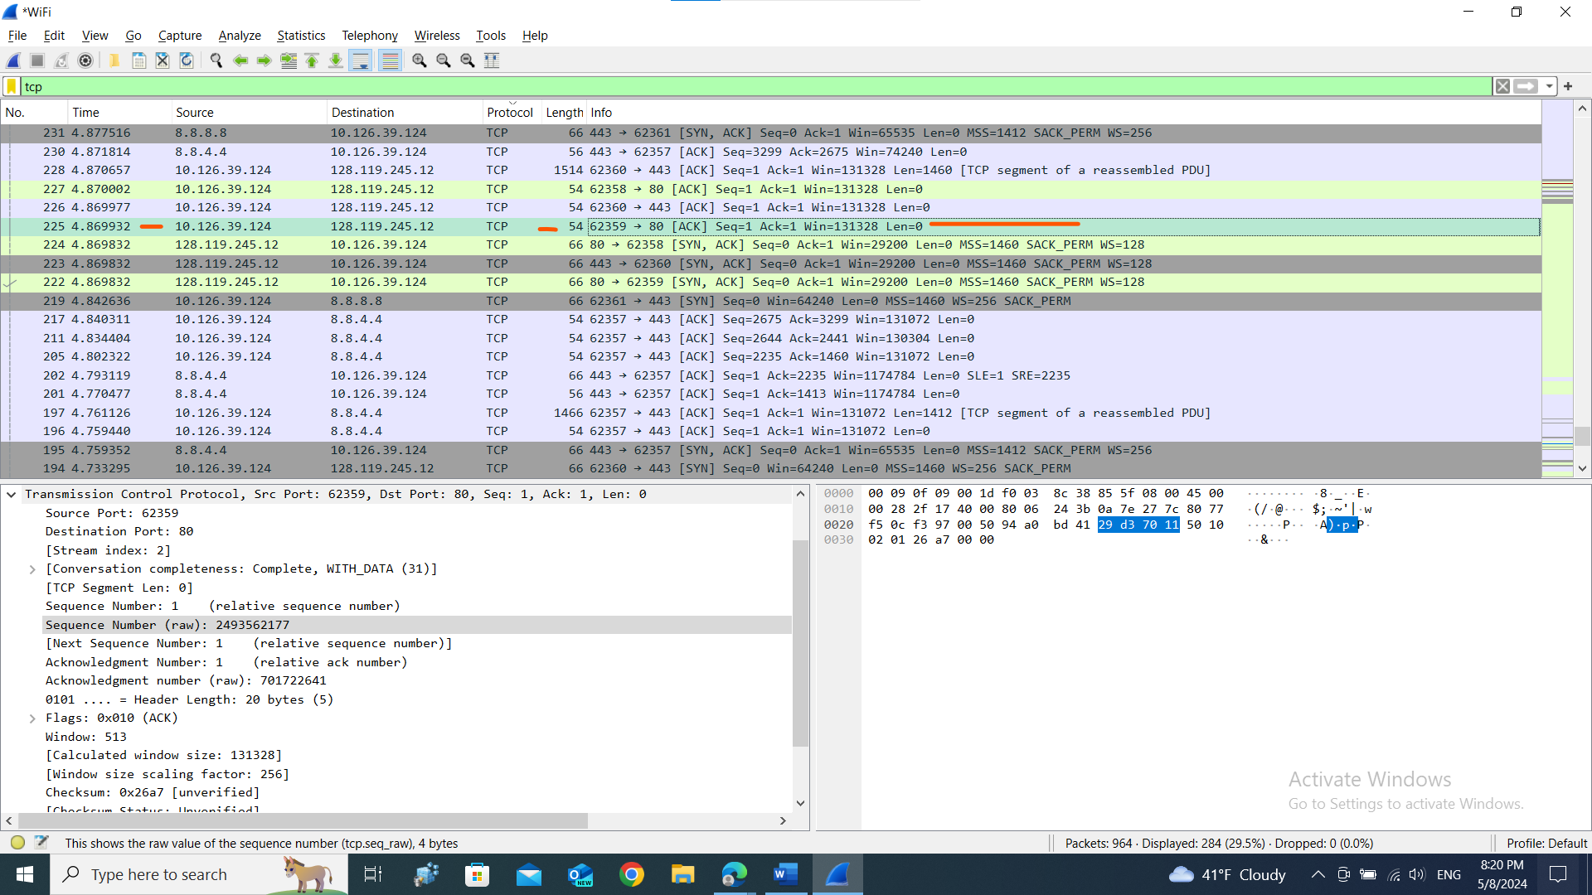
RTT = receive time – send time .
- What is the length of each of the first six TCP segments?
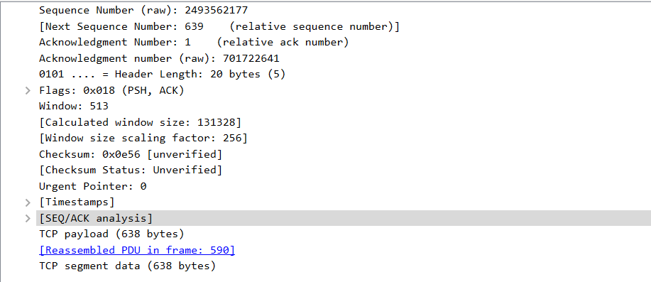
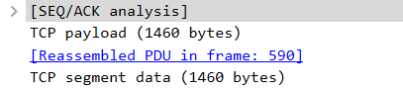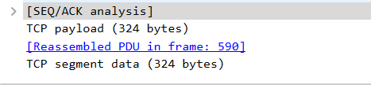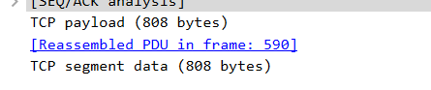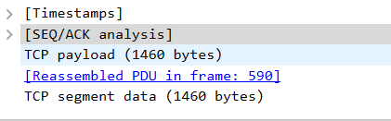
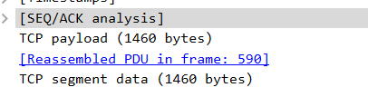
- What is the minimum amount of available buffer space advertised at the received for the entire trace? Does the lack of receiver buffer space ever throttle the sender?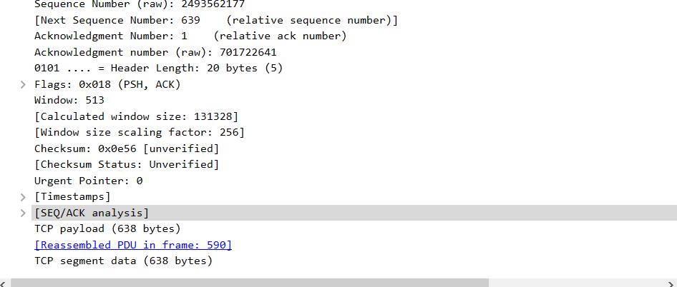
No ..segment length less then window size
- Are there any retransmitted segments in the trace file? What did you check for (in the trace) in order to answer this question?
Ans. No. I check the source port .
- How much data does the receiver typically acknowledge in an ACK? Can you identify cases where the receiver is ACKing every other received segment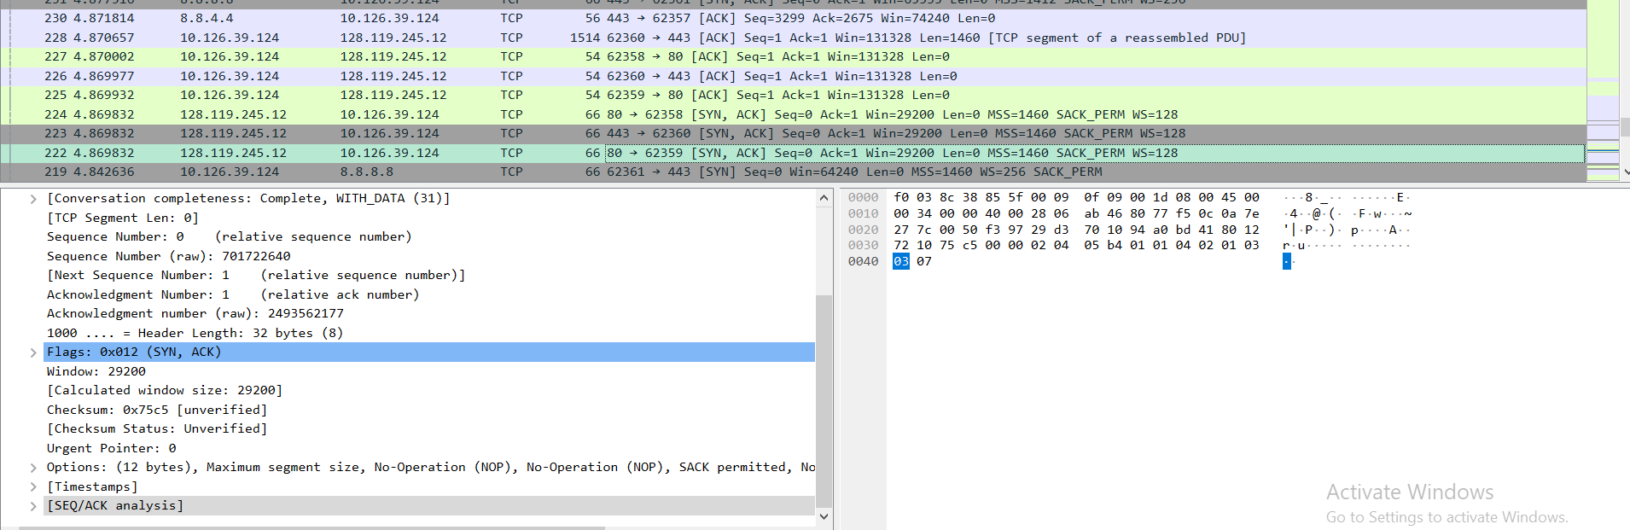
- What is the throughput (bytes transferred per unit time) for the TCP connection? Explain how you calculated this value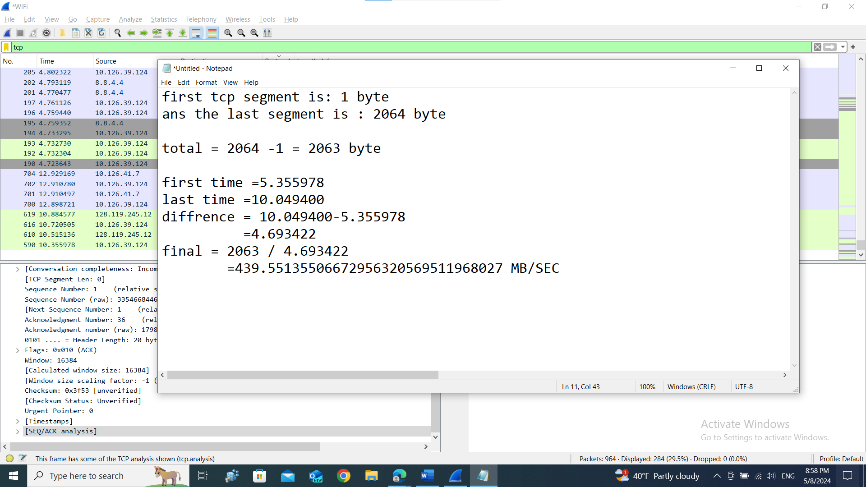
- Use the Time-Sequence-Graph(Stevens) plotting tool to view the sequence number versus time plot of segments being sent from the client to the gaia.cs.umass.edu server. Can you identify where TCP’s slowstart phase begins and ends, and where congestion avoidance takes over? Comment on ways in which the measured data differs from the idealized behavior of TCP that we’ve studied in the text.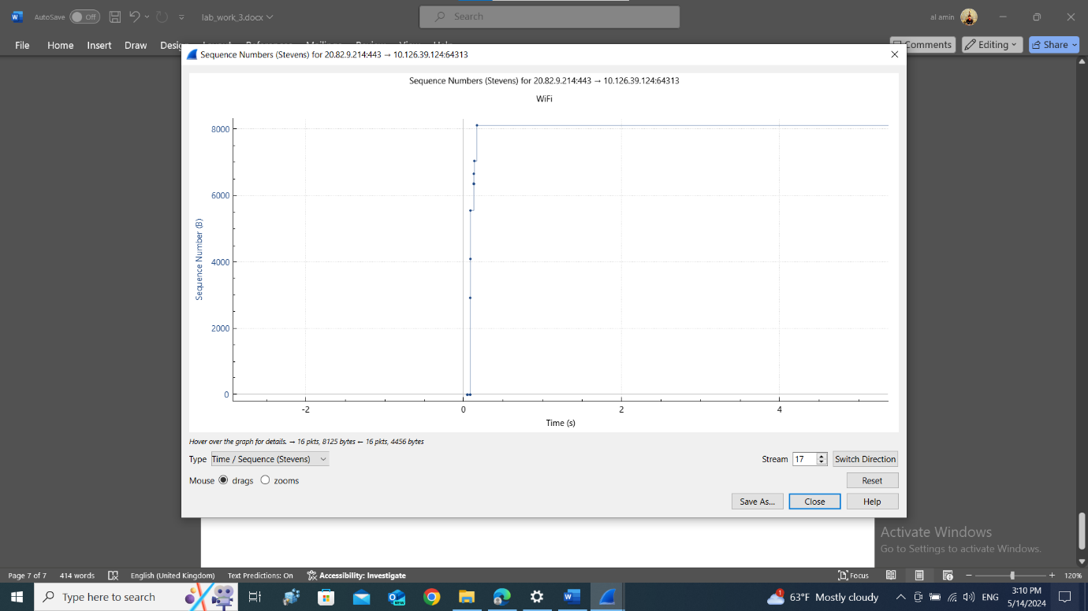
- Answer each of two questions above for the trace that you have gathered when you transferred a file from your computer to gaia.cs.umass.edu?
Ans. Already answer in the avobe.

