Introduction:
The objective of this design is to create a database system for managing article postings. The system includes multiple entities such as authors, articles, categories, comments, and tags, which are interconnected using relational database principles. The design ensures efficient data organization, retrieval, and relationship management between the tables.

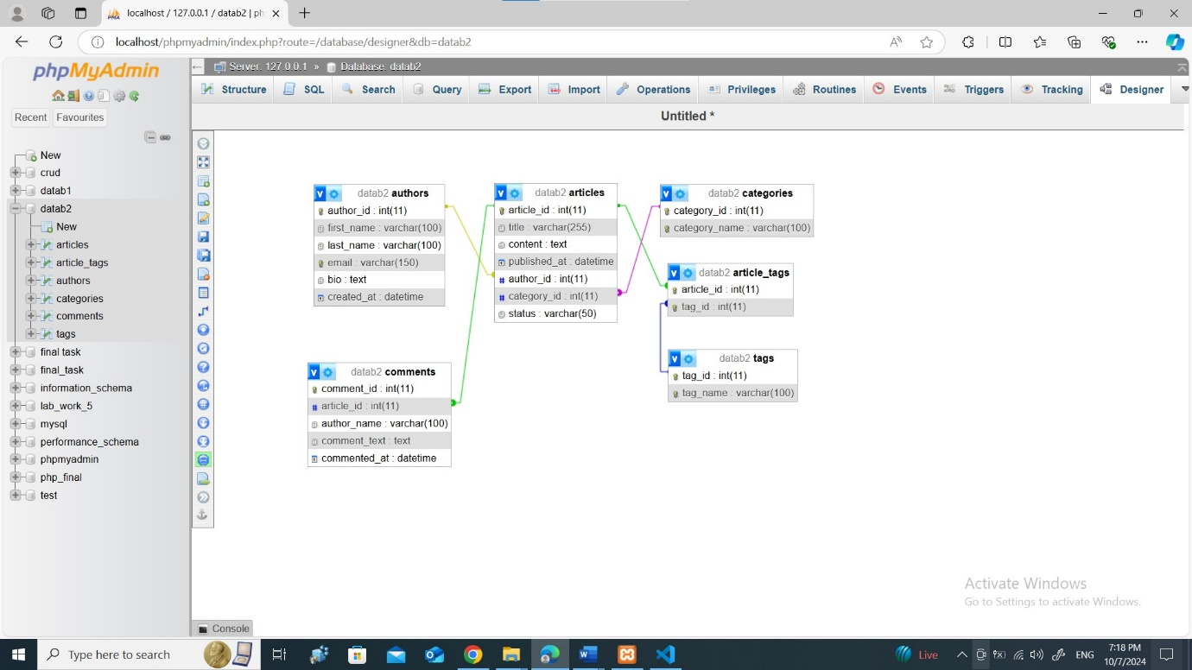
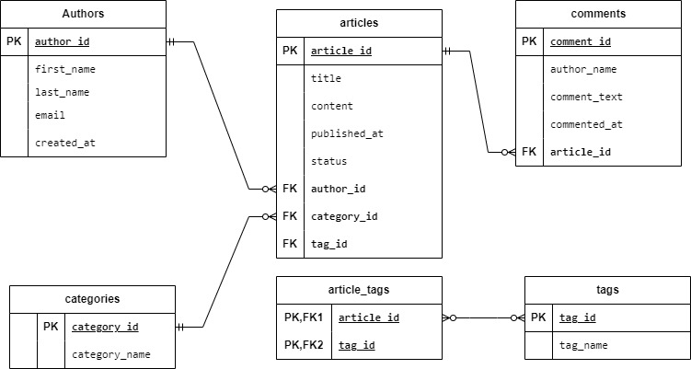

Example ER Diagram:
- Authors ← (One-to-Many) → Articles
- Articles ← (Many-to-One) → Categories
- Articles ← (One-to-Many) → Comments
- Articles ← (Many-to-Many via Article_Tags) → Tags

Key Concepts:
- Composite Primary Key: In the article_tags table, the primary key is composed of both article_id and tag_id. This ensures that the same article cannot be associated with the same tag more than once, thereby enforcing uniqueness in the relationship between the two entities.
- Relational Integrity: Foreign key constraints are used in each table to maintain relationships and ensure referential integrity, which means data consistency is enforced across tables.

Conclusion:
This database design effectively organizes the content and relationships necessary for managing a posting articles system. By defining clear relationships between authors, articles, categories, comments, and tags, the system ensures easy management of the posting process while maintaining data integrity and flexibility for future expansion.

