SQL Assignment: Transactions and Procedures
This report provides an analysis of SQL Server transactions and procedures using the AdventureWorks2019 database. It includes explanations, custom procedures, and test outputs.

Selected Transaction:
Procedure: usp_UpdateEmployeeHireInfo .
This transaction updates an employee's hiring information.
- Purpose: Ensures data consistency by grouping multiple update operations into a single transaction.
- Rollback Scenario: If the employee ID does not exist or a constraint is violated, all updates are rolled back.
- Commit Scenario: All changes are saved to the database only if all operations are successfully executed.

Procedure with Transaction:
- Procedure Name: InsertMultipleRecordsWithTransaction
- Description: This procedure uses a transaction to insert two related records into Person.Person and HumanResources.Employee. If any insert fails, the entire transaction is rolled back to ensure data integrity.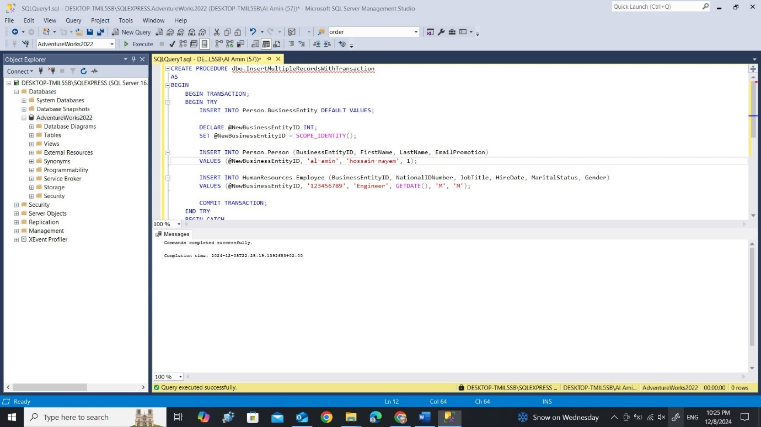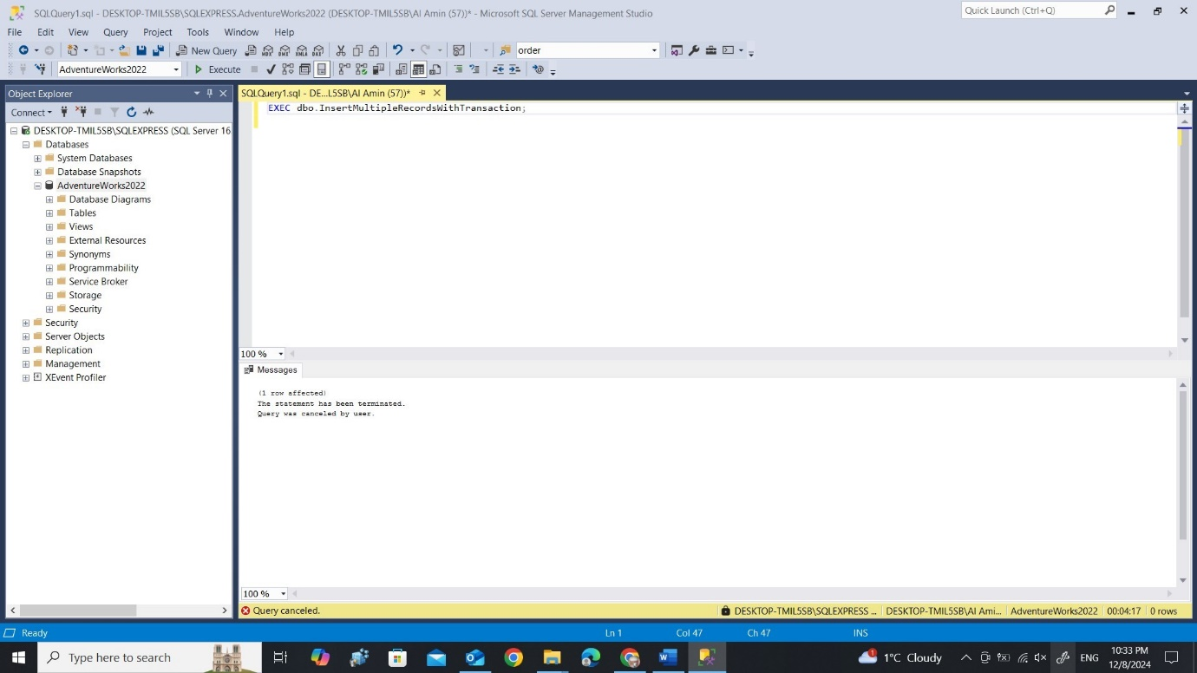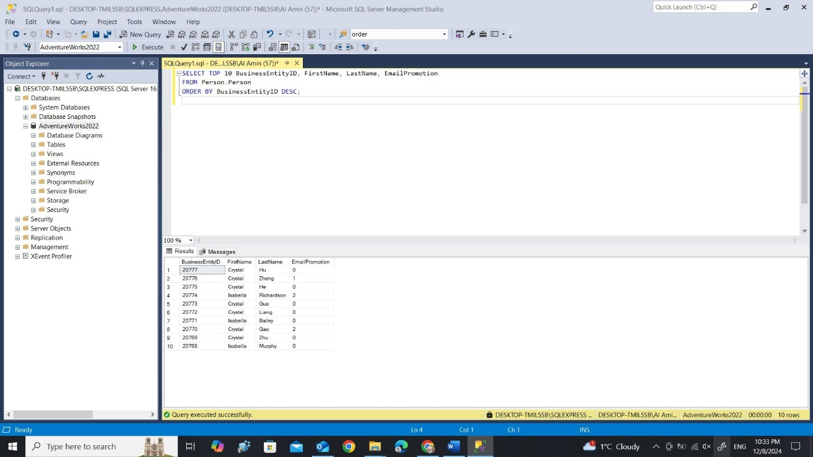

Procedure to Create old_tmp Table:
- Procedure Name: CreateOldTmpTable
- Description: This procedure creates an old_tmp table to store 1/3 of the users with the oldest password modification dates. The table is dropped if it already exists.
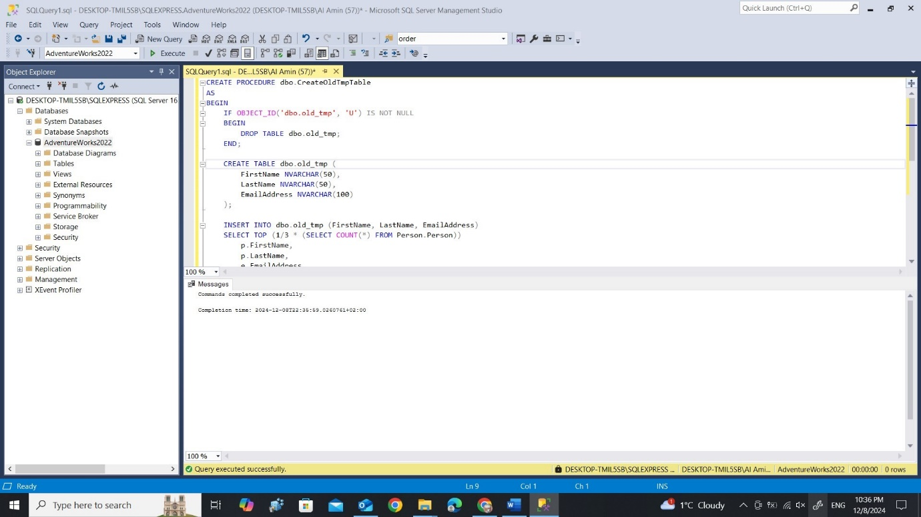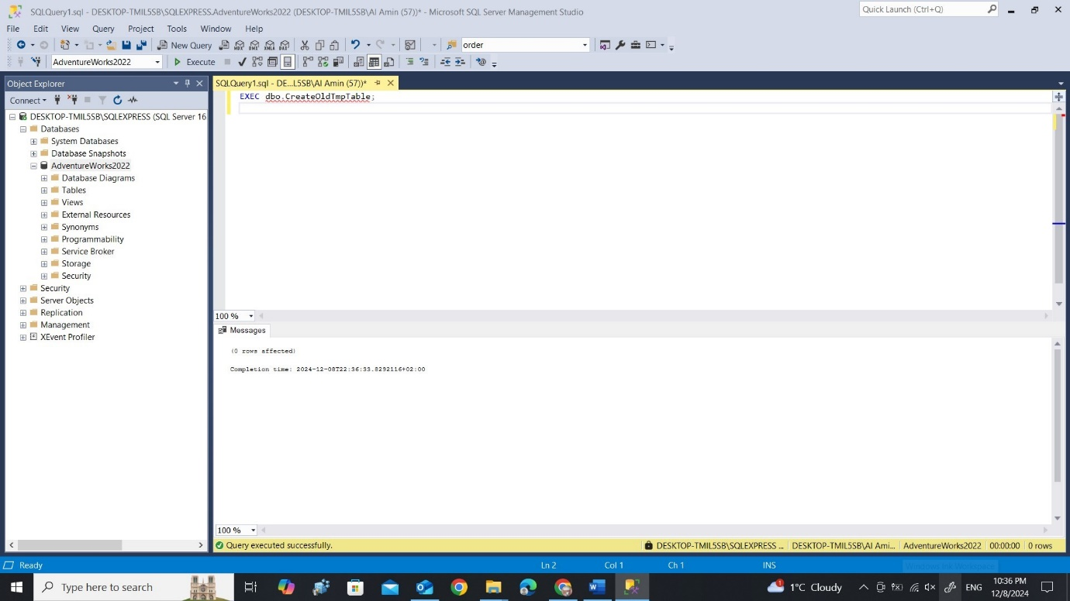

Procedure for Product Price Analysis:
- Procedure Name: AnalyzeProductPriceChanges
- Description: This procedure analyzes product price history and stores data in a new table Product_analysis. It includes details such as the product ID, name, category, supplier, average price, last price, and total number of prices.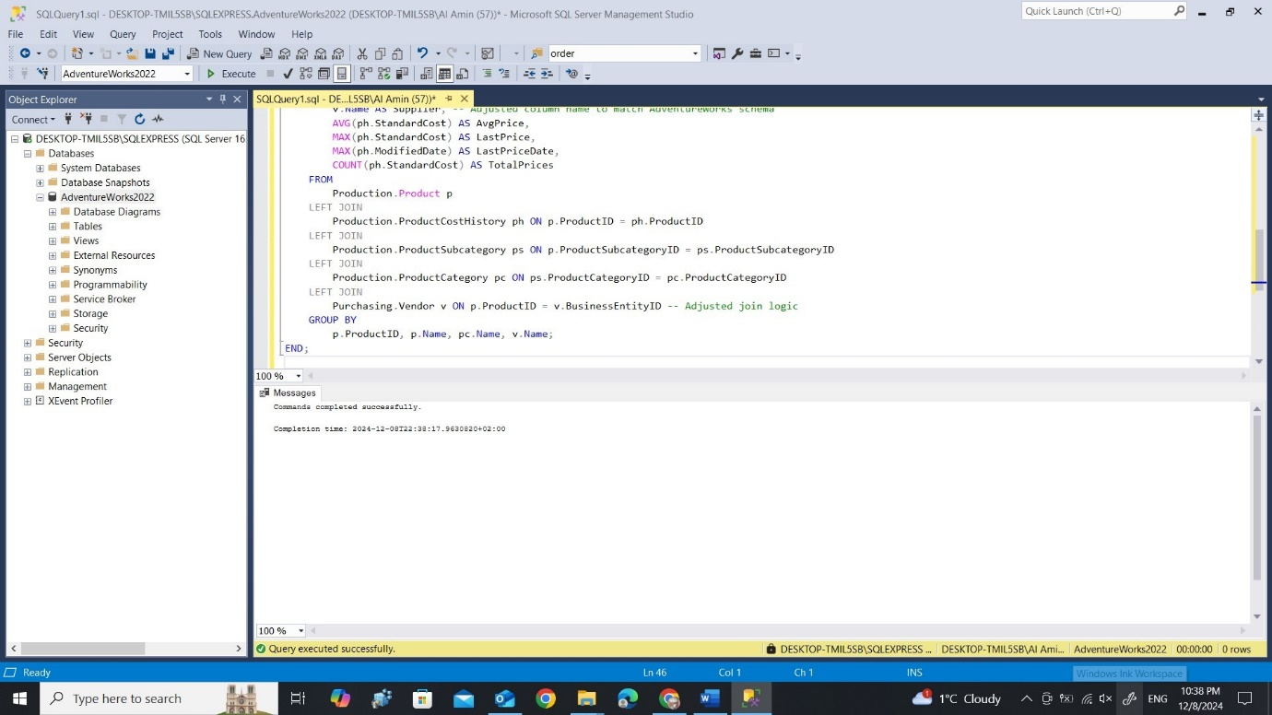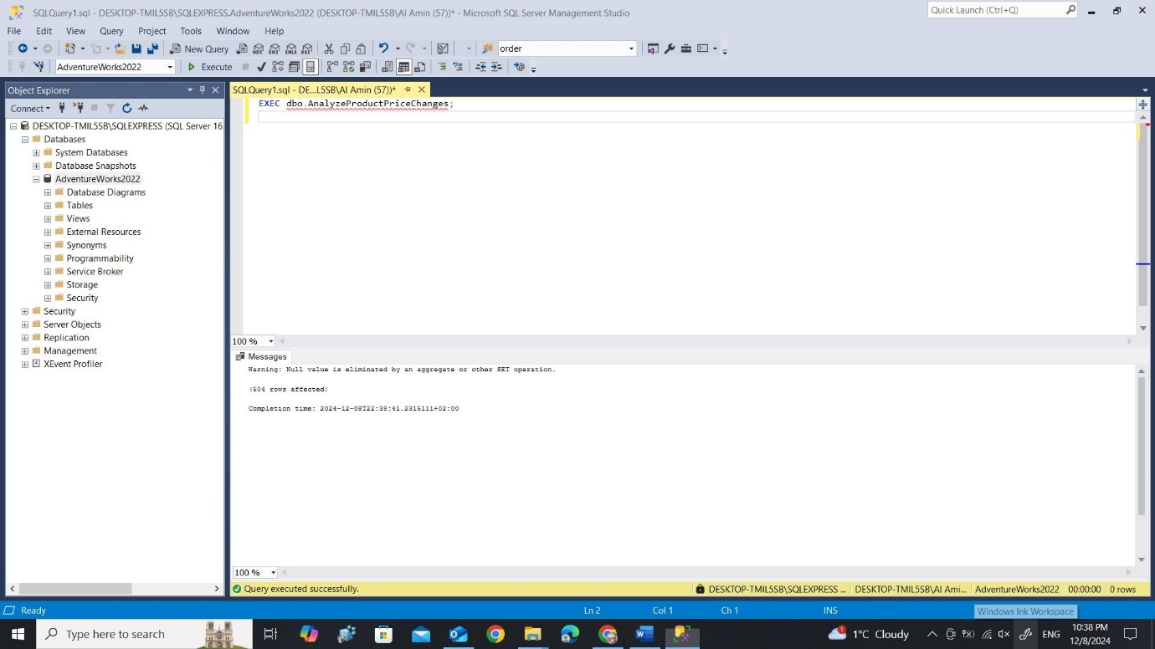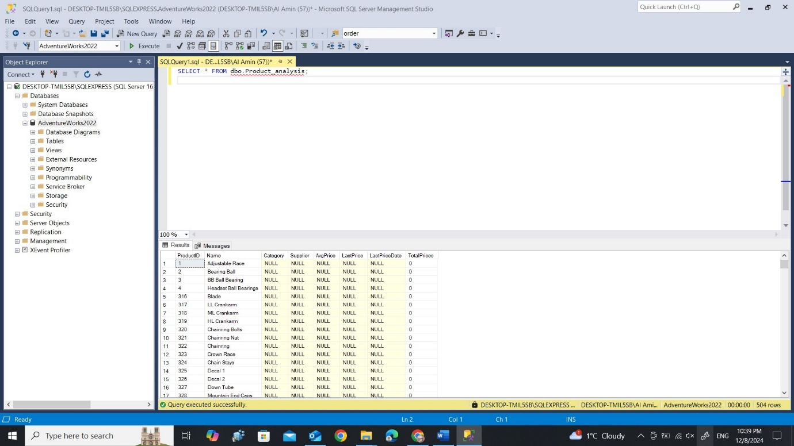

Summary
- Transactions were analyzed for their role in ensuring database consistency and error handling.
- Three custom procedures were created:
  - A transaction with two inserts and rollback functionality.
  - A procedure to create and populate the old_tmp table with users having the oldest passwords.
  - A procedure to analyse product price changes and generate a summary table.
All procedures were tested, and screenshots of results were included in the report.

