REPORT
Step 1 :
CREATE TABLE groups (
ID INT AUTO_INCREMENT PRIMARY KEY,
group_name VARCHAR(50) NOT NULL);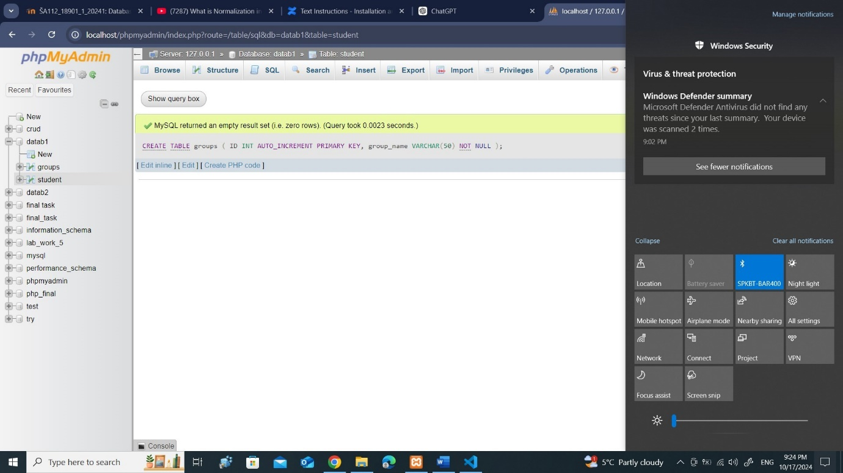
step 2 :
INSERT INTO groups (group_name)
SELECT DISTINCT `group` FROM student;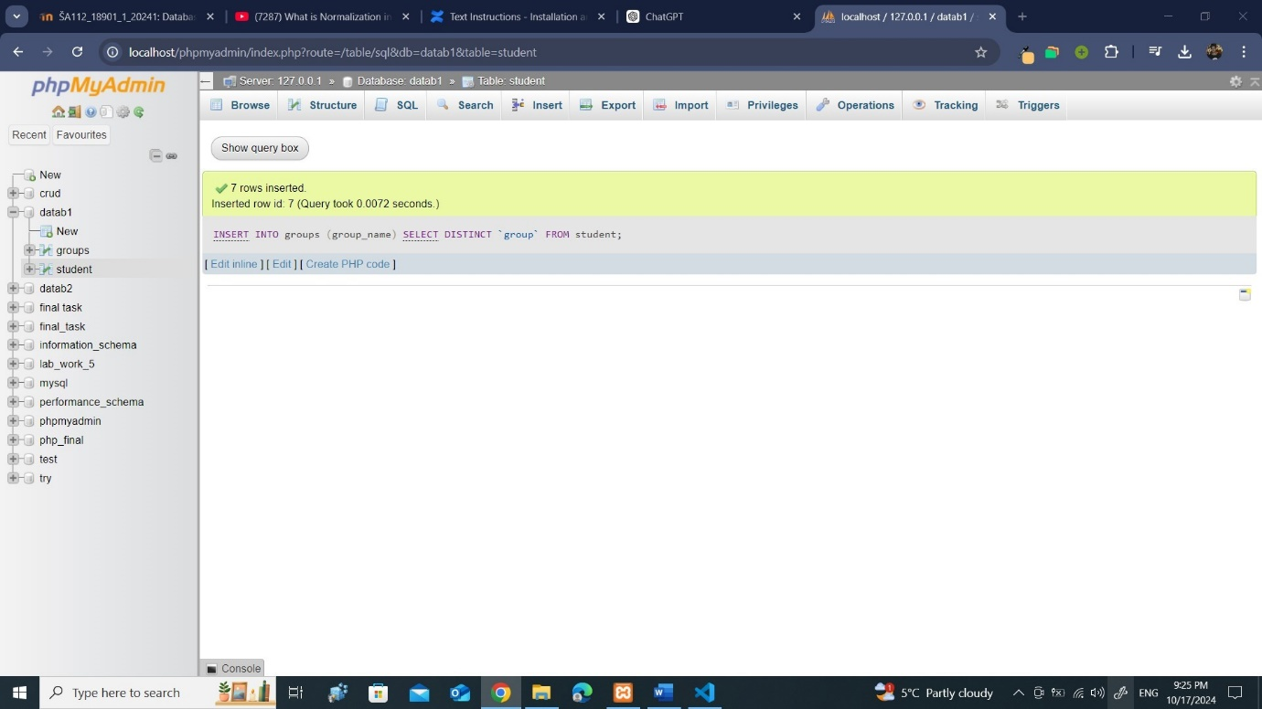
Step 3 :
ALTER TABLE student
ADD COLUMN groups_ID INT;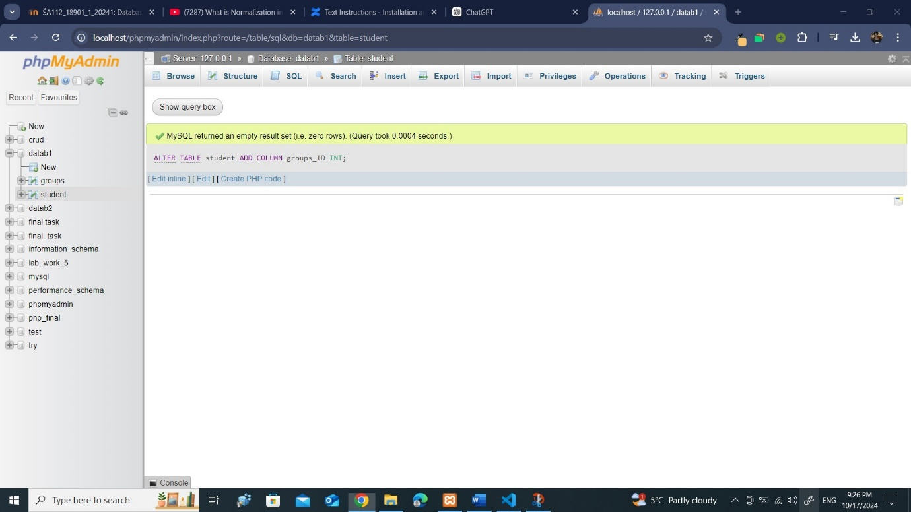
Step 4 :
UPDATE student
INNER JOIN groups ON student.`group` = groups.group_name
SET student.groups_ID = groups.ID;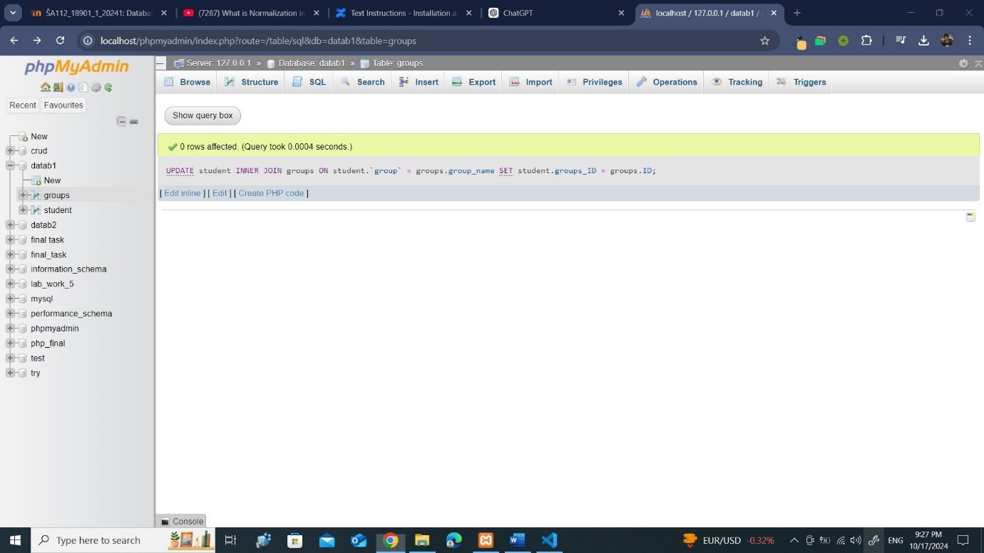
Step 5 :
ALTER TABLE student
DROP COLUMN `group`;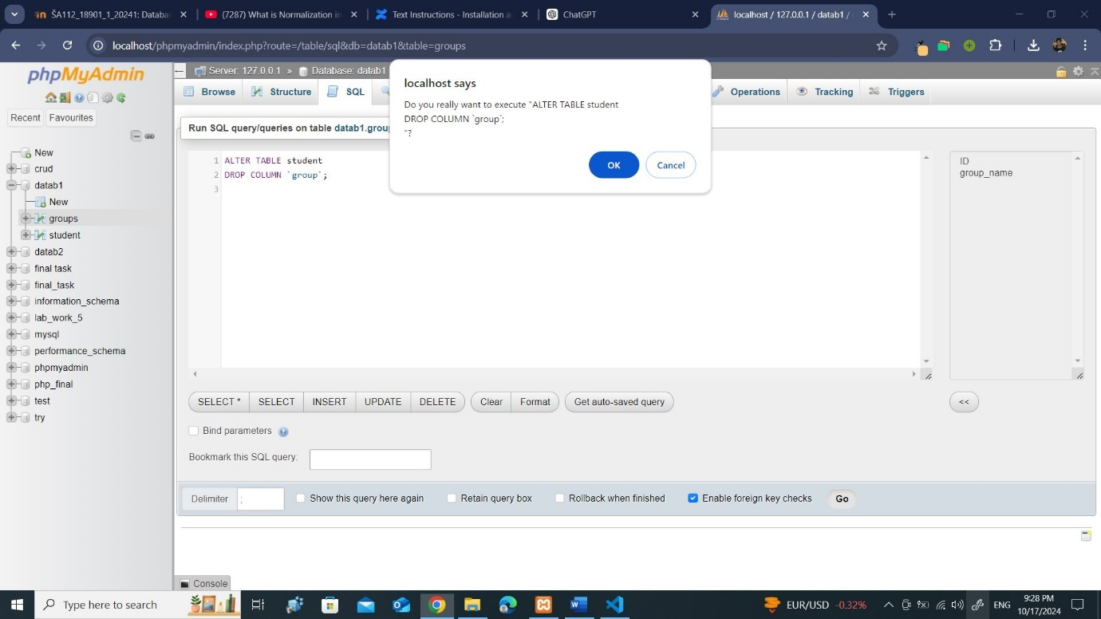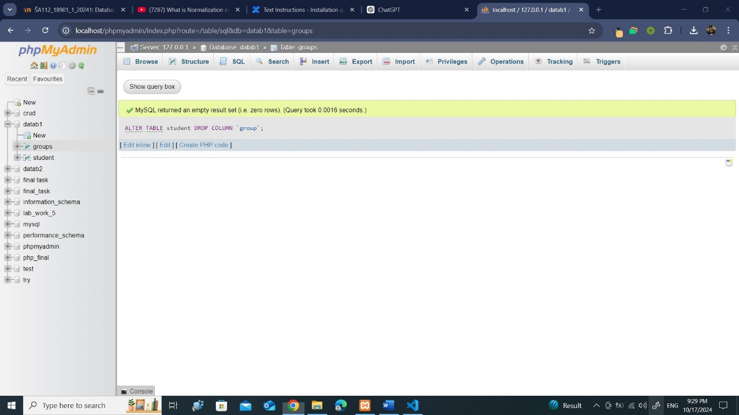
Step 6 :
ALTER TABLE student
ADD CONSTRAINT fk_groups
FOREIGN KEY (groups_ID) REFERENCES groups(ID);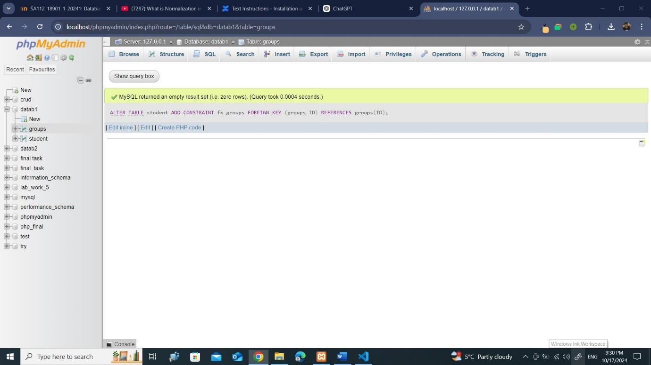step 7 :
CREATE TABLE cities (
ID INT AUTO_INCREMENT PRIMARY KEY,
city_name VARCHAR(50) NOT NULL
);

CREATE TABLE statuses (
ID INT AUTO_INCREMENT PRIMARY KEY,
status_name VARCHAR(50) NOT NULL
);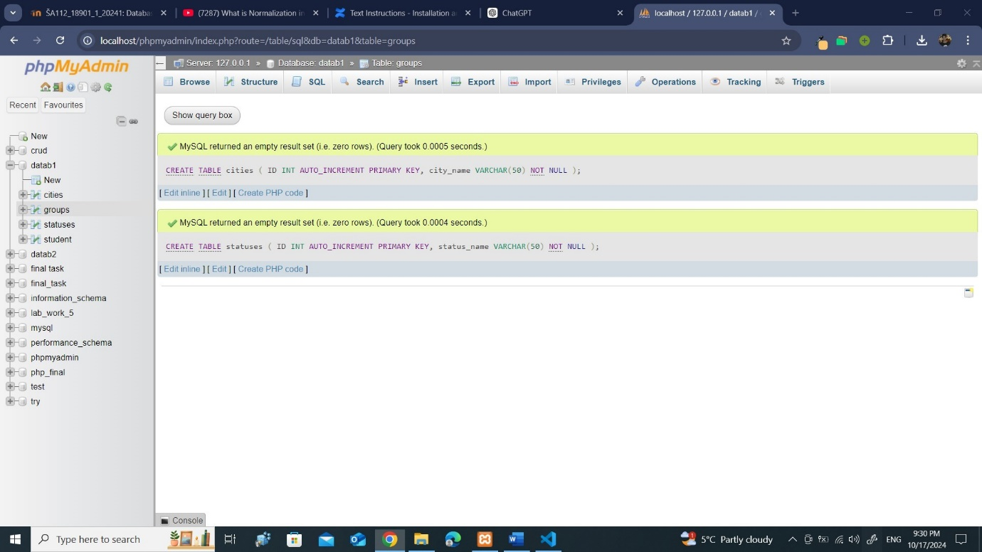
Step 8 :
INSERT INTO cities (city_name)
SELECT DISTINCT city FROM student;

INSERT INTO statuses (status_name)
SELECT DISTINCT status FROM student;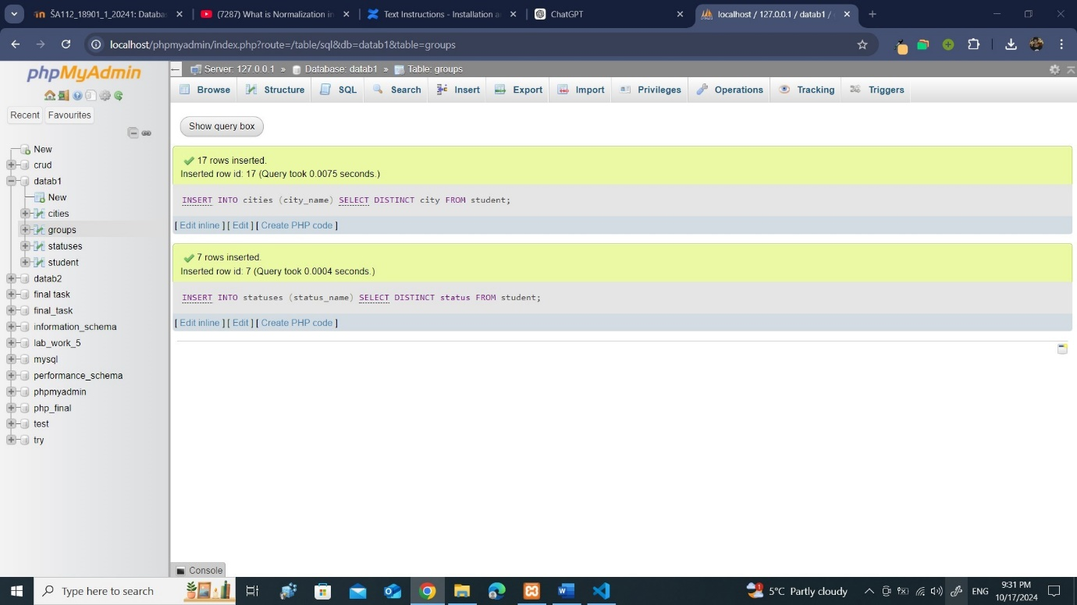
Step 9 :
ALTER TABLE student
ADD COLUMN city_ID INT,
ADD COLUMN status_ID INT;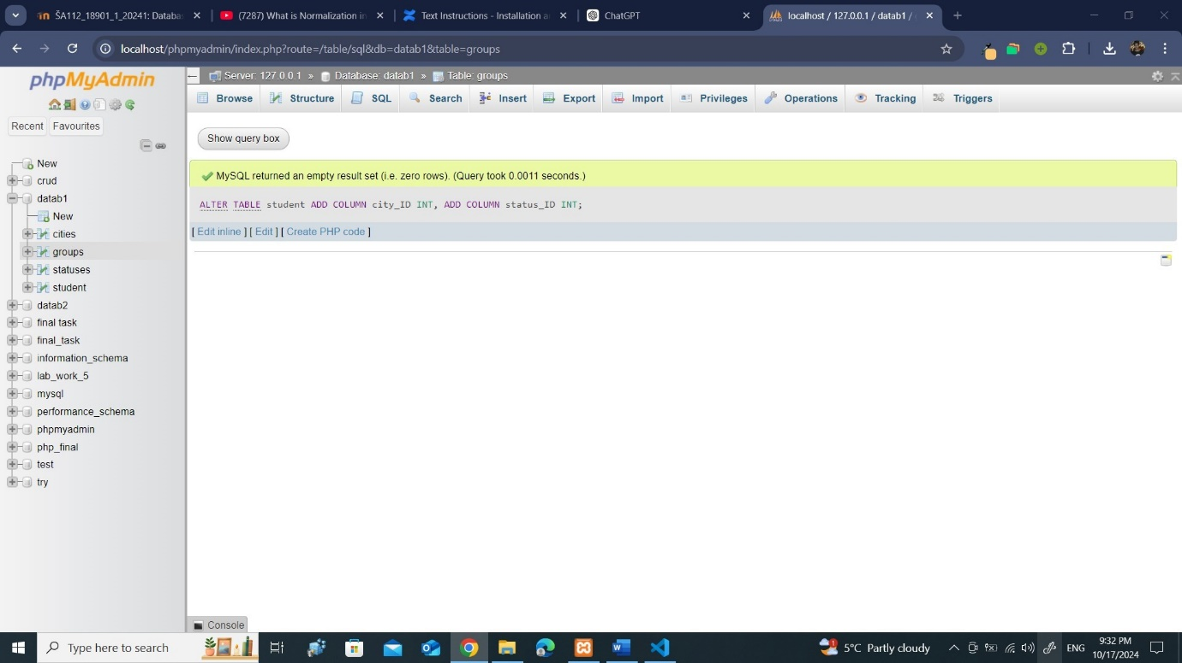

step 10 :
UPDATE student
INNER JOIN cities ON student.city = cities.city_name
SET student.city_ID = cities.ID;

UPDATE student
INNER JOIN statuses ON student.status = statuses.status_name
SET student.status_ID = statuses.ID;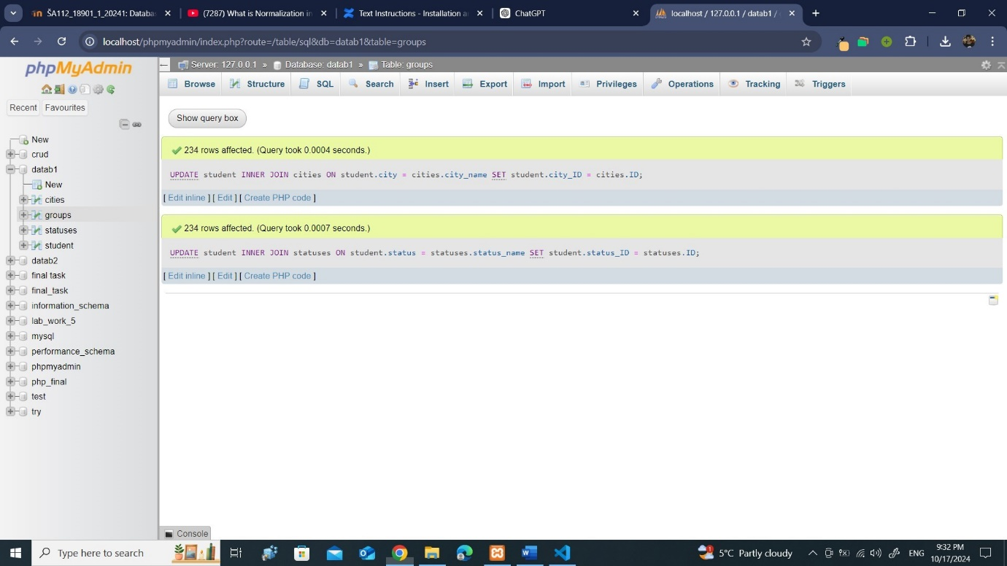
Step 11 :
ALTER TABLE student
DROP COLUMN city,
DROP COLUMN status;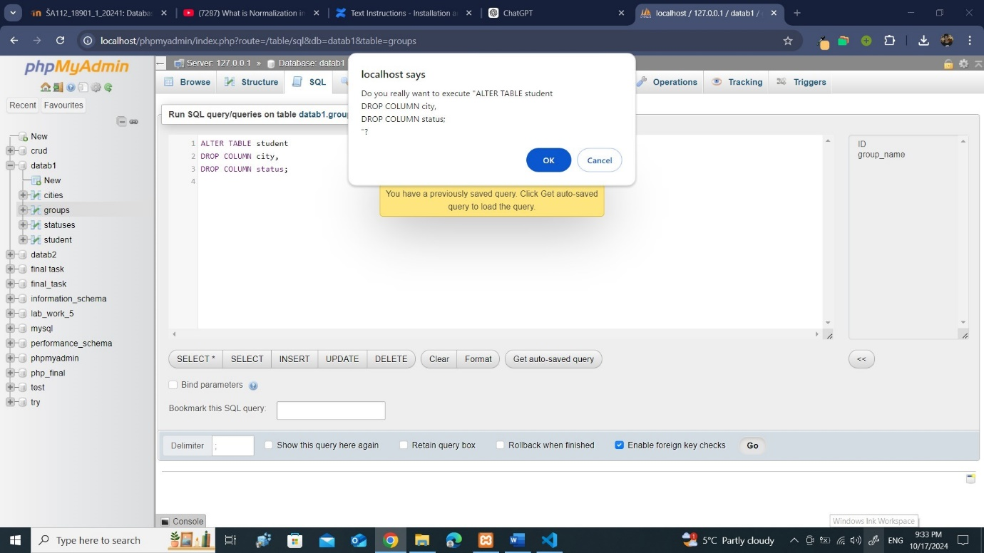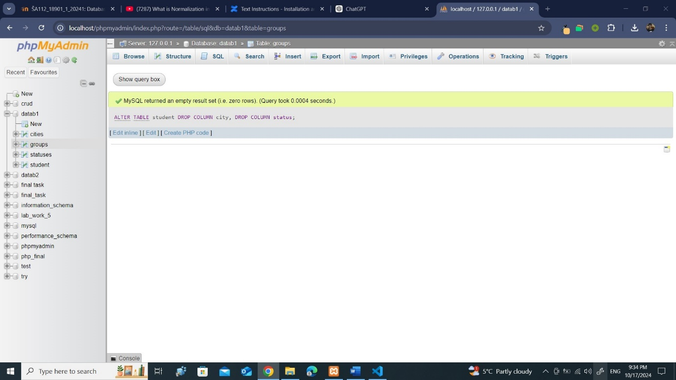
Step 12 :
ALTER TABLE student
ADD CONSTRAINT fk_cities
FOREIGN KEY (city_ID) REFERENCES cities(ID);

ALTER TABLE student
ADD CONSTRAINT fk_statuses
FOREIGN KEY (status_ID) REFERENCES statuses(ID);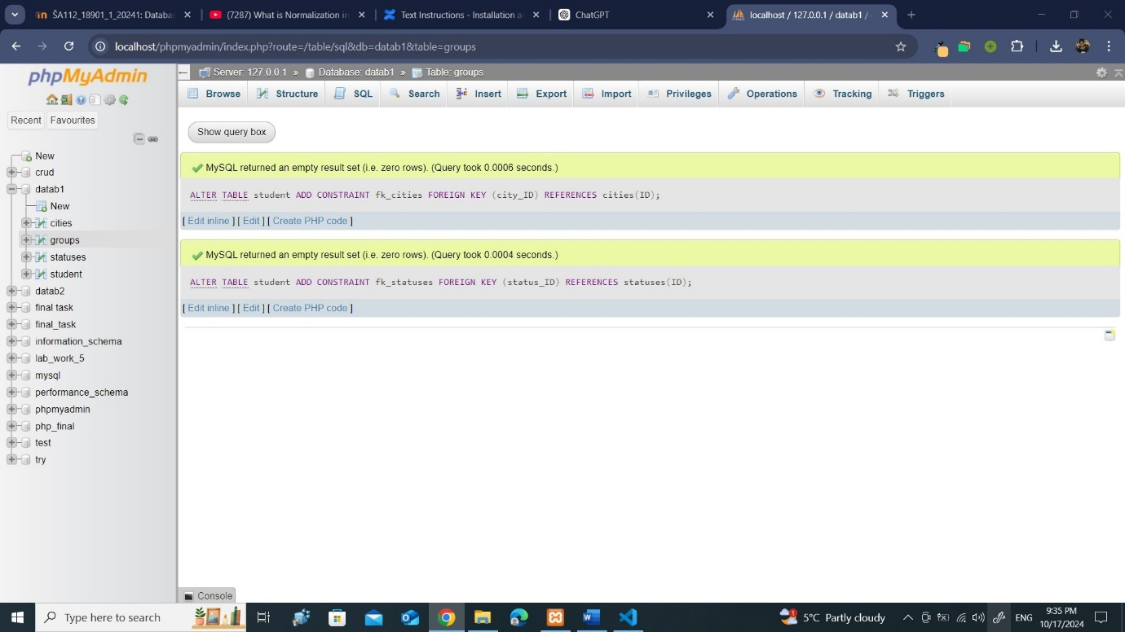

And this is how the new database looks.