Database Functions Assignment
Introduction;
This report demonstrates the creation and usage of SQL functions to retrieve data from the AdventureWorks database. The task involved creating:
- A Table-Valued Function to find employees by job title and arrange them by vacation hours.
- A Scalar-Valued Function to retrieve an employee's salary rate based on their Person ID.
Both functions were implemented, tested, and the results are documented below.

Table-Valued Function:
Objective:
This function retrieves employee details (FirstName, LastName, VacationHours) from the Employee and Person tables filtered by JobTitle and outputs the data unsorted. Sorting is applied during function execution.
SQL Code
CREATE FUNCTION dbo.GetEmployeesByJobTitle
(
@JobTitle NVARCHAR(50) -- Input parameter for the job title
)
RETURNS TABLE
AS
RETURN
(
SELECT
p.FirstName,
p.LastName,
e.VacationHours
FROM
HumanResources.Employee e
INNER JOIN
Person.Person p
ON
e.BusinessEntityID = p.BusinessEntityID
WHERE
e.JobTitle = @JobTitle -- Filters by the specified job title
);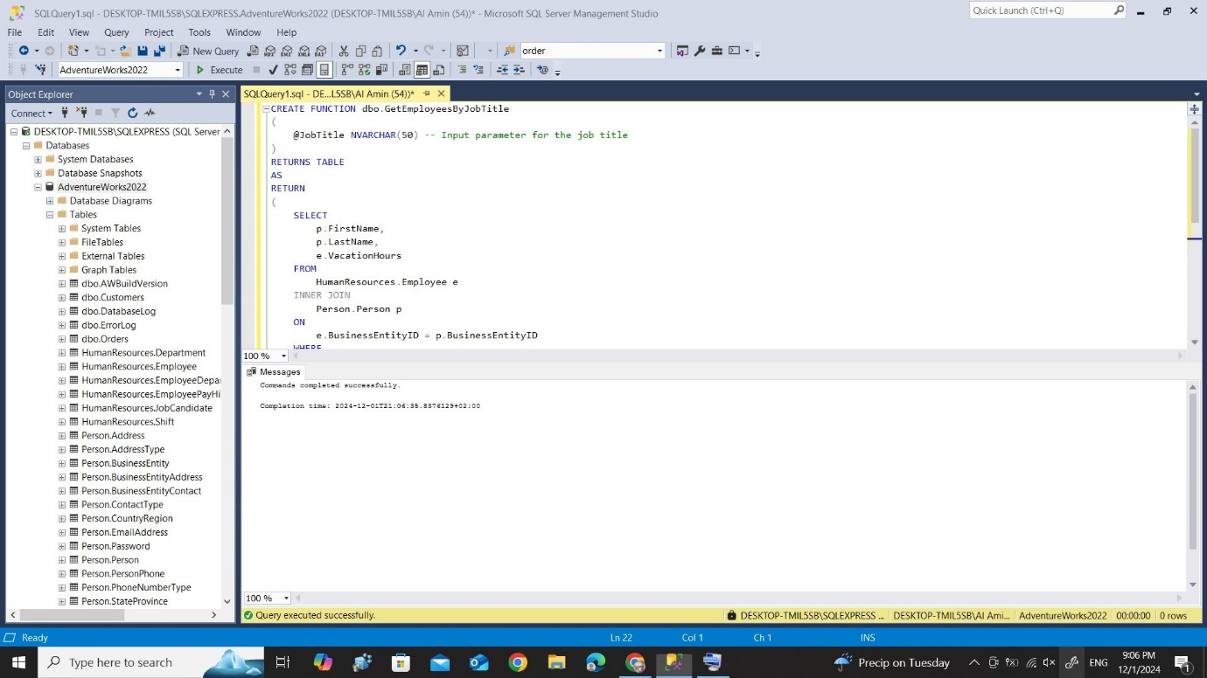
Execution Example:
SELECT *
FROM dbo.GetEmployeesByJobTitle('Engineering Manager')
ORDER BY VacationHours ASC; -- Sorting applied here
Screenshot of Results:
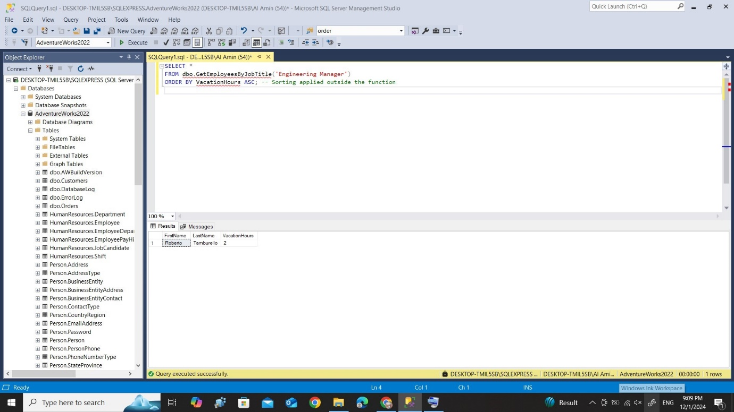

Scalar-Valued Function:
Objective:
This function retrieves the salary rate (Rate) of an employee from the EmployeePayHistory table based on their PersonID.
SQL Code
CREATE FUNCTION dbo.GetEmployeeSalaryRate
(
@PersonID INT -- Input parameter for the person's ID
)
RETURNS DECIMAL(10, 2)
AS
BEGIN
DECLARE @SalaryRate DECIMAL(10, 2); -- Variable to store the salary rate

SELECT
@SalaryRate = eph.Rate
FROM
HumanResources.EmployeePayHistory eph
INNER JOIN
HumanResources.Employee e
ON
eph.BusinessEntityID = e.BusinessEntityID
WHERE
e.BusinessEntityID = @PersonID;

RETURN @SalaryRate;
END;

Execution Example
SELECT dbo.GetEmployeeSalaryRate(1) AS SalaryRate;
Screenshot of Results:
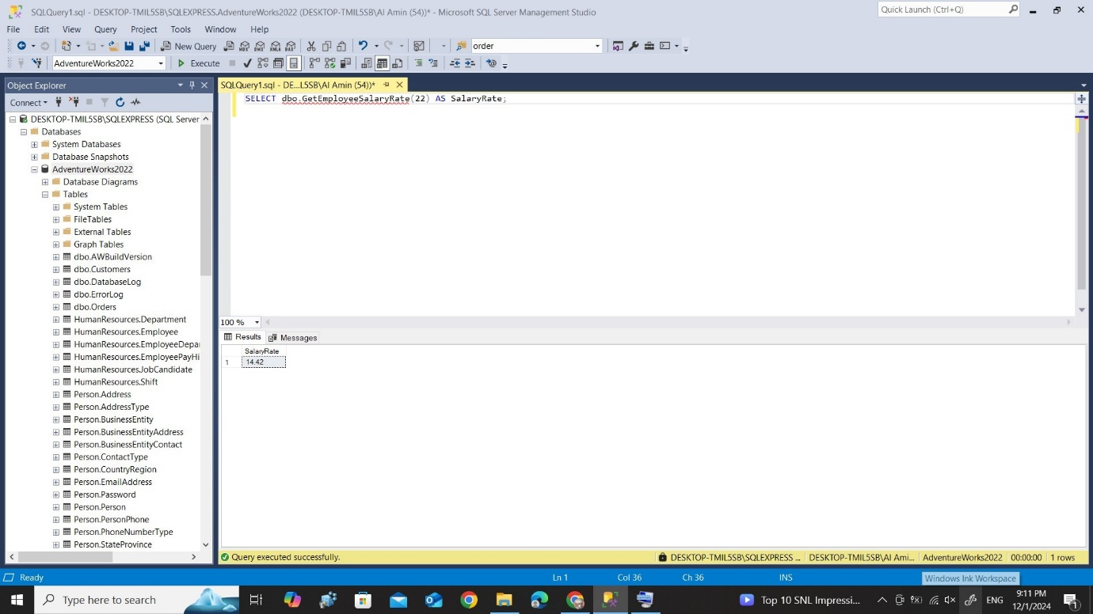

Conclusion:
Both functions were successfully created and tested. The following were accomplished:
- Table-Valued Function: Retrieves employee details filtered by JobTitle, and sorting is applied during execution.
- Scalar-Valued Function: Retrieves the salary rate of an employee based on their PersonID.
The screenshots of the test results are attached for reference.

