**PHP 5 Command-Line on Windows**

**Method 1: All-in-One Installation**

There are some excellent all-in-one Windows distributions that contain Apache, PHP, MySQL and other applications in a single installation file, e.g. [XAMPP](http://www.apachefriends.org/en/xampp.html), [WampServer](http://www.wampserver.com/en/) and [Web.Developer](http://www.devside.net/server/webdeveloper).

## Download and Install the latest WampServer from [here](http://www.wampserver.com/en/).

## Changing Environment Variables in Windows

1. Open up your System Control Panel and choose “Advanced system Settings”.
2. From the Advanced Tab, click on the Environment Variables button on the bottom.

[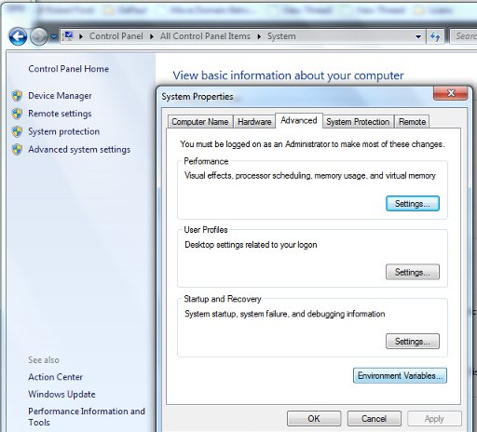](http://willj.co/wp-content/uploads/2012/10/setting-php-path-var-02.jpg)

1. From the System Variables section (bottom half) scroll down until you find the Path variable.
2. A lot of the time you’ll have additional filepaths separated by semi-colons(;) – they’re automatically added when you install some programs.
3. You need to add your WAMP php.exe filepath to the end of these strings.

[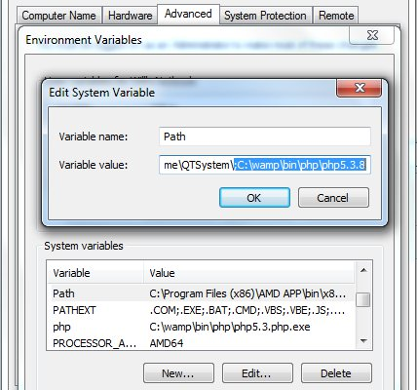](http://willj.co/wp-content/uploads/2012/10/setting-php-path-var-03.jpg)

1. NOTE: you don’t actually include the \php.exe portion.  With that in mind, you need to make sure there are no other files that start with php.  If you have a standard installation of WAMP you’ll be okay.  Just watch out for .dll files.
2. Once you’ve entered your path, hit OK and restart your comptuer.
3. Once you’ve restarted, try running a script by using: php your_script_name.php

**Method 2: Manual Installation: Install PHP 5 as an Apache 2.2 module**

Before installing PHP 5, make sure have a working local installation of Apache on your Windows PC; if not installed follow steps below: else proceed to PHP 5 manual installation:

**Apache Manual Installation:**

**Step 1: configure IIS, Skype and other software (optional)**

If you have a Professional or Server version of Windows, you may already have IIS installed. If you would prefer Apache, either [remove IIS as a Windows component or disable its services](http://support.microsoft.com/kb/321141).

Apache listens for requests on TCP/IP port 80. The default installation of Skype also listens on this port and will cause conflicts. To switch it off, start Skype and choose Tools > Options > Advanced > Connection. Ensure you untick “Use port 80 and 443 as alternatives for incoming connections”.

### Step 2: download the files

We are going to use the unofficial Windows binary from [Apache Lounge](http://www.apachelounge.com/). This version has performance and stability improvements over the official Apache distribution, although I am yet to notice a significant difference. However, it is provided as a manually installable ZIP file from [www.apachelounge.com/download/](http://www.apachelounge.com/download/)

You should also [download and install the Windows C++ runtime from Microsoft.com](http://www.microsoft.com/downloads/details.aspx?FamilyID=200b2fd9-ae1a-4a14-984d-389c36f85647&DisplayLang=en). You may have this installed already, but there is no harm installing it again.

As always, remember to virus scan all downloads.

### Step 2: extract the files

We will install Apache in C:Apache2, so extract the ZIP file to the root of the C: drive.

Apache can be installed anywhere on your system, but you will need to change the configuration file paths accordingly…

### Step 3: configure Apache

Apache is configured with the text file **confhttpd.conf** contained in the Apache folder. Open it with your favourite text editor.

Note that all file path settings use a ‘/’ forward-slash rather than the Windows backslash. If you installed Apache anywhere other than C:Apache2, now is a good time to search and replace all references to “c:/Apache2″.

There are several lines you should change for your production environment:

Line 46, listen to all requests on port 80:

Listen *:80

Line 116, enable mod-rewrite by removing the # (optional, but useful):

LoadModule rewrite_module modules/mod_rewrite.so

Line 172, specify the server domain name:

ServerName localhost:80

Line 224, allow .htaccess overrides:

AllowOverride All

### Step 4: change the web page root (optional)

By default, Apache return files found in its htdocs folder. I would recommend using a folder on an another drive or partition to make backups and re-installation easier. For the purposes of this example, we will create a folder called D:WebPages and change httpd.conf accordingly:

Line 179, set the root:

DocumentRoot "D:/WebPages"

and line 204:

<Directory "D:/WebPages">

### Step 5: test your installation

Your Apache configuration can now be tested. Open a command box (Start > Run > cmd) and enter:

cd Apache2bin

httpd -t

Correct any httpd.conf configuration errors and retest until none appear.

### Step 6: install Apache as a Windows service

The easiest way to start Apache is to add it as a Windows service. From a command prompt, enter:

cd Apache2bin

httpd -k install

Open the Control Panel, Administrative Tools, then Services and double-click Apache2.2. Set the Startup type to “Automatic” to ensure Apache starts every time you boot your PC.

Alternatively, set the Startup type to “Manual” and launch Apache whenever you choose using the command “net start Apache2.2″.

### Step 7: test the web server

Create a file named index.html in Apache’s web page root (either htdocs or D:WebPages) and add a little HTML code:

<html>

<head><title>testing Apache</title></head>

<body><p>Apache is working!</p></body>

</html>

Ensure Apache has started successfully, open a web browser and enter the address**http://localhost/**. If all goes well, your test page should appear.

In general, most problems will be caused by an incorrect setting in the httpd.conf configuration file. Refer to the [Apache documentation](http://httpd.apache.org/docs/2.2/) if you require further information.

**PHP 5 Manual Installation**

**Step 1: download the files**

Download the latest PHP 5 ZIP package from [www.php.net/downloads.php](http://www.php.net/downloads.php)

**Step 2: extract the files**

We will install the PHP files to C:php, so create that folder and extract the contents of the ZIP file into it.

PHP can be installed anywhere on your system, but you will need to change the paths referenced in the following steps.

**Step 3: configure php.ini**

Copy C:phpphp.ini-recommended to C:phpphp.ini. There are several lines you will need to change in a text editor (use search to find the current setting).

Define the extension directory:

extension_dir = "C:phpext"

Enable extensions. This will depend on the libraries you want to use, but the following extensions should be suitable for the majority of applications (remove the semi-colon comment):

extension=php_curl.dll

extension=php_gd2.dll

extension=php_mbstring.dll

extension=php_mysql.dll

extension=php_mysqli.dll

extension=php_pdo.dll

extension=php_pdo_mysql.dll

extension=php_xmlrpc.dll

If you want to send emails using the PHP mail() function, enter the details of an SMTP server (your ISP’s server should be suitable):

[mail function]

; For Win32 only.

SMTP = mail.myisp.com

smtp_port = 25

; For Win32 only.

sendmail_from = my@emailaddress.com

**Step 4: add C:php to the path environment variable**

To ensure Windows can find PHP, you need to change the path environment variable. From the Control Panel, choose System, (then “Advanced system settings” in Vista), select the “Advanced” tab, and click the “Environment Variables” button.

Scroll down the System variables list and click on “Path” followed by the “Edit” button. Enter “**;C:php**” to the end of the Variable value line (remember the semi-colon).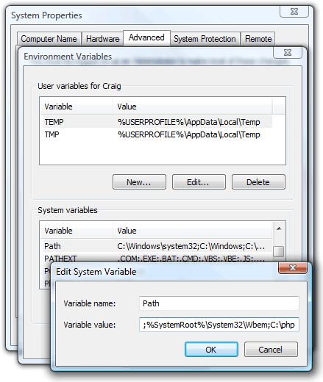

Now OK your way out. You might need to reboot at this stage.

**Step 5: configure PHP as an Apache module**

Ensure Apache is not running (use “net stop Apache2.2″ from the command line) and open its confhttpd.conf configuration file in an editor. The following lines should be changed:

Line 239, add index.php as a default file name:

DirectoryIndex index.php index.html

At the bottom of the file, add the following lines (change the PHP file locations if necessary):

# PHP5 module

LoadModule php5_module "c:/php/php5apache2_2.dll"

AddType application/x-httpd-php .php

PHPIniDir "C:/php"

Save the configuration file and test it from the command line (Start > Run > cmd):

cd Apache2bin

httpd -t

**Step 6: test a PHP file**

Create a file named index.php in Apache’s web page root (either htdocs or D:WebPages) and add this code:

<?php phpinfo(); ?>

Ensure Apache has started successfully, open a web browser and enter the address**http://localhost/**. If all goes well, a “PHP version” page should appear showing all the configuration settings.