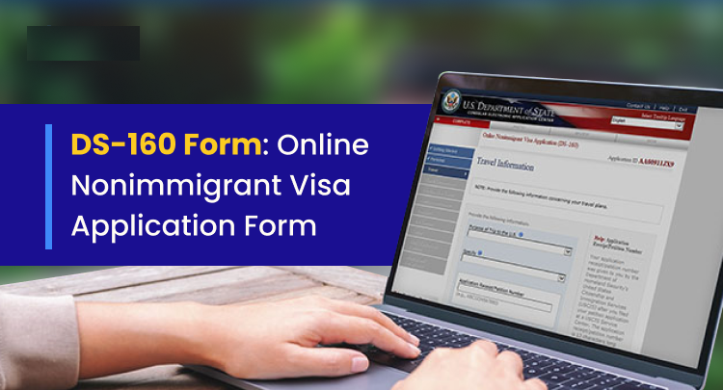
DS-160 Submission Report
Date: 12/13/2025
Question | Answer
Full Name (Arabic) | ﻲﻠﻋ ﺪﻤﺤﻣ
First Name (Arabic) | ﺪﻤﺤﻣ
Last Name (Arabic) | ﻲﻠﻋ
Current_Workplace | ﺔﻴﺳﺪﻨﻬﻟﺍ ﺕﺎﻣﺪﺨﻠﻟ ﻒﻳﻮﺳ ﻰﻨﺑ
ContactInformation | ﺮﺼﻣ ،ﺓﺮﻫﺎﻘﻟﺍ

