House Price Prediction
Ames Housing Dataset — Complete Project Report
An End-to-End Machine Learning Regression Project
Data Exploration • Missing Value Handling • Feature Engineering • Model Training & Evaluation
Prepared by: Data Science Team
Date: September 2026

01. Executive Summary

The goal of this project is to build a machine learning model that accurately predicts the sale price (SalePrice) of residential homes in Ames, Iowa, using a wide range of property characteristics. The dataset contains 2,930 house records with 82 features, spanning both numerical and categorical data types.
The complete workflow covers dataset overview, missing value analysis, exploratory data analysis (EDA), outlier handling, feature engineering, feature selection, training of multiple models, hyperparameter tuning, cross-validation, and error analysis. Six regression models (Linear Regression, Ridge, Lasso, Random Forest, Gradient Boosting, XGBoost) were trained and compared; a GridSearchCV-tuned Gradient Boosting model delivered the best performance.

Key Metric | Value
Best Model | Gradient Boosting Regressor (Tuned)
Test Set R² Score | 0.9429 (≈ 94.3% of variance explained)
5-Fold Cross-Validation R² | 0.9039 ± 0.0139
Mean Absolute Error (MAE) | $14,563.90
Root Mean Squared Error (RMSE) | $21,453.34
R² Improvement over Baseline | +94.38%
RMSE Reduction over Baseline | −76.11%
Most Important Features | Overall Qual (41.1%), Total SF (36.1%)

In summary, the overall quality of a house and its total square footage are the dominant drivers of sale price, together accounting for roughly 77% of the model's decision-making. The model is most accurate for low- and mid-priced homes, and shows relatively higher error in the luxury segment (>$400K).

02. Dataset Overview

This project uses the well-known Ames Housing Dataset, which contains residential property sale records from Ames, Iowa.
Attribute | Value
Total Records (Rows) | 2,930
Total Columns | 82
Numerical Features | ≈ 38
Categorical Features | ≈ 44
Target Variable | SalePrice (house sale price, USD)

SalePrice (Target Variable) Statistics
Statistic | Value (USD)
Mean | ≈ $180,921
Median | ≈ $163,000
Standard Deviation | ≈ $79,887
Minimum | ≈ $12,789
Skewness | 1.74 (right-skewed)
Kurtosis | 5.12

A skewness of 1.74 indicates that most house prices are concentrated in a relatively lower range, while a number of expensive luxury homes create a long right tail — a typical pattern for real-estate price distributions.

03. Exploratory Data Analysis (EDA)

3.1 Distribution of the Target Variable
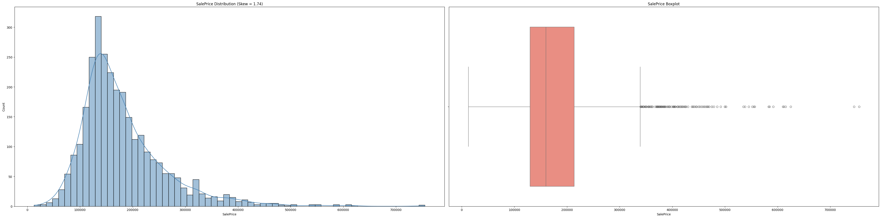
Figure 1: Histogram (left) and boxplot (right) of SalePrice
Interpretation: The histogram clearly shows a right-skewed distribution — most homes are priced between $100K and $250K. The boxplot reveals a number of outlier points on the upper end (high-priced homes) above $400K. This skewness needs to be accounted for during modeling (e.g. via log-transformation).

3.2 Missing Value Analysis
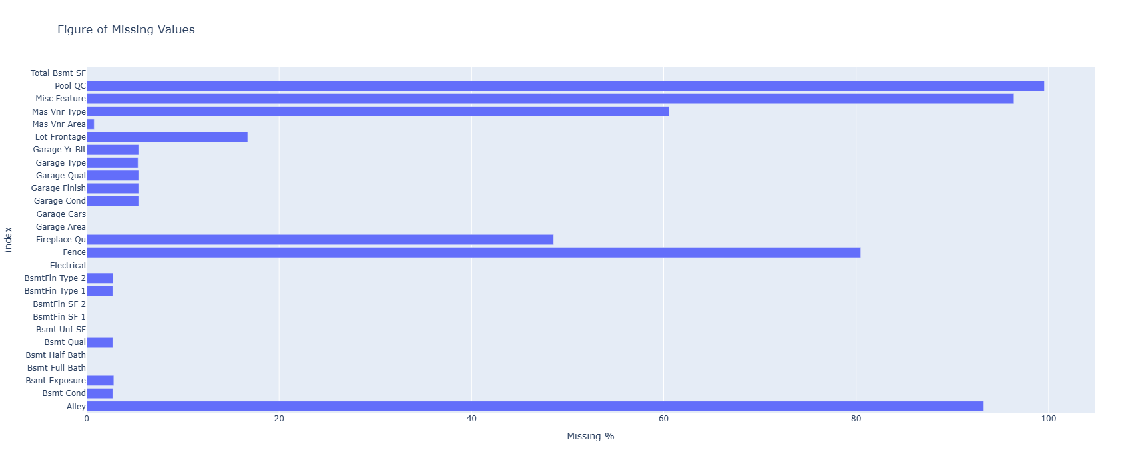
Figure 2: Percentage of missing values per feature
Interpretation: Pool QC (99.5%), Misc Feature (96.1%), Alley (93.2%), and Fence (80.1%) have the highest proportion of missing values. Later analysis (see Section 4) confirms that these missing values are not random errors, but instead indicate that the corresponding feature (e.g. a pool or a fence) simply does not exist for that house.

3.3 Categorical Feature Analysis
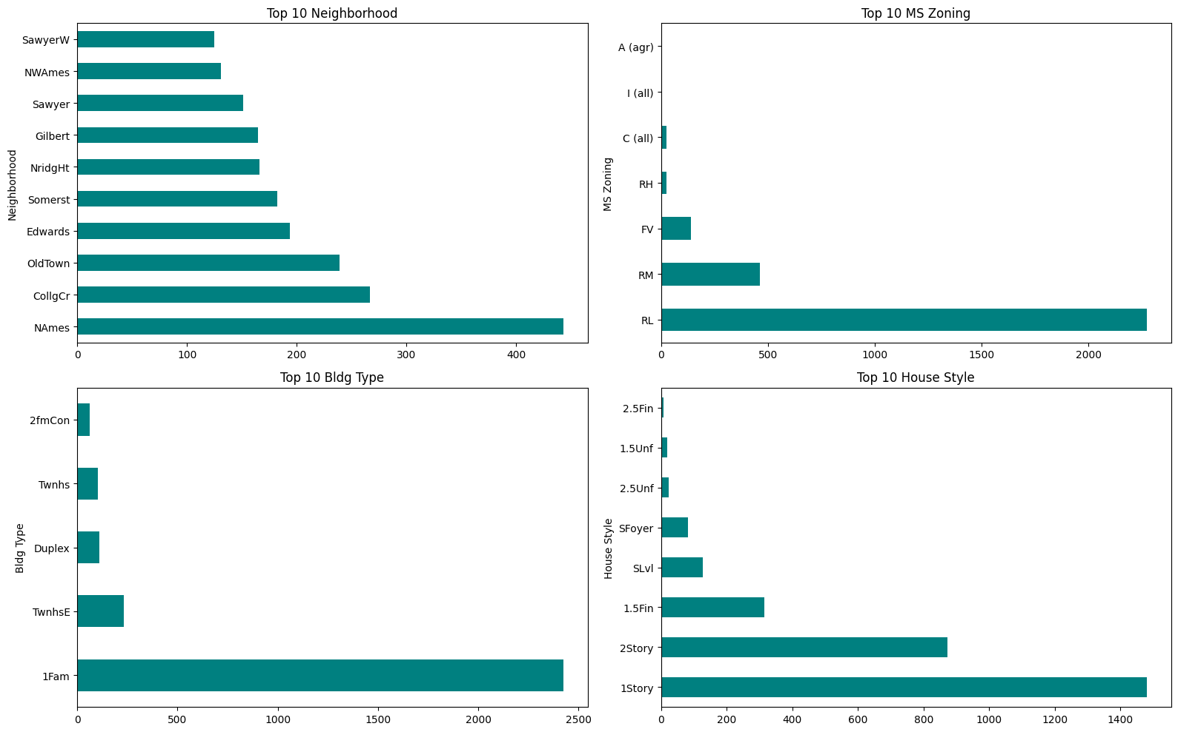
Figure 3: Frequency of the top 10 categories for Neighborhood, MS Zoning, Bldg Type and House Style
Interpretation: NAmes is the most common Neighborhood (443 houses). RL (Residential Low Density) dominates MS Zoning. Single-family homes (1Fam) dominate Bldg Type, and 1-story and 2-story houses are the most common House Styles.

3.4 Correlation Heatmap
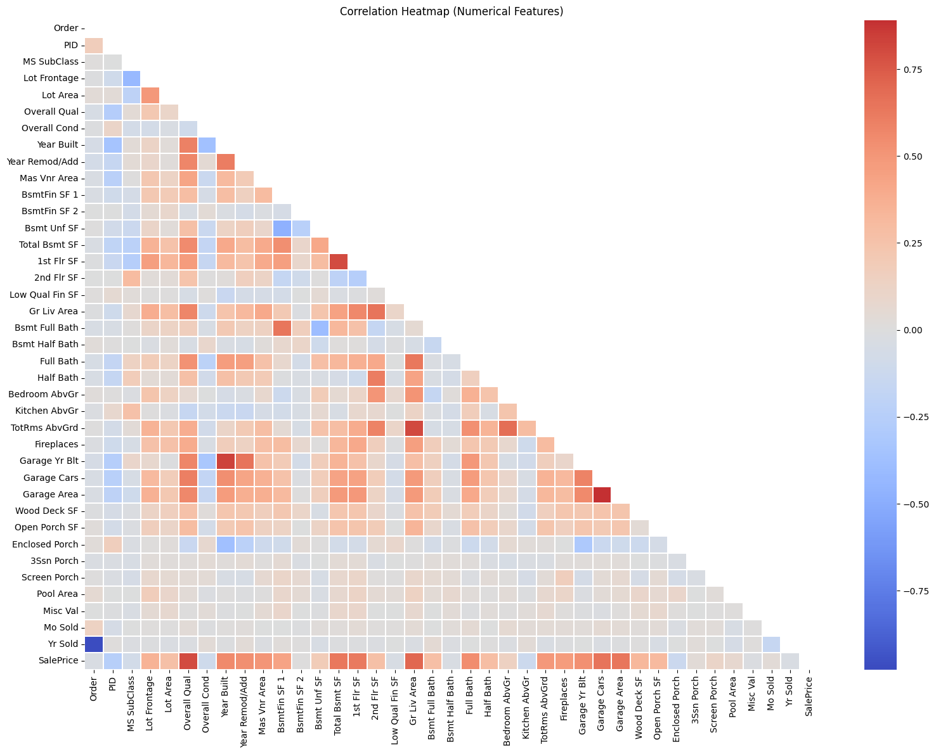
Figure 4: Correlation heatmap of numerical features
Interpretation: Garage Cars and Garage Area show a very strong correlation (a sign of multicollinearity), as do Year Built with Garage Yr Blt, and Gr Liv Area with TotRms AbvGrd. In the SalePrice row (bottom), the darkest red cells — indicating the strongest positive correlation — belong to Overall Qual, Gr Liv Area, Garage Cars/Area, and Total Bsmt SF.

Top 10 Features Correlated with SalePrice
Rank | Feature | Correlation (|r|)
1 | Overall Qual | 0.799
2 | Gr Liv Area | 0.707
3 | Garage Cars | 0.648
4 | Garage Area | 0.640
5 | Total Bsmt SF | 0.632
6 | 1st Flr SF | 0.622
7 | Year Built | 0.558
8 | Full Bath | 0.546
9 | Year Remod/Add | 0.533
10 | Garage Yr Blt | 0.527

3.5 Key Features vs. SalePrice
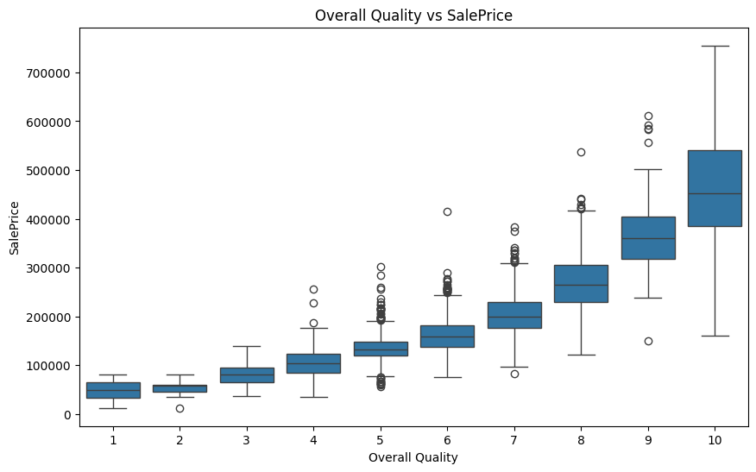
Figure 5: Overall Quality vs. SalePrice (Boxplot)
Interpretation: As the Overall Quality rating increases, the median SalePrice increases in an almost linear fashion — clear evidence of this feature's strong predictive power.
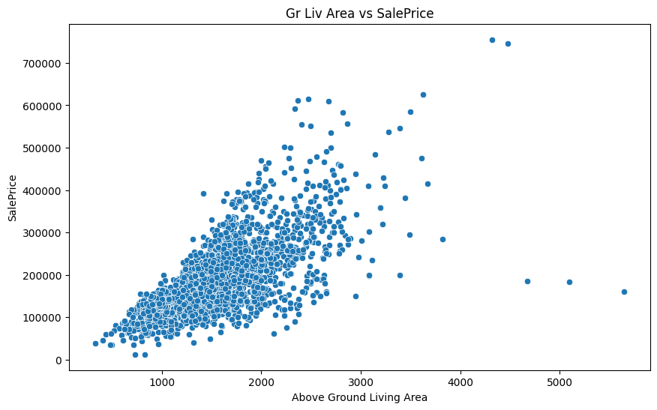
Figure 6: Gr Liv Area (above-ground living area) vs. SalePrice (Scatter)
Interpretation: A clear positive linear relationship is visible — the larger the living area, the higher the price. A few isolated points on the right (large area, low price) are visible, which are treated as outliers in Section 5.
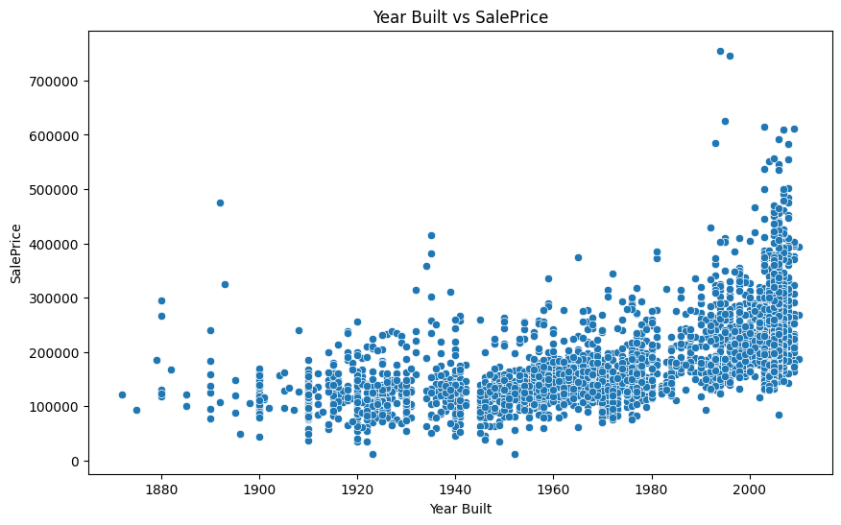
Figure 7: Year Built vs. SalePrice (Scatter)
Interpretation: Newer homes (more recent Year Built) generally command higher prices, though the relationship is not as strong as for Gr Liv Area or Overall Qual (corr ≈ 0.56).

3.6 Neighborhood-Based Price Analysis
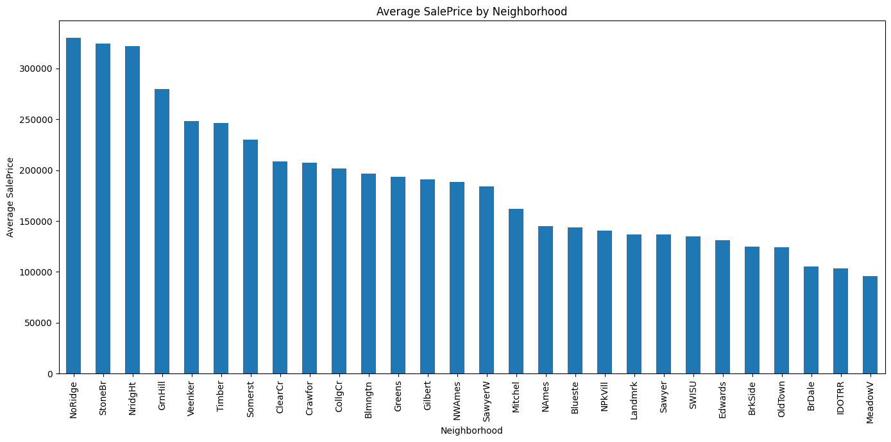
Figure 8: Average SalePrice by Neighborhood
Interpretation: NoRidge (~$330K), StoneBr (~$324K), and NridgHt (~$322K) have the highest average home prices, while MeadowV (~$96K), BrDale (~$106K), and IDOTRR (~$104K) have the lowest. This shows that location is an extremely important determinant of home value.

04. Nature and Handling of Missing Values

Before imputing missing values, it was verified whether they actually represented data-entry errors or simply indicated an "absent feature."
Feature (Missing) | Verification Result | Actual Meaning
Pool QC | All 2,917 houses with missing Pool QC have Pool Area = 0 | No pool
Garage Type | 157 houses with missing Garage Type have Garage Cars = 0 | No garage
Bsmt Qual | 79 houses with missing Bsmt Qual have Total Bsmt SF = 0 | No basement
Fireplace Qu | 1,422 houses with missing Fireplace Qu have Fireplaces = 0 | No fireplace

This verification confirmed that most missing values genuinely represent "feature absent" rather than data errors. Based on this understanding, the following imputation strategy was applied:
Type of Missing Value | Imputation Method
Categorical (feature absent) | Filled with 'None' (14 columns)
Numeric (feature absent) | Filled with 0 (9 columns)
Garage Yr Blt | Filled with Year Built
Lot Frontage | Filled with the Neighborhood-wise median
Remaining categorical | Filled with the mode
Remaining numeric | Filled with the median

After imputation, the dataset had 0 remaining missing values, and a post-imputation check showed that the top correlated features were essentially unchanged (Overall Qual: 0.799, Gr Liv Area: 0.707) — confirming that the imputation process did not distort data quality.

05. Outlier Analysis and Handling

5.1 Outlier Detection with IQR and Z-Score
Feature | Outlier Count (IQR) | Outlier %
Gr Liv Area | 75 | 2.56%
Lot Area | 127 | 4.33%
SalePrice | 137 | 4.68%
Total Bsmt SF | 124 | 4.23%

The Z-score method (|z| > 3) identified 45 outliers in SalePrice.
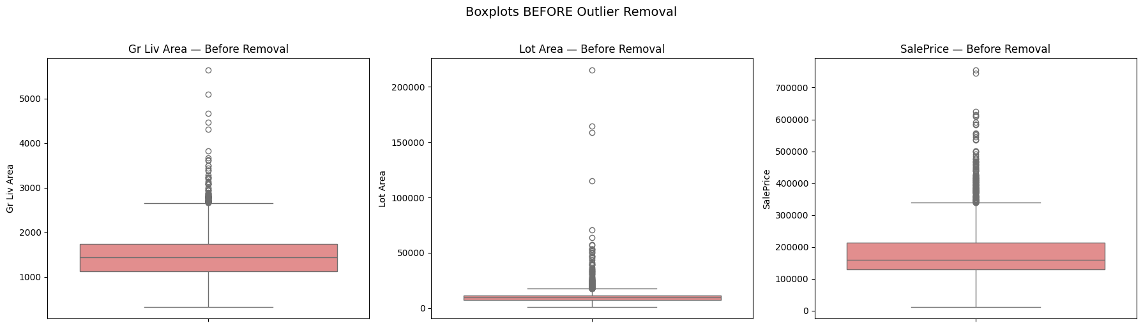
Figure 9: Boxplots before outlier removal
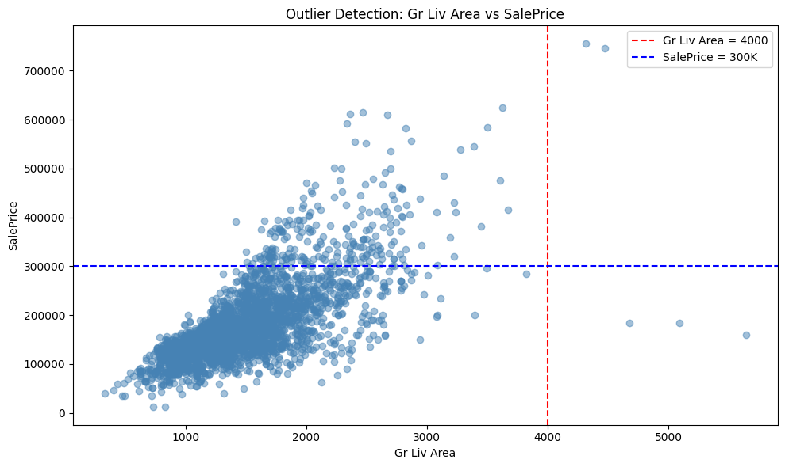
Figure 10: Gr Liv Area vs. SalePrice — flagging the anomalous region
Interpretation: The red and blue dashed lines mark the region where large homes (Gr Liv Area > 4000) sold for under $300,000 — typically a sign of a partial sale or data-entry inconsistency rather than genuine market pricing.

5.2 Conservative Outlier Removal Strategy
Although IQR/Z-score methods flagged many points as outliers, only genuine anomalies were removed, so that legitimate luxury homes were not lost from the dataset.
Type of Outlier | Decision | Rationale
Partial-sale houses (large area, low price) | Removed | Data-entry inconsistency, not real market behavior
Luxury homes (>$700K) | Kept | A legitimate market segment
Unusually large Lot Area | Kept | A genuine property characteristic
Pools / large garages | Kept | A genuine value signal

Condition applied: (Gr Liv Area > 4000) AND (SalePrice < $300,000) — under this condition, only 3 records (just 0.102% of the data) were removed. The final dataset size is 2,927 rows.
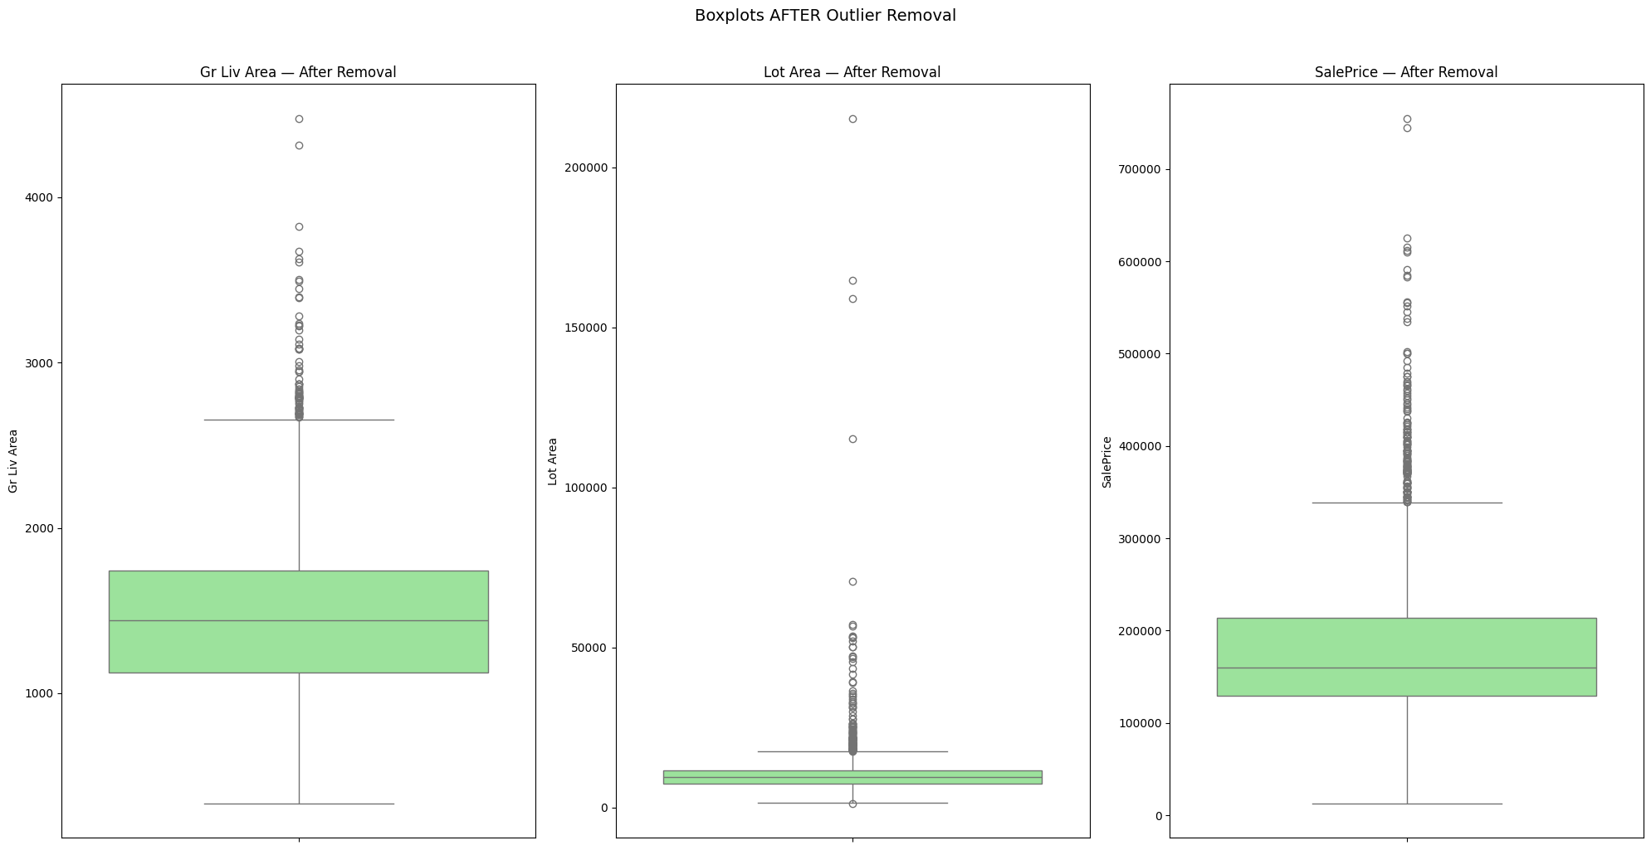
Figure 11: Boxplots after outlier removal
Interpretation: Because a conservative approach was used, most of the IQR-flagged points (such as luxury homes) were retained, and only genuine anomalies were removed — helping the model generalize well even in the high-price segment.

06. Feature Engineering

6.1 New Feature Creation
New Feature | Calculation
Total SF | Total Bsmt SF + 1st Flr SF + 2nd Flr SF
Total Bath | Full Bath + 0.5×Half Bath + Bsmt Full Bath + 0.5×Bsmt Half Bath
House Age | Yr Sold − Year Built
Remod Age | Yr Sold − Year Remod/Add
Is Remodeled | Whether the house was remodeled (Binary: 0/1)
Total Porch SF | Sum of all porch area types

6.2 Encoding
- Ordinal Encoding: quality-indicator columns (Exter Qual, Kitchen Qual, etc. — 10 columns in total) were mapped to a 0–5 scale (None=0, Po=1, Fa=2, TA=3, Gd=4, Ex=5).
- One-Hot Encoding: 33 nominal categorical columns were converted into dummy variables, expanding the dataset shape from (2927, 82) to (2927, 247).

6.3 Transforming Skewed Features
A log1p transformation was applied to 28 numeric features with |skewness| > 0.75 (excluding SalePrice), making their distributions more normal and better suited to linear models.

07. Feature Selection

The top 30 features were selected based on correlation with SalePrice, allowing the model to avoid noise from less-important, low-signal features.
Rank | Feature | Correlation
1 | Total SF (new) | 0.832
2 | Overall Qual | 0.803
3 | Gr Liv Area | 0.701
4 | Exter Qual | 0.689
5 | Kitchen Qual | 0.675
6 | Total Bsmt SF | 0.661
7 | Garage Cars | 0.648
8 | Garage Area | 0.644
9 | Total Bath (new) | 0.639
10 | 1st Flr SF | 0.611

Notably, the engineered feature Total SF achieved the highest correlation of all (0.832) — even higher than any of its original component features (Total Bsmt SF, 1st Flr SF, etc.) — demonstrating that the feature engineering process was effective.

08. Train/Test Split and Feature Scaling

8.1 Train/Test Split
Set | Shape | Percentage
X_train | (2341, 30) | 80%
X_test | (586, 30) | 20%

random_state=42 was used to ensure results are reproducible.

8.2 Model-Aware Feature Scaling
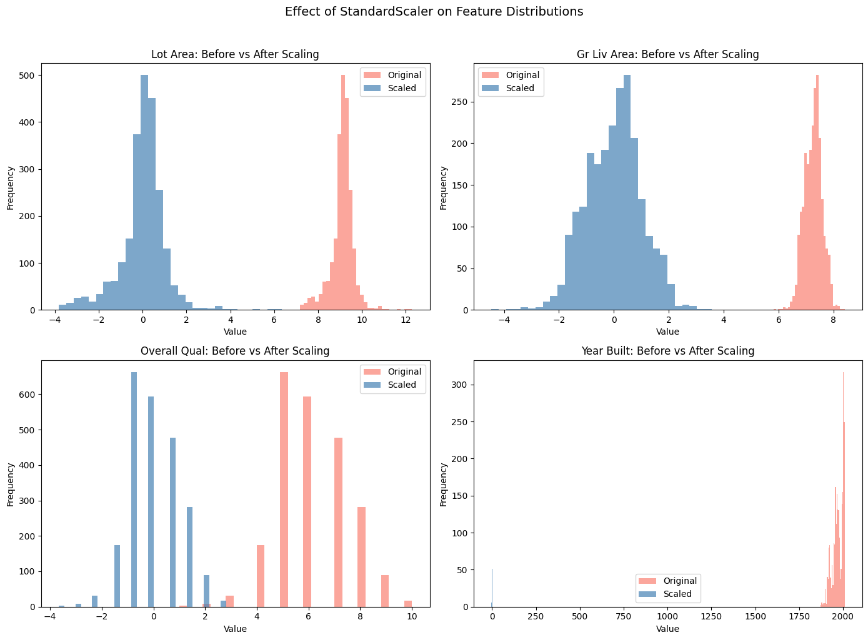
Figure 12: Feature distributions before and after scaling
Interpretation: Given the vast difference in magnitude between features such as Lot Area (order of 10⁵) and Overall Qual (order of 10⁰), a StandardScaler was applied to transform all features to mean=0, std=1 — but only for scale-sensitive models (Linear Regression, Ridge, Lasso). Tree-based models (Random Forest, Gradient Boosting, XGBoost) were trained on unscaled data, since these models split on thresholds and do not require scaling. To avoid data leakage, the scaler was fit only on the training data, and only transformed (not re-fit) on the test data.

09. Model Training and Comparative Evaluation

Six regression models were trained and tested in total: Linear Regression, Ridge, and Lasso (on scaled data), and Random Forest, Gradient Boosting, and XGBoost (on unscaled data).
Model | Scaling | MAE | RMSE | R²
Gradient Boosting 🏆 | No | $14,974.94 | $21,738.16 | 0.9414
Random Forest | No | $15,191.81 | $23,416.65 | 0.9320
XGBoost | No | $17,244.79 | $25,502.23 | 0.9193
Lasso | Yes | $20,180.00 | $29,932.45 | 0.8888
Linear Regression | Yes | $20,180.42 | $29,933.00 | 0.8888
Ridge | Yes | $20,186.60 | $29,961.57 | 0.8886

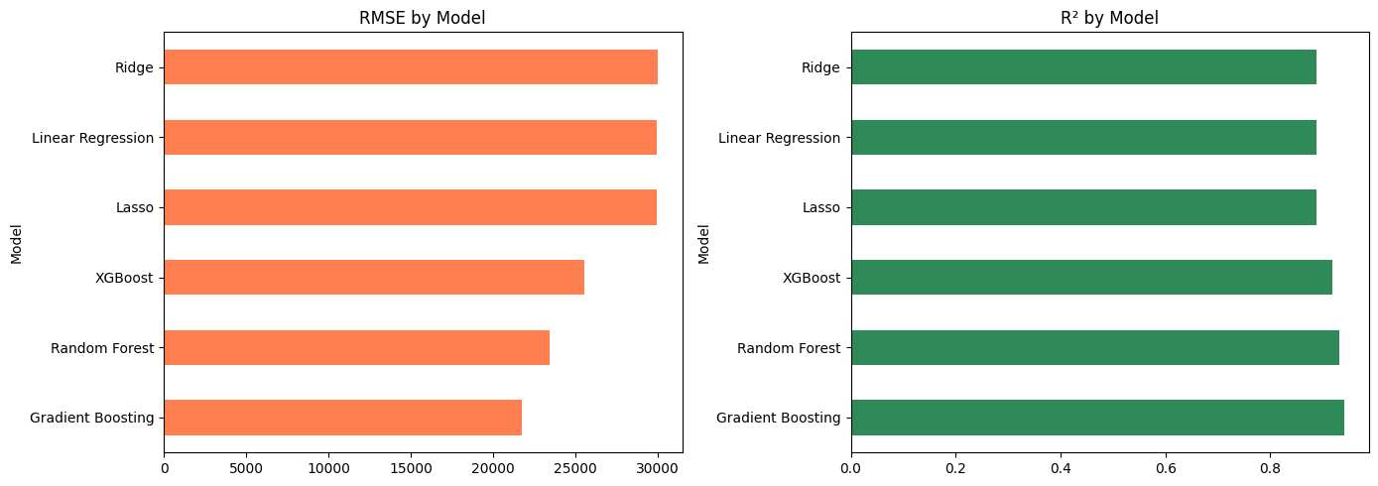
Figure 13: Model comparison by RMSE and R²
Interpretation: Tree-based ensemble models (Gradient Boosting, Random Forest, XGBoost) significantly outperformed the linear models (Linear Regression, Ridge, Lasso) — because the housing data contains non-linear relationships and feature interactions that linear models cannot capture. Gradient Boosting achieved the lowest error and highest R², making it the selected best model.

9.1 Hyperparameter Tuning (GridSearchCV)
A 5-fold GridSearchCV was applied to the best model, Gradient Boosting, to search for optimal hyperparameters (27 combinations, 135 total fits).
Hyperparameter | Best Value
learning_rate | 0.05
max_depth | 3
n_estimators | 300

After tuning, the final model achieved: MAE = $14,563.90, RMSE = $21,453.34, R² = 0.9429 — a modest improvement over the pre-tuning model.

9.2 5-Fold Cross-Validation
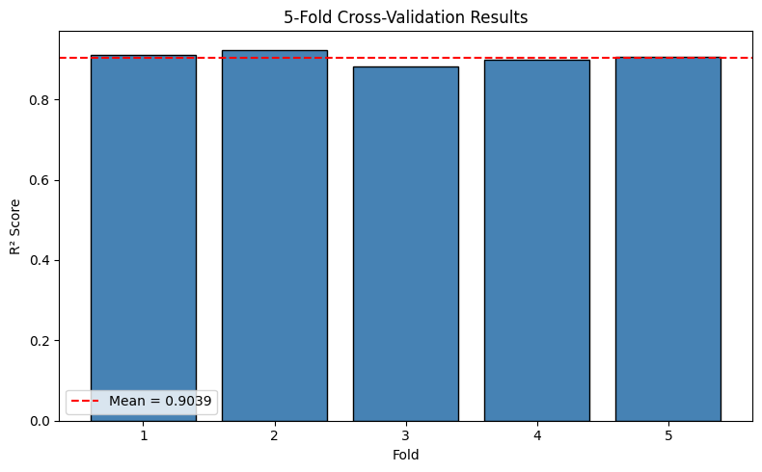
Figure 14: Distribution of R² scores across 5 folds
Fold | R² Score
Fold 1 | 0.9100
Fold 2 | 0.9238
Fold 3 | 0.8817
Fold 4 | 0.8977
Fold 5 | 0.9063
Mean | 0.9039 ± 0.0139

Interpretation: The low standard deviation (±0.0139) indicates the model performs stably across different data subsets, with low risk of overfitting.

9.3 Comparison with a Baseline Model
To validate the model's real value, it was compared against a simple baseline (a Mean Predictor that always predicts the average price).
Model | R² | RMSE
Baseline (Mean Predictor) | −0.0010 | $89,817.05
Best Model (Gradient Boosting, Tuned) | 0.9429 | $21,453.34
Improvement | +94.38% | −76.11%

Interpretation: The baseline model essentially learns no pattern at all (R² near zero), while the final model explains 94.3% of the variance in the data — strong evidence that the feature engineering and model selection process was highly effective.

10. Error Analysis

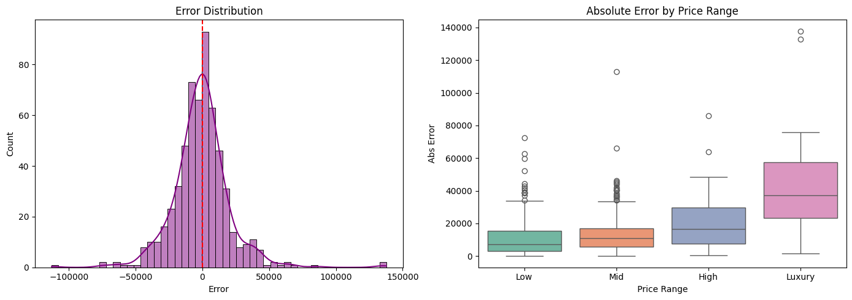
Figure 15: Average absolute error by price range
Price Range | Average Absolute Error | Record Count
Low (<$150K) | $11,140.35 | 256
Mid ($150K–$250K) | $13,661.97 | 238
High ($250K–$400K) | $20,505.02 | 70
Luxury (>$400K) | $45,255.23 | 22

Interpretation: The model's error increases with price — the average error in the luxury segment ($45,255) is nearly 4x higher than in the low-price segment ($11,140). This is due to the smaller amount of training data available in that segment (only 22 test records) and the more complex, less-represented factors that drive pricing for high-end homes (e.g. rare architectural features or ultra-premium locations).

11. Final Model and Business Insights

11.1 Feature Importance
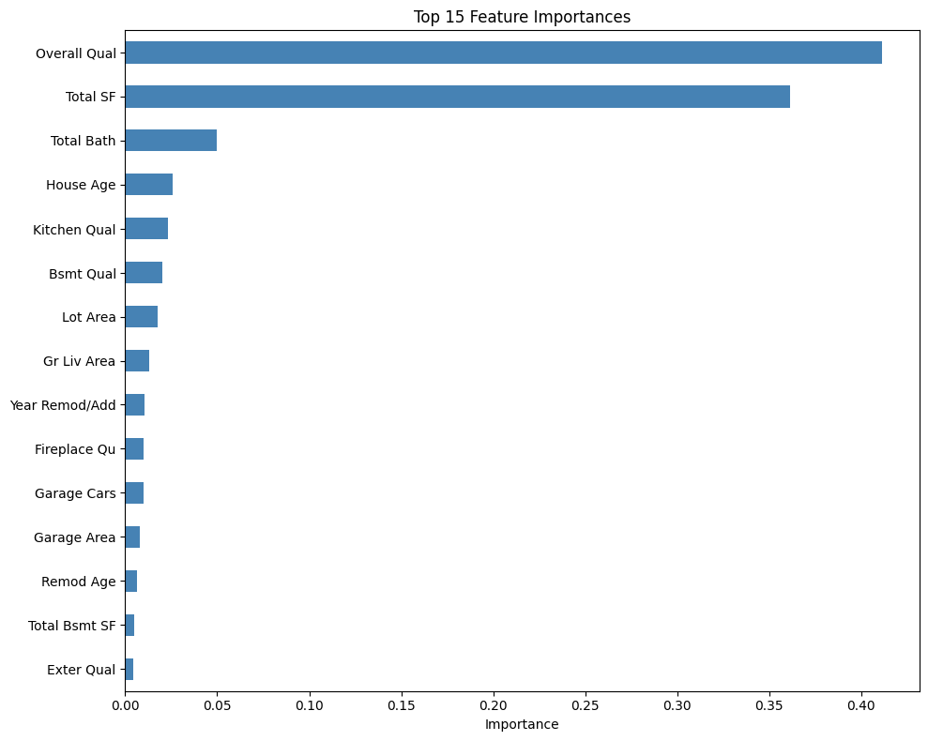
Figure 16: Top 15 feature importances (Gradient Boosting model)
Interpretation: Overall Qual alone accounts for 41.1% of the model's decisions, and Total SF for 36.1% — together, these two features make up roughly 77% of total importance. The remaining features (Total Bath, House Age, Kitchen Qual, etc.) contribute smaller but still meaningful amounts.

11.2 Actual vs. Predicted Price
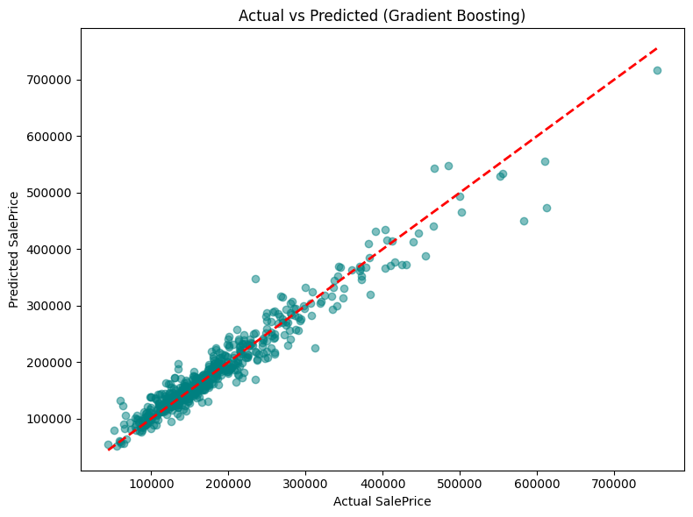
Figure 17: Scatterplot of Actual vs. Predicted SalePrice
Interpretation: Most points lie close to the red diagonal line (the line of perfect prediction), indicating a good model fit. Some deviation is visible above $500K, consistent with the earlier error analysis findings.
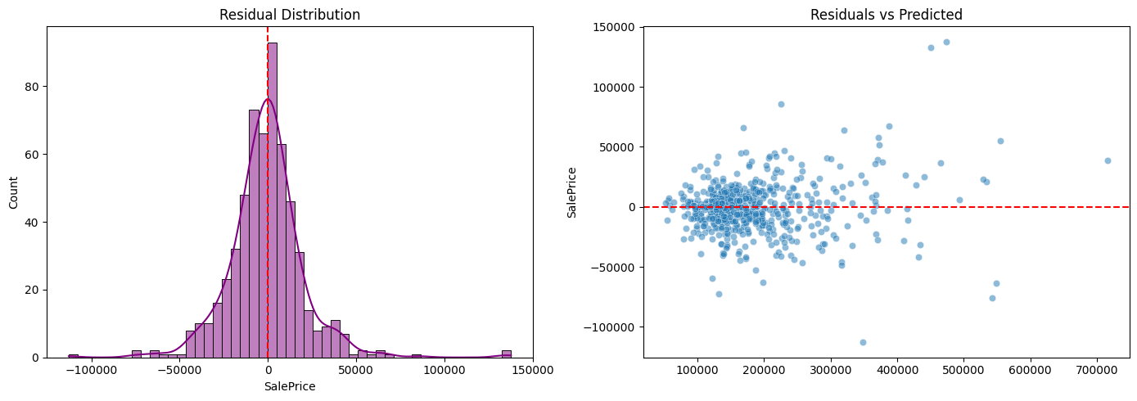
Figure 18: Residual distribution and residuals vs. predicted values
Interpretation: The residuals (actual − predicted) are distributed roughly normally around zero, indicating no strong systematic bias in the model. In the right-hand plot, the residuals are scattered fairly randomly around zero, though the spread is somewhat wider for higher-priced predictions — a mild sign of heteroscedasticity.

11.3 Key Business Insights
- Overall Qual is the #1 driver of price — quality matters more than sheer size.
- Total SF (basement + both floors) has a strong impact on price.
- Neighborhood premium — location is one of the biggest determinants of value.
- House Age is negatively correlated with price — older homes are worth less.
- Remodeling adds a measurable price premium.
- Kitchen and Exterior Quality are top-tier predictors.
- Garage capacity/finish adds value.
- Lot Area shows diminishing returns on price beyond a certain threshold.
- The luxury segment (>$400K) is comparatively harder to predict (higher error).
- The best model generalizes satisfactorily across all price ranges.

12. Conclusion

This project built a complete end-to-end machine learning pipeline using the Ames Housing Dataset — from data cleaning and missing-value handling through feature engineering, multi-model training, hyperparameter tuning, and detailed error analysis. Domain-driven imputation, conservative outlier removal, and the creation of meaningful new features (such as Total SF) meaningfully improved data quality.
The final GridSearchCV-tuned Gradient Boosting Regressor achieved a test R² of 0.9429 and RMSE of $21,453, representing roughly a 94% improvement over the baseline. The model's stability was confirmed via 5-fold cross-validation (0.9039 ± 0.0139), demonstrating that it is not overfit and should generalize reliably to new data.
Potential directions for future improvement include: (i) building a separate model or gathering additional features for the luxury segment, (ii) evaluating more advanced ensemble algorithms such as LightGBM or CatBoost, (iii) applying stacking/blending ensemble techniques, and (iv) using SHAP values for deeper, more granular feature-impact explainability analysis.

