Using Windows 8 Client Hyper-V

Provided by  
Work Smart



Contents

Topics in this guide include:

Practical applications for Client Hyper-V

Hardware requirements

Enabling Client Hyper-V

Tools

What isn’t included in Client Hyper-V?

For more information

This guide is for informational purposes only. MICROSOFT MAKES NO WARRANTIES, EXPRESS, IMPLIED, OR STATUTORY, AS TO THE INFORMATION IN THIS DOCUMENT. © 2013 Microsoft Corporation. All rights reserved.

More Work Smart content: http://microsoft.com/microsoft-IT

Client Hyper-V® is the virtualization technology built into Windows® 8. Client Hyper-V is the same virtualization technology previously available only in Windows Server®. A similar functionality in Windows 7 is called Windows XP Mode.

Client Hyper-V enables you to run more than one 32-bit or 64-bit x86 operating system at the same time on the same host computer. But instead of working directly with the computer’s hardware, the operating systems run inside a virtual machine (VM).

Hyper-V enables developers and IT professionals to easily maintain multiple test environments and provides a simple mechanism to quickly switch between these environments.

Practical applications for Client Hyper-V

As a developer or IT professional, consider using Client Hyper-V for any of the following scenarios:

* Build a test lab infrastructure on your desktop or laptop. After creating virtual machines and testing them on the desktop or laptop, move the VMs to a Windows Server production environment.
* Test an application with different operating systems. For example, you might have an application that you need to test in Windows 8, Windows 7, and Windows XP. You can create three VMs with these OS versions on your desktop or laptop. You then can run your tests (except for scale/performance tests) on the Client Hyper-V computer instead of in a production environment or dedicated testing lab.
* Export, or simply copy, a VM from your production environment, import it to your desktop or laptop with Client Hyper-V (you’ll need to adjust settings), and do the required troubleshooting. Then export the VM (with adjustments) back to the production environment.
* Using VM networking, create a multi-computer environment for test/development/demonstration that doesn’t affect the production network.
* Take a snapshot of a virtual machine while it is running. A snapshot saves everything about the virtual machine, enabling you to go back to a previous point in time in the life of a VM. This is a great tool when you are trying to debug tricky problems.
* Mount and boot a Windows operating system using Windows To Go Virtual Hard Disks (VHDs) from a USB drive as a virtual machine.

Interaction with Windows Update

A computer running Client Hyper-V can take advantage of Windows Update, so you don’t need to set up additional maintenance processes.

Wireless network adapters and sleep states

Client Hyper-V works with wireless network adapters and is compatible with sleep states. For example, if you are running Client Hyper-V on a laptop and you close the lid, the VMs that are running will be put into a saved state. The VMs can be resumed when the computer wakes.

Hardware requirements

Hyper-V supports creation of both 32-bit and 64-bit operating systems in VMs. To be the Client Hyper-V host system, your computer must:

* Be running a 64-bit version of Windows 8 Professional or Enterprise Editions.
* Have a CPU that supports Second Level Address Translation (SLAT), a feature present in the current generation of 64-bit processors by Intel and AMD. To determine if a CPU supports SLAT, go to [http://social.technet.microsoft.com/wiki/contents/  
  articles/1401.aspx](http://social.technet.microsoft.com/wiki/contents/articles/1401.aspx).
* Microsoft IT recommends testing of the CPU for NX and SSE2. You can use the Sysinternals COREINFO tool to test for both. For more information, go to <http://technet.microsoft.com/en-us/sysinternals/cc835722>. Because BIOS support for virtualization is required, before you enable Client Hyper-V, ensure that your computer has the latest BIOS version. For information on checking and changing the virtualization support settings of your system BIOS, check with your computer manufacturer. Visit [http://social.technet.microsoft.com/wiki/contents/  
  articles/3190.aspx](http://social.technet.microsoft.com/wiki/contents/articles/3190.aspx).
* Have 4 gigabytes (GB) of RAM. Hyper-V’s dynamic memory allows memory needed by the VM to be allocated and de-allocated dynamically (you specify a minimum and maximum), and it shares unused memory between VMs. You can run a few VMs on a computer that has 4 GB of RAM. The number of VMs that you can run will depend on the RAM size and required performance. At the upper end of the spectrum, you can create large VMs with 32 processors and 512 GB RAM (maximum RAM per VM).

For storage, you can add multiple hard disks to the IDE or SCSI controllers available in the VM. You can use Virtual Hard Disks (.VHD or .VHDX files) or actual disks that you pass directly through to the virtual machine. VHDs can also reside on a remote file serve. That makes it easy to maintain and share a common set of predefined VHDs across a team.

Hyper-V’s “Live Storage Move” capability helps your VMs to be fairly independent of the underlying storage. With Live Storage Move, you can move the VM’s storage from one local drive to another, to an USB drive, or to a remote file share without needing to stop your VM. This is very handy for fast deployments if you need a VM quickly. You can start a VM from a VM library maintained on a file share, and then move the VM’s storage to your local drive.

Enabling Client Hyper-V

You can enable Client Hyper-V in Windows 8 in three ways.

Use the Control Panel

1. In the Windows 8 Control Panel, tap or click Programs, and then tap or click **Programs and Features**.
2. Tap or click **Turn Windows features on or off**.

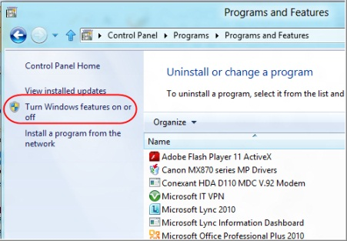

1. In the **Windows Features** dialog box, select the check-boxes for the **Hyper-V** items that you want to install, and then tap or   
   click **OK**.

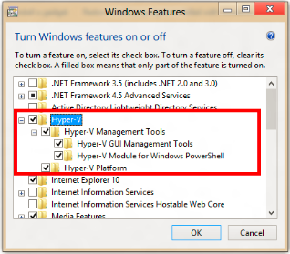

Windows searches for and installs the required files.

1. Tap or click **Close**.

Use Windows PowerShell

At the Windows PowerShell® prompt (using administrator credentials), type the following:

**enable-WindowsOptionalFeature -Online -FeatureName Microsoft-Hyper-V -All**

Use the Windows Command Prompt

At the Windows command prompt (using administrator credentials), type the following:

**Dism /online /enable-feature /featurename:Microsoft-Hyper-V –All**

NOTE You must restart your computer to complete the Hyper-V installation. Depending on your computer manufacturer, you may have to pause a few seconds before restarting for the required changes to take effect. If you use a laptop, you may have to remove the battery before restarting. After restarting the computer, you can use Hyper-V Manager or Windows PowerShell to create and manage VMs. You can also use VM Console to connect to VMs remotely.

For more information on configuring Hyper-V, go to <http://technet.microsoft.com/en-us/library/hh846766.aspx>.

Tools

VM management and other tools created for Server Hyper-V, such as VMM P2V or Sysinternals Disk2vhd tools, will also work in Client Hyper-V. Disk2vhd is available at <http://technet.microsoft.com/en-us/sysinternals/ee656415.aspx>.

Hyper-V virtual switch extensions and Windows PowerShell scripts for managing VMs that you develop and test on Client Hyper-V can be moved to Server Hyper-V.

NOTE Bluetooth Network Interface Cards (NICs) do not appear as Ethernet NICs and are not usable by Client Hyper-V VMs.

Hyper-V Manager

Enabling Client Hyper-V also installs Hyper-V Manager. You can use Hyper-V Manager to create and manage your virtual machines.

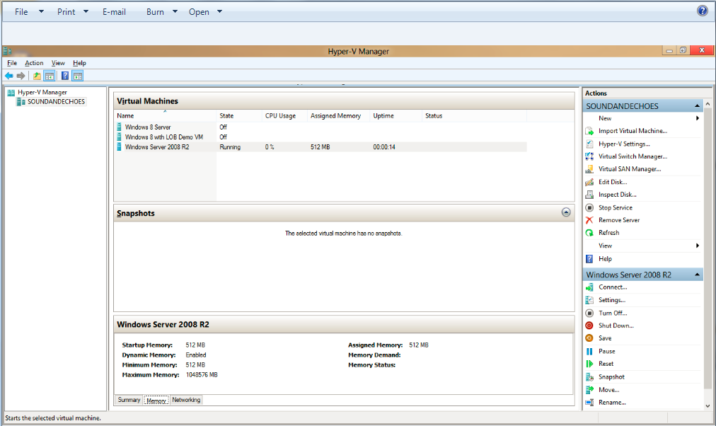

For more information on the Hyper-V Manager user interface, go to <http://technet.microsoft.com/library/cc770494.aspx>.

Using Windows PowerShell

The Windows PowerShell scripts for managing VMs that you create using Client Hyper-V are fully compatible with Windows Server 8 Hyper-V. For example, assuming you had the .xml files for these VMs already available on your computer, network share, or USB storage, the following Windows PowerShell command would start them all for you on your Client Hyper-V computer:

**Dir *.xml | import-vm | start-vm**

For more information on Hyper-V Windows PowerShell cmdlets, go to <http://technet.microsoft.com/library/hh848559.aspx>.

Using Hyper-V with Remote FX

If you have used Hyper-V before and are used to using Remote FX to interact with VMs, note that the new version of Remote Desktop Protocol (RDP) includes support for the following:

* USB redirection. To enable in RDP, go to **Show Options>Local Resources Tab>More**
* Multi-point touch to a Windows 8 VM if you’re using a touch-enabled device
* Bi-directional audio
* Host folder sharing
* Host printer sharing
* Smart-card authentication

VM Console and Remote Desktop Connection

Windows provides two mechanisms to peek into the VM: the VM Console and the Remote Desktop Connection.

The VM Console (also known as VMConnect) is a console view of the VM. It provides a single monitor view of the VM with resolution up to 1600 x 1200 in 32-bit color. This console provides you with the ability to view the VM’s booting process.

For a richer experience, you can connect to the VM using Remote Desktop Connection. With Remote Desktop Connection, the VM takes advantage of capabilities present on your physical PC. For example, if you have multiple monitors, the VM can show its graphics on all of these monitors. Similarly, if you have a multipoint touch-enabled interface on your PC, the VM can use this interface to give you a touch experience.

The VM also has full multimedia capability because it leverages the physical system’s speakers and microphone. The Root OS (the main Windows OS that’s managing the VMs) can also share its Clipboard and folders with the VMs. And finally, with Remote Desktop Connection, you can attach any USB device directly to the VM.

What Isn’t Included in Client Hyper-V?

There are some features included in Windows Server “8” Hyper-V that are not included in Client Hyper-V. These include:

* Remote FX capability to virtualize GPUs (software GPU in RDP 80)
* Live VM migration
* Hyper-V Replica
* SR-IOV [spell out on first ref?]networking
* Synthetic fiber channel

To learn more about the differences among Client Hyper-V, Hyper-V Server 8, and Windows Server 8, go to <http://technet.microsoft.com/en-us/library/hh831410.aspx>.

Limitations of Client Hyper-V

Features or applications that depend on specific hardware will not work well in a VM. For example, Windows BitLocker and Measured Boot, which rely on TPM (Trusted Platform Module), might not function properly in a VM. Applications that require processing with GPUs, without providing software fallback, might not work well either. In addition, applications that rely on sub 10ms timers (latency-sensitive, high-precision applications) could experience issues running in a VM.

The root OS is also running on top of the Hyper-V virtualization layer, and is unique in the use of direct access to all hardware. This is why applications with special hardware requirements continue to work unhindered in the root OS while latency-sensitive, high-precision applications could experience issues running in the root OS.

NOTE Do not run a virus scanner in the VM. For the optimal experience, use System Center 2012 Endpoint Protection on the host. System Center 2012 Endpoint Protection “knows” to avoid Hyper-V specific files.

For more information

Microsoft IT Showcase   
<http://microsoft.com/microsoft-IT>

Microsoft Hyper-V Server 2012   
<http://www.microsoft.com/en-us/server-cloud/hyper-v-server/default.aspx>

Hyper-V Overview  
<http://technet.microsoft.com/en-us/library/hh831531.aspx>

