COMMAND DESK
Worker Roster
Every model in the system and what it does. Requirements are in document 03; guards are in document 04.
Document 02 · version 1.0 · 3 August 2026 · one of four

At a glance
Worker | Model | What it does
nova_voice | llama3.2 local | Input and output.
router | claude cheap tier | Resolves a request to exactly one worker, with a confidence value.
hub | claude-sonnet-5 | Sole decision authority.
personal_assistant | claude-haiku-4.5 | Sam’s day, and mail.
builder | claude-haiku-4.5 | Architecture, implementation, debugging and deployment.
tester | claude-haiku-4.5 | Verification of Builder’s output.
research | claude-haiku-4.5 | Investigates a subject and returns findings that can be acted on.
consolidator | llama3.2 local | The long-term store.
clerk | cheap tier | Produces the factual record of a completed session.
checker | cheap tier | Extracts four fields from a stated intention.
angel | cheap tier | Writes Sam a note where an automated check has flagged a session.
memory | unassigned | The knowledge base and decision log.
writing | unassigned | Drafts and edits in Sam’s voice for material that is not email.
forge | claude-sonnet-5 | Generates options, defends them under challenge, and returns one recommendation.
mind | claude-sonnet-5 | Challenges.
observer | cheap tier | Audits system behaviour across time.
watcher | cheap tier | Produces an independent account of work already performed, without sight of what the performing worker claimed.
billing_agent | to be determined | Produces quotes and invoices.

The chain
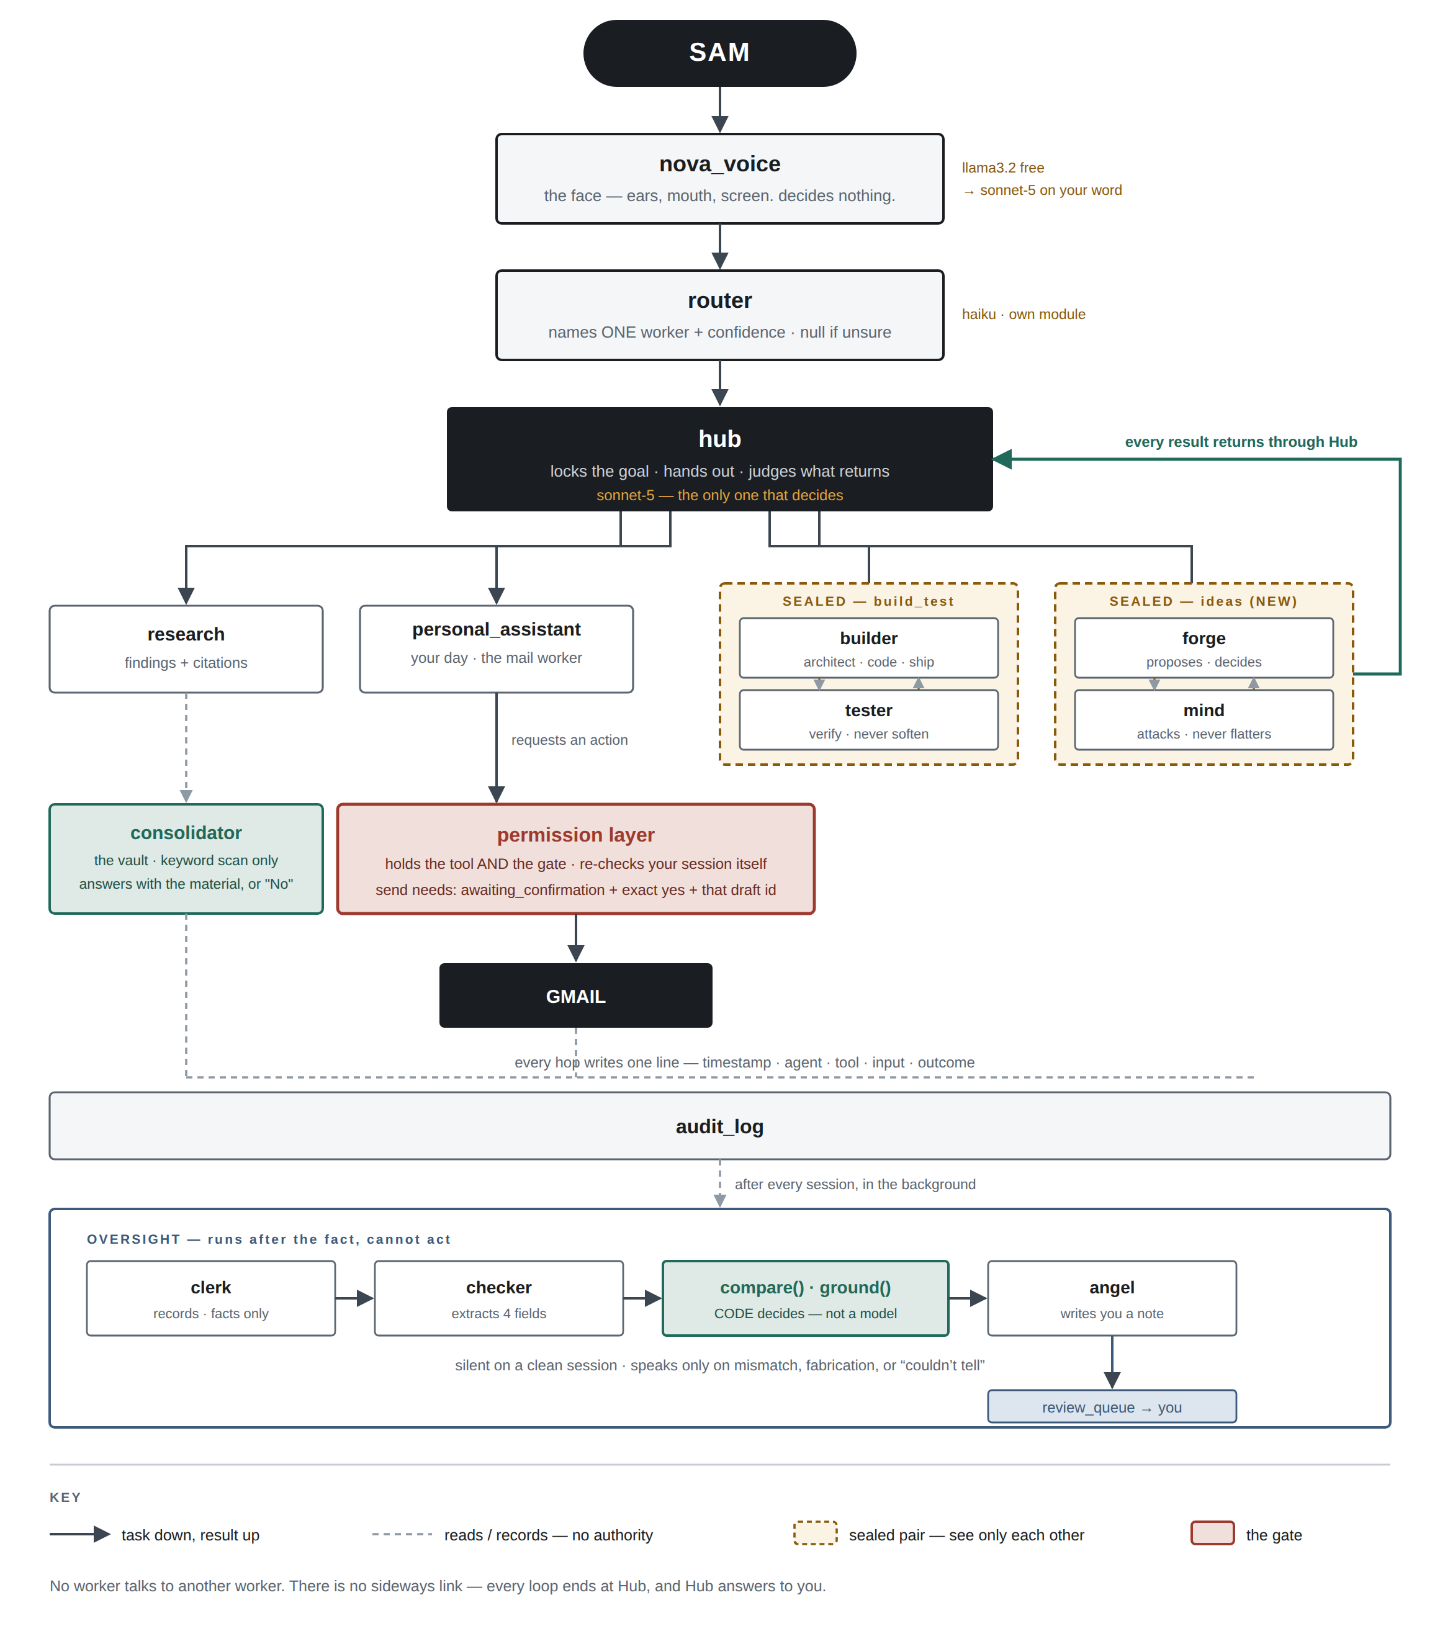
Task descends, result ascends, every loop terminates at Hub. No lateral path exists between workers.

Who can see whom
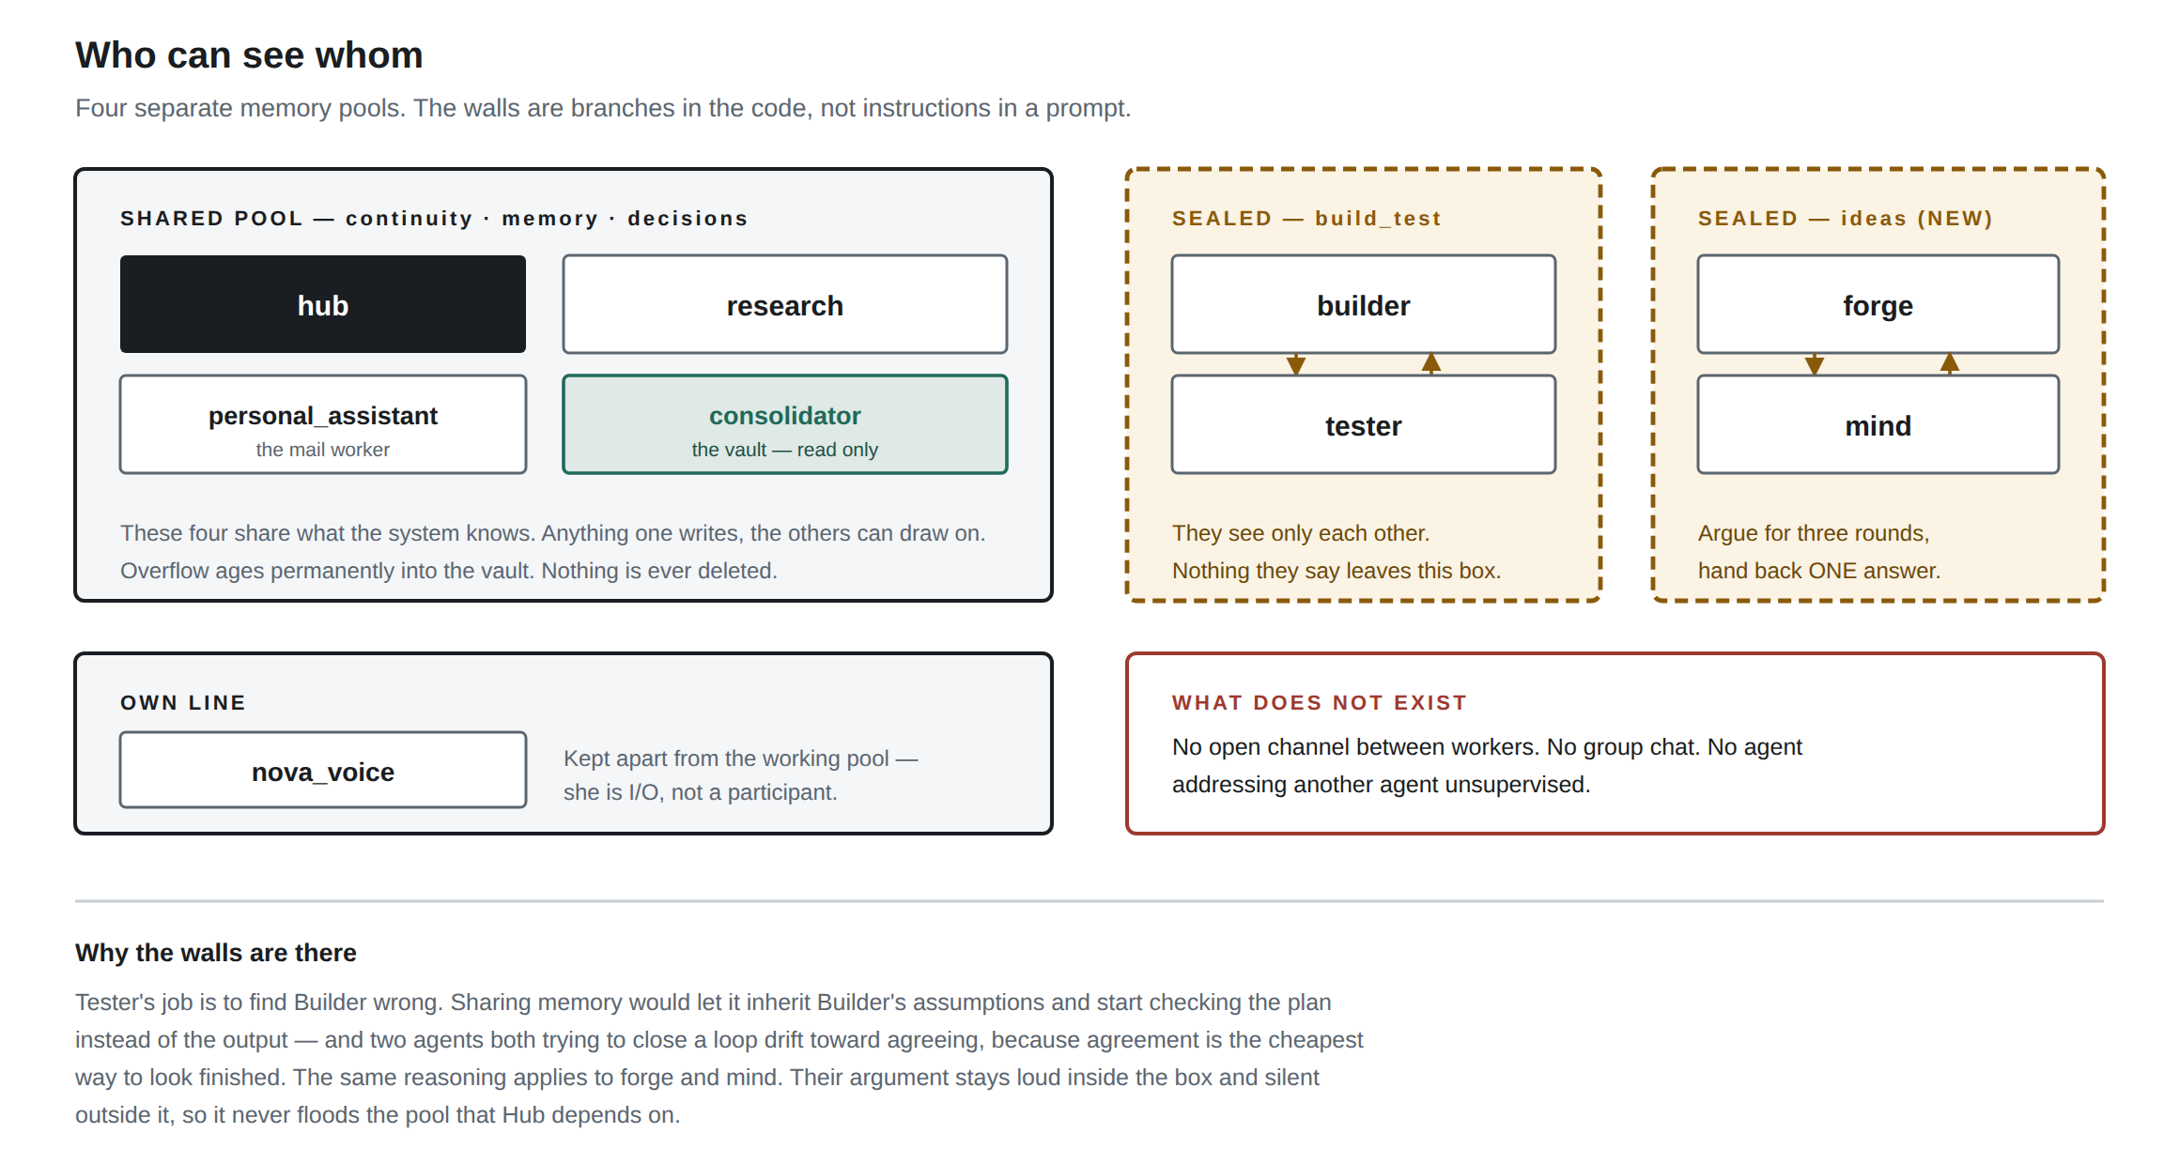
Four memory pools. Each wall is a branch in the orchestrator rather than an instruction in a prompt, which is why it holds.

Each worker
GROUP A — LIVE

nova_voice
llama3.2 local, escalating to claude-sonnet-5 · pool: own line
Input and output. Receives what Sam says, returns the reply in speech and on screen. Holds no authority.
OUTPUT
Standard schema. Result is rendered to speech and to screen.

router
claude cheap tier, dedicated module · pool: none
Resolves a request to exactly one worker, with a confidence value. Logged on every evaluation.
OUTPUT
Declared override: worker (string or null), confidence, reason.

hub
claude-sonnet-5, fixed · pool: shared
Sole decision authority. Locks the goal, allocates work, evaluates what returns, and determines whether it proceeds, returns for correction, or reaches Sam.
OUTPUT
Standard schema, preceded by the INTENT line. The INTENT line is a declared override.

personal_assistant ◆ PRIORITY
claude-haiku-4.5 · pool: shared
Sam’s day, and mail. Reads the inbox, determines what is material, and prepares replies in Sam’s recorded style. The only worker whose requests reach outside the system.
OUTPUT
Standard schema. Declared override: the received message and the prepared draft are returned together for comparison.

builder
claude-haiku-4.5 · pool: isolated — build_test
Architecture, implementation, debugging and deployment. Delivers to Tester for verification.
OUTPUT
Standard schema.

tester
claude-haiku-4.5 · pool: isolated — build_test
Verification of Builder’s output. Writes and executes tests, and reports defects without moderation.
OUTPUT
Standard schema. Evidence is mandatory on a pass.

research
claude-haiku-4.5 · pool: shared
Investigates a subject and returns findings that can be acted on.
OUTPUT
Standard schema. Evidence carries the sources.

consolidator
llama3.2 local · pool: shared — vault owner
The long-term store. Determines whether a subject has arisen previously.
OUTPUT
Declared override: the matching material, or the single word No.

clerk
cheap tier, post-session · pool: none
Produces the factual record of a completed session.
OUTPUT
Declared override: requested, performed, resulted. Facts only.

checker
cheap tier, extraction only · pool: none
Extracts four fields from a stated intention. Determines nothing.
OUTPUT
Declared override: action, recipient, amount, reference. The standard schema does not apply.

angel
cheap tier, conditional · pool: none
Writes Sam a note where an automated check has flagged a session. The last read before an effect reaches a third party.
OUTPUT
Declared override: a note written into the review queue.

GROUP B — ON THE BOX, NOT CONNECTED

memory
unassigned — prompt present, not in configuration · pool: shared (proposed)
The knowledge base and decision log. Recalls what was decided and on what basis.
OUTPUT
Declared override: decision, reason, evidence reference, date — or a clean nil return.

writing
unassigned — prompt present, not in configuration · pool: shared (proposed)
Drafts and edits in Sam’s voice for material that is not email. Superseded for mail by style_profile.
OUTPUT
Declared override: finished text.

GROUP C — SPECIFIED, TO BUILD

forge ◆ PRIORITY
claude-sonnet-5 · pool: isolated — ideas
Generates options, defends them under challenge, and returns one recommendation. Determination is its function.
OUTPUT
Standard schema. Declared override: recommendation, and rejected options each with the reason for rejection.

mind ◆ PRIORITY
claude-sonnet-5 · pool: isolated — ideas
Challenges. Identifies the strongest objection to Forge’s position, and states plainly where a position holds.
OUTPUT
Declared override: one objection with its failure condition, or a stated basis on which the position holds.

observer
cheap tier, read-only · pool: observer_readonly
Audits system behaviour across time. Reports on request. Holds no decision authority.
OUTPUT
Declared override: finding, threshold met, evidence identifiers, confidence, affected workers, and one line on why it matters. No recommendation.

watcher
cheap tier · pool: none — record only
Produces an independent account of work already performed, without sight of what the performing worker claimed.
OUTPUT
Declared override: performed, not performed, unverifiable — the shape a worker returns, written from the record alone.

GROUP D — NAMED, SCOPE OUTSTANDING

billing_agent ◆ PRIORITY
to be determined · pool: to be determined
Produces quotes and invoices. Scope not yet written. The requirements below hold whatever it becomes.
OUTPUT
Standard schema.

