COMMAND DESK
Maps
Two diagrams. The path a request takes, and which workers can see which.
Document 06 · version 1.0 — LOCKED · 3 August 2026 · one of seven

The chain
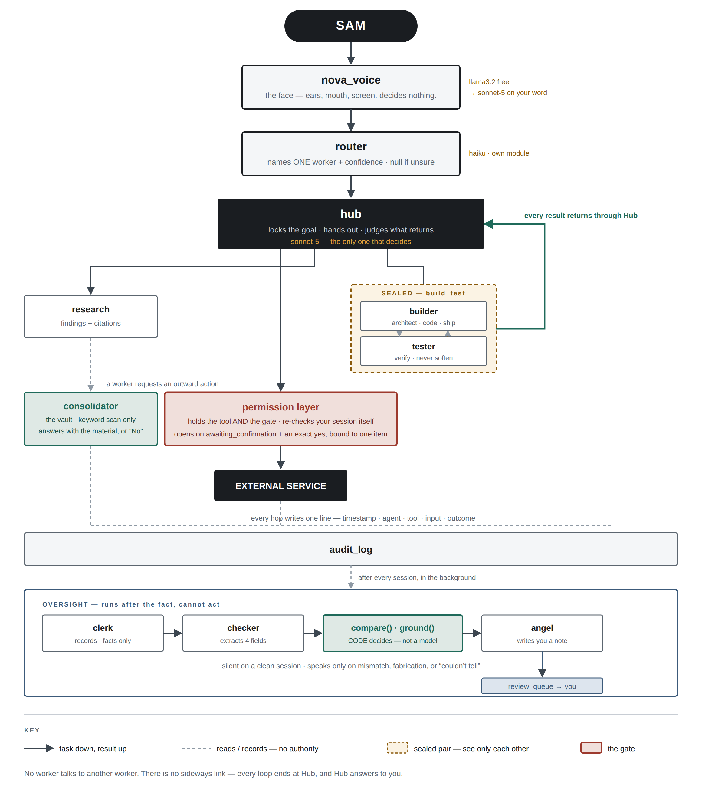
Task descends, result ascends, every loop terminates at Hub. No lateral path exists between workers.

Who can see whom
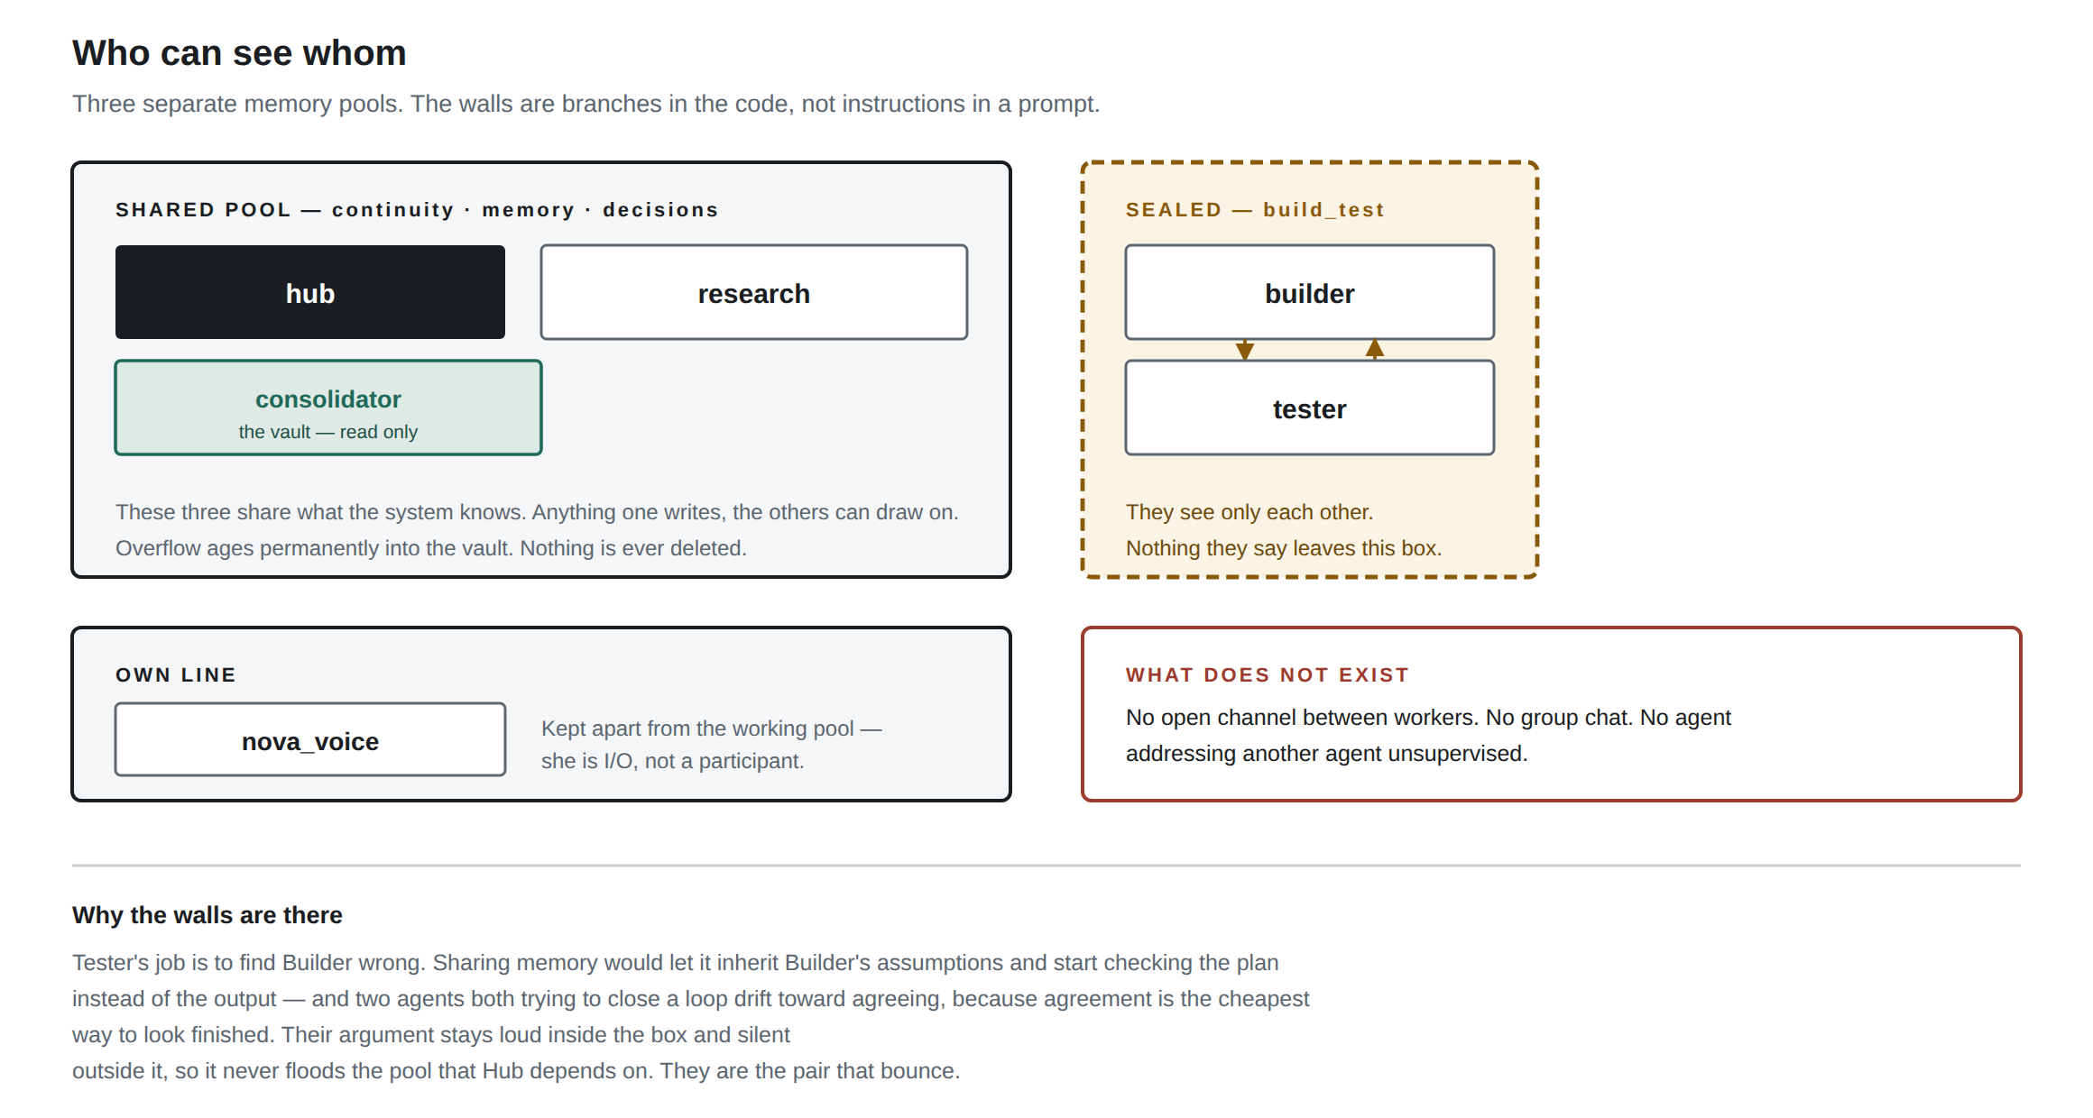
Three memory pools. Each wall is a branch in the orchestrator rather than an instruction in a prompt, which is why it holds.

Reading the maps
On the map | What it means
Solid arrow | Task passed down, result returned up. The only path work travels.
Dashed line | Reads or records. No authority to act on what it sees.
Dashed gold box | A sealed pair. They see each other and nothing else, and nothing they produce leaves.
Red box | The gate. Every outward effect passes through it.
Black box | Sam, Hub and the external service — the three points that decide or receive.
Three things read directly off the chain. Nova sits at the top and decides nothing. The permission layer sits between every worker and the outside, so no worker holds a tool. Oversight sits beneath everything, running after the fact with no authority to act on what it finds.

