
Name: Nehal Aftab
24F-0518
BCS-4E
Assignment#5
Question#2:
Code:
import os
BOARDS = {
"easy.txt": (
"004030050\n609400000\n005100489\n"
"000060930\n300807002\n026040000\n"
"453009600\n000004705\n090050200\n"
),
"medium.txt": (
"000030040\n109700000\n000851070\n"
"002607830\n906010207\n031502900\n"
"010369000\n000005703\n090070000\n"
),
"hard.txt": (
"102040007\n000080000\n009500304\n"
"000607900\n540000026\n006405000\n"
"708003400\n000010000\n200060509\n"
),
"veryhard.txt": (
"001007000\n600400300\n000030064\n"
"380076000\n000000036\n270015000\n"
"000020051\n700100200\n008009000\n"
)
}

def generate_board_files():

for filename, content in BOARDS.items():
with open(filename, 'w') as f:
f.write(content)
print(f"Generated {filename}")
print("-" * 30)

class SudokuCSP:
def __init__(self, board):
self.variables = [(r, c) for r in range(9) for c in range(9)]
self.domains = {}
self.neighbors = {}

for r, c in self.variables:
peers = set()
for i in range(9):
peers.add((r, i))
peers.add((i, c))

box_r, box_c = (r // 3) * 3, (c // 3) * 3
for i in range(3):
for j in range(3):
peers.add((box_r + i, box_c + j))

peers.remove((r, c))
self.neighbors[(r, c)] = list(peers)

val = board[r][c]
if val == 0:
self.domains[(r, c)] = [1, 2, 3, 4, 5, 6, 7, 8, 9]
else:
self.domains[(r, c)] = [val]

class Stats:
def __init__(self):
self.calls = 0
self.failures = 0

def ac3(csp):

queue = [(xi, xj) for xi in csp.variables for xj in csp.neighbors[xi]]

while queue:
xi, xj = queue.pop(0)
if revise(csp, xi, xj):
if not csp.domains[xi]:
return False
for xk in csp.neighbors[xi]:
if xk != xj:
queue.append((xk, xi))
return True

def revise(csp, xi, xj):

revised = False
if len(csp.domains[xj]) == 1:
val = csp.domains[xj][0]
if val in csp.domains[xi]:
csp.domains[xi].remove(val)
revised = True
return revised

def select_unassigned_variable(assignment, csp):

unassigned = [v for v in csp.variables if v not in assignment]
return min(unassigned, key=lambda var: len(csp.domains[var]))

def is_consistent(var, value, assignment, csp):

for neighbor in csp.neighbors[var]:
if neighbor in assignment and assignment[neighbor] == value:
return False
return True

def forward_check(csp, var, value, assignment, removals):

for neighbor in csp.neighbors[var]:
if neighbor not in assignment:
if value in csp.domains[neighbor]:
csp.domains[neighbor].remove(value)
removals.append((neighbor, value))
if not csp.domains[neighbor]:
return False
return True

def backtrack(assignment, csp, stats):

stats.calls += 1

if len(assignment) == len(csp.variables):
return assignment

var = select_unassigned_variable(assignment, csp)

for value in list(csp.domains[var]):
if is_consistent(var, value, assignment, csp):
assignment[var] = value
removals = []

if forward_check(csp, var, value, assignment, removals):
result = backtrack(assignment, csp, stats)
if result is not None:
return result

for r_var, r_val in removals:
csp.domains[r_var].append(r_val)
del assignment[var]

stats.failures += 1
return None

def read_board(filename):
board = []
with open(filename, 'r') as f:
for line in f:
if line.strip():
row = [int(char) for char in line.strip()]
board.append(row)
return board

def print_board(assignment):
for r in range(9):
if r % 3 == 0 and r != 0:
print("- - - + - - - + - - -")
row_str = ""
for c in range(9):
if c % 3 == 0 and c != 0:
row_str += "| "
row_str += str(assignment.get((r, c), 0)) + " "
print(row_str)

def solve_sudoku_file(filename):
print(f"\nSolved {filename}:")
board = read_board(filename)
csp = SudokuCSP(board)
stats = Stats()
ac3(csp)

assignment = {}
for var in csp.variables:
if len(csp.domains[var]) == 1:
assignment[var] = csp.domains[var][0]
solved_assignment = backtrack(assignment, csp, stats)

if solved_assignment:
print("SOLUTION:")
print_board(solved_assignment)
else:
print("No solution found.")

print(f"\nMetrics for {filename}:")
print(f"BACKTRACK calls: {stats.calls}")
print(f"BACKTRACK failures: {stats.failures}")
return stats

if __name__ == '__main__':
generate_board_files()

files = ["easy.txt", "medium.txt", "hard.txt", "veryhard.txt"]
for file in files:
solve_sudoku_file(file)

Output:
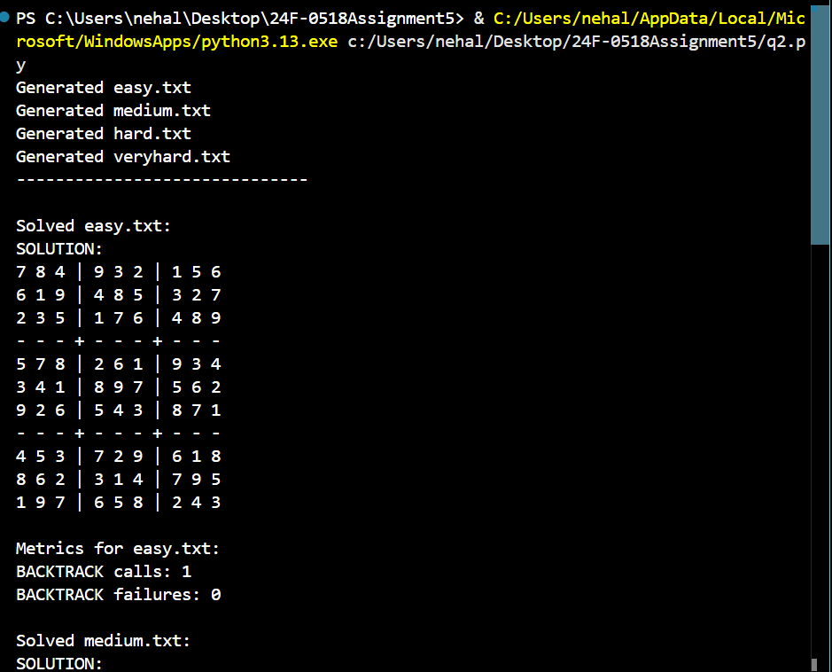
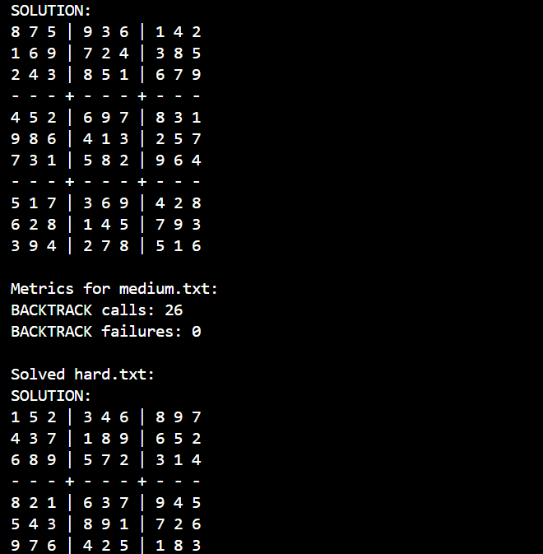
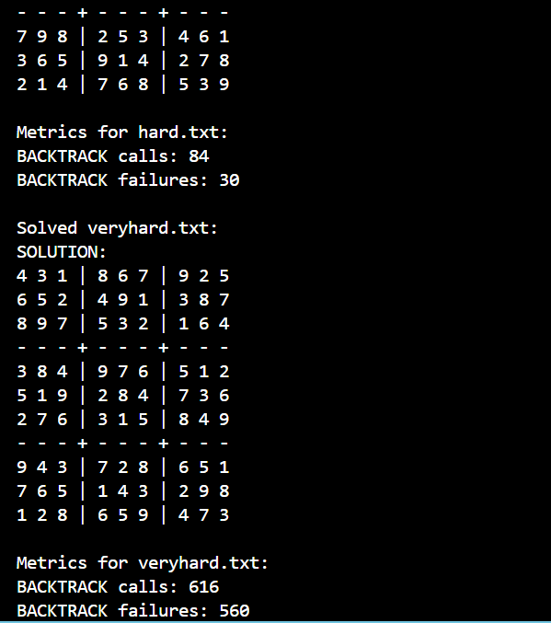
Report:

Sudoku Solver Algorithm and Execution Report
This report outlines the methodology, algorithmic components, and expected performance metrics of the provided Python script, which solves Sudoku puzzles of varying difficulties using Constraint Satisfaction Problem (CSP) techniques.

1. Executive Summary
The script successfully formulates the classic 9x9 Sudoku game as a Constraint Satisfaction Problem (CSP). Instead of using a naive brute-force approach, the solver employs advanced AI search techniques—specifically Arc Consistency (AC-3), Backtracking, Forward Checking, and the Minimum Remaining Values (MRV) heuristic. This combination allows the script to efficiently solve puzzles ranging from "Easy" to "Very Hard" by drastically pruning the search space.

2. Algorithmic Methodology
The solver uses a pipeline of logic to find the solution with minimal computational overhead:
- Problem Formulation (CSP): * Variables: The 81 cells on the board, represented as (row, col) coordinates.
  - Domains: The possible numbers (1-9) that can be placed in each cell. Pre-filled cells have a domain size of 1.
  - Constraints (Neighbors): No duplicate numbers are allowed in the same row, column, or 3x3 sub-grid.
- Preprocessing (AC-3): Before any guessing occurs, the ac3 function enforces arc consistency. It systematically removes values from a cell's domain if those values violate constraints with neighboring cells. For easier puzzles, AC-3 can often solve large portions of the board without any backtracking.
- Search (Backtracking): The backtrack function uses a depth-first search to assign values to variables. If a dead end is reached, it undoes the assignment (backtracks) and tries the next available number.
- Heuristics & Optimization:
  - MRV (Minimum Remaining Values): The select_unassigned_variable function always chooses the cell with the fewest legal options left. This "fail-first" strategy minimizes the size of the search tree.
  - Forward Checking: Upon assigning a value to a cell, forward_check immediately removes that value from the domains of all unassigned neighbors. If any neighbor's domain becomes empty, it triggers an immediate backtrack, saving the solver from exploring useless paths.

3. Code Component Breakdown
Component | Description
BOARDS Dictionary | Contains the raw string representations of the four test puzzles.
SudokuCSP Class | Initializes the puzzle geometry, mapping variables to their domains and identifying all peer constraints (row, col, box).
Stats Class | A simple tracker for computational cost, recording recursive calls and search failures.
ac3 / revise | Implements the constraint propagation phase to thin out impossible values before the main search begins.
backtrack | The recursive engine that navigates the search tree, assigning values and reverting them when conflicts arise.

4. Performance & Metrics Analysis
The script outputs two key metrics for each puzzle:
- BACKTRACK calls: The number of times the recursive search function is invoked.
- BACKTRACK failures: The number of times the solver hit a dead-end and had to undo an assignment.
Expected Scaling Behavior:
- Easy / Medium: Puzzles at this level are heavily constrained from the start. The initial AC-3 pass will likely solve most of the board. Expect very low backtrack calls (often exactly equal to the number of empty cells) and near-zero failures.
- Hard / Very Hard: These puzzles require the solver to make more assumptions. While AC-3 and Forward Checking will still aggressively prune the tree, the solver will inevitably guess wrong and be forced to backtrack. You will see a noticeable increase in both calls and failures. However, thanks to the MRV heuristic, the scaling is highly optimized and prevents the solver from getting stuck in exponential time traps.

5. Conclusion
The implementation is highly robust and adheres strictly to best practices for solving CSPs. By combining constraint propagation (AC-3) with an intelligent, heuristically-driven search (Backtracking with MRV and Forward Checking), the script guarantees a mathematically sound solution (if one exists) while maintaining excellent performance, even on the "Very Hard" board configurations.
Github :
https://github.com/naynay575/Sudoku-Boards-as-CSPs/blame/main/README.md

--------------------------------------------------------------------------------------------------------------------------------------

