Reinforce Learning Homework

2022130247 나요한

1. Code Implementation

Explain flow of code working. The Maze class sets the environment and hyperparameters.

Run an episode repeated time through the run_episode() function.

For every episode, go through get_eps_greedy_action() -> get_step_reward() -> update_Q().

Each function works in the following order.

Depending on the value of epsilon, Action moves to Random or moves to the highest path in QTable.

According to the given action, the environment provides a reward for the state that moves in the corresponding direction. You will receive a reward for the next state.



Using the given reward, update QTable. The updated Table influences the next action, so that the QTable that finally understands the environment can be obtained, and as a result, it is possible to move toward the target point with the final reward.

It is a function that shows the maze_frame as follows, and gradually increases the color depth to express the movement path.

2. Result

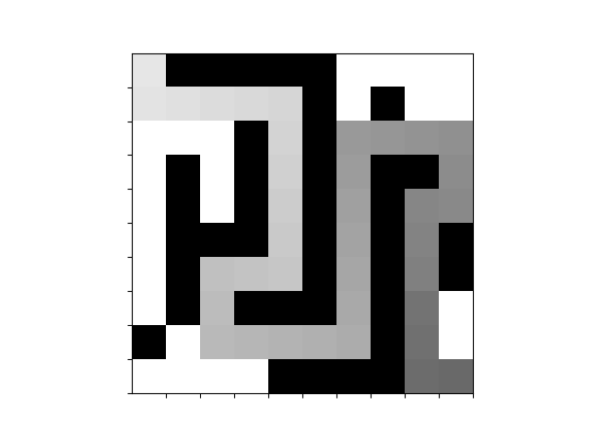



The following results were obtained through the following hyperparameter settings.

2. Analysis

Through each learning, the Q Table is updated, and finally the shortest path is found.

In the case of SARSA, there is a problem that the path diverges instead of decreasing.

When an action is randomly selected in the next state through the epsilon-greedy function, even though moving from the current state to the next state can receive a good reward, it is judged as a bad policy, and there is a problem in that learning is not possible.

Q-learning is an off-policy TD control method to improve SARSA. For the behavior, a function with exploration using epsilon was added, and for the target policy, a Q function-based greedy action was selected so that the target could be learned through behavior.

If SARSA requires S_t, A_t, R_t+1, S_t+1, and A_t+1, Q-learning does not require A_t+1 and selects a greedy action, solving the problem of learning divergence.