Report
Laboratory #7

“I2C Interface to a Real Time Clock (RTC) Device”

by
Nayara Ferreira
&
Muayd Alali

11/29/2012

Introduction
The purpose of this lab was to make a communication link between the HyperTerminal and the I²C Real-Time Clock provided. The code written must allow the user to read the time (in hours, minutes and seconds) and the date (in years, months and day) from the RTC, and display them on the HyperTerminal upon request.

Design and Implementation
When the program starts, it will display the menu on the HyperTerminal. The user will be prompted to enter a character ( ‘M’, ‘t’ or ‘d’). When ‘M’ is entered, the initial menu will be displayed. When ‘t’ is entered, the time (hrs:mins:secs) will be displayed on the HyperTerminal. When ‘d’ is entered, the date (day/month/year) will be displayed on the HyperTerminal. The program will also display the time in minutes and seconds (mins.secs) on the four 7-segemnt displays on the PIC16F877.

Test Results
The code was successfully able to perform all tasks required.

Summary and Conclusions
After initializing our functions, variables and registers associated with the 7-segment display and the I²C RTC, the program will call the display function that will display the menu on the HyperTerminal screen. Based on the user’s input, the program will take the proper action. If ‘M’ was entered, the program will display the menu. If ‘t’ was entered, the program will call the time display function, which will read the values stored in the RTC, perform the needed logical operations to display time in a correct format. If ‘d’ was entered, the program will call the date display function, which will also perform the logical operations needed to display the date in the correct format. The program will also read the time in minutes and seconds from the RTC and display it on the 7-segemnt displays. The whole process will be done in a continuous while-loop allowing the user to make multiple inputs, and display the time and date continuously.

References
M. Uijt de Haag and T. Bambeck, “2C – Part 1 – Master Operation
– Lecture 14 Notes,” September 2009.

Appendix A. Flow-chart
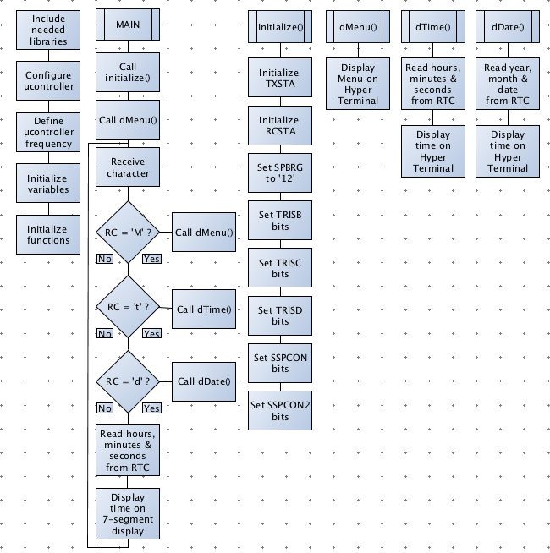

Appendix B. Source Code

/*
* File: labcode07.c
* Author: Nayara Oliva Ferreira,
* Muayd Alali
*
*
* Created on November 28, 2012, 11:34 PM
*/

#include <stdio.h>
#include <stdlib.h>
#include <xc.h>

//__PROG_CONFIG(1,0x3F39);
__CONFIG(FOSC_XT & WDTE_OFF & PWRTE_OFF & CP_OFF & BOREN_OFF & LVP_OFF & CPD_OFF & WRT_ON);

// Oscillator frequency for delay
#define _XTAL_FREQ 4000000

void initialize();
void i2c_waitForIdle();
void i2c_start();
void i2c_stop();
int i2c_read(unsigned char ack);
unsigned char i2c_write(unsigned char i2cWriteData);
void dMenu();
void dTime();
void dDate();
char Get7SegmentCode(char r);
void putch(char byte);

char RC,
send_day1,
send_day2,
send_month1,
send_month2,
send_year1,
send_year2;

char temp_byte,
date_byte,
month_byte,
year_byte,
sec_byte,
min_byte,
hrs_byte,
temporary;

char send_sec1,
send_sec2,
send_min1,
send_min2,
send_hours1,
send_hours2;

char num1,
num2,
num3,
num4,
d1,
d2,
d3,
d4;

int main(void) {

initialize();

dMenu();
_delay(1);

while(1) {
if(RCIF == 1){
RC = RCREG;

if(RC == 'M') {
dMenu();
}

else if(RC == 't') {
dTime();

}

else if(RC == 'd') {
dDate();

}

}

i2c_start();
i2c_write(0b11010000);
i2c_write(0x00);
i2c_stop();

i2c_start();
i2c_write(0b11010001);
sec_byte = i2c_read(1);
min_byte = i2c_read(1);
hrs_byte = i2c_read(0);
i2c_stop();

send_sec1 = ((sec_byte & 0b11110000) >> 4);
d3 = Get7SegmentCode(send_sec1);
send_sec2 = (sec_byte & 0b00001111);
d4 = Get7SegmentCode(send_sec2);

send_min1 = ((min_byte & 0b11110000) >>4);
d1 = Get7SegmentCode(send_min1);
send_min2 = (min_byte & 0b00001111);
d2 = Get7SegmentCode(send_min2);

PORTD = d1;
RB1 = 1;
__delay_ms(4);
RB1 = 0;
PORTD = d2;
RB2 = 1;
__delay_ms(4);
RB2 = 0;
PORTD = d3;
RB3 = 1;
RD7 = 1;
__delay_ms(4);
RB3 = 0 ;
PORTD = d4;
RB4 = 1 ;
__delay_ms(4);
RB4 = 0;

}

return(EXIT_SUCCESS);
}

void initialize(){

TXSTA = 0b00100110;
SPBRG = 12;
RCSTA = 0b10010000;
TRISD = 0b00000000;
TRISB = 0b11100001;
TRISC = 0b10111111;
PORTB = 0b00000000;

SSPCON = 0x38;
SSPCON2 = 0x00;
SSPADD = 9;
CKE = 1;
SMP = 1;
SSPIF = 0;
BCLIF = 0;

}

void i2c_waitForIdle() {

while((SSPCON2 & 0x1F) | R_nW) {};
}

void i2c_start() {

i2c_waitForIdle();

SEN=1;
}

void i2c_stop() {

i2c_waitForIdle();

PEN=1;
}

unsigned char i2c_write(unsigned char i2cWriteData) {

i2c_waitForIdle();

SSPBUF=i2cWriteData;

return(!ACKSTAT);
}

int i2c_read(unsigned char ack) {

unsigned char i2cReadData;
i2c_waitForIdle();
RCEN=1;
i2c_waitForIdle();
i2cReadData=SSPBUF;
i2c_waitForIdle();

if(ack) {
ACKDT=0;
}

else {
ACKDT=1;
}

ACKEN=1; //send acknowledge

return(i2cReadData);
}

void dMenu() {

putch(0x0c);
printf("\r\n MENU:\n");
printf("\r\n M Main menu\n");
printf("\r\n t RTC time in hours,minutes and seconds\n");
printf("\r\n d RTC date in days, month and year\n");
return;
}

void dTime(){

i2c_start();
i2c_write(0b11010000);
i2c_write(0x00);
i2c_stop();

i2c_start();
i2c_write(0b11010001);
sec_byte = i2c_read(1);
min_byte = i2c_read(1);
hrs_byte = i2c_read(0);
i2c_stop();

send_sec1 = ((sec_byte & 0b11110000) >> 4);
send_sec2 = (sec_byte & 0b00001111);
send_min1 = ((min_byte & 0b11110000) >>4);
send_min2 = (min_byte & 0b00001111);
send_hours1 = ((0x10 & month_byte)>>4);
send_hours2 = (hrs_byte & 0b00001111);
printf("\r%d%d:%d%d.%d%d\n",send_hours1,
send_hours2,
send_min1,
send_min2,
send_sec1,
send_sec2);
}

void dDate(){

i2c_start();
i2c_write(0b11010000);
i2c_write(0x03);
i2c_stop();

i2c_start();
i2c_write(0b11010001);
date_byte = i2c_read(1);
temporary = i2c_read(1);
month_byte = i2c_read(1);
year_byte = i2c_read(0);
i2c_stop();
printf("\r%d%d/%d%d/%d%d\n\r",((0x30 & date_byte) >> 4),
(0x0F & date_byte),
((0x10 & month_byte) >> 4),
(0x0F & month_byte),
((0xF0 & year_byte) >> 4),
(0x0F & year_byte));

}

char Get7SegmentCode(char r) {

switch(r){
case 0: return(0b00111111);
case 1: return(0b00000110);
case 2: return(0b01011011);
case 3: return(0b01001111);
case 4: return(0b01100110);
case 5: return(0b01101101);
case 6: return(0b01111100);
case 7: return(0b00000111);
case 8: return(0b01111111);
case 9: return(0b01100111);
default: return(0b00111111);

}
}

void putch(char byte) {

while(!TXIF) continue;
TXREG=byte;
}

