Report
Laboratory #0
“Getting Started with MPLAB X IDE”

by
Nayara Oliva Ferreira

09/13/2012

1. Introduction
In this practice our purpose was to learn how to use the MPLAB tools like simulate programs, debug programs and also familiarize with writing programs and flow charts.

2. Design and Implementation
The program need to know when you press the button , and when you press it the program needs to rotates segment on left-most 7 segment display. We needed first to create a project and import the code that was provided by the teacher. The next step was to run the assembly code and see the generated machine code. There is two ways to do that Menu / Window / PIC Memory Views / Program Memory and Menu / Window / Output /Disassembly Listing File . In the first option there is a table and it showing you the address of the registers that was established in the beginning of the program. The table it’s divided in 5 columns: line , address , opcode , label and disAssy . The second way show us the same information but instead of one table it will show the machine code on the left side of each line. The next step was to simulating the program. To start we must right-click in the project , click on Properties and select the simulator from the middle window .After this it was possible to debug the program selecting Launch Debugger and using a small toolbar.
The next task was to open Menu/Window/Debugging/Watches a new tab will open down the program code , there I entered PORTB,TRISB,PORTD,TRISD,WREG,STATUS,TOGGLE and SEL by clicking on <Enter a new watch> and typing the variables I want to watch. After this I went to Menu/Window/Simulator/Stimulus/Asynchronous there clicking in Pin I choose pin RB0 and selected set high in action and debugged my program. RB0 its 1 so the program will be all the time in LED_NXT function. Then I selected pulse low in action for RB0 and typed 20 in width to execute as low sign for 20 cycles. When I debugged the program will be 20 cycles executing TST and LED_CHG in other words will execute 20 instructions with RB0 as 0 , and then RB0 will return 1.
Line of the code | Register changed | New value in the Register
bsf STATUS,RP0 | STATUS | 0x3E (CD,Z,nPD,nTO,RP changed to 0x01)
clrf TRISD | PORTD | 0x00
movlw B'00000001' | WREG | 0x01
movwf TRISB | TRISB | 0x01
bcf STATUS,RP0 | STATUS | 0x1E
movwf SEL | SEL | 0x01
Movwf PORTD | PORTD | 0x01
Movlw B'00000010' | WREG | 0x02
Movwf PORTB | PORTB | 0x02
clrf TOGGLE | TOGGLE | 0x00
By stimulus I changed RB0 to high + btfsc PORTB,0 | PORTB | 0x03
Jumped to LED_NXT + movf SEL,W | WREG / STATUS | 0x01 / 0x1A
clrf TOGGLE | STATUS | 0x1E
Table 1 – Changes in the register when by stimulus RB0 is set high.
Remembering that the difference between this table to when change RB0 in stimulus to pulse low 20 cycles is that when executing the first line of TST he program will jump to LED_CHG and will execute 20 instructions considering RB0 set low.
While I was debugging the program with RB0 as described before I watched the registers (table 1) changes and checked with the flow chart. In both cases they occurred perfectly as the flow chart.
After that I connected the micro-controller to test the program on it. After connecting the energy on it and connecting the micro-controller on my laptop I right-clicked on my project , clicked on Properties and selected IDC3. The next step was to program into the device and test a break point. Also I debugged the program and there were modifications on the registers, all the changes were consistent with the flow chart. The changes is the registers were very equal to the table 1 the difference is that to keep RB0 as set low you must keep pushing the button and then it’s possible to see that the program will be executing TST and LED_CHG while you are pushing the button . When you release the button then the program will execute LED_NXT and the next segment will be on.

3. Summary and Conclusions
With this practice I've been able to learn how to use MPLAB and its tools to program in a microcontroller , more specifically PIC16F877. Since how to make a new project , programing on the device until debug and watch how the program behavior and even be able to find errors from this. As a conclusion I assume that making a good flow chart before coding it’s essential for succeed or having less errors. Also having good commentaries on your code makes possible to easily follow the flow chart and check if the code it’s going according to your plans and as an consequence successes.

Appendix A. Flow-chart
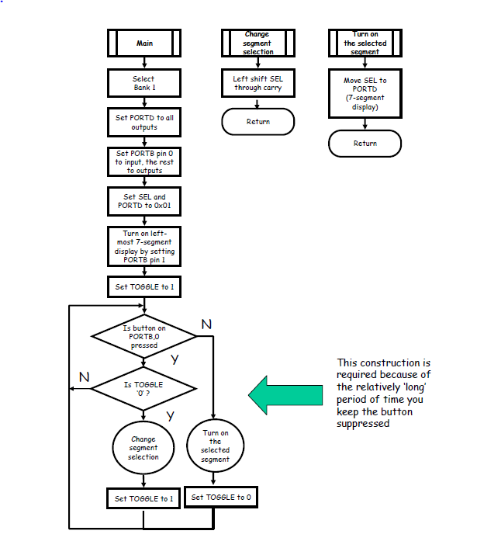

Appendix B. Source Code
;**********************************************************
;*
;* Laboratory # 0
;*
;* Program reads the state of RB0 pushbutton (normal=1)
;* On each succesive press, rotates segment on left-most
;* 7 segment display. (portD if simulating)
;*
;* EE3954 Microprocessors and Microcontrollers
;*
;******** **************************************************

list p=16f877 ; Assembler directive to turn list on
; and give 16F877 listing codes

; CONFIG
__CONFIG 0x3F39 ; Code protect OFF, Debug DISABLED, Flash Write ENABLED
; Data EE Protection OFF, Low Voltage Programming DISABLED,
; Brown-out detection DISABLED, Power-up Timer DISABLED,
; Watchdog Timer DISABLED, XT Oscillator slected

;
; Define some 8-bit file register labels
; See PIC16F877 datasheet for location of the Special Function Registers
;
PORTB equ 0x06 ; in BANK 0
TRISB equ 0x06 ; in BANK 1
PORTD equ 0x08 ; in BANK 0
TRISD equ 0x08 ; in BANK 1
STATUS equ 0x03 ; in all BANKS

; Define some uninitialized general purpose memory
group1 udata 0x20
SEL res 1
TOGGLE res 1

; Now define some BIT labels...
W equ d'0' ; destination=W ('working' register)
F equ d'1' ; destination=f
RP1 equ d'6' ; bank select high bit in status reg.
RP0 equ d'5' ; bank select low bit in status reg.
CARRY equ d'0' ;carry bit in status reg

;
; Executable part of program starts here...
; Start at the reset vector
;
org 0x000 ; program starts at Program Memory location 0x0000
nop ; nop required by older MPLAB ICD system
;
; First allow program to initialize registers
;
Init: clrf STATUS ; clear status reg, to select BANK0
bsf STATUS,RP0 ; select bank 1 so we can access the TRISD register
clrf TRISD ; set all direction bits of PORTD to '0': all outputs
movlw B'00000001' ; set up I/O data for configuring PortB
movwf TRISB ; set bit 0 of PORTB to 1:input; all other bits to 0:outputs
bcf STATUS,RP0 ; select bank 0 so we can access the PORTD register
clrf PORTD ; set all bits to '0' - turns off all segments.
movlw B'00000001' ; move the binary number B'00000001' into W
movwf SEL ; and store in memory location SEL (= address 0x20 in memory)
movwf PORTD ; store it also to PORTD, turn on top segment.
movlw B'00000010' ; move the binary number B'00000010' to PORTB,
movwf PORTB ; this will turn on the left-most 7-segment display
clrf TOGGLE ; set RAM location TOGGLE (=0x21) to all zeros: B'00000000'
bcf STATUS,CARRY ; Clears the carry bit in the status register

TST: btfsc PORTB,0 ; port B bit 0 is tested (RB0 button normally '1')
goto LED_NXT ; if button not pressed, then go to line labeled LED_NXT
LED_CHG:
btfsc TOGGLE,0 ; button pressed(='0'), test bit 0 of TOGGLE register
goto TST ; if TOGGLE bit 0 is set, then go to line labeled TST
rlf SEL,F ; if TOGGLE bit 0 is clear, left-shift contents of SEL
bsf TOGGLE,0 ; and, set bit 0 of TOGGLE
goto TST ; return to RB0 switch testing statement
LED_NXT:
movf SEL,W ; get display data (contents of SEL to W)
movwf PORTD ; put display data in W to PORTD (outputs the bit pattern in W)
clrf TOGGLE ; set all bits of TOGGLE back to 0 including bit 0
goto TST ; return to bit testing statement

end ; Assembler directive = quit assembling = assembly code after this line is IGNORED

