Report
Laboratory #01
“Indirect Addressing and Subroutines”

by
Nayara Oliva Ferreira

09/20/2012

1. Introduction
The purpose of this lab is to write a specific value in all the general purpose registers for each bank. For perform this purpose it’s required the use of indirect addressing and do-while loops.

2. Design and Implementation
To design the program required for this practice using the teacher’s slides I checked that the addresses he wanted us to fill with specific numbers were for bank 0 from 0x20 to 0x70 , for bank 1 from 0xA0 to 0xEF , for bank 2 from 0x110 to 0x16F and for bank 3 from 0x190 to 0x1E5. Knowing this all the addresses in bank 0 should be write with 0xF1 value , bank 1 with 0x05 , bank 2 with 0xA2 and bank 3 with 0x88. The best way to this is using a loop and indirect address because with a combination of both it’s not necessary to literally write all the values for all the addresses. The first thing to do is select the bank necessary. Since you are going to change the value of a range of addresses now you need to set the first address you want to writing something it to FSR and then with a loop you move the literal value you want to write in the address to INDF (writing to INDF you automatically write the literal value to the FSR address). Then increase FSR one time to point to the next address and the subtract the last address you want to write the value from the current address. If the result of the subtraction is zero you make the same process for the next bank , if the result it’s not zero you go back to the loop beginning.

3. Test Results
After writing the code running into the device it was required to check the results. To make that it’s necessary go to the menu Window/PIC Memory Views/File Registers window and outputting this data to a text file. I made that to show what was filled in each bank , and one at a time.
To show what was filled in bank zero I inserted a break point and saved the file register as showed next in figure 1 and figure 2.
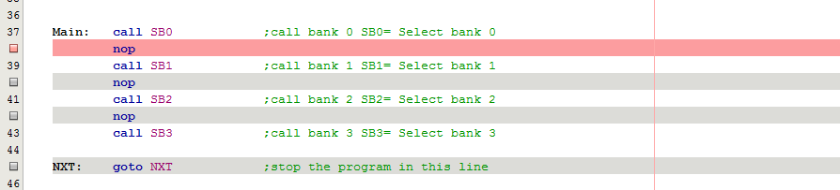
Figure 1
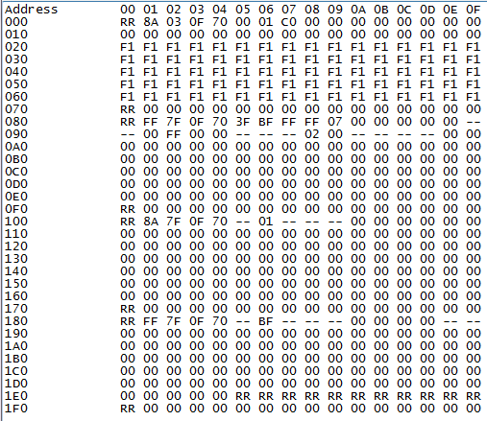
Figure 2
To show what was filled in bank one I inserted a break point and saved the file register as showed next in figure 3 and figure 4.
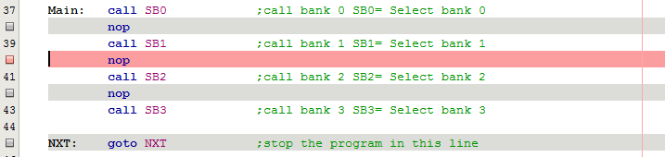
Figure 3
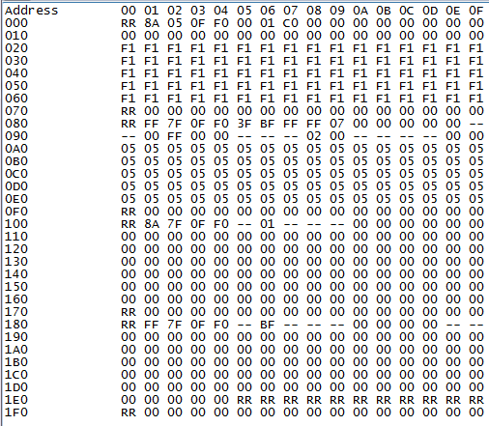
Figure 4
To show what was filled in bank two I inserted a break point and saved the file register as showed next in figure 5 and figure 6.
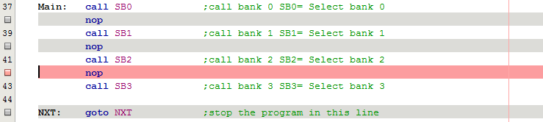
Figure 5
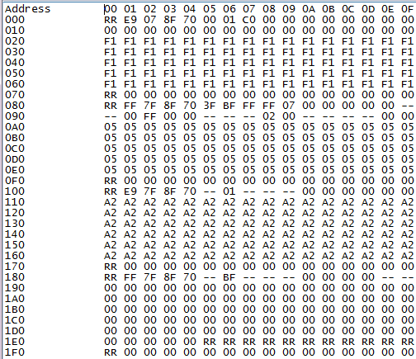
Figure 6
To show what was filled in bank three I inserted a break point and saved the file register as showed next in figure 7 and figure 8.
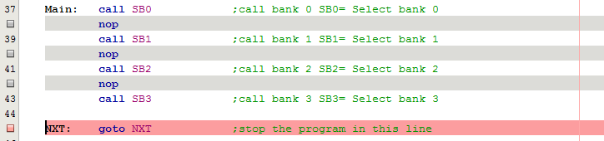
Figure 7
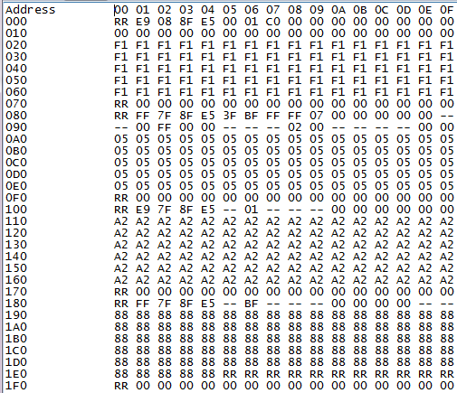
Figure 8

4. Summary and Conclusions
Many times we will find ourselves in situations where we need to write a code to change the value of various address in one time. The most practice way to do that and the shortest code it’s to use indirect addressing and loops. Using these techniques I could make exactly what was required in the practice 01. The results were consistent with expected. The excellence of the results are consequence of consistent processes, in other words, the code followed severely the steps of the flow chart.

Appendix A. Flow Chart

Main
Process lbank0
Move 0xF1 to INDF

Go to next address
Subtract 0x70 from current address
Process lbank1
Move 0x05 to INDF
Go to next address
Subtract 0xF0 from current address
Process lbank2
Move 0xA2 to INDF
Go to next address
Subtract 0x70 from current address
Process lbank3
Move 0x88 to INDF
Go to next address
Subtract 0xE5 from current address
Is it 0?
Process lbank0

Is it 0?
Process lbank1

Is it 0?
Process lbank2

Is it 0?
Process lbank3

Return
Return
Return
Return
SB0
SB1
SB2
SB3
SB1
SB2
SB3
Select Bank 0
Set the first address
Check if Z flag is 0
N
Y
Select Bank 1
Set the first address
Check if Z flag is 0
N
Y
Select Bank 2
Set the first address
Check if Z flag is 0
N
Y
Select Bank 3
Set the first address
Check if Z flag is 0
N
Y

SB0

Appendix B. Source Code
;**********************************************************
;*
;* Laboratory # 1
;*
;* Program that uses indirect addressing to set especific values for each
;* bank for all the general purpuse registers.
;*
;* EE3954 Microprocessors and Microcontrollers
;* Made by : Nayara Oliva Ferreira
;******** **************************************************

list p=16f877 ; Assembler directive to turn list on
; and give 16F877 listing codes

; CONFIG
__CONFIG 0x3F39 ; Code protect OFF, Debug DISABLED, Flash Write ENABLED
; Data EE Protection OFF, Low Voltage Programming DISABLED,
; Brown-out detection DISABLED, Power-up Timer DISABLED,
; Watchdog Timer DISABLED, XT Oscillator slected

INDF equ 0x00
FSR equ 0x04
STATUS equ 0x03 ; in all BANKS

; Now define some BIT labels...
W equ d'0' ; destination=W ('working' register)
F equ d'1' ; destination=f
Z equ d'2' ; destination=z

org 0x000 ; program starts at Program Memory location 0x0000
nop ; nop required by older MPLAB ICD system

Main: call SB0 ;call bank 0 SB0= Select bank 0
nop
call SB1 ;call bank 1 SB1= Select bank 1
nop
call SB2 ;call bank 2 SB2= Select bank 2
nop
call SB3 ;call bank 3 SB3= Select bank 3

NXT: goto NXT ;stop the program in this line

SB0: bcf STATUS,7 ;select bank 0 and 1
movlw 0x20 ;set the first address
movwf FSR ;of the set to be changed
LBANK0: movlw 0xF1 ;move the value wanted to be write in all the GPR LBANK0 = Loop Bank 0
movwf INDF ;move the value to the FRS address
incf FSR,F ;point to the next address
movlw 0x70 ;move number 0x70 to W , adress we want to stop writing 0xF1
subwf FSR,W ;subtract 0x70 from current address
btfss STATUS,Z ;check if the result from the subtraction is 0
goto LBANK0 ;go to LBANK0
return
SB1: bcf STATUS,7 ;select bank 0 and 1
movlw 0xA0 ;set the first address
movwf FSR ;of the set to be changed
LBANK1: movlw 0x05 ;move the value wanted to be write in all the GPR LBANK0 = Loop Bank 1
movwf INDF ;move the value to the FRS address
incf FSR,F ;point to the next address
movlw 0xF0 ;move number 0xF0 to W , adress we want to stop writing 0x05
subwf FSR,W ;subtract 0xF0 from current address
btfss STATUS,Z ;check if the result from the subtraction is 0
goto LBANK1 ;go to LBANK1
return
SB2: bsf STATUS,7 ;select bank 0 and 1
movlw 0x10 ;set the first address
movwf FSR ;of the set to be changed
LBANK2: movlw 0xA2 ;move the value wanted to be write in all the GPR LBANK0 = Loop Bank 2
Movwf INDF ;move the value to the FRS address
incf FSR,F ;point to the next address
movlw 0x70 ;move number 0x70 to W , adress we want to stop writing 0xA2
subwf FSR,W ;subtract 0xF0 from current address
btfss STATUS,Z ;check if the result from the subtraction is 0
goto LBANK2
return
SB3: bsf STATUS,7 ;select bank 0 and 1
movlw 0x90 ;set the first address
movwf FSR ;of the set to be changed
LBANK3: movlw 0x88 ;move the value wanted to be write in all the GPR LBANK0 = Loop Bank 3
movwf INDF ;move the value to the FRS address
incf FSR,F ;point to the next address
movlw 0xE5 ;move number 0xE5 to W , adress we want to stop writing 0x88
subwf FSR,W ;subtract 0xF0 from current address
btfss STATUS,Z ;check if the result from the subtraction is 0
goto LBANK3 ;go to LBANK3
return

end

