Report
Laboratory #04
“I/O Peripheral : the Analog-to-Digital Converter”

by
Nayara Oliva Ferreira

10/25/2012

1. Introduction
In this lab we want to read the voltage from a potentiometer and write them in the 7-segment display. For this is going to be necessary to use the ADC and polling checking.

2. Design and Implementation
To read the potentiometer we need to set the ADC on. To that you need first to select bank 0 and then set the ADCON0 where we set the GO to zero , select AN0/RA0 as specified on the lab and set ADON to 1 to turn the A/D conversion status on. Now select bank 1 and configure bit 1 and 2 of port B as outputs so we can display the number in the correctly displays. The next step is to set port D as output, and port A as inputs. After that I configured ADCON1 setting ADFM as 0 so the bits are going to be left justified and also set the 4 MSB to 0 so RA0/AN0 are going to be analog inputs.
That was the initialization now in the main subroutine all we need to do is first call the 20 us delay. This delay it’s necessary before start converting to convert the analog input correctly . To start the conversion we set GO to 1 and then we check if the conversion is over. After check we write the numbers to the displays. To do that was necessary to write 2 look-up tables. Since we have a table with the binary number corresponding to a voltage it’s easy to make a lookup table with the first number with the decimal number e another lookup table with the second number after the decimal point. To display then all you have to do is turn off all the 7-segment display ,turn on the specific display ( 1 or 2 ) , then move the binary number you collected from the conversion to the W register, call the lookup table of the display you are working now and move the number returned from the lookup table to port D to finally display it. Between the display of the two 7-segment it’s necessary to call a look of 0.004 seconds so we can see them. It’s good to call the same loop after the displaying the voltage to again we have the time to see them and turn off the displays and then call the main subroutine. So this will be constantly repeating and displaying the correct number when we change the resistance of the potentiometer.
Now I’ll describe the check routine. To check if the conversion is over we check if the bit GO of ADCON0 is 0. This bit will turn off automatically we the conversion is over. If the conversion is not over the subroutine will keep checking until the conversion is over. So when is over we move what is inside the ADRESH , because the selected left-justified, and copy to W register. And move this value to a general purpose memory that I called TEMPH. All we need to do now to display them correctly since we want the 3 MSB is rotate them 5 times, so the 3 MSB will be the 3 LSB. After that we AND this number rotated to 7. When we do that we erase whatever is in the 5 MSB turning them to 0 and keep the 3 LSB . This way we keep the information necessary to display in the Main function. After that I add two nops to wait for the 4 instruction cycle. This way to make the conversion and keep constantly checking is called Polling.

3. Test Results
The program followed exactly as described by the flow chart and displayed all the voltages correctly . The result was checked by the TA.

4. Summary and Conclusions
To do the ADC conversions we can use interrupts or polling. As I was doing my lab I notice that at least in this case it’s much easier to code and to understand using the polling method. The interrupt method requires to be more alert about the flags and also how long it’s taking to call the interrupts. It’s necessary more coding to make the interrupt method. In my opinion the polling method it’s much easier and much shorter than the interrupt method for this case.

Appendix A. Flow-chart
INIT
Main
Turn off the displays
Check
Call Delay
Is GO = 0 ?
N
Select Bank 0
Set ADCON0 to ‘01000001’
Goto Main
Set GO to 1
Y
Call check
Read A/D result from ADRESH
Select Bank 1

Set Port B bit 1 and 2 as outputs
Turn off the display
Rotate to right 5 times
Set port D as outputs
Set port A as inputs
Set ADCON1 to ‘00000000’
Clear the display
Turn on display 2
Move TEMPH to W, call the lookup table and copy the value to port D
Call Loop
Turn off the display
Turn on display 1
Move TEMPH to W, call the lookup table and copy the value to port D
Call Loop
AND result from rotation with 7
Return

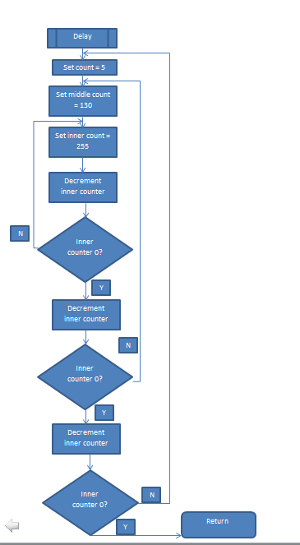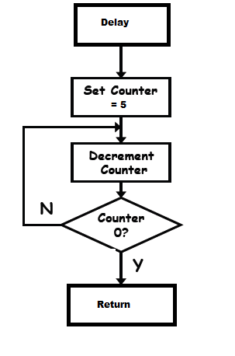
Figure 1 – Loop Subroutine

Appendix B. Source Code
;**********************************************************
;*
;* Laboratory # 4
;*
;* This lab requires to use teh ADC to obtain a voltage measurement and display it at
;* the 2 seven-segment-dislay.
;*
;* EE3954 Microprocessors and Microcontrollers
;* Student: Nayara Oliva Ferreira
;*
;***********************************************************
list p=16f877 ; Assembler directive to turn list on
; and give 16F877 listing codes

; CONFIG
__CONFIG 0x3F39 ; Code protect OFF, Debug DISABLED, Flash Write ENABLED
; Data EE Protection OFF, Low Voltage Programming DISABLED,
; Brown-out detection DISABLED, Power-up Timer DISABLED,
; Watchdog Timer DISABLED, XT Oscillator slected

;
; Define some 8-bit file register labels
; See PIC16F877 datasheet for location of the Special Function Registers
;
PORTB equ 0x06 ; in BANK 0
TRISB equ 0x06 ; in BANK 1
TRISA equ 0x05 ; in BANK 1
PORTA equ 0x05 ; in BANK 0
PORTD equ 0x08 ; in BANK 0
TRISD equ 0x08 ; in BANK 1
ADCON0 equ 0x1F ; in BANK 0
ADCON1 equ 0x1F ; in BANK 1
STATUS equ 0x03 ; in all BANKS
PCL equ 0x02 ; in all BANKS
ADRESH equ 0x1E ; in BANK 0
TEMPH equ 0x24 ; in BANK 0
TEMPL equ 0x25 ; in BANK 0
COUNT equ 0x26 ; in BANK 0
D1 equ 0x30 ; in all BANKS
D2 equ 0x31 ; in all BANKS
F equ d'1' ; destination F
RP0 equ d'5' ; bank select low bit in status reg.
COUT equ 0x20 ; outer counter
CIN equ 0x21 ; inner counter
org 0x000

INIT_ADC: clrf STATUS ; clear status reg, to select BANK0
movlw b'01000001' ; set AN0/RA0 sset GO to 0 and say the conversio is in progress
movwf ADCON0 ; Configure ADC via ADCON0
bsf STATUS,RP0 ; select bank 1 so we can access the TRISD register
movlw b'11111001' ; set up I/O data for configuring PortB
movwf TRISB ; set bit 0,5,6,7 of PORTB to 1:input; all other bits to 0:outputs
movlw b'00000000' ; set up I/O data for configuring PortB
movwf TRISD ; set all bits to 0:outputs
movlw b'11111111' ;all pins of PORTA are inputs
movwf TRISA
movlw b'00000000'
movwf ADCON1 ; Configure ADC via ADCON1
bcf STATUS, RP0 ; Switch back to bank 0
clrf D1 ; clear to make sure it's going to start displaying number 0
clrf D2 ; clear to make sure it's going to start displaying number 0

MAIN: call DELAY ; Wait for TACQ
bsf ADCON0,2 ; Start conversion (set GO)
call CHECK ; to check if the conversion is over then start displaying it
clrf PORTB ; turns off all segments
bsf PORTB,2 ; turn on display 2
movf TEMPH,W ; move what is in TEMPH to W
call DISP2 ; call the DISP2 subroutine to get the second binary value to display
movwf PORTD ; display the digits
call Loop ; call a delay so can display a apropriate time
clrf PORTB ; turns off all segments
movf TEMPH,W ; move what is in TEMPH to W
bsf PORTB,1 ; turn on display 1
call DISP1 ; call the DISP2 subroutine to get the second binary value to display
movwf PORTD ; display the digits
call Loop ; call a delay so can display a apropriate time
clrf PORTB ; turns off all segments
goto MAIN ; return to the start so keeps doing it constantly

CHECK: btfsc ADCON0,2 ; Wait for conversion to complete
goto CHECK ; use POLLING
movf ADRESH,W ; Read A/D result (high byte)
movwf TEMPH ; Write to TEMPH
rrf TEMPH ; right rotate TMP 5 times so the 3 MSB are going to be the 3 LSB
rrf TEMPH
rrf TEMPH
rrf TEMPH
rrf TEMPH
movlw 0x07 ;AND TMP with d'7' so whatever is on the the first 5 bits are going yo be 0 because 0 AND X (whatever) = to 0
; and 1 AND X(whatever) = X , so we arer going to keep the original 3 LSB
andwf TEMPH
nop ; 1 Wait for 4 instruction cycles
nop ; 1
return

DISP1: addwf PCL,F ;Computed goto to show the numbers that should be displayed on the first 7-segment display
retlw b'10111111' ;d'0.'
retlw b'10111111' ;d'0.'
retlw b'10000110' ;d'1.'
retlw b'11011011' ;d'2.'
retlw b'11011011' ;d'2.'
retlw b'11001111' ;d'3.'
retlw b'11100110' ;d'4.'
retlw b'11100110' ;d'4.'

DISP2: addwf PCL,F ;Computed goto to show the numbers that should be displayed on the second 7-segment display
retlw b'01001111' ;d'3'
retlw b'01100111' ;d'9'
retlw b'01111100' ;d'6'
retlw b'01011011' ;d'2'
retlw b'01111111' ;d'8'
retlw b'01100110' ;d'4'
retlw b'00000110' ;d'1'
retlw b'00000111' ;d'7'

DELAY: movlw 0x05 ; 1 (delay of 0 us)
movwf COUNT ; 1
NXT: decfsz COUNT ; 1/2
goto NXT ; 2
return ; 2

Loop: movlw d'5' ; delay of 0.004 s
movwf COUT
INNER: movlw d'210'
movwf CIN
NXT2: decfsz CIN,F
goto NXT2
decfsz COUT,F
goto INNER
return

end

