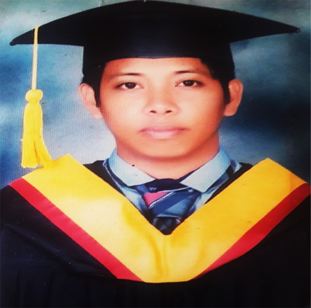Rya­­­n Lester Bulot

Blk-11 Lot-8 Ph-1 Sec-4 Pabahay 2000 SJDM, Bulacan

Mobile: 09053095494 E-mail: Rbulot12@gmail.com

Personal Profile

Age: 29

Birth Date: May 6, 1989

Birth Place: Bohol

Religion: Catholic

Sex: Male

Work Experience

* Node.js Developer Out-Works (Full-Time Home Based)

Node.js Developer

July 2018 – Present

* Web Developer Green Pasture Recruitment Agency

CodeIgniter Programmer

April 2017 – Present

* On-The Job Trainee PNP-ITMS (System Mng’t Division )

PHP Programmer

August 2016 – January 2017

System Developed

* FilipinaMatcher.com Node.js, Angular.js, MySql

And Payroll Management HTML5, CSS3 , Materialize CSS

* HRIS w/ Payroll System Node.js, Express.js, MySql

And Payroll Management HTML5, CSS3 , BOOTSTRAP

* Leon-Gallery.com Codeigniter,REST API,MySql

PHP,HTML5, CSS3, (BOOTSTRAP)

Seminars Attended

* 6th I.T Congress Cinema 4, Ever Gotesco, Commonwealth

Feb. 18, 2016

* Y4IT Research Summit U.P Diliman, Quezon City

March 15, 2016

* 14th Y4IT Congress SMX Convention Center, MOA, Pasay City

Sep. 29, 2016

Duties and Responsibilities

* Green Pasture Integrated EmployeeAnd Payroll Management
* Main Developer of the project
* Presenting ideas for system improvements, including cost proposals
* Producing detailed specifications and writing the program codes
* Testing the product in controlled, real situations before going live
* Preparation of training manuals for users
* Maintaining the system
* Leon Gallery
* Front – End Developer
* Supporting the user
* Upload Videos and Images of the Gallery in the system

Skills

Technical: Computer Troubleshooting and Reformat

Programming Language: PHP, MySql, HTML5, CSS3, AJAX,

Knowledge in Rest API, JSON, JS and JAVA

Node.js, Express.js, JQuery, Angular 1.5

Adonis Framework

Frameworks: Bootstrap, CodeIgniter , Node.js ,Express.js, Adonis Framework, Materialize CSS

Education

Tertiary: Colegio de San Gabriel Arcangel

2013 – 2017 Area E, Sapang Palay, CSJDM, Bulacan

Bachelor of Sciene in Information Technology

Secondary: St. Mary’s Academy

2005 – 2006 Pabahay 2000, CSJDM , Bulacan

Primary: Mahonri Academy

2000 – 2001 Mabuhay 2000, Dasmarinas, Cavite

Referrences

Engr. Marcos G. Villena

Dean/ Department Head

Colegio de San Gabriel Arcangel

Tel: 09155322643

Ms. Irish M. Sabote

Globe Telecom

Network Engineer

Tel: 09274538288

Mr. Alvin Buenaventura

TechieGrp

Wordpress Programmer

Tel : 09979965162

*I certifythatall information indicated herewith is true and correct to the best of my knowledge and belief.*

Ryan Lester Bulot