TORMS — Complete System Specification
Field | Value
Product | TORMS — Transcript & Official Records Management System
Document type | Complete System Specification (SRS + Architecture + Features + LLD)
Date | November 2026
Classification | Proprietary

Document contents
- System Requirements Specification (SRS)
- Architecture Design
- Features & Requirements
- Low-Level Design (LLD) Workflows

Part 1 — System Requirements Specification (SRS)

Transcript & Official Records Management System (TORMS)
Field | Value
Document ID | SRS-TORMS-001
Product | TORMS (Transcript & Official Records Management System)
Repository | WMSU/wmsu-platform  (  apps/records-web  ,  apps/base-api  module  records  )
Version | 1.0
Date | November 2026
Classification | Proprietary

1. Introduction

1.1 Purpose
This Software Requirements Specification defines functional and non-functional requirements for TORMS, the official academic records and certification system managing transcript of records (TOR) issuance, certification document processing, academic ledger management, alumni registry, public document verification, and records office operations for Philippine university compliance.

1.2 Scope
In scope
- TOR request management: creation, requirement tracking, payment verification linkage, status workflow, document generation, issuance logging, print audit trail
- Certification types and certification request processing: honorable dismissal, good moral character, units earned, completion certificates, diploma verification
- Public document verification: unauthenticated QR code and reference number verification with tamper-evident audit trails
- Academic ledger projections synchronized from USiS enrollment system (grades, enrollment history)
- Ledger discrepancy detection and reconciliation workflows
- Alumni registry: profile management, standing classification, graduation-driven enrollment
- Records officer dashboard and comprehensive reporting (issuance statistics, request aging, alumni demographics)
- University Platform Access SSO integration (platform code records)
- Student self-service request submission and status tracking
- Document numbering schemes and template management
- Integration with UFMS for payment/clearance verification where configured
Out of scope
- Authoritative grade entry and enrollment workflow (owned by USiS)
- Tuition assessment, cashiering, official receipt issuance (owned by UFMS)
- Library operations, document repository (owned by ULMIS, UDMS)
- Inventory and asset management (owned by UIMS)
- Student admissions and registration approval (owned by USiS)

1.3 Definitions
Term | Definition
TORMS | Transcript & Official Records Management System
TOR | Transcript of Records — official academic transcript document
Issuance | Generated official document with verification metadata, print log, and QR code
Ledger projection | TORMS copy of academic grades and enrollment history synchronized from USiS (USiS remains system of record)
Certification | Official non-TOR document types: honorable dismissal, good moral character, units earned, completion, diploma verification
Verification token | Unique code (UUID or sequential) enabling public unauthenticated verification of issued documents
Discrepancy | Mismatch between TORMS ledger projection and USiS source data requiring registrar review
Alumni standing | Classification of alumni status: active, inactive, distinguished, emeritus

1.4 References
- WMSU/wmsu-platform/README.md
- apps/web-portal/public/docs/TORMS-Complete-Guide.html
- apps/web-portal/public/docs/TORMS-API-Specs-Manual.html
- USiS Grade Projection API Specification
- UFMS Internal Clearance API Specification
- University Platform Access Architecture

2. Overall Description

2.1 Product Perspective
TORMS operates within the WMSU Campus Information System modular architecture:
Component | Technology | Role
Records web | React 19 + Vite | Staff and student UI for requests, issuance, alumni management
Base API records module | AdonisJS 7 + Lucid ORM | REST services at  /api/v1/records/*
Database | PostgreSQL schema  records | Official records system of record for issuances and alumni
Identity provider | University Platform Access | Authentication, authorization, user management
Queue system | BullMQ + Redis | Background jobs (sync, notifications, report generation)

Surface | Dev port | Production example
Records web | http://127.0.0.1:5181 | https://records.wmsu.edu.ph
Base API | http://127.0.0.1:3500 | https://api.wmsu.edu.ph
Identity API | http://127.0.0.1:3411 | https://auth.wmsu.edu.ph
Public verify | Records web  /verify | https://records.wmsu.edu.ph/verify

Health endpoint:GET /health → { status: 'ok', service: 'base-api', module: 'records' }

2.2 User Classes
Role | Primary capabilities | Access level
Records Officer | Process TOR/certification requests, sync academic data, issue documents, manage alumni, generate reports | Full records management
Student | Submit and track own TOR/certification requests, download issued documents | Own requests only
Registrar (cross-system) | Review sync discrepancies, approve special requests | Records oversight
Alumni | Update contact information, view issued documents | Own alumni profile
Identity Administrator | Full TORMS access when  records  platform granted | All TORMS permissions
Public Visitor | Verify authenticity of issued documents without authentication | Verification only

Frontend permission checks provide user experience; API enforces authorization on every route.

2.3 Constraints
- Platform tile visibility requires Identity platform grant records
- Grades are NOT authored in TORMS — all academic data synchronized read-only from USiS
- Sync discrepancies must surface to records officers for manual review and resolution
- Public verification is unauthenticated and rate-limited to prevent abuse
- Internal alumni-from-graduation route requires service API key protection
- TOR and certification numbering must follow configured foundation settings (year-based, sequential)
- Document templates and layout configured per institution requirements
- Historical data integrity preserved — issued documents immutable after generation

2.4 Assumptions
- USiS enrollment system is running and grade data available for synchronization
- Payment/clearance verification checks integrate with UFMS when configured (optional gating)
- Graduation events from USiS enrollment trigger internal alumni profile creation
- Document issuance templates provided in PDF generation format (e.g., Puppeteer/headless Chrome)
- University seal and authorized signatory images configured in system settings
- Records office staff trained on request processing workflows
- Demo/staging environments provision sample students, requests, and issued documents
- Regular automated sync jobs scheduled (nightly grade sync, weekly enrollment history)

3. Functional Requirements

3.1 Authentication & Authorization
ID | Requirement | Priority
FR-AUTH-001 | System shall authenticate all users via University Platform Access SSO | Must
FR-AUTH-002 | System shall resolve user home path based on role (records officer →  /staff  , student →  /student  , alumni →  /alumni  ) | Must
FR-AUTH-003 | System shall enforce  torms.*  permission checks on every authenticated API endpoint | Must
FR-AUTH-004 | Public verification routes shall be unauthenticated with rate limiting | Must
FR-AUTH-005 | Internal service routes shall require  X-Service-Api-Key  header validation | Must

3.2 TOR Request Management
ID | Requirement | Priority
FR-TOR-001 | Students shall submit TOR requests with purpose, delivery mode (pickup/mail), and copies quantity | Must
FR-TOR-002 | System shall assign unique request numbers using configured format (e.g.,  TOR-2026-0001  ) | Must
FR-TOR-003 | System shall track request status: submitted → requirements_pending → requirements_complete → processing → approved → issued → released | Must
FR-TOR-004 | Records officers shall view all TOR requests with filtering by status, date, student | Must
FR-TOR-005 | Records officers shall transition request status with required notes for audit | Must
FR-TOR-006 | System shall validate clearance requirements before allowing approval (configurable) | Must
FR-TOR-007 | System shall verify payment status from UFMS if payment gating enabled | Should
FR-TOR-008 | System shall attach requirement documents (clearance certificate, ID, etc.) | Must
FR-TOR-009 | System shall notify students on status transitions via email/SMS when configured | Should
FR-TOR-010 | System shall generate TOR PDF document with academic ledger, seal, and signatories | Must
FR-TOR-011 | System shall embed verification QR code on generated TOR documents | Must
FR-TOR-012 | System shall log all TOR print events with timestamp, officer, and copy count | Must
FR-TOR-013 | Students shall download digital copy of issued TOR via portal | Must

3.3 Certification Request Management
ID | Requirement | Priority
FR-CRT-001 | System shall support certification types: honorable dismissal, good moral character, units earned, completion, diploma verification | Must
FR-CRT-002 | Students shall submit certification requests with type selection and purpose | Must
FR-CRT-003 | System shall assign unique certification numbers per type (e.g.,  HD-2026-0001  ,  GMC-2026-0001  ) | Must
FR-CRT-004 | System shall track certification status workflow parallel to TOR (submitted → processing → issued → released) | Must
FR-CRT-005 | Records officers shall configure certification types with templates and requirements | Should
FR-CRT-006 | System shall generate certification PDFs from configured templates with verification codes | Must
FR-CRT-007 | System shall log certification print events | Must

3.4 Academic Ledger Sync
ID | Requirement | Priority
FR-LED-001 | System shall synchronize grade data from USiS via internal API pull | Must
FR-LED-002 | System shall create/update ledger projection records without mutating USiS source | Must
FR-LED-003 | System shall detect discrepancies between ledger projection and USiS source | Must
FR-LED-004 | System shall surface discrepancy reports to records officers with comparison view | Must
FR-LED-005 | Records officers shall manually resolve discrepancies with audit logging | Must
FR-LED-006 | System shall synchronize enrollment history (terms, status, programs) from USiS | Must
FR-LED-007 | System shall track sync run metadata (timestamp, record count, errors) | Must
FR-LED-008 | System shall retry failed sync operations with exponential backoff | Should
FR-LED-009 | Records officers shall manually trigger on-demand sync for specific students | Should

3.5 Alumni Registry
ID | Requirement | Priority
FR-ALM-001 | System shall create alumni profile automatically from USiS graduation event via internal API | Must
FR-ALM-002 | Alumni shall update contact information (address, phone, email) via portal | Must
FR-ALM-003 | Alumni shall view issued TOR and certification documents | Must
FR-ALM-004 | Records officers shall maintain alumni standing classification (active, inactive, distinguished, emeritus) | Should
FR-ALM-005 | System shall track alumni employment and further education (self-reported) | Should
FR-ALM-006 | Records officers shall generate alumni demographic reports | Should
FR-ALM-007 | System shall support bulk alumni data import from legacy systems | Could

3.6 Public Document Verification
ID | Requirement | Priority
FR-VRF-001 | System shall provide public  /verify  page without authentication | Must
FR-VRF-002 | Public users shall verify documents by entering verification code or scanning QR | Must
FR-VRF-003 | System shall return verification result: valid (with student name, document type, issue date) or invalid | Must
FR-VRF-004 | System shall NOT expose sensitive PII beyond name, document type, and issue date | Must
FR-VRF-005 | System shall log all verification attempts with IP address and timestamp | Must
FR-VRF-006 | System shall rate-limit verification endpoint to prevent scraping (e.g., 10 requests/minute/IP) | Must
FR-VRF-007 | System shall display verification result with institutional branding | Should

3.7 Dashboard & Reporting
ID | Requirement | Priority
FR-DSH-001 | Records officers shall view dashboard with pending requests, recent issuances, sync status | Must
FR-DSH-002 | Dashboard shall display KPIs: total requests by status, average processing time, issuance volume by month | Should
FR-RPT-001 | System shall generate TOR issuance report by date range, program, student type | Must
FR-RPT-002 | System shall generate certification issuance report by type and date range | Must
FR-RPT-003 | System shall generate request aging report (days in each status) | Must
FR-RPT-004 | System shall generate alumni demographics report (graduation year, program, location) | Should
FR-RPT-005 | System shall export all reports in CSV and PDF formats | Must
FR-RPT-006 | System shall log all report exports with user and timestamp for audit | Must

3.8 Configuration Management
ID | Requirement | Priority
FR-CFG-001 | Administrators shall configure document numbering schemes (prefix, year format, sequence) | Must
FR-CFG-002 | Administrators shall upload document templates (TOR, certifications) in PDF-compatible format | Should
FR-CFG-003 | Administrators shall configure authorized signatories with titles and signature images | Must
FR-CFG-004 | Administrators shall configure clearance requirement rules per document type | Should
FR-CFG-005 | System shall maintain audit log of configuration changes | Must

4. External Interface Requirements

4.1 Integration Interfaces
Interface | Direction | Protocol | Purpose
University Platform Access | Inbound | OIDC/JWKS | SSO authentication, JWT verification, role resolution
USiS Enrollment API | Inbound | REST+JSON | Grade projection pull, enrollment history sync
USiS Graduation Events | Inbound | REST/Webhook | Alumni profile creation trigger
UFMS Finance API | Outbound (optional) | REST+JSON | Payment/clearance verification for request gating
SMTP/SMS Gateway | Outbound | SMTP/HTTP | Request status notifications
Object Storage | Outbound | S3-compatible | Issued document archival (PDF storage)

4.2 API Specifications
Records API base:/api/v1/records/*
Internal service routes:/api/v1/records/internal/* (service key protected)
Public routes:/api/v1/records/public/verify/* (unauthenticated, rate-limited)
OpenAPI documentation: Available at /api/v1/records/docs (Swagger UI)
Authentication: Bearer JWT from University Platform Access in Authorization header

4.3 User Interface Requirements
- Responsive design supporting desktop (≥1280px), tablet (768-1023px), and mobile (360-767px)
- Browser compatibility: Chrome/Edge (latest 2), Firefox (latest 2), Safari (latest 2)
- Accessibility: WCAG 2.1 Level AA for public verification page
- Print-optimized PDF generation for TOR and certifications
- QR code rendering in standard formats (PNG, SVG)
- Document preview before issuance
- Bulk request processing interface for records officers

5. Non-Functional Requirements

5.1 Performance
ID | Requirement | Target
NFR-PERF-001 | API response time (p95) for standard queries | ≤ 2 seconds
NFR-PERF-002 | TOR/certification PDF generation time | ≤ 10 seconds
NFR-PERF-003 | Public verification response time (p95) | ≤ 1 second
NFR-PERF-004 | Health check endpoint response time | ≤ 500 ms
NFR-PERF-005 | Academic ledger sync job completion for 1000 students | ≤ 30 minutes

5.2 Scalability
ID | Requirement
NFR-SCAL-001 | Support ≥10,000 alumni records
NFR-SCAL-002 | Support ≥5,000 TOR requests per academic year
NFR-SCAL-003 | Horizontal scaling of API replicas
NFR-SCAL-004 | Background job queue processing with worker pools

5.3 Security
ID | Requirement
NFR-SEC-001 | TLS 1.2+ required for all client-server communication
NFR-SEC-002 | RBAC enforcement on every authenticated API endpoint using  torms.*  permissions
NFR-SEC-003 | Service-to-service communication via API keys for internal routes
NFR-SEC-004 | Public verification rate limiting (10 requests/minute/IP)
NFR-SEC-005 | Document verification tokens cryptographically unique (UUID v4)
NFR-SEC-006 | Issued document PDFs stored with restricted access (records officers only)
NFR-SEC-007 | Audit logging of all issuance, print, and configuration changes
NFR-SEC-008 | CORS allowlist limited to authorized web client origins
NFR-SEC-009 | Non-root container execution in production
NFR-SEC-010 | Student PII protection per RA 10173 (Data Privacy Act)

5.4 Reliability
ID | Requirement
NFR-REL-001 | System availability ≥99% during business hours
NFR-REL-002 | Automated database backups (daily incremental, weekly full)
NFR-REL-003 | Point-in-time recovery capability ≤15 minutes RPO
NFR-REL-004 | Graceful degradation when USiS/UFMS temporarily unavailable
NFR-REL-005 | Issued documents immutable — no deletion, only void with audit trail

5.5 Maintainability
ID | Requirement
NFR-MAIN-001 | Modular domain architecture with separation of concerns
NFR-MAIN-002 | Comprehensive API documentation (OpenAPI 3.0+)
NFR-MAIN-003 | Structured logging with correlation IDs
NFR-MAIN-004 | Database schema migrations versioned and reversible
NFR-MAIN-005 | Document template hot-reloading without deployment

5.6 Compliance
ID | Requirement
NFR-COMP-001 | RA 10173 (Data Privacy Act) compliance for student/alumni PII
NFR-COMP-002 | FERPA-equivalent protections for educational records
NFR-COMP-003 | Audit trail retention ≥7 years per Philippine records management guidelines
NFR-COMP-004 | Document issuance chain of custody preservation

6. Verification Criteria

6.1 Functional Verification
Scenario | Expected result | Test type
Records officer login via SSO | Redirect to  /staff  dashboard | Integration
Student login via SSO | Redirect to  /student  requests page | Integration
Student submit TOR request | Request created with status  submitted | E2E
Records officer transition request to processing | Status updated, audit log entry created | Unit
Generate TOR PDF | PDF file generated with QR code and ledger data | Integration
Public verify valid TOR code | Returns valid with student name, document type, issue date | API test
Public verify invalid code | Returns invalid/not found | API test
Sync grades from USiS | Ledger projections created/updated, no USiS mutation | Integration
Detect grade discrepancy | Discrepancy record created, visible in officer view | Unit
Alumni graduation trigger | Alumni profile created via internal API | Integration
Rate limit verification endpoint | HTTP 429 after 10 requests in 1 minute | Security test

6.2 Non-Functional Verification
Scenario | Expected result | Test type
100 concurrent public verifications | p95 response ≤1s, no errors | Load test
TOR PDF generation for 50-page transcript | Completes in ≤10s | Performance test
Unauthorized access to internal sync API | HTTP 401/403 | Security test
Database failover | Recovery within 15 minutes | DR drill

7. Document Control
Version | Date | Description
1.0 | November 2026 | Complete System Specification from wmsu-platform records module

Related Design Documents
- TORMS-Architecture.md — Architecture design (containers, domains, security, deployment)
- TORMS-Features-Requirements.md — Feature catalog + requirements traceability
- TORMS-LLD.md — Low-level design workflows (TOR, certifications, sync, verification, alumni)
End of SRS — TORMS

Part 2 — Architecture Design

TORMS — Transcript & Official Records Management System Architecture
Field | Value
Document ID | AD-TORMS-001
Product | TORMS
Companions | TORMS-SRS.md  ·  TORMS-Features-Requirements.md  ·  TORMS-LLD.md
Date | November 2026

1. Purpose
Architecture design for TORMS within WMSU CIS modular monolith — covering system context, container architecture, domain module organization, security architecture, deployment topology, integration patterns, and quality attributes for official records management.

2. System Context
TORMS integrates with Identity for SSO, USiS for academic data sync, and optional UFMS for clearance checks:
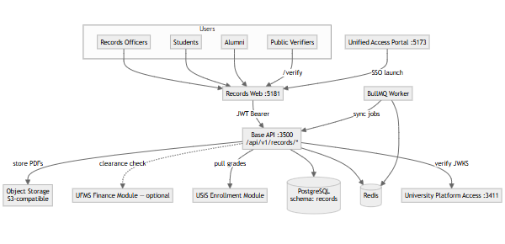
Key relationships:
- Records officers, students, and alumni authenticate via Portal SSO
- Public verifiers access /verify without authentication
- All authenticated requests flow through Base API records module
- USiS is authoritative source for grades; TORMS stores projections
- UFMS provides optional clearance/payment verification
- Background sync jobs run via BullMQ worker
- Issued document PDFs archived to object storage

3. Container View
Container | Technology | Port | Purpose
Records web | React 19 + Vite | 5181 | Staff operations, student requests, alumni portal, public verify
Base API (records module) | AdonisJS 7 + Lucid ORM | 3500 | Domain services, controllers, business logic
PostgreSQL | PostgreSQL 15+ | 5432 | Schema  records  — official records SoR (issuances, alumni)
Redis | Redis 7+ | 6379 | Cache, queue backend, rate limiting
BullMQ Worker | Node.js + BullMQ | N/A | Background sync, notifications, PDF generation
Object Storage | S3-compatible | N/A | Issued document PDF archival
University Platform Access | Identity service | 3411 | Authentication, authorization
USiS Enrollment | CIS module | 3500 | Grade/enrollment history source

Deployment notes:
- Records web served statically from CDN or Vite dev server
- Base API runs in containerized Node.js (non-root)
- PostgreSQL schema records isolated within wmsu_cis database
- Redis persistent (AOF + RDB) for queue durability
- Worker pool for concurrent job processing

4. Domain Module Architecture
TORMS records module organized by official records lifecycle:
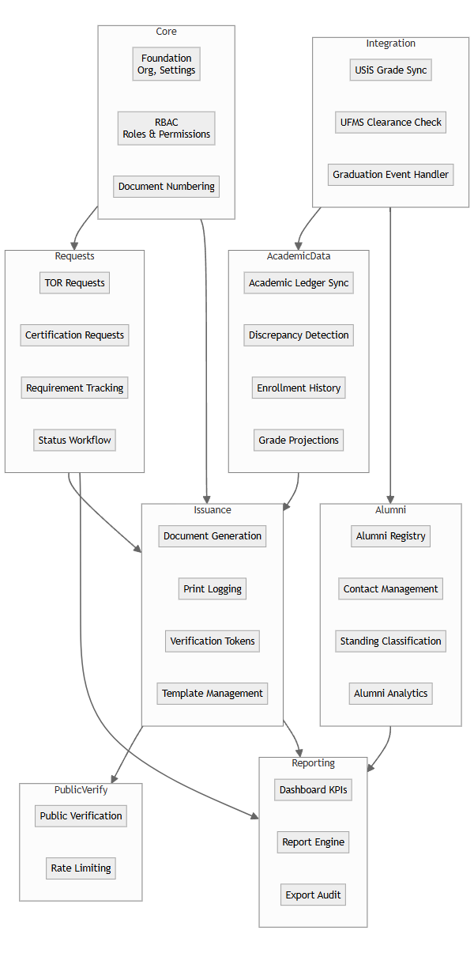
Domain responsibilities:
Domain | Key entities | Services
Core | Organization, Campus, DocumentNumbering, Settings | Foundation config, numbering schemes
Requests | TORRequest, CertificationRequest, RequestRequirement, StatusHistory | Request lifecycle management
Issuance | Issuance, IssuanceLog, VerificationToken, PrintEvent | Document generation, verification
Academic Data | LedgerProjection, GradeProjection, Discrepancy, SyncRun | USiS data sync, discrepancy detection
Alumni | AlumniProfile, AlumniContact, AlumniEmployment, AlumniEducation | Alumni registry, standing management
Integration | USiSGradeSync, UFMSClearanceClient, GraduationEventHandler | External system integration
Public Verify | VerificationAttempt, RateLimitRecord | Public verification, rate limiting
Reporting | Report, ReportExport, DashboardMetric | Analytics, export audit

5. Security Architecture

5.1 Authentication Flow
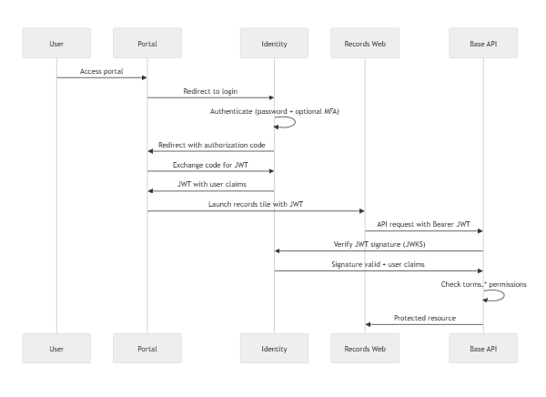
Public verification flow:
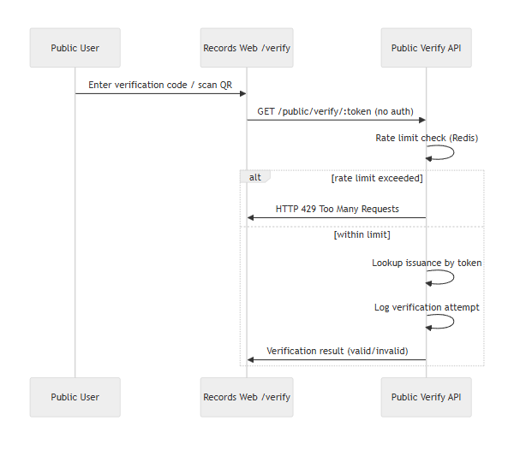
Security controls:
Layer | Control | Implementation
Transport | TLS 1.2+ | Reverse proxy termination
Authentication | OIDC/JWT | Identity service RS256 tokens
Authorization | RBAC | torms.*  permission checks
Public endpoints | Rate limiting | Redis-backed limiter (10/min/IP)
Internal APIs | Service keys | X-Service-Api-Key  header
Document access | Role-based | Issued PDFs restricted to officers
Verification tokens | UUID v4 | Cryptographically unique

5.2 Permission Model
TORMS permission categories:
- torms.requests.* — Request management (view, create, transition)
- torms.issuance.* — Document generation and printing
- torms.alumni.* — Alumni registry management
- torms.sync.* — Academic sync operations
- torms.reports.* — Report generation and export
- torms.config.* — System configuration
Role mappings:
- records_officer → All torms.* permissions
- student → torms.requests.own, torms.issuance.view_own
- alumni → torms.alumni.own, torms.issuance.view_own
- registrar (cross-system) → torms.sync.view, torms.reports.view

6. Data Architecture

6.1 Schema Organization
PostgreSQL schema records contains:
Core tables:
- organizations, campuses, settings
- document_numbering_schemes
Request lifecycle:
- tor_requests, certification_requests
- request_requirements, request_status_history
Issuance:
- issuances, issuance_logs, print_events
- verification_tokens
Academic data (projections from USiS):
- ledger_projections, grade_projections
- enrollment_history
- discrepancies, sync_runs
Alumni:
- alumni_profiles, alumni_contacts
- alumni_employment, alumni_education
- alumni_standing_history
Integration:
- sync_runs, clearance_checks
Verification:
- verification_attempts (audit log)
Reporting:
- report_exports (audit log)

6.2 Data Sync Strategy
USiS → TORMS sync:
- Pull model: TORMS queries USiS internal API
- Frequency: Nightly automated job (2:00 AM) + on-demand manual trigger
- Data: Grades, enrollment history, graduation events
- Idempotency: Upsert by student_id + term + course
- Discrepancy detection: Compare projection against USiS source after sync
No reverse sync: TORMS never writes back to USiS. USiS remains single source of truth for academic data.

7. Deployment Topology

7.1 Production Architecture
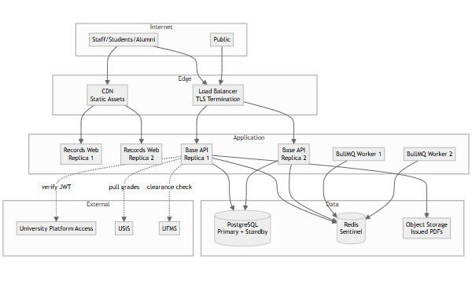
Sizing guidance:
- API: 2 replicas, 2 vCPU / 4 GB RAM each
- Worker: 2 replicas, 1 vCPU / 2 GB RAM each
- PostgreSQL: 4 vCPU / 16 GB RAM
- Redis: 2 vCPU / 4 GB RAM
- Object Storage: S3-compatible managed service

7.2 Local Development
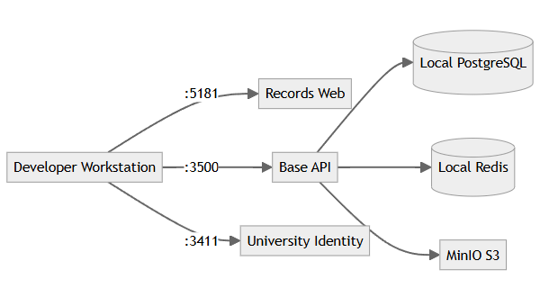

8. Integration Architecture

8.1 USiS Academic Data Sync
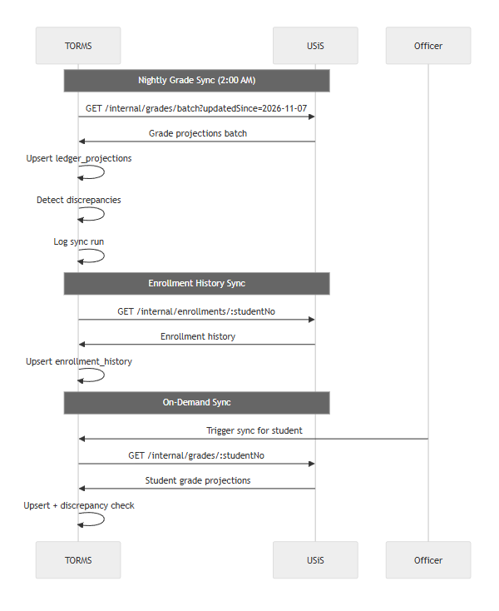

8.2 UFMS Clearance Check
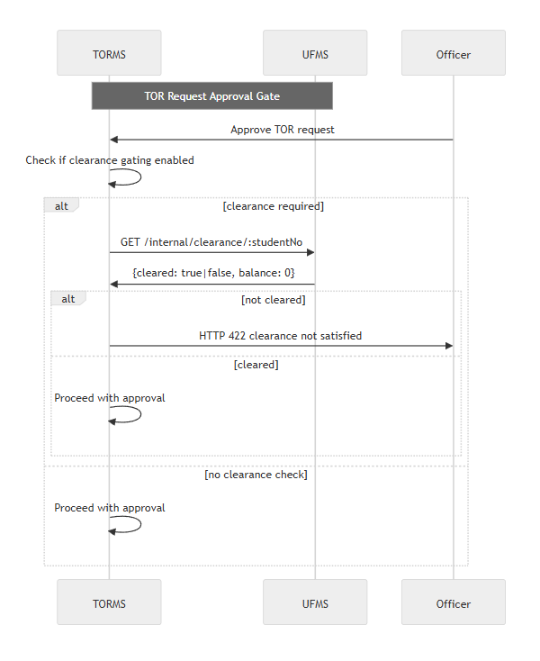

8.3 Alumni Creation Trigger
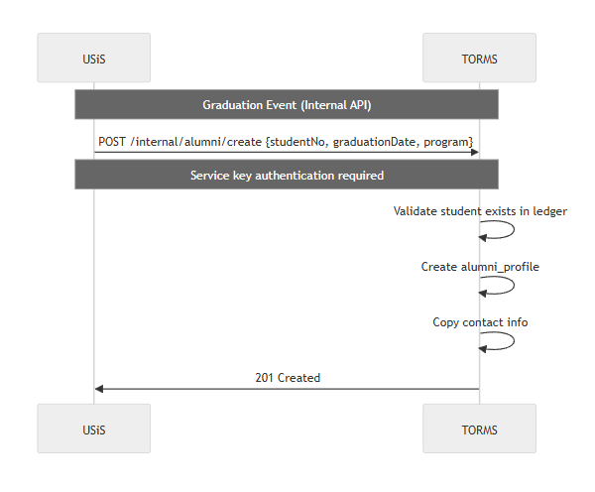

9. Quality Attributes

9.1 Performance
Optimization strategies:
- Database indexing on student_no, status, issue_date, verification_token
- Redis caching for frequently accessed settings (document numbering, templates)
- Background PDF generation (async job queue) for large TOR documents
- Lazy loading in records web UI
- Paginated API responses (default 25, max 100)
- Read replicas for reporting queries
Monitoring:
- APM (Sentry/OpenTelemetry) for request tracing
- PDF generation time metrics
- Sync job duration and error rates
- Public verification endpoint latency

9.2 Scalability
Horizontal scaling:
- Stateless API design
- Load balancer with health checks
- Worker pool for concurrent job processing
- Database connection pooling (PgBouncer)
Data growth:
- Partitioning for large tables (issuances, verification_attempts) by year
- Archival strategy for old verification attempts (retain 1 year)

9.3 Reliability
Failure handling:
- Graceful degradation when USiS unavailable (serve cached ledger projections, warn users)
- Retry logic for sync jobs (exponential backoff)
- Circuit breaker for external API calls
- Immutable issued documents — no deletion, only void with audit trail
Data integrity:
- Foreign key constraints
- Transaction management with rollback
- Idempotent sync operations
- Audit trails for all state changes

9.4 Maintainability
Code organization:
- Domain-driven design with bounded contexts
- Service layer abstraction
- Shared validation schemas
- OpenAPI documentation
Operational:
- Structured JSON logging
- Feature flags
- Blue-green deployment
- Automated schema migrations

9.5 Compliance
Data privacy (RA 10173):
- Student PII access restricted by role
- Public verification limited to name + document metadata
- Audit logging of document access
- Retention policies configurable
Records management:
- Issued documents immutable (void only, never delete)
- 7-year audit trail retention
- Chain of custody preservation for issuances
End of Architecture Design — TORMS

Part 3 — Features & Requirements

TORMS — Transcript & Official Records Management System Features & Requirements
Field | Value
Document ID | FEAT-TORMS-001
Product | TORMS
Companions | TORMS-SRS.md  ·  TORMS-LLD.md
Date | November 2026

1. Feature Summary
TORMS provides comprehensive official records management for Philippine university compliance:
Area | Features | Status
Authentication | University Platform Access SSO, role-based routing | Delivered
TOR Requests | Submission, status workflow, requirement tracking, PDF generation, print logging | Delivered
Certifications | Multiple types (honorable dismissal, good moral, units, completion), PDF generation | Delivered
Academic Ledger | Grade/enrollment sync from USiS, discrepancy detection, reconciliation | Delivered
Alumni Registry | Profile management, contact updates, standing classification | Delivered
Public Verification | Unauthenticated QR/code verification with rate limiting | Delivered
Dashboard | KPIs, pending requests, recent issuances, sync status | Delivered
Reporting | Issuance reports, request aging, alumni demographics, export audit | Delivered
Configuration | Document numbering, templates, signatories, clearance rules | Delivered

2. Feature Catalog
Feature ID | Feature | Description | Priority | Actors
F-AUTH-01 | SSO Authentication | University Platform Access OIDC/JWT | Must | All
F-AUTH-02 | Role Routing | Home path by role (staff/student/alumni) | Must | All
F-AUTH-03 | Permission Enforcement | torms.*  checks on all endpoints | Must | System
F-TOR-01 | TOR Request Submission | Student submits with purpose, delivery mode, copies | Must | Student
F-TOR-02 | Request Numbering | Auto-assign unique numbers (TOR-YYYY-NNNN) | Must | System
F-TOR-03 | Status Workflow | submitted → requirements_pending → processing → approved → issued → released | Must | Officer, System
F-TOR-04 | Request Management | Officer view/filter/search all requests | Must | Officer
F-TOR-05 | Status Transitions | Officer advances status with notes | Must | Officer
F-TOR-06 | Clearance Validation | Check clearance before approval (configurable) | Must | System
F-TOR-07 | Payment Verification | UFMS payment check if gating enabled | Should | System
F-TOR-08 | Requirement Attachments | Upload/attach requirement documents | Must | Student, Officer
F-TOR-09 | Request Notifications | Email/SMS on status transitions | Should | System
F-TOR-10 | TOR PDF Generation | Generate with ledger, seal, signatures | Must | System
F-TOR-11 | Verification QR Codes | Embed QR on TOR documents | Must | System
F-TOR-12 | Print Logging | Log print events with timestamp/officer | Must | System
F-TOR-13 | Digital Download | Student download issued TOR | Must | Student
F-CRT-01 | Certification Types | Honorable dismissal, good moral, units, completion, diploma verify | Must | System
F-CRT-02 | Certification Requests | Student submit with type and purpose | Must | Student
F-CRT-03 | Certification Numbering | Type-specific numbering (HD-YYYY-NNNN) | Must | System
F-CRT-04 | Certification Workflow | submitted → processing → issued → released | Must | Officer, System
F-CRT-05 | Certification Configuration | Configure types, templates, requirements | Should | Admin
F-CRT-06 | Certification PDF | Generate from templates with verification codes | Must | System
F-CRT-07 | Certification Print Log | Log print events | Must | System
F-LED-01 | Grade Sync | Pull grades from USiS internal API | Must | System
F-LED-02 | Ledger Projections | Create/update projections (no USiS mutation) | Must | System
F-LED-03 | Discrepancy Detection | Compare projections to USiS source | Must | System
F-LED-04 | Discrepancy Reports | Surface discrepancies to officers | Must | Officer
F-LED-05 | Manual Resolution | Officer resolves discrepancies with audit | Must | Officer
F-LED-06 | Enrollment History Sync | Sync enrollment records from USiS | Must | System
F-LED-07 | Sync Metadata Tracking | Log run timestamp, count, errors | Must | System
F-LED-08 | Sync Retry Logic | Exponential backoff on failure | Should | System
F-LED-09 | On-Demand Sync | Officer trigger sync for specific student | Should | Officer
F-ALM-01 | Alumni Auto-Creation | Create from USiS graduation event | Must | System
F-ALM-02 | Contact Updates | Alumni update address/phone/email | Must | Alumni
F-ALM-03 | Document Viewing | Alumni view issued TOR/certifications | Must | Alumni
F-ALM-04 | Standing Classification | Maintain alumni standing (active, distinguished, etc.) | Should | Officer
F-ALM-05 | Employment Tracking | Self-reported employment/education | Should | Alumni
F-ALM-06 | Alumni Reports | Demographic reports by graduation year/program | Should | Officer
F-ALM-07 | Bulk Import | Import legacy alumni data | Could | Admin
F-VRF-01 | Public Verify Page | /verify  without authentication | Must | Public
F-VRF-02 | Code/QR Entry | Enter code or scan QR | Must | Public
F-VRF-03 | Verification Result | Return valid (name, type, date) or invalid | Must | System
F-VRF-04 | PII Protection | No sensitive data beyond name/type/date | Must | System
F-VRF-05 | Verification Logging | Log attempts with IP/timestamp | Must | System
F-VRF-06 | Rate Limiting | 10 requests/minute/IP | Must | System
F-VRF-07 | Branded Display | Show university branding on results | Should | System
F-DSH-01 | Officer Dashboard | Pending requests, recent issuances, sync status | Must | Officer
F-DSH-02 | KPIs | Requests by status, processing time, issuance volume | Should | Officer
F-RPT-01 | TOR Issuance Report | By date range, program, student type | Must | Officer
F-RPT-02 | Certification Report | By type and date range | Must | Officer
F-RPT-03 | Request Aging Report | Days in each status | Must | Officer
F-RPT-04 | Alumni Demographics | By graduation year, program, location | Should | Officer
F-RPT-05 | Report Export | CSV and PDF formats | Must | Officer
F-RPT-06 | Export Audit Log | Log exports with user/timestamp | Must | System
F-CFG-01 | Numbering Schemes | Configure prefix, year format, sequence | Must | Admin
F-CFG-02 | Template Upload | PDF-compatible document templates | Should | Admin
F-CFG-03 | Signatory Config | Authorized signatories with titles/signatures | Must | Admin
F-CFG-04 | Clearance Rules | Configure requirements per document type | Should | Admin
F-CFG-05 | Config Audit Log | Log configuration changes | Must | System

3. Requirements Traceability Matrix

3.1 Functional Requirements Mapping
Requirement ID | Requirement | Related Features | Priority | Implementation Status
FR-AUTH-001..005 | Authentication and authorization | F-AUTH-01..03, F-VRF-01 | Must | Delivered
FR-TOR-001..013 | TOR request management | F-TOR-01..13 | Must/Should | Delivered
FR-CRT-001..007 | Certification management | F-CRT-01..07 | Must/Should | Delivered
FR-LED-001..009 | Academic ledger sync | F-LED-01..09 | Must/Should | Delivered
FR-ALM-001..007 | Alumni registry | F-ALM-01..07 | Must/Should/Could | Delivered
FR-VRF-001..007 | Public verification | F-VRF-01..07 | Must/Should | Delivered
FR-DSH-001..002 | Dashboard | F-DSH-01..02 | Must/Should | Delivered
FR-RPT-001..006 | Reporting | F-RPT-01..06 | Must/Should | Delivered
FR-CFG-001..005 | Configuration | F-CFG-01..05 | Must/Should | Delivered

3.2 Non-Functional Requirements Mapping
NFR Category | Requirement ID | Related Features | Implementation Approach
Performance | NFR-PERF-001..005 | All features | Database indexing, Redis caching, async PDF generation, pagination
Scalability | NFR-SCAL-001..004 | All features | Horizontal API scaling, worker pools, table partitioning
Security | NFR-SEC-001..010 | F-AUTH-  , F-VRF-  , F-CFG-* | TLS, RBAC, rate limiting, UUID tokens, audit logging, RA 10173 compliance
Reliability | NFR-REL-001..005 | All features | HA deployment, backups, DR procedures, graceful degradation, immutable docs
Maintainability | NFR-MAIN-001..005 | All features | Modular architecture, OpenAPI, structured logs, versioned migrations
Compliance | NFR-COMP-001..004 | Student/alumni data | RA 10173, FERPA-equivalent, 7-year audit retention

3.3 Source Requirements Traceability
WMSU TOR VI.E.6 compliance matrix:
TOR Requirement | Feature IDs | Implementation Notes | Compliance Status
TOR request and processing | F-TOR-01..13 | Full lifecycle from submission to issuance | Delivered
Multiple certification types | F-CRT-01..07 | Honorable dismissal, good moral, units, completion, diploma verify | Delivered
Academic record management | F-LED-01..09 | USiS sync with discrepancy detection; TORMS is projection, not SoR | Delivered
Alumni registry | F-ALM-01..07 | Auto-creation from graduation, contact management, standing | Delivered
Document verification | F-VRF-01..07 | Public QR/code verification with rate limiting | Delivered
Clearance integration | F-TOR-06, F-TOR-07 | UFMS clearance checks when enabled | Delivered
Print audit trails | F-TOR-12, F-CRT-07 | Print event logging for accountability | Delivered
Reporting and analytics | F-RPT-01..06, F-DSH-01..02 | Issuance, aging, alumni reports with export | Delivered

Deferred/Out of scope:
- Grade entry and enrollment workflows → USiS responsibility
- Financial transactions and cashiering → UFMS responsibility
- Library, documents, inventory → ULMIS, UDMS, UIMS

4. Non-Functional Requirements Summary

4.1 Performance Targets
Metric | Target | Measurement
API response (p95) | ≤2s standard queries | APM monitoring
PDF generation | ≤10s per TOR | Performance profiling
Public verification (p95) | ≤1s | Load testing
Academic sync (1000 students) | ≤30 minutes | Job duration metrics

4.2 Security Controls
Control | Implementation | Verification
TLS enforcement | Reverse proxy/ingress | SSL Labs scan
RBAC | torms.*  permission checks | Automated security tests
Rate limiting | Redis-backed (10/min/IP) | Load test verification
Audit logging | Structured logs for issuance/print/config | Log review
Token uniqueness | UUID v4 | Code review + statistical testing

4.3 Reliability Measures
Measure | Target | Method
Availability | ≥99% business hours | SLA monitoring
Backup frequency | Daily incremental, weekly full | Automated verification
RPO | ≤15 minutes | DR drill testing
Document immutability | No deletion post-issuance | Business rule enforcement + audit

5. Actors & Feature Access
Actor | Primary Features | Restricted Features
Records Officer | F-TOR-04..12, F-CRT-05..07, F-LED-04..05, F-LED-09, F-ALM-04, F-RPT-01..06, F-DSH-01..02, F-CFG-01..05 | Full records management
Student | F-TOR-01, F-TOR-08, F-TOR-13, F-CRT-02 | Own requests only
Alumni | F-ALM-02, F-ALM-03, F-ALM-05 | Own profile and documents
Registrar (cross-system) | F-LED-04, F-RPT-01..06 | Oversight and reports
Public | F-VRF-01..07 | Verification only
System (Background) | F-TOR-02..03, F-TOR-10..12, F-CRT-06..07, F-LED-01..03, F-LED-06..08, F-ALM-01, F-VRF-03..06 | Automated operations

End of Features & Requirements — TORMS

Part 4 — Low-Level Design (LLD) Workflows

TORMS — Transcript & Official Records Management System Low-Level Design
Field | Value
Document ID | LLD-TORMS-001
Product | TORMS
Companion | TORMS-SRS.md
Date | November 2026

1. Purpose
This Low-Level Design documents critical workflows for TORMS TOR requests, certification issuance, academic ledger synchronization from USiS, public document verification, alumni management, and records officer operations — providing sequence diagrams, state machines, and implementation details.

2. System Context (Multi-Role Architecture)
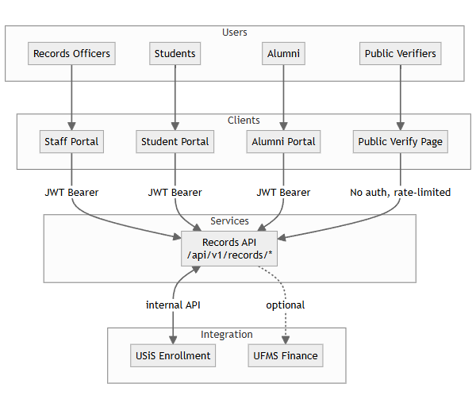
Role-specific routes:
- Records officer: /staff/*
- Student: /student/*
- Alumni: /alumni/*
- Public: /verify

3. TOR Request Workflow

3.1 TOR Request State Machine
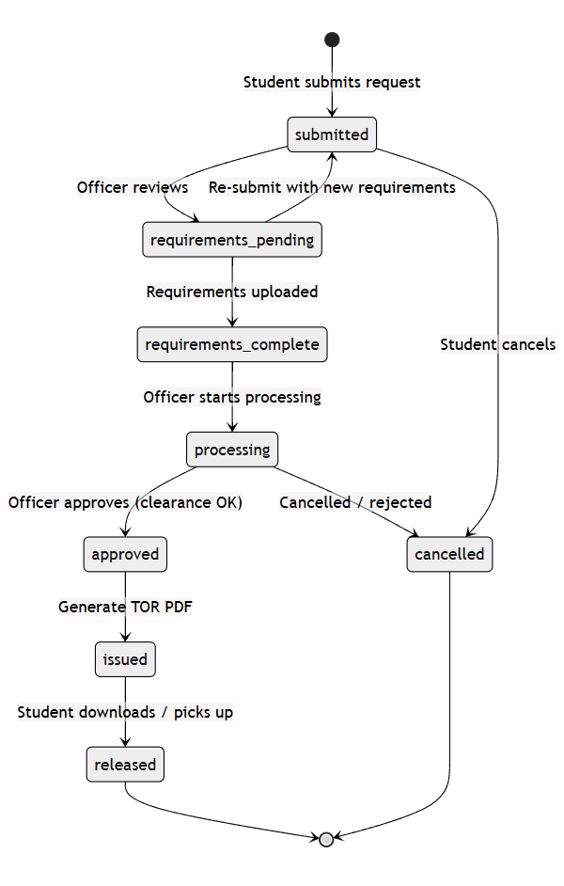

3.2 TOR Request Submission Sequence
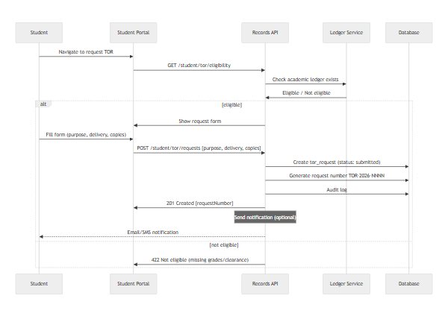

3.3 Officer Request Processing
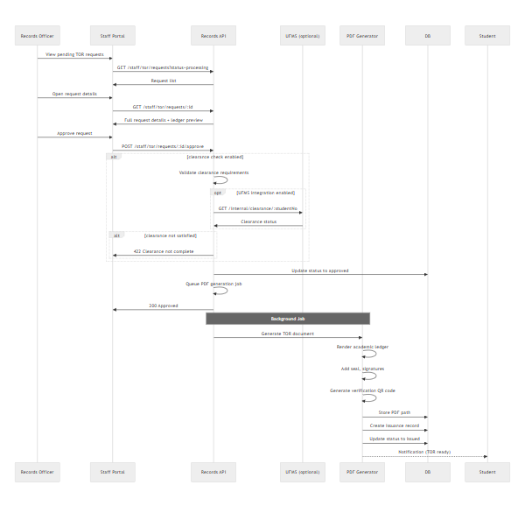

4. Certification Request Workflow

4.1 Certification Types and Numbering
Certification Type | Code | Number Format | Typical Use
Honorable Dismissal | HD | HD-2026-0001 | Transfer to another institution
Good Moral Character | GMC | GMC-2026-0001 | Employment, visa applications
Units Earned | UE | UE-2026-0001 | Proof of partial completion
Completion | CMPL | CMPL-2026-0001 | Program completion (non-degree)
Diploma Verification | DV | DV-2026-0001 | Verify diploma authenticity

4.2 Certification Request State Machine
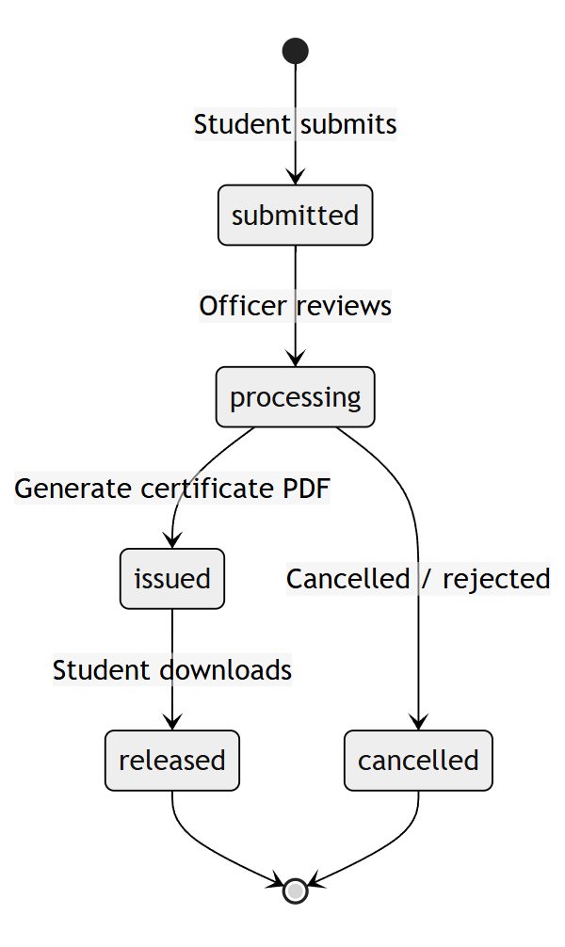

4.3 Certification Issuance Sequence
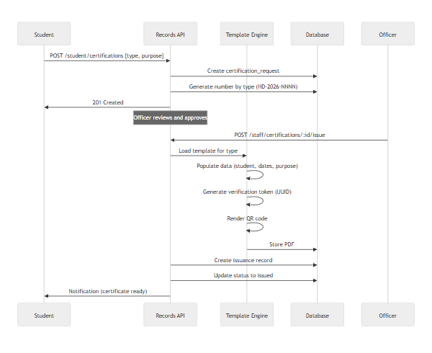

5. Academic Ledger Sync from USiS

5.1 Nightly Batch Sync
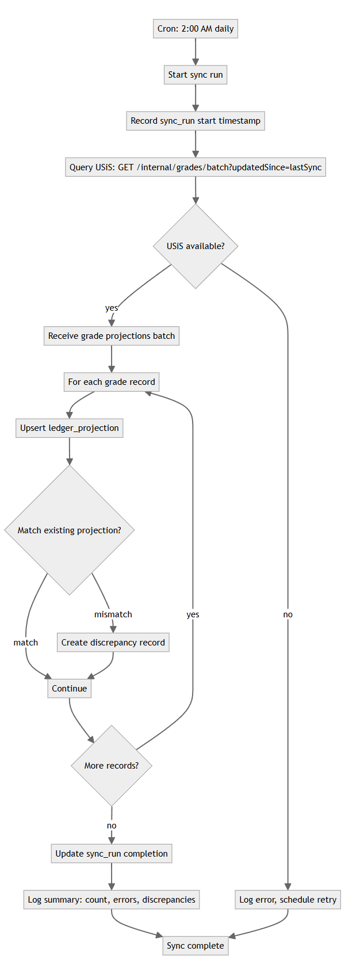

5.2 Discrepancy Detection Logic
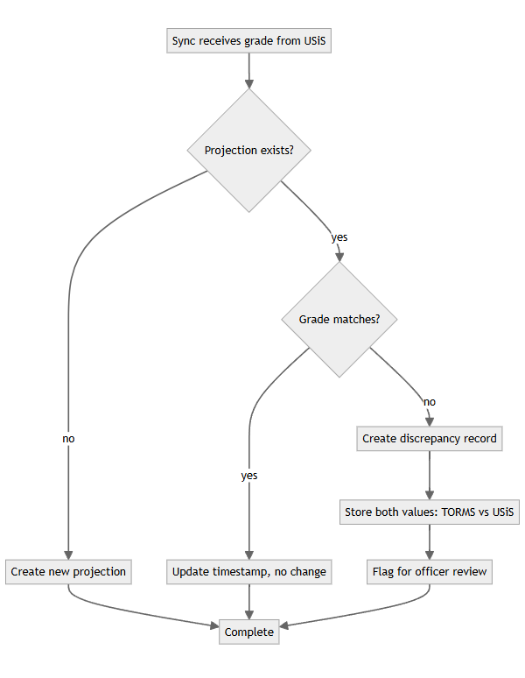

5.3 Discrepancy Resolution
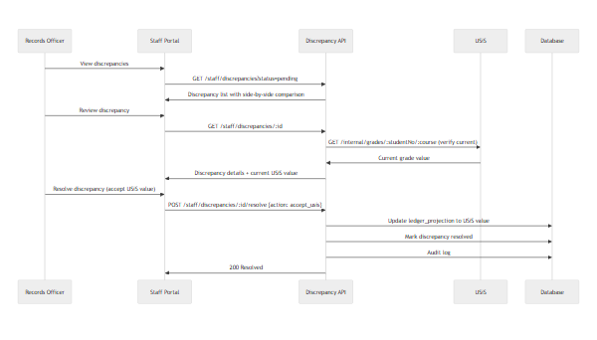

6. On-Demand Sync for Specific Student
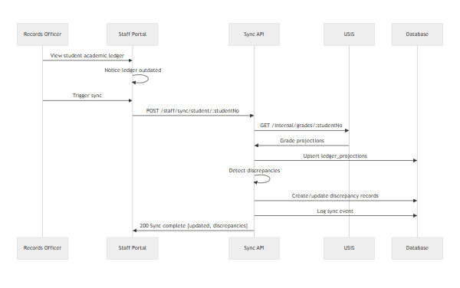

7. Public Document Verification

7.1 Verification Flow
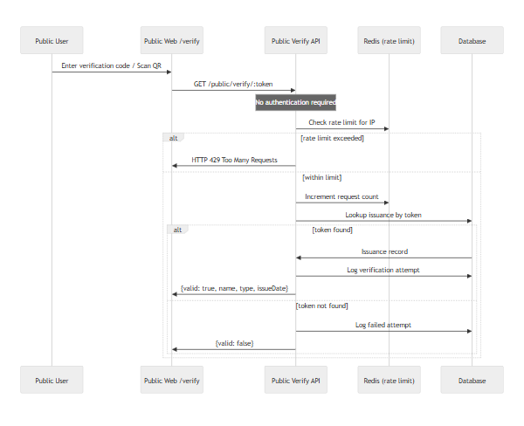

7.2 Rate Limiting Logic
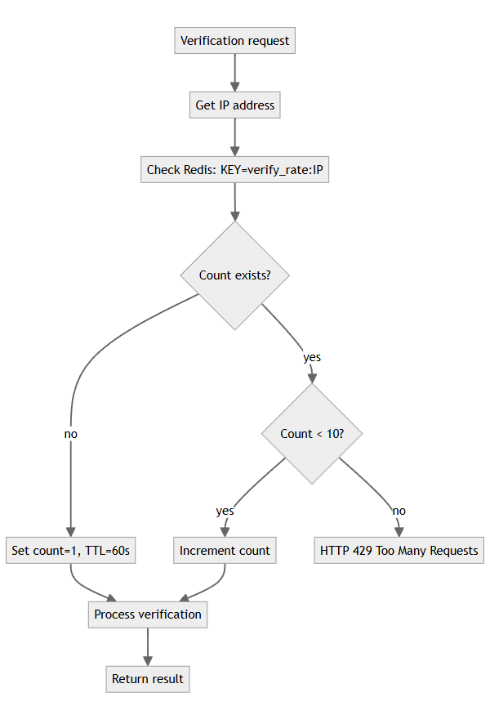

8. Alumni Management

8.1 Alumni Creation from Graduation Event
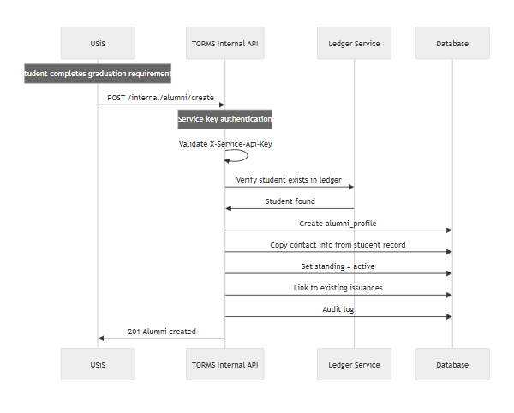

8.2 Alumni Self-Service
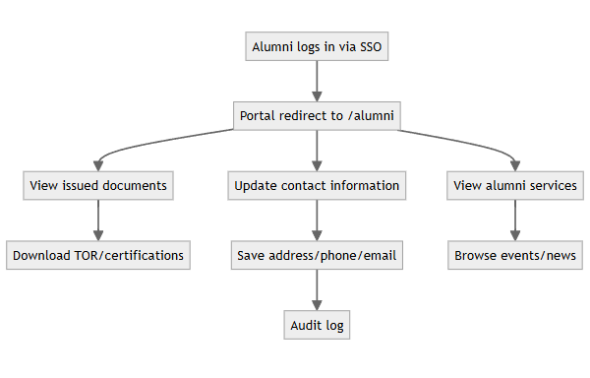

9. Records Officer Dashboard

9.1 Dashboard Data Flow
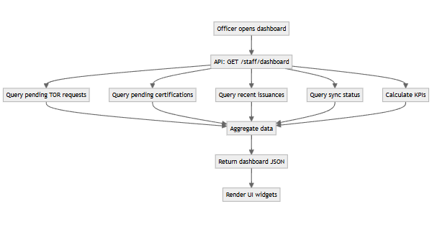

9.2 KPI Calculations
KPI | Calculation | Data source
Total pending requests | Count where status IN (submitted, requirements_pending, processing) | tor_requests + certification_requests
Average processing time | AVG(issued_at - submitted_at) for last 30 days | issuances
Issuance volume (monthly) | Count issuances grouped by month | issuances
Sync status | Latest sync_run timestamp + error count | sync_runs
Discrepancy count | Count where status = pending | discrepancies
Alumni registered (YTD) | Count created this year | alumni_profiles

10. Report Generation

10.1 Report Export Workflow
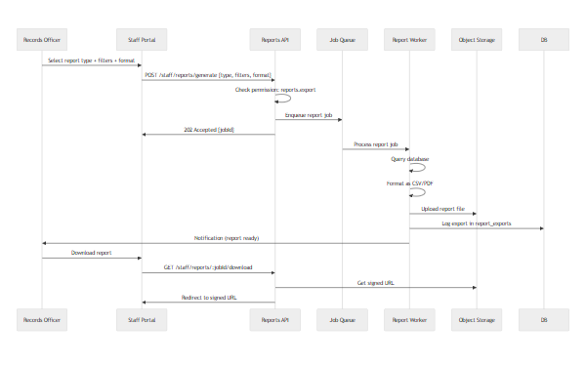

10.2 Report Types
Report Type | Query complexity | Typical runtime
TOR Issuance | Simple (issuances + student join) | <5s
Certification Issuance | Simple (issuances + type filter) | <5s
Request Aging | Medium (status history aggregation) | 10-30s
Alumni Demographics | Medium (alumni + program join, grouping) | 10-30s
Sync Status | Simple (latest sync_runs) | <2s

11. Error Cases & Edge Conditions
Case | Expected Behavior | HTTP Status | User Message
TOR request without academic ledger | Block submission | 422 | "Academic records not found. Contact registrar."
Approve TOR with pending clearance | Block approval | 422 | "Clearance requirements not satisfied."
UFMS unavailable during clearance check | Log error, allow manual override | 503 | "Clearance service unavailable. Manual verification required."
Public verify with invalid token | Return not found | 404 | "Invalid verification code."
Public verify exceeds rate limit | Block request | 429 | "Too many verification attempts. Try again in 1 minute."
Sync while USiS down | Log error, retry scheduled | N/A | "Sync failed. Will retry automatically."
Duplicate alumni creation (graduation replay) | Idempotent — return existing | 200 | Existing alumni ID
Student accesses other student's TOR request | Authorization failure | 403 | "Access denied."
Alumni updates to restricted fields (e.g., graduation date) | Block update | 422 | "Field cannot be modified."
PDF generation failure | Log error, flag for manual generation | 500 | "Document generation failed. Request logged."
Discrepancy resolve without permission | Authorization failure | 403 | "Insufficient permissions."

12. Background Job Workflows

12.1 Nightly Sync Job Schedule
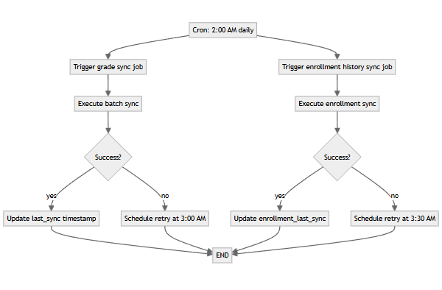

12.2 PDF Generation Job
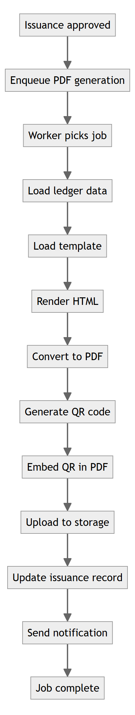
End of LLD — TORMS

