UFMS — Complete System Specification
Field | Value
Product | UFMS — University Financial Management System
Document type | Complete System Specification (SRS + Architecture + Features + LLD)
Date | November 2026
Classification | Proprietary

Document contents
- System Requirements Specification (SRS)
- Architecture Design
- Features & Requirements
- Low-Level Design (LLD) Workflows

Part 1 — System Requirements Specification (SRS)

University Financial Management System (UFMS)
Field | Value
Document ID | SRS-UFMS-001
Product | UFMS (University Financial Management System)
Repository | WMSU/wmsu-platform  (  apps/finance-web  ,  apps/base-api  module  finance  )
Version | 1.0
Date | November 2026
Classification | Proprietary
TOR reference | VI.E.3 (finance consolidation under CIS)

1. Introduction

1.1 Purpose
This Software Requirements Specification defines functional and non-functional requirements for UFMS, the comprehensive campus financial operations system managing budgeting, government-style accounting (JEV/GL), tuition fee schedules and payment plans, cashiering and receivables, accounts payable and disbursement, procurement, point-of-sale operations — with internal APIs for USiS assessment and clearance integration.

1.2 Scope
In scope
- Budget management: plans, obligations, availability checks, monitoring, approvals, utilization tracking
- Accounting: journal entry vouchers (JEV), general ledger (GL), trial balance, bank reconciliation, fiscal period close
- Tuition and fees: fee schedules, payment policies, installment plans, assessment generation
- Cashiering and receivables: student payments, official receipt (OR) series, daily collection reports, deposit slips
- Accounts payable: supplier invoices, disbursement vouchers, check/ADA processing
- Procurement: vendor master, purchase requisition (PR), request for quotation (RFQ), purchase order (PO), inspection and acceptance report (IAR)
- Point-of-sale (POS): terminals, catalog, sales transactions, end-of-day closing; read-only stock snapshots from UIMS
- Configuration: chart of accounts (COA), fund structure, bank accounts, fiscal periods, approval workflows
- Reporting and analytics: budget vs actual, trial balance, aging reports, statement of account, dashboard KPIs
- University Platform Access SSO integration (platform code finance)
- Internal APIs for USiS assessment/payment handoff and clearance status
Out of scope
- Student registration, grades, admissions (owned by USiS)
- Transcript of records and certification issuance (owned by TORMS)
- Inventory master data and asset lifecycle authorship (owned by UIMS — UFMS POS may read stock snapshots)
- Library operations (owned by ULMIS)
- Document management repository (owned by UDMS)
- Inventing university fee policy amounts in documentation beyond configured schedules

1.3 Definitions
Term | Definition
UFMS | University Financial Management System
JEV | Journal Entry Voucher — government accounting document
GL | General Ledger — comprehensive accounting record
COA | Chart of Accounts — hierarchical account structure
OR | Official Receipt — government-issued payment receipt
DV | Disbursement Voucher — payment authorization document
IAR | Inspection and Acceptance Report — procurement delivery verification
Hard budget stop | System setting that blocks obligations when funds unavailable
Assessment | Tuition and fee calculation for a student enrollment period

1.4 References
- WMSU/wmsu-platform/README.md
- apps/web-portal/public/docs/UFMS-Complete-Guide.html
- apps/web-portal/public/docs/UFMS-API-Specs-Manual.html
- USiS Internal API Specification (assessment handoff)
- UIMS Stock Snapshot API Specification (POS integration)
- University Platform Access Architecture

2. Overall Description

2.1 Product Perspective
UFMS operates within the WMSU Campus Information System modular architecture:
Component | Technology | Role
Finance web | React 19 + Vite | Multi-role financial operations UI
Base API finance module | AdonisJS 7 + Lucid ORM | REST services at  /api/v1/finance/*
Database | PostgreSQL schema  finance | Financial system of record
Identity provider | University Platform Access | Authentication, authorization, user management
Queue system | BullMQ + Redis | Background jobs (reports, notifications, reconciliation)

Surface | Dev port | Production example
Finance web | http://127.0.0.1:5182 | https://finance.wmsu.edu.ph
Base API | http://127.0.0.1:3500 | https://api.wmsu.edu.ph
Identity API | http://127.0.0.1:3411 | https://auth.wmsu.edu.ph

Health endpoint:GET /health → { status: 'ok', service: 'base-api', module: 'finance' }

2.2 User Classes
Role | Primary capabilities | Access level
Cashier | Record student payments, issue official receipts, daily collection, POS operations | Payment processing
Accounting | Journals, GL, reconciliation, trial balance, period close | Full accounting
Budget Officer | Budget plans, obligations, monitoring, approval workflows | Budget oversight
Procurement Officer | PR → RFQ → PO → IAR workflows, vendor management | Procurement processes
Treasury | Disbursement vouchers, check/ADA processing, bank reconciliation | Payment disbursement
Registrar (limited) | Read-only access to student account status, clearance verification | Cross-system queries
Identity Administrator | Full UFMS access when  finance  platform granted | All UFMS permissions

Frontend permission checks provide user experience; API enforces authorization on every route.

2.3 Constraints
- Platform tile visibility requires Identity platform grant finance
- Internal USiS integration routes require service API key protection (browser never receives key)
- Budget availability may enforce hard-stop when configured — blocks obligations if funds insufficient
- Fee schedules are configuration data — this SRS does not invent tariff amounts
- COA structure and fiscal periods must be configured before live posting
- OR series must be activated and assigned to cashiers before receipt issuance
- Government accounting conventions (JEV, GL) follow Philippine GASB/IPSAS-aligned standards
- POS reads stock data from UIMS as snapshots — UFMS does not author inventory masters

2.4 Assumptions
- COA, fund structure, and fiscal periods seeded or configured during deployment
- USiS enrollment system calls UFMS internal APIs for assessment upsert and payment status queries
- SMTP/notification infrastructure configured for approval alerts and reminders
- University seal and authorized signatory images available for document generation
- Bank account details configured for reconciliation
- Cashiers assigned to specific OR series for accountability
- Demo/staging environments provision sample COA, students, transactions
- UIMS inventory system running when POS stock integration enabled

3. Functional Requirements

3.1 Authentication & Authorization
ID | Requirement | Priority
FR-AUTH-001 | System shall authenticate all users via University Platform Access SSO | Must
FR-AUTH-002 | System shall resolve user home path based on role (cashier →  /cashier  , accounting →  /accounting  , etc.) | Must
FR-AUTH-003 | System shall enforce  finance.*  permission checks on every authenticated API endpoint | Must
FR-AUTH-004 | Internal service routes shall require  X-Service-Api-Key  header validation | Must
FR-AUTH-005 | Browser clients shall never receive service API keys | Must

3.2 Configuration Management
ID | Requirement | Priority
FR-CFG-001 | Administrators shall configure chart of accounts (COA) with hierarchical structure | Must
FR-CFG-002 | System shall support fund structure configuration (general, special, trust, etc.) | Must
FR-CFG-003 | Administrators shall configure bank accounts with reconciliation parameters | Must
FR-CFG-004 | Administrators shall define fiscal periods with open/closed status | Must
FR-CFG-005 | System shall configure OR series with prefix, start number, end number, and cashier assignment | Must
FR-CFG-006 | Administrators shall configure approval workflows for budgets, disbursements, procurement | Should
FR-CFG-007 | System shall maintain audit log of configuration changes | Must

3.3 Budget Management
ID | Requirement | Priority
FR-BDG-001 | Budget officers shall create budget plans with allocation by fund, account, and period | Must
FR-BDG-002 | System shall support budget approval workflow (draft → submitted → approved) | Must
FR-BDG-003 | System shall track obligations against approved budget | Must
FR-BDG-004 | System shall check budget availability before allowing obligation posting | Must
FR-BDG-005 | System shall enforce hard budget stop when configured (block if insufficient funds) | Must
FR-BDG-006 | Budget officers shall monitor budget utilization with real-time reports | Must
FR-BDG-007 | System shall generate budget vs actual reports by period, fund, account | Must
FR-BDG-008 | System shall support budget amendments and realignments with approval | Should

3.4 Accounting
ID | Requirement | Priority
FR-ACC-001 | Accountants shall create journal entry vouchers (JEV) with debit/credit lines | Must
FR-ACC-002 | System shall validate JEV balance (total debit = total credit) before posting | Must
FR-ACC-003 | System shall post JEV entries to general ledger (GL) with audit trail | Must
FR-ACC-004 | System shall maintain GL balances by account, fund, and fiscal period | Must
FR-ACC-005 | System shall generate trial balance report for specified period | Must
FR-ACC-006 | Accountants shall perform bank reconciliation with imported bank statements | Must
FR-ACC-007 | System shall support fiscal period close with validation and lock mechanism | Must
FR-ACC-008 | System shall prevent posting to closed periods without administrator override | Must
FR-ACC-009 | System shall generate financial statements (income statement, balance sheet) | Should

3.5 Tuition and Fee Management
ID | Requirement | Priority
FR-TUI-001 | Administrators shall configure fee schedules by program, year level, and term | Must
FR-TUI-002 | System shall define payment policies (full, installment) with due dates | Must
FR-TUI-003 | System shall calculate tuition assessments based on enrolled units and fee schedules | Must
FR-TUI-004 | System shall generate assessment documents linked to USiS enrollments | Must
FR-TUI-005 | System shall track installment payment schedules with penalty calculations | Should
FR-TUI-006 | System shall support scholarships and discounts with GL posting rules | Should

3.6 Cashiering and Receivables
ID | Requirement | Priority
FR-CSH-001 | Cashiers shall look up student accounts by student number or name | Must
FR-CSH-002 | System shall display outstanding assessments and payment history | Must
FR-CSH-003 | Cashiers shall record student payments with payment mode (cash, check, online) | Must
FR-CSH-004 | System shall reject invalid payments (unknown student, zero amount, negative amount) | Must
FR-CSH-005 | System shall issue official receipt (OR) from assigned series upon payment | Must
FR-CSH-006 | System shall generate OR PDF with payment details, OR number, and QR code | Must
FR-CSH-007 | System shall post payment to GL automatically (debit cash, credit receivable) | Must
FR-CSH-008 | Cashiers shall generate daily collection report at end of shift | Must
FR-CSH-009 | System shall create deposit slip for bank remittance | Must
FR-CSH-010 | System shall track OR series usage and alert when nearing end | Should

3.7 Accounts Payable and Disbursement
ID | Requirement | Priority
FR-APY-001 | Accountants shall register supplier invoices with amount, due date, and terms | Must
FR-APY-002 | System shall create disbursement vouchers (DV) linked to invoices or obligations | Must
FR-APY-003 | System shall support DV approval workflow with authorization limits | Must
FR-APY-004 | Treasury shall process approved DVs with check or ADA (advice to debit account) | Must
FR-APY-005 | System shall post disbursement to GL (debit expense/asset, credit payable/cash) | Must
FR-APY-006 | System shall track check status (issued, cleared, stale, cancelled) | Should
FR-APY-007 | System shall generate aging report for accounts payable | Must

3.8 Procurement
ID | Requirement | Priority
FR-PRC-001 | System shall maintain supplier/vendor master with contact and tax details | Must
FR-PRC-002 | Requestors shall create purchase requisitions (PR) with item details and justification | Must
FR-PRC-003 | System shall support PR approval workflow | Must
FR-PRC-004 | Procurement officers shall issue request for quotation (RFQ) to suppliers | Should
FR-PRC-005 | Procurement officers shall award supplier and create purchase order (PO) | Must
FR-PRC-006 | System shall track PO status (issued, partially received, fully received, cancelled) | Must
FR-PRC-007 | Receiving officers shall create inspection and acceptance report (IAR) upon delivery | Must
FR-PRC-008 | System shall link IAR to PO and trigger accounts payable invoice creation | Must
FR-PRC-009 | System shall enforce budget availability check before PO creation | Must

3.9 Point-of-Sale (POS)
ID | Requirement | Priority
FR-POS-001 | Cashiers shall configure POS terminals with assigned location and cashier | Must
FR-POS-002 | System shall maintain POS catalog with items and prices | Must
FR-POS-003 | System shall query UIMS for real-time stock availability (read-only snapshot) | Should
FR-POS-004 | Cashiers shall build sale transaction with multiple line items | Must
FR-POS-005 | System shall calculate sale total with taxes/discounts if configured | Should
FR-POS-006 | System shall complete sale with payment and issue OR/receipt | Must
FR-POS-007 | System shall post POS sale to GL (debit cash, credit revenue) | Must
FR-POS-008 | Cashiers shall perform end-of-day (EOD) closing with summary report | Must
FR-POS-009 | System shall prevent further sales on closed terminal until new day started | Must

3.10 Internal API for USiS Integration
ID | Requirement | Priority
FR-INT-001 | USiS shall upsert student assessments via internal API (service key protected) | Must
FR-INT-002 | System shall accept assessment data (student number, term, fee line items) and generate assessment document | Must
FR-INT-003 | USiS shall query payment status via internal API | Must
FR-INT-004 | System shall return payment status (pending, partial, verified) with amounts | Must
FR-INT-005 | USiS/TORMS shall query financial clearance status via internal API | Must
FR-INT-006 | System shall return clearance status (cleared if no outstanding balance, otherwise balance amount) | Must

3.11 Dashboard and Reporting
ID | Requirement | Priority
FR-DSH-001 | Finance dashboard shall display KPIs: total collections, outstanding receivables, disbursements, budget utilization | Must
FR-DSH-002 | Dashboard shall show recent transactions and pending approvals | Should
FR-RPT-001 | System shall generate trial balance report by period and fund | Must
FR-RPT-002 | System shall generate budget vs actual report with variance analysis | Must
FR-RPT-003 | System shall generate accounts receivable aging report | Must
FR-RPT-004 | System shall generate accounts payable aging report | Must
FR-RPT-005 | System shall generate statement of account for students | Must
FR-RPT-006 | System shall generate daily collection report by cashier | Must
FR-RPT-007 | System shall export all reports in CSV, Excel, and PDF formats | Must
FR-RPT-008 | System shall log all report exports with user and timestamp for audit | Must

4. External Interface Requirements

4.1 Integration Interfaces
Interface | Direction | Protocol | Purpose
University Platform Access | Inbound | OIDC/JWKS | SSO authentication, JWT verification, role resolution
USiS Enrollment API | Inbound | REST+JSON | Assessment upsert, payment status query, clearance verification
TORMS Records API | Inbound | REST+JSON | Clearance verification for TOR requests
UIMS Inventory API | Outbound (optional) | REST+JSON | POS stock availability snapshots
SMTP/SMS Gateway | Outbound | SMTP/HTTP | Approval notifications, payment reminders
Bank API | Outbound (optional) | SFTP/API | Bank statement import for reconciliation
Object Storage | Outbound | S3-compatible | OR PDF archival, report storage

4.2 API Specifications
Finance API base:/api/v1/finance/*
Internal service routes:/api/v1/finance/internal/* (service key protected)
OpenAPI documentation: Available at /api/v1/finance/docs (Swagger UI)
Authentication: Bearer JWT from University Platform Access in Authorization header

4.3 User Interface Requirements
- Responsive design supporting desktop (≥1280px), tablet (768-1023px), and mobile (360-767px)
- Browser compatibility: Chrome/Edge (latest 2), Firefox (latest 2), Safari (latest 2)
- Accessibility: WCAG 2.1 Level AA for public-facing payment status pages
- Print-optimized views for OR, financial statements, reports
- Real-time budget availability indicators
- Bulk transaction processing interfaces for accounting
- POS terminal optimized for touch/barcode scanner input

5. Non-Functional Requirements

5.1 Performance
ID | Requirement | Target
NFR-PERF-001 | API response time (p95) for standard queries | ≤ 2 seconds
NFR-PERF-002 | Payment recording and OR generation | ≤ 3 seconds
NFR-PERF-003 | Budget availability check | ≤ 1 second
NFR-PERF-004 | Health check endpoint response time | ≤ 500 ms
NFR-PERF-005 | Trial balance generation for 10,000 transactions | ≤ 30 seconds

5.2 Scalability
ID | Requirement
NFR-SCAL-001 | Support ≥20,000 student accounts
NFR-SCAL-002 | Support ≥100,000 transactions per academic year
NFR-SCAL-003 | Horizontal scaling of API replicas
NFR-SCAL-004 | Background job queue processing with worker pools

5.3 Security
ID | Requirement
NFR-SEC-001 | TLS 1.2+ required for all client-server communication
NFR-SEC-002 | RBAC enforcement on every authenticated API endpoint using  finance.*  permissions
NFR-SEC-003 | Service-to-service communication via API keys for internal routes
NFR-SEC-004 | Financial data encryption at rest for sensitive fields (bank accounts, OR numbers)
NFR-SEC-005 | Audit logging of all financial transactions, posting, and configuration changes
NFR-SEC-006 | CORS allowlist limited to authorized web client origins
NFR-SEC-007 | Non-root container execution in production
NFR-SEC-008 | Budget and disbursement approval workflows with authorization limits
NFR-SEC-009 | OR series accountability tracking by cashier
NFR-SEC-010 | Password/MFA enforcement for privileged financial roles

5.4 Reliability
ID | Requirement
NFR-REL-001 | System availability ≥99.5% during business hours
NFR-REL-002 | Automated database backups (daily incremental, weekly full)
NFR-REL-003 | Point-in-time recovery capability ≤15 minutes RPO
NFR-REL-004 | Graceful degradation when USiS/UIMS temporarily unavailable
NFR-REL-005 | Posted GL entries immutable — corrections via reversing JEV only
NFR-REL-006 | Fiscal period close prevents accidental posting to closed periods

5.5 Maintainability
ID | Requirement
NFR-MAIN-001 | Modular domain architecture with separation of concerns
NFR-MAIN-002 | Comprehensive API documentation (OpenAPI 3.0+)
NFR-MAIN-003 | Structured logging with correlation IDs
NFR-MAIN-004 | Database schema migrations versioned and reversible
NFR-MAIN-005 | COA and configuration hot-reloading without deployment

5.6 Compliance
ID | Requirement
NFR-COMP-001 | RA 10173 (Data Privacy Act) compliance for student financial data
NFR-COMP-002 | Philippine government accounting standards alignment (GASB/IPSAS)
NFR-COMP-003 | Audit trail retention ≥7 years per government records management
NFR-COMP-004 | OR series accountability and reconciliation
NFR-COMP-005 | Financial statement accuracy and timeliness

6. Verification Criteria

6.1 Functional Verification
Scenario | Expected result | Test type
Cashier login via SSO | Redirect to  /cashier  dashboard | Integration
Record student payment | Payment saved, OR issued, GL posted | E2E
Record payment with invalid student number | HTTP 422 rejection | Unit
Record payment with zero amount | HTTP 422 rejection | Unit
Budget obligation exceeds available with hard stop | HTTP 422 rejection | Unit
Budget obligation without hard stop | Allowed with warning | Unit
Post JEV with unbalanced debit/credit | HTTP 422 validation error | Unit
USiS upsert assessment via internal API | Assessment created, linked to student | Integration
USiS query payment status | Returns pending/partial/verified accurately | Integration
Query clearance with outstanding balance | Returns not cleared with balance amount | Integration
Query clearance with zero balance | Returns cleared | Integration
POS query UIMS stock | Returns available quantity | Integration (optional)
Generate trial balance | Balanced report with all accounts | Integration
Fiscal period close | Period locked, posting prevented | E2E

6.2 Non-Functional Verification
Scenario | Expected result | Test type
100 concurrent payment recordings | p95 response ≤3s, no errors | Load test
Trial balance for 10K transactions | Completes in ≤30s | Performance test
Unauthorized access to internal API | HTTP 401/403 | Security test
Database failover | Recovery within 15 minutes | DR drill

7. Document Control
Version | Date | Description
1.0 | November 2026 | Complete System Specification from wmsu-platform finance module

Related Design Documents
- UFMS-Architecture.md — Architecture design (containers, domains, security, deployment)
- UFMS-Features-Requirements.md — Feature catalog + requirements traceability
- UFMS-LLD.md — Low-level design workflows (cashiering, budget, procurement, disbursement, POS, USiS integration)
End of SRS — UFMS

Part 2 — Architecture Design

UFMS — University Financial Management System Architecture
Field | Value
Document ID | AD-UFMS-001
Product | UFMS
Companions | UFMS-SRS.md  ·  UFMS-Features-Requirements.md  ·  UFMS-LLD.md
Date | November 2026

1. Purpose
Architecture design for UFMS within WMSU CIS modular monolith — covering system context, container architecture, domain module organization, security architecture, deployment topology, integration patterns, and quality attributes for university financial management.

2. System Context
UFMS integrates with Identity for SSO, USiS for assessment/payment handoff, and optional UIMS for POS stock:
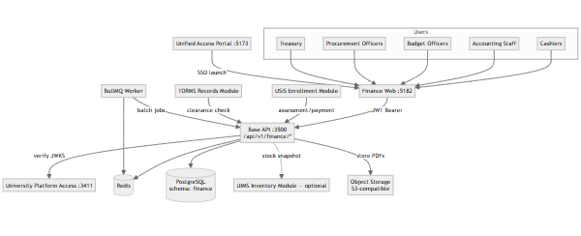
Key relationships:
- Financial staff authenticate via Portal SSO
- All UI interactions flow through Base API finance module
- USiS enrollment system calls UFMS internal APIs for assessment upsert and payment verification
- TORMS records system calls UFMS for clearance checks
- UFMS may query UIMS for POS stock availability (optional integration)
- Background jobs (reports, reconciliation, notifications) run via BullMQ worker
- OR PDFs and financial reports archived to object storage

3. Container View
Container | Technology | Port | Purpose
Finance web | React 19 + Vite | 5182 | Multi-role financial operations UI
Base API (finance module) | AdonisJS 7 + Lucid ORM | 3500 | Domain services, controllers, business logic
PostgreSQL | PostgreSQL 15+ | 5432 | Schema  finance  — financial system of record
Redis | Redis 7+ | 6379 | Cache, queue backend, rate limiting
BullMQ Worker | Node.js + BullMQ | N/A | Background jobs (reports, reconciliation)
Object Storage | S3-compatible | N/A | OR PDF archival, report storage
University Platform Access | Identity service | 3411 | Authentication, authorization
USiS Enrollment | CIS module | 3500 | Assessment/payment client

Deployment notes:
- Finance web served statically from CDN or Vite dev server
- Base API runs in containerized Node.js (non-root)
- PostgreSQL schema finance isolated within wmsu_cis database
- Redis persistent (AOF + RDB) for queue durability
- Worker pool for concurrent job processing

4. Domain Module Architecture
UFMS finance module organized by financial operation domains:
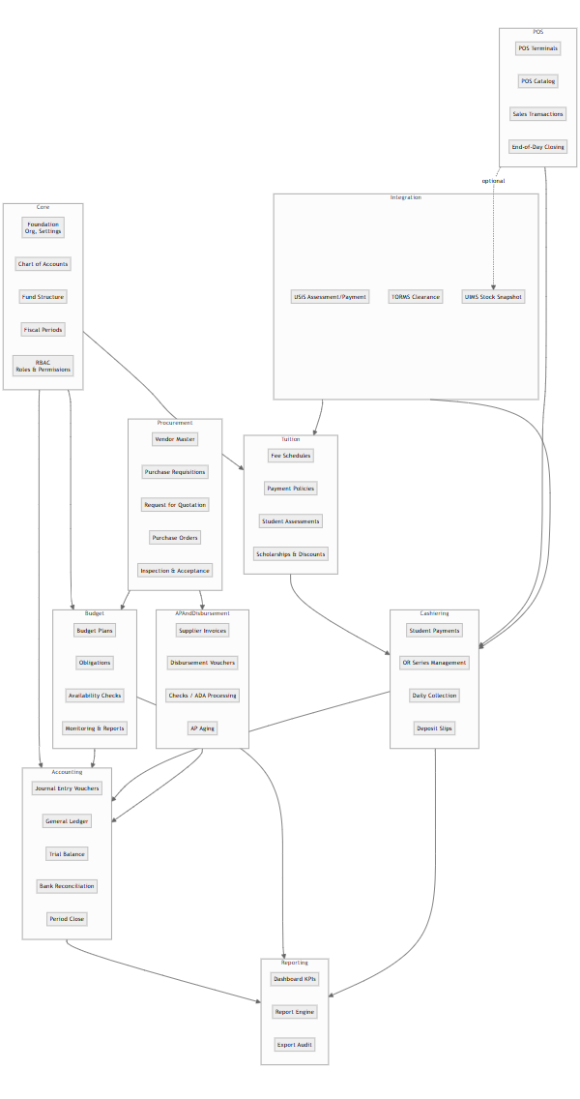
Domain responsibilities:
Domain | Key entities | Services
Core | Organization, Campus, COA, Fund, FiscalPeriod, Settings | Foundation config, COA management
Budget | BudgetPlan, BudgetLine, Obligation | Budget planning, obligation tracking, availability checks
Accounting | JournalEntry, GLAccount, GLBalance, BankReconciliation | JEV posting, GL maintenance, trial balance, period close
Tuition | FeeSchedule, PaymentPolicy, Assessment, Scholarship | Fee configuration, assessment generation
Cashiering | Payment, OfficialReceipt, ORSeries, CollectionReport | Payment processing, OR issuance, daily collection
AP & Disbursement | Invoice, DisbursementVoucher, Check, ADA | Supplier invoices, payment disbursement
Procurement | Vendor, PurchaseRequisition, PurchaseOrder, InspectionReport | Procurement lifecycle
POS | POSTerminal, POSCatalogItem, Sale, SaleLine | Point-of-sale operations
Integration | AssessmentSync, PaymentStatusQuery, ClearanceCheck, StockSnapshot | External system integration
Reporting | Report, ReportExport, DashboardMetric | Analytics, export audit

5. Security Architecture

5.1 Authentication Flow
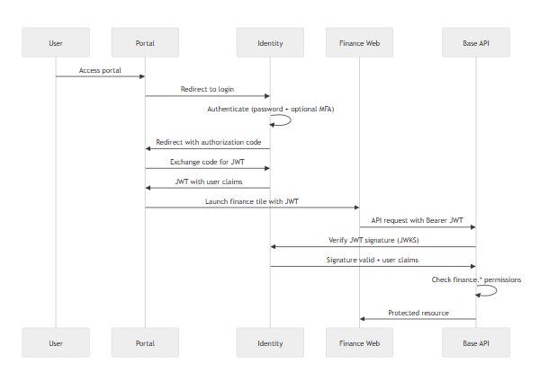
Internal API flow (USiS):
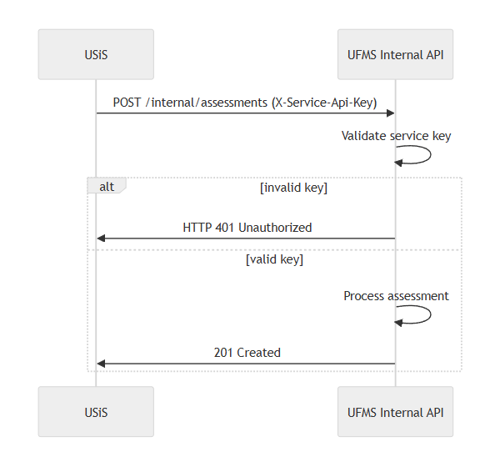
Security controls:
Layer | Control | Implementation
Transport | TLS 1.2+ | Reverse proxy termination
Authentication | OIDC/JWT | Identity service RS256 tokens
Authorization | RBAC | finance.*  permission checks
Internal APIs | Service keys | X-Service-Api-Key  header
Financial data | Encryption at rest | Sensitive fields encrypted (bank accounts, OR)
Approval workflows | Authorization limits | Role-based approval authority
OR accountability | Cashier assignment | OR series tracked by cashier

5.2 Permission Model
UFMS permission categories:
- finance.cashier.* — Payment processing, OR issuance
- finance.accounting.* — JEV, GL, reconciliation, period close
- finance.budget.* — Budget planning, obligations, monitoring
- finance.procurement.* — PR, PO, IAR workflows
- finance.treasury.* — Disbursement vouchers, checks/ADA
- finance.pos.* — POS operations
- finance.reports.* — Report generation and export
- finance.config.* — System configuration
Role mappings:
- cashier → finance.cashier.*, finance.pos.*
- accountant → finance.accounting.*, finance.reports.view
- budget_officer → finance.budget.*, finance.reports.budget
- procurement_officer → finance.procurement.*
- treasurer → finance.treasury.*, finance.accounting.view
- finance_admin → All finance.* permissions

6. Data Architecture

6.1 Schema Organization
PostgreSQL schema finance contains:
Core tables:
- organizations, campuses, settings
- chart_of_accounts, funds, fiscal_periods
Budget:
- budget_plans, budget_lines, obligations
Accounting:
- journal_entries, journal_entry_lines, gl_accounts, gl_balances
- bank_accounts, bank_reconciliations
Tuition:
- fee_schedules, payment_policies, assessments, assessment_lines
- scholarships, scholarship_grants
Cashiering:
- payments, official_receipts, or_series
- collection_reports, deposit_slips
AP & Disbursement:
- vendors, invoices, disbursement_vouchers
- checks, ada_records
Procurement:
- purchase_requisitions, purchase_orders, inspection_reports
POS:
- pos_terminals, pos_catalog_items, sales, sale_lines
Integration:
- assessment_syncs (USiS)
- payment_status_queries (USiS)
- clearance_checks (TORMS)
- stock_snapshots (UIMS)
Reporting:
- report_exports (audit log)

6.2 Integration Strategy
USiS → UFMS integration:
- Assessment upsert: USiS posts assessment data to UFMS when enrollment submitted
- Payment status query: USiS queries UFMS for real-time payment verification
- Clearance query: USiS/TORMS check student financial clearance status
- Authentication: Service API key in X-Service-Api-Key header
- Frequency: Real-time on-demand
UFMS → UIMS integration (optional POS stock):
- Stock query: UFMS queries UIMS for item availability during POS transaction
- Pattern: Read-only snapshot, no write-back to UIMS
- Frequency: Real-time during POS operations

7. Deployment Topology

7.1 Production Architecture
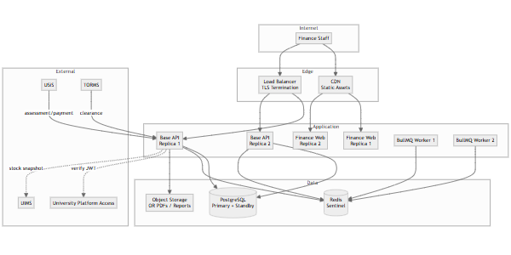
Sizing guidance:
- API: 2–3 replicas, 2 vCPU / 4 GB RAM each
- Worker: 2 replicas, 1 vCPU / 2 GB RAM each
- PostgreSQL: 4–8 vCPU / 16–32 GB RAM (financial workload)
- Redis: 2 vCPU / 4 GB RAM
- Object Storage: S3-compatible managed service

7.2 Local Development
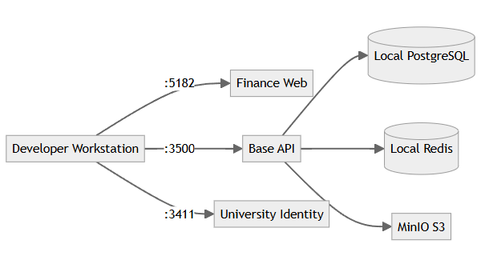

8. Integration Architecture

8.1 USiS Assessment Handoff
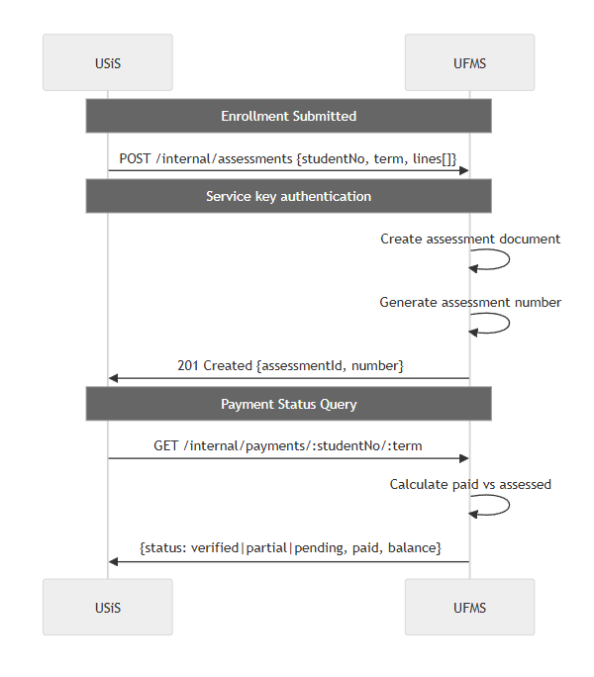

8.2 TORMS Clearance Check
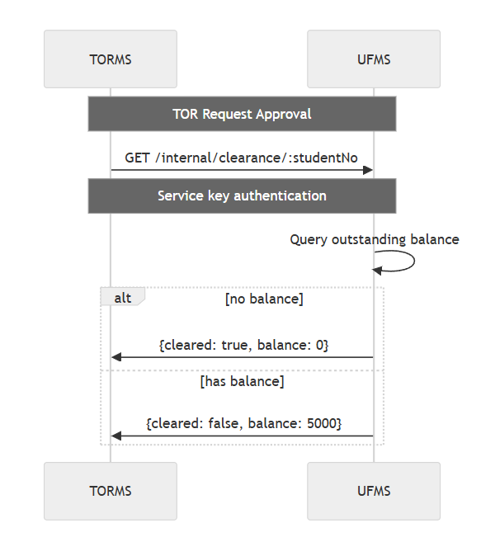

8.3 UIMS Stock Snapshot (Optional POS)
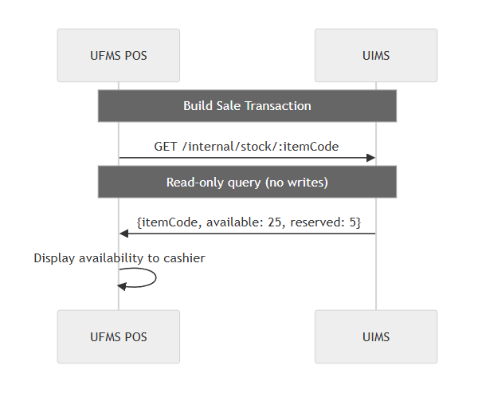

9. Quality Attributes

9.1 Performance
Optimization strategies:
- Database indexing on student_no, account_code, fiscal_period, status
- Redis caching for COA structure, fee schedules, OR series
- Background report generation (async job queue) for large datasets
- Lazy loading in finance web UI
- Paginated API responses (default 25, max 100)
- Read replicas for reporting queries
Monitoring:
- APM (Sentry/OpenTelemetry) for request tracing
- Payment processing time metrics
- Budget availability check latency
- GL posting performance
- Report generation duration

9.2 Scalability
Horizontal scaling:
- Stateless API design
- Load balancer with health checks
- Worker pool for concurrent job processing
- Database connection pooling (PgBouncer)
Data growth:
- Partitioning for large tables (journal_entry_lines, payments) by fiscal year
- Archival strategy for old fiscal periods (closed > 7 years)

9.3 Reliability
Failure handling:
- Graceful degradation when USiS/UIMS unavailable (cache last-known status, warn users)
- Retry logic for internal API calls (exponential backoff)
- Circuit breaker for external service calls
- Immutable posted GL entries — corrections via reversing JEV only
- Fiscal period close prevents accidental posting
Data integrity:
- Foreign key constraints
- Transaction management with rollback
- JEV debit/credit balance validation
- Budget availability checks before obligations
- OR series sequence integrity

9.4 Maintainability
Code organization:
- Domain-driven design with bounded contexts
- Service layer abstraction
- Shared validation schemas
- OpenAPI documentation
Operational:
- Structured JSON logging
- Feature flags
- Blue-green deployment
- Automated schema migrations
- COA hot-reloading

9.5 Compliance
Data privacy (RA 10173):
- Student financial data access restricted by role
- Audit logging of payment access and modifications
- Retention policies configurable
Financial accountability:
- Posted GL entries immutable (reversing JEV for corrections)
- OR series accountability by cashier
- 7-year audit trail retention
- Budget vs actual transparency
- Fiscal period integrity
End of Architecture Design — UFMS

Part 3 — Features & Requirements

UFMS — University Financial Management System Features & Requirements
Field | Value
Document ID | FEAT-UFMS-001
Product | UFMS
Companions | UFMS-SRS.md  ·  UFMS-LLD.md
Date | November 2026

1. Feature Summary
UFMS provides comprehensive campus financial operations management:
Area | Features | Status
Authentication | University Platform Access SSO, role-based routing | Delivered
Configuration | COA, funds, fiscal periods, OR series, approval workflows | Delivered
Budget | Planning, obligations, availability checks, monitoring, reports | Delivered
Accounting | JEV, GL, trial balance, bank reconciliation, period close | Delivered
Tuition | Fee schedules, payment policies, assessments, scholarships | Delivered
Cashiering | Student payments, OR issuance, daily collection, deposit slips | Delivered
AP & Disbursement | Invoices, disbursement vouchers, checks/ADA, aging reports | Delivered
Procurement | Vendor master, PR, RFQ, PO, IAR workflows | Delivered
POS | Terminals, catalog, sales, EOD closing, UIMS stock integration | Delivered
USiS Integration | Assessment upsert, payment status query, clearance verification | Delivered
Dashboard | KPIs, recent transactions, pending approvals | Delivered
Reporting | Trial balance, budget vs actual, aging, SOA, export audit | Delivered

2. Feature Catalog
Feature ID | Feature | Description | Priority | Actors
F-AUTH-01 | SSO Authentication | University Platform Access OIDC/JWT | Must | All
F-AUTH-02 | Role Routing | Home path by role (cashier/accounting/budget/procurement) | Must | All
F-AUTH-03 | Permission Enforcement | finance.*  checks on all endpoints | Must | System
F-AUTH-04 | Service Key Protection | Internal API routes require service key | Must | System
F-CFG-01 | COA Management | Configure chart of accounts with hierarchy | Must | Admin
F-CFG-02 | Fund Structure | Configure funds (general, special, trust) | Must | Admin
F-CFG-03 | Bank Accounts | Configure bank accounts with reconciliation parameters | Must | Admin
F-CFG-04 | Fiscal Periods | Define periods with open/closed status | Must | Admin
F-CFG-05 | OR Series Management | Configure OR series with cashier assignment | Must | Admin
F-CFG-06 | Approval Workflows | Configure approval workflows with limits | Should | Admin
F-CFG-07 | Config Audit Log | Log configuration changes | Must | System
F-BDG-01 | Budget Planning | Create budget plans with allocations | Must | Budget Officer
F-BDG-02 | Budget Approval | Workflow: draft → submitted → approved | Must | Budget Officer
F-BDG-03 | Obligation Tracking | Track obligations against budget | Must | System
F-BDG-04 | Availability Check | Verify funds before obligation | Must | System
F-BDG-05 | Hard Budget Stop | Block obligations if insufficient funds (configurable) | Must | System
F-BDG-06 | Budget Monitoring | Real-time utilization reports | Must | Budget Officer
F-BDG-07 | Budget vs Actual | Generate variance reports | Must | Budget Officer
F-BDG-08 | Budget Amendments | Support realignments with approval | Should | Budget Officer
F-ACC-01 | JEV Creation | Create journal entry vouchers | Must | Accountant
F-ACC-02 | JEV Validation | Validate debit/credit balance | Must | System
F-ACC-03 | GL Posting | Post JEV to general ledger | Must | System
F-ACC-04 | GL Balances | Maintain balances by account/fund/period | Must | System
F-ACC-05 | Trial Balance | Generate trial balance report | Must | Accountant
F-ACC-06 | Bank Reconciliation | Import and reconcile bank statements | Must | Accountant
F-ACC-07 | Period Close | Close fiscal period with lock | Must | Accountant
F-ACC-08 | Closed Period Protection | Prevent posting to closed periods | Must | System
F-ACC-09 | Financial Statements | Generate income statement, balance sheet | Should | Accountant
F-TUI-01 | Fee Schedules | Configure fees by program/level/term | Must | Admin
F-TUI-02 | Payment Policies | Define payment policies with due dates | Must | Admin
F-TUI-03 | Assessment Calculation | Calculate tuition from enrolled units | Must | System
F-TUI-04 | Assessment Generation | Generate assessment documents | Must | System
F-TUI-05 | Installment Tracking | Track installment schedules with penalties | Should | System
F-TUI-06 | Scholarships & Discounts | Support scholarship application to assessments | Should | Admin
F-CSH-01 | Student Account Lookup | Look up by student number or name | Must | Cashier
F-CSH-02 | Payment History Display | Show assessments and payment history | Must | Cashier
F-CSH-03 | Payment Recording | Record payments with payment mode | Must | Cashier
F-CSH-04 | Payment Validation | Reject invalid payments | Must | System
F-CSH-05 | OR Issuance | Issue official receipt from assigned series | Must | System
F-CSH-06 | OR PDF Generation | Generate OR PDF with QR code | Must | System
F-CSH-07 | GL Auto-Posting | Post payment to GL automatically | Must | System
F-CSH-08 | Daily Collection Report | Generate end-of-shift report | Must | Cashier
F-CSH-09 | Deposit Slip Creation | Create bank remittance deposit slip | Must | Cashier
F-CSH-10 | OR Series Alert | Alert when series nearing end | Should | System
F-APY-01 | Invoice Registration | Register supplier invoices | Must | Accountant
F-APY-02 | DV Creation | Create disbursement vouchers | Must | Accountant
F-APY-03 | DV Approval | Workflow with authorization limits | Must | Treasury
F-APY-04 | Check/ADA Processing | Process approved DVs | Must | Treasury
F-APY-05 | Disbursement GL Posting | Post disbursement to GL | Must | System
F-APY-06 | Check Status Tracking | Track check lifecycle | Should | Treasury
F-APY-07 | AP Aging Report | Generate aging report | Must | Accountant
F-PRC-01 | Vendor Master | Maintain supplier/vendor records | Must | Procurement
F-PRC-02 | PR Creation | Create purchase requisitions | Must | Requestor
F-PRC-03 | PR Approval | Approval workflow | Must | Procurement
F-PRC-04 | RFQ Issuance | Issue request for quotation | Should | Procurement
F-PRC-05 | PO Creation | Award supplier and create PO | Must | Procurement
F-PRC-06 | PO Status Tracking | Track PO lifecycle | Must | Procurement
F-PRC-07 | IAR Creation | Create inspection and acceptance report | Must | Receiving
F-PRC-08 | IAR-to-AP Link | Link IAR to PO and create AP invoice | Must | System
F-PRC-09 | Budget Check for PO | Verify budget before PO | Must | System
F-POS-01 | Terminal Configuration | Configure POS terminals | Must | Admin
F-POS-02 | POS Catalog | Maintain POS catalog with prices | Must | Admin
F-POS-03 | Stock Availability | Query UIMS for stock (optional) | Should | System
F-POS-04 | Sale Transaction | Build sale with multiple items | Must | Cashier
F-POS-05 | Sale Calculation | Calculate total with taxes/discounts | Should | System
F-POS-06 | Sale Completion | Complete sale with OR issuance | Must | Cashier
F-POS-07 | POS GL Posting | Post sale to GL | Must | System
F-POS-08 | EOD Closing | End-of-day closing with summary | Must | Cashier
F-POS-09 | Closed Terminal Protection | Prevent sales on closed terminal | Must | System
F-INT-01 | Assessment Upsert | USiS posts assessments via internal API | Must | System
F-INT-02 | Assessment Document | Generate assessment from USiS data | Must | System
F-INT-03 | Payment Status Query | USiS queries payment status | Must | System
F-INT-04 | Payment Status Response | Return pending/partial/verified status | Must | System
F-INT-05 | Clearance Query | TORMS/USiS query financial clearance | Must | System
F-INT-06 | Clearance Response | Return cleared status with balance | Must | System
F-DSH-01 | Finance Dashboard | Display KPIs, recent transactions, pending approvals | Must | All Finance
F-DSH-02 | Dashboard Widgets | Collections, receivables, disbursements, budget utilization | Should | All Finance
F-RPT-01 | Trial Balance Report | By period and fund | Must | Accountant
F-RPT-02 | Budget vs Actual Report | With variance analysis | Must | Budget Officer
F-RPT-03 | AR Aging Report | Accounts receivable aging | Must | Cashier, Accountant
F-RPT-04 | AP Aging Report | Accounts payable aging | Must | Accountant
F-RPT-05 | Statement of Account | Student SOA | Must | Cashier
F-RPT-06 | Daily Collection Report | By cashier | Must | Cashier
F-RPT-07 | Report Export | CSV, Excel, PDF formats | Must | All Finance
F-RPT-08 | Export Audit Log | Log exports with user/timestamp | Must | System

3. Requirements Traceability Matrix

3.1 Functional Requirements Mapping
Requirement ID | Requirement | Related Features | Priority | Implementation Status
FR-AUTH-001..005 | Authentication and authorization | F-AUTH-01..04 | Must | Delivered
FR-CFG-001..007 | Configuration management | F-CFG-01..07 | Must/Should | Delivered
FR-BDG-001..008 | Budget management | F-BDG-01..08 | Must/Should | Delivered
FR-ACC-001..009 | Accounting | F-ACC-01..09 | Must/Should | Delivered
FR-TUI-001..006 | Tuition and fees | F-TUI-01..06 | Must/Should | Delivered
FR-CSH-001..010 | Cashiering and receivables | F-CSH-01..10 | Must/Should | Delivered
FR-APY-001..007 | Accounts payable and disbursement | F-APY-01..07 | Must/Should | Delivered
FR-PRC-001..009 | Procurement | F-PRC-01..09 | Must/Should | Delivered
FR-POS-001..009 | Point-of-sale | F-POS-01..09 | Must/Should | Delivered
FR-INT-001..006 | USiS integration (internal APIs) | F-INT-01..06 | Must | Delivered
FR-DSH-001..002 | Dashboard | F-DSH-01..02 | Must/Should | Delivered
FR-RPT-001..008 | Reporting | F-RPT-01..08 | Must | Delivered

3.2 Non-Functional Requirements Mapping
NFR Category | Requirement ID | Related Features | Implementation Approach
Performance | NFR-PERF-001..005 | All features | Database indexing, Redis caching, async jobs, pagination
Scalability | NFR-SCAL-001..004 | All features | Horizontal API scaling, worker pools, table partitioning
Security | NFR-SEC-001..010 | F-AUTH-  , F-CFG-  , F-CSH-05 | TLS, RBAC, service keys, encryption, audit logging, OR accountability
Reliability | NFR-REL-001..006 | All features | HA deployment, backups, DR procedures, immutable GL, period close
Maintainability | NFR-MAIN-001..005 | All features | Modular architecture, OpenAPI, structured logs, versioned migrations
Compliance | NFR-COMP-001..005 | Financial data | RA 10173, GASB/IPSAS alignment, 7-year audit retention, OR accountability

3.3 Source Requirements Traceability
WMSU TOR VI.E.3 compliance matrix:
TOR Requirement | Feature IDs | Implementation Notes | Compliance Status
Budget management and monitoring | F-BDG-01..08 | Planning, obligations, availability checks, utilization | Delivered
Journal entry and general ledger | F-ACC-01..09 | JEV, GL posting, trial balance, reconciliation, period close | Delivered
Tuition fee management | F-TUI-01..06 | Fee schedules, payment policies, assessments | Delivered
Cashiering and receivables | F-CSH-01..10 | Payments, OR issuance, daily collection, deposits | Delivered
Accounts payable and disbursement | F-APY-01..07 | Invoices, DVs, checks/ADA, aging | Delivered
Procurement workflows | F-PRC-01..09 | PR, RFQ, PO, IAR, vendor management | Delivered
Point-of-sale operations | F-POS-01..09 | Terminals, sales, EOD, UIMS integration | Delivered
USiS integration | F-INT-01..06 | Assessment handoff, payment status, clearance | Delivered
Financial reporting | F-RPT-01..08 | Trial balance, budget vs actual, aging, SOA, export audit | Delivered
Configuration and setup | F-CFG-01..07 | COA, funds, periods, OR series, workflows | Delivered

Deferred/Out of scope:
- Student registration and admissions → USiS responsibility
- TOR issuance → TORMS responsibility
- Inventory masters → UIMS responsibility
- Library operations → ULMIS

4. Non-Functional Requirements Summary

4.1 Performance Targets
Metric | Target | Measurement
API response (p95) | ≤2s standard queries | APM monitoring
Payment + OR | ≤3s | Performance profiling
Budget availability check | ≤1s | Real-time testing
Trial balance (10K txns) | ≤30s | Job duration metrics

4.2 Security Controls
Control | Implementation | Verification
TLS enforcement | Reverse proxy/ingress | SSL Labs scan
RBAC | finance.*  permission checks | Automated security tests
Service keys | Internal API protection | Integration tests
Encryption at rest | Bank accounts, OR numbers | Security audit
Audit logging | All transactions, posting, config | Log review
OR accountability | Cashier assignment | Reconciliation reports

4.3 Reliability Measures
Measure | Target | Method
Availability | ≥99.5% business hours | SLA monitoring
Backup frequency | Daily incremental, weekly full | Automated verification
RPO | ≤15 minutes | DR drill testing
GL immutability | Reversing JEV only | Business rule enforcement
Period close integrity | Posting prevention on closed | Automated tests

5. Actors & Feature Access
Actor | Primary Features | Restricted Features
Cashier | F-CSH-01..10, F-POS-01..09 | Own cashier operations
Accountant | F-ACC-01..09, F-APY-01..07, F-RPT-01, F-RPT-04 | Full accounting
Budget Officer | F-BDG-01..08, F-RPT-02 | Budget oversight
Procurement Officer | F-PRC-01..09 | Procurement processes
Treasury | F-APY-03..06, F-ACC-06 | Disbursement authority
Finance Admin | F-CFG-01..07, All reports | System configuration
USiS (System) | F-INT-01..06 | Internal API only (service key)
TORMS (System) | F-INT-05..06 | Clearance API only (service key)

End of Features & Requirements — UFMS

Part 4 — Low-Level Design (LLD) Workflows

UFMS — University Financial Management System Low-Level Design
Field | Value
Document ID | LLD-UFMS-001
Product | UFMS
Companion | UFMS-SRS.md
Date | November 2026

1. Purpose
This Low-Level Design documents critical workflows for UFMS cashiering, budget management, procurement, disbursement, POS operations, and USiS integration — providing sequence diagrams, state machines, and implementation details.

2. System Context (Multi-Role Architecture)
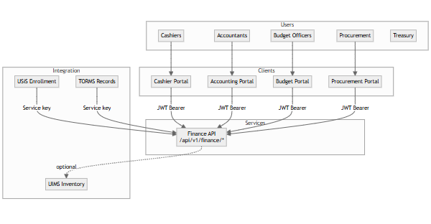
Role-specific routes:
- Cashier: /cashier/*
- Accounting: /accounting/*
- Budget: /budget/*
- Procurement: /procurement/*
- Treasury: /treasury/*

3. Cashiering Workflow

3.1 Student Payment Processing
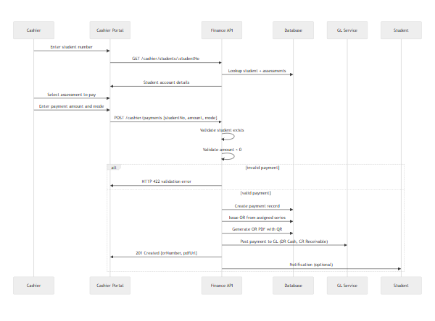

3.2 Official Receipt Issuance
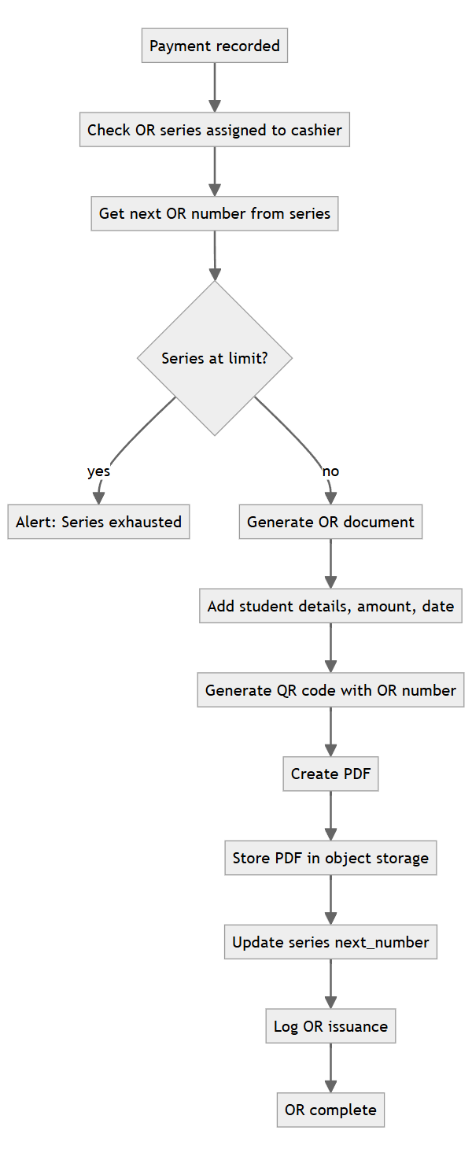

3.3 Daily Collection Report
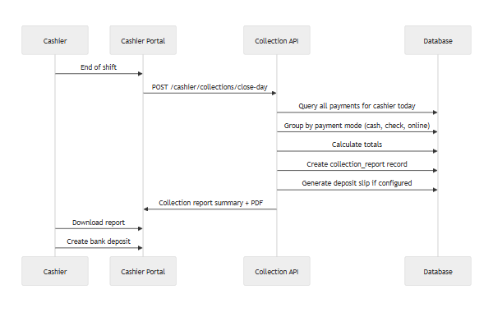

4. Budget Workflow

4.1 Budget Planning and Approval
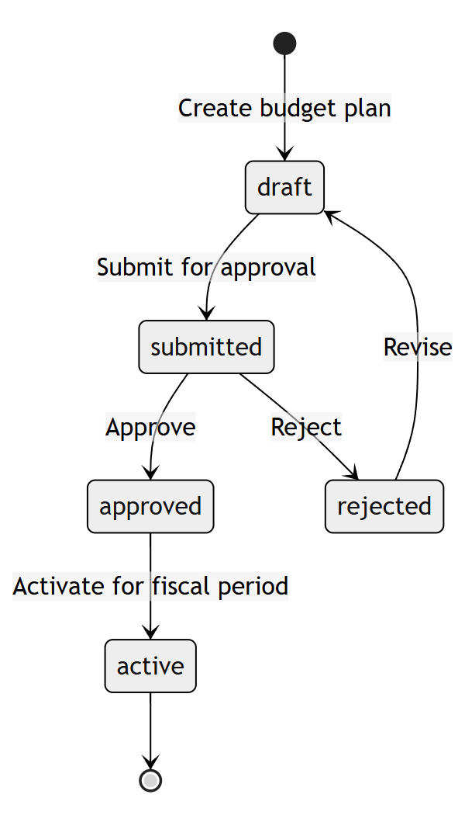

4.2 Budget Obligation and Availability Check
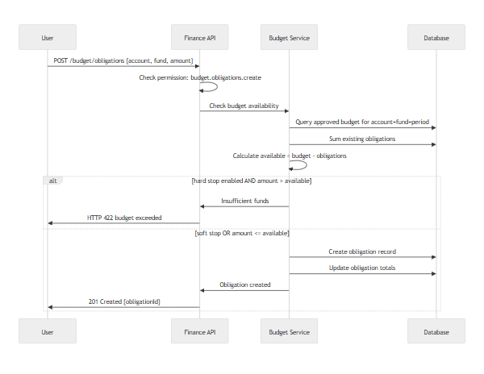

4.3 Budget Monitoring Dashboard
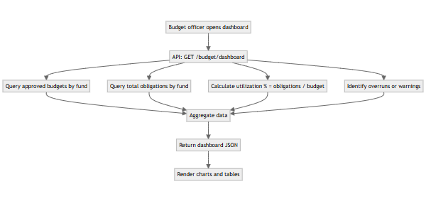

5. Procurement Workflow

5.1 Procurement Lifecycle State Machine
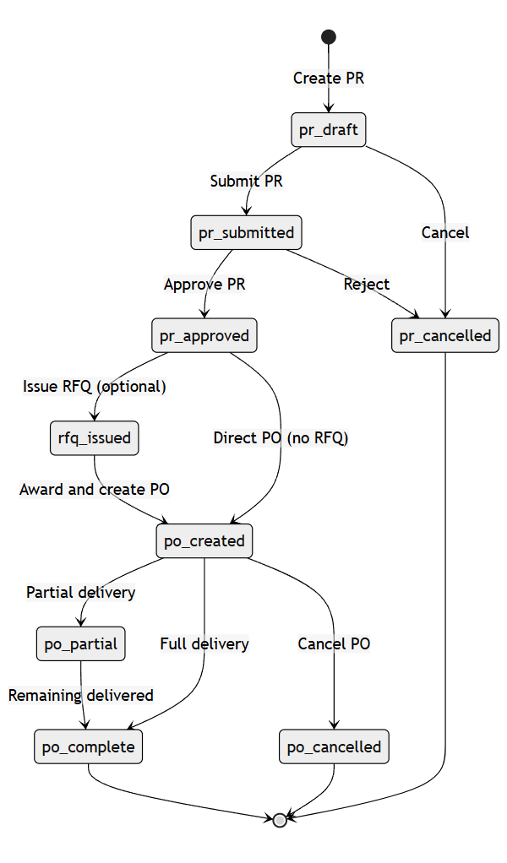

5.2 Purchase Order Creation and Budget Check
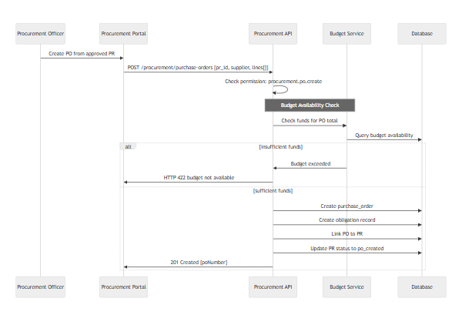

5.3 Inspection and Acceptance Report (IAR)
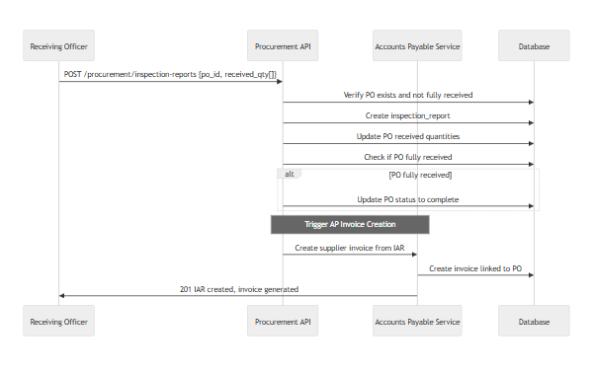

6. Accounting Workflow

6.1 Journal Entry Voucher (JEV) Posting
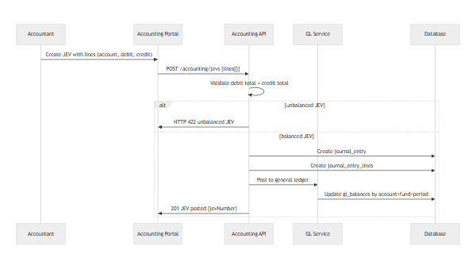

6.2 Trial Balance Generation
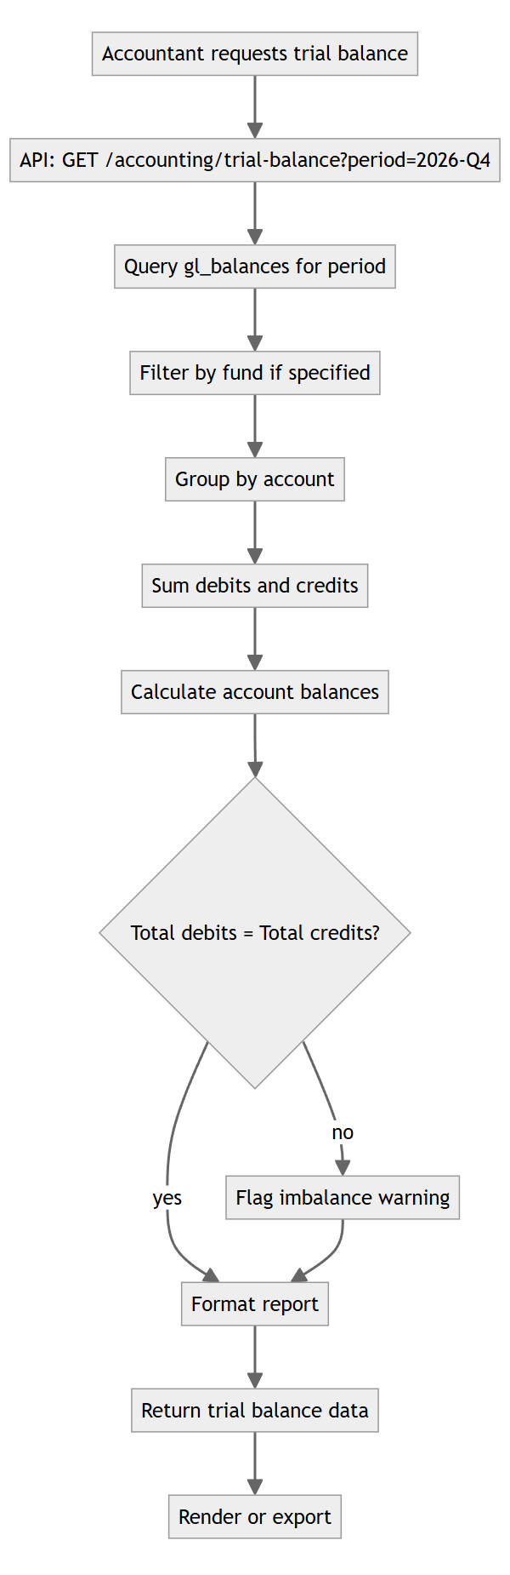

6.3 Fiscal Period Close
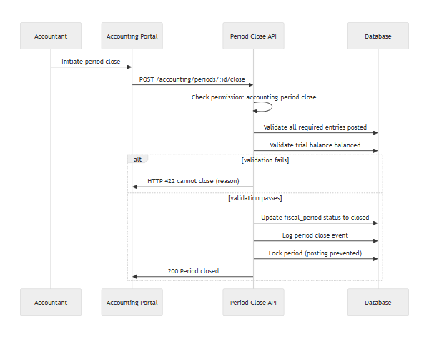

7. USiS Integration Workflows

7.1 Assessment Upsert from USiS
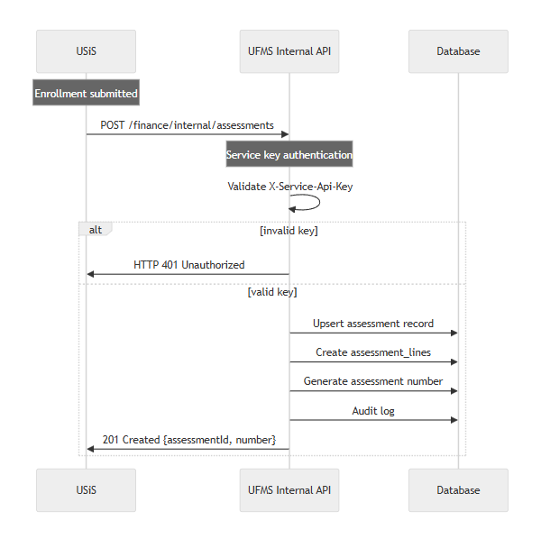

7.2 Payment Status Query from USiS
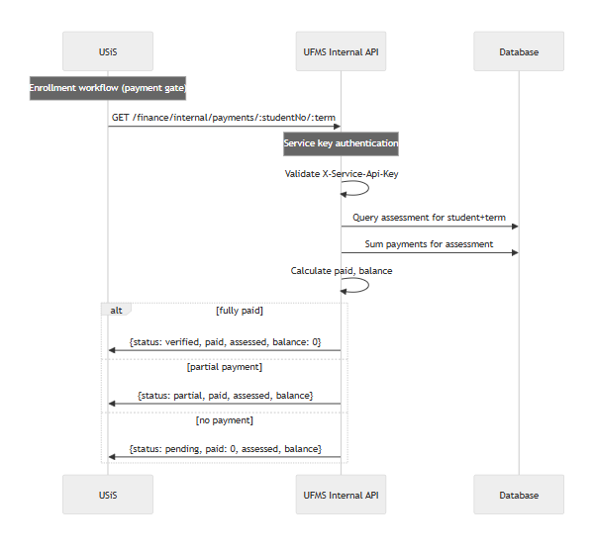

7.3 Clearance Check from TORMS
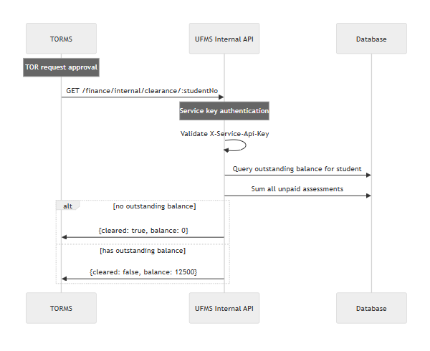

8. Point-of-Sale (POS) Workflow

8.1 POS Sale Transaction
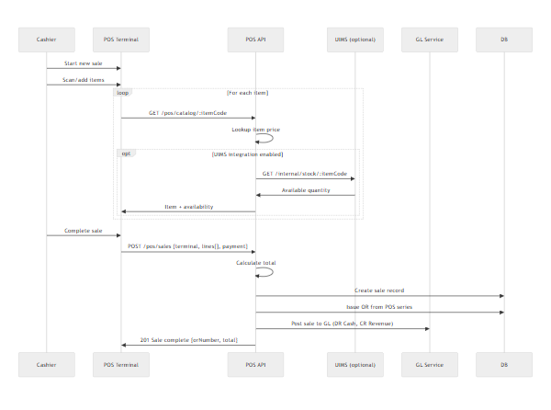

8.2 POS End-of-Day Closing
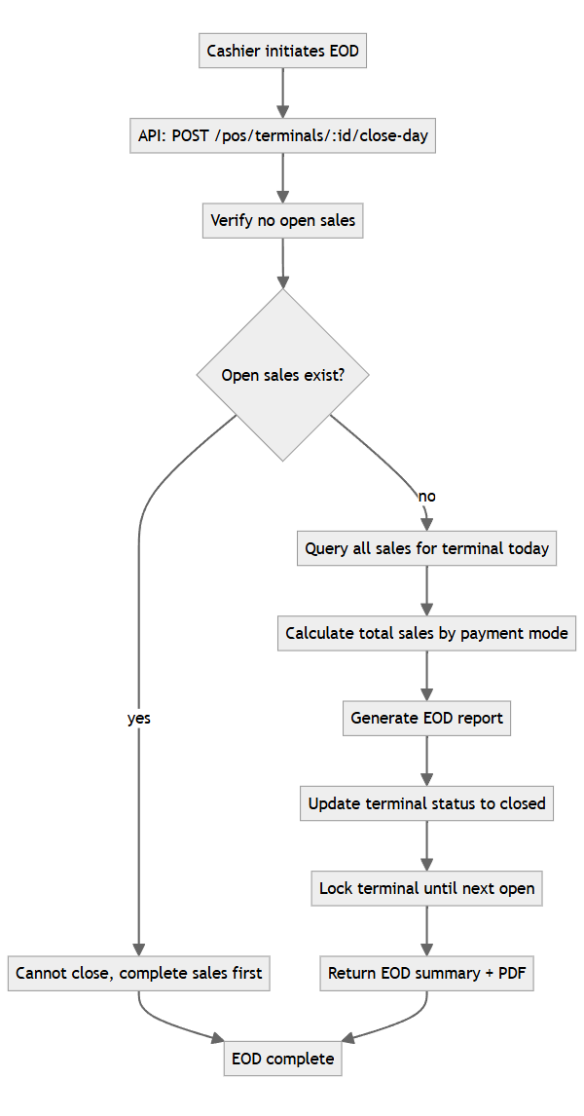

9. Disbursement Workflow

9.1 Disbursement Voucher (DV) Processing
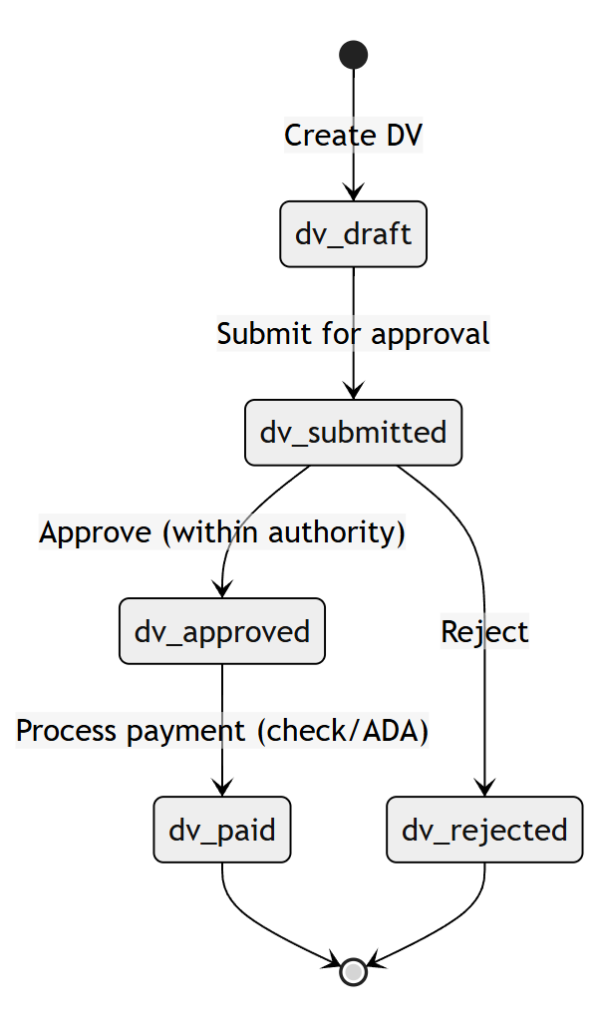

9.2 Check Processing
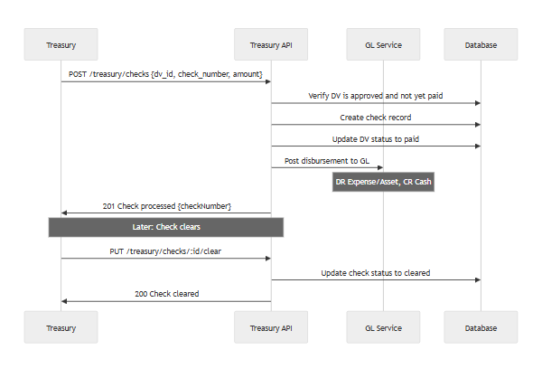

10. Error Cases & Edge Conditions
Case | Expected Behavior | HTTP Status | User Message
Record payment for unknown student | Reject payment | 422 | "Student not found."
Record payment with amount ≤ 0 | Reject payment | 422 | "Invalid payment amount."
Budget obligation exceeds available (hard stop) | Block obligation | 422 | "Insufficient budget: Available ₱50,000, Requested ₱75,000."
Post JEV with unbalanced debit/credit | Block posting | 422 | "JEV unbalanced: Debit ₱100,000, Credit ₱95,000."
Post to closed fiscal period | Block posting | 422 | "Cannot post to closed period 2026-Q3."
USiS calls internal API without service key | Block request | 401 | "Service key required."
Create PO without approved PR | Block PO creation | 422 | "PR must be approved before PO."
IAR for non-existent PO | Reject IAR | 404 | "Purchase order not found."
POS sale on closed terminal | Block sale | 422 | "Terminal is closed. Start new day first."
Close EOD with open sales | Block close | 422 | "Cannot close. {N} sales still open."
OR series exhausted | Alert + block payment | 422 | "OR series exhausted. Request new series."
UIMS unavailable during POS stock check | Log warning, allow sale without stock check | 200 | "(Stock check unavailable)"

11. Background Job Workflows

11.1 Bank Reconciliation Import
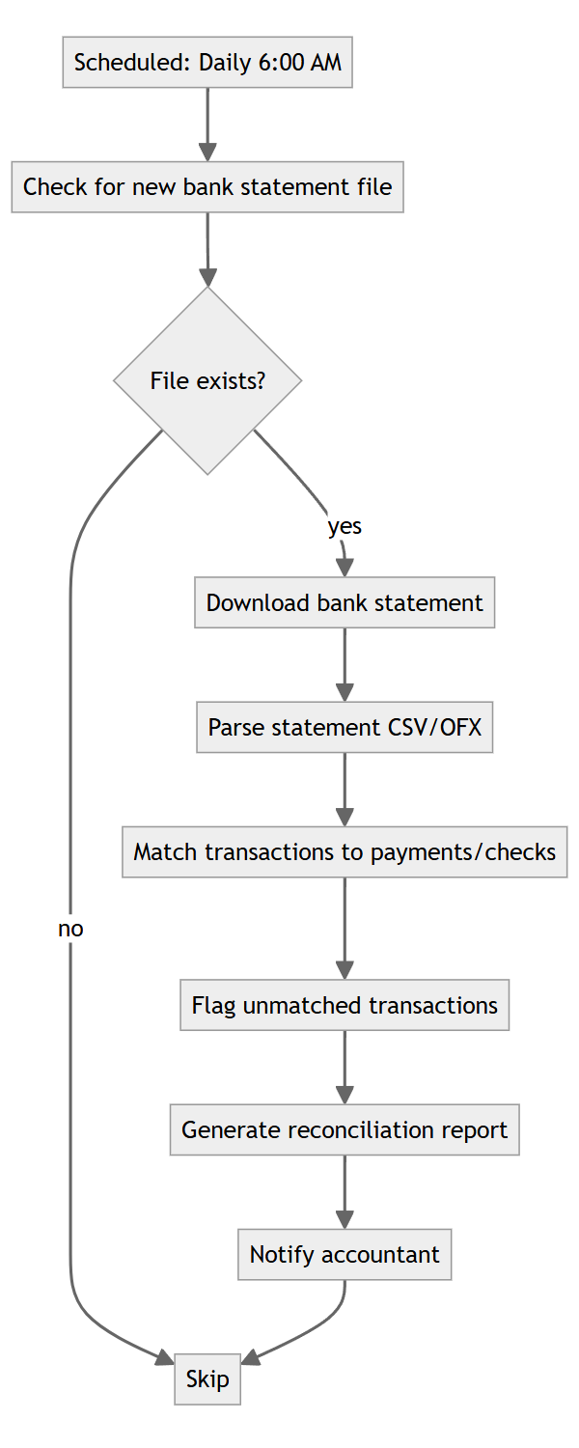

11.2 Payment Reminder Notifications
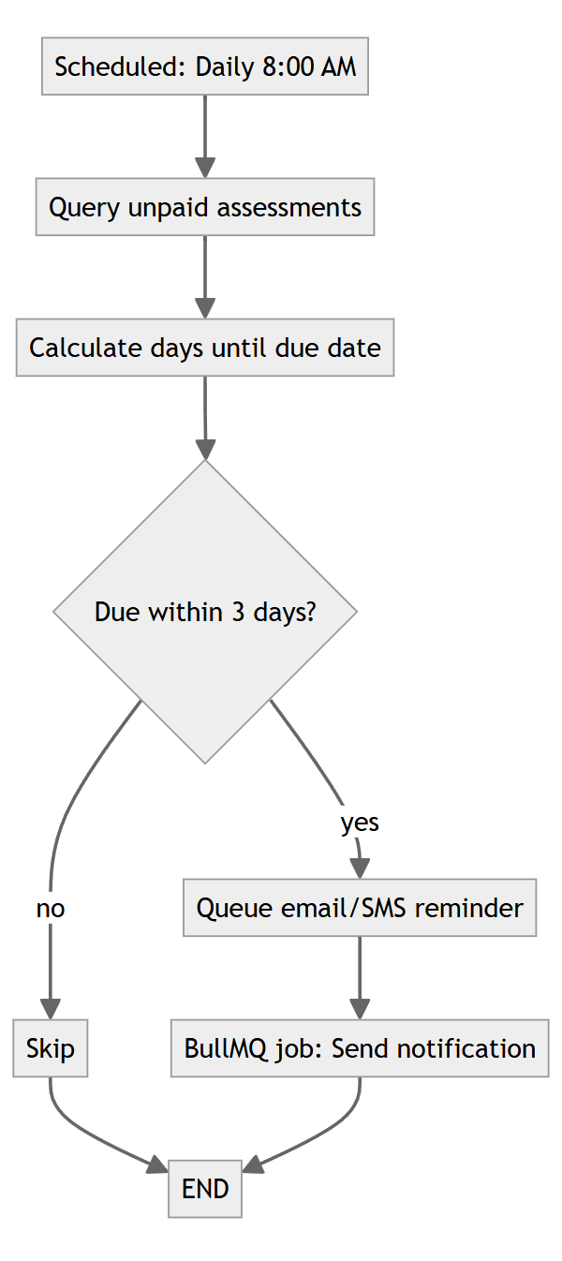
End of LLD — UFMS

