USiS — Complete System Specification
Field | Value
Product | USiS — University Student Information System
Document type | Complete System Specification (SRS + Architecture + Features + LLD)
Date | November 2026
Classification | Proprietary

Document contents
- System Requirements Specification (SRS)
- Architecture Design
- Features & Requirements
- Low-Level Design (LLD) Workflows

Part 1 — System Requirements Specification (SRS)

University Student Information System (USiS)
Field | Value
Document ID | SRS-USIS-001
Product | USiS (University Student Information System)
Repository | WMSU/wmsu-platform  (  apps/enrollment-web  ,  apps/base-api  module  enrollment  )
Version | 1.0
Date | November 2026
Classification | Proprietary

1. Introduction

1.1 Purpose
This Software Requirements Specification defines functional and non-functional requirements for USiS, the comprehensive student information system managing the complete academic lifecycle from admissions through graduation — including student registration, enrollment, advising, scheduling, academic records, grade management, assessment coordination, clearance processing, faculty evaluation, and student support services.

1.2 Scope
In scope
- Student self-service portal: profile management, enrollment workflow, schedule viewing, assessment/payment status, certificate of registration (COR), grades, academic history, support request submission
- Faculty portal: class rosters, grade encoding/submission, advising sessions, academic dashboards
- Registrar portal: applicant management, student admission, enrollment approval workflows, academic structure configuration (programs, curricula, sections), registration oversight, comprehensive reporting
- Office staff portals: Admissions (entrance exam coordination, applicant tracking), Office of Student Affairs (OSA: discipline, organizations, activities), Guidance (counseling sessions, assessments), Student Health Services (medical records, clearance), Scholarship Office (awards, disbursements, monitoring)
- Internal integration APIs for UFMS (assessment/payment handoff) and TORMS (grade projections)
- University Platform Access SSO integration (platform code enrollment)
- Queue management system for student services
- Faculty evaluation module with anonymous submissions
- Clearance certificate generation with public QR verification
- Academic calendar and enrollment window management
- Real-time enrollment conflict detection and waitlist management
Out of scope
- Public guest application forms and entrance exam delivery (hosted in Unified Access Portal /apply*)
- Financial cashiering, official receipt issuance, general ledger posting (UFMS)
- Transcript of Records (TOR) issuance and alumni registry management (TORMS)
- Library, document management, inventory operations (ULMIS, UDMS, UIMS)
- Learning management system and course content delivery (external LMS integration ready)

1.3 Definitions
Term | Definition
USiS | University Student Information System — enrollment and academic lifecycle platform
COR | Certificate of Registration — official enrollment document issued to students
Assessment | Tuition and fee calculation prepared for an enrollment period and synchronized with UFMS for payment processing
Role pack | Collection of USiS permission codes mapped from University Platform Access Identity role
Enrollment workflow | State-based process from draft enrollment through advising, payment verification, registrar approval, to registered status
Clearance graph | Network of office-specific clearance requirements and status checks across university departments
Grade projection | Academic grade record synchronized from USiS to TORMS for transcript generation
Section | Class offering with instructor, schedule, room, and enrollment capacity

1.4 References
- WMSU/wmsu-platform/README.md
- apps/web-portal/public/docs/USIS-Complete-Guide.html
- apps/web-portal/public/docs/USIS-API-Specs-Manual.html
- University Platform Access Architecture (Identity integration)
- UFMS Internal API Specification (assessment handoff)
- TORMS Sync Protocol (grade projections)

2. Overall Description

2.1 Product Perspective
USiS operates within the WMSU Campus Information System (CIS) modular architecture:
Component | Technology | Role
Enrollment web | React 19 + Vite | Multi-role portal UI (student, faculty, registrar, offices)
Base API enrollment module | AdonisJS 7 domain module | REST services at  /api/v1/enrollment/*
Database | PostgreSQL schema  enrollment | Academic system of record (SoR)
Identity provider | University Platform Access | Authentication, authorization, MFA, role management
Queue system | BullMQ + Redis | Background jobs (notifications, batch processing, reports)

Surface | Dev port | Production access
Enrollment web | http://127.0.0.1:5180 | https://enrollment.wmsu.edu.ph  (example)
Base API | http://127.0.0.1:3500 | https://api.wmsu.edu.ph
Identity API | http://127.0.0.1:3411 | https://auth.wmsu.edu.ph
Portal launcher | http://127.0.0.1:5173 | https://portal.wmsu.edu.ph

Health endpoint:GET /health → { status: 'ok', service: 'base-api', module: 'enrollment' }

2.2 User Classes
Role | Primary capabilities | Access level
Student | View profile, enroll in courses, view schedules/grades, submit support requests, download COR, track payments, evaluate faculty | Own data only
Faculty | View assigned classes, encode/submit grades, conduct advising sessions, generate class reports, manage attendance | Assigned classes
Adviser | Review advisee enrollments, approve/recommend course selections, monitor academic progress | Assigned students
Registrar | Manage applicants, approve enrollments, configure academic structures, oversee all registrations, generate institutional reports | System-wide academic data
Admissions Officer | Manage entrance exam schedules, process applications, track admission workflows | Applicant records
OSA Staff | Manage student discipline, organization accreditations, event coordination | Student conduct records
Guidance Counselor | Schedule counseling sessions, maintain confidential records, issue clearances | Counseling records
Health Services Staff | Maintain medical records, manage health clearances, track vaccinations | Student health records
Scholarship Officer | Manage scholarship awards, track disbursements, monitor academic requirements | Scholarship records
Cashier (read-only) | View assessment and payment status for student services | Payment status queries
Identity Administrator | Full system access when  enrollment  platform granted | All USiS permissions

Frontend permission checks provide user experience only; API enforces authorization on every authenticated route.

2.3 Constraints
- Platform tile visibility requires Identity platform grant enrollment
- Menu and feature access controlled by role-specific permission packs
- Guest application forms redirect to Portal; USiS does not host public /apply* routes
- Payment verification strictly depends on UFMS internal APIs — USiS never invents "paid" status
- Grade system of record is USiS; TORMS consumes projections read-only
- Multi-campus university structure with hierarchical org units (University → Campus → College → Department → Program)
- Academic calendar windows control enrollment availability
- Real-time section capacity enforcement prevents over-enrollment
- Prerequisite and co-requisite validation enforced at enrollment time
- Assessment amount calculation follows configured fee schedules — amounts not hard-coded in SRS

2.4 Assumptions
- University Platform Access Identity and Base API are running and reachable
- Demo/staging environments provision seed users, academic structures, and sample enrollments
- Fee schedules and assessment rules maintained in UFMS configuration — not independently managed in USiS
- Entrance exam scores and applicant data synced from Portal admission module
- Academic year and term structures configured before enrollment windows open
- Room and schedule data available for conflict checking
- Email/SMS notification infrastructure configured for enrollment alerts

3. Functional Requirements

3.1 Authentication & Authorization
ID | Requirement | Priority
FR-AUTH-001 | System shall authenticate all users via University Platform Access SSO JWKS verification | Must
FR-AUTH-002 | System shall resolve user home path based on role packs (student →  /student  , registrar →  /registrar  , faculty →  /faculty  ) | Must
FR-AUTH-003 | System shall enforce permission checks on every API endpoint using role-specific permission codes | Must
FR-AUTH-004 | System shall support MFA for privileged roles (registrar, office heads) when Identity enforces | Must
FR-AUTH-005 | System shall provide graceful error handling when Identity service unavailable | Must

3.2 Student Portal
ID | Requirement | Priority
FR-STU-001 | Students shall view and update demographic profile information with field-level validation | Must
FR-STU-002 | Students shall initiate enrollment for available academic terms within enrollment windows | Must
FR-STU-003 | Students shall search available sections by subject, instructor, schedule, and available seats | Must
FR-STU-004 | Students shall add sections to enrollment with real-time conflict detection (schedule, prerequisite) | Must
FR-STU-005 | Students shall view total units and enforcement of minimum/maximum load limits | Must
FR-STU-006 | Students shall submit enrollment for advising approval when required by program | Must
FR-STU-007 | Students shall view assessment amounts after enrollment submission with line-item breakdown | Must
FR-STU-008 | Students shall view payment status synchronized from UFMS without locally caching paid state | Must
FR-STU-009 | Students shall download PDF Certificate of Registration (COR) after enrollment approval | Must
FR-STU-010 | Students shall view class schedules in calendar and list formats with room/instructor details | Must
FR-STU-011 | Students shall view posted grades by term with GPA calculation | Must
FR-STU-012 | Students shall view academic history including all prior enrollments and grades | Must
FR-STU-013 | Students shall submit support requests to designated offices (OSA, Guidance, Health, Scholarship) | Must
FR-STU-014 | Students shall submit organization accreditation applications with file attachments | Should
FR-STU-015 | Students shall request student ID cards through portal | Should
FR-STU-016 | Students shall obtain queue tickets for office services | Should
FR-STU-017 | Students shall evaluate faculty anonymously during evaluation windows | Must
FR-STU-018 | Students shall view clearance status with office-by-office breakdown | Must
FR-STU-019 | Students shall download clearance certificates with QR verification codes | Must

3.3 Faculty Portal
ID | Requirement | Priority
FR-FAC-001 | Faculty shall view assigned class sections with enrollment rosters | Must
FR-FAC-002 | Faculty shall encode preliminary and final grades for enrolled students | Must
FR-FAC-003 | Faculty shall validate grade completeness before submission | Must
FR-FAC-004 | Faculty shall submit grades with digital signature/confirmation | Must
FR-FAC-005 | Faculty shall view grade submission history and status | Must
FR-FAC-006 | Faculty shall request grade corrections with justification after submission | Should
FR-FAC-007 | Faculty shall download class rosters as CSV and PDF | Must
FR-FAC-008 | Faculty shall mark student attendance by session | Should
FR-FAC-009 | Faculty shall view advisee list with enrollment status | Must
FR-FAC-010 | Faculty shall approve/reject advisee enrollment plans | Must
FR-FAC-011 | Faculty shall add advising notes and recommendations | Must
FR-FAC-012 | Faculty shall view evaluation summary results (anonymized) | Should

3.4 Registrar Portal
ID | Requirement | Priority
FR-REG-001 | Registrar shall view and search applicant records from admission pipeline | Must
FR-REG-002 | Registrar shall admit applicants with student number assignment and Identity account provisioning | Must
FR-REG-003 | Registrar shall view all student enrollments with filtering by term, program, status | Must
FR-REG-004 | Registrar shall approve or reject enrollment submissions with reason codes | Must
FR-REG-005 | Registrar shall perform batch enrollment approval with selection criteria | Should
FR-REG-006 | Registrar shall override enrollment business rules with audit logging | Must
FR-REG-007 | Registrar shall manage academic calendar with term dates and enrollment windows | Must
FR-REG-008 | Registrar shall configure programs, curricula, and courses | Must
FR-REG-009 | Registrar shall define section offerings with instructor, schedule, room, capacity | Must
FR-REG-010 | Registrar shall configure prerequisite and co-requisite rules | Must
FR-REG-011 | Registrar shall configure grading systems and policies by program | Must
FR-REG-012 | Registrar shall generate enrollment reports (summary by program, status, term) | Must
FR-REG-013 | Registrar shall generate grade reports (distribution, dean's list, deficiency) | Must
FR-REG-014 | Registrar shall export reports as CSV, Excel, and PDF | Must
FR-REG-015 | Registrar shall monitor grade submission status across all sections | Must
FR-REG-016 | Registrar shall initiate faculty evaluation periods by term | Must
FR-REG-017 | Registrar shall view aggregated evaluation results with filtering | Should
FR-REG-018 | Registrar shall manage waitlists and process seat releases | Should

3.5 Office Portals
ID | Requirement | Priority
FR-OFF-001 | Admissions officers shall schedule entrance exam sessions with capacity management | Must
FR-OFF-002 | Admissions officers shall view exam results and track admission decisions | Must
FR-OFF-003 | OSA staff shall manage student discipline cases with confidential records | Must
FR-OFF-004 | OSA staff shall process organization accreditation applications with approval workflow | Must
FR-OFF-005 | OSA staff shall coordinate campus events and student participation tracking | Should
FR-OFF-006 | Guidance counselors shall schedule confidential counseling sessions | Must
FR-OFF-007 | Guidance counselors shall maintain counseling records with restricted access | Must
FR-OFF-008 | Guidance counselors shall issue guidance clearances | Must
FR-OFF-009 | Health services staff shall maintain student medical records | Must
FR-OFF-010 | Health services staff shall track vaccinations and health requirements | Must
FR-OFF-011 | Health services staff shall issue health clearances | Must
FR-OFF-012 | Scholarship officers shall manage scholarship awards by type and amount | Must
FR-OFF-013 | Scholarship officers shall track disbursement schedules | Must
FR-OFF-014 | Scholarship officers shall monitor scholarship academic requirements | Must
FR-OFF-015 | All offices shall contribute to student clearance status graph | Must

3.6 Assessment & Payment Integration
ID | Requirement | Priority
FR-PAY-001 | System shall prepare tuition assessment documents from enrollment data | Must
FR-PAY-002 | System shall synchronize assessment data to UFMS via internal API | Must
FR-PAY-003 | System shall query UFMS for payment verification status | Must
FR-PAY-004 | System shall block enrollment progression when payment pending per business rules | Must
FR-PAY-005 | System shall never locally cache or invent "payment verified" status | Must
FR-PAY-006 | System shall display assessment line items from configured fee schedules | Must
FR-PAY-007 | System shall support installment payment plans tracked in UFMS | Should

3.7 Grade Management & TORMS Sync
ID | Requirement | Priority
FR-GRD-001 | System shall enforce grade encoding deadlines by academic calendar | Must
FR-GRD-002 | System shall validate grade values against configured grading system | Must
FR-GRD-003 | System shall calculate GPA using weighted credit hours | Must
FR-GRD-004 | System shall lock submitted grades from faculty modification | Must
FR-GRD-005 | System shall process registrar-approved grade corrections with audit trail | Must
FR-GRD-006 | System shall expose grade projection API for TORMS consumption | Must
FR-GRD-007 | System shall maintain grade history for all correction cycles | Must

3.8 Clearance Management
ID | Requirement | Priority
FR-CLR-001 | System shall maintain configurable clearance requirements by office and term | Must
FR-CLR-002 | System shall aggregate clearance status from multiple office systems | Must
FR-CLR-003 | System shall generate clearance certificates with QR verification tokens | Must
FR-CLR-004 | System shall provide public unauthenticated clearance verification endpoint | Must
FR-CLR-005 | System shall enforce clearance requirements for enrollment, graduation, and document issuance | Must

3.9 Faculty Evaluation
ID | Requirement | Priority
FR-EVL-001 | System shall configure evaluation periods by term with questionnaire templates | Must
FR-EVL-002 | System shall require students to evaluate enrolled faculty within evaluation window | Must
FR-EVL-003 | System shall enforce anonymous submission (no linkage to student identity in results) | Must
FR-EVL-004 | System shall aggregate evaluation responses with statistical summaries | Must
FR-EVL-005 | System shall restrict raw evaluation access to authorized administrators | Must
FR-EVL-006 | Faculty shall view anonymized aggregated results for own sections | Should

3.10 Reporting & Analytics
ID | Requirement | Priority
FR-RPT-001 | System shall generate enrollment summary reports by term, program, level | Must
FR-RPT-002 | System shall generate grade distribution reports by course and section | Must
FR-RPT-003 | System shall generate dean's list and academic probation lists | Must
FR-RPT-004 | System shall generate graduation candidate lists | Must
FR-RPT-005 | System shall export all reports in CSV, Excel, and PDF formats | Must
FR-RPT-006 | System shall log all report exports with user and timestamp for audit | Must

4. External Interface Requirements

4.1 Integration Interfaces
Interface | Direction | Protocol | Purpose
University Platform Access | Inbound | OIDC/JWKS | SSO authentication, JWT verification, role resolution
UFMS Finance APIs | Outbound | REST+JSON | Assessment upsert, payment status query, clearance verification
TORMS Records APIs | Outbound | REST+JSON | Grade projection sync, academic history provision
Portal Admissions | Inbound | REST+JSON | Applicant data sync from entrance exam and application system
SMTP/SMS Gateway | Outbound | SMTP/HTTP | Enrollment notifications, grade alerts, deadline reminders
Object Storage | Outbound | S3-compatible | Document attachments (support requests, ID photos)

4.2 API Specifications
Enrollment API base:/api/v1/enrollment/*
OpenAPI documentation: Available at /api/v1/enrollment/docs (Swagger UI)
Authentication: Bearer JWT from University Platform Access in Authorization header
Internal service routes:/api/v1/enrollment/internal/* protected by X-Service-Api-Key header

4.3 User Interface Requirements
- Responsive design supporting desktop (≥1280px), tablet (768-1023px), and mobile (360-767px)
- Browser compatibility: Chrome/Edge (latest 2 versions), Firefox (latest 2), Safari (latest 2)
- Accessibility: WCAG 2.1 Level AA conformance for student-facing flows
- Print-optimized views for COR, schedules, clearance certificates
- Real-time updates for enrollment conflicts and seat availability
- Progressive enhancement for offline-capable features (view cached COR/schedule)

5. Non-Functional Requirements

5.1 Performance
ID | Requirement | Target
NFR-PERF-001 | API response time (p95) for standard queries | ≤ 2 seconds
NFR-PERF-002 | API response time (p95) for enrollment submission | ≤ 5 seconds
NFR-PERF-003 | Concurrent user support during enrollment peak | ≥ 500 active sessions
NFR-PERF-004 | Health check endpoint response time | ≤ 500 ms
NFR-PERF-005 | Report generation for standard queries | ≤ 10 seconds
NFR-PERF-006 | Real-time conflict detection during enrollment | ≤ 1 second

5.2 Scalability
ID | Requirement
NFR-SCAL-001 | Support ≥15,000 enrolled students per term
NFR-SCAL-002 | Support ≥1,000 concurrent enrollment transactions
NFR-SCAL-003 | Horizontal scaling of API replicas without session affinity
NFR-SCAL-004 | Database read replicas for reporting queries

5.3 Security
ID | Requirement
NFR-SEC-001 | TLS 1.2+ required for all client-server communication
NFR-SEC-002 | RBAC enforcement on every authenticated API endpoint
NFR-SEC-003 | Service-to-service communication via API keys for internal routes
NFR-SEC-004 | Sensitive data (grades, discipline, counseling) encrypted at rest
NFR-SEC-005 | Password policy and MFA enforcement delegated to Identity service
NFR-SEC-006 | CORS allowlist limited to authorized web client origins
NFR-SEC-007 | Rate limiting on public clearance verification endpoints
NFR-SEC-008 | Audit logging of privileged operations (enrollment override, grade corrections)
NFR-SEC-009 | Non-root container execution in production
NFR-SEC-010 | Regular dependency vulnerability scanning and patching

5.4 Reliability
ID | Requirement
NFR-REL-001 | System availability ≥99.5% during enrollment periods
NFR-REL-002 | Automated database backups (daily incremental, weekly full)
NFR-REL-003 | Point-in-time recovery capability ≤15 minutes RPO
NFR-REL-004 | Documented disaster recovery procedures with quarterly drill
NFR-REL-005 | Graceful degradation when UFMS/TORMS temporarily unavailable

5.5 Maintainability
ID | Requirement
NFR-MAIN-001 | Modular domain architecture with clear separation of concerns
NFR-MAIN-002 | Comprehensive API documentation (OpenAPI 3.0+)
NFR-MAIN-003 | Structured logging with correlation IDs for request tracing
NFR-MAIN-004 | Observability via Sentry/OpenTelemetry when configured
NFR-MAIN-005 | Database schema migrations versioned and reversible

5.6 Compliance
ID | Requirement
NFR-COMP-001 | Data privacy compliance with RA 10173 (Data Privacy Act of 2012)
NFR-COMP-002 | Purpose limitation for student personal data collection
NFR-COMP-003 | Student consent management for optional data uses
NFR-COMP-004 | Data retention policies aligned with university records management
NFR-COMP-005 | FERPA-equivalent protections for educational records

6. Verification Criteria

6.1 Functional Verification
Scenario | Expected result | Test type
SSO login as student | Redirect to  /student  with profile data | Integration
SSO login as registrar | Redirect to  /registrar  with system dashboard | Integration
Enroll in section with prerequisite not met | Error message with missing prerequisite details | Unit
Enroll in section with schedule conflict | Error message with conflicting section details | Unit
Submit enrollment for advising | Status changes to "pending_advising" | Integration
Faculty encode grades | Grades saved; submission blocked until complete | E2E
Faculty submit grades | Grades locked; visible to student | E2E
Query UFMS for verified payment | Enrollment progresses to registrar approval | Integration
Query UFMS for pending payment | Enrollment blocked with payment required message | Integration
Generate clearance certificate | PDF with QR code generated | E2E
Verify valid clearance QR | Public endpoint returns valid clearance data | API test
Verify invalid clearance QR | Public endpoint returns not found / invalid | API test
Sync grades to TORMS | TORMS receives grade projections via internal API | Integration

6.2 Non-Functional Verification
Scenario | Expected result | Test type
500 concurrent enrollments | p95 response time ≤5s, no errors | Load test
Unauthorized API access | HTTP 401/403 with error message | Security
Horizontal scaling test | Add replica; traffic balanced; session independent | Scalability
Database failover | Recovery within 15 minutes with data integrity | DR drill

7. Document Control
Version | Date | Description
1.0 | November 2026 | Complete System Specification from wmsu-platform enrollment module

Related Design Documents
- USiS-Architecture.md — Architecture design (containers, domains, security, deployment)
- USiS-Features-Requirements.md — Feature catalog + requirements traceability matrix
- USiS-LLD.md — Low-level design workflows (enrollment, grading, advising, clearance, UFMS/TORMS integration)
End of SRS — USiS

Part 2 — Architecture Design

USiS — University Student Information System Architecture
Field | Value
Document ID | AD-USIS-001
Product | USiS
Companions | USiS-SRS.md  ·  USiS-Features-Requirements.md  ·  USiS-LLD.md
Date | November 2026

1. Purpose
Architecture design for USiS within the WMSU Campus Information System modular monolith — covering system context, container architecture, domain module organization, security architecture, deployment topology, integration patterns, and quality attributes.

2. System Context
USiS operates within the CIS ecosystem, integrating with Identity, UFMS, TORMS, and the Portal:
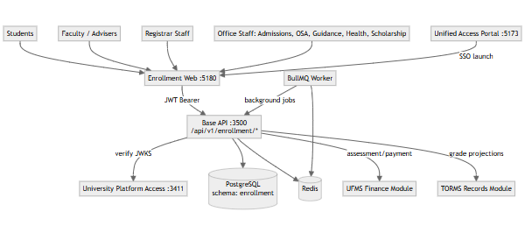
Key relationships:
- Students, faculty, and staff authenticate through Portal SSO, launching enrollment web
- All UI interactions flow through Base API enrollment module endpoints
- Identity service provides JWT verification and role resolution
- UFMS owns financial transactions; USiS queries payment status
- TORMS consumes grade projections; USiS remains academic SoR
- Background jobs (notifications, reports) processed by BullMQ worker

3. Container View
Container | Technology | Port | Purpose
Enrollment web | React 19 + Vite | 5180 | Multi-role portal UI (student, faculty, registrar, offices) with responsive design
Base API (enrollment module) | AdonisJS 7 + Lucid ORM | 3500 | Domain services, controllers, validators, business logic
PostgreSQL | PostgreSQL 15+ | 5432 | Schema  enrollment  — academic system of record
Redis | Redis 7+ | 6379 | Session cache, queue backend, real-time data
BullMQ Worker | Node.js + BullMQ | N/A | Background job processor (notifications, reports, sync)
University Platform Access | Identity service | 3411 | Authentication, authorization, MFA, user management
Unified Access Portal | React SPA | 5173 | SSO launcher and guest admissions UI

Health monitoring:GET /health returns service status and active module checks.
Deployment notes:
- Enrollment web statically served from CDN or Vite dev server
- Base API runs in containerized Node.js (non-root)
- Postgres uses schema isolation (enrollment) within shared wmsu_cis database
- Redis configured for persistence (AOF + RDB) for queue durability
- Worker deployed as separate container/process pool

4. Domain Module Architecture
USiS enrollment module organized by academic lifecycle domains:
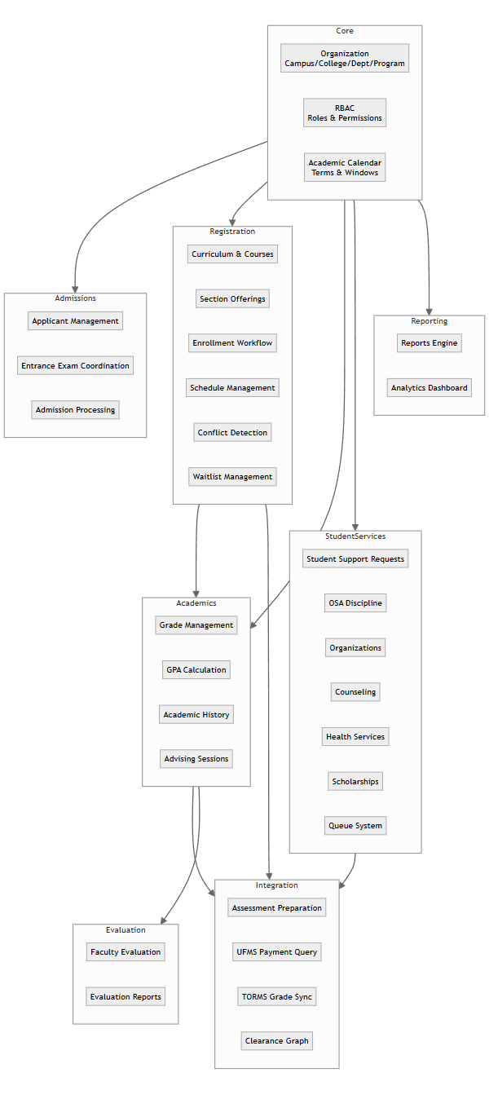
Domain responsibilities:
Domain | Key entities | Services
Core | Organization, Campus, College, Department, Program, AcademicTerm, EnrollmentWindow | Org hierarchy, calendar management, RBAC
Admissions | Applicant, EntranceExam, AdmissionDecision | Applicant tracking, exam scheduling, admission workflow
Registration | Curriculum, Course, Section, Enrollment, EnrollmentItem, Prerequisite | Section offerings, enrollment workflow, conflict detection, waitlist
Academics | Grade, GradeSubmission, AcademicRecord, AdvisingSession | Grade encoding, submission, GPA calculation, advising
Student Services | SupportRequest, DisciplineCase, Organization, CounselingSession, HealthRecord, Scholarship | Multi-office student support, clearance contribution
Integration | Assessment, PaymentStatus, GradeProjection, ClearanceItem | UFMS/TORMS handoff, clearance aggregation
Evaluation | EvaluationPeriod, EvaluationResponse, EvaluationSummary | Anonymous faculty evaluation
Reporting | Report, ReportExport, Dashboard | Enrollment/grade reports, analytics

5. Security Architecture

5.1 Authentication Flow
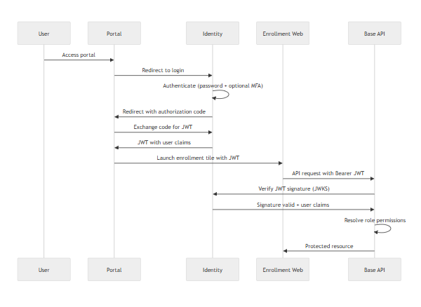
Security controls:
Layer | Control | Implementation
Transport | TLS 1.2+ | Reverse proxy/ingress termination
Authentication | OIDC/JWT | Identity service RS256 tokens
Authorization | RBAC | Permission checks on every API endpoint
API protection | Rate limiting | Redis-backed rate limiter
Secrets | Environment variables | Never in codebase or client
Database | Schema isolation | enrollment  schema, role-based PG access
Internal APIs | Service keys | X-Service-Api-Key  header validation
Public endpoints | Rate limiting | Clearance verification endpoint

5.2 Permission Model
USiS defines granular permissions mapped to Identity roles:
Permission categories:
- enrollment.* — Enrollment CRUD and approval
- grades.* — Grade encoding, submission, corrections
- students.* — Student profile and records
- sections.* — Section management
- advising.* — Advising workflows
- offices.* — Office-specific permissions (OSA, Guidance, Health, Scholarship)
- reports.* — Report generation and export
- evaluation.* — Faculty evaluation management
Role examples:
- student role → enrollment.own, grades.view_own, clearance.view_own
- faculty role → grades.encode, grades.submit, advising.manage
- registrar role → enrollment.approve, students.manage, reports.export
- osa_staff role → offices.osa.*, students.discipline

6. Data Architecture

6.1 Schema Organization
PostgreSQL schema enrollment contains all USiS tables:
Core tables:
- organizations, campuses, colleges, departments, programs
- academic_terms, enrollment_windows
- users (Identity reference cache)
Academic structure:
- curricula, courses, prerequisites, sections
- instructors, room_schedules
Enrollment lifecycle:
- enrollments, enrollment_items, enrollment_history
- waitlists
Grades:
- grades, grade_submissions, grade_history
- academic_records (computed)
Student services:
- support_requests, discipline_cases, organizations
- counseling_sessions, health_records, scholarships
Integration:
- assessments, payment_status_cache (UFMS)
- grade_projections (TORMS)
- clearance_items, clearance_certificates
Evaluation:
- evaluation_periods, evaluation_responses
Reporting:
- report_exports (audit log)

6.2 Migration Strategy
- Migrations tracked in enrollment.uims_adonis_schema table
- Schema changes deployed via node ace migration:run
- Rollback capability for reversible migrations
- Data seeds for demo/staging environments

7. Deployment Topology

7.1 Production Architecture
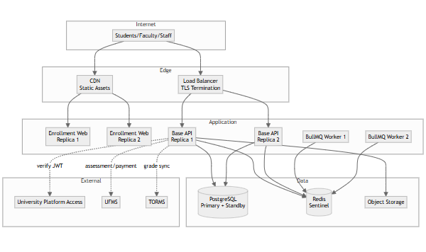
Sizing guidance (500 concurrent users):
- API: 2–3 replicas, 2 vCPU / 4 GB RAM each
- Worker: 2 replicas, 1 vCPU / 2 GB RAM each
- PostgreSQL: 4 vCPU / 16 GB RAM, managed service preferred
- Redis: 2 vCPU / 8 GB RAM, Sentinel for HA
Scalability:
- Stateless API enables horizontal scaling
- Read replicas for reporting queries
- CDN for static assets reduces origin load

7.2 Local Development
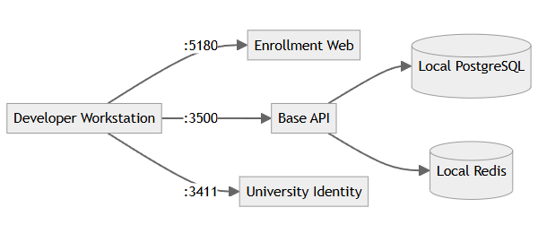
Local ports:
- Portal: 5173
- Identity: 3411
- Base API: 3500
- Enrollment web: 5180
- Finance web: 5182 (UFMS)
- Records web: 5181 (TORMS)
Infrastructure: Docker Compose for PostgreSQL, Redis, MinIO

8. Integration Architecture

8.1 Internal Service Communication
UFMS Integration (Financial):
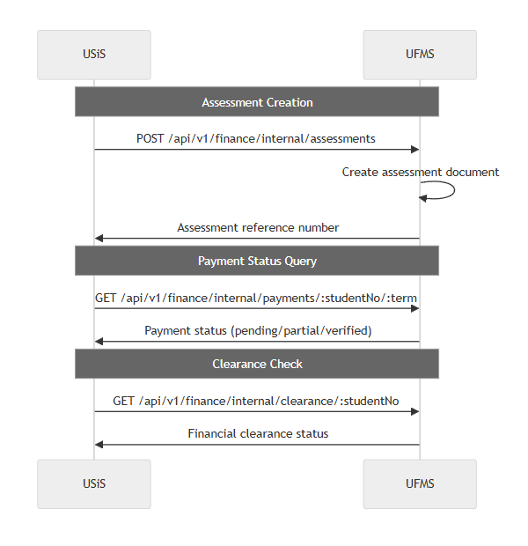
TORMS Integration (Academic Records):
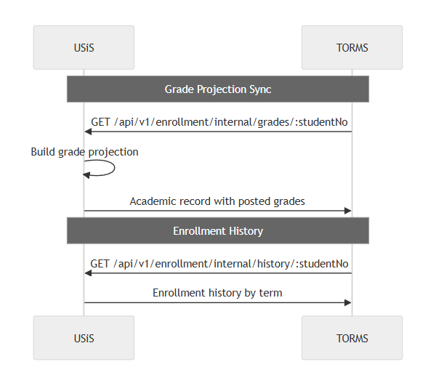
Service-to-service security:
- Internal routes protected by X-Service-Api-Key header
- Service keys hashed in database, plaintext only in secure config
- Browser clients never receive service keys

8.2 External System Integration
System | Protocol | Pattern | Frequency
Portal Admissions | REST API | Applicant sync | Real-time webhook + nightly batch
SMTP Gateway | SMTP | Email notifications | Event-driven
SMS Gateway | HTTP API | SMS alerts | Event-driven
Object Storage (S3) | S3 API | File uploads | On-demand

9. Quality Attributes

9.1 Performance
Optimization strategies:
- Database indexing on frequently queried fields (student_no, term, status)
- Query optimization with Lucid eager loading to prevent N+1
- Redis caching for static reference data (programs, courses)
- Lazy loading of enrollment web routes
- Paginated API responses (default 25, max 100 items)
- Background jobs for heavy operations (report generation, bulk notifications)
Monitoring:
- APM (Sentry/OpenTelemetry) for request tracing
- Database slow query logging
- API endpoint metrics (response time, error rate)

9.2 Scalability
Horizontal scaling:
- Stateless API design (session state in Redis/JWT)
- Load balancer with health check probes
- Database connection pooling (PgBouncer)
- Queue-based job processing prevents request timeout
Vertical limits:
- Single PostgreSQL instance supports 15,000 students (tested)
- Read replicas for reporting offload main database

9.3 Reliability
Failure handling:
- Graceful degradation when UFMS/TORMS unavailable (cached status, error messaging)
- Retry logic with exponential backoff for transient failures
- Circuit breaker pattern for external service calls
- Database transaction management with rollback on error
Data integrity:
- Foreign key constraints enforce referential integrity
- Enrollment business rules validated in service layer
- Idempotency keys for critical operations (enrollment submission)
- Audit trail for all state changes

9.4 Maintainability
Code organization:
- Domain-driven design with clear boundaries
- Service layer abstraction separates business logic from controllers
- Shared validation schemas (Vine validators)
- Comprehensive OpenAPI documentation
Operational:
- Structured JSON logging with correlation IDs
- Feature flags for gradual rollout
- Blue-green deployment support
- Automated schema migration in CI/CD

9.5 Compliance
Data privacy (RA 10173):
- Purpose limitation for personal data collection
- Access controls restrict PII to authorized roles
- Data retention policies configurable
- Student consent management for optional uses
Academic records protection:
- FERPA-equivalent access restrictions
- Audit logging of grade access and modifications
- Secure transmission of transcripts to TORMS
- Public clearance verification without exposing PII
End of Architecture Design — USiS

Part 3 — Features & Requirements

USiS — University Student Information System Features & Requirements
Field | Value
Document ID | FEAT-USIS-001
Product | USiS
Companions | USiS-SRS.md  ·  USiS-LLD.md
Date | November 2026

1. Feature Summary
USiS provides comprehensive student information management across the complete academic lifecycle:
Area | Features | Status
Authentication | University Platform Access SSO integration, role-based routing | Delivered
Student Portal | Profile, enrollment workflow, schedule, assessments, COR, grades, history | Delivered
Faculty Portal | Class rosters, grade encoding/submission, advising, reports | Delivered
Registrar Portal | Applicant management, enrollment approval, academic configuration, reports | Delivered
Office Portals | Admissions, OSA, Guidance, Health Services, Scholarship management | Delivered
Assessment Integration | UFMS assessment/payment handoff with real-time status sync | Delivered
Grade Management | Encode, submit, corrections, GPA calculation, TORMS sync | Delivered
Clearance System | Multi-office clearance graph, certificate generation, QR verification | Delivered
Faculty Evaluation | Anonymous evaluation, aggregated results | Delivered
Reporting | Enrollment, grade, clearance, scholarship reports with export | Delivered

2. Feature Catalog
Feature ID | Feature | Description | Priority | Actors
F-AUTH-01 | SSO Authentication | University Platform Access OIDC/JWT authentication | Must | All
F-AUTH-02 | Role-based Routing | Automatic home path resolution (student/faculty/registrar/office) | Must | All
F-AUTH-03 | Permission Enforcement | Granular permission checks on all API endpoints | Must | System
F-STU-01 | Student Profile | View/edit demographic info, contact details, emergency contacts | Must | Student
F-STU-02 | Enrollment Workflow | Search sections, add to cart, conflict detection, submit for approval | Must | Student
F-STU-03 | Schedule Viewing | Calendar and list views of enrolled sections with details | Must | Student
F-STU-04 | Assessment View | Line-item assessment breakdown from UFMS integration | Must | Student
F-STU-05 | Payment Status | Real-time UFMS payment verification status display | Must | Student
F-STU-06 | COR Generation | Download PDF Certificate of Registration after approval | Must | Student
F-STU-07 | Grade Viewing | Posted grades by term with GPA calculation | Must | Student
F-STU-08 | Academic History | Complete enrollment and grade history across all terms | Must | Student
F-STU-09 | Support Requests | Submit help requests to offices (OSA, Guidance, Health, Scholarship) | Must | Student
F-STU-10 | Organization Applications | Apply for student organization accreditation with attachments | Should | Student
F-STU-11 | ID Card Request | Digital student ID request submission | Should | Student
F-STU-12 | Queue Tickets | Obtain service queue numbers for office visits | Should | Student
F-STU-13 | Faculty Evaluation | Anonymous faculty evaluation during evaluation windows | Must | Student
F-STU-14 | Clearance Status | View office-by-office clearance breakdown | Must | Student
F-STU-15 | Clearance Certificate | Download clearance certificate with QR verification code | Must | Student
F-FAC-01 | Class Rosters | View enrolled students in assigned sections | Must | Faculty
F-FAC-02 | Grade Encoding | Enter preliminary and final grades with validation | Must | Faculty
F-FAC-03 | Grade Submission | Submit completed grades with digital confirmation | Must | Faculty
F-FAC-04 | Grade History | View submission history and status by section | Must | Faculty
F-FAC-05 | Grade Corrections | Request corrections after submission with justification | Should | Faculty
F-FAC-06 | Roster Export | Download class rosters as CSV and PDF | Must | Faculty
F-FAC-07 | Attendance Tracking | Mark student attendance by session | Should | Faculty
F-FAC-08 | Advisee Management | View assigned advisees with enrollment status | Must | Faculty/Adviser
F-FAC-09 | Advising Approval | Approve or recommend modifications to advisee enrollments | Must | Faculty/Adviser
F-FAC-10 | Advising Notes | Add recommendations and session notes | Must | Faculty/Adviser
F-FAC-11 | Evaluation Results | View anonymized aggregated evaluation results | Should | Faculty
F-REG-01 | Applicant Management | View/search applicants from admission pipeline | Must | Registrar
F-REG-02 | Student Admission | Admit applicants with student number and Identity provisioning | Must | Registrar
F-REG-03 | Enrollment Review | View all enrollments with advanced filtering | Must | Registrar
F-REG-04 | Enrollment Approval | Approve/reject enrollments with reason codes | Must | Registrar
F-REG-05 | Batch Approval | Process multiple enrollments with criteria selection | Should | Registrar
F-REG-06 | Business Rule Override | Override system rules with audit logging | Must | Registrar
F-REG-07 | Academic Calendar | Configure terms, enrollment windows, deadlines | Must | Registrar
F-REG-08 | Program Management | Define programs, curricula, courses | Must | Registrar
F-REG-09 | Section Management | Create sections with instructor, schedule, room, capacity | Must | Registrar
F-REG-10 | Prerequisite Rules | Configure prerequisite and co-requisite chains | Must | Registrar
F-REG-11 | Grading System Config | Define grading policies and scales by program | Must | Registrar
F-REG-12 | Enrollment Reports | Summary by program, status, term with export | Must | Registrar
F-REG-13 | Grade Reports | Distribution, dean's list, probation lists | Must | Registrar
F-REG-14 | Report Export | CSV, Excel, PDF export for all reports | Must | Registrar
F-REG-15 | Grade Monitoring | Track submission status across sections | Must | Registrar
F-REG-16 | Evaluation Management | Configure evaluation periods and questionnaires | Must | Registrar
F-REG-17 | Evaluation Reports | View aggregated results with filtering | Should | Registrar
F-REG-18 | Waitlist Management | Manage waitlists and seat releases | Should | Registrar
F-ADM-01 | Entrance Exam Scheduling | Schedule exam sessions with capacity management | Must | Admissions
F-ADM-02 | Exam Results | View exam scores and track admission decisions | Must | Admissions
F-OSA-01 | Discipline Management | Manage discipline cases with confidential records | Must | OSA Staff
F-OSA-02 | Organization Accreditation | Process student organization applications | Must | OSA Staff
F-OSA-03 | Event Coordination | Manage campus events and participation tracking | Should | OSA Staff
F-GDN-01 | Counseling Scheduling | Schedule confidential counseling sessions | Must | Guidance
F-GDN-02 | Counseling Records | Maintain restricted-access counseling notes | Must | Guidance
F-GDN-03 | Guidance Clearance | Issue guidance clearances | Must | Guidance
F-HLT-01 | Medical Records | Maintain student health records | Must | Health Services
F-HLT-02 | Vaccination Tracking | Track immunization requirements | Must | Health Services
F-HLT-03 | Health Clearance | Issue health clearances | Must | Health Services
F-SCH-01 | Scholarship Awards | Manage scholarship types and awards | Must | Scholarship
F-SCH-02 | Disbursement Tracking | Track scholarship disbursement schedules | Must | Scholarship
F-SCH-03 | Academic Requirements | Monitor scholarship academic standing requirements | Must | Scholarship
F-INT-01 | Assessment Preparation | Generate tuition assessments from enrollment data | Must | System
F-INT-02 | UFMS Assessment Sync | Push assessments to UFMS via internal API | Must | System
F-INT-03 | Payment Status Query | Real-time UFMS payment verification | Must | System
F-INT-04 | TORMS Grade Sync | Expose grade projections for TORMS consumption | Must | System
F-INT-05 | Clearance Aggregation | Multi-system clearance status consolidation | Must | System
F-CLR-01 | Clearance Requirements | Configure clearance items by office and term | Must | System
F-CLR-02 | Clearance Certificate** | Generate certificates with QR codes | Must | System
F-CLR-03 | Public Verification | Unauthenticated clearance verification endpoint | Must | Public
F-EVL-01 | Evaluation Configuration | Setup periods, questionnaires, response scales | Must | Registrar
F-EVL-02 | Evaluation Submission | Students evaluate faculty anonymously | Must | Student
F-EVL-03 | Result Anonymization | Ensure no student-response linkage in results | Must | System
F-EVL-04 | Statistical Aggregation | Compute evaluation statistics by section/faculty | Must | System
F-RPT-01 | Enrollment Summary | Reports by term, program, level | Must | Registrar
F-RPT-02 | Grade Distribution | Reports by course and section | Must | Registrar
F-RPT-03 | Dean's List | Academic honor roll generation | Must | Registrar
F-RPT-04 | Graduation Candidates | Eligible graduates by term | Must | Registrar
F-RPT-05 | Report Export Audit | Log all report exports for compliance | Must | System

3. Requirements Traceability Matrix

3.1 Functional Requirements Mapping
Requirement ID | Requirement | Related Features | Priority | Implementation Status
FR-AUTH-001 | SSO via University Platform Access JWKS | F-AUTH-01 | Must | Delivered
FR-AUTH-002 | Role-based home path resolution | F-AUTH-02 | Must | Delivered
FR-AUTH-003 | Permission enforcement on all endpoints | F-AUTH-03 | Must | Delivered
FR-AUTH-004 | MFA support for privileged roles | F-AUTH-01 | Must | Identity-delegated
FR-AUTH-005 | Graceful Identity service degradation | F-AUTH-01 | Must | Delivered
FR-STU-001..019 | Student portal features | F-STU-01..15 | Must/Should | Delivered
FR-FAC-001..012 | Faculty portal features | F-FAC-01..11 | Must/Should | Delivered
FR-REG-001..018 | Registrar portal features | F-REG-01..18 | Must/Should | Delivered
FR-OFF-001..015 | Office portal features | F-ADM-01..02, F-OSA-01..03, F-GDN-01..03, F-HLT-01..03, F-SCH-01..03 | Must/Should | Delivered
FR-PAY-001..007 | Assessment/payment integration | F-INT-01..03 | Must/Should | Delivered
FR-GRD-001..007 | Grade management and sync | F-FAC-02..05, F-INT-04 | Must | Delivered
FR-CLR-001..005 | Clearance management | F-CLR-01..03, F-INT-05 | Must | Delivered
FR-EVL-001..006 | Faculty evaluation | F-EVL-01..04, F-STU-13, F-FAC-11 | Must/Should | Delivered
FR-RPT-001..006 | Reporting and analytics | F-RPT-01..05 | Must | Delivered

3.2 Non-Functional Requirements Mapping
NFR Category | Requirement ID | Related Features | Implementation Approach
Performance | NFR-PERF-001..006 | All features | Database indexing, caching, query optimization, background jobs
Scalability | NFR-SCAL-001..004 | All features | Horizontal API scaling, read replicas, stateless design
Security | NFR-SEC-001..010 | F-AUTH-  , F-INT- | TLS, RBAC, rate limiting, encryption, audit logging
Reliability | NFR-REL-001..005 | All features | HA deployment, backups, DR procedures, graceful degradation
Maintainability | NFR-MAIN-001..005 | All features | Modular architecture, OpenAPI docs, structured logging, versioned migrations
Compliance | NFR-COMP-001..005 | Student data features | RA 10173 compliance, purpose limitation, consent management, FERPA-equivalent

3.3 Source Requirements Traceability
WMSU TOR VI.E.1 compliance matrix:
TOR Requirement | Feature IDs | Implementation Notes | Compliance Status
Applicant management and admissions | F-REG-01, F-REG-02, F-ADM-01, F-ADM-02 | Portal handles entrance exam delivery; USiS receives results | Delivered
Student registration and enrollment | F-STU-02, F-REG-03, F-REG-04 | Complete workflow with advising, payment, approval gates | Delivered
Subject/section scheduling | F-REG-09, F-STU-03, F-FAC-01 | Real-time conflict detection, capacity enforcement | Delivered
Grade encoding and management | F-FAC-02, F-FAC-03, F-REG-15 | Faculty encode, registrar monitors, TORMS sync | Delivered
Student academic records | F-STU-07, F-STU-08, F-INT-04 | USiS is SoR; TORMS consumes projections | Delivered
Assessment and payment coordination | F-INT-01, F-INT-02, F-INT-03 | UFMS integration; no local payment invention | Delivered
Clearance processing | F-CLR-01, F-CLR-02, F-CLR-03, F-STU-14, F-STU-15 | Multi-office graph, QR verification | Delivered
Faculty evaluation | F-EVL-01, F-EVL-02, F-STU-13 | Anonymous submissions, aggregated results | Delivered
Student support services | F-STU-09, F-OSA-01..03, F-GDN-01..03, F-HLT-01..03, F-SCH-01..03 | Multi-office portal with permission packs | Delivered
Institutional reporting | F-RPT-01..05, F-REG-12..14 | CSV/Excel/PDF export with audit logging | Delivered

Deferred/Out of scope:
- Public guest application UI → Unified Access Portal responsibility
- Financial transaction processing → UFMS responsibility
- TOR issuance and alumni registry → TORMS responsibility
- Library, documents, inventory → ULMIS, UDMS, UIMS

4. Non-Functional Requirements Summary

4.1 Performance Targets
Metric | Target | Measurement
API response (p95) | ≤2s standard, ≤5s enrollment | APM monitoring
Concurrent users | ≥500 active sessions | Load testing
Health check | ≤500ms | Uptime monitoring
Report generation | ≤10s standard | Query optimization

4.2 Security Controls
Control | Implementation | Verification
TLS enforcement | Reverse proxy/ingress | SSL Labs scan
RBAC | Permission checks on all endpoints | Automated security tests
Rate limiting | Redis-backed rate limiter | Load test verification
Audit logging | Structured logs for privileged ops | Log review

4.3 Reliability Measures
Measure | Target | Method
Availability | ≥99.5% during enrollment | SLA monitoring
Backup frequency | Daily incremental, weekly full | Automated backup verification
RPO | ≤15 minutes | Tested recovery procedures
Graceful degradation | UFMS/TORMS outage handling | Circuit breaker testing

5. Actors & Feature Access
Actor | Primary Features | Restricted Features
Student | F-STU-01..15, F-EVL-02 | Own data only; cannot view other students
Faculty | F-FAC-01..11 | Assigned classes only
Adviser | F-FAC-08..10 | Assigned advisees only
Registrar | F-REG-01..18, F-RPT-01..05 | System-wide academic data
Admissions Officer | F-ADM-01, F-ADM-02 | Applicant records
OSA Staff | F-OSA-01..03 | Student conduct records
Guidance Counselor | F-GDN-01..03 | Confidential counseling data
Health Services | F-HLT-01..03 | Student health records
Scholarship Officer | F-SCH-01..03 | Scholarship data
Public | F-CLR-03 | Clearance verification only
System (Background) | F-INT-01..05, F-RPT-05 | Automated integrations

End of Features & Requirements — USiS

Part 4 — Low-Level Design (LLD) Workflows

USiS — University Student Information System Low-Level Design
Field | Value
Document ID | LLD-USIS-001
Product | USiS
Companion | USiS-SRS.md
Date | November 2026

1. Purpose
This Low-Level Design documents critical workflows for USiS enrollment, grade management, advising, assessment/payment integration, clearance processing, and faculty evaluation — providing sequence diagrams, state machines, and implementation details for development and QA teams.

2. System Context (Multi-Portal Architecture)
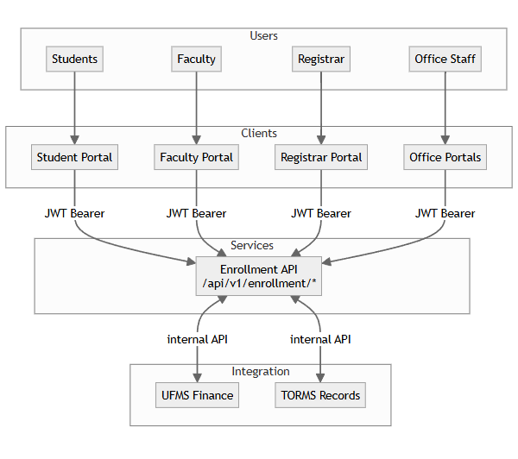
Client-specific routes:
- Student: /student/*
- Faculty: /faculty/*
- Registrar: /registrar/*
- Offices: /offices/:officeType/*

3. Student Enrollment Workflow

3.1 Enrollment State Machine
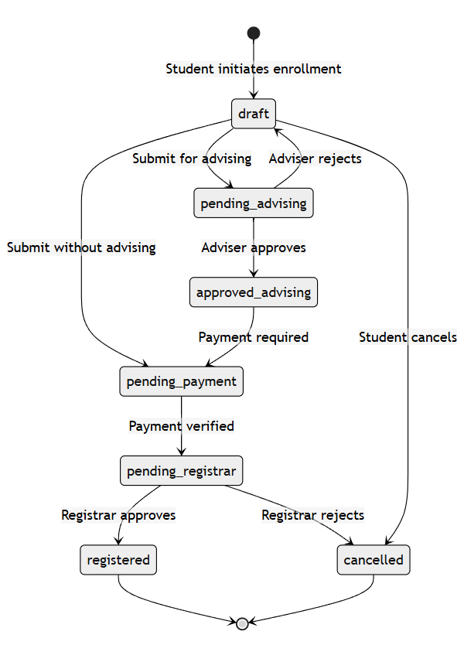

3.2 Enrollment Submission Sequence
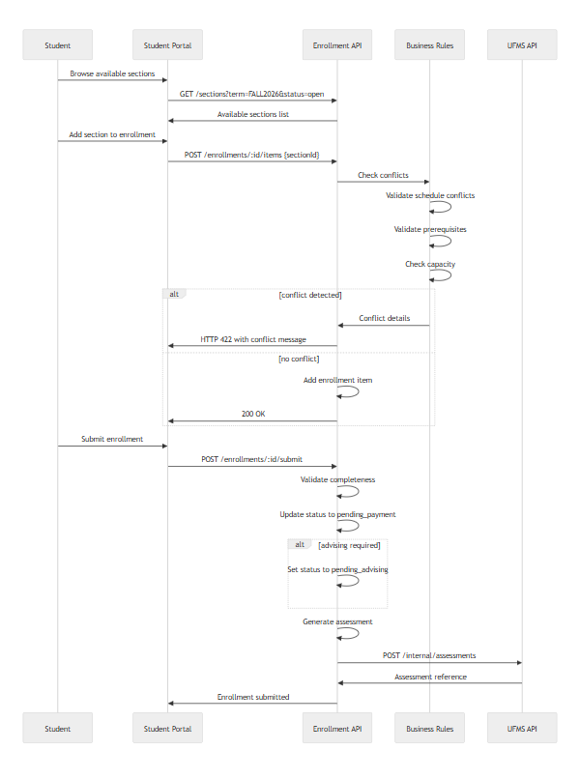

3.3 Conflict Detection Logic
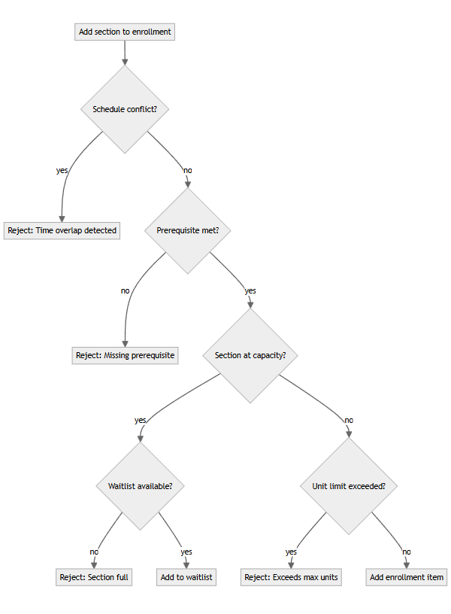

4. Grade Management Workflow

4.1 Faculty Grade Submission
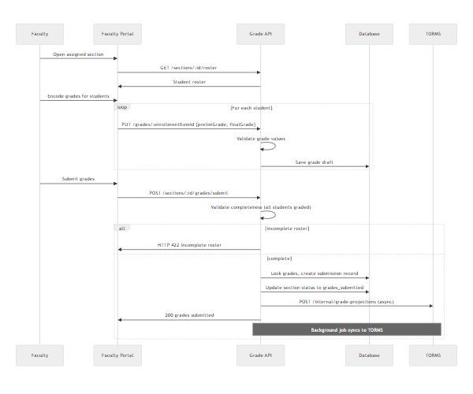

4.2 Grade Correction Workflow
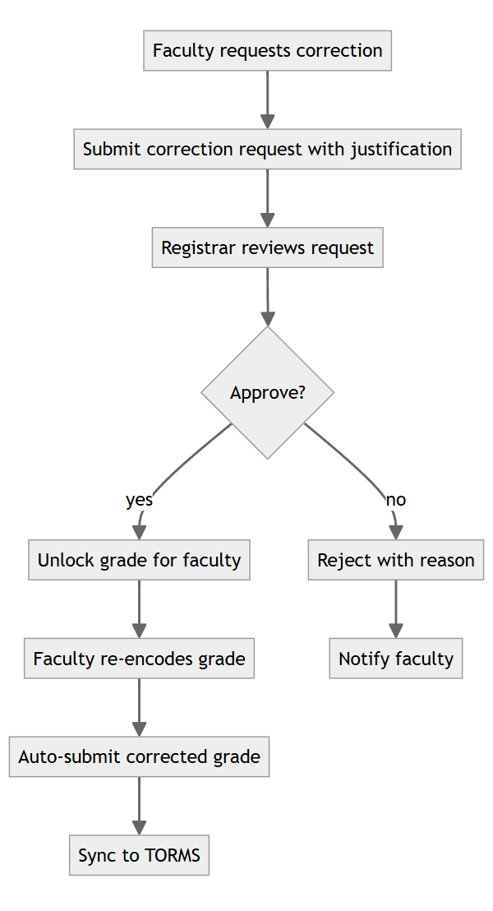

5. Advising Workflow
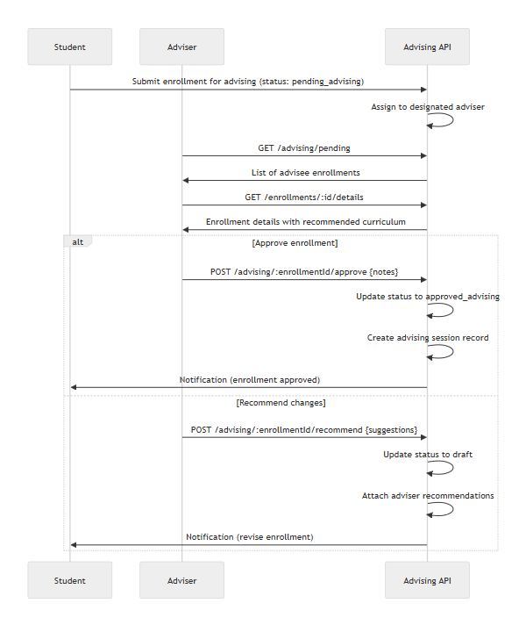

6. Assessment & Payment Integration

6.1 Assessment Preparation
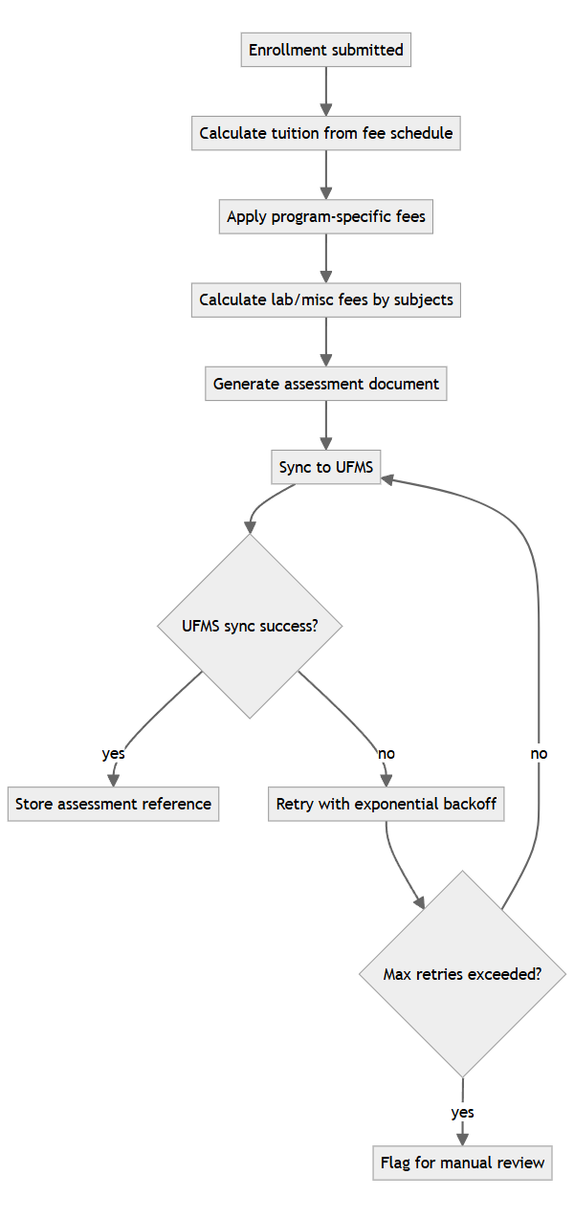

6.2 Payment Status Verification
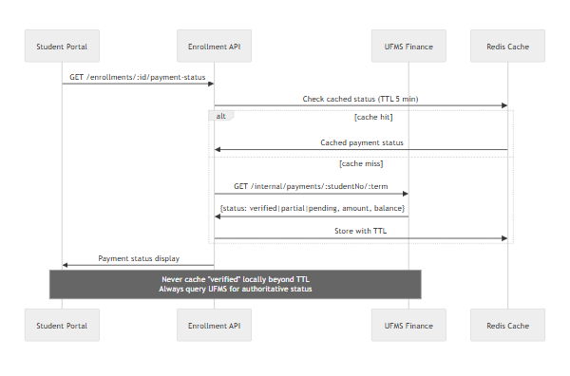

7. Clearance Management

7.1 Clearance Status Aggregation
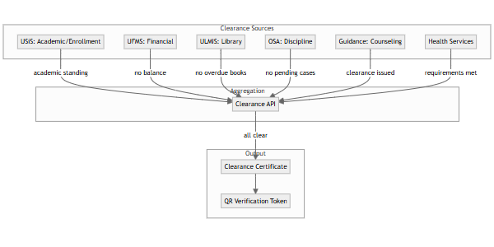

7.2 Clearance Certificate Generation
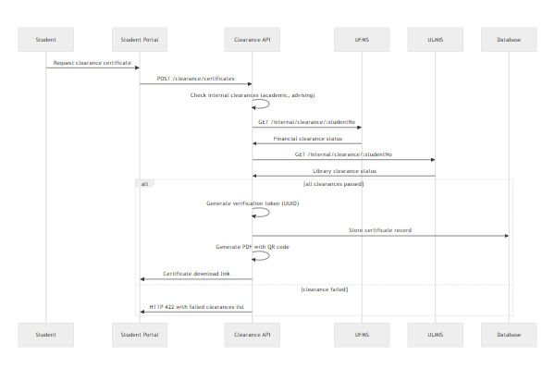

7.3 Public Clearance Verification
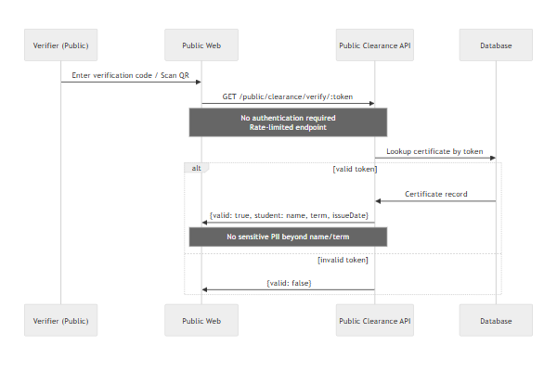

8. Faculty Evaluation Workflow

8.1 Evaluation Period Setup
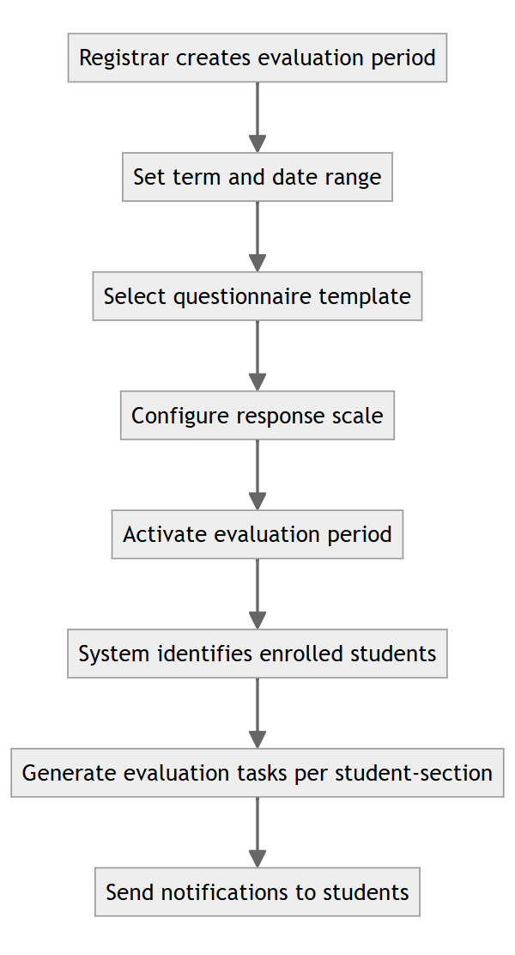

8.2 Anonymous Submission
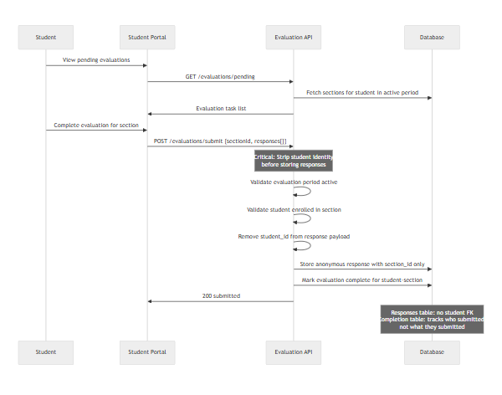

8.3 Result Aggregation
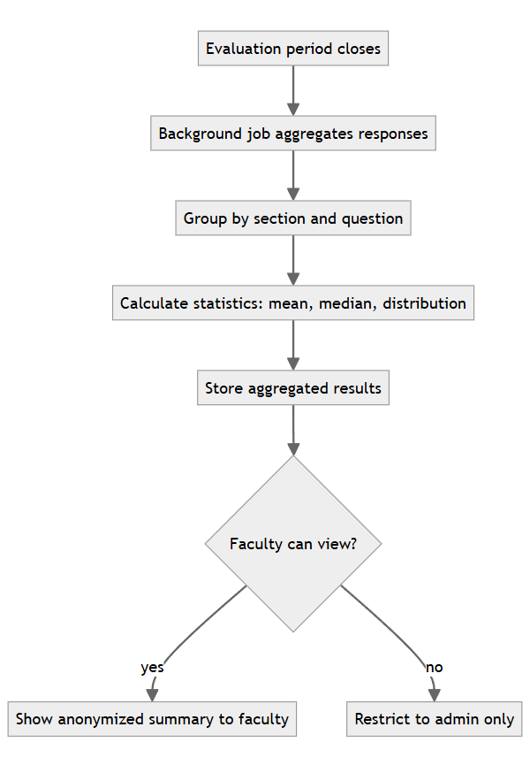

9. Registrar Enrollment Approval
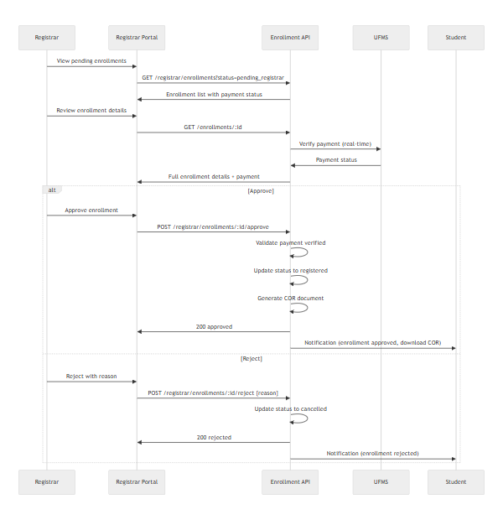

10. Office Support Request Workflow
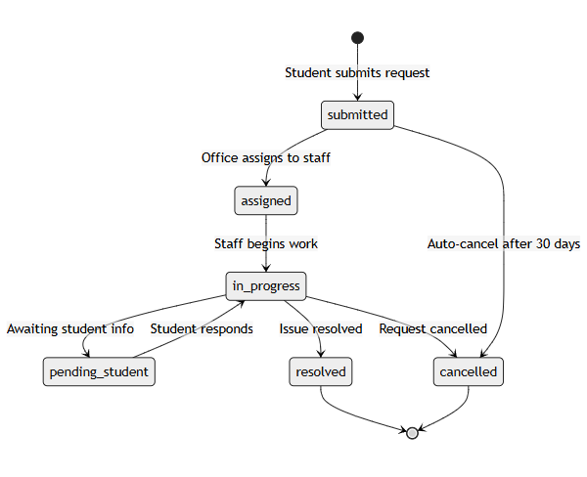

11. Error Cases & Edge Conditions
Case | Expected Behavior | HTTP Status | User Message
Enroll with schedule conflict | Block enrollment, return conflicting section | 422 | "Schedule conflict with [Section Name] on [Days] at [Time]"
Enroll with missing prerequisite | Block enrollment, list missing prerequisites | 422 | "Prerequisite required: [Course Code]"
Enroll in full section without waitlist | Block enrollment | 422 | "Section is full. No waitlist available."
Submit incomplete grade roster | Block submission | 422 | "Cannot submit. [N] students have no grades."
Query UFMS when service down | Return cached status with warning | 200 | "Payment status (last checked [timestamp]). Verify with cashier if recently paid."
Generate clearance with ULMIS down | Fail certificate generation | 503 | "Clearance unavailable. Library system temporarily unreachable."
Verify invalid clearance token | Return not found | 404 | "Invalid verification code."
Faculty view grades before submission | Allow view of draft grades | 200 | Display with "Draft" indicator
Student access other student's data | Authorization failure | 403 | "Access denied."
Registrar override without permission | Authorization failure | 403 | "Insufficient permissions for override."
Evaluation submission outside period | Block submission | 422 | "Evaluation period has ended."
Duplicate enrollment submission (idempotency) | Return original submission result | 200 | Previous submission details

12. Background Job Workflows

12.1 Nightly Grade Sync to TORMS
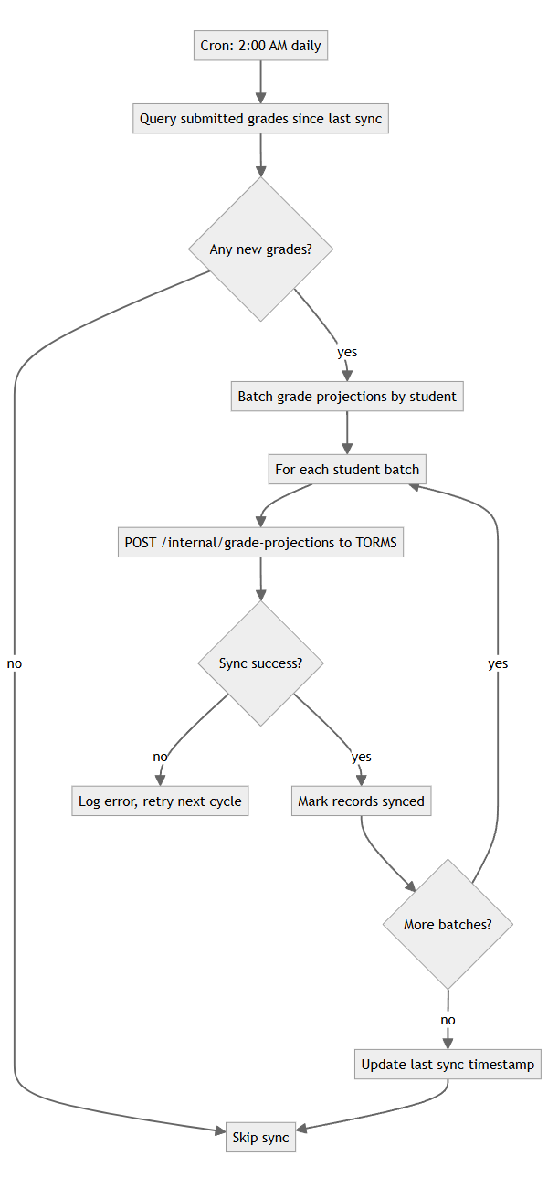

12.2 Enrollment Deadline Notifications
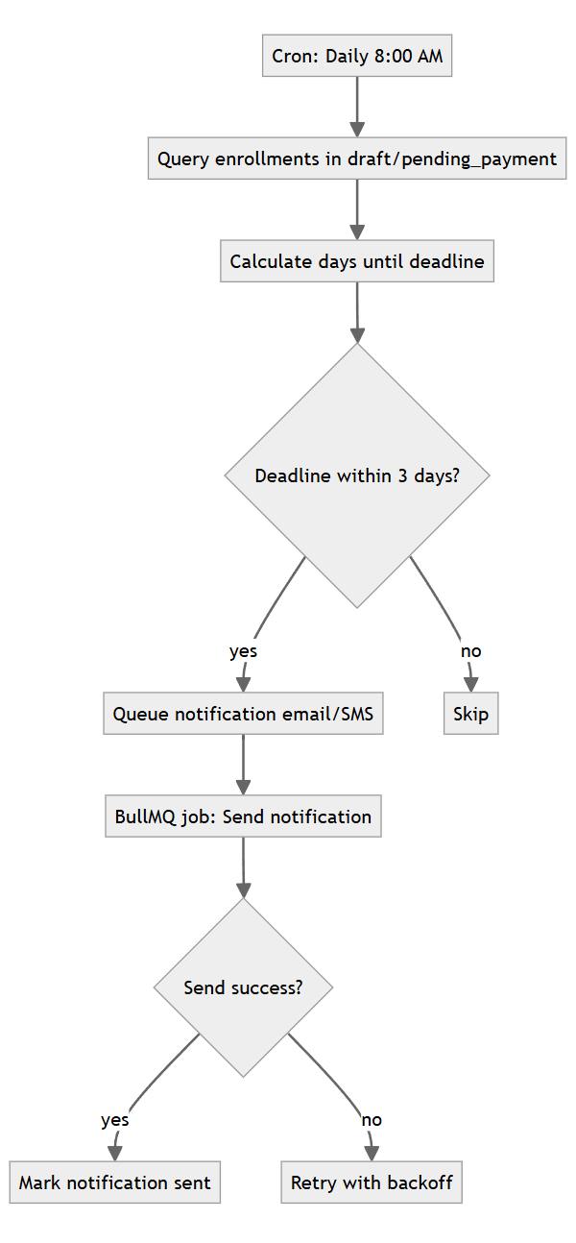
End of LLD — USiS

