Executed Proof-of-Concept Report
Digital Twin Assisted GNSS Spoofing Detection and Bounded Response
Research execution record for the revised SDAV manuscript
Status statement. A genuine PX4/Gazebo/ROS 2 software-in-the-loop experiment could not be executed in the present environment because ROS 2, Gazebo, Docker/Podman, and PX4 were not available, and the execution shell could not resolve GitHub to obtain the PX4 source. The experiment reported here is therefore an executed reduced-order 3D cyber-physical proof of concept. It implements the architecture logic but must not be described as PX4/Gazebo validation, hardware-in-the-loop validation, or flight validation.

1. Purpose and evidential scope
The purpose of this proof of concept was to test whether the principal information flows proposed in the manuscript can be implemented in an executable system: GNSS measurements are compared with a predictive digital twin and a GNSS-independent navigation source; the resulting residual evidence is interpreted by a probabilistic classifier; an assurance rule prevents stale digital-twin information from independently authorizing a response; and a bounded response can isolate GNSS and continue or terminate the mission using independent navigation. The experiment was designed as an architecture-level feasibility test rather than a realistic radio-frequency representation of GNSS spoofing.
This scope is consistent with the literature showing that UAVs can be manipulated by deceptive GPS signals (Kerns et al., 2014), that spoofing defenses benefit from independent observables (Psiaki and Humphreys, 2016), and that independent inertial information can support spoofing detection (Vinoj and Lalu, 2024). The use of a model-based backup for recovery is also consistent with prior work demonstrating software-sensor recovery on robotic vehicles, including a quadrotor (Choi et al., 2020). These studies motivate the architecture but do not validate the numerical results of this simulator.

2. Executed system
The simulator uses a reduced-order three-dimensional translational vehicle model following a five-waypoint mission. Vehicle acceleration is generated by a bounded waypoint controller. The operational estimator is GNSS-dominant before detection and switches to a separate odometry surrogate after GNSS isolation. The digital twin propagates position and velocity using recent control inputs and is corrected by the independent odometry stream. Communication-delay scenarios delay these external twin inputs without altering the independent onboard navigation surrogate.
Element | Executed implementation
Vehicle | 3D translational waypoint-following surrogate; 20 Hz dynamics and control
GNSS | 5 Hz position and velocity observations with declared simulation noise
Independent source | GNSS-independent odometry surrogate with measurement noise and random-walk bias
Digital twin | Control-driven state propagation with independent-telemetry correction
Evidence | Covariance-normalized twin residual, independent-navigation residual, and GNSS temporal residual
Classifier | Standardized logistic regression using five multi-source features
Assurance | Probability threshold + temporal persistence + stale-twin gate requiring independent evidence
Response | Detection-only; fixed route-retracing return-to-base; or GNSS isolation with mission continuation

3. Experimental design
Residual covariance matrices were estimated from a separate set of 25 nominal calibration trials. Detector thresholds were then established using a separate benign calibration set containing nominal operation, temporary GNSS degradation, and communication delay. Classifier training, validation, and held-out testing used disjoint random seeds so that individual simulation traces did not appear in more than one partition.
Partition | Trials
Residual covariance calibration | 25 nominal
Benign threshold calibration | 10 nominal + 10 GNSS degradation + 10 communication delay
Classifier training | 20 per scenario across six scenarios (120 total)
Validation | 8 per scenario (48 total)
Held-out test | 20 per scenario (120 total: 60 attack, 60 benign)
Response-policy experiment | 20 per scenario per policy (360 policy runs); identical seeds reused across policies
Weak-attack stress test | 30 trials per attack scenario (90 total)

The primary training/test attack family sampled abrupt horizontal position steps from 12 to 25 m with an additional 0 to 0.8 m/s velocity bias, or gradual horizontal carry-off rates from 0.25 to 0.80 m/s capped at 30 m. The combined spoofing-and-communication scenario additionally imposed 0.55 to 1.20 s of external-twin telemetry delay. These values are experimental simulator parameters, not claims about typical real-world spoofing magnitudes or aircraft tolerances.
The weak-attack stress test intentionally moved outside the training range: abrupt position steps were reduced to 6–12 m, and gradual carry-off was reduced to 0.10–0.25 m/s. This additional test was included because performance on the same generative range used for training can overstate generalization.

4. Detection methods
Three detection configurations were compared. The GNSS-only temporal baseline used consistency between consecutive GNSS position/velocity observations. The twin-residual baseline used only the covariance-normalized disagreement between GNSS and the digital twin. The proposed detector combined the twin residual, the independent-navigation residual, the GNSS temporal residual, twin age, and GNSS route deviation in a logistic-regression classifier. A response alert required three consecutive positive samples. When the twin was stale, the alert additionally required strong independent-navigation evidence. Thresholds and persistence were selected using the validation data rather than the held-out test data.
The final multi-source probability threshold was 0.757, with 3 consecutive 5 Hz samples required for an event-level alert. On the held-out sample-level data, the probability output had a Brier score of 0.020, a 10-bin expected calibration error of 0.019, and an ROC AUC of 0.994. These values describe calibration within this synthetic data-generating process and should not be interpreted as real-world AI assurance evidence.

5. Held-out detection results
Method | Attacks detected | Recall (95% Wilson CI) | Benign false alerts | False-alert rate (95% CI) | Median latency (s)
GNSS-only temporal | 0/60 | 0.000 (0.000-0.060) | 1/60 | 0.017 (0.003-0.089)
Multi-source + assurance | 60/60 | 1.000 (0.940-1.000) | 0/60 | 0.000 (0.000-0.060) | 4.5
Twin residual | 54/60 | 0.900 (0.799-0.953) | 1/60 | 0.017 (0.003-0.089) | 24.1

The GNSS-only temporal baseline did not detect any of the 60 held-out attack trials. This outcome is consistent with the design of the simulated attacks: both abrupt and gradual manipulations were constructed to preserve enough temporal coherence that consecutive GNSS observations alone were weak evidence. The twin-only detector detected 54 of 60 attack trials, but its median latency was 24.1 s and one benign communication-delay trial generated an event-level alert. The multi-source detector generated alerts in all 60 held-out attack trials and none of the 60 benign trials. The corresponding 95% Wilson interval for attack recall was 0.940–1.000 and for the false-alert rate was 0–0.060. The finite-sample intervals are important: the observed 100%/0% rates do not establish perfect population performance.
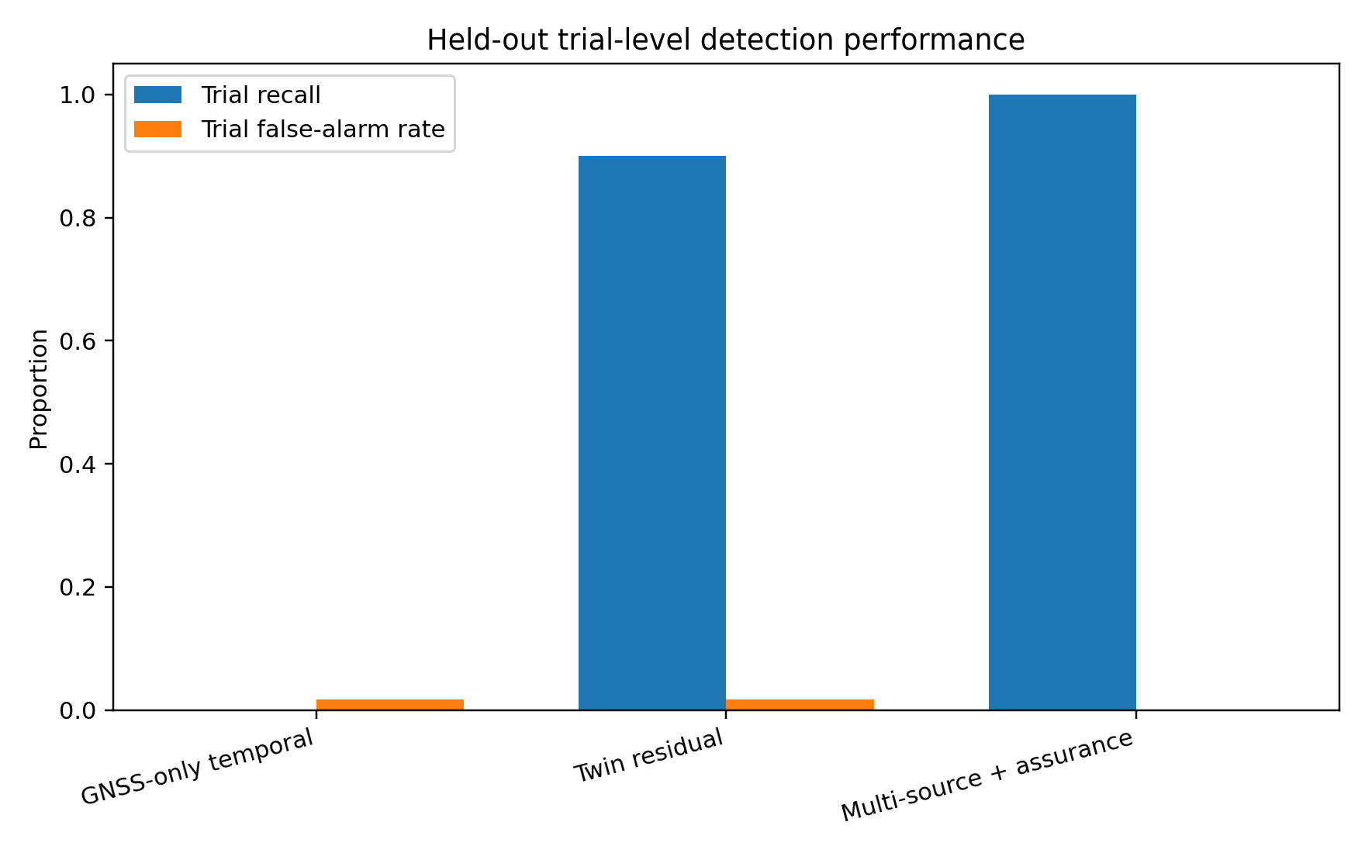
Figure 1. Held-out trial-level detection performance in the reduced-order simulator.
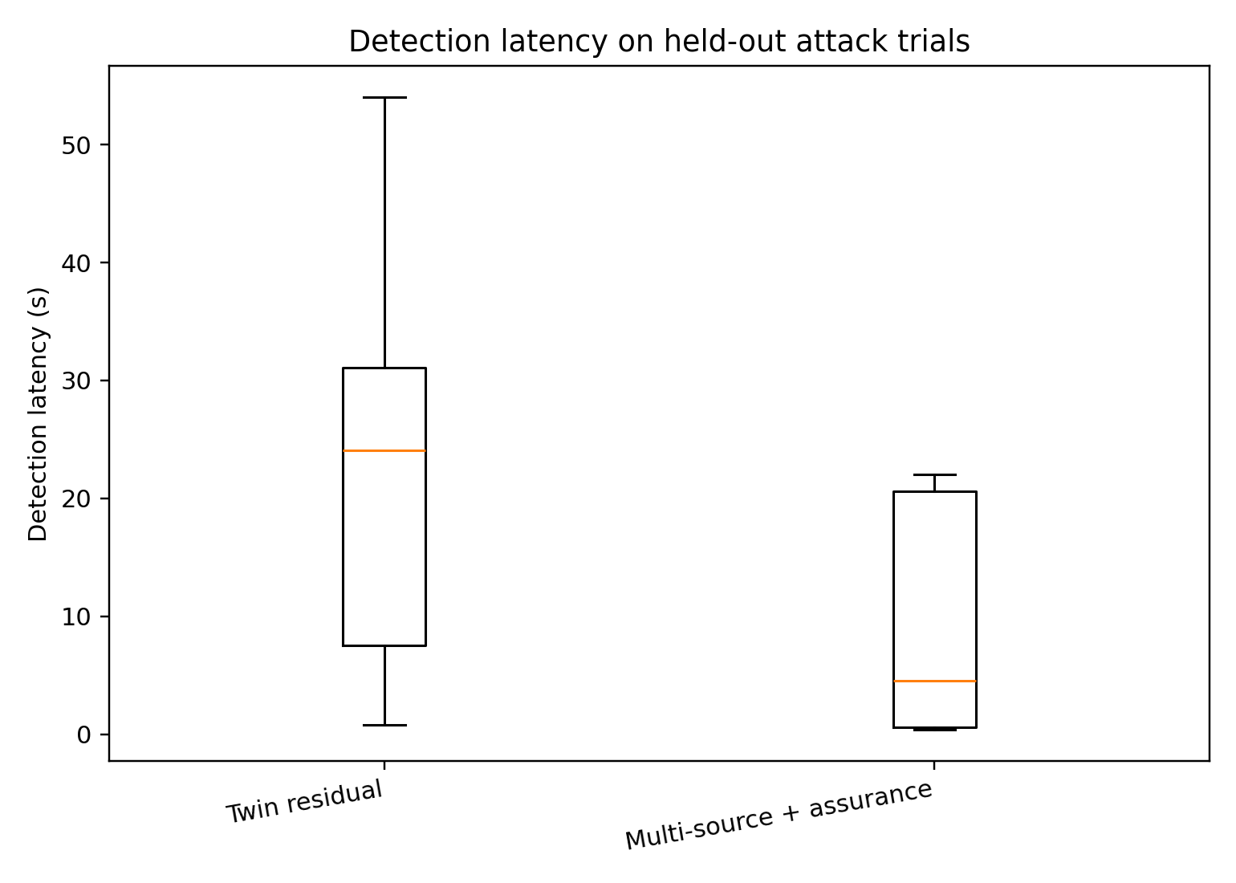
Figure 2. Detection latency for attack trials detected by the twin-only and multi-source methods.

6. Scenario-level and weak-attack behavior
Scenario | Alert rate | Median latency (s) | 95th percentile latency (s)
abrupt_spoof | 1.00 | 0.4 | 0.6
comm_delay | 0.00
gnss_degradation | 0.00
gradual_spoof | 1.00 | 4.5 | 12.7
nominal | 0.00
spoof_comm | 1.00 | 20.6 | 21.2

Abrupt spoofing was detected rapidly in the held-out data, whereas gradual carry-off required longer observation. The combined spoofing-and-communication scenario was slower because stale twin information was not allowed to independently authorize the response. This is a desirable architectural behavior in principle, but the precise latency is specific to this simulator and assurance rule.
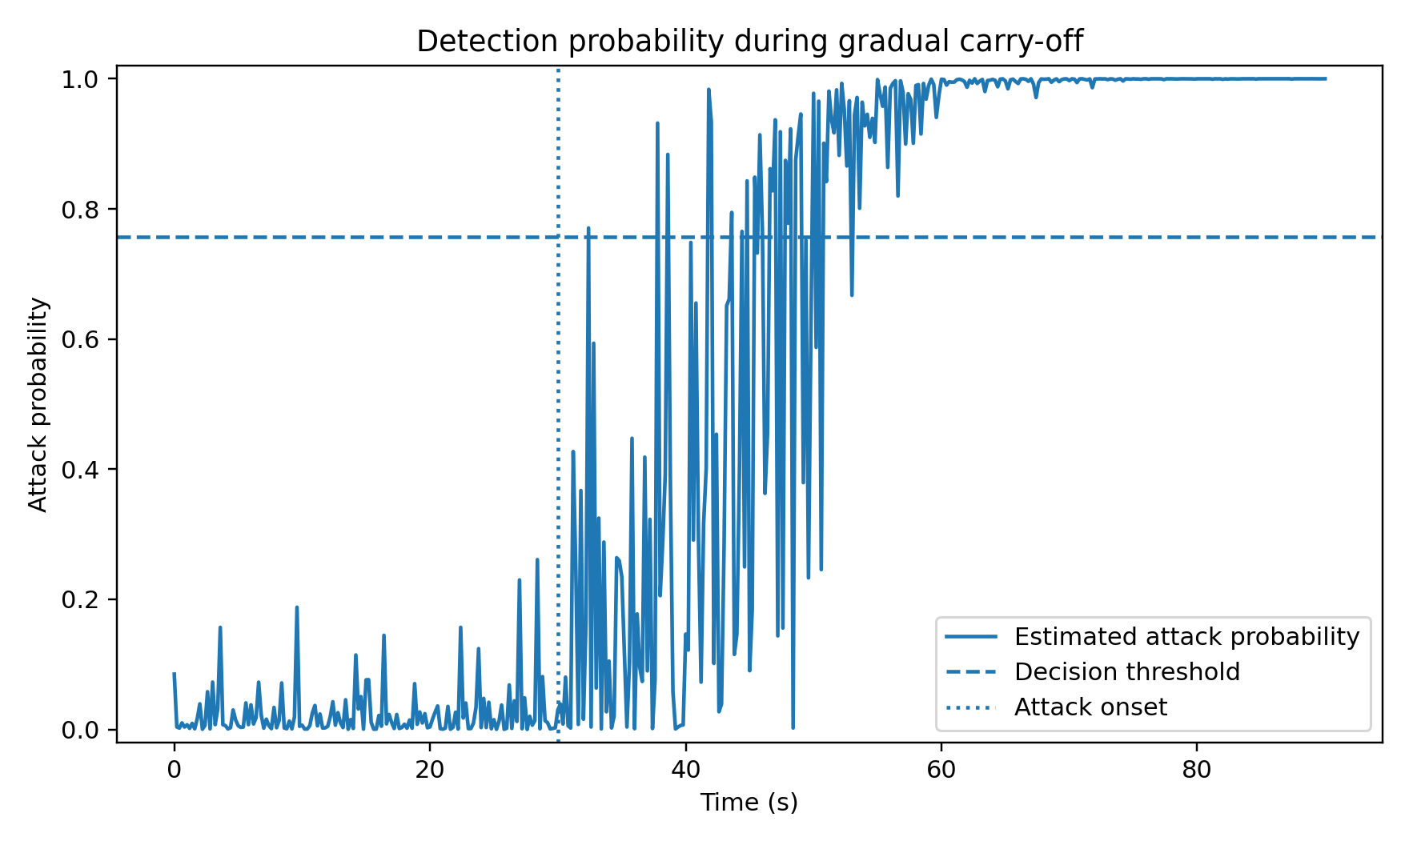
Figure 3. Representative gradual carry-off trial. The vertical line indicates attack onset; the horizontal line is the validation-selected decision threshold.
Weak-attack scenario | Detection rate | Median latency (s) | 95th percentile latency (s)
abrupt_spoof | 1.00 | 0.6 | 4.5
gradual_spoof | 1.00 | 29.3 | 45.2
spoof_comm | 1.00 | 32.2 | 48.6

In the out-of-range weak-attack stress test, the multi-source detector still produced an event-level alert in all 90 attack trials, but gradual attacks were much slower: median latency increased to 29.3 s for gradual carry-off and 32.2 s when combined with communication delay. The twin-only detector failed on weak abrupt and weak gradual attacks without communication delay. The stress test therefore provides a more cautious result than the main held-out experiment: the proposed evidence fusion remained sensitive in this simulator, but weak coherent manipulation substantially delayed detection.

7. Response-policy evaluation
Response policies were evaluated with identical scenario seeds so that all three policies experienced the same pre-response stochastic conditions. The detection-only condition recorded the alert but did not isolate GNSS. The fixed fail-safe isolated GNSS and retraced previously traversed route segments toward the launch point. The bounded-continuation policy isolated GNSS and continued the mission using the independent navigation surrogate. The comparison therefore evaluates architectural behavior after detection; it is not intended to establish that mission continuation is universally preferable to return-to-base.
Policy | Median max deviation (m) | P95 max deviation (m) | >10 m rate | >20 m rate | Mission completion | Return home
bounded_continue | 2.63 | 9.22 | 0.033 | 0.000 | 1.000 | 0.000
detection_only | 17.39 | 23.18 | 0.933 | 0.300 | 0.133 | 0.000
fixed_rtb | 2.89 | 10.29 | 0.067 | 0.000 | 0.000 | 0.600

Across 60 paired attack trials, the median maximum true route deviation was 17.39 m with detection only, 2.89 m with the fixed return-to-base policy, and 2.63 m with bounded continuation. A paired Wilcoxon signed-rank comparison between detection-only and bounded continuation gave p < 0.001. The fixed and bounded policies also differed statistically (p = 0.00013), but their median paired difference was only 0.20 m; this small effect should not be presented as a practically important safety advantage without a mission-specific safety model. The 10 m and 20 m boundaries used in this analysis are diagnostic thresholds only and are not regulatory or certified safety limits.
The bounded policy completed all 60 attack missions in the simulator after switching to the independent navigation source. The fixed policy intentionally terminated the mission objective and returned to the launch point in 36 of 60 attack trials before the 90 s simulation ended. The remaining fixed-policy trials were still executing the return trajectory when the simulation terminated. These outcomes mainly illustrate the trade-off between mission continuation and conservative termination; they do not establish which policy would be preferable in an actual aircraft.
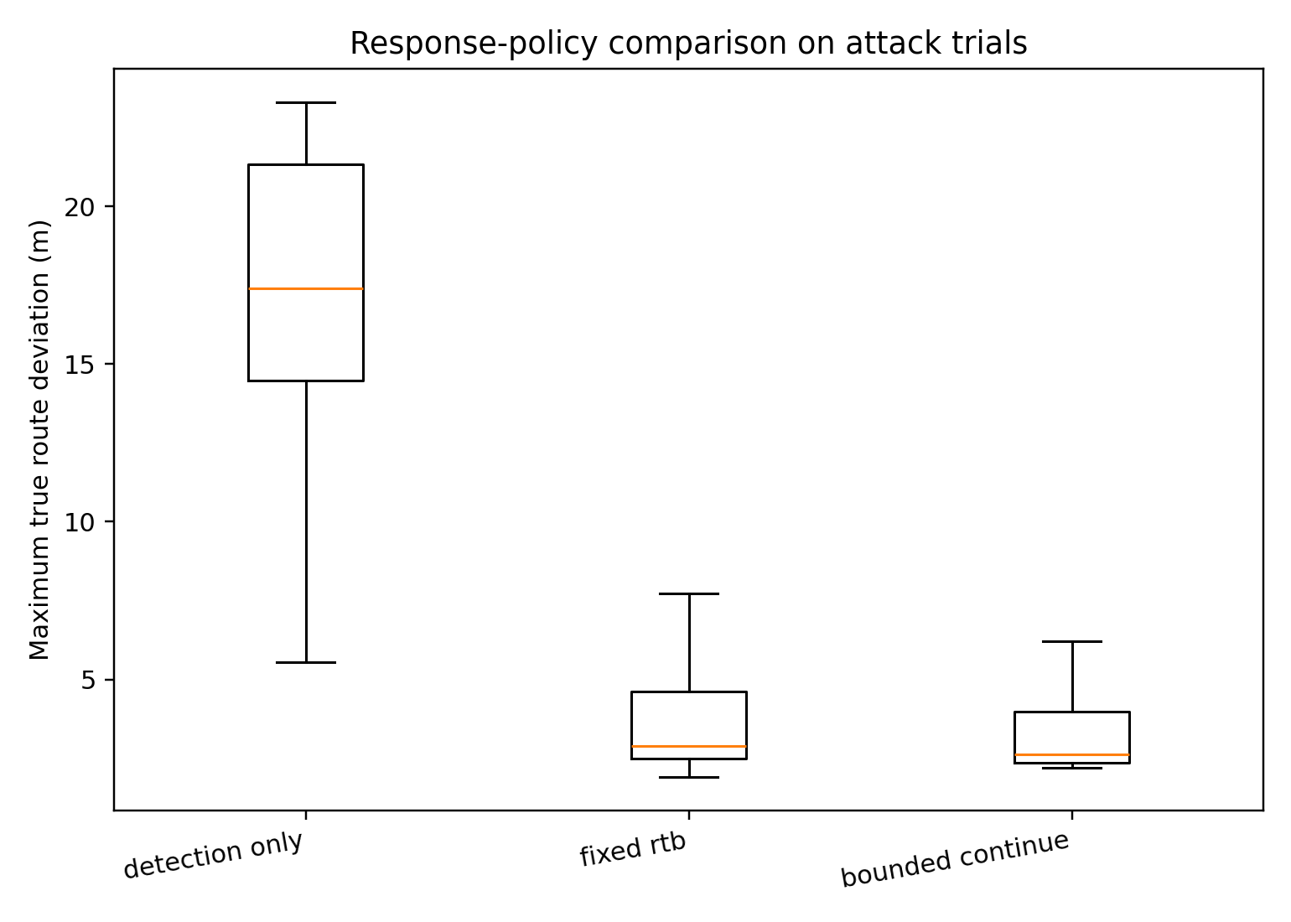
Figure 4. Maximum true route deviation under the three response policies for the paired attack trials.

8. Requirements exercised by the proof of concept
The experiment does not verify every requirement proposed in Section 5. The table below summarizes the evidential status. This distinction should be preserved in the manuscript and reviewer response.
Req. | Status | Evidence in this execution | Limit
SR-01 | Implemented and exercised | Twin and independent-navigation normalized residuals calculated in all trials; held-out detection metrics reported | Reduced-order synthetic state and sensor model
SR-02 | Implemented and exercised | Gradual carry-off scenarios and weak-attack stress tests; detection latency reported | Attack profiles are simulated biases rather than RF-level spoofing
SR-03 | Implemented and exercised | GNSS-independent odometry surrogate included and used by classifier and response logic | Independent source is synthetic odometry, not a real INS/visual estimator
SR-04 | Partially implemented | 0.55-1.20 s communication-delay scenario; twin-age variable used in assurance gate | No packet-level network stack or clock attack
SR-05 | Not implemented |  | No cryptographic identity/integrity/replay mechanism in reduced-order simulator
SR-06 | Partially implemented | Probabilistic logistic classifier; Brier score and 10-bin ECE evaluated | No explicit OOD detector, explanation method, or lifecycle provenance service
SR-07 | Partially implemented | Three-sample persistence and stale-twin assurance gate before response | Only one data-quality condition modeled
SR-08 | Implemented and exercised | Action set restricted to detection-only, fixed route-retracing RTB, or GNSS isolation plus mission continuation | Not a certified response policy
SR-09 | Partially represented | Bounded response does not require external twin after detection; independent navigation used after GNSS isolation | No actual onboard/ground process separation in PX4/ROS 2
SR-10 | Not implemented |  | Human operator and decision timeout not included in this execution
SR-11 | Implemented and exercised | GNSS isolated after alert and navigation switched to independent odometry surrogate | Alternative localization quality is simplified
SR-12 | Not implemented |  | GNSS quarantine and reintegration not modeled
SR-13 | Partially implemented | Twin-age signal identifies communication-induced staleness and gates response | No replay/authorization checks
SR-14 | Not implemented |  | No signed/version-controlled runtime configuration mechanism
SR-15 | Partially implemented | Time-stamped CSV evidence, scenario parameters, model parameters, and results are retained | Logs are reproducible but not tamper-evident
SR-16 | Not verified as an operational requirement | Detection latency measured in simulated mission time | No PX4/real-time hardware timing or mission-specific certified time-to-unsafe boundary

9. Interpretation and publication limits
The executed proof of concept provides evidence that the architecture can be made computationally explicit in a reduced-order simulation and that multi-source evidence can outperform two intentionally simpler residual baselines within the defined synthetic scenario family. It also demonstrates the functional difference between detection, source isolation, and response policy. These are useful architecture-level results, but they are not sufficient to claim operational cyber resilience.
- The flight dynamics are reduced-order translational dynamics rather than PX4 flight-control dynamics.
- GNSS spoofing is represented as controlled position/velocity bias. Carrier tracking, correlation peaks, signal power, Doppler, multipath physics, receiver acquisition, and RF propagation are not simulated.
- The independent navigation source is a synthetic odometry surrogate, not a real INS, visual-inertial estimator, or certified navigation source.
- Training, validation, and main held-out test data are generated by the same simulator family, although disjoint random seeds and an out-of-range weak-attack stress test were used.
- The AI assurance implementation is partial. Probability calibration and a stale-twin gate were evaluated; explicit out-of-distribution detection, explanation consistency, provenance enforcement, and adversarial ML testing were not implemented.
- Cryptographic telemetry protection, replay defense, tamper-evident audit storage, human operator timing, GNSS reintegration, and software/configuration signing were not executed.
- The response-policy comparison uses simplified mission logic. The route-deviation thresholds are analytical values and are not aviation safety standards.
Accordingly, a defensible manuscript description would be: “A reduced-order software proof of concept was executed to test the internal information-flow and response logic of the proposed architecture.” It would not be defensible to write that the architecture has been validated in PX4/Gazebo, that it has been proven cyber-resilient, or that the results establish airworthiness or certification readiness.

10. Required next validation stage
The next stage should migrate the same test logic into a genuine PX4/Gazebo software-in-the-loop environment. PX4 is an open-source autopilot supporting SITL and ROS 2/DDS integration and provides simulator failure-injection mechanisms; however, its generic “wrong GPS” failure mode is not a substitute for a controlled gradual carry-off spoofing model. The next experiment should therefore inject reproducible GNSS position/velocity bias at the simulator or sensor-message boundary, retain simulator ground truth only for evaluation, and record PX4 estimator innovations, vehicle state, communication timing, detector output, and response commands. The experimental variables and metrics already defined in Section 7 can be reused.

References
Choi, H., Kate, S., Aafer, Y., Zhang, X., and Xu, D. (2020). Software-based Realtime Recovery from Sensor Attacks on Robotic Vehicles. Proceedings of the 23rd International Symposium on Research in Attacks, Intrusions and Defenses (RAID 2020), 349-364.
Kerns, A. J., Shepard, D. P., Bhatti, J. A., and Humphreys, T. E. (2014). Unmanned Aircraft Capture and Control Via GPS Spoofing. Journal of Field Robotics, 31(4), 617-636. https://doi.org/10.1002/rob.21513.
Meier, L., and The PX4 Contributors. PX4 Autopilot. Zenodo. https://doi.org/10.5281/zenodo.595432.
Pischulti, P. K., and Klaus, D. M. (2024). Towards Fault Management Autonomy - The Development and Evaluation of a Self-Sufficient Anomaly Response System Architecture for Deep Space Habitats. 53rd International Conference on Environmental Systems, ICES-2024-420.
Psiaki, M. L., and Humphreys, T. E. (2016). GNSS Spoofing and Detection. Proceedings of the IEEE, 104(6), 1258-1270. https://doi.org/10.1109/JPROC.2016.2526658.
Tabassi, E. (2023). Artificial Intelligence Risk Management Framework (AI RMF 1.0). NIST AI 100-1. https://doi.org/10.6028/NIST.AI.100-1.
Vinoj, V. S., and Lalu, V. (2024). INS aided spoofing detection of high dynamic GNSS receiver for launch vehicle applications: A loosely coupled approach. Advances in Space Research, 74(6), 2814-2829. https://doi.org/10.1016/j.asr.2024.03.018.
Wei, X., Sun, C., Li, X., and Ma, J. (2024). GNSS spoofing detection for UAVs using Doppler frequency and Carrier-to-Noise Density Ratio. Journal of Systems Architecture, 153, 103212. https://doi.org/10.1016/j.sysarc.2024.103212.

