OUTPUT



GRAPH

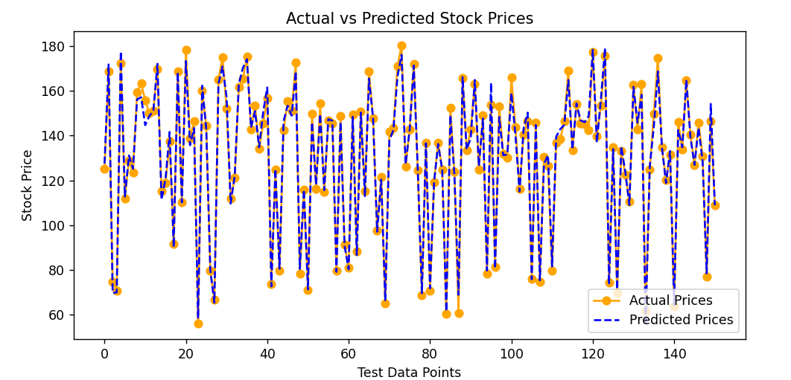

Next day’s Prediction

