Document History

|  |  |  |  |  |  |
| --- | --- | --- | --- | --- | --- |
| **History** | **Status** | **Date** | **Viewable** | **Editable** | **Responsible** |
| Add Chapter 1   * Rationale   Add Chapter 2   * Technology Review * Development Tools |  |  |  |  |  |
| Update Chapter 1   * Rationale   Add Chapter 1   * Extensions   Add Chapter 2   * Traditional Review * Literature Review * Business Review |  |  |  |  |  |
| Update Chapter 2   * Traditional Review * Literature Review * Business Review * Technology Review * Development Tools   Add Chapter 3   * Quality Standard   Add Chapter 4   * Motivation * Aims and Objectives * Deliverables and Limits * Software Process * Features and  Schedule Plan |  |  |  |  |  |

**Abstract**

Kokha hospital is a host health promoting hospital is a hospital that takes responsibility for support patient transfer from health-promoting hospitals to reduce the number of patient transfer to the main hospital and also provide support for medical health care and services in Kokha district. With the number of patients that increases every year related to the complexity and differently of patient symptoms. The medical consulting system is notably significant. But due to the usual consult procedures of the hospital, the staff need to deal with duplicate tasks and inconvenience to collect and manage documents inevitably.

So, Kokha e-consult system is developed to solve these problems. It is a web application which provides consult tools that help medical personnel able to manage and receive information efficiently. It contains two parts. First is create tools for the consult form. Second is support tools for supporting the primary doctor or medical personnel to make a decision which provides an instant message, report data visualization and consult directory management.

Chapter One | **Rationale**

**1.1 Introduction and Background**

In Thailand, there are 798 health-promoting hospitals in 12 public health services area which take care more than 60 million people of the population. However, the ratio of doctor to patient is 1: 8,467 which five times over than the standard (1: 1,500) cause the shortage of medical personnel situation. This consequence leads to cause of many inconvenience services for the patient. Many hamlet hospitals have only nurses or the health-volunteers to take care the villager. Some of them have an illness that the community or small hospital cannot handle so, moving patient to a potential hospital is always occur.

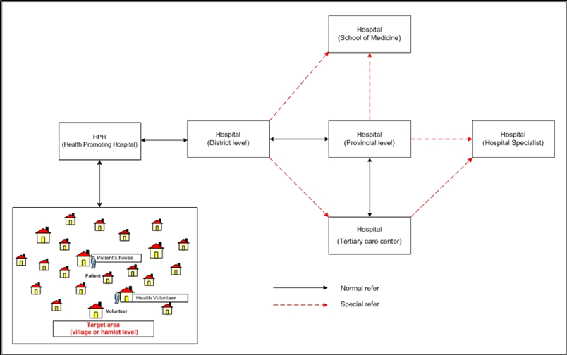

*Figure 1 Healthcare ecosystem in Thailand*

Kokha hospital in Kokha District, Lampang is one of a host health promoting hospital (Middle-level hospital: M2) in Thailand. It has a responsibility to be a receptacle hospital for nine districts in Lampang for decrease patient transfer to the district and province level hospital and also support medical health care and services in Kokha district.

Due to the problem in the first paragraph, the medical personnel were created the medical consultation system to mitigate the situation. The system is a process whereby the physician or medical personnel communicate with another physician to review patient's medical history, examine and give recommendations for patient treatment. In Kokha hospital, the consulting system mostly used with the group of patients with NCDs (non-communicable diseases).

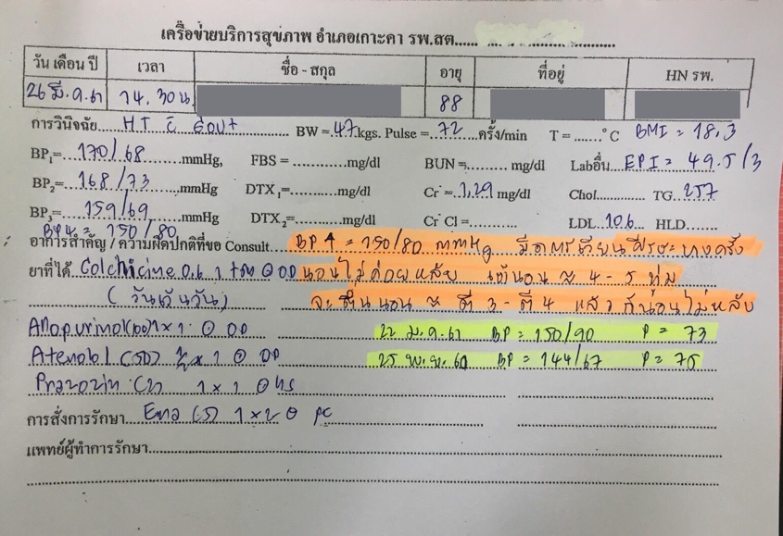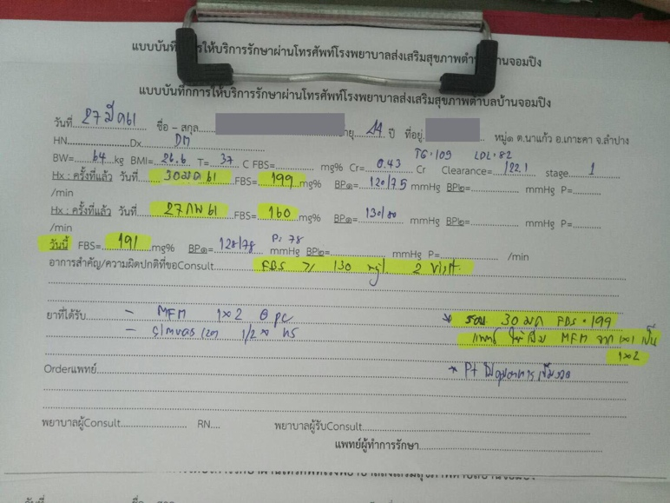

*Figure 2 Kokhha Hospital Ask for Consult Paper* *Figure 3 Kokhha Hospital Consult paper*

In Kokka Hospital, the consult procedure was done by writing in a paper form (figure2) and sent to target place (figure3). However, to get the result faster. They are using a chat application to communicate which cause first, the duplicate process by writing in a form next take a picture and sent then the receiver redoes it again. Second, might occur misunderstanding in teaching because of this process cannot be trusted and accepted related to the quality of treatment standards. Third, it cannot implement as medical records. So, they need to do the digitization (transfer from raw data to digital data) or rewrite it into the paper document by themselves.

Consequently, Kokka e-consult web application is created to solve this problem with an aim to be a consulting tool which provides the feature to reduce redundancy of consulting method.

**1.2 Extension**

**1.2.1 Kokka Hospital**

Kokha hospital in Kokha District, Lampang is a host health promoting hospital middle level 2 (Middle-level hospital: M2) with the capability for support 120 beds of patients and take responsibility for support patient transfer from health-promoting hospitals in 9 districts in Lampang. To reduce the transmission to the principal hospital, support medical health care and services in Kokha district which needs to be served both inside and outside their responsibility area. The result is present in an increasing number of patients in a few years. Therefore, NCD clinic has been creating to separate chronic patients out of general patients but with the number of chronic patients that increases every year.

*Figure 4 The ratio of illness per 100,000 of population 2556 – 2560*

Not only it leads to cause of over waiting time for healthcare service but also relating to the number of increasing of the patient, each has different symptoms and different complexity for treatment, so it is difficult to provide and support a medical care and services without advice from a medical expert

**1.2.2 NCDs**

NDCs or Non-Communicable Diseases is a group of uninfected chronic disease which mean that it cannot infect people. The severity symptoms will gradually increase if not get the treated well. So as a result, they need to regular and prolonged medical visits are required.

Chapter Two | **Business & Literature Review**

**2.1 Traditional System Review**

**2.2 Literature Review**

**2.3 Business Review**

**2.4 Technology Review**

|  |  |  |
| --- | --- | --- |
| **Laravel** | **Vue.js 2** | **MySQL** |
|  |  |  |
|  | Vue is an open-source progressive JavaScript framework for building user interfaces | MySQL is open source relational database management system (RDBMS) |
| **Technology Description** | | |
|  |  |  |
| **Alternative Technology** | | |
| * Symfony * CodeIgniter * Yii 2 * Phalcon | * React.js * Angular 4 * Ember.js | * PostgreSQL * MariaDB * SQLite |
| **The selection of this technology** | | |
|  | * ง่ายต่อการเรียนรู้ * พัฒนา application ได้เร็ว * Component   data binding | * reliable * easy to use * free to use * supported by Oracle Corporation |

**2.5 Development Tools Review**

|  |  |  |
| --- | --- | --- |
| **PhpStrom** | **Atom** | **phpMyAdmin** |
|  |  |  |
|  |  |  |
| **Technology Description** | | |
|  |  |  |
| **Alternative Technology** | | |
|  |  |  |
| **The selection of this technology** | | |
|  |  |  |

Chapter Three | **Quality Standard**

Chapter Four | **Project Plan**

**4.1 Motivation**

Kokha e-consult system is a web application which provides consult tools that can help medical personnel able to manage and receive information efficiently.

**4.2 Aims and Objectives**

**4.2.1 Aims**

The project aim is to develop a web application to help medical personnel in Kokha Hospital manage with consulting tasks more effective

* + 1. **Objectives**

1. This application will develop to provide the e-consult form for Kokha hospital.

2. This application will develop to provide the indirect message for medical personnel able to contact with the target hospital.

3. This application will develop to provide printing function for reducing error from a copy.

4. This application will develop to provide report data visualizations.

**4.3 Deliverables and Limits**

**4.3.1 Deliverables**

**4.3.1.1 System Architecture**

**4.3.1.2 Documents**

**4.3.2 Limits**

**4.3.3 Future work**

**4.4 Software Process**

**4.5 Features & Schedule Plan**

**4.5.1 Features**

**4.5.2 Schedule Plan**

Chapter Five | **References**

[1] <https://www.hfocus.org/content/2016/02/11644>

[2] <https://www.tcijthai.com/news/2017/29/watch/6708>

[3] Ref doc ของ อจ ก๊อปไว้แล้ว หาไม่เจอออ TOT

[4] Ref kokha hospital