## Abstract

Thailand has more than 720 small hospitals around the country. Related to the distance, lots of doctors and medical professionals are in the city, especially in the big city. Inverse, farther from the town there is the barely number of them or none. Medical is seriously related to people life. So, medical experts are needed, but not everyone is an expert. Trying to solve the problem, they create a "consult" which is a form for fill a patient's health problem and sent it to the medical expert to perceive better diagnose.

To get faster diagnose, the faraway staffs trying to use a technology which is chatting application to communicate with the expert. But there are problems which are first, sending and receiving process are duplicate by sender "writing - taking pictures" and wait for the receiver to redo the same method to send the information back. Second, in term of medical the chat applications are not accepted, it cannot be the efficiency data in the mechanical analysis.

E-consult system develops to solve these problems. It is a web application which provides consult tools that help medical personnel able to get information efficiently. It contains two parts. First is create tools for the consult form. Second is support tools for supporting the primary doctor or medical personnel to make a decision which provides an instant message, report data visualization and consult directory management.

Chapter I | Introduction and Background

In Thailand, there are 798 community hospitals in 12 public health services area which take care more than 60 million people of the population. However, the ratio of doctor to patient is 1: 8,467 which five times over than the standard (1: 1,500) [1] cause the shortage of medical personnel situation. This consequence leads to cause of many inconvenience services for the patient. Some of them have an illness that the community or small hospital cannot handle so, moving patient to a potential hospital is always occur.

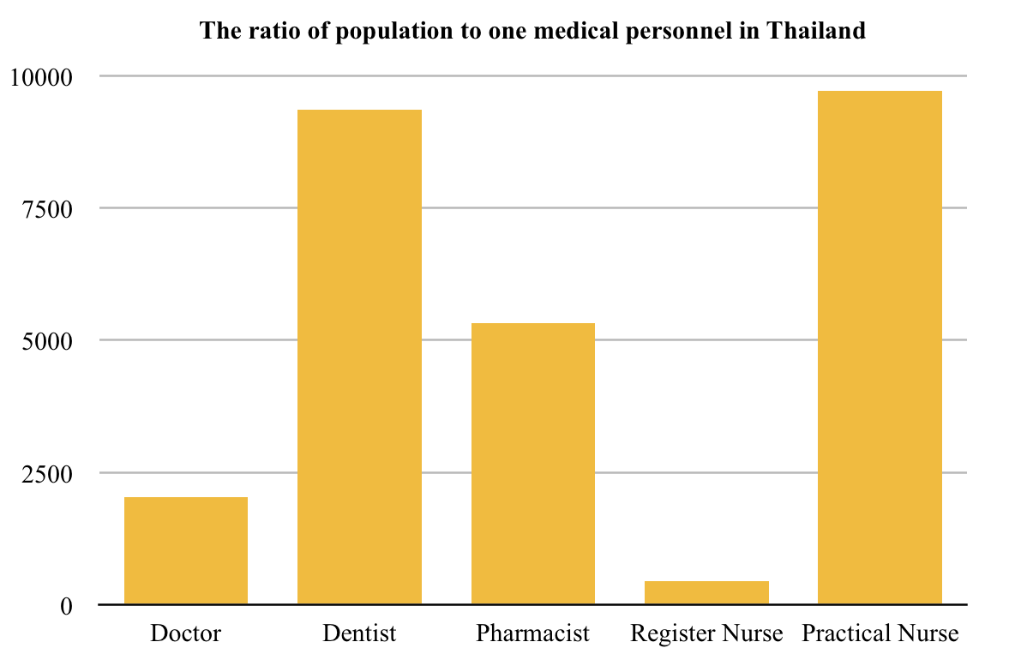

*Figure 1 The ratio of population to one medical personnel in Thailand 2015*[2]

Due to this problem, the medical personnel were created the medical consultation system to mitigate the situation. The system is a process whereby the physician or medical personnel communicate with another physician to review patient's medical history, examine and give recommendations for patient treatment which in Thailand the procedure was done by writing in a paper form and sent to target place. However, to get the result faster in Thailand for now, they are using a chat application to communicate which cause first, the duplicate process by writing in a form next take a picture and sent then the receiver redoes it again. Second, might occur misunderstanding in teaching because of this process cannot be trusted and accepted related to the quality of treatment standards. Third, it cannot implement as medical records. So, they need to do the digitisation (transfer from raw data to digital data) or rewrite it into the paper document by themselves.

Consequently, E-consult web application is created to solve this problem with an aim to be a consulting tool which provides the feature to reduce redundancy of consulting method.

## Chapter II | Literature Review

2.1 Business Review

2.2 Business Tools and Software Review

Line

2.3 Technology Review

|  |  |  |
| --- | --- | --- |
| Laravel | Vue.js 2 | MySQL |
|  |  |  |
| Description |  |  |
|  | Vue is an open-source progressive javascript framework for building user interfaces. | MySQL is open source relational database management system (RDBMS) |
| Alternative |  |  |
| * Symfony * CodeIgniter * Yii 2 * Phalcon | * React.js * Angular 4 * Ember.js | * PostgreSQL * MariaDB * SQLite |
| The selection of this technology |  |  |
|  | * ง่ายต่อการเรียนรู้ * พัฒนา application ได้เร็ว * Component * data binding | * reliable * easy to use * free to use * supported by Oracle Corporation |

2.4 Development Tool Review

|  |  |  |
| --- | --- | --- |
| PhpStrom | Atom | phpMyAdmin |
|  |  |  |
| Description |  |  |
|  |  |  |
| Alternative |  |  |
|  |  |  |
| The selection of this tool |  |  |
|  |  |  |

|  |  |  |
| --- | --- | --- |
|  |  |  |
|  |  |  |
|  |  |  |
|  |  |  |
|  |  |  |
|  |  |  |
|  |  |  |
|  |  |  |

npm

composer

## Chapter III | Quality Standard

## Chapter IV | Project Plan

4.1 Motivation

4.2 Aims and Objectives

4.2.1 Aims

เพื่อให้การปรึกษาของแพทย์กับพยาบาลในพื้นที่ขาดแคลนแพทย์เฉพาะทาง ให้ง่ายขึ้นและ

4.2.2 Objectives

The objective of this project is to develop a web application that

4.3 Software architecture

User <-> web application <-> webservice <-> database

From figure XXX, the flow start from user use any browser to request web application from server, server will provide web application to the browser. Then, whenever user use the feature from web application, web application will send request for the service to web server. The function of web server is to respond the request from web application and access to the database.

4.4 Software Process

4.5 Features & Schedule Plan

4.5.1 Features

Feature#01: Authentication System

Feature#02: Account Management

Feature#03: พยาบาล case

Feature#04: หมอดู case + ตอบ

Feature#05: Case history + สรุปผล พิมพ์

Feature#06: Cases statistic report data visitulization

## Chapter V | Reference

[1] <https://www.hfocus.org/content/2016/02/11644>

[2] <https://www.tcijthai.com/news/2017/29/watch/6708>