**Coding:**

Implement SPA (<https://i-msdn.sec.s-msft.com/dynimg/IC690875.png>) with authentication page and one more page + RestAPI on backend for CRUD operations on one table.

DB:

tblEmployees:

empID (identity field)

empName

empActive

emp_dpID – foreign key to tblDepartments

tblDepartments:

dpID

dpName

Sample UI:

**Grid View**:



|  |  |  |  |  |  |  |
| --- | --- | --- | --- | --- | --- | --- |
|  |  | empID | empName | empActive | empDepartment |  |
| View | Edit | 1 | Lisa | Yes | HR | Delete |
| View | Edit | 2 | Erik | Yes | Tech | Delete |
| View | Edit | 3 | Don | Yes | Finance | Delete |
| View | Edit | 4 | Peter | No | Tech | Delete |



**Edit form**:

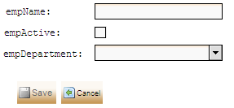

+ it should have one “Search” feature:

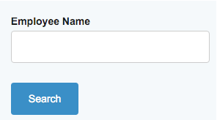

And it should search ONLY with “Start with” criteria! (not include!).

**!!!NOTE!!!**

UI beauty is NOT considered at all. So, html/css doesn’t matter!

However, it should be Angular or React.

Conditions:

1. Table theoretically can have more fields and a lot of data.
2. So, paging is essential part of this test task.
3. Please use MySQL for test task.
4. Don’t use Hibernate or any other ORM.
5. Please configure swagger.
6. Please write a small tutorial how to start a project and attach a database dump with test data.
7. put test task in zip format to Google Drive (or equivalent) and send link to download it to [jobs@ukeess.com](mailto:jobs@ukeess.com).

**Thanks**!