Robust Control of a Nonlinear Quadrotor Under Payload and Model Uncertainty:
PID Optimization and Integral-LQR Comparison
Nurtas Nazarbayev | NIS Shymkent Abay, Kazakhstan
Working scientific manuscript · 17 October 2026 · Simulation study · Not peer reviewed
Scope note: This study uses nonlinear six-degree-of-freedom state propagation, but actively controls only altitude and roll. It does not establish safe three-dimensional flight.

Abstract
Background. Comparing automatically tuned PID gains only against a weak manually tuned controller can overstate the value of optimization. External methodological feedback motivated a conventional PID re-tuning procedure, an integral-LQR comparator, explicit actuator metrics, repeated stochastic tuning, and separation between development and final evaluation.
Methods. Four controllers—carefully tuned PID, Performance Auto-PID, Robust Auto-PID, and actuator-aware integral LQR—were evaluated on a reconstructed 17-state nonlinear quadrotor model. The model includes first-order rotor dynamics, rotor limits, simplified aerodynamics, synthetic wind and payload uncertainty, measurement noise, and 0–30 ms feedback delays. Controller settings and analysis criteria were frozen before drawing 100 new paired synthetic conditions (400 controller-condition simulations).
Results. Altitude-task pass fractions were 95/100, 95/100, 93/100, and 99/100, respectively. Relative to conventional PID, none of the three paired differences met the multiplicity-adjusted 0.05 criterion (exact McNemar/Holm). Robust Auto-PID had 0.081 s lower mean settling time and 0.051 m·s lower altitude integral absolute error, but 2 fewer passing conditions. Integral LQR had higher altitude pass frequency yet much higher roll error and rotor saturation. All controllers exhibited horizontal drift greater than 2 m in every condition, and LQR exceeded 45° in the descriptive unwrapped-yaw diagnostic in 10 conditions.
Conclusions. Controller rankings depend on which performance dimension is examined. Automatic tuning did not establish superior strict altitude-task success relative to a carefully tuned conventional PID baseline in the frozen synthetic test. Better altitude outcomes must not be equated with whole-aircraft stabilization or real-world flight safety.
Keywords: quadrotor · PID · nonlinear simulation · differential evolution · robustness · integral LQR · actuator saturation · paired Monte Carlo

1. Introduction
Quadrotor dynamics couple four thrust-producing rotors to six rigid-body degrees of freedom, creating underactuation and interactions among position, attitude, and actuator constraints. Foundational modeling and control treatments show why practical control evaluation must account for coupled dynamics and limited actuator authority [1, 2]. Optimization of PID gains is attractive because it can automate multi-objective tuning, but nominal improvements do not necessarily generalize to payload shifts, wind, measurement delay, or motor uncertainty.
The preceding V1 manuscript reported strong results for two automated PID variants relative to a fixed-gain benchmark. The present V2 is a separately documented reconstruction based on that manuscript, rather than a claim to have recovered all original code and constants. Its scientific purpose is to challenge, not merely confirm, the earlier conclusion: a carefully optimized conventional baseline and a model-based integral-LQR controller might remove the apparent advantage of Auto-PID. Differential Evolution [3], local Nelder–Mead refinement [4], and discrete-time optimal control are used as comparative procedures, not presented as newly invented algorithms.
Technical feedback by Dr. Ali Nasir prompted six methodological improvements: (1) a stronger conventional PID baseline; (2) integral-LQR comparison; (3) development/held-out separation; (4) reporting actuator control effort and saturation; (5) multiple stochastic-optimizer seeds; and (6) explicit treatment of a 3.0 kg payload challenge as known versus unknown during design. This contribution is limited to feedback; it does not denote formal supervision, authorship, peer review, or endorsement.

1.1 Research question and expectations
Research question. Under a reconstructed nonlinear quadrotor model, do performance-oriented and robustness-oriented auto-tuned PID controllers provide better altitude-task reliability than a carefully tuned conventional PID and an actuator-aware integral LQR, when tuning and final paired evaluation are separated?
The expected advantage was that the robust objective would improve pass probability under model uncertainty. A competing expectation was that conventional tuning or integral LQR could match or outperform the automatic methods once motor saturation and measurement delay were modeled fairly. Both favorable and unfavorable outcomes are retained.

1.2 Contributions and scope
The study combines (i) a common actuator- and measurement-constrained model for all four controllers; (ii) a transparent re-tuning record after correcting a collective-thrust allocation defect; (iii) freeze-protected paired final simulations; (iv) adjusted tests of paired binary outcomes and descriptive bootstrap intervals for continuous metrics; and (v) explicit diagnostics of uncontrolled horizontal motion and yaw. No physical hardware, flight logs, or system-identification data were used.

2. Reconstructed nonlinear model

2.1 State representation and equations
The simulation state has 17 elements: position r∈R³, inertial velocity v∈R³, unit attitude quaternion q∈R⁴, body angular velocity ω∈R³, and four rotor angular velocities Ω₁…Ω₄. The rigid-body dynamics are a Newton–Euler formulation with quaternion kinematics:
m v̇ = R(q) [0, 0, T]ᵀ + Fdrag − m g e₃
I ω̇ = τ + τdist − ω × (I ω) − Dω ω ; q̇ = ½ q ⊗ [0, ω]
Each rotor produces quadratic thrust and reaction moment, with first-order speed response. Quaternion normalization follows each integration step; the numerical integrator is fourth-order Runge–Kutta at 10 ms. The nominal hover reference is computed from 1.50 kg, g = 9.81 m/s², and four equal rotor thrusts.
fᵢ = kf Ωᵢ² ; Mᵢ = km Ωᵢ² ; Ω̇ᵢ = (Ωᵢ,cmd − Ωᵢ) / τm

2.2 Numerical values and their evidentiary status
Parameter | Value | Provenance
Nominal mass | 1.50 kg | V1 manuscript
Inertia Ixx / Iyy / Izz | 0.034 / 0.034 / 0.060 kg·m² | V1 manuscript
Arm length | 0.23 m | V1 manuscript
Maximum rotor angular speed | 950 rad/s | V1 manuscript
Thrust limit per rotor | 12 N | V1 manuscript
Motor time constant | 0.045 s | V1 manuscript
Controller integration step | 0.010 s | V1 manuscript
kf = 12 / 950² | 1.32964×10⁻⁵ N·s²/rad² | derived from documented limits
km/kf | 0.020 m | reconstruction assumption
Linear drag / angular damping | 0.12 / 0.015 | reconstruction assumptions
Rate-filter time constant / PID anti-windup gain | 0.04 s / 0.5 | reconstruction assumptions

Drag, damping, rotor torque ratio, noise distribution, delay process, and parts of the original optimization configuration were not numerically recoverable from the V1 manuscript. The listed values must not be represented as experimentally identified parameters. The results are conditional on this reconstructed plant.

2.3 Collective-priority actuator allocation
During reconstruction, an earlier allocator was found to distort the requested collective thrust when independently clipping rotor thrusts. Before common re-tuning, it was replaced with a feasible allocator that prioritizes bounded collective thrust T∈[0,48] N and clips requested roll torque to the available differential-thrust headroom:
c = Tclip / 4 ; |d| ≤ min(c, 12 − c)
f₀ = f₂ = c ; f₁ = c + d ; f₃ = c − d ; τroll = 2 ℓ d
This allocation conserves the feasible collective thrust in the present altitude/roll configuration while respecting per-rotor limits, but it cannot always satisfy an aggressive roll-torque request. Pitch and yaw command channels are not actively closed. Maximum observed saved-trial collective-command mismatch was 7.11×10⁻¹⁵ N, within numerical precision; roll-torque allocation gaps were separately reported.

2.4 Fair measurement interface
All controllers observe noisy and delayed altitude and Euler roll, not exact velocity and angular-rate states. Velocity/rate estimates are filtered finite differences from that same observation chain. The LQR design also includes a nominal internal actuator-state predictor driven by its own command; no privileged true motor state is fed back. Synthetic altitude noise has base standard deviation 0.003 m and roll noise 0.05°; both are multiplied by each condition’s noise-scale draw. The four controllers in each final condition share the same noise realizations.

3. Controller design and selection

3.1 Carefully tuned conventional PID
Altitude and roll use a derivative-on-measurement PID law with filtered derivative estimates and back-calculation anti-windup. The conventional reference was strengthened through a deterministic altitude grid, a roll grid, and local Powell refinement using development-only scenarios. It shares motor limits, the corrected allocator, and the same delayed measurements as the automated methods. The final six gains represent a carefully tuned comparator, not an intentionally weak V1 baseline.
uPID = Kp (r − y) + Ki ∫(r − y)dt − Kd (filtered dy/dt)

3.2 Performance and Robust Auto-PID
Performance Auto-PID used ten independent seeded Differential Evolution runs, followed by a declared Nelder–Mead local refinement of the median-ranked development candidate if it improved the development objective. Robust Auto-PID used ten independent seeded Differential Evolution runs with a tail-risk and pass-penalty objective; its reported selected solution did not accept local refinement. In both cases gains were selected without consulting S1–S3 required-challenge results or final condition outcomes. The robust development loss takes the conceptual form:
Jrobust = mean(L) + 0.7 CVaR₀.₇₅(L) + 22 (1 − Ppass)²
The study retains ten optimizer attempts rather than selecting and reporting only one favorable run. Median-ranked selection reduces dependence on the single best stochastic result, but does not eliminate optimizer-design bias. The exact development loss also contains altitude IAE, settling, overshoot, saturation, thrust-command RMS, roll IAE, and violations of prescribed gates; the supplied source code is authoritative for coefficients.

3.3 Actuator-aware integral LQR
A four-state hover-linearized model was used separately for altitude and roll. The state vectors consist of channel tracking error, filtered rate estimate, nominal actuator increment, and an integrated error term. Zero-order hold discretization is performed at 0.01 s and a discrete algebraic Riccati equation yields each gain. Q/R matrices were selected using development-only grid searches. LQR and PID use the same measured z and roll feedback, although their controller architectures necessarily differ.
uLQR = −K xaug ; J = Σ (xaugᵀ Q xaug + uᵀ R u)

3.4 Final frozen parameter record
Controller | Altitude gain / K vector | Roll gain / K vector
Conventional PID | 30.853, 15.994, 12.457 | 0.9769, 0.0138, 0.2827
Performance Auto-PID | 31.045, 15.996, 12.533 | 1.1514, 0.0271, 0.3462
Robust Auto-PID | 29.723, 15.735, 11.749 | 1.0901, 0.0986, 0.3749
Integral LQR | 46.1908, 19.7629, 0.6504, 10.6697 | 3.2261, 1.0802, 0.9810, 0.3984

For reproducibility, these are rounded display values only. Full-precision gain arrays, LQR Q/R weight matrices, source checksums, and the controller-selection provenance are in the frozen protocol and code archive. The LQR selected Q/R values are Qz=diag(300,30,0.1,20), Rz=0.15; Qroll=diag(60,5,0.01,1), Rroll=5.

4. Experimental protocol

4.1 Development conditions and separation
Development tuning used six labeled physical cases spanning 1.30–2.35 kg, modest-to-strong wind and torque disturbances, altered actuator/drag/inertia/thrust parameters, two prescribed measurement-noise seeds, and 0 or 30 ms measurement delay (24 case-seed-delay combinations per controller). A separate four-case development gate used three other noise seeds and three delay settings for 36 diagnostics per controller. Both sets informed development and auditing and therefore must not be described as blind external validation. The historical 40-condition V1 set and previously viewed V2 100-condition sets were excluded from the new final draw.
The designated 3.0 kg S3 challenge was withheld from gain selection; however, its outcome had been examined in earlier reconstruction work, so it is reported only as a known diagnostic and not as independent final proof of payload robustness. The final condition range intentionally ends at 2.60 kg, meaning the independent 100-condition sample does not test the 3.0 kg challenge itself.

4.2 Frozen final condition distribution
Synthetic uncertainty | Sampling interval / rule
Actual mass | Uniform 1.30–2.60 kg
Horizontal wind speed | Uniform 0–7.5 m/s
Vertical wind component | Uniform −2.5 to +2.5 m/s
External roll torque | Uniform −0.08 to +0.08 N·m
Inertia scale | Uniform 0.85–1.15
Motor time-constant scale | Uniform 0.80–1.25
Rotor thrust scale | Uniform 0.90–1.08
Drag scale | Uniform 0.70–1.35
Measurement noise scale | Uniform 0.50–1.80
Measurement delay | Discrete 0, 10, 20, 30 ms

A distinct pseudorandom draw generated each of 100 condition vectors; all four controllers received each condition and identical paired noise arrays (100 × 4 = 400 runs). Disturbances lasted from 3–5 s. The initial roll was 8°, initial altitude was 0 m, commanded altitude 2 m, and trial horizon 12 s (1,201 integration samples). The distribution is a synthetic stress design, not a measured environmental or fleet distribution.

4.3 Predefined primary endpoint
The primary outcome is an altitude-task pass, rather than an unrestricted flight-stability pass. A trial passes only if all of the following conditions hold: finite numerical state, maximum |roll| below 65°, maximum |z| below 25 m, settling within ±5% of the 2 m target by 5.8 s (remaining inside until end), overshoot at most 14%, and absolute final altitude error at most 0.085 m. Thresholds were frozen ahead of the final condition draw and were not subsequently altered. The saturation and yaw/drift diagnostics are secondary and cannot retrospectively change primary pass classification.
Secondary outcomes are altitude settling time, altitude integral absolute error (IAE), roll IAE, rotor-command saturation fraction, RMS thrust increment, roll-allocator mismatch, and unregulated position/attitude excursions. A 45° unwrapped-yaw diagnostic and a 2 m horizontal-drift diagnostic are explicitly descriptive, not pre-established airworthiness criteria.

4.4 Statistics and freeze integrity
Each controller’s pass fraction receives a Wilson 95% confidence interval [5]. Three pre-planned paired comparisons against conventional PID use exact two-sided McNemar discordant-pair tests; Holm correction controls familywise multiplicity at α=0.05 [6]. For secondary continuous metrics, paired per-condition differences are summarized with 10,000 bootstrap resamples and 95% percentile intervals; these exploratory intervals are not confirmatory multiplicity-adjusted significance tests. Pairing controls synthetic condition and noise variability within each four-controller block.
Before the final draw, the freeze manifest and its source hashes were verified. A mismatched copied value in the `conditions_seed` protocol field was identified before outcomes were generated. The authorized `final_future_seed`, deterministically derived from the SHA-256 commitment, was 4229883130818374818; a dated pre-execution erratum documents this discrepancy without silently editing the original protocol. This is a disclosed procedural correction and should be weighed in any audit of preregistration quality.

5. Final held-out results

5.1 Primary outcome and mean continuous performance
Controller | Passes / 100 | Wilson 95% CI | Settling (s) | Altitude IAE | Roll IAE | Saturation
Carefully tuned PID | 95 | 88.8–97.8% | 2.468 | 1.514 | 9.256 | 2.35%
Performance Auto-PID | 95 | 88.8–97.8% | 2.491 | 1.523 | 9.677 | 2.41%
Robust Auto-PID | 93 | 86.3–96.6% | 2.387 | 1.463 | 11.255 | 2.43%
Actuator-aware LQR-I | 99 | 94.6–99.8% | 2.364 | 1.461 | 19.240 | 5.85%

Altitude IAE is expressed in m·s; roll IAE in deg·s. Settling time is mean per-condition settling time over a 12 s evaluation. No horizon-censored cases appeared in this sample. All summary numbers above derive from the frozen 400-row result file. The point estimates must be interpreted conditional on the synthetic distribution and selected threshold definition.
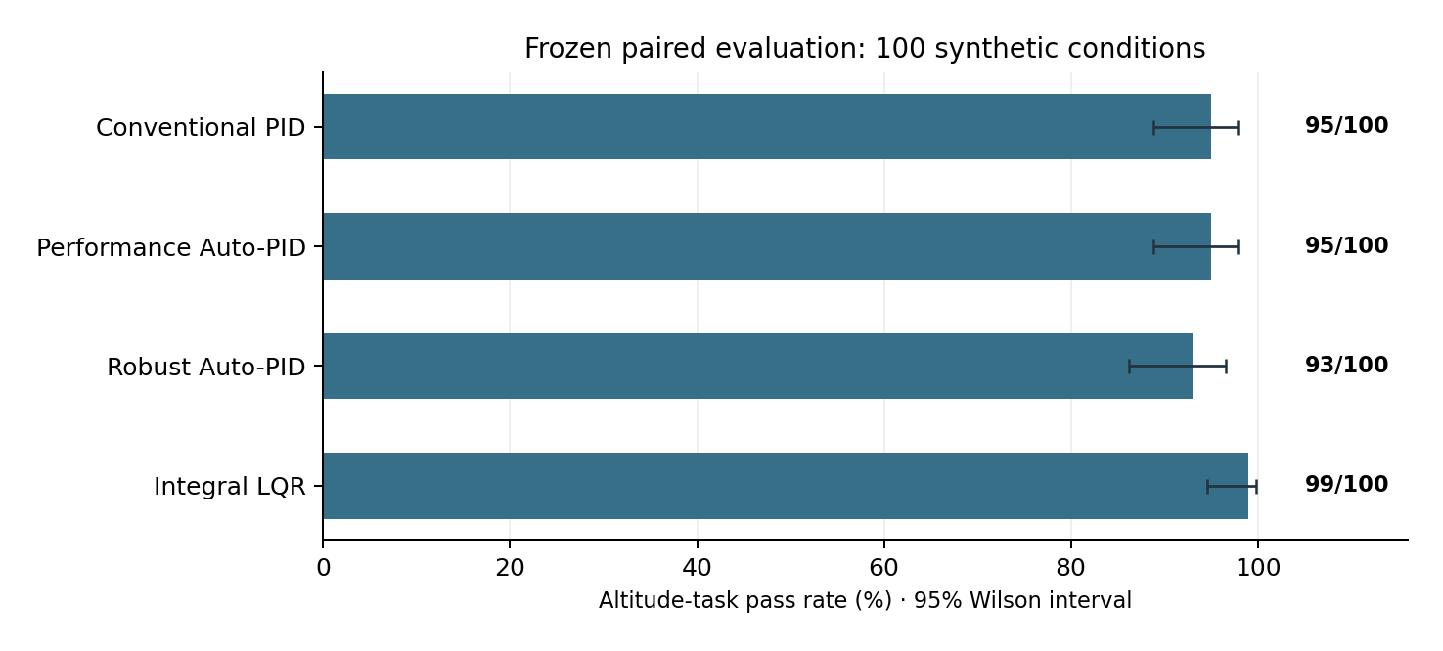
Figure 1. Altitude-task pass fractions across 100 matched synthetic conditions with Wilson 95% intervals. Higher values do not establish flight safety.

5.2 Pre-planned paired pass-rate comparisons
Alternative vs tuned PID | Baseline-only pass | Alternative-only pass | Exact p | Holm-adjusted p
Performance Auto-PID | 0 | 0 | 1.000 | 1.000
Robust Auto-PID | 2 | 0 | 0.500 | 1.000
Integral LQR-I | 0 | 4 | 0.125 | 0.375

No planned comparison achieved a Holm-adjusted p-value below 0.05. The 95% versus 99% comparison for LQR-I reflects four discordant pairs in its favor, but this sample is too small to reject equality under the specified paired test. Robust Auto-PID passed two fewer cases than conventional PID, despite lower average altitude error and settling time. This distinction is central: a controller may improve average tracking while losing performance relative to a hard overshoot threshold.

5.3 Secondary paired effects and control allocation
Relative to conventional PID, the mean paired Robust Auto-PID settling-time difference was −0.081 s (bootstrap 95% percentile interval −0.103 to −0.053 s), and the altitude IAE difference was −0.051 m·s (−0.058 to −0.044). These do not constitute a multiplicity-adjusted proof of general controller superiority. Relative to conventional PID, LQR-I increased mean paired roll IAE by 9.983 deg·s (5.118 to 15.469) and mean rotor saturation by 3.498 percentage points (1.886 to 5.391).
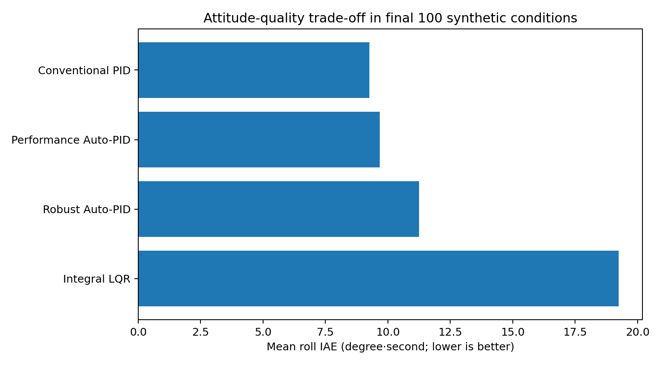
Figure 2. Mean roll IAE per controller. Smaller means tighter roll regulation within the simulated trials.
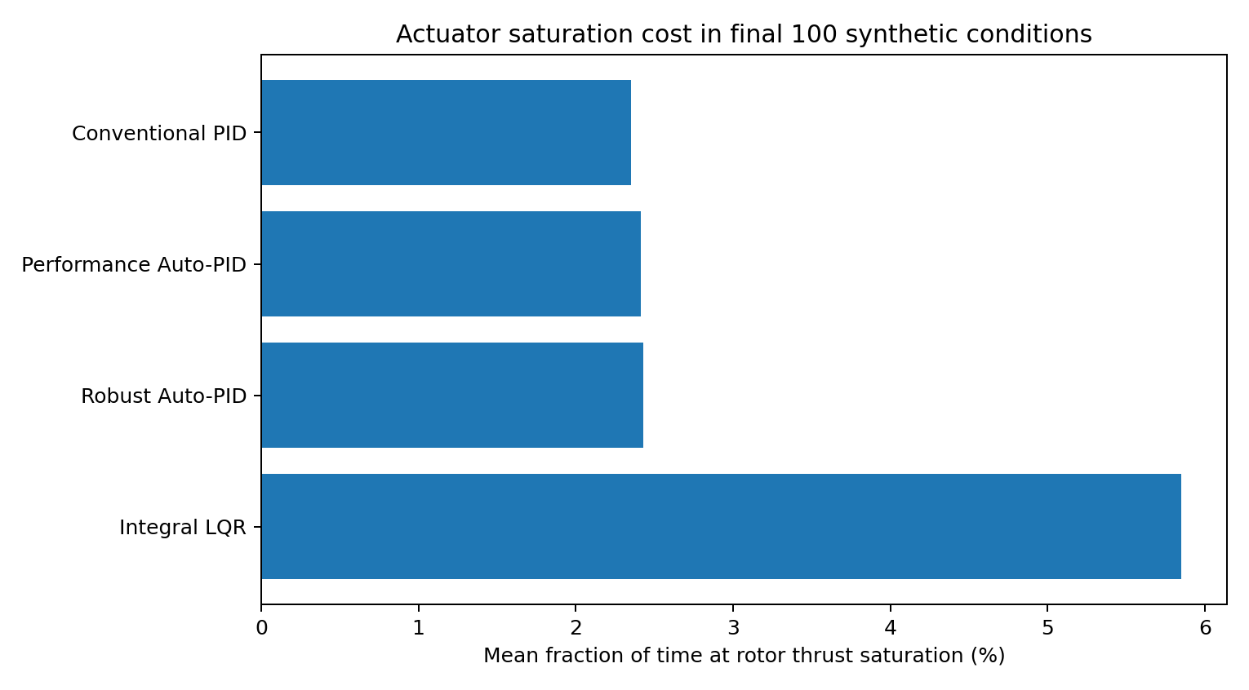
Figure 3. Average fraction of time steps with at least one rotor at a thrust limit. Results are controller- and model-specific.

5.4 Failure cases and uncontrolled degrees of freedom
Controller | Primary fails | Overshoot fails | Yaw >45° cases* | XY drift >2 m cases* | Max XY drift (m)
Conventional PID | 5 | 5 | 0 | 100 | 19.176
Performance Auto-PID | 5 | 5 | 0 | 100 | 17.116
Robust Auto-PID | 7 | 7 | 0 | 100 | 14.364
Integral LQR-I | 1 | 1 | 10 | 100 | 18.690

* Descriptive non-certification diagnostics. Every primary failure was attributable to exceeding the 14% overshoot threshold. No trial in the saved dataset exceeded the settling-time or final-error threshold. LQR-I reached a maximum recorded absolute unwrapped yaw of 509.756° and exhibited substantially larger roll IAE. All controllers crossed 2 m horizontal displacement at least once in each of their 100 runs. The x/y/yaw axes are not actively stabilized by this control architecture.
An additional interpretation warning concerns Euler yaw unwrapping: large accumulated yaw excursions can reflect real unregulated rotation and/or Euler-coordinate sensitivity during coupled attitude motion. They are meaningful as declared diagnostics, but further body-frame attitude analysis is necessary before making detailed physical yaw-stability claims.

5.5 Independent trajectory replay of the altitude-bound criterion
An additional post-final reproducibility audit was carried out using the unmodified frozen simulator, controller vectors, deterministic noise streams, and exactly the 100 previously saved condition rows. This was a replay of the existing study, not a new held-out experiment, and no controllers or pass rules were modified. All 400 replayed trial records reproduced the archived pass decisions and eleven checked numeric metrics. The largest absolute numerical discrepancy among the compared saved metrics was 1.72 × 10⁻¹².
The archived 400-row summary did not independently contain the maximum absolute altitude used in the predefined |z| < 25 m guard. The replay now reports this criterion directly for every condition and controller:
Controller | Maximum |z| (m) | Cases with |z| < 25 m
Carefully Tuned PID | 2.4612 | 100/100
Performance Auto-PID | 2.4548 | 100/100
Robust Auto-PID | 2.4998 | 100/100
Integral LQR | 2.2865 | 100/100
All 400 replayed trajectories satisfied the altitude bound; the largest observed |z| was 2.4998 m. This closes an export-level audit gap without changing the originally reported 95%, 95%, 93%, and 99% altitude-task pass fractions. Agreement with the same frozen simulator is a numerical reproducibility check, not independent validation of real quadrotor physics.

6. Discussion

6.1 The initial Auto-PID superiority proposition was not supported
The most important result is not a single controller ranking. The clearly tuned conventional PID passed 95% of the frozen synthetic cases; Performance Auto-PID matched that result exactly and Robust Auto-PID fell to 93%. Exact paired comparisons did not establish any Auto-PID advantage on the strict binary endpoint. This finding directly addresses the methodological risk raised in external feedback: a weak baseline can make a sophisticated tuner appear unreasonably effective. Once the baseline and actuator treatment were improved, the headline ordering changed.

6.2 Performance is multidimensional
Robust Auto-PID reduced average settling time and integrated altitude error but crossed the pass/fail overshoot boundary more often. LQR-I attained the largest pass fraction and shortest average settling time while requiring substantially more rotor saturation and exhibiting worse roll behavior. A useful engineering report should show a Pareto-style trade-off rather than converting a favorable metric into a blanket safety claim. The results support neither “auto-tuning universally wins” nor “LQR is safe in flight.”

6.3 The allocator correction matters causally
The collective-thrust priority correction changed the plant seen by the tuning procedures and therefore required a fresh, common re-tuning stage. Post-correction gain sets must not be retrospectively used to reinterpret the numerical record of V1, whose modeling and gains were different. The experiment is better described as V2 on a reconstructed model with a documented allocator fix and prospectively frozen post-fix controller gains.

6.4 Dependence on endpoint definition
The study deliberately names the primary endpoint “altitude-task pass” because only altitude and roll are feedback-regulated. Its finite-state and roll/altitude safeguards are insufficient to guarantee safe three-dimensional flight. The apparent 99% LQR success fraction coexists with severe yaw diagnostics in some trials, confirming that threshold choices define the scientific claim. A future trial with position, pitch, and yaw stabilization and clearly specified whole-flight constraints would address a different research question and would require a new prospective protocol.

6.5 External feedback response
Feedback request | Implementation / evidence
Strong conventional PID baseline | Deterministic tuning + local refinement, identical measurement and actuator interface; compare against 95/100 baseline.
Integral LQR benchmark | Discrete-time four-state actuator-aware altitude and roll LQR included as fourth comparator.
Held-out separation | Six development physical cases; four development gate cases; fresh 100-condition frozen draw; historical sets excluded.
Control effort and saturation | Thrust increment RMS, rotor saturation and torque allocation mismatch recorded and compared.
Multiple random optimizer runs | 10 independent seeded Differential Evolution runs each for Performance and Robust modes.
3.0 kg payload knowledge | 3.0 kg S3 excluded from gain selection, but was historically viewed; final 100-case test sampled masses only to 2.6 kg.

This response matrix documents what was done, not a statement that the feedback provider validated, accepted, or endorsed the results.

7. Limitations and open reproducibility issues
Model identification. The rotor model, drag, damping, sensor model and torque ratio are not calibrated from physical measurements. A result robust across one synthetic uncertainty family may fail under different real disturbances, aerodynamics, coupling, ESC response or failure modes. The uncertainty draws are not a representative population of weather or drone platforms.
Control scope. The model propagates full nonlinear 6-DOF states, yet only two channels are actively controlled. Pitch, yaw, and x/y motion can drift. The study is not an autonomous flight-control validation, certification, or hardware-robustness demonstration.
Selection and multiplicity. Numerous development candidate settings and exploratory secondary outcomes were inspected before freezing. The final tests address the declared outcome, but do not erase all model-development bias. Bootstrap CIs for multiple secondary metrics should be read descriptively. Comparisons across the four controllers share the same simulator assumptions and are not independent laboratory replications.
Protocol and export auditability. The seed field discrepancy was documented in a written pre-execution erratum and remains disclosed in the unchanged frozen protocol. A previous read-only CSV audit verified archived outcomes but lacked independent per-case max-|z| traces. The subsequent post-final trajectory replay re-executed the same 100 frozen physical conditions and paired noise for all four controllers, verified the maximum-|z| < 25 m guard in every trial, and matched the archived pass decisions and eleven checked numeric metrics. This validates consistency with the frozen implementation but does not validate the simulator against physical flight data.
Historical provenance and peer review. This V2 simulator is a disclosed reconstruction based on an earlier 2026 manuscript. Numerical agreement with selected older outputs is not proof of original-source recovery. There is no claim of independent peer review, publication acceptance, external laboratory validation, or professor supervision. Final statistical confidence intervals are conditional on code and synthetic sampling and must not be reported as real-world drone reliability.
Physical-model scope of the audit. Hover at nominal 1.50 kg requires 14.715 N collective thrust (3.67875 N per rotor; about 526 rad/s). These analytic checks support internal consistency, not experimental motor identification. The stated 12 N-per-rotor limit is nominal: under the synthetic thrust-scale range 0.90–1.08, the modeled maximum physical rotor thrust can reach 12.96 N at the same 950 rad/s cap. Wind labeled “horizontal wind” is applied only along the +x world axis in the current simulator, not at randomized headings. Neither assumption should be mistaken for a validated flight envelope.
Audit independence. The 400-run replay uses an independent script to check archived metrics and previously omitted altitude bounds but deliberately reuses the frozen dynamics and measurement implementation. It therefore tests computational repeatability rather than independently re-derived equations, flight hardware, or external peer review. A robotics/control-systems expert must examine torque and actuator modeling, the chosen uncertainty distribution, uncontrolled axes, and experimental claims before this paper is represented as externally reviewed.
Additional audit source. See independent_trajectory_replay.py, replayed_max_altitude_all_400.csv, replay_summary.csv, and replay_verification.json in the accompanying independent-audit archive.

8. Conclusions
In 100 newly frozen synthetic uncertainty conditions, conventional PID, Performance Auto-PID, Robust Auto-PID and actuator-aware integral LQR passed the predeclared altitude task 95, 95, 93 and 99 times, respectively. Holm-adjusted exact paired tests found no statistically established binary pass-rate advantage over conventional PID. Robust Auto-PID improved average altitude response, but not the stringent pass probability. Integral LQR obtained high altitude-task success while producing unfavorable roll and actuator-effort diagnostics. The results reinforce the importance of carefully tuned baselines, frozen paired evaluation, and honest reporting of failure and uncontrolled degrees of freedom.
The next scientific step is not to alter these frozen gains after viewing final results. It is to have the reconstructed model and protocol critically reviewed, independently reproduce the outputs, and, in a separate prospectively designed study, incorporate full position/attitude stabilization, real actuator identification and hardware-in-the-loop or flight-test validation.

Data, code, provenance, and acknowledgment
The accompanying data package includes FROZEN_FINAL_PROTOCOL.json, SEED_COMMITMENT.json, PRE_EXECUTION_SEED_ERRATUM.md, frozen_source/, future_final_runner.py, final_conditions_FROZEN.csv, final_400_paired_controller_trials.csv, statistics_pre_registered.json, read-only verification scripts, and SHA-256 manifests. The final condition seed is 4229883130818374818; the frozen commitment is 3ab3904bedd8aca22957292fb3aba4f49430b13afd992915732c40a15c1c062b. Because the final runner is one-shot protected, do not rerun it to select preferred trials.
Acknowledgment. The author acknowledges Dr. Ali Nasir for constructive technical suggestions that informed the study design. The acknowledgment does not imply his supervision, independent verification, co-authorship, or endorsement. Any future correspondence should describe his contribution as feedback only.
Research integrity. No unobserved physical flight tests are claimed. All numerical results are reconstructed-model outcomes. Any revision to the frozen hypothesis or model after inspecting these final results must be described as a new exploratory or prospectively registered study, not a retroactive improvement of this blind test.

References
[1] Mahony, R., Kumar, V., & Corke, P. (2012). Multirotor aerial vehicles: Modeling, estimation, and control of quadrotor. IEEE Robotics & Automation Magazine, 19(3), 20–32. https://doi.org/10.1109/MRA.2012.2206474
[2] Goodarzi, F., Lee, D., & Lee, T. (2013). Geometric nonlinear PID control of a quadrotor UAV on SE(3). arXiv:1304.6765. https://arxiv.org/abs/1304.6765
[3] Storn, R., & Price, K. (1997). Differential evolution – A simple and efficient heuristic for global optimization over continuous spaces. Journal of Global Optimization, 11, 341–359. https://doi.org/10.1023/A:1008202821328
[4] Nelder, J. A., & Mead, R. (1965). A simplex method for function minimization. The Computer Journal, 7(4), 308–313. https://doi.org/10.1093/comjnl/7.4.308
[5] Wilson, E. B. (1927). Probable inference, the law of succession, and statistical inference. Journal of the American Statistical Association, 22(158), 209–212. https://doi.org/10.1080/01621459.1927.10502953
[6] Holm, S. (1979). A simple sequentially rejective multiple test procedure. Scandinavian Journal of Statistics, 6(2), 65–70. https://www.jstor.org/stable/4615733
[7] Nazarbayev, N. (2026). Automated PID Controller Tuning for Quadrotor Control Using Differential Evolution and Nelder–Mead Optimization [Unpublished original research manuscript]. This internal source supplies the documented V1 model parameters and context; it is not peer-reviewed.

Appendix A. Study record and checksums
Before treating this manuscript as externally publishable, a human scientific reviewer should examine the source implementation against the theoretical equations, the physical actuator and disturbance models, and the uncontrolled yaw and lateral dynamics. The 29 original read-only data checks and the subsequent 400/400 full-trajectory replay with verified altitude bounds establish computational repeatability, not empirical or independent physics validation.
Raw final 400-trial CSV SHA-256: 9ab61fffe4d17c112c74f3d9791e8fd23121a2da56c2249ec621bb2142ec143b
Frozen final runner SHA-256: 4d6720bf78ea552a2034b1b1210163501202cb0a60709d6c5c72b51f812e332a
The original final archive is supplied separately. For auditability, full-precision numerical data in the underlying CSV and JSON files supersede rounded values in this document.

