PROGRAMME GUIDE
Distance Education Programmes

DIPLOMA IN COMPUTER EDUCATION (DCEd)

- Scheme of Examination
- Detailed Syllabus
- Counseling and Study Structure
- Study Modules & Books Information
- Date Schedule & Instructions for Submitting Assignments

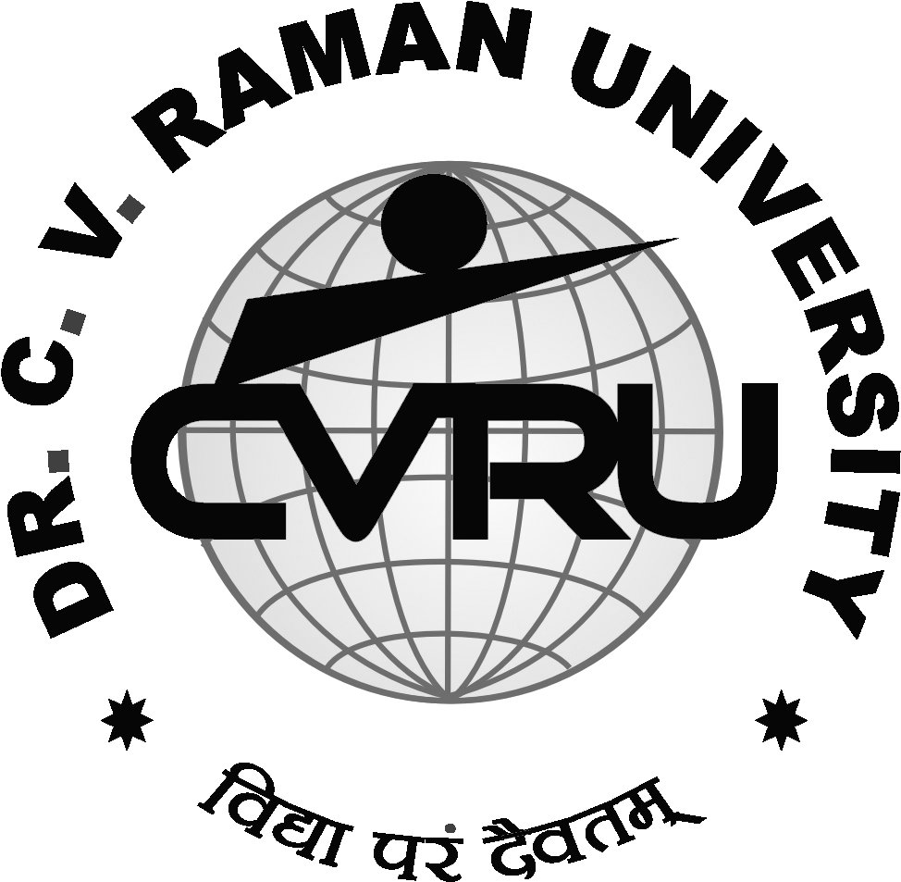

Instititute of Open and Distance Education (IODE)
Dr. C.V.Raman University
Kargi road, kota, Bilaspur, chattisgarh
Phone : 07753-253737, 8827920016, 8827920019 Fax : 07753-253728
E-mail: iode@cvru.ac.in Website: www.cvru.ac.in
DIPLOMA IN COMPUTER EDUCATION (DCEd)

Eligibility – Class 12th Pass Duration – 12 Months
Course | Name of the Course | Credit | Total Marks | Theory |  | Practical |  | Assignments
 |  |  |  | Max | Min | Max | Min | Max | Min
First Semester
DCED1 | Fundamentals of Computers and Information Technology | 3 | 100 | 70 | 23 | - | - | 30 | 10
DCED2 | Operating Systems (DOS,Windows) | 3 | 100 | 50 | 17 | 20 | 7 | 30 | 10
DCED3 | MS Office (Word, Excel) | 3 | 100 | 50 | 17 | 20 | 7 | 30 | 10
DCED4 | Introduction to FoxPro | 3 | 100 | 50 | 17 | 20 | 7 | 30 | 10
DCED5 | Principles of Internet and Applications | 4 | 100 | 50 | 17 | 20 | 7 | 30 | 10
 | Total |  | 500 | 270 | 98 | 80 | 29 | 150 | 54
Second Semester
DCED6 | Development of learners and teaching learning process | 4 | 100 | 50 | 17 | 20 | 7 | 30 | 10
DCED7 | Essentials of Education Technology and Management | 4 | 100 | 50 | 17 | 20 | 7 | 30 | 10
DCED8 | Project – Micro Teaching / Lesson Plan | 8 | 100 | - | - | 100 | 33 | - | -
 | Total |  | 300 | 100 | 36 | 140 | 51 | 60 | 22

Evaluation Scheme
- 33% in each theory, practical, project, dissertation & internal assessment
- 36% Aggregate marks to pass
Detailed Syllabus
DCED1 - FUNDAMENTALS OF COMPUTERS AND INFORMATION TECHNOLOGY
Brief history of computer, Definition of computer, characteristics of computer, applications of computer, computer v/s calculator, computer Vs human being, Types of computers Generations of computers, Basic components of a computer system - Control unit, ALU, Input/Output their functions and characteristics. instruction cycle of computer.
Personal Computer (PCs) – evolution of PCs, configurations of PCs- PC/XT, AT, 486, Pentium computers and Newer, PCs, Motherboard and its various sections, use of Expansion slots and various types of extension cards, Introduction and main capabilities & characteristics of new microprocessors--Dual core, Core 2 duo and quad core processors, Memory –primary and secondary types of memory RAM, ROM, EPROM, PROM, Cache Memory, SDRAM, DDR, DDR2 etc.
Input/Output & Storage Units-: Introduction, types, functions and working principles of various I/O devices like - Keyboard, Mouse, Trackball, Joystick, Digitizing tablet, Scanners, Digital Camera, MICR, OCR, OMR, Bar-code Reader, Voice Recognition, Light pen, Touch Screen, Monitors - characteristics and types of monitor -Digital, Analog, Size, Resolution, Refresh Rate, Interlaced / Non Interlaced, Dot Pitch, Video Standard - VGA, SVGA, XGA etc, Printers and its types – Daisy wheel, Dot Matrix, Inkjet, Laser, Line Printer, Plotter, Multi Functions Devices (MFD), Sound Card and Speakers, Storage fundamentals - Primary Vs Secondary Data Storage and Retrieval methods - Sequential, Index Sequential and Direct Access, SIMM, Various Storage Devices - Magnetic Tape, Magnetic Disks, Cartridge Tape, Hard Disk Drives, Floppy Disks (Winchester Disk), Optical Disks, CD, VCD, CD-R, CD-RW, Zip Drive, flash drives Video Disk , Blue Ray Disc, SD/MMC Memory cards, Physical structure of floppy & hard disk, drive naming conventions in PC. DVD, DVD-RW.
Software and its Need, Types of Software - System software, Application software, Utility Software, System Software - Operating System, Programming languages, Assemblers, Compilers and Interpreter, Introduction to various operating system for PCs—DOS, Windows, Linux etc.
File System basics – File Allocation Table (FAT & FAT 32), NTFS and ext3 file systems, files & directory structure and its naming rules, booting process details of DOS and Windows, DOS system files.
Programming languages- Machine, Assembly, High Level, 4GL, their merits and demerits, Application Software and its types - Word-processing, Spreadsheet, Presentation Graphics, Data Base Management Software, Graphics, Browsers, E-mail clients, Report Writers etc., characteristics, Uses and examples and area of applications of each of them.
Computer Virus - working principles, Types of viruses, virus detection and prevention, viruses on network, Viruses on Windows and Linux.
Use of communication and IT , Communication Process, Communication types- Simplex, Half Duplex, Full Duplex, Communication Protocols, Communication Channels - Twisted, Coaxial, Fiber Optic, Serial and Parallel Communication, Modem - Working and characteristics, Types of network Connections - Dialup, Leased Lines, ISDN, DSL, RF, Broad band ,Types of Network - LAN, WAN, MAN ,Internet, VPN etc., Topologies of LAN - Ring, Bus, Star, Mesh and Tree topologies, Components of LAN -Media, NIC, NOS, Bridges, HUB, Routers, Repeater and Gateways. Internet & its working. Various services of Internet.
Computer Applications in Business-Need and Scope, Computer Applications in daily life, Sales, Marketing, advertising, GIS, Multimedia, Computer Applications in Classes, Virtual Classrooms, Computer applications in Offices, Information System for Accounting-Cost and Budgetary Control, Marketing and Manufacturing, Computer Applications in Materials Management, Insurance and Stock-broking, Production planning and Control, Purchasing, Banking, Credit and Collection, Warehousing. Use of computers in common public services and e-governance. Various e-governance initiatives in India.
DCED2 - OPERATING SYSTEMS
Fundaments of operating system , definition and need. Main Services of operating system , various types of operating system, (definition and characteristics), multitasking, multiprocessing , multiprogramming, real time, time sharing, parallel, network operating system, booting process, file system.
DISK OPERATING SYSTEMS (DOS) - Introduction, History & versions of DOS DOS basics- Physical structure of disk, drive name, FAT, file & directory structure and naming rules, booting process, DOS system files.
DOS commands: Internal - DIR, MD, CD, RD, COPY, DEL, REN, VOL, DATE, TIME, CLS, PATH, TYPE etc.
External Commands - CHKDSK, XCOPY, PRINT, DISKCOPY, DISKCOMP, DOSKEY, TREE, MOVE, LABEL, APPEND, FORMAT, SORT, FDISK, BACKUP, EDIT, MODE, ATTRIB, HELP, SYS etc
WINDOWS - Introduction to Windows, its various versions and features. Hardware requirements for various versions of Windows. Working with Windows (XP or Windows 7) Windows concepts, Windows Structure, Desktop, Taskbar, Start Menu, Working with files and folders, create, copy, delete, renaming and moving files and folders, working with recycle bin-restoring deleted files, emptying the recycle bin, searching files and folders .My computer, formatting floppy disks, Using CDROM Disk and Dives.
Using Windows Accessories programs- Calculator, Notepad, Paint, WordPad, Character map, Paint, Command line.
Using Media Player, Sound Recorder, Volume Control.Taking Printout from programs, Printer Properties, Add fonts to Windows (Specially adding Hindi Fonts and using them). Setting up Regional and Language settings in Windows.
Advanced features of Windows -Managing Hardware & Software – Add or remove Hardware devices to/from computer, Add/remove programs, Using Scanner, Web camera, sharing of printers.
System Tools - Backup, Clipboard Viewer, Disk Defragmenter, Drive Space, Scandisk, System Information windows update.
Communication – Setting up Dial up Networking with Windows, Internet connection with Windows, Direct Cable Connection, Setting up TCP/IP properties, Hyper Terminal, Phone Dial ,Browsing the Web with internet explorer, communication through Outlook Express, Multiple Users Features of Windows. Creating and deleting user, changing user password etc. Accessibility Features of Windows.-Sharing Information between Programs, sharing folders and drives browsing the entire network, mapping windows shared drives, Using shared printers - Understanding OLE - Embed/Link Using Cut and Paste and Embed/Link Using Insert Object - Manage Embedded/Linked Object.
DCED3 – MS OFFICE
MS Word Basics: Introduction to MS Office; its components, Introduction to MSWord; Features & area of use. Working with MS Word.; Menus & Commands; Toolbars & Buttons; Shortcut Menus, Wizards & Templates; Creating a New Document; Saving document, Saving as different format, Different Page Views and layouts; Applying various Text Enhancements; Working with – Styles, Text Attributes; Paragraph and Page Formatting- Using page border and watermark, Text Editing using various features ; Bullets, Numbering, Auto formatting, word count, various page view options, Printing & various print options
Advanced Features of MS-Word: Spell Check, Thesaurus, Find & Replace; Headers & Footers ; Inserting – Page Numbers, Pictures, Files, Auto texts, Symbols etc.; Working with section breaks and page breaks, Working with Columns, Tabs & Indents; Creation & Working with Tables including conversion to and from text; Margins & Space management in Document; Adding References – footnotes, endnotes, and Table of contents, Insert drawing, Mail Merge, Envelops & Mailing Labels, protect and secure documents in MS Word, Working in different languages in MS Word. Using Unicode in MS Word, Insert WordArt and other objects like shapes, clipart, charts and SamrtArts, symbol in Document. Using Macros in Word- Record, edit and run macros.
MS Excel: Introduction and area of use; Working with MS Excel.; concepts of Workbook & Worksheets; Using Wizards; Various Data Types; Using different features with Data, Cell and Texts; Inserting, Removing & Resizing of Columns & Rows; Working with Data & Ranges; Different Views of Worksheets; Zooming, Column Freezing, Labels, Hiding, Splitting etc.; Using different features with Data and Text; Use of Formulas, Calculations using various type of functions-Logical, string, date & time, maths and other types; Cell Formatting including Borders & Shading; conditional formatting, sorting data items, Working with Different Chart Types; Printing of Workbook & Worksheets with various options. Import and export excel sheets to/from various format, add headers and footers, using macros in excel sheet- Record, edit and run macros.
DCED4 – INTRODUCTION TO FOXPRO
FOXPRO - THE RDBMS FOR PC
FoxPro - Versions, features, requirement of Hardware and Software, FoxPro - Menu System, Working with FoxPro, Creating Database File Some common operations on data- CREATE, LIST, APPEND, CLOSE, QUIT, FoxPro - Data Types
VIEWINING AND EDITING DATA
Data Displaying and Monitoring Commands - DISPLAY, LIST, LOCATE, EDIT, CHANGE, BROWSE, REPLACE, DELETE, RECALL, PACK (All Commands with various Options)
MODIFY STRUCTURE, MEMO FIELD AND FILE UTILITIES - File utilities in FoxPro - DISPLAY DIRECTORY, COPY, DELETE, RENAME.
SORTING AND INDEXING OF DATABASE FILES
Sorting & Indexing Concept, Sort Commands - Single & Multiple Key, Advantage & Disadvantages of Sort
Indexing Vs Sorting, Single & Multiple Key, Indexing, FIND, SEEK, Rushmore Technology
PRINTING REPORTS AND LABELS
FoxPro Report - its creation, features & Utilities, Preview, Printing, Custom Report, grouping & Subgrouping.
FoxPro Label - Designing & Printing
MEMORY VARIABLES, DATE & TIME FUNCTIONS AND KEYBOARD MACROS
Memory Variables - Creation and Uses, Simple Vs Array, Saving and Restoring Memory Variables, ?/??/??? Commands, Time & Date Functions and Commands, Date Arithmetic, Converting Defining Function Keys, Keyboard Macros - Creating and Using
MATHEMATICAL COMMANDS AND FUNCTIONS
Arithmetic Operations, Mathematical Functions, Mathematical, Commands, Statistical Functions.
PROGRAMMING WITH FOXPRO
Concepts of FoxPro commands file, Modify Commands, Conditioning , Branching and Looping within Program files with Do-While Enddo, If - Endif, Scan-Endscan, For - Endfor, Docase-Endcase, Text - Endtext, Executing Commands from other command files, Macro Substitution
ERROR CONDITIONS AND PROGRAM DEBUGGING AIDS
Common Error Massages, Debugging techniques and commands
MULTIPLE DATA FILES
Concept of Multiple Database Files - Using multiple database files, Relationing the database - SET RELATION, UPDATE, APPEND FROM, COPY TO, JOIN, Relation Query by Example and SQL, CUSTOM SCREENS & USER DEFINE FUNCTIONS & OTHER TOOLS, Create Custom Screen with @, @_GET, @_EDIT, _SAY_GET_READ, Creating Box & Lines, User Define Functions, Custom Screen, Designing and their Use, FoxDoc for documentation.
DCED5 - PRINCIPLES OF INTERNET AND APPLICATIONS
Computer Networks – Introduction, topologies, layers, equipments used in networking-bridges, routers and gateways, servers, types of servers, types of networking – peer to peer, client-server, types of networks – LAN, MAN, WAN, Intranet, Subnet, Internet, VPN. Media used in networking – wired and wireless, CAT5 and CAT 6 Cables, Fiber cable.
Internet – History, WWW and HTTP evaluation, services offered by Internet – e-mail, WWW, FTP, telnet, News and USENET, Ghopher, WAIS, IRC, VOIP, WAP, Webcasting and Podcasting, e-com, m-com, Social Networking. Connectivity method to Internet – Dialup, DSL, ISDN, VSAT, RFID, Broadband, leased line- advantages and limitations of each method. Setting in Windows/Linux to connect the Internet. Internet addressing basics, domain names basics, DNS, DHCP, TCP/IP protocols, URIs and URLs, Domain anme, process of obtaining domain names – TLD and Sub domains, Indian Domain names, Web servers – functions and capabilities, Introduction to PWS, IIS, Apache etc.
Browsers – features, services offered by browsers, browsers evaluation, extensions and plug-ins for browsers, some important plug-ins introduction like – flash, java, silverlight, etc. features of some major browsers – IE, Firefox, and Google Chrome.
E-mail- Process, obtaining an e-mail address, types of email services – Web based and POP3. Understanding e-mail address, SMTP and MIME protocols, Using web based and pop3 e-mail – creating a message, sending a message, CC, BCC, replay, forward, reply to all, attach a document, add signature to mail, spam mails handling, junk mails, etc. email clients software – installation and configuration. Configuring and Using Outlook Express.
File Transfer using FTP – FTP Process fundamentals, How to use FTP using browsers, FTP using client software like – Cute FTP, WS FTP, File Zilla etc. File formats and Transfer types, Anonymous and non- anonymous FTP.
Telnet – Features, session, using telnet with browsers, Client programs, with Windows.
UseNet – Features, differences between e-mails and newsgroups, various types of usenet groups, usenet protocols, major newsgroups, process of joining a newsgroup of your interest. Start your own newsgroup. Using browser as the newsgroup reader.
Gopher, WAIS, ARICHE and Veronica – features, How to use these services, their features.
Internet Relay Chat – Its features, use, IRC servers, Web based and telnet based chats, Chatting programs, Chat commands, using some web based IRC program like yahoo messenger and Google talk etc.
Web Servers – features, services offered by web servers, various ports, introduction to Unix/Linux and Windows based web servers – PWS, IIS, Apache, Tomcat etc. Hosting directories, Concepts of Virtual Directires, Types of files used – HTML, ASP, JSP, .PHP, .cgi, .pl, .aspx, etc., need of .NET framework on servers, FrontPage extension. Process of transfer files on Web servers using FTP.
Firewalls – Uses working and applications. Setting up firewall on your system.
Data Security on Internet – Introduction to data security on Internet, Importance of password handling, Encryption technology, digital security, digital certificate, SSL and digital watermark.
Languages of Internet – a brief introduction to HTML, DHTML, XML, .NET, PHP, JAVA, JavaScript, AJAX, VB.Net, C# and CSS (Brief intro, features, at least 2 examples and explanation of each.
DCED6 - DEVELOPMENT OF LEARNERS AND TEACHING LEARNING PROCESS
Nature of Psychology and learners
Psychology: Its meaning, nature, methods and scope: fund educational psychology. Stages of Human development: state specific characteristic developmental tasks.
Adolescence in Indian context
Characteristics and problems of adolescents their needs and aspirations. Guiding and counseling adolescents.
Learning and Motivation
Nature of learning: learning theories – Factors influencing learning and teaching process: learner related. Motivation – nature, types: techniques of enhancing learner’s motivation.
Intelligence
Nature and characteristics of intelligence and its development. Measuring Intelligence – Verbal. non verbal and performance tests representative of group test and individual test of each.
Exceptional children
Concept of exceptional children types, and characteristics of each type including children with learning disabilities.
Personality – Definition, meaning and nature: development of personality
DCED7 - ESSENTIALS OF EDUCATION TECHNOLOGY AND MANAGEMENT
Definition of educational technology – Distinction between hardware and software technologies. Their role in modern educational practices. Hardware technologies: Important accessories and their application – OHP, Still and movie projectors, Audio- Video recording instruments, TV, Computers, New technologies like – e-mail: internet: etc.
Use of strategies like teleconferencing – micro teaching, programmed instruction, language, and laboratory. Instructional material – linear, branching programmer.
Meaning of Guidence - Ratioale for guidance services concept of counseling directed and non – directed counseling. Organization school guidance services: use of community resources for school guidance services.
Meaning of Management in Education - Managing men resources and materials. Implications for educational initiations. Managing curriculum, managing co-curriculum, managing school discipline, and managing physical resources.
Evaluating Institutional Performance - Methods used, pupil evaluation, teacher evaluation, evaluation of institutional performance.

DCED8 - PROJECT – MICRO TEACHING / LESSON PLAN
COUNSELING AND STUDY STRUCTURE
Sl. No. | Course Code | Title of the Course | Credit | Total Hours of Study | Counseling and Study Structure (hours) |  |  |  | Project
 |  |  |  |  | Face to Face Counseling | Self study | Practical | Assignments | Project
Semester I
1 | DCED1 | Fundamentals of Computers & Information Technology | 3 | 90 | 12 | 51 | - | 27 | -
2 | DCED2 | Operating System (DOS, Windows) | 3 | 90 | 12 | 33 | 18 | 27 | -
3 | DCED3 | MS-Office (MS-Word, Excel) | 3 | 90 | 12 | 33 | 18 | 27 | -
4 | DCED4 | Introduction to Foxpro | 3 | 90 | 12 | 33 | 18 | 27 | -
5 | DCED5 | Principles of Internet and ApplicationS | 4 | 120 | 16 | 44 | 24 | 36 | -
Semester II
6 | DCED6 | Development of Learners and Teaching Learning Process | 4 | 120 | 16 | 44 | 24 | 36 | -
7 | DCED7 | Essentials of Education Technology and Management | 4 | 120 | 16 | 44 | 24 | 36 | -
8 | DCED8 | Project-Micro Teaching / Lesson Plan | 8 | 240 | - | - | - | - | 240

STUDY MODULES AND BOOKS INFORMATION
Course  Code | Name of the Course | Books / Modules to be used
Semester-I
DCED1 | Fundamentals of Computers & Information Technology | - AISECT Module S01- Fundamentals of Computers & Information Technology
DCED2 | Operating System (DOS, Windows) | - AISECT Module S02-Disc Operating System & S18-MS Windows
DCED3 | MS-Office (MS-Word, Excel) | - AISECT Module S19-MS Word & S20-MS Excel
DCED4 | Introduction to Foxpro | - AISECT Module S07-Foxpro
DCED5 | Principles of Internet and Application | - AISECT Module S27-Internet
Semester-II
DCED6 | Development of Learners and Teaching Learning Process | - Development of Learners and Teaching Learning Process by R.S. Sharma (Hindi & English)
DCED7 | Essentials of Education Technology and Management | - Essentials of Educational Technology by J.C. Agrawal (Hindi & English)
DCED8 | Project-Micro Teaching / Lesson Plan | - Micro Teaching by Y.K. Singh  - Shukhsm Sikshan by Ramprasad Kathooria

DATE SCHEDULE AND INSTRUCTIONS FOR SUBMITTING ASSIGNMENTS

DUE DATE OF SUBMISSION OF ALL ASIGNMENTS AT THE STUDY CENTRE
Year | Assignment No. | Due Date
Semester - I | DCED(1)  DCED(2)  DCED(3)  DCED(4)  DCED(5) | April 30 (for January Session )  October 31 (for July Session)
Semester - II | DCED(6)  DCED(7) | April 30 (for January Session )  October 31 (for July Session)

Note: Assignments of the course are available for download at the CVRU Website http://www.cvru.ac.in . You can download the assignments as per your course, follow the instructions given and submit it before due dates at the study centre.

